REVISED TARIFF STRUCTURE STATEMENT

**ActewAGL Distribution Electricity Network**

4 October 2016

Table of Contents

1 Introduction 1

1.1 About ActewAGL Distribution 1

1.2 Regulation 3

1.3 Policy and regulatory background 3

1.4 Objective of this document 5

1.5 Compliance with Rule requirements 8

2 Proposed tariff structure 9

2.1 Proposed tariff classes 9

2.2 Proposed tariff structure for residential consumers 10

2.3 Proposed tariffs for low voltage commercial consumers 29

2.4 Proposed tariffs for high voltage commercial consumers 45

2.5 Tariff setting to comply with pricing principles 48

2.6 Our approach to updating our tariffs annually 52

Attachment 1 Price Setting Description 53

Attachment 2 Standalone costs and avoidable costs 59

# 

***List of tables***

Table 1-2: How the Revised TSS complies with the Rule requirements 8

Table 2-1: Top Peak Demand Days: Weekdays and weekends 17

Table 2-2: Peak Demand Days: Individual Residential Consumer (2015/16) 18

Table 2-3: Residential Peak Demand Tariff Parameters 19

Table 2-4: AAD’s proposed tariff structure for residential consumers 22

Table 2-5: Estimated change in indicative residential network bills (indicative 2017/18 tariffs) 25

Table 2-6: LV Commercial Peak Demand Tariff Parameters 36

Table 2-7: AAD’s proposed tariff structure for Low Voltage Commercial Consumers 38

Table 2-8: Estimated change in LV commercial network bills (indicative 2017/18 tariffs) 41

Table 2-9: AAD’s existing HV commercial tariffs 45

Table 2-10: AAD’s proposed tariff structure for HV Commercial Consumers 47

***List of figures***

Figure 1-1: The energy market 1

Figure 1-2: Our distribution network’s assets 1

Figure 1-3: Our service area in the Australian Capital Territory 2

Figure 1-4: How consumers can respond to price signals 3

Figure 1-5: Process for introducing cost–reflective tariffs 7

Figure 2-1: Residential peak demand tariff 10

Figure 2-2: Example of two consumers’ half hourly maximum demand (in peak period) each day of a calendar month (kW) 11

Figure 2-3: Maximum net system load profile by time of day, 2014 (MW) 13

Figure 2-4: Residential zone substation – Percentage of monthly peak deamnd events by time of day, 2015 15

Figure 2-5: Sample of residential consumers – Percentage of peak demand events by time of day, 2015/16 16

Figure 2-6: Peak residential load, by seaons, 2014 (MW) 18

Figure 2-7: Residential bill impacts for different consumption profiles (indicative 2017/18 tariffs) 26

Figure 2-8: Estimated savings on demand tariff compared to the residential Basic and TOU Tariffs 28

Figure 2-9: Proposed kW demand tariff for low voltage commercial consumers 30

Figure 2-10: Commercial Zone Substations – Percentage of monthly peak demand events by time of day, 2015 31

Figure 2-11: Sample of Commercial Consumers – Percentage of peak demand events by time of day, 2015/16 32

Figure 2-12: Commercial Zone Substations – Percentage of monthly peak demand events by day of week, 2015 33

Figure 2-13: Sample of Commercial Consumers – Percentage of peak demand events by day of week, 2015/16 33

Figure 2-14: Peak commercial load, by seaons, 2014 (MW) 34

Figure 2-15: Refined kW demand tariff for low voltage commercial consumers 36

Figure 2-16: LV commerical bill impacts for different consumption profiles (indicative 2017/18 tariffs) 42

Figure 2-17: Estimated savings on demand tariff compared to the LV commercial General Network and TOU Tariffs 44

***Glossary***

ACT Australian Capital Territory

AEMC Australian Energy Market Commission

AEMO Australian Energy Market Operator

AER Australian Energy Regulator

DAPR Distribution Annual Planning Report

DNSP Distribution Network Service Provider

DUOS Distribution Use of System

ECRC Energy Consumer Reference Council

EV Electric vehicles

HV High Voltage

GST Goods and Services Tax

kVA Kilovolt-amperes

KWh Kilowatt hours

LRMC Long-run marginal cost

LV Low Voltage

MVA Mega volt amps

MW Megawatt

NEL National Electricity Law

NEO National Electricity Objective

NER National Electricity Rules

NMI National Metering Identifiers

NUOS Network Use of System

OH Overhead

p.a. Per annum

PV Photovoltaic

TOU Time of use

TSS Tariff Structure Statement

TUOS Transmission Use of System

UG Underground

# Introduction

## About ActewAGL Distribution

ActewAGL Distribution (AAD) owns and operates the electricity network in the ACT, and gas networks in the ACT and surrounding areas in New South Wales. We own and operate 2,400 kilometres of overhead electricity lines, 2,700 kilometres of underground cables and almost 4,900 kilometres of natural gas pipelines and serve around 180,000 residential and commercial electricity and gas consumers.

We are responsible for the power lines and other infrastructure required to transport electricity through the network to your home or business. We undertake electricity network maintenance, connect new consumers, plan and construct new infrastructure, provide emergency responses, and install, replace and read consumers’ electricity meters.

**Figure 1-1: The energy market**

**Electricity Generation**

**Power plant, wind and solar.**

**Transmission Lines**

**Carry electricity long distances.**

**$$**

**Distribution Lines**

**Carry electricity to customers.**

**Retailer**

**The company that bills you for your power usage. You can choose your retailer.**

**Your Home or Business**

**Uses electricity for lighting, heating and to power appliances.**

Within the ACT, we operate and maintain a network of poles, wires, transformers and other equipment to distribute electricity safely and reliably to consumers. The AAD network is an essential part in the process of moving electricity from where it is generated to where it is used by our consumers as demonstrated in Figures 1-1 and 1-2. Our service area is shown in Figure 1-3 (overleaf).

**Figure 1-2: Our distribution network’s assets**

**15**

**Zone substations**

**4,500**

**Street transformers**

**2,390km**

**Overhead wires**

**2,690km**

**Underground cables**

**Covering**

**2,360km2**

**Figure 1-3: Our service area in the Australian Capital Territory**

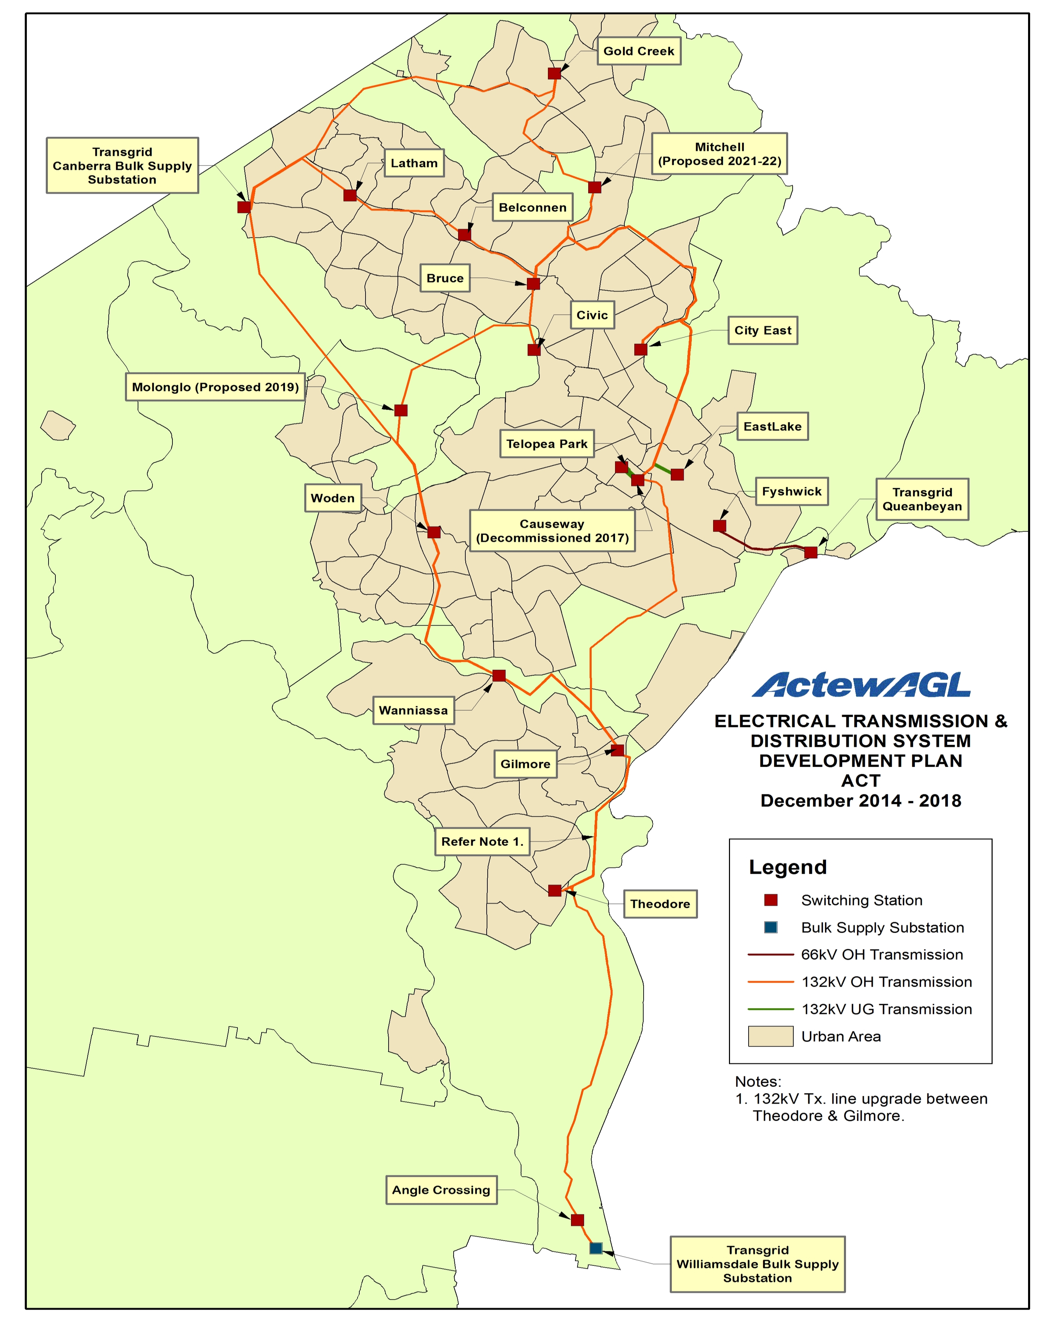

## Regulation

Like all electricity distribution network service providers in the National Electricity Market (NEM), AAD is a regulated business. As such, AAD complies with the National Electricity Rules (‘the Rules’) and the National Electricity Law (NEL). The Australian Energy Market Commission (AEMC) is responsible for setting the Rules. The Australian Energy Regulator (AER) monitors and enforces compliance with these regulatory requirements.

The AER determines the revenue we are allowed to collect over a five year period via distribution charges although we have some flexibility around how those charges are applied to our consumers.

## Policy and regulatory background

In recent years there has been a move across the electricity industry in reforming network tariffs to move away from flat rate consumption based charges to tariff structures that better reflect the marginal cost of providing network services to individual consumers. This was initially driven by the impact on the electricity grid of rising maximum demand which required increased investment in some electricity networks at a time when consumption was either flat or falling.

As shown in Figure 1-4, changing the pricing structure for electricity network tariffs provides an opportunity to encourage the use of the network at off-peak times and mitigate the impact of rising peak demand, confirming, delaying or reducing the need for investment in new capacity.

**Figure 1-4: How consumers can respond to price signals**

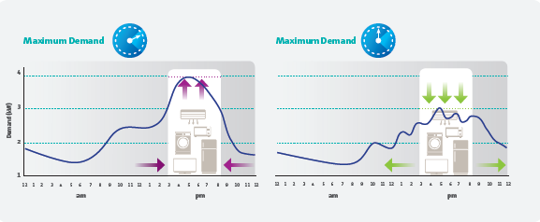

The tariff reform was initiated by the AEMC’s 2012 *Power of Choice* review. The review proposed the implementation of tariffs that reflect the cost of network services and provide consumers with price signals to encourage efficient use of network assets, in particular, the efficient use of electricity at times of aggregate peak demand on the network. Following the *Power of Choice* review, the AEMC made a number of changes to the Rules in November 2014. The key features of these changes are outlined in the box below.

***Key features of the Distribution Pricing Arrangements Rule Change***

1. A **network pricing objective** was codified in the Rules. The objective requires each network tariff to reflect the efficient costs of providing network services to consumers assigned to a tariff and that tariffs can be transitioned to cost reflective levels over time.
2. DNSPs must base their tariffs on the **Long Run Marginal Costs** (LRMC) of supply.
3. DNSPs must recover their allowed revenue in a way that **minimises distortions** to price signals for efficient usage as provided by LRMC based prices.
4. DNSPs must: (a) **manage the impact** of annual changes in network prices on consumers; and, (b) set network prices which consumers are reasonably capable of understanding.
5. Tariffs must be set so as to recover an amount of revenue that lies between the **stand alone and avoidable costs** of supply to a customer (or group of customers).
6. Tariffs must recover any residual costs in a way that **least distorts consumption** behaviour.

Cost-reflective prices are a fundamental part of the concept of economic efficiency which underlies the National Electricity Objectives (NEO). Section 7 of the NEL outlines the NEO:

*The objective of this Law is to promote efficient investment in, and efficient operation and use of, electricity services for the long term interests of consumers of electricity with respect to—*

*(a) price, quality, safety, reliability and security of supply of electricity; and*

*(b) the reliability, safety and security of the national electricity system.*

The NEO guides all AER decisions, and reflects the concept of economic efficiency, which has three sub-components: *productive*, *allocative* and *dynamic* efficiency.

|  |
| --- |
| ***Components of economic efficiency***  Economic efficiency (which underpins and is required by the NEO) is comprised of:  **Productive Efficiency** (‘promote efficient investment in’): Tariffs for regulated services should, in totality, only recover the ‘efficient costs’ of investing in regulated services.  **Allocative Efficiency** (‘efficient….use of, electricity services’): Tariffs for regulated services should be reflective of the forward looking costs of providing those services (cost reflective), so that consumption only occurs where the benefit to the consumer outweighs the cost to the society of providing those services.  **Dynamic Efficiency** (‘for the long term interests of consumers of electricity with respect to…price’): Regulated businesses should be incentivised to seek out efficiency gains over time, and improve performance where the benefits exceed the costs, such that efficiency is promoted in the long-term. |

For the purposes of designing tariffs, the most important of the components in the box above is **allocative efficiency.** In the context of the electricity industry, the most fundamental component of allocative efficiency is that consumers should consume electricity up to the point where the marginal benefit to them of consuming an additional unit of energy (kWh, kW or kVA, depending on the cost driver being priced) equals the marginal cost[1] of providing that extra unit of energy to that consumer.

When price deviates from the marginal cost of supply, consumers will consume either:

* too much of the service, which will occur if the marginal price is less than its true cost (that is, some consumers will consume electricity services despite the fact that the cost of providing them with an additional unit of that service exceeds the benefit that they receive from consuming that service), or
* not enough of the service, which will occur if the marginal price is greater than its cost of supply (that is, some consumers will not consume electricity services despite the fact that the cost of providing them with an incremental unit of that service is less than the incremental benefit that they would receive from consuming that additional unit).

## Objective of this document

The Tariff Structure Statement (TSS) seeks to provide our consumers and other stakeholders with clear and accessible information about current network tariffs and how these may change in the future. AAD prepared a proposed TSS that was submitted to the AER in November 2015. The proposed TSS took into account response to changes in electricity markets (for example, the growth of rooftop photovoltaic (PV) systems, battery storage and electric vehicles). In the proposed TSS, we undertook a comprehensive review of our network costs and existing tariff structures, and consulted widely with the Canberra community, large consumers and retailers (see Section 6). The Rules require network businesses like AAD to develop a TSS that clearly shows how the pricing principles have been applied to develop price structures and indicative price levels, typically for a five year regulatory period.[2]

In this revised version of the TSS, AAD has made adjustments to the proposed residential and commercial demand tariffs in response to the AER’s draft decision. AAD has adjusted the charging window of the residential demand tariff and adopted an anytime window for the LV demand tariff, which is consistent with the AER’s recommendations in the draft decision.

This is our first (revised) TSS to the AER under the new Rules. Once approved, the TSS remains in place for the remainder of the current regulatory period (that is, from 1 July 2017 until 30 June 2019), unless an event occurs that is beyond the distribution business’ reasonable control and could not reasonably have been foreseeable requires a change to be made, and the AER approves that change.

The tariff structures contained in the approved TSS will form the basis for AAD’s annual pricing proposals for the financial years 2017/18 and 2018/19. The AER will conduct an approval process for annual prices to check consistency with the TSS, compliance with pricing principles and other requirements, such as the control mechanism under the AER’s distribution determination.

The timeline for the review and implementation of the new network tariff structure over the next 12 to 15 months is shown at Figure 1-5. The AER reviewed the proposed TSS and made a draft decision on 2 August 2016. A final decision is due in February 2017.

**Figure 1-5: Process for introducing cost–reflective tariffs**

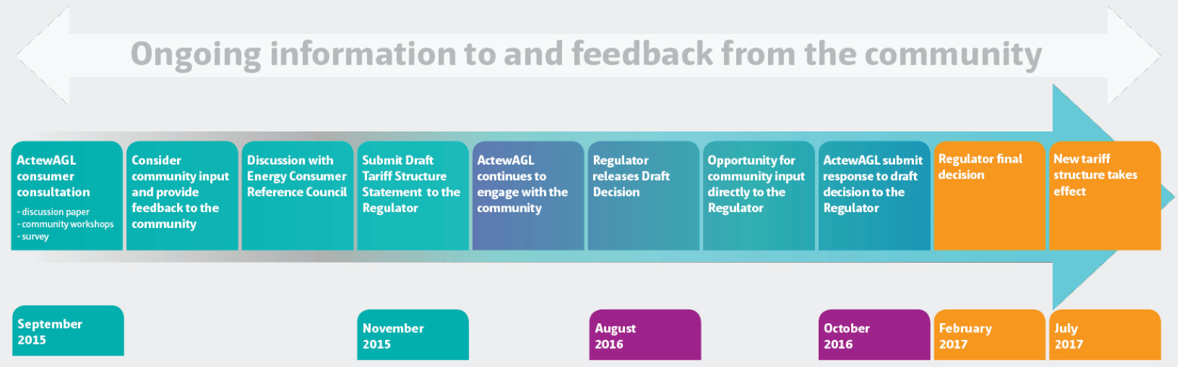

## Compliance with Rule requirements

To help with the review process, Table 1-1 below sets out how we demonstrate compliance with the TSS Rule requirements. AAD’s TSS contains the sections referenced to address Rule 6.18, while the TSS Explanatory Statement addresses both Rules 6.18 and 6.8.

Table 1-1: How the Revised TSS complies with the Rule requirements

|  |  |  |
| --- | --- | --- |
| Requirement | Rule: 6.18 | Reference in the TSS Explanatory Statement |
| The TSS must include **tariff classes** | 6.18.1A(a)(1) | Section 2.1 |
| The TSS must include the policies and procedures for **assigning consumers to tariffs and reassigning** from one to another | 6.18.1A(a)(2) | Sections 2.2 - 2.4 |
| The TSS must include the **structures** for each tariff | 6.18.1A(a)(3) | Sections 2.2-2.4 |
| The TSS must include the **charging parameters** for each tariff | 6.18.1A(a)(4) | Sections 2.2 - 2.4 |
| The TSS must include a **description of the approach to be taken in setting each tariff** in each pricing proposal during the regulatory period | 6.18.1A(a)(5) | Section 2 and Attachment 1 |
| The TSS must be accompanied by an **indicative pricing schedule** | 6.18.1A(e), 6.8.2(d1) | Indicative pricing schedules for NUOS and ACS are provided in Attachments 3 and 4. |
| **Requirement** | **Rule: 6.8** | **Reference in the TSS Explanatory Statement and Overview Paper** |
| TSS to be accompanied by an **Overview Paper** | 6.8.2(c1a) | Overview Paper provided separately |
| A description of **engagement with consumers, retailers and stakeholders** in developing the TSS | 6.8.2(c1a), 11.73.2 | TSS Explanatory Statement Sections 6 and 7, and the Overview Paper. |
| A description of how the **TSS complies with the pricing principles,** including supporting materials | 6.8.2(c), 11.73.2 | Section 2.5.  Attachment 1 sets out how tariffs are based on LRMC. Attachment 2 describes how the revenue to be recovered from each tariff class lies between stand alone and avoidable costs. |

# Proposed tariff structure

The network tariffs in AAD’s TSS are designed to meet the network pricing objective and comply with the pricing principles contained in the Rules. Importantly, the transition to more cost-reflective tariffs incorporates feedback from our consumers and retailers. AAD will continue to build a better understanding of consumers’ ability to respond to market signals provided by more cost-reflective tariffs.

The changes proposed to the tariff structure are designed to increase cost-reflectivity rather than to increase the revenue that AAD can recover from the network as this is set by the AER for each regulatory control period.

This section outlines our proposed tariff structure as follows.

* Explanation of proposed network tariff classes (Section 2.1).
* Details of the tariff structure, tariffs and charging parameters for tariffs offered to residential, low voltage commercial and high voltage commercial consumers in Sections 2.2 - 2.4, respectively.
* A description of the way in which the tariffs comply with the pricing principles (Section 2.5).
* An explanation of how AAD will update our tariffs annually (Section 2.6).

## Proposed tariff classes

AAD’s approach to the classification of tariff classes remains unchanged. Consumers are currently classified into three tariff classes:

1. Residential
2. Commercial low voltage (LV)
3. Commercial high voltage (HV)

In accordance with Clause 6.18.1A(a) of the Rules, these are the classes into which retail consumers for direct control services will be classified during the 2015 – 2019 regulatory period.

The tariff classes are set on an economically efficient basis. Consumers within each tariff class have similar load and connection profiles, which mean they impose similar costs on the network. Thus, setting tariffs within tariff classes enables AAD to distinguish those similar costs and apply charges to each tariff class appropriately, which results in an efficient outcome.

Consistent with (clause 6.18.3(d)), these tariff classes also enable AAD to avoid unnecessary transaction costs by treating consumers with similar profiles in a similar way. These tariff classes have proven to provide the most cost-effective way of grouping consumers together to minimise administrative costs, compared to offering additional classes and re-assigning existing consumers to different classes.

## Proposed tariff structure for residential consumers

Consistent with our transition strategy to more cost-reflective tariffs, we will introduce a new residential demand tariff that takes advantage of the expected availability of remotely read interval meters from December 2017. The assignment of consumers to this tariff was explained in Section 7 but is repeated here for the reader’s convenience.

Within this subsection, we outline the structure of the revised tariff (subsection 2.2.1) including the original proposal (2.2.1.1), the AER’s draft decision in relation to the original proposal (2.2.1.2) and the revised version of the proposal (2.2.1.3) as well as the assignment policy for the proposed tariff (subsection 2.2.1.4). Other changes that have been made to the structure of residential tariffs are then explained in subsection 2.2.2. Finally, in subsection 2.2.3 the indicative residential consumer bill impacts are presented.

### Proposed demand tariff

During AAD’s review of network tariffs and engagement with consumers, AAD identified the value of introducing a demand tariff for residential consumers. The new peak period demand tariff will offer residential consumers a more cost reflective option than existing residential tariffs. Consumers on the new demand tariff will pay a bill that more closely reflects the long term marginal cost of supplying electricity to them, and will enable residential consumers to more actively manage and control the size of their electricity bills by considering when and how they use electricity.

The new demand tariff will comprise a fixed component, a usage component and a demand component, as shown in Figure 2-1 below.

**Figure 2-1: Residential peak demand tariff**

In line with current practice, the **fixed supply** component of the demand tariff would not vary with the level of energy consumption or demand. The fixed charge is determined as the residual of the long run marginal cost (LRMC) (of providing electricity services) allocation that is not recovered from demand or energy charges. The fixed charge relates to the connection services provided to consumers and ensures approved revenue requirements are met. The fixed charge signals the cost of maintaining connection assets as well as servicing consumers, for example, consumer related costs such as the network call centre.

Part of the consumer’s bill would be based on **energy** consumption, with the rate reflecting the cost of supplying energy outside those times when our network is expected to experience peak demands (because any peak demand related future costs would, in time, be fully signalled and recovered through the demand component).

Part of the consumer’s bill would be based on the **demand** that the consumer places on the network during periods of peak demand. The demand component is structured in this way because it addresses the main driver of our future costs that can be influenced by consumers’ current consumption behaviour. The peak demand component is applied to a set time period.

Figure 2-2 provides an example to show how a consumer may have several peaks during a calendar month – some of these peaks may occur during the defined peak period of the day, and others may not. A consumer’s highest (half hourly) demand period that occurs during the defined peak period, within a single calendar month, constitutes the basis for the demand component of the new tariff. Figure 2-2 identifies several maximum demand periods in the calendar month for two different hypothetical consumers – ‘high peak Harry’ and ‘flat load Phil’. For ‘high peak Harry’, the maximum half hourly demand is 3.5 kW for the month. For ‘flat load Phil’, the maximum half hourly demand is lower at 1.5 kW for the calendar month.

**Figure 2-2: Example of two consumers’ half hourly maximum demand (in peak period) each day of a calendar month (kW)**

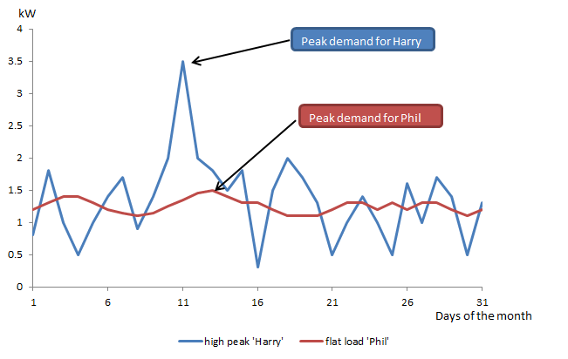

This maximum half hourly demand (within the peak periods of a calendar month) is then multiplied by two, to convert the demand to an hourly basis. The demand tariff component of 19 cents per kW per day (see Indicative Tariff Schedule) is then multiplied by the maximum hourly demand. This illustration is outlined in the box below.

### *Examples of calculation of daily residential demand charge*

### High peak ‘Harry’

### Convert maximum half hourly demand to hourly demand

### (3.5kW x 2 = 7kW)

### Apply maximum (hourly) demand to the demand component of the tariff to calculate cost to the consumer

### (7kW x $0.19 = $1.33)

### High peaks ‘Harry’ pays $1.33 per day, each day of that month, for the demand component of his bill.

### Flat load ‘Phil’

### Convert maximum half hourly demand to hourly demand

### (1.5kW x 2 = 3kW)

### Apply maximum (hourly) demand to the demand component of the tariff to calculate cost to the consumer

### (3kW x $0.19 = $0.57)

### Flat load ‘Phil’ pays $0.57 per day, each day of that month, for the demand component of his bill.

In its Draft Decision, the AER proposed changes to AAD’s demand charging window for the residential demand tariff. The next four subsections explain:

* the demand charging window set out in the Proposed TSS (subsection 2.2.1.1);
* the AER’s draft decision requiring AAD to refine the charging window (subsection 2.2.1.2);
* the subsequent analysis undertaken and decisions made by AAD to comply with the AER’s requirements (subsection 2.2.1.3); and
* the revised assignment policy (subsection 2.2.1.4).

#### Demand charging window in proposed TSS

In the proposed TSS, the demand component of the new demand tariff was defined as:

* within peak times of every day (7-9am and 5-8pm); and
* during a calendar month.

When designing the time period that should apply to the peak period demand tariff, AAD examined the load profile of our system. Figure 2-3 below shows the maximum demand levels reached on our network for each half hour period in 2014. It shows that our system peaks are high in the morning (7:00 – 9:00 am), and in the evening (5:00 – 8:00 pm). In the Proposed TSS, AAD set the demand charging window as 7:00 – 9:00am and 5:00 – 8:00pm. Thus, to send a price signal to our residential consumers about when it is most costly to use the network, the demand component of the new tariff was based on the maximum demand recorded each day (across both time periods) in the Proposed TSS.

Our residential TOU peak periods (7:00 – 9:00 am and 5:00 – 8:00 pm) have previously been set to align with the system’s maximum load. AAD considered that this consistency between the existing TOU peak period and the proposed new demand tariff peak period would make it simpler for consumers to understand the transition from the existing TOU tariff to the new demand tariff. It was also acknowledged that in future reviews of electricity network tariffs (related to future TSS’), the time periods that apply to the demand component may vary according to analysis of the peak load periods at that time.

**Figure 2-3: Maximum net system load profile by time of day, 2014 (MW)**

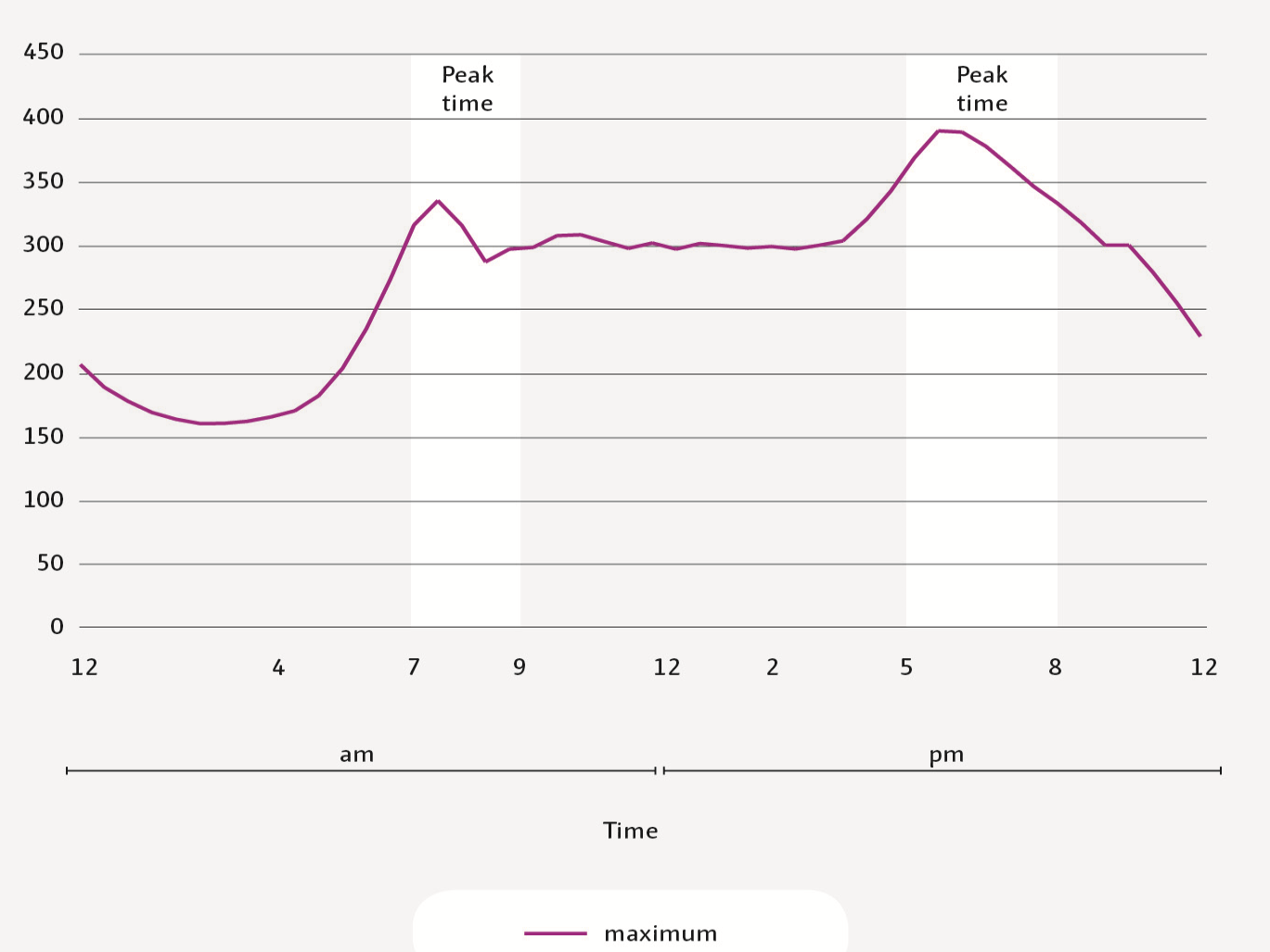

Source: Australian Energy Market Operator (AEMO) load profile data, ACT, 2014 (http://www.aemo.com.au/Electricity/Data/Metering/Load-Profiles).

#### AER Draft Decision on residential demand charging window

On 2 August 2016, the AER released its Draft Decision on AAD’s proposed TSS. The AER is:

*“not satisfied that … elements of ActewAGL’s charging windows contribute to the achievement of compliance with the distribution pricing principles”*[3].

To address this, the AER required AAD to limit its residential peak demand charging window to the following options:

1. Option 1 - Single evening window (i.e. remove morning peak window (all year)); or
2. Option 2- Restrict the morning peak charging window to winter only (i.e. remove summer morning peak window); and/or
3. Option 3 - Implement off peak weekend periods (i.e. apply demand charge to weekdays only)[4].

AAD has undertaken extensive analysis of the options identified by the AER in order to refine the residential demand charging window in line with the draft decision. This analysis and the refined version of the residential demand tariff structure and parameters are outlined in subsection 2.2.1.3.

#### Analysis to refine residential demand charging window

To refine the demand charging window from the proposed structure, it is important to:

1. align the demand window with network peaks; and
2. ensure the refinement is easily understood by consumers.

To align the demand window with network peaks (item 1, above), AAD considered the time of the day, days of the week, and seasons in which the residential load is highest on our network. To ensure a smooth transition to the new kW demand tariff for new consumers, AAD considered the structure of our existing residential tariffs (item 2, above). The analysis below is used to refine the demand charging window and evaluate the three options contained in the AER’s Draft Decision.

***Time of Day***

The ‘time of day’ analysis addresses the AER’s concern in its draft decision that the demand charging window should apply in the evening only (option 1) or in the evening all year round, and during the morning in winter only (option 2). In response to this, AAD has reviewed the time of the day at which peaks occurs in two different ways:

* at the zone substations that predominantly service residential consumers; and
* for individual residential consumers using a representative sample of consumers.

Figure 2-4 shows that the zone substations that predominantly service residential consumers experience the majority of peaks in the evening. This is because most residential consumers are at home at this time of the day and the resulting activity in households at this time of day is reflected in the high percentage of peaks occurring at this time.

**Figure 2-4: Residential zone substations - Percentage of monthly peak demand events by time of day, 2015**

Source: AAD

This analysis of the time of day at which peaks occur can be extended to individual residential consumers. To analyse individual residential consumers’ demand profiles, AAD commissioned a study of 300 individual residential consumers.

***Overview of Demand Study of Residential Customers***

AAD conducted a study to analyse the effect of applying the new demand tariff to residential customers. AAD collected electricity consumption and demand data from around 300 premises in Canberra over the seven months to June 2016. AAD analysed the characteristics of these customers’ demand and consumption data to gain a better understanding of their usage and demand patterns. This is an ongoing study and will inform price setting in the future, when a full year of data has been collected.

The data presented in Figure 2-5, shows the time of day at which the representative sample of residential consumers peaks. It shows that the majority of individual residential consumers ‘peak’ between 5:00pm – 8:00pm. This is consistent with the results at the predominantly residential zone substations shown in Figure 2-4.

**Figure 2-5: Sample of Residential Consumers - Percentage of peak demand events by time of day, 2015/16**

Source: AAD

Based on the results presented in Figure 2-4 and 2-5 above, the demand parameter has been revised to apply only in the evening (5:00 – 8:00pm). This means that the demand charge will apply to a residential customer’s maximum demand between 5:00 – 8:00pm. This revision aligns with Option 1 of the AER’s draft decision (see Section 2.2.1.2).

This evening demand charging window will reward a change in customer behaviour that reduces the load during the evening. AAD will continue to evaluate the timing of peak load incidents to check that the demand charging window aligns with the peak load profile.

***Day of Week***

AAD then analysed the days of the week on which demand peaks occur. Similar to the analysis undertaken to set the ‘time of day’ for the demand charging window, AAD has reviewed the days of the week at which peaks occur at predominantly residential zone substations and for individual residential consumers. This analysis addresses the AER’s concern in its draft decision that the top three peak days during 2013/14 and 2014/15 occurred on weekdays rather than weekends[5].

Residential Zone Substation Analysis

Table 2-1 shows the days of the week on which the top 20 peak days at the predominantly residential zone substations occurred, in 2013/14 and 2014/15. In total, 15 per cent of peak days occurred on the weekend in 2013/14, and 8 per cent in 2014/15. These results also indicate that peaks are driven by the weather rather than the day of the week. For example, residential demand peaked when:

* Canberra’s maximum temperature is relatively low (under 15 degrees Celsius) because consumers have turned on their heating ; and
* Canberra’s maximum temperature is relatively high (over 30 degrees Celsius) because air conditioners are being heavily utilised for cooling.

**Table 2-1: Top 20 peak demand days: weekdays and weekends**

|  |  |  |
| --- | --- | --- |
|  | 2013/14 | 2014/15 |
| Weekdays |  |  |
| Maximum temperature under 15°C | 76 | 92 |
| Maximum temperature over 30°C | 9 | 0 |
| *Total Weekdays* | *85* | *92* |
| Weekends |  |  |
| Maximum temperature under 15°C | 10 | 8 |
| Maximum temperature over 30°C | 5 | 0 |
| *Total Weekends* | 15 | 8 |

Source: AAD

Results from Residential Demand Study

Using data collected as part of the residential consumer data study, the day on which the customers’ peak demand occurred was analysed.

As shown in the Table 2-2 below, there are 1,617 customer months in the sample (number of customers multiplied by the number of months each customer was included in the study). In 473 of these customer months, the maximum demand occurred on a Saturday or Sunday, out of a possible 1,617 customer months.

This means that 29 per cent of the days on which maximum demand occurred fell on a weekend. Interestingly, weekend days represent 29 per cent of the days in the week[6]. Hence, this analysis showed that the percentage of weekend days on which maximum demand occurs for residential consumers is exactly proportional to the weekend days in a week. Given that residential peak demand occurs on a spread of weekdays and weekends, AAD concludes that the demand charging window will apply on all days of the week.

**Table 2-2: Peak Demand Days: Individual residential consumers (2015/16)**

|  |  |
| --- | --- |
| Customers months (in sample period) (a) | 1,617 |
| Peak days on weekends (b) | 473 |
| Percentage of peak days on weekends (a/b) | 29% |

***Seasonality***

After addressing the time of the day and day of the week on which the demand charging window should apply, the next analysis focussed on whether there should be a seasonal variation in the demand parameter. Figure 2-6 clearly shows the residential system load profile for the peak days of each season in 2014. Specifically, it shows that the peak is higher in winter than other seasons.

**Figure 2-6: Peak residential load, by season, 2014 (MW)**Source: AEMO and AAD data

The residential demand tariff is already structured so that the demand component is seasonal. Our transition towards more cost reflective tariffs requires careful consideration of consumers’ ability to understand and respond to the new demand tariff. For this reason, the demand parameter has been set at the same level across seasons. This will enable a sound transition to the new demand tariff because this approach maximises simplicity and understanding.

AAD will continue to monitor the seasonal variation of peaks, while taking into account consumers’ ability to understand the demand tariff. This approach enables AAD to set a cost reflective tariff structure, but have the flexibility for customers to adjust to the different elements of the tariff over time.

***Summary***

At the predominantly residential zone substations and for representative individual residential consumers, the above analysis shows that maximum demand occurs:

* in the evening (5:00pm – 8:00pm);
* on a spread of weekend and weekdays; and
* is highest during winter.

Hence, AAD’s refined demand charging window is based in the evening (5:00 – 8:00pm) of each day, all year round. There will not be any seasonal variation in demand parameters in this regulatory period to keep the tariff simple when it is introduced. The design of the demand component will send a cost reflective signal to our consumers about when reducing their demand can help them save money on their bill and help keep network costs efficient, which will help lower future network tariffs.

Table 2-3 provides a summary explanation of the revised demand tariff by showing the tariff parameters and the reason for selecting those parameters. As explained above, the proposed demand tariff for residential consumers will be based on the maximum half hourly demand that occurs within the peak period of a calendar month. Only residential consumers who have remotely read interval meters installed will be assigned to the new peak period demand tariff (see subsection 2.2.1.4 for more detail about the assignment policy).

**Table 2-3:** **Residential peak demand tariff parameters**

|  |  |  |  |  |
| --- | --- | --- | --- | --- |
|  | Maximum demand | Time of day | Day of Week | Seasonality |
| **Parameters** | Maximum half-hourly demand period in a calendar month. | Maximum demand periods are constrained to peak period: 5-8pm. | Maximum demand window to apply every day of the week. | No seasonality in the demand tariff, during this regulatory period.  Same demand charge applied all year round (each calendar month). |
| **Reason** | Sends price signal to consumers about the impact of their behaviour on network costs. | System (and residential zone substation) peak occurs in the evening (5-8pm). | Peak demand days are driven by the weather and can therefore fall on weekends. | Structure has been set up so that demand charge may have a seasonal element in future. |

This new demand tariff has been carefully designed to take advantage of advanced metering technology that is expected to be available from 1 December 2017 under the metering Rule change. The advanced metering technology coupled with the new peak period demand tariff will help to send a signal to consumers about when the use of the network is likely to bring forward the need for investment in additional capacity which creates upward pressure on tariffs. Other factors that have been taken into account in the design of the new tariff include:

* the administrative costs associated with transitioning to a demand-based tariff;
* the reality that most consumers will not have meters that allow the levying of a demand-based price signal;
* feedback from consumers that there needs to be increased communication around the types of network tariffs, so it important that we allow time to provide this;
* the fact that some consumers may not understand and have the ability to effectively respond to these cost-reflective tariffs in the immediate period; and
* the need to keep the impact of a new tariff on consumers’ bills manageable.

#### Assignment policy for the proposed demand tariff

Metering technology is a critical enabler for introducing more cost-reflective tariffs. Most of AAD’s existing interval meters are not capable of being read for demand purposes without significant investment. Hence, the introduction of the residential peak period demand tariff has been established to coincide with the introduction of remotely read interval meters from 1 December 2017. This means that only consumers who have remotely read interval meters installed will be assigned to the new peak period demand tariff as their default tariff. Specifically, from 1 December 2017, these residential consumers will be automatically assigned to the new demand tariff in one of two ways.

1. Residential consumers who move into **new premises** and are connected with a remotely read interval meter, will default to the peak demand tariff with an opt-out provision to the residential TOU tariff. This is a change from the existing policy which assigns new consumers to the TOU tariff by default with an opt-out provision to the Residential Basic tariff. It is also a change from the assignment policy in the Proposed TSS which assigned new residential consumers to the demand tariff (by default) on a mandatory basis (i.e. with no opt-out provision).
2. When an existing residential consumer has a **replacement meter** installed that is a remotely read meter, they will also be assigned to the new demand tariff by default. This is also a change from our existing policy in which consumers who have a replacement meter installed remain on their existing tariff. To assist existing consumers adjust to the new demand tariff, consumers who are assigned to the peak period demand tariff (by default) will be able to opt out of the demand tariff to the TOU tariff. This process can be undertaken by the customer contacting their retailer and requesting the change. AAD currently replaces approximately 2,000 meters per year.

This assignment policy means that, with new customer connections and customers with replacement meters being assigned to the demand tariff, the following residential tariffs will eventually become obsolete.

* Residential Basic Network (code 010 and 011)
* Residential 5000 Network (code 020 and 021)
* Residential with Heat Pump Network (code 030 and 031)

The Off Peak tariffs (codes 060 and 070) which apply to controlled loads will continue to be offered, as these are supplementary tariffs that encourage usage at off peak times.

The revised assignment policy creates greater choice of tariffs for consumers. For example, when a customer defaults to the new demand tariff, they will have a choice to switch to the residential Time-of-Use tariff by contacting their retailer and request the change. This also addresses the concern about greater choice of tariffs that was raised in submissions to the AER by Origin and the Clean Energy Council.

Importantly, if a consumer on the demand tariff opts-out to the TOU tariff, they will be ineligible to return to the demand tariff again within 12 months. This provision prevents consumers from switching between the demand and TOU tariffs because cost reflectivity is based on a 12 month cost profile.

### Changes in other residential tariffs

We currently offer residential consumers a range of residential tariffs. These include Residential Basic, Time-of-Use tariff, Residential 5000 and Residential Heat Pump tariffs. In addition, residential consumers can combine these tariffs with a controlled load tariff (Off Peak Night or Off Peak Day and Night tariff). Each of the residential tariffs has been reviewed to base them on the LRMC of the network (as per Clause 6.18.5(f) of the Rules).

Our residential tariff structure, tariffs, charging parameters, eligibility and assignment of consumers to tariffs is summarised in Table 2-4.

Table 2-4: AAD’s proposed tariff structure for residential consumers

| Tariff | Consumer eligible to receive tariff | Component | Unit | Charging parameter | Proposed Change |
| --- | --- | --- | --- | --- | --- |
| Peak Period Demand* | Residential consumers (as defined in Residential Basic tariff) and electric vehicles recharge facilities (on residential properties) with a remotely read meter  Tariff becomes **default** for new consumers and those with remotely read meters from 1 December 2017. | Fixed network access charge  Energy consumption charge  Seasonal demand charge (seasonal variation is not applied this regulatory period) | ¢/day  ¢/kWh  c/kW/day | **Peak Times:** 5pm – 8pm every day  Maximum demand (during peak times) each calendar month  This parameter is seasonal but the seasonal charges are set at the same level for 2017/18-2018/19 | This is a new residential tariff |
| Residential Basic Network* | Private dwellings (excluding serviced apartments), including living quarters on farms, charitable homes, retirement villages, etc.  Tariff becomes **obsolete** to new consumers from 1 December 2017. | Fixed network access charge  Energy consumption charge | ¢/day  ¢/kWh |  | Review of fixed and energy charge to be based on LRMC |
| Residential TOU Network* | Residential consumers (as defined above) and electric vehicles recharge facilities (on residential properties) with a TOU or remotely read interval meter.  TOU is **no longer** the default tariff for consumers with remotely read meters from 1 December 2017. TOU is opt-in tariff. | Fixed network access charge  Energy consumption charge based on time of use | ¢/day  ¢/kWh | **Max Times**: 7am – 9am and 5pm – 8pm every day  **Mid Times**: 9am – 5pm and 8pm – 10pm every day  **Economy Times**: All other times | Review of fixed and energy charges to be based on LRMC |
| Residential 5000* | Residential consumers who have large continuous (rather than time controlled) loads, such as electric hot water systems, and consume over 5,000 kWh per annum.  Tariff becomes **obsolete** to new consumers from 1 December 2017. | Fixed network access charge  Inclining block tariff energy consumption charge with 2 tiers | ¢/day  ¢/kWh | Tier break set at 60 kWh per day | Review of fixed and energy charges to be based on LRMC |
| Residential with Heat Pump* | Only available to residential consumers with a reverse cycle air conditioner.  Tariff becomes **obsolete** to new consumers from 1 December 2017. | Fixed network access charge  Inclining block tariff energy consumption charge with 2 tiers | ¢/day  ¢/kWh | Tier break set at 165 kWh per day | Review of fixed and energy charges to be based on LRMC |
| Off-Peak (1) Night Network | Available only to consumers utilising a controlled load element – it is applicable to permanent heat (or cold) storage, electric vehicle recharge, and CNG vehicle gas compression installations. | Energy consumption charge | ¢/kWh | Within controlled period: 10pm – 7am only | Review of energy charges to be based on LRMC |
| Off-Peak (3) Day & Night Network | Available only to consumers utilising a controlled load element – it is applicable to permanent heat (or cold) storage installations. | Energy consumption charge | ¢/kWh | Within controlled period: 10pm – 7am and 9am – 5pm only | Review of energy charges to be based on LRMC |
| *For each of these tariffs, two separate charges apply – one which includes a meter capital charge (consumers who connected before 30 June 2015) and one which excludes the meter capital charge for those consumers connected to the network after 1 July 2015 and who have paid for their meter. | | | | | |

### 

### Indicative bill impacts for residential consumers

The new residential demand tariff has been designed with emphasis on a household’s maximum electricity demand, rather than consumption. This is in contrast to the existing residential tariffs which reflect a household’s consumption over a billing period.

***Key findings of AAD's residential customer impact analysis***

* Households with relatively low peak demand (during peak times) are expected to be better off on a demand tariff than the existing residential tariffs.
* Households with relatively high peak demand (during peak times) are expected to be worse off on a demand tariff.
* Households can actively reduce demand during the 5pm – 8pm window in two ways;
  + operating high demand appliances consecutively rather than concurrently; or
  + shifting the use of high demand appliances to outside the window.

The demand tariff will result in some consumers paying less to use the network and others paying more. The impact of the demand tariff on individual consumers will depend on their specific circumstances, such as their consumption, their maximum demand and how they respond to cost-reflective price signals. Further, whether an individual consumer’s bill is expected to be higher or lower will depend on how retailers choose to incorporate proposed network tariffs into retail tariffs.

We have estimated the *indicative* network bill impact of the introduction of the new demand tariff using 5 steps.

* Step 1—establish a wide range of *hypothetical* consumption profiles—from 2,000kWh p.a. to 11,000kWh p.a. The typical household in Canberra consumes 7,500kWh per annum.
* Step 2—apply three types of load profiles that reflect the maximum demand placed on the network by consumers. These assumed load profiles are based on existing network load factors.[7] The load factors used for the consumer impact analysis are 0.24 (associated with relatively high maximum demand), 0.29 (associated with average maximum demand) and 0.35 (associated with relatively low maximum demand).
* Step 3—calculate the hourly maximum demand using Steps 1 and 2.
* Step 4—calculate the residential NUOS bill, for each consumption profile, that is driven by the demand tariff component.
* Step 5—add fixed charges and consumption charges to the demand charge, for each consumption profile, to calculate the total indicative network bill for residential consumers using the demand tariff.

The total estimated network bill for a consumer on the demand tariff (using different tariffs and consumption profiles), and the equivalent bill on the Residential Basic tariff is depicted in Table 2-5.

Assuming that a consumer is on the Residential Basic tariff, the estimated current network bill is $773 per year. This consumer will:

* be better off by about $60 over 5 years (or $12 p.a.) if they moved to a Time-of-Use tariff.
* be better off by about $80 over 5 years (or $16 p.a.) if they moved to the proposed demand tariff, assuming the consumer has an average peak demand.
* be better off by about $260 over 5 years (or $52 p.a.) if they were assigned to the proposed demand tariff and respond to the price signals by reducing their demand during peak periods. Likewise, those consumers that already have lower peak demand would experience a similar network bill impact.
* be worse off by about $130 over 5 years (or $26 p.a.) if they have high peak demand. As a result, these consumers with higher than average demand during peak periods can either:
* Continue to maintain their profile but are likely to experience an increase in their network bill compared to existing Basic or Time-of-Use tariffs. Therefore, their bills better reflect the costs that they impose on the electricity network at peak periods.
* Change their consumption patterns by using appliances outside of the peak period and hence mitigate against the potential increase in their network bill. As a result, based on the cost-reflective demand tariff, consumers can make informed decisions about how to control their usage and bill.

**Table 2-5: Estimated change in residential network bills (indicative 2017/18 tariffs)**

|  |  |  |  |  |  |  |
| --- | --- | --- | --- | --- | --- | --- |
|  | Total Annual Network Bill ($) | | | Difference from Basic tariff ($) | | |
| *Annual Consumption (kWh)* | *3,500* | *7,500* | *10,000* | *3,500* | *7,500* | *10,000* |
| Flat rate Basic tariff | $427 | $773 | $990 | - - | - | - |
| Time-of-Use tariff (average profile) | $421 | $761 | $974 | - 6 | -12 | -16 |
| Proposed demand tariff (low peak demand) | $403 | $722 | $921 | -24 | -52 | -69 |
| Proposed demand tariff (average peak demand) | $419 | $757 | $968 | -8 | -16 | -22 |
| Proposed demand tariff (high peak demand) | $439 | $800 | $1,025 | 12 | 26 | 35 |

A comparison of network prices for residential consumers on the demand, TOU and Residential Basic tariffs is depicted in Figure 2-7. Average prices—total bill divided by energy consumption—are shown on the vertical axis and the hypothetical annual consumption is shown on the horizontal axis (kWh). The following conclusions can be seen in Figure 2-7 below.

* Consumers with an average peak demand are on average likely to receive a network bill similar to what they could expect on the Residential Basic or Time-of-Use network tariffs.
* Consumers with a low maximum demand (and therefore a high load factor) are on average likely to receive a lower network bill than they would on the current network tariffs.
* Consumers with a high maximum peak demand (and therefore a low load factor) are on average likely to receive a higher network bill than they would on the current network tariffs.

**Figure 2-7: Residential bill impacts for different consumption profiles (indicative 2017/18 tariffs)**

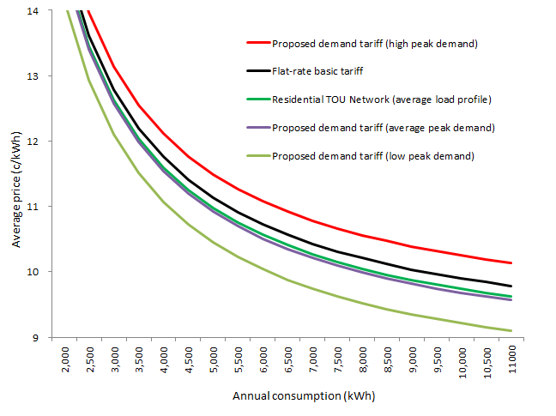

Note: The average price for the residential TOU tariff has been calculated using the profile for consumers on the residential Basic tariff.

Figure 2-8 below provides an alternative method for illustrating the same analysis. It shows the positive or negative savings that a residential consumer can expect from shifting to the new demand tariff. These savings have been estimated for consumers transitioning (from the Residential Basic or TOU tariff), for a range of consumption, and take into account whether the consumer has high, low or average maximum demand during peak times.

Interestingly, it shows that consumers with a high demand profile (during peak periods) would expect to pay more if they take-up the new demand tariff compared to either the Residential Basic or TOU tariff. This is exactly what cost-reflective tariffs are designed to do – those who place a higher load on the network at peak periods bear the costs. This is represented by the red and yellow bars to the left of the vertical centre axis. It therefore signals to these consumers to either shift or reduce their load.

In contrast, residential consumers with a relatively low maximum demand during the peak period are expected to have the greatest saving when shifting from the Residential Basic or TOU tariff to the demand tariff (green and black bars).

Further, residential consumers with average maximum demand during peak times are expected to have a greater saving if they are shifting from the Residential Basic tariff than the TOU tariff (blue and grey bars).

In summary, and consistent with how a demand tariff ought to work in principle, the indicative effect of the proposed demand tariff on a consumer’s network depends on their demand profile during peak periods. Further, since network charges typically comprise about a third of the total retail bill, the relative effect of introducing the proposed demand tariff on consumer’s retail bills becomes less significant.

**Figure 2-8: Estimated Savings on demand tariff compared to the residential Basic and TOU tariffs**

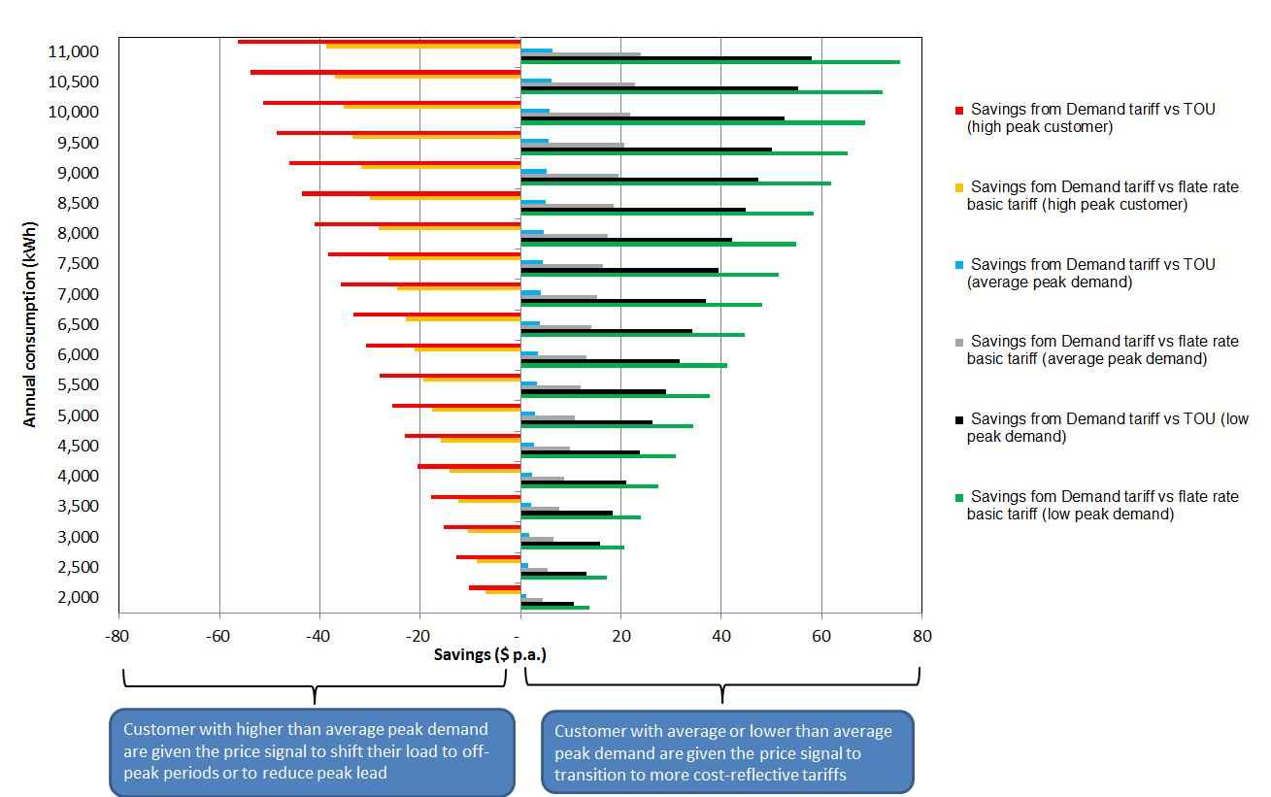

## Proposed tariffs for low voltage commercial consumers

AAD currently offers low voltage (LV) commercial consumers a range of tariffs. These include a block tariff, TOU tariff, demand and capacity tariffs.

Based on AAD’s review of LV commercial tariffs, AAD will offer more cost reflective tariffs to all LV commercial consumers. This is consistent with feedback AAD received from the business community and commercial consumers that they would welcome tariffs that encourage users to modify energy use in peak periods. Hence, in this regulatory period, AAD proposes to introduce a new kW based demand tariff for LV commercial consumers. This new tariff has the same structure as the proposed residential demand tariff.

The rest of this subsection:

* provides an outline of the structure of the proposed new tariff (subsection 2.3.1);
* covers the assignment policy ( subsection 2.3.2);
* explains other changes that have been made to the structure of commercial LV tariffs (subsection 2.3.3); and
* provides indicative bill impacts (subsection 2.3.4).

### Structure of the new low voltage commercial demand tariff

The kW demand tariff for LV commercial consumers will be structured in the same way as the proposed demand tariff for residential consumers, as outlined in Section 2.2. Specifically, the new kW demand tariff will include a fixed, usage and demand component.

The next three subsections explain the demand charging window set out in the Proposed TSS (subsection 2.3.1.1), the AER’s Draft Decision requiring AAD to refine the charging window (subsection 2.3.1.2), and the subsequent analysis undertaken to refine the LV commercial demand charging window (subsection 2.3.1.3).

#### Demand charging window in Proposed TSS

In the Proposed TSS, the new LV commercial demand tariff (shown in Figure 2-9) was defined as:

* a fixed component;
* TOU energy components (based on the same business, evening and off-peak times as the kVA demand tariff – see Indicative Tariff Schedule for more details); and
* a demand charge that is applied to the maximum demand in a billing period.

**Figure 2-9: Proposed kW demand tariff for low voltage commercial consumers**

In the Proposed TSS, AAD explained that in future, we may consider refining the LV commercial demand tariffs further by incorporating a peak period element to the tariff. However, in the current regulatory period, AAD explained that it was focussed on providing a tariff structure that offered all LV commercial consumers cost-reflective tariffs, and that the demand tariff was based on the same charging parameters as other commercial kVA demand tariffs.

#### AER Draft Decision on LV commercial demand charging window

In its Draft Decision on AAD’s proposed TSS the AER stated it is:

*“… not satisfied that an ‘anytime’ demand tariff that charges customers the same demand rate during times of high and low network congestion is cost reflective.”[8]*

In particular, the AER was concerned that businesses that do not contribute to system peak would be penalised even if their business was functioning late at night or early in the morning. To address this, the AER requires AAD to limit the demand charging window that applies to the kW demand tariff. AAD has further analysed the profile of the commercial load on our network and refined the scope of the demand charging window. The analysis and conclusions are presented in 2.3.1.3 below.

#### Analysis to refine LV commercial kW demand charging window

To refine the demand charging window from the proposed structure of an anytime maximum demand to a peak period maximum demand charging window, it is important to:

1. align the demand window with network peaks; and
2. ensure the refinement is easily understood by consumers.

To align the demand window with network peaks (item 1, above), AAD considered the time of the day, days of the week, and season in which the commercial load is highest on our network. To ensure a smooth transition to the new kW demand tariff for new consumers, AAD considered the structure of our existing LV commercial tariffs (item 2, above).

***Time of Day***

Currently, AAD’s LV commercial TOU, KVA demand and Capacity tariffs each have a peak consumption period. This peak period, known as the “business time” is from 7:00am to 5:00pm on weekdays, with no seasonal variation. For this reason, the analysis below is undertaken with reference to this existing peak period.

To determine the time of day at which the peak period of the new kW demand tariff should apply, AAD began by analysing the time of day at which the monthly peaks occurred at zone substations within our network that serve predominantly commercial consumers. Figure 2-10 shows that in 2015, the majority of these peaks occurred in the middle of the day, during business hours.

**Figure 2-10: Commercial Zone Substations – Percentage of monthly peak demand events by time of day, 2015**

Source: AAD

Several of our zone substations service a mix of residential and commercial consumers. To capture a broader range of commercial consumer’s peak times, we analysed the profile of 1,200 individual commercial consumers from across the network. This data is presented in Figure 2-11, which shows the time of day at which the sample of commercial consumers’ demand peaked in 2015/16. It shows that the majority of individual commercial consumers ‘peak’ between 7:00am – 8:00am. This is because most commercial consumers turn on their heaters or air conditioners at this time of the day.

**Figure 2-11: Sample of Commercial Consumers - Percentage of peak demand events by time of day, 2015/16**

Source: AAD data based on sample of 1,200 Small LV Commercial Consumers

Based on the above analysis of peak times and the timing of the existing LV commercial tariffs’ peak period, the demand charging window for the new kW demand tariff will apply between 7:00am and 5:00pm. In the future, this demand charging window may be refined, particularly as AAD gathers data on consumers’ response to the new kW demand tariff.

***Day of the Week***

The peak period in AAD’s existing suite of cost reflective LV commercial tariffs applies on weekdays only. The peak period doesn’t apply on weekends because not all businesses operate on weekends, so the commercial load doesn’t peak during weekends.

To test whether the peak period of the new kW demand tariff should also apply to weekdays only, AAD analysed the days of the week on which peaks occurred for the commercial load profile and the sample of commercial consumers.

Figure 2-12 shows the days of the week that the predominantly commercial zone substations recorded maximum demand for each month of 2015. It shows that the predominantly commercial zone substations recorded peaks across all weekdays, but no peaks on weekends.

**Figure 2-12: Commercial Zone Substations – Percentage of monthly peak demand events by day of week, 2015**

Source: AAD

Figure 2-13 below confirms that most commercial loads peak during weekdays. This analysis was undertaken using the sample of 1,200 small LV commercial consumers. We identified the day of the week on which each of these consumers’ monthly demand peaked, and found that 85 per cent of consumer’s peaks occurred on weekdays. This evidence further supports applying the kW demand charging window on weekdays only.

**Figure 2-13: Sample of Commercial Consumers – Percentage of peak demand events by day of week, 2015/16**

Source: AAD data based on sample of 1,200 Small LV Commercial Consumers

***Seasonality***

After addressing the time of day and day of the week on which the peak demand charge should apply, AAD then analysed the commercial peaks across seasons. Figure 2-14 shows the commercial system load profile for the peak days of each season in 2014.

**Figure 2-14: Peak commercial system load, by season, 2014 (MW)**



Note: Calculated by deducting estimated residential load from AEMO gross load profile.

Figure 2-14 clearly shows that the peak commercial system load profile differs between seasons with the highest loads in summer and winter. For this reason, the structure of the LV commercial demand tariff has been adjusted in the Revised TSS so that the demand component is seasonal. This change in structure aligns with the residential demand tariff which also has a seasonal demand component.

Like the residential demand tariff, the demand parameter has been set at the same level across seasons in this regulatory period. Our transition towards more cost reflective tariffs requires careful consideration of consumer’s ability to understand and respond to the new demand tariff. This approach maximises simplicity and understanding.

AAD will continue to monitor the seasonal variation of peaks, while taking into account consumers’ ability to understand the demand tariff. This approach enables AAD to set a cost reflective tariff structure, but have the flexibility for customers to adjust to the different elements of the tariff over time.

***Conclusion: peak demand window***

Given the evidence presented above, AAD has refined the demand charging window for the LV commercial kW demand tariff from an “anytime” maximum demand charging window to a peak demand charging window that applies from 7:00am – 5:00pm on weekdays, all year round.

This time window is consistent with AAD’s other cost reflective commercial tariffs including the TOU, KVA demand and capacity tariffs. Thus, consumers transitioning from other LV commercial tariffs to the kW demand tariff would focus on the same peak period. This would enhance a smooth transition from the Time-of-Use tariff to the kW demand tariff.

***Other Demand Tariff Components***

This refinement to the demand component of the new tariff required AAD to review the other components of the kW demand tariff. It was considered that the TOU consumption component should be adjusted to an anytime consumption component, similar to the approach adopted for the residential demand tariff. The reasons for this adjustment to the consumption component are below.

1. The highly cost reflective peak demand charge signals to consumers when it is more expensive to use the network. There is no advantage to signalling this via the consumption component when the demand component already sends the signal.
2. The structure of the kW based demand tariff (which is designed for small LV commercial consumers) has the same structure as the new residential demand tariff.

***Summary***

The refined LV commercial kW demand tariff is structured to be cost reflective and simple to enable consumers to respond to the price signal. In summary, the tariff structure includes:

* a fixed component;
* anytime usage component; and
* a peak demand charge that is applied to the maximum demand, in a defined peak period, in a billing cycle period (based on the same business times as the TOU tariff – see Indicative Tariff Schedule for more details).

**Figure 2-15: Refined kW demand tariff for low voltage commercial consumers**

Table 2-6 provides a summary explanation of the revised demand tariff by showing the tariff parameters and the reason for selecting those parameters. As explained above, the proposed kW demand tariff for LV commercial consumers will be based on the maximum half hourly demand that occurs within the peak period of a billing period. Only LV commercial consumers who have remotely read interval meters installed will be assigned to the new peak period demand tariff (see subsection 2.3.1.4 for more detail about the assignment policy).

**Table 2-6:** **LV commercial peak demand tariff parameters**

|  |  |  |  |  |
| --- | --- | --- | --- | --- |
|  | Maximum demand | Time of Day | Day of Week | Seasonality |
| Parameters | Maximum half-hourly demand period in a billing period. | Maximum demand periods are constrained to peak period: 7am-5pm. | Maximum demand window to apply to weekdays only. | No seasonality in the demand tariff, during this regulatory period.  Same demand charge applied all year round (each calendar month). |
| Reason | Sends price signal to consumers about the impact of their behaviour on network costs. | System (and commercial zone substation) peak occurs during business hours of operation (7am-5pm). | Peak demand is driven when the majority of businesses are operating, which is on weekdays. | Structure has been set up so that demand charge may have a seasonal variation in future. |

### Changes in assignment policy

From 1 December 2017, LV commercial consumers who move to new premises with a remotely read meter or whose meter is replaced with a remotely read interval meter will be assigned to the kW demand tariff by default.

This is a change from our existing policy which assigns new consumers to the TOU tariff (code 90). From 1 December 2017 (date of Metering Rule change implementation), these consumers with a remotely read interval meter will be assigned to the new kW demand tariff by default.

The exception to the above assignment policy is for small unmetered loads (code 135) and streetlighting (code 80), where most of the usage is not measured using a meter. In the case of small unmetered loads (which applies to eligible installations such as telephone boxes), AAD has not connected meters to these loads. The streetlight tariff applies only to usage for public lighting loads that operate at night. Most of these loads are also unmetered. These tariffs do not vary with usage, or load profile, and therefore, there is no need for AAD to transition these loads onto a demand tariff as consumers on these tariffs are unlikely to respond.

The introduction of the kW demand tariff and change in assignment policy have been established to coincide with the date for the introduction of metering competition—1 December 2017. This means that consumers who have remotely read interval meters, will be assigned to a demand tariff from that date, by default. Those customers have the choice to opt-out of the demand tariffs to the Time-of-Use (code 90 and 91), KVA demand (code 101 and 103) or Capacity (code 103 and 105) tariffs by contacting their retailer and request the change. This is a change from the assignment policy in the Proposed TSS in which LV commercial consumers were to be assigned to the kW demand tariff on a mandatory basis (i.e. with no opt-out provision).

This assignment policy means that our General Network commercial LV tariff (codes 040 and 041) will eventually become obsolete. This is because, over time, all LV Commercial consumers will have their meter replaced with a remotely read interval meter which will mean they are assigned to the kW demand tariff (with an opt-out provision to other cost reflective tariffs).

Importantly, if a consumer on this demand tariff opts-out, they will be ineligible to return to this tariff again within 12 months. This provision prevents consumers from switching between tariffs because cost reflectivity is based on a 12 month cost profile.

### Changes in low voltage commercial tariffs

Our proposed LV commercial tariff structure, tariffs, charging parameters, eligibility and assignment of consumers to tariffs is summarised in Table 2-7. In summary, each of the tariffs has been reviewed to base the tariffs on LRMC (as per Rule 6.18.5(f)) and the new kW demand tariff has been added to the structure.

Table 2-7: AAD’s proposed tariff structure for low voltage commercial consumers

| Tariff | Consumer eligible to receive tariff | Component | Unit | Charging parameter | Proposed Change |
| --- | --- | --- | --- | --- | --- |
| General Network* | Available to all existing LV Commercial consumers.  Tariff becomes **obsolete** to new consumers from 1 December 2017. | Fixed network access charge  Inclining block tariff energy consumption charge with 2 tiers | ¢/day  ¢/kWh | Tier break is set at 330 kWh per day | Review of fixed and energy consumption charge to be based on LRMC |
| General TOU Network* | Available to all existing LV Commercial consumers with an interval meter.  TOU is **not** the default tariff for new consumers with a remotely read meter after 1 December 2017. | Fixed network access charge (per connection point)  Energy consumption charge based on time of use | ¢/day  ¢/kWh | **Business Times:** 7am – 5pm weekdays  **Evening Times:** 5pm – 10pm every weekdays  **Off-Peak Times:** All other times | Review of fixed and energy consumption charge to be based on LRMC |
| TOU kW Demand Network* | Available to low voltage consumers with a remotely read meter (except those consumers with an embedded generation system).  Tariff becomes new **default** tariff for LV commercial consumers from 1 December 2017. | Fixed network access charge (per connection point)  Energy consumption charge  Maximum demand charge | ¢/day  ¢/kWh  ¢/kW/day | Peak times: 7am – 5pm week days  Maximum demand (during peak times) in the billing period | New tariff introduced to offer all LV Commercial consumers access to a demand tariff |
| TOU kVA Demand Network* | Available to all LV Commercial consumers with an interval meter (except those consumers with an embedded generation system). | Fixed network access charge (per connection point)  Maximum demand charge  Energy consumption charge based on time of use | ¢/day  ¢/kVA/day  ¢/kWh | Maximum Demand charge applied to the maximum demand in the billing period  Energy charges:  **Business Times:** 7am – 5pm weekdays  **Evening Times:** 5pm – 10pm weekdays  **Off-Peak Times**: All other times | Review of fixed and energy consumption charge to be based on LRMC |
| TOU Capacity Network* | Open to all LV Commercial consumers with an interval meter.  Prescribed for low voltage consumers with embedded generation. | Fixed network access charge  Maximum demand charge  Capacity charge  Energy consumption charge based on time of use | ¢/day  ¢/kVA/day  ¢/kVA/day  ¢/kWh | Maximum Demand charge applied to the maximum demand in the billing period  Capacity charge applied to the maximum demand in the previous 12 months  Energy charges:  **Business Times:** 7am – 5pm weekdays  **Evening Times:** 5pm – 10pm weekdays  **Off-Peak Times**: All other times | Review of fixed and energy consumption charge to be based on LRMC |
| Small Unmetered Loads Network | Applies to eligible installations as determined by ActewAGL, including: telephone boxes, telecommunication devices. | Fixed network access charge  Energy consumption charge | ¢/day  ¢/kWh |  | Review of fixed and energy consumption charge to be based on LRMC |
| Street lighting Network* | Applies to the night-time lighting of streets and public ways and places. | Fixed network access charge  Energy consumption charge | ¢/day  ¢/kWh |  | Review of fixed and energy consumption charge to be based on LRMC |
| *For each of these tariffs, two separate charges apply – one which includes a meter capital charge (consumers who connected before 30 June 2015) and one which excludes the meter capital charge for those consumers connected to the network after 1 July 2015 and who have paid for their meter. | | | | | |

### Indicative bill impacts for low voltage commercial consumers

The new kW demand tariff has been designed with emphasis on low voltage commercial consumers’ maximum electricity demand, rather than consumption. This is in contrast to some of the existing commercial LV tariffs which, due to metering capability, reflect a commercial customer’s consumption over a billing period.

***Key findings of AAD's low voltage customer impact analysis***

* LV customers with relatively low peak demand (during peak times) are expected to be better off on a demand tariff than the existing General or TOU tariffs.
* LV customers with relatively high peak demand (during peak times) are expected to be worse off on a demand tariff.
* LV customers can actively reduce demand during the 7am-5pm window in two ways;
  + operating high demand appliances consecutively rather than concurrently; or
  + shifting the use of high demand appliances to outside the window.

The demand tariff will result in some consumers paying less to use the network and others paying more. The impact of the demand tariff on individual consumers will depend on their specific circumstances, such as their consumption, their maximum demand and how they respond to cost-reflective price signals. Further, whether an individual consumer’s bill is expected to be higher or lower will depend on how retailers choose to incorporate proposed network tariffs into retail tariffs.

We have estimated the *indicative* bill impact of the introduction of the new kW-based demand tariff using 5 steps:

* Step 1—establish a wide range of *hypothetical* consumption profiles—from 2,000kWh p.a. to 78,000kWh p.a.
* Step 2—apply three types of load profiles. Load profiles are based on existing network load factors.[9] The load factors used for the consumer impact analysis are 0.27 (high), 0.33 (medium) and 0.38 (low).
* Step 3—calculate the hourly maximum demand using Steps 1 and 2.
* Step 4—calculate the low voltage commercial consumer NUOS bill, for each consumption profile, that is driven by the demand tariff component.
* Step 5—add fixed charges and consumption charges to the demand charge, for each consumption profile, to calculate the total indicative network bill for low voltage commercial consumers using the demand tariff.

More specifically, Table 2-8 compares the total estimated network bill (using different consumption profiles), and the equivalent bill on the General Network tariff. For example, the average annual consumption for LV commercial consumers in the ACT is 30,000 kWh per year. Assuming that this consumer is on the General tariff, the estimated current network bill is $3,671 p.a. This LV commercial consumer will:

* be better off by about $9 over 5 years (or $2 p.a.) if they moved to the proposed demand tariff, assuming an average peak demand.
* be better off by about $1,100 over 5 years (or $230 p.a.) if they were assigned to the proposed demand tariff and respond to the price signals by reducing their demand during peak periods. Likewise, those consumers that already have lower peak demand would experience a similar network bill impact.
* be worse off by about $1,900 over 5 years (or $376 p.a.) if they have high peak demand. As a result, this type of consumer with higher than average demand during peak periods can either:
* Continue to maintain their profile but are likely to experience an increase in their network bill compared to existing General or Time-of-Use tariffs. Therefore, the amount they will pay will better reflect the costs that they impose on the electricity network at peak periods.
* Reduce their consumption patterns outside of the peak period and hence mitigate against the potential increase in their network bill. As a result, based on the cost-reflective demand tariff, consumers can make informed decisions about how to control their usage and bill.

**Table 2-8: Estimated change in LV commercial network bills (indicative 2017/18 tariffs)**

|  |  |  |  |  |  |  |
| --- | --- | --- | --- | --- | --- | --- |
|  | Total Annual Network Bill ($) | | | Difference from Basic tariff ($) | | |
| *Annual Consumption (kWh)* | *10,000* | *30,000* | *50,000* | *10,000* | *30,000* | *50,000* |
| Flat rate Basic tariff | $1,375 | $3,671 | $5,967 | - | - | - |
| Time-of-Use tariff (average profile) | $1,389 | $3,711 | $6,034 | $13 | $40 | $66 |
| Proposed demand tariff (low peak demand) | $1,300 | $3,446 | $5,591 | -$75 | -$226 | -$376 |
| Proposed demand tariff (average peak demand) | $1,375 | $3,670 | $5,964 | -$1 | -$2 | -$3 |
| Proposed demand tariff (high peak demand) | $1,501 | $4,048 | $6,595 | $125 | $376 | $627 |

A comparison of network prices for LV commercial consumers on the demand, TOU and General tariff is depicted in Figure 2-16. Average prices—total bill divided by energy consumption—are shown on the vertical axis and the hypothetical annual consumption is shown on the horizontal axis (in kWh). The following conclusions can be drawn:

* Consumers with an average peak demand are on average likely to receive a network bill similar to what they could expect under the General or Time-of-Use network tariff.
* Consumers with a low maximum demand (and therefore a high load factor) are on average likely to receive a network bill lower than they would under the current network tariffs.
* Consumers with a high maximum demand (and therefore a low load factor) are on average likely to receive a higher network bill than they would under the current network tariffs.

**Figure 2-16: LV commercial bill impacts for different consumption profiles (indicative 2017/18 tariffs)**

Note: The average price for the commercial time-of-use tariff has been calculated using the profile for consumers on the commercial General tariff.

Figure 2-17 below provides an alternative way to illustrate the same analysis. It shows the positive or negative savings that LV commercial customers can expect from shifting to the new kW demand tariff. These savings have been estimated for consumers transitioning (from the General or TOU tariff), for a range of consumption profiles, and take into account whether the consumer has high, low or average maximum demand during peak times.

Interestingly, it shows that consumers with a high demand profile (during peak periods) would expect to pay more if they take-up the new demand tariff compared to either the General or TOU tariff. This is exactly what cost-reflective tariffs are designed to do – those who place a higher load on the network at peak periods bear the costs. This is represented by the red and yellow bars to the left of the vertical centre axis. It therefore signals to these consumers to either shift or reduce their load.

In contrast, LV commercial consumers with a relatively low maximum demand during the peak period are expected to have the greatest saving when shifting from the General or TOU tariff to the demand tariff (green and black bars).

Further, LV commercial consumers with average maximum demand during peak times are expected to have a greater saving if they are shifting from the General than the TOU tariff (blue and grey bars).

In summary, and consistent with the function of a demand tariff, the indicative effect of the proposed demand tariff on a consumer’s network bill depends on their demand profile during peak periods. Further, since network charges typically comprise about a third of the total retail bill, the relative effect of introducing the proposed demand tariff on consumer’s retail bills becomes less significant.

**Figure 2-17: Estimated savings on demand tariff compared to the LV commercial General Network and TOU tariffs.**

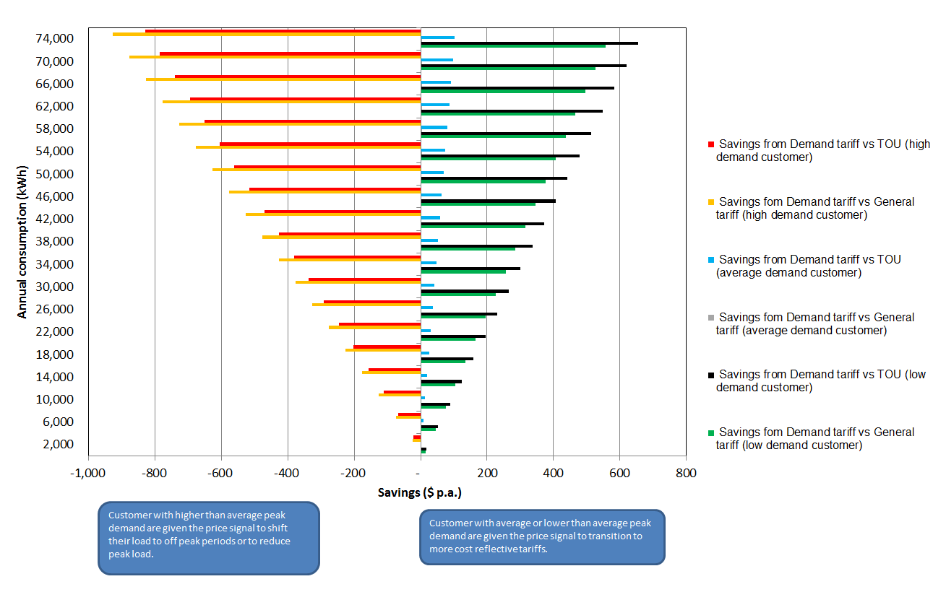

## Proposed tariffs for high voltage commercial consumers

AAD currently offers high voltage (HV) commercial consumers a set of tariffs that include a fixed component, a TOU energy component, a maximum demand component and a capacity component. As shown in Table 2-9 below, the HV commercial tariffs differ depending on whether:

* the consumer or AAD owns and maintains the HV assets (such as transformers); and
* the consumer or AAD owns and maintains the LV network.

The table below provides an outline of how each of the existing HV commercial tariffs are defined.

Table 2-9: AAD’s existing HV commercial tariffs

|  |  |  |  |  |  |
| --- | --- | --- | --- | --- | --- |
| Code | Tariff | Ownership and maintenance of HV assets | | Ownership and maintenance of LV Network | |
|  |  | AAD | Consumer | AAD | Consumer |
| 111 | HV TOU Demand Network | ✓ |  | ✓ |  |
| 112 | HV TOU Demand Network – Consumer HV |  | ✓ | ✓ |  |
| 121 | HV TOU Demand Network – Consumer LV | ✓ |  |  | ✓ |
| 122 | HV TOU Demand Network – Consumer HV and LV |  | ✓ |  | ✓ |

The proposed change to the HV commercial tariff structure is to consolidate the number of tariffs from four to three. Specifically, from 1 July 2017, we propose to eliminate the HV TOU Demand Network – Consumer HV (Code 112) tariff. The tariff currently has no consumers, so there is no consumer impact from this proposal. Given that we have a relatively small number of HV commercial consumers (26), and that the tariffs offered to those consumers are already similar, this change will simplify the tariff schedule.

During the consumer engagement program associated with the development of this TSS, AAD has taken direct input from a number of HV commercial consumers, who indicated an interest in better communication to ensure they understood the tariff options and were therefore able to manage their energy consumption accordingly. This consumer communication will continue to be an important part of future stages of tariff reform for HV commercial consumers.

### Changes in HV commercial tariffs

AAD’s proposed HV commercial tariff structure, tariffs, charging parameters, eligibility and assignment of consumers to tariffs are summarised in Table 2-10.

The main change to the tariffs offered to HV commercial consumers are a review of tariff charges to base them on LRMC and the elimination of one of the tariffs (code 112) to simplify the structure while managing consumer impacts.

Table 2-10: AAD’s proposed tariff structure for HV commercial consumers

| Tariff | Consumer eligible to receive tariff | Component | Unit | Charging parameter | Proposed Change |
| --- | --- | --- | --- | --- | --- |
| TOU Demand Network | Large consumers taking supply at high voltage with a low voltage network owned and maintained by AAD. | All three tariffs have the following components:   * Fixed network access charge (per connection point) * Maximum demand charge * Capacity charge * Energy consumption charge based on time of use | $/day  ¢/kVA/day  ¢/kVA/day  ¢/kWh | Demand charge applied to the maximum demand in the billing period  Capacity charge applied to the maximum demand in the previous 12 months  Energy charges:  **Business Times:** 7am – 5pm weekdays  **Evening Times:** 5pm – 10pm weekdays  **Off-Peak Times:** All other times | Levels have been refined according to cost reflectivity principle and based on LRMC |
| TOU Demand Network – Consumer LV | Large consumers taking supply at high voltage where the consumer owns and is fully responsible for its own low voltage network. | Levels have been refined according to cost reflectivity principle and based on LRMC |
| TOU Demand Network – Consumer HV and LV | Large consumers taking supply at high voltage where the consumer owns and is fully responsible for their own low voltage network and where the consumer owns and is responsible for their high voltage assets. | Levels have been refined according to cost reflectivity principle and based on LRMC |

## Tariff setting to comply with pricing principles

In this subsection, AAD sets out how tariffs have been set, and how they comply with each of the pricing principles in the Rules.

### Tariffs to be based on the long run marginal cost

In order to be consistent with Clauses 6.18.5 (f), all of AAD’s network tariffs have been reviewed to be based on the LRMC of providing electricity network services. Network businesses have flexibility about how they measure their LRMC.

To guide the development of AAD’s tariffs, we conducted a LRMC study using the Average Incremental Cost (AIC) approach. This decision to use the AIC approach is consistent with the AEMC’s conclusion regarding the AIC approach, which noted that:

For the remainder of the network where no network constraints are anticipated in the foreseeable future or advanced metering is not in place, then simpler approaches to calculating forward looking costs, such as the AIC methodology, may be sufficient.[10]

The AIC methodology produces an estimate which is averaged across both time and location. This averaging produces a lack of granularity which is reasonable given that we are not applying either locational specific pricing or critical peak pricing.

The AIC approach is underpinned by AAD’s forecast of the expected change in future costs (numerator) as a result of forecast changes in demand for electricity network services (denominator), with both the numerator and denominator discounted back to create a net present value (NPV)[11].

The net present value of capital works related to increased demand for the next 10 years was calculated to be $84 million. The NPV of operating expenditure on this demand driven capital expenditure is estimated to be $20 million. These capital and operating expenditure forecasts are required to facilitate the increase in demand estimated to have a NPV of 590 MVA. Dividing the NPV of the costs by the NPV of the increase in demand determines the average LRMC for AAD’s distribution network calculated to be $197 per KVA per annum in terms of 2014/15 prices.

Before the LRMC was applied to the maximum demand for each tariff, it was inflated by CPI for each year. The CPI for 2016/17 was estimated using the latest available ABS statistics. For subsequent years, AAD used the AER’s CPI forecasts that were included in its final decision on AAD’s distribution prices. The CPI adjustment raised the LRMC in nominal terms from $197 to $210 per KVA pa in 2017/18 and $215 per KVA pa in 2018/19. Using the AIC approach derives a LRMC estimate that is based on $/kVA. AAD split the process for determining DUOS tariffs based upon the LRMC into two basic steps.

1. determine the total amount of the LRMC which is to be recovered in each tariff; and
2. determine the prices to be applied to each component of each tariff so as to recover the LRMC for each tariff.

In determining the total LRMC to be applied to each tariff (step 1):

* the maximum demand for the total load on each tariff was estimated[12]; and then
* the LRMC was applied to these maximum demands to determine the total LRMC to be recovered within each tariff.

A different approach was used to set tariffs with a demand component compared to those without a demand component, as explained below.

**Demand based tariffs**

Each charging component within the overall tariff has been set on the basis that the overall network tariff is on a price path to fully reflect the LRMC. Where a tariff has (or it is proposed to have) a demand tariff component, AAD has based the demand rate on the LRMC, with a transition path to a fully cost reflective level over time. The energy and fixed components of the tariff were set using existing flat and TOU tariffs’ energy and fixed component levels as a starting point to move towards LRMC. In this way, AAD has taken into account consumers’ bill impacts and the side constraint. The energy charges were set to become more cost-reflective over time, subject to a transition period. The fixed charges were set after determining the demand and energy charges, to recover the residual of the revenue requirement that is not recovered through demand or energy charges.

**Non-demand based tariffs**

Where a tariff does not have a demand tariff component, AAD has generally sought to retain fixed charges at similar levels to what they are currently, and adjusted the energy charge so that the average revenue generated from that tariff equals the LRMC for consumers on that tariff. In relation to tariffs that do not have a demand tariff component, AAD’s approach should not materially distort consumption or investment decisions. This is because whilst translating a $/kVA LRMC to a $/kWh variable charge is mathematically correct, the resultant $/kWh tariff will not be perfectly reflective of the costs of any kWh of energy that is charged using that tariff component.

AAD’s approaches to demand and non-demand based tariffs has ensured that tariffs are based on the LRMC and generate revenue that comply with the AER’s average revenue constraints.

Our approach to basing tariffs on LRMC is outlined in more detail in Attachment 1.

### There are no cross subsidies between tariff classes

The Rule changes retain the existing pricing principle that is designed to avoid cross-subsidies between different classes of consumers (that is, residential and commercial consumers). This principle requires the revenues recovered from each tariff class to be between the avoidable cost of not providing the service and the stand-alone cost of providing the service to the relevant consumers. This safeguards against large cross-subsidies between tariff classes, consistent with Clause 6.18.5 (e). The existing side constraints, which limit annual price movements within a tariff class, are also retained. Attachment 2 sets out how AAD calculated standalone and avoidable costs

### Tariffs recover total efficient costs

The revenue to be recovered from each network tariff must recover the network business' total efficient costs of providing network services in a way that minimises distortions to price signals that encourage efficient use of the network by consumers. This principle has three parts:

1. to enable the recovery of total efficient costs;
2. that the revenue from each tariff reflects the total efficient cost of providing services to those consumers; and
3. that revenue is recovered in a way that minimises distortions to consumers’ usage decisions consistent with Clause 6.18.5 (g).

Each year AAD will adjust the price levels, consistent with the approach outlined in the Revised TSS, such that the expected revenue from all tariffs is in accordance with the AER’s distribution determination. AAD will also ensure that tariffs reflect the total efficient costs of serving each consumer assigned to each tariff by basing tariffs on LRMC (see Attachment 1).

### Consideration of consumer impacts

Tariffs are to be developed in line with a new consumer impact principle that requires network businesses to consider the impact on consumers of changes in network prices and to develop price structures that are able to be understood by consumers, as per Clause 6.18.5(h).

AAD have considered the consumer impacts of changing network tariffs in determining how to transition consumers to cost reflective prices over time. AAD agree with the AEMC that clear, understandable and stable network prices, in accordance with the principles in the network pricing Rules, will facilitate the ability of consumers to receive and respond to future price signals.[13]

AAD’s ability to move to more cost reflective tariffs is dependent on the availability of advanced metering technology. AAD expect this technology change to have the greatest impact on residential and small low voltage commercial consumers. These consumers are expected to be impacted by the availability of advanced metering technology in one of two ways:

1. new consumers who are connected with a remotely read interval meter; and
2. existing consumers who have their existing meter upgraded to a remotely read interval meter.

AAD considers consumers in the latter category, who have their metering technology upgraded, may be less able to mitigate the impact of changes in tariffs. This is because these consumers may have already made consumption and investment decisions on the basis of existing tariff structures, which are less cost reflective than our proposed tariff structure that include demand tariffs for all residential and commercial consumers. For instance, consumers may have installed appliances which have relatively low energy consumption but higher energy demand. Other consumers may have less control over their appliances (and in turn how they use energy), such as in situations where consumers are renting their premises. Therefore, residential consumers are assigned to the new demand tariff due to the replacement of their meter will have the ability to opt out of the demand tariff to the TOU tariff.

### Capable of being understood

AAD have designed tariffs to ensure they are reasonably capable of being understood by consumers, in accordance with Clause 6.18.5 (i).

Over time, as many network businesses across Australia move towards more cost reflective tariff structures, the familiarity and therefore understanding of demand tariffs will improve. This will include a greater understanding of the drivers of network costs and how network prices reflect these costs.

In setting the proposed tariff structure for 2017/18 and 2018/19, AAD have carefully assessed the ability of consumers to understand changes to the tariff structure. For example, the new demand tariffs for residential and LV commercial consumers are based on a single charge in every season applied over a peak time period. While a more complex tariff may be more cost reflective, it is also less likely to be appreciated and understood, which may lead to consumers being unaware or unable to respond to the price signal. Through AAD’s continuing consumer engagement process, we will monitor understanding of consumers—particularly the new tariff and assignment policy—and revaluate the trade-off between cost reflectivity and complexity to determine the most appropriate way in which the tariff structures could be altered in the future.

### Tariffs comply with jurisdictional obligations

As per Clause 6.18.5 (j), network tariffs must comply with any jurisdictional pricing obligations imposed by state or territory governments. If network businesses need to depart from the above principles to meet jurisdictional pricing obligations, they must do so transparently and only to the minimum extent necessary. In line with ACT Government requirements, AAD recovers the following jurisdictional schemes in the ACT, (based on 2015/16).

* The Energy Industry Levy (EIL) $1m;
* The Utilities Network Facilities Tax (UNFT) $6.3m;
* The Feed-in Tariff (FiT) $15.3m; and
* The Feed-in Tariff for large schemes (FiT L) $8.4m[14]

These jurisdictional schemes are recovered in our NUOS tariffs.

## Our approach to updating our tariffs annually

The AER is required to make a final determination on the Revised TSS by 27 February 2017. The AER’s TSS determination will apply for each of the two years covering 1 July 2017 to 30 June 2018 and 1 July 2018 to 30 June 2019.[15]

AAD’s annual pricing proposal[16] will apply methodology detailed in Attachment 1 and cover the following.

* Incorporate use of updated cost or volume information to derive updated tariff levels.
* Explain material differences (if any) between the tariffs included in the TSS indicative tariff schedule and those in our annual pricing proposal.
* Demonstrate compliance with the AER’s TSS final determination.

The Rules do not permit us to amend the approved TSS in the first year of the TSS.[17] Should it be necessary to revise the tariff structure for the second year of the TSS (2018/19), AAD will consult with stakeholders and seek the approval of the AER nine months before any changes are to come into effect, pursuant to Rule 6.18.1B(b). Otherwise, as part of on-going consumer engagement, we propose to inform the ECRC of the annual changes, and also communicate to consumers through our website.

Attachment 1 Price Setting Description

* + 1. Estimating Long Run Marginal Cost

The requirement to take into account the LRMC when developing network prices reflects a fundamental economic concept - namely allocative efficiency. Allocatively efficient outcomes will be promoted if customers consume electricity up to the point where the marginal benefit to them of consuming an additional unit of energy (kWh, kW or kVA, depending on the cost driver being priced) equals the marginal cost of providing that extra unit of energy to that customer. When price deviates from the marginal cost of supply — in this case, the LRMC — customers will consume either:

* too much of the service. For example, when the price of an additional unit of electricity service is less than the cost of those services, some customers will consume more of those services. This creates an overall welfare loss (an economically inefficient outcome) as the cost of providing those customers with an additional unit of electricity services exceeds the benefit those customers receive from consuming those electricity services; or,
* not enough of the service. For example, when the price of an additional unit of electricity services is greater than the cost of those services, some customers will be unable consume those services (perhaps due to a budget constraint). This creates an overall welfare loss (an economically inefficient outcome) as the overall net benefits of supplying electricity services could be increased by reducing the price of the electricity services and thereby allowing customers to obtain the benefits of consumption that are in excess of the LRMC.

**LRMC Approach**

The LRMC for a network service can be calculated in a number of different ways. One calculation method is the Average Incremental Cost (AIC) approach, which is underpinned by a business’ forecast of the change it expects to incur in its future costs (numerator) as a result of its forecast change in demand for its service/s (denominator), with both the numerator and denominator discounted back to create a net present value (NPV).

$$ΣNPV (Forecast capital and operating costs)$$

$$NPV (Forecast growth in service attribute driving those costs)$$

An alternative approach is to use the perturbation approach. This approach, in practical terms, seeks to ascertain how a business’ expected future costs would change (in NPV terms) if there were to be an incremental increase (or decrease) in the future levels of demand for its services, relative to its underlying forecast.

$$ΣNPV (Revised Capex \& Opex Program less Initial Capex \& Opex program)$$

$$NPV (Revised demand forecast less Initial Demand Forecast)$$

Consistent with Rule 6.18.5 (f), AAD have considered the costs and benefits of both methodologies and have adopted the AIC method of calculating the LRMC. The AIC approach ensures that if AAD’s underlying demand and cost forecasts eventuate, the NPV of revenue generated over the evaluation period from the implementation of LRMC-based tariffs will equal the NPV of the costs that AAD incurs. Also, the AIC method was preferable because it is underpinned by forecasts that have already been subjected to AER scrutiny during the recent regulatory review process. Further, it is commonly used by distribution networks as it is generally considered to be well suited to situations where there is a fairly consistent profile of investment over time to service growth in demand.

**What is included in AAD’s LRMC calculation?**

* Forecast augmentation capital expenditure: The timing and size (and therefore cost) of expenditure in this cost category are influenced by changes in AAD’s customers’ future demand, therefore, these costs have been included in the calculation.
* Incremental forecast operating expenditure: The timing and size (and therefore cost) of AAD’s expenditure on demand management programs and some short run operational and maintenance costs are influenced by changes in its consumers’ future demand and / or consumption behaviour, therefore, these costs have been included in the calculation.
* Costs related to zone substations and feeders.

**What is excluded from AAD’s LRMC calculation?**

* Forecast replacement capital expenditure: The timing and scale of AAD’s future replacement capital expenditure is predominately driven by condition and risk factors affecting individual assets (or categories of assets). It is not materially impacted by the loadings (whether peak demand or energy throughput) placed on those assets.
* Forecast capital expenditure for customer connections: AAD has concluded that in general, signalling these costs to the broader customer base through a LRMC based variable charge is likely to diminish economic efficiency as the timing and scale of this expenditure is predominately driven by the location and particular connection characteristics of the connecting customer rather than the broader customer base.
* Forecast corporate safety related and IT capital expenditure costs: The timing and scale of these costs will not be affected by AAD’s consumers changing their current demand or energy consumption behaviour, and therefore, these costs have been excluded from the calculation.
* Sunk costs: As these costs have already been incurred, these costs cannot be influenced by AAD’s consumers changing their demand or energy consumption behaviour.
* Forecast of non-incremental operating expenditure: As this expenditure will not be influenced by AAD’s customers changing their future demand or energy consumption behaviour, these costs have not been included in the calculation. This includes general management costs.
* AAD’s sub-transmission system: These are classified as dual function assets and are regulated as transmission assets, hence, they are not included in the LRMC.

**LRMC Calculation**

The net present value of capital works related to increased demand for the next 10 years was calculated to be $84 million. The NPV of operating expenditure on this demand driven capital expenditure is estimated to be $20 million. These capital and operating expenditure forecasts are required to facilitate the forecast increase in demand estimated to have a NPV of 590 MVA in total capacity. Dividing the NPV of the costs by the NPV of the increase in demand determines the average LRMC for AAD’s distribution network calculated to be $197 per KVA per annum in terms of 2014/15 prices.

AAD notes that the LRMC estimate is influenced by a number of data limitations. For example, the AIC approach depends on forecasts of capital expenditure, operating expenditure and demand growth. Any calculation that is based on forecasts is subject to a degree of error. While the inputs are as robust as possible, care must be taken when interpreting the results and drawing implications for tariff design.

AAD’s forecast increase in additional capital and operating expenditure, together with very low forecast growth rates for demand, (attributable to the declining average residential consumption), result in a proportionately high estimate of LRMC. For this reason, and consistent with the obligation to base tariffs on LRMC, the LRMC estimate must be carefully interpreted to reflect actual capacity availability in existing areas, otherwise it would inadvertently provide a signal to existing customers that there were capacity constraints when the existing network has sufficient capacity to meet demand.

AAD’s LRMC will change over time as significant network augmentation projects are included or excluded from the LRMC calculation depending on the time period covered for the LRMC calculation. For example, some of the expected future increase in electricity demand is associated with the extension of AAD’s existing distribution network to new residential sub-divisions. In practice, it is difficult to isolate incremental demand in existing network areas from demand forecasts for AAD’s overall network. As a result, the LRMC is based on the total additional forecast demand growth and total additional capital augmentation, including extensions of the network to provide access to the network in new areas.

Rule 6.18.5(c) foreshadows that network service providers (such as AAD) may have cause to vary from tariffs which would otherwise satisfy the pricing principles set out in rules 6.18.5 (e)-(g). In particular, the NER anticipates a possible need for a transition period as tariffs change and the need to consider the impacts on consumers. Some of these practical limitations and considerations are set out in section A.1.2 below. In framing the NER, the AEMC provided tacit acknowledgment that an extended transition period may be required, “… a reason transition period (which may extend over more than one regulatory control period)” — noting that a regulatory control period is generally five years.

**Future LRMC Calculations**

In future, AAD’s estimate of LRMC may be refined according to tariff classes to provide a more accurate pricing signal to consumers. LRMC estimates will become more accurate over time as AAD establish a process of collecting sample data on an ongoing basis, which provides detailed information about consumers’ load profiles. Furthermore, as remotely read interval meters are introduced, both consumers and network providers will have access to a greater range of more detailed information. This will assist consumers to manage their electricity load, increasing understanding of behavioural factors that can influence their bill. It will also provide detailed information to AAD about the load profile of different tariff classes at different zone substations, which is expected to lead to a more accurate estimate of LRMC-based tariffs.

In this regulatory period, AAD has chosen not to undertake locational pricing. AAD is focussed on first establishing the core elements of a cost-reflective tariff structure, and then refining those elements in the future, once there is familiarity with and acceptance of that cost reflective tariff structure. To continue the successful transition towards a more cost reflective tariff structure, that transition has to proceed in defined steps that consumers can understand. In summary, locational pricing is a valid concept as it is more cost-reflective than a service area-wide price, but it is not the first step that needs to be taken, and in our view could introduce more complexity than is useful in this stage of the transition.

Taking the above considerations into account, AAD has based tariff levels on the LRMC, as explained below.

* + 1. AAD’s approach to setting prices based on the LRMC

Before the LRMC was applied to the maximum demand for each tariff, it was inflated by CPI for each year. The CPI for 2016/17 was estimated using the latest available ABS statistics. For subsequent years, AAD used the AER’s CPI forecasts that were included in its final decision on AAD’s distribution prices. The CPI adjustment raised the LRMC in nominal terms from $197 to $210 per KVA pa in 2017/18 and $215 per KVA pa in 2018/19. Using the AIC approach derives a LRMC estimate that is based on $/kVA. AAD split the process for determining DUOS tariffs based upon the LRMC into two basic steps.

1. determine the total amount of the LRMC which is to be recovered in each tariff; and
2. determine the prices to be applied to each components of each tariff so as to recover the LRMC for each tariff.

In determining the total LRMC to be applied to each tariff (step 1):

* the maximum demand for the total load on each tariff was estimated; and then
* the LRMC was applied to these maximum demands to determine the total LRMC to be recovered within each tariff.

The maximum demand for each tariff was calculated by applying an estimate of the annual load factor for each tariff to the energy consumed under each tariff in 2013/14. For the residential tariffs, the annual load factor was estimated using the residual load profile for the 2014 calendar year less an assumed load profile for small non-residential consumers.

In estimating the load factors, AAD recognised that it was also necessary to take into account other relevant factors. These include the standard of supply to different tariff classes, the fact that off peak loads are unlikely to have an effect on the LRMC of the network, and that high voltage consumers make a capital contribution towards their high voltage asset and towards upstream augmentation.

In addition, the average tariff for each tariff class is subject to a side constraint[18] during the current regulatory period. This means that the tariff level may be constrained from recovering the full LRMC in each tariff.

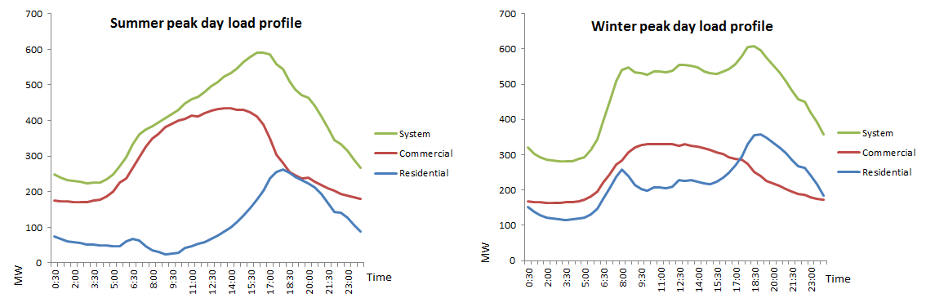The adjusted load factors were applied to the energy consumption for each tariff to determine the maximum demand of the load for each tariff. If the maximum demand for all tariffs is aggregated, they are necessarily larger than the system peak because the peak for different tariffs or even tariff classes, don’t occur simultaneously. This is shown in the charts below which show that our summer system peak in 2014 occurred on the same day as the peak for our commercial consumers (in 2014). In the winter of 2014, our system peak occurred on the same day as the peak for our residential consumers.

Given the different characteristics of commercial and residential loads, they typically peak at different times rather than simultaneously. In the same way, the estimated maximum demand for each tariff would not occur simultaneously. For this reason, AAD has applied a diversity factor to lower the maximum demand of all tariffs so that when the diversified maximum demand is applied to the LRMC, the tariffs recover those costs to comply with the AER’s price determination for each year. In setting the levels of the tariff components that make up each tariff, AAD has adopted slightly different approaches, depending on whether a tariff has a demand component or not. These approaches are described below.

**Demand based tariffs**

As explained above, each charging component within the overall network tariff has been set on the basis that the overall network tariff is on a price path to fully reflect the LRMC. Where a tariff has (or it is proposed to have) a demand tariff component, AAD has based the demand rate on the LRMC, with a transition path to a fully cost reflective levels over time. The energy and fixed components of the tariff were set using existing flat and TOU tariffs’ energy and fixed component levels as a starting point to move towards LRMC. In this way, AAD has taken into account consumers’ bill impacts and the side constraint. The energy charges were set to become more cost-reflective over time, subject to a transition period. The fixed charges were set after determining the demand and energy charges, to recover the residual of the revenue requirement that is not recovered through demand or energy charges.

**Non-demand based tariffs**

Where a tariff does not have a demand tariff component, AAD has generally sought to retain fixed charges at similar levels to what they are currently, and adjusted the energy charge so that the average revenue generated from that tariff equals the LRMC for consumers on that tariff. In relation to tariffs that do not have a demand tariff component, AAD’s approach should not materially distort consumption or investment decisions (it may in fact reduce distortions). This is because whilst translating a $/kVA LRMC to a $/kWh variable charge is mathematically correct, the resultant $/kWh tariff will not be perfectly reflective of the costs of any kWh of energy that is charged using that tariff component.

AAD’s approaches to demand and non-demand based tariffs has ensured that tariffs are based on the LRMC and generate revenue that comply with the AER’s average revenue constraints.

Attachment 2 Standalone costs and avoidable costs

This Attachment discusses the methodology AAD used to generate the stand alone and avoidable cost efficiency test. In setting its tariffs, AAD must comply with Rule 6.18.5 (e) which requires:

‘…that for each tariff class, the revenue expected to be recovered must lie on or between:

(1) an upper bound representing the stand alone cost of serving the retail consumers who belong to that class; and

(2) a lower bound representing the avoidable cost of not serving those retail consumers’

For a tariff to be deemed to be efficient under the Rules, it must deliver a stream of revenue from a class of consumers, that is between this upper and lower bound. This is commonly known as the ‘efficient pricing band’. Tariff prices are deemed to be efficient if revenue recovered is (1) less than the stand alone cost and (2) greater than the avoidable cost. There are two reasons why a price within this ‘band’ is deemed to be efficient.

1. Less than the stand alone cost: Breaching this upper bound may result in that tariff class being incentivised to inefficiently by-pass AAD’s existing distribution network in order to avoid paying AAD’s network tariffs, despite the fact that the incremental cost to AAD of providing these services to that consumer (or tariff class) may be less than the alternative (by-pass) option.
2. Greater than the avoidable cost: If the revenue expected to be recovered from a tariff class does not exceed the cost that the business would avoid if they did not provide them with electricity services, that tariff class is (a) being subsidised by other tariff classes, and (b) would be over-consuming electricity services, relative to efficient levels (assuming that the consumer or tariff class’ demand curve is not perfectly inelastic).

The estimation of avoidable costs and stand alone costs are explained separately below. These cost estimates are then compared to the expected revenue from each tariff class in Table A1.

A.2.1 Stand Alone Costs

AAD has taken a tailored approach to establishing the costs that relate to the different tariff classes.

A key assumption that AAD has made in interpreting the Rules is that the stand-alone cost test should reflect the opportunity cost to the consumer of maintaining their existing connection to the distribution network (i.e., it should reflect the next most feasible, economic alternative to the current electricity supply solution). This principle is central to the economic equation faced by the consumer: – to stay connected to the distribution network, and pay a retail electricity bill that reflects all components of the electricity value chain; or disconnect from the distribution network, and instead, adopt an alternative source of electricity.

AAD notes that there are a number of methodologies that can, and have previously been, utilised to estimate the stand-alone cost of servicing a consumer, or group of consumers. These broadly include:

* A by-pass solution, that assumes a:
  + Network solution: For example, the construction of a connection from the consumer’s premises into the transmission network in order to by-pass the distribution network, or
  + Non-network solution: For example, on-site generation via the construction of a solar PV system plus battery storage plus (potentially) back-up generation (for residential and small commercial consumers) or an embedded generation system (for larger consumers).
* A ‘notional’ network solution, that assumes a:
  + ‘Bottom-up’ build of stand-alone costs, via the construction of a modern day equivalent, optimised asset base in support of the delivery of services to each consumer or group of consumers on a stand-alone basis; and
  + ‘Top-down’ approach, which involves allocating each existing asset / asset type to a consumer or group of consumers, based on some allocation process/methodology. The allocation driver is generally based on the key underlying cost driver.

Having regard to this, AAD has utilised the by-pass solution methodologies to calculate the stand-alone cost of supply. The methodology used by AAD differs for HV commercial consumers compared to residential and LV commercial consumers.

AAD has taken a “modelled” network approach for **HV commercial consumers** based on their respective circumstances. This involves modelling the total cost of by-passing the distribution network and connecting a consumer into the existing electricity transmission network, with the stand alone test being such that every modelled consumer’s DUOS bill must be less than their calculated stand alone cost. To do this, AAD has estimated the costs (in NPV terms) that two of its largest High Voltage consumers would have to incur if they were to by-pass AAD’s distribution network, and then compared this to the NPV of those consumer’s future DUOS bills.

AAD has taken a “modelled” non-network approach for **residential and LV commercial consumers**. This means that the cost per kWh of installing, operating and maintaining a standalone power system that is configured is based on typical retail/small commercial consumer’s consumption profile (as applicable) and provides an equivalent level of reliability to consumers. To do this, AAD estimated the cost to various sized residential and small commercial consumers of installing a PV and battery system. AAD then compared the cost to each type of consumer of installing these systems (in NPV terms) to an estimate of the *retail* bill that each consumer would avoid (again, in NPV terms) if they were to cease obtaining reticulated electricity services.

A.2.2 Avoidable Costs

With regard to avoidable costs, AAD’s model includes long term assumptions consistent with the LRMC approach set out in Attachment 1. With respect to the consumption profile of the consumer, AAD assumes that the consumers would make a contribution to co-incident peak demand consistent with an average consumer within that tariff class. Therefore:

the avoided cost = the average coincident peak demand (kVA) for that tariff class * $kVA LRMC calculated for their relevant voltage level

In relation to the Avoidable Cost test (which checks that a tariff class’ avoidable cost is less than the DUOS revenue for that tariff class), AAD notes that there are a number of factors that affect the way the avoidable cost of supply could be estimated. These factors are discussed below along with the implication and approach taken by AAD.

* The period over which avoided costs should be calculated (short term versus long-term).
  + - Implication: This will affect whether or not avoided capex costs should be included, or just operating and maintenance costs,
* Approach: The average consumption (kWh) of each consumer class has been estimated and then multiplied by an estimate of the short-run operating and maintenance costs ($/kWh), in order to inform our estimate of the costs that AAD would avoid if an average consumer within that tariff class no longer required any energy to be transported through AAD’s distribution network.
* The consumption profile of the consumer assumed to be disconnecting from the grid.
  + - Implication: This will affect whether or not AAD will avoid future augmentation costs (because this will be a function of whether or not and the degree to which a consumer is assumed to use electricity at times when the broader network is peaking).
* Approach: The co-incident peak demand of each consumer class has been estimated and multiplied by the LRMC of supply in order to inform our estimate of the costs that AAD would avoid if an average consumer within that tariff class no longer consumed energy during times of system peak demand.
* Whether the avoided cost calculation should be based on the avoided costs of serving an individual consumer, or a group of consumers, and if the latter, whether that group should be assumed to be in a similar location.
  + - Implication: This will influence whether future capital expenditure associated with upgrading the network to meet required levels of service and replacement expenditure should be included in the calculation.
* Approach: The avoidable cost calculation is based on the avoided costs of serving an individual consumer rather than a group of consumers, except in regions where large upgrades are expected and en-masse disconnection of a consumer class could change upgrade requirements. This methodology implicitly assumes that AAD will not avoid, or be able to downsize or change the timing of, any replacement expenditure if a consumer disconnects from AAD’s network.

Table A2-1 below shows the results of the avoidable cost and stand alone cost efficiency tests for each tariff class.

1. The avoidable cost is lower than the DUOS revenue for each tariff class.
2. The standalone cost is greater than the revenue for each tariff class.
   1. In the case of our *residential and LV commercial consumers*, the stand alone cost should be compared to the NUOS revenue because we assume that the consumers in these tariff classes would bypass the electricity grid altogether. Hence the relevant revenues to be compared in the stand alone cost test are those where the consumer no longer pays the NUOS bill. The analysis shows that the NUOS revenues are still lower than the stand alone cost.
   2. In the case of our *HV commercial consumers*, the stand alone cost should be compared to the DUOS revenue because the stand alone cost for those consumers is based on by-passing only the distribution network (and connecting into the transmission network).

Hence, the table shows that the NUOS and DUOS revenue for each tariff class lies within the lower bound of the avoidable cost and the upper bound of the stand alone cost. The tariffs therefore comply with Rule 6.18.5 (e).

Table A2-1: Avoidable and stand alone costs, 2017/18 ($’000)

|  |  |  |  |  |  |
| --- | --- | --- | --- | --- | --- |
|  | Avoidable Cost | DUOS bill | NUOS bill | Stand alone cost | Compliance check |
| Residential | 42,296 | 54,929 | 111,667 | 608,146 | yes |
| Commercial LV | 11,592 | 61,175 | 128,944 | 313,103 | yes |
| Commercial HV | 3,943 | 7,957 | n/a | 56,685 | yes |
| Total |  | **124,061** |  |  |  |

1. Noting that the marginal cost may vary depending on a range of factors, such as the location at which the consumption takes place, or the time of day/week/season/year at which the consumption occurs.
2. The Rule changes put in place transitional provisions for the initial TSS to be effective for the last two years (2017/18 and 2018/19) of the current regulatory control period (2014/15 to 2018/19). As a result, network prices for 2015/16 and 2016/17 will be set under the pricing Rules that have applied prior to the introduction of the new Rules on 1 December 2014. A subsequent TSS will be developed in consultation with customers, for the next 5-year regulatory period 2019–24.
3. Australian Energy Regulator, Draft Decision: Tariff Structure Statement Proposal ActewAGL, August 2016, page 8.
4. Australian Energy Regulator, Draft Decision: Tariff Structure Statement Proposal ActewAGL, August 2016, page 8.
5. AAD Proposed Tariff Structure Statement, page 33.
6. 2 / 7 = 29 per cent
7. Load factors are average consumption per hour divided by the maximum consumption per hour.
8. Australian Energy Regulator, Draft Decision: Tariff Structure Statement Proposal ActewAGL, August 2016, page 8.
9. Load factors are average consumption per hour divided by the maximum consumption per hour.
10. AEMC *National Electricity Amendment (Distribution Network Pricing Arrangements) Rule 2014,* Rule Determination, p.129
11. NPV (Forecast capital and operating costs) / NPV (Forecast growth in service attributes driving those costs)
12. The maximum demand for each tariff was calculated by applying an estimate of the annual load factor for each tariff to the energy consumed under each tariff in 2013/14.
13. AEMC 2014, *National Electricity Amendment (Distribution Network Pricing Arrangements) Rule 2014,* Rule Determination, p.12
14. ActewAGL Distribution, *2015/16 Network* *Pricing Proposal,* p.29
15. After this, we will be required to submit another TSS proposal together with our regulatory proposal for the regulatory control period 1 July 2019-30 June 2024.
16. Consistent with the contents of the pricing proposal specified in Rule 6.18.2(b)
17. Rule 6.18.1B(a) and 11.73.2. The financial year 2017/18 is the first year during which the TSS will be effective. This is the third year of our regulatory control period (2015/16-2018/19).
18. As per Rule 6.18.6, the side constraint provisions in the NER seek to limit the impact of network price changes on consumers.