

Proposed amendment

Electricity distribution network service providers

Roll forward model handbook

August 2016

© Commonwealth of Australia 2016

This work is copyright. In addition to any use permitted under the Copyright Act 1968, all material contained within this work is provided under a Creative Commons Attributions 3.0 Australia licence, with the exception of:

* the Commonwealth Coat of Arms
* the ACCC and AER logos
* any illustration, diagram, photograph or graphic over which the Australian Competition and Consumer Commission does not hold copyright, but which may be part of or contained within this publication. The details of the relevant licence conditions are available on the Creative Commons website, as is the full legal code for the CC BY 3.0 AU licence.

Requests and inquiries concerning reproduction and rights should be addressed to the   
Director, Corporate Communications,   
Australian Competition and Consumer Commission,   
GPO Box 4141,   
Canberra ACT 2601   
or publishing.unit@accc.gov.au.

Inquiries about this publication should be addressed to:

Australian Energy Regulator  
GPO Box 520  
Melbourne Vic 3001

Tel: (03) 9290 1444  
Fax: (03) 9290 1457

Email: [AERInquiry@aer.gov.au](mailto:AERInquiry@aer.gov.au)  
AER Reference: 58930

Amendment record

|  |  |  |  |
| --- | --- | --- | --- |
| Handbook version | Model version | Date | Pages |
| 1 | 1 | June 2008 | 21 |
| 2 | 2 | August 2016 | 32 |

Contents

Shortened forms i

1 Nature and authority 1

1.1 Introduction 1

Authority 1

1.2 Role of the model 1

1.3 Confidentiality 1

1.4 Process for revision 1

1.5 Version history and effective date 1

2 The model 2

2.1 Overview of the RFM 2

2.2 DMS input sheet 3

2.3 RFM input sheet 4

2.3.1 Opening regulatory asset base and tax asset base 7

2.3.2 Actual nominal capital expenditure—as-incurred 9

2.3.3 Actual nominal asset disposals—as-incurred 10

2.3.4 Actual nominal net customer contributions—as-incurred 10

2.3.5 Actual real net capital expenditure—as-incurred 10

2.3.6 Inflation and rate of return 10

2.3.7 Real straight-line depreciation option 10

2.3.8 Forecast real straight-line depreciation 10

2.3.9 Forecast nominal final year asset adjustments 11

2.4 Adjustment for previous period sheet 11

[2.4.1 Nominal adjustments for difference between forecast and   
 actual net capex 12](#_Toc456014969)

2.5 RAB roll forward sheet 13

2.5.1 Real asset values 15

2.5.2 Nominal asset values 16

2.6 Total RAB roll forward sheet 16

2.7 TAB roll forward sheet 18

2.7.1 Opening tax asset values 20

2.7.2 Actual net capex 20

2.7.3 Actual tax depreciation 21

2.8 RAB remaining lives sheet 21

2.9 TAB remaining lives sheet 25

2.10 PTRM input summary sheet 27

Shortened forms

|  |  |
| --- | --- |
| Shortened form | Extended form |
| AER | Australian Energy Regulator |
| capex | capital expenditure |
| CPI | consumer price index |
| DNSP | distribution network service provider |
| NEL | National Electricity Law |
| NER | National Electricity Rules |
| PTRM | post-tax revenue model |
| RAB | regulatory asset base |
| RFM | roll forward model |
| TAB | tax asset base |
| WACC | weighted average cost of capital |

# Nature and authority

## Introduction

This handbook sets out the Australian Energy Regulator’s (AER) roll forward model (RFM) for electricity distribution network service providers (DNSPs). The RFM is a series of Microsoft Excel spreadsheets developed in accordance with the requirements of clause 6.5.1 of the National Electricity Rules (NER).

## Authority

Clause 6.5.1(b) of the NER requires the AER to develop and publish the RFM, in accordance with the distribution consultation procedures.

## Role of the model

DNSPs are required to submit a completed RFM to the AER as part of their regulatory proposals. However, the AER recognises that there may be a need for some flexibility in applying the RFM in order to account for the particular circumstances a DNSP may face. A number of elements of the RFM where this may be the case have been identified in this handbook. A DNSP will need to propose and justify a departure from any element of the RFM for the purposes of addressing its specific circumstances as part of its regulatory proposal, which will be considered and assessed by the AER on a case-by-case basis in making its distribution determination.

The RFM is used by the AER to determine the closing regulatory asset base (RAB) for a regulatory control period. This closing RAB value for a regulatory control period becomes the opening RAB to be used for the purposes of making a building block determination for the next regulatory control period. The roll forward of the opening RAB for the next regulatory control period, on a forecast indicative basis, is undertaken in the AER’s post-tax revenue model (PTRM) in accordance with the requirements of the NER.

## Confidentiality

The AER’s obligations regarding confidentiality and the disclosure of information provided to it by a DNSP are governed by the Competition and consumer Act 2010 (Cth), the National Electricity Law (NEL) and the NER.

## Process for revision

The AER may amend or replace the RFM from time to time in accordance with clause 6.5.1(c) of the NER and the distribution consultation procedures. The AER will publish a revised version of this handbook to accompany each version of the RFM it amends or replaces in the future.

## Version history and effective date

A version number and an effective date of issue will identify each version of this handbook.

# The model

## Overview of the RFM

The RFM is used to calculate the total value of assets for a DNSP across a regulatory control period. Specifically, the RFM is a set of Microsoft Excel spreadsheets combined into one file, often referred to as a singular spreadsheet that perform calculations to derive a closing RAB for the current regulatory control period from a given set of inputs.[1] The RFM allows the user to vary the inputs to assess their impact on the output data and other derived parameters. Figure 1 provides an overview of this process.

Figure 1 Overview of the RFM spreadsheets



In Figure 1, each box represents a spreadsheet within the RFM. Sheets are classified as primarily about inputs (left column), calculations (centre column) or outputs (right column). The flow of data is therefore from left to right, and simplified links between the sheets are shown with blue arrows.

To operate the RFM, the user enters all the required data on the RFM input sheet—for example, the opening RAB and TAB values, actual capital expenditure (capex) across the regulatory control period, or the actual consumer price index (CPI) rate. These inputs often requires reconciliation with previous models (RFM or PTRM) approved for the current building block determination applying to the current regulatory control period, or annual information reported by the DNSPs. In this sense, the majority of inputs to the RFM will be the output from other parts the previous final decision.

The RFM then uses this data to undertake the RAB (and TAB) roll forward, consistent with the requirements of the NER. Under this approach, the RAB is rolled forward during each year of the current regulatory control by adding capex (net of disposals and customer contributions[2]), subtracting depreciation and indexing for actual CPI in the RAB roll forward sheet. The required true-up for RAB adjustments (such as for using an estimate of capex) in the final year of the previous regulatory control period is calculated in the Adjustment for previous period sheet. The Total RAB roll forward sheet then draws the data from the RAB roll forward and Adjustment for previous period sheets to bring together the closing RAB for the current regulatory control period.

The roll forward of the TAB is undertaken in a similar, but simpler manner in the TAB roll forward sheet. Unlike the RAB, the TAB is not used to derive revenues explicitly and so the final year capex estimate true-up can be accommodated by replacing with actual capex in the relevant year of incurrence.[3]

The **RAB remaining lives** and **TAB remaining lives** sheets roll forward the weighted average remaining life of each asset class based on actual depreciation of the opening asset value and net capex incurred in each regulatory control period.

Finally, because the outputs of the RFM become inputs to the PTRM, there is a presentation sheet which provides a summary of output data in the format required for feeding into the PTRM.

The user should not alter the names of any sheets or defined name ranges within the RFM. These RFM components are used when automatically importing into the AER’s data management system (DMS). If these elements are changed, errors may occur.

## DMS input sheet

The **DMS input** sheet captures business specific, non-financial information that is required for the AER to import the RFM into its DMS. To allow this automatic import to take place, this spreadsheet has been locked (using the Excel ‘Protect sheet’ command) so that the layout of this sheet cannot be changed.

Contact details for those responsible for preparing and submitting the RFM are recorded in rows 14 to 31. These will be stored in the DMS. These inputs also control the headings displayed at the top of other sheets in the RFM.

Context details for the RFM are recorded in the lower section. Many of these details (such as the dates of the regulatory control period) are automatically populated from the RFM input sheet and so the cells here are hidden. The stage of the regulatory process is set in cell C46 using a drop down menu.[4] If this is not enough description to uniquely identify the RFM submission, a description should be placed in cell C53 (for example, a resubmission of the Regulatory proposal RFM with revised data values after an error was corrected).

Figure 2 provides an example of the **DMS input** sheet.

Figure 2 DMS input sheet

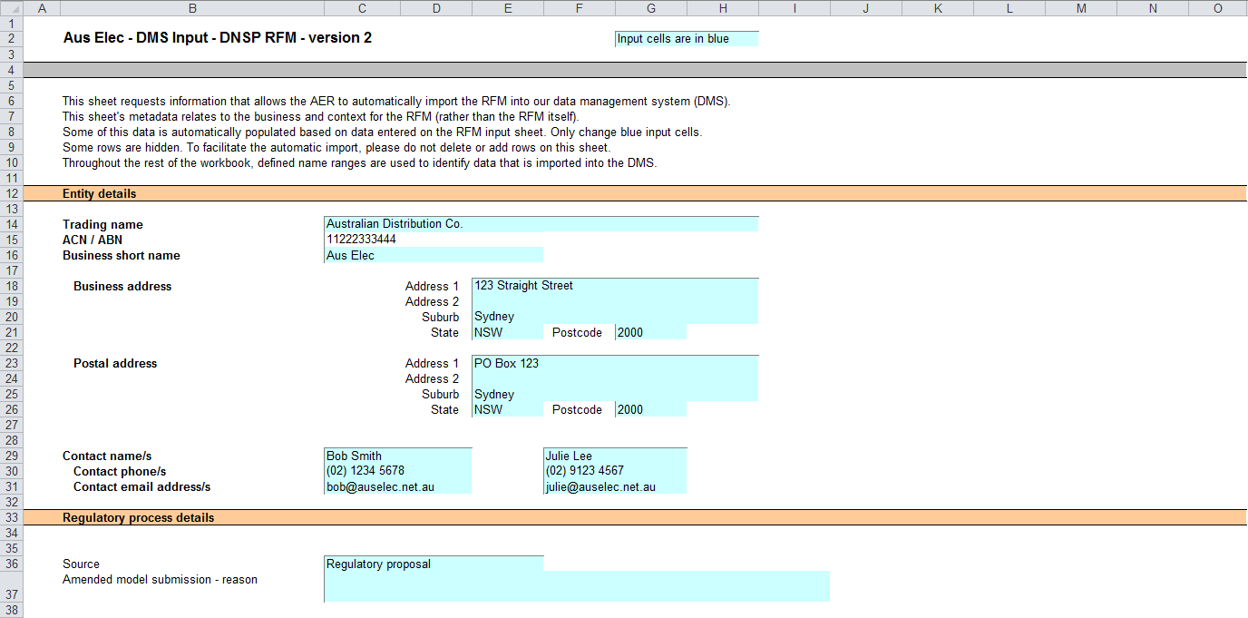

## RFM input sheet

The **RFM input** sheet provides for key input variables to be entered in the RFM. They are automatically linked to corresponding cells in other relevant sheets. Values should be entered into each cell with light blue shading. This sheet comprises of the following sections:

* opening RAB and opening tax asset base (TAB)
* actual nominal capex—as-incurred
* actual nominal asset disposals—as-incurred
* actual nominal customer contributions—as-incurred
* actual real net capex—as-incurred
* inflation and rate of return
* real straight-line depreciation option
* forecast real straight-line depreciation
* forecast nominal final year asset adjustments.

The input data to be recorded in the RFM must be in a consistent format as the data collected from the DNS in accordance with the AER’s regulatory information notice (RIN).

The RFM can accommodate input data for up to 11-year period. This includes the final year of the previous regulatory control period, as well as up to 10 years of the current regulatory control period. Input cells outside of the relevant regulatory control period should be left blank.

The RFM is configured as follows:

* Uses the straight-line depreciation method as the default position for calculating depreciation for regulatory and tax purposes—If DNSPs intend to propose other depreciation profiles, it is recommended that they raise this as part of pre-lodgement discussions.[5] For example, this could take place during the framework and approach process for a determination.[6]
* Recognises capex on a full as-incurred approach—This method for recognising capex calculates the return on capital and return of capital (regulatory depreciation) based on as-incurred capex; that is, when expenditure is incurred.
* Uses the weighted average method as the default position for calculating the average remaining asset lives for the RAB and TAB by asset classes—If DNSPs intend to propose using other approaches to calculate the average remaining lives for a group of assets, it is recommended that they raise this as part of pre-lodgement discussions or as part of the framework and approach process.

Figure 3 provides an example of the **RFM input** sheet.

Figure RFM input sheet

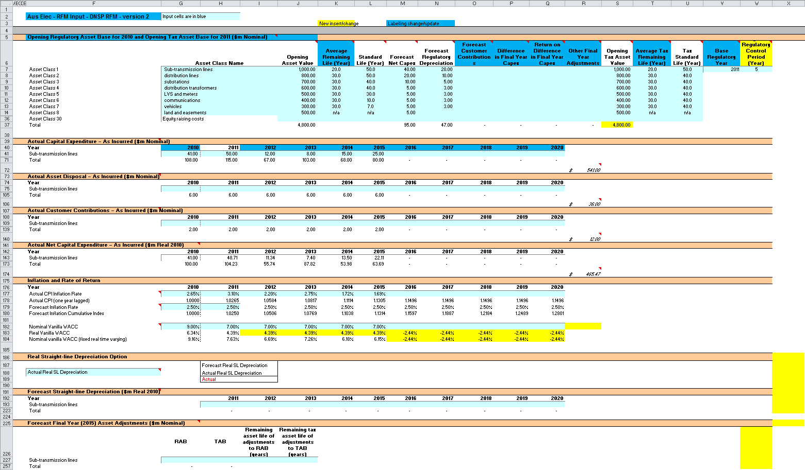

### Opening regulatory asset base and tax asset base

The opening RAB is the value of assets on which a return will be earned. The opening TAB is used to calculate the depreciation for tax purposes. The **RFM input** sheet requires values for the opening RAB (broken into asset classes in rows 7 to 36) at the start of the final year of the previous regulatory control period. The values for the opening TAB, also broken into asset classes, are required at the start of the first year of the current regulatory control period. The RAB and TAB will differ each year to reflect actual capex, asset disposals, customer contributions (for the RAB), and regulatory depreciation (for the RAB) or tax depreciation (for the TAB).

The recorded input values are linked to subsequent sheets which calculate an annual balance of the RAB and TAB for the current regulatory control period. Notes have been included for various cells with specific comments and explanations about the relevance of the inputs.

Asset class name

The asset classes/names are recorded in column G. It is important that the number of asset classes recorded in the RAB section matches the number of asset classes identified in the capex section. This allows the RFM to model consistent depreciation across the asset classes.

The RFM is configured to accommodate up to 30 asset classes.[7] The number of asset classes used in the RFM will vary between businesses.[8] However, for each business, the number of asset classes used in the RFM must be consistent with that used in the AER’s PTRM to allow the closing RAB values determined in the RFM to be used as inputs to the opening RAB values in the PTRM.

RAB values by asset class derived from the RFM may be aggregated or disaggregated into different classes when forming inputs for the PTRM for the subsequent regulatory control period where this meaningfully improves the accuracy or administrative convenience of asset calculations.

Opening asset value

The opening asset values for each asset class are recorded in column J. These values should be as at the start of the final year of the previous regulatory control period and would be contained in the RFM used for the current building block determination for the DNSP. They are linked to the **Adjustment for previous period** and **RAB roll forward** sheets.

Average remaining life

The remaining lives of each asset class are recorded in column K, based on the economic lives of the assets as at the start of the current regulatory control period. These values should be consistent with those contained in the PTRM used in the current building block determination for the DNSP. They are linked to the **RAB roll forward** and RAB remaining lives sheets.

Standard life

The standard lives of each asset class are recorded in column L and measure how long the infrastructure would physically last if it had just been built. These values should be consistent with those contained in the PTRM used in the current building block determination for the DNSP. They are linked to the **RAB roll forward** and RAB remaining lives sheets.

Forecast net capex

The forecast net capex values for each asset class are recorded in column M. They are based on the estimates made in the final year of the previous regulatory control period. These values would be contained in the RFM used for the current building block determination for the DNSP. They are linked to the **Adjustment for previous period** and **RAB roll forward** sheets.

Forecast regulatory depreciation

The forecast regulatory depreciation values for each asset class are recorded in column N. They are based on the estimates made for the final year of the previous regulatory control period. These values would be contained in the RFM used for the current building block determination for the DNSP. They are linked to the **Adjustment for previous period** sheet.

Forecast customer contributions

The forecast customer contribution values for each asset class are recorded in column O. They are based on the estimates made in the final year of the previous regulatory control period. These values would be contained in the RFM used for the current building block determination for the DNSP. They are linked to the TAB roll forward sheet.

Difference in final year capex

The difference in final year capex values for each asset class are recorded in column P. They are based on the capex 'true-up' adjustment made to the closing RAB for the previous regulatory control period. These values would be contained in the RFM used for the current building block determination for the DNSP. These values are linked to the **Adjustment for previous period** sheet.

Return on difference in final year capex

The return on difference in final year capex values for each asset class are recorded in column Q. They are based on the accumulated return associated with the final year capex 'true-up' adjustment made to the closing RAB for the previous regulatory control period. These values would be contained in the RFM used for the current building block determination for the DNSP. These values are linked to the **Adjustment for previous period** sheet.

Other final year adjustments

The other final year adjustment values for each asset class are recorded in column R. This data may be required for DNSPs which adjusted their closing RAB by removing or adding assets (such as a change in service classification) in the final year of the previous regulatory control period. The amount of other final year adjustments (if any) would be contained in the RFM used for the current building block determination for the DNSP.[9] These values are linked to the **Adjustment for previous period** sheet.

Tax asset values—opening tax asset value, average tax remaining life, tax standard life

The RFM includes a mechanism to roll forward tax asset values between regulatory control periods. The **RFM input** sheet requires the tax asset values comprising of the opening tax values, average tax remaining lives and tax standard lives for each asset class. The RFM is configured to calculate tax asset values using actual capex, including the value of contributed assets on an as-incurred basis, asset disposals and tax depreciation.

For each asset class, the opening tax values at the start of the first year of the current regulatory control period are recorded in column S, the average tax remaining lives are recorded in column T and the tax standard lives are recorded in column U. These values are linked to the **TAB roll forward** sheet to calculate a running balance of the tax asset values for the current regulatory control period.

Base regulatory year

The regulatory year for the start of the current regulatory control period is recorded in cell V7.

Length of the current regulatory control period

The number of years in the current regulatory control period is recorded in cell W7.

### Actual nominal capital expenditure—as-incurred[10]

The actual capex values for the current regulatory control period (including the final year for the previous regulatory control period) are recorded for each year in rows 41 to 70 (by asset class). Generally, capex falls into three broad categories:

* asset augmentation (e.g. works to enlarge a network or to increase the capability of a network)
* asset replacement (e.g. replacing assets that have passed their useful lives)
* non-network asset (e.g. support the business expenditure).

These inputs are assumed to be in middle of the year terms based on nominal dollar terms.

### Actual nominal asset disposals—as-incurred

The actual asset disposal values for each year are recorded in rows 75 to 104. These inputs are assumed to be in middle of the year terms based on nominal dollar terms.

### Actual nominal net customer contributions—as-incurred

The values of actual assets contributed by other parties over the regulatory control period for each year are recorded in rows 109 to 138. These inputs are assumed to be in middle of the year terms based on nominal dollar terms.

### Actual real net capital expenditure—as-incurred

This section on actual real net capex does not require inputs to be recorded. For each asset class, actual real net capex values are calculated based on the recorded actual nominal capex values less asset disposal values and contributed assets, and adjusted for actual inflation. The real net capex values are displayed in rows 143 to 172 and form part of the roll forward of the RAB in the **Adjustment for previous period** and **RAB roll forward** sheets and the TAB in the TAB roll forward sheet. These values are assumed to be in middle of the year terms, based on the final year of the previous regulatory control period real dollar terms.

### Inflation and rate of return

This section records the actual annual inflation rates (based on the consumer price index) over the current regulatory control period and in the previous regulatory control period (rows 177 to 178). It also records the forecast inflation and weighted average cost of capital (WACC) rates used in the building block determinations corresponding to the two regulatory control periods (rows 179 to 184). These parameters are linked to the **Adjustment for previous period** and **RAB roll forward** sheets.

### Real straight-line depreciation option

The RFM provides the user an option at cell F188 (drop down function) to select the RAB roll forward to be undertaken using forecast straight-line depreciation or actual straight-line depreciation. If forecast depreciation is selected, the RAB roll forward calculations will use the depreciation inputs at section 2.3.8 which reflect the approved forecasts for the current regulatory control period. If actual depreciation is selected, the RAB roll forward calculations will use actual capex to calculate depreciation.

### Forecast real straight-line depreciation

When the forecast depreciation option is selected, the approved forecast real straight-line depreciation values for each year are recorded at rows 193 to 222. Otherwise, there is no need to record any inputs in this section if actual depreciation is selected. The approved forecast depreciation values would be contained in the PTRM used for the current building block determination for the DNSP. These values are linked to the **RAB roll forward** sheet.

### Forecast nominal final year asset adjustments

Some DNSPs may need to adjust their closing RAB and TAB at the end of the current regulatory control period for asset movements (such as a change in service classification). The values for these asset adjustments and associated remaining asset lives are recorded in rows 227 to 256, and are linked to the **Total RAB roll forward and TAB roll forward** sheets.

## Adjustment for previous period sheet

The **Adjustment for previous period** sheet calculates the required true-up of RAB adjustments to be made for the final year of the previous regulatory control period for forecast and actual net capex values.

This adjustment is consistent with the requirements of clause S6.2.1(e)(3) of the NER, which specifies that a reconciliation includes adjustments to remove any benefit or penalty on the returns associated with any difference between the forecast and actual capex values for the final year of the previous regulatory control period.

This sheet calculates the difference between forecast and actual net capex for the final regulatory year of the previous regulatory control period, as well as the aggregate compounded return on that difference (rows 11 to 167). This adjustment is made to the closing RAB at the end of the current regulatory control period in the **Total RAB roll forward** sheet. This two-step process is outlined in Box 1.

|  |
| --- |
| Box Adjusting for actual capex in the final year of the previous regulatory control period |
| 1) Calculating the difference between actual and forecast net capex  Nominal actual net capex (including a half-nominal vanilla WACC allowance) –  Nominal forecast net capex (including a half-nominal vanilla WACC allowance) =  Nominal difference between forecast and actual net capex.  2) Calculating the nominal return on the difference and compounding it for each year of the current regulatory control period  Nominal difference between forecast and actual net capex × nominal vanilla WACC per annum (compounded) |
| Notes:   * Nominal forecast net capex = estimated net capex allowed in the final year of the previous regulatory control period. * Nominal actual net capex = actual net capex incurred during the final year of the previous regulatory control period. * The nominal return on the difference between actual and forecast net capex is calculated by applying the nominal vanilla WACC (adjusted for actual inflation) applicable to the current regulatory control period (as determined in the current building block determination). * Each of these adjustments is made to the final closing RAB for the current regulatory control period in the **Total RAB roll forward** sheet. |

Figure 4 provides an example of the **Adjustment for previous period** sheet.

Figure Adjustment for previous period sheet

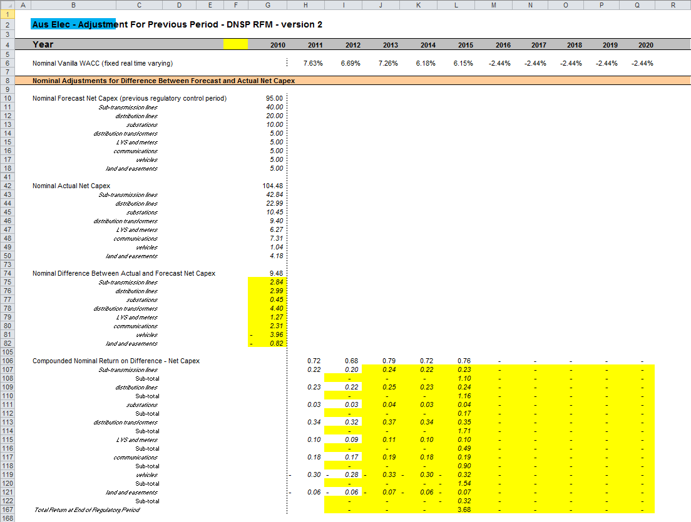

### Nominal adjustments for difference between forecast and actual net capex

This section calculates the difference between forecast and actual net capex for the final year of the previous regulatory control period and determines the compounded return on that difference. The process involved is based on that depicted in Box 1.

The nominal forecast net capex values for each asset class in the final year of the previous regulatory control period are displayed in rows 10 to 40. The values are sourced from the **RFM input** sheet. Row 10 displays the sum of each asset class values for rows 11 to 40.

The nominal actual net capex values (including a half WACC allowance) for each asset class in the final year of the previous regulatory control period are calculated in rows 42 to 72. Given the timing assumption that capex on average takes place halfway through the year, a half-nominal vanilla WACC is applied to the actual net capex for each asset class to ‘gross-up’ the actual values.[11] Row 42 displays the sum of each asset class calculations for rows 43 to 72.

The differences between the actual and forecast net capex values for each asset class are calculated in rows 75 to 104. Row 74 displays the sum of each asset class calculations for those rows.

Finally, in rows 106 to 166 a nominal vanilla WACC (row 6) is applied to calculate the nominal return on the difference, which is compounded to the end of the current regulatory control period.[12] The total compounded nominal return at the end of the current regulatory control period is displayed in row 167. This value is linked to the **Total RAB roll forward** sheet.

## RAB roll forward sheet

The **RAB roll forward** sheet calculates the nominal closing RAB (which becomes the opening RAB for the following year) for each year of the current regulatory control period. Under clauses 6.5.1(e) and S6.2.1 of the NER, in rolling forward the RAB each year during the current regulatory control period, the AER must have regard to actual data such as actual capex and inflation outcomes. Accordingly, the opening RAB for the first year of the current regulatory control period is rolled forward for:

* actual net capex (as-incurred)
* regulatory depreciation values (adjusted for actual inflation).[13]

Depending on which option for depreciation has been selected in the RFM input sheet, the RAB roll forward calculations will use either forecast straight-line depreciation or actual straight-line depreciation. The option to be selected must be consistent with that set out in current building block determination for the DNSP. Forecast straight-line depreciation refers to the amounts approved for the current regulatory control period, reflecting forecast capex used for the current building block determination. Actual straight-line depreciation uses the amounts that are calculated based on actual capex incurred during the current regulatory control period.

The process for rolling forward the RAB from year to year over the current regulatory control period, under the full as-incurred approach for recognising capex, is set out in Box 2.[14]

|  |
| --- |
| Box Rolling forward the RAB in the current regulatory control period |
| Rolling forward actual net capex and depreciation amounts into the RAB  Opening RAB for year 1 of the current regulatory control period +  Nominal actual net capex for year 1 –  Nominal regulatory depreciation for year 1 =  Closing RAB for year 1 of the current regulatory control period. This becomes:  Opening RAB for year 2 of the current regulatory control period +  Nominal actual net capex for year 2 –  Nominal regulatory depreciation for year 2 =  Closing RAB for year 2 of the current regulatory control period. This becomes:  Opening RAB for year 3 of the current regulatory control period  … =  Closing RAB for year 5 of the current regulatory control period =  Interim closing RAB for the current regulatory control period. |
| Where:   * Opening RAB for year 1 of the current regulatory control period = closing RAB for the final year of the previous regulatory control period. * Nominal actual net capex = real actual net capex (including half-nominal vanilla WACC allowance) adjusted for actual inflation. * Nominal regulatory depreciation = Nominal straight-line depreciation – actual inflation adjustment on the opening RAB.   Notes:   * The interim closing RAB for the current regulatory period plus the final adjustments for the final year of the current regulatory control period (these adjustments are made in the **Total RAB roll forward** sheet—see Box 3 for a description) becomes the opening RAB for the next regulatory control period. |

Figure 5 provides an example of the **RAB roll forward** sheet.

Figure RAB roll forward sheet

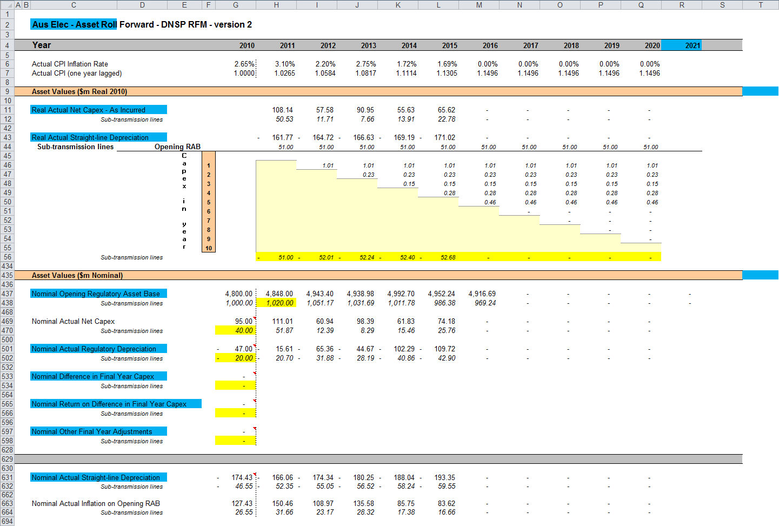

### Real asset values

Real asset values are displayed in rows 11 to 41. The real actual net capex values (including a half-nominal vanilla WACC allowance) for each asset class are displayed in rows 12 to 41.[15] Row 11 displays the sum of each asset class values for those rows.

These capex values for the current regulatory control period (sourced from the **RFM input** sheet) are those provided by the DNSP to the AER for the purpose of rolling forward its RAB to the end of the current regulatory control period.

The real straight-line depreciation values for each asset class are set out at rows 44 to 433. Row 43 displays the sum of each asset class calculations for those rows. If the forecast depreciation option was selected, then the forecast depreciation inputs are sourced from the RFM input sheet. If the actual depreciation option was selected, then the depreciation calculations are based on the opening RAB, actual net capex values and asset lives from the **RFM input** and RAB roll forward sheets.

### Nominal asset values

Nominal asset values are displayed in rows 437 to 693. The nominal opening RAB values for each year are displayed in row 437, based on the sum of each asset class calculations for rows 438 to 467. The nominal opening RAB for the first year of the current regulatory control period (cell H437) is calculated by taking the opening RAB value for the final year of the previous regulatory control period (cell G437), adding forecast net capex value for that year (G469), adding (typically negative) regulatory depreciation value for that year (G501) and adding other capex/asset adjustment values where relevant (cells G533, G565 and G597). These values are all sourced from the RFM input sheet.

The nominal opening RAB values for the remaining years of the current regulatory control period are calculated in accordance with Box 2. The nominal actual net capex values for each year (row 469) are equal to the real actual net capex values (row 11) indexed by actual inflation (row 7). The nominal regulatory depreciation values (row 501) are calculated as the net total of the nominal straight-line depreciation (row 631) and the actual inflation applied to the opening RAB (row 663).

## Total RAB roll forward sheet

The **Total RAB roll forward** sheet brings together the relevant data from the **Adjustment for previous period** and **RAB roll forward** sheets to calculate the final closing RAB for the current regulatory control period in nominal terms.[16]

In this sheet, row 7 displays the opening RAB values for each year of the current regulatory control period, based on the sum of each asset class calculations for rows 8 to 37. These rows are in turn based on the interim closing RAB in row 201. The calculations at rows 8 to 37 reflect the opening RAB values in the **RAB roll forward** sheet. The nominal actual net capex (row 39), regulatory depreciation (row 71) values and other as-incurred capex/asset adjustments that may be required—e.g. difference in final year capex (row 103), return on difference in final year capex (row 135) and other final year adjustments (row 167) are sourced from the **RAB roll forward** sheet.

Rows 233 to 327 represent the required adjustments to be made for the final year of the current regulatory control period and are sourced from the **Adjustment for previous period** and RFM input sheets. These adjustments include:

* the difference between forecast and actual net capex for the final year of the previous regulatory control period (and a compounded return on that difference)
* other asset adjustments for the final year of the current regulatory control period.

The process for calculating the final closing RAB for the current regulatory control period is set out in Box 3.

|  |
| --- |
| Box Calculating the final closing RAB for the current regulatory control period |
| Adjustments to be made for the final year of the current regulatory control period to calculate final closing RAB  Interim closing RAB for the current regulatory control period +  Difference between nominal actual net capex and forecast net capex +  Compounded nominal return on that difference for net capex +  Final year asset adjustments (where applicable) =  Closing RAB for the current regulatory control period =  Opening RAB for the first year of the next regulatory control period. |
| Note:   * The opening RAB for the first year of the next regulatory control period becomes an input into the PTRM for the purposes of determining the return on capital and return of capital (depreciation) for the next regulatory control period. |

The closing RAB for the current regulatory control period is shown in row 329. This value becomes the opening RAB for the next regulatory control period and is used as an input into the PTRM for calculating the allowed return on capital and the return of capital (depreciation) in the next building block determination. A breakdown of the closing RAB values by asset classes are displayed in rows 330 to 359.

Figure 6 provides an example of the **Total RAB roll forward** sheet.

Figure Total RAB roll forward sheet

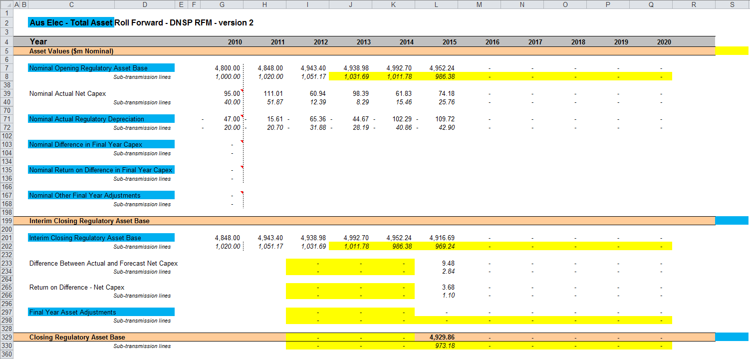

## TAB roll forward sheet

The **TAB roll forward** sheet calculates the nominal opening TAB values for each year of the current regulatory control period by taking the opening TAB value for the start of the current regulatory control period and adjusting for forecast net capex, which was included in the final year of the previous regulatory control period, with actual net capex for that year. [17] The opening TAB value is then rolled forward for actual net capex and tax depreciation values for each year of the current regulatory control period. Since the calculations are based on actual nominal data the roll forward of the TAB values does not require any adjustments for inflation. Any required adjustments to be made to the TAB for the final year of the current regulatory control period are also applied in this sheet.

The process for rolling forward the TAB for year to year over the current regulatory control period is set out in Box 4.[18]

|  |
| --- |
| Box Rolling forward the TAB in the current regulatory control period |
| Rolling forward actual net capex and depreciation amounts into the TAB  Opening TAB for the first year of the current regulatory control period –  Nominal forecast net capex for the final year of the previous period +  Nominal actual net capex for the final year of the period =  Adjusted opening TAB for year 1 of the current regulatory control period.  Adjusted opening TAB for year 1 of the current regulatory control period +  Nominal actual net capex for year 1 –  Nominal actual tax depreciation for year 1 =  Closing TAB for year 1 of the current regulatory control period. This becomes:  Opening TAB for year 2 of the current regulatory control period +  Nominal actual net capex for year 2 –  Nominal actual tax depreciation for year 2 =  Closing TAB for year 2 of the current regulatory control period. This becomes:  Opening TAB for year 3 of the current regulatory control period  … =  Closing TAB for year 4 of the current regulatory control period. This becomes:  Opening TAB for year 5 of the current regulatory control period +  Nominal actual net capex for year 5 –  Nominal actual tax depreciation for year 5 +  Final year asset adjustments (where applicable) =  Closing TAB for year 5 of the current regulatory control period =  Opening TAB for the first year of the next regulatory control period. |
| Where:   * Nominal actual net capex = nominal actual gross capex – nominal actual asset disposals. * Nominal actual tax depreciation = nominal actual straight-line tax depreciation.   Note:   * The closing TAB for the current regulatory control period becomes the opening TAB for the next regulatory control period. |

Figure 7 provides an example of the **TAB roll forward** sheet.

Figure Tax value roll forward sheet

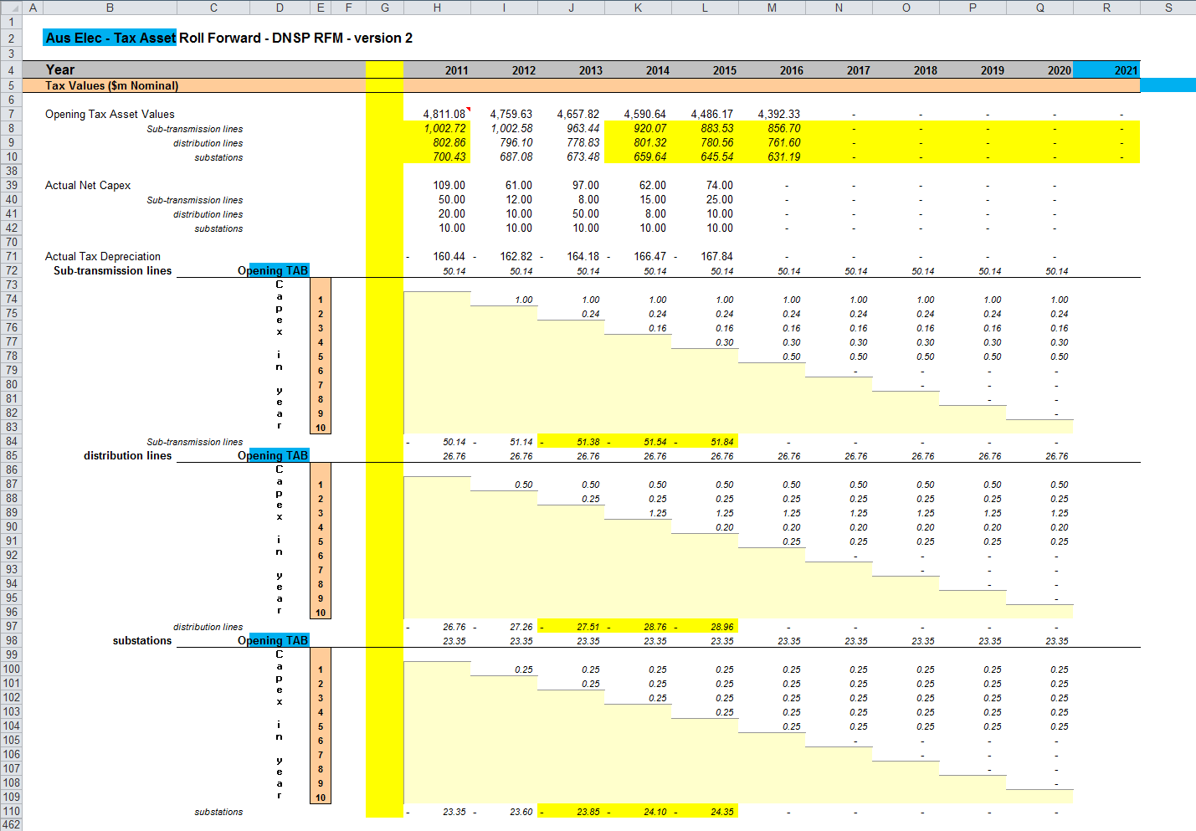

### Opening tax asset values

The opening tax asset value (cells H7 to H37) at the start of the first year of the current regulatory control period is adjusted by removing forecast net capex for the final year of the previous regulatory control period so that actual net capex for that year is included in the TAB. Rows 8 to 37 roll forward the opening TAB values for each asset class by taking the previous year’s nominal opening TAB value, then adding nominal actual net capex for the year and subtracting nominal actual tax depreciation for the year.

Based on the sum of each asset class calculations for those rows, the opening TAB value for each year of the current regulatory control period is displayed in row 7. These values are calculated in accordance with Box 4. For a 5 year regulatory period, the opening TAB value for the next regulatory control period is shown in cell M7. This value is used as an input into the PTRM for calculating the tax depreciation in the next building block determination. A breakdown of the closing TAB values by asset classes are displayed in cells M8 to M37.

### Actual net capex

The actual net capex values for each asset class (rows 40 to 69) and each year of the current regulatory control period are calculated by taking nominal actual capex from the **RFM input** sheet (rows 41 to 70) and subtracting nominal actual disposals from the same sheet (rows 75 to 104). Note that the resulting capex used for tax purposes includes the value of customer contributions. Row 39 displays the sum of each asset class calculations for rows 40 to 69.

### Actual tax depreciation

The actual tax depreciation values for each asset class (rows 72 to 461) and each year of the current regulatory control period are calculated based on the nominal opening TAB values, nominal actual net capex values and tax asset lives, in accordance with the straight-line method. Row 71 displays the sum of each asset class calculations for those rows.

## RAB remaining lives sheet

The **RAB remaining lives** sheet calculates the average RAB remaining lives of each asset class using a weighted average method. The weighted average remaining lives at the end of the current regulatory control period for the RAB are used as inputs to the PTRM for the next regulatory control period to calculate the depreciation schedules in the building block determination. The sheet is set up to accommodate asset life tracking over four five-year periods, however the calculations can be expanded to cover more if required.[19]

For the first period that the RFM version 2 is used, the inputs for these calculations are sourced from the RFM **input** sheet. The input cells include formula references to the correct cells within the RFM. In future periods the RAB remaining lives sheet will also require inputs obtained from the RFMs for decisions relating to previous periods. The process for updating this data is set out in Box 5.

|  |
| --- |
| Box Input process required for updating RAB remaining life calculations |
| First period that RFM version 2 is used:  All inputs for the remaining life calculations are linked to the relevant value within the RFM.  No further inputs are required. |
| Subsequent period that RFM version 2 is used:  Input cells (light blue) will no longer be referencing the correct cells. These links must be replaced with the actual values approved in the previous decision RFM. These values include:   * Start period * CPI * Nominal vanilla WACC (fixed real time varying) * Value of net addition (capex) * Standard asset life * Value of final year asset adjustments * Remaining life of final year asset adjustments.   These values can be copied from the previous decision RFM's **RAB remaining lives** sheet for each year of the preceding periods.  The original input cell formulae for CPI, WACC, capex and standard lives (columns D to H) can be replicated in the relevant year of the subsequent period to ensure automatic updates. |

The process for calculating the weighted average remaining lives for the RAB is set out in Box 6.[20] A similar process applies for calculating the weighted average remaining lives for the TAB.

|  |
| --- |
| Box 6 Calculating the RAB weighted average remaining asset lives |
| Calculating the RAB weighted average remaining asset lives by asset class  Opening RAB for start year –  Total real actual depreciation on opening RAB  = Closing capital value of opening RAB.  Real actual net capex for year 1 –  Total real actual depreciation on net capex for year 1 =  Closing capital value of net capex for year 1.  ... *For each year of actual capex…*  Value of final year RAB adjustments –  Total real actual depreciation on RAB adjustments  = Closing capital value of RAB adjustments  Sum of closing capital values  = Total closing capital value for the asset class.  Opening RAB average remaining life – number of years of depreciation applied to opening RAB  = Closing average remaining life of opening RAB  Asset class RAB standard life – number of years of depreciation applied to capex for year 1  = Closing average RAB remaining life of capex for year 1  … *For each year of actual capex…*  RAB adjustments average remaining life – number of years of depreciation applied to RAB adjustments  = Closing average remaining life of RAB adjustments.  Closing capital value of opening RAB ÷ Total closing capital value for the asset class × Closing average remaining life of opening RAB +  Closing capital value of net capex for year 1 ÷ Total closing capital value for the asset class × Closing average RAB remaining life of capex for year 1 +  … *For each year of actual capex …* +  Closing capital value of RAB adjustments ÷ Total closing capital value for the asset class × Closing average remaining life of RAB adjustments  = **Weighted average remaining life for the RAB asset class.** |
| Where:   * Opening RAB for start year = closing RAB for the final year of the regulatory control period preceding first use of version 2 of the RFM. * Total real actual depreciation on opening RAB = the sum of the real actual depreciation on opening RAB calculated for the regulatory control period. * Real actual net capex = real actual net capex (including half-nominal vanilla WACC allowance) * Total real actual depreciation on net capex = the sum of the real actual depreciation on net capex calculated for the regulatory control period * The opening RAB average remaining life is that used for the building block determination where version 2 of the RFM is first used. * The asset class RAB standard life is that used for the current building block determination.   Note: The calculation of the TAB weighted average remaining lives by asset class follows the same process, with:   * opening TAB replacing opening RAB * total actual depreciation on opening TAB replacing total real actual depreciation on opening RAB * actual net capex (excluding half-nominal vanilla WACC) replacing real actual net capex (including half-nominal vanilla WACC) * final year TAB adjustments replacing final year RAB adjustments * total actual depreciation on net capex replacing total real actual depreciation on net capex * opening TAB average remaining life replacing opening TAB average remaining life and * asset class TAB standard life replacing asset class RAB standard life, and * TAB adjustments average remaining life replacing RAB adjustments average remaining life. |

In calculating the weighted average remaining lives for each asset class, first the actual depreciated capital (or asset) value and remaining life of each capital stream is calculated for each year.[21] For asset class 1 these calculations in real dollar terms are set out in rows 18 to 39 and 42 to 63 respectively. For each year, the remaining life of each capital stream is then weighted by its associated closing capital value as a proportion of the total closing capital value of the asset class. The result is the weighted average remaining life for the asset class as a whole. For asset class 1, this value is shown in row 65. The weighted average remaining lives for the other asset classes in the RAB are calculated and shown at rows 119 to 1631.

Figure 8 provides an example of the **RAB remaining lives** sheet.

Figure 8 RAB remaining lives sheet

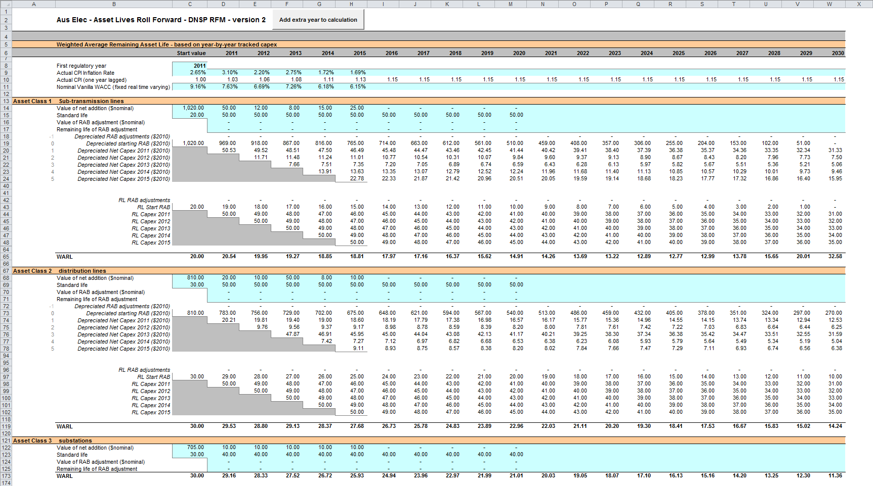

## TAB remaining lives sheet

The **TAB remaining lives** sheet calculates the average TAB remaining lives of each asset class using a weighted average method. The process for calculating the remaining asset lives for the TAB is broadly the same as described in Box 6. However, all calculations are performed in nominal dollar terms, and actual net capex is gross capex less disposals (but including customer contributions) and does not include the half-nominal vanilla WACC allowance. The weighted average remaining lives at the end of the current regulatory control period for the TAB are used as inputs to the PTRM for the next regulatory control period to calculate the tax depreciation schedules for the purposes of tax analysis in the building block determination.

For the first period that the RFM version 2 is used, the inputs for these calculations are sourced from the RFM input sheet and no manual updating is required. For subsequent periods the same update process as described in Box 5 is required for the TAB remaining lives sheet. The weighted average remaining lives for the asset classes in the TAB are calculated and shown at rows 60 to 1626.

Figure 9 provides an example of the **TAB remaining lives** sheet.

Figure 9 TAB remaining lives sheet

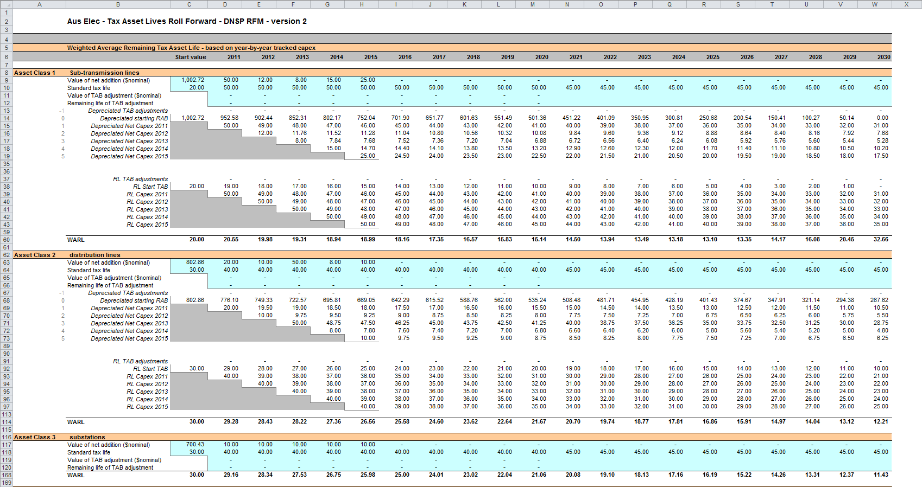

## PTRM input summary sheet

The **PTRM input summary** sheet outlines the opening RAB values (column J) and the opening TAB values (column N) for the next regulatory control period. These values are set out by asset classes in rows 7 to 36, based on the closing RAB and TAB values as calculated in the RFM. The average remaining lives for regulatory and tax purposes, and the base regulatory year for the start of the next regulatory control period are also displayed in columns L, O and Q respectively. All values are outputs from the RFM that need to be entered into the **PTRM input** sheet of the PTRM for the next regulatory control period. The information from the **PTRM input summary** sheet is sourced from the **RFM input**, **Total RAB roll forward**, **TAB roll forward, RAB remaining lives** and **TAB remaining lives** sheets.[22]

Figure 10 provides an example of the **PTRM input summary** sheet.

Figure 10 PTRM input summary sheet

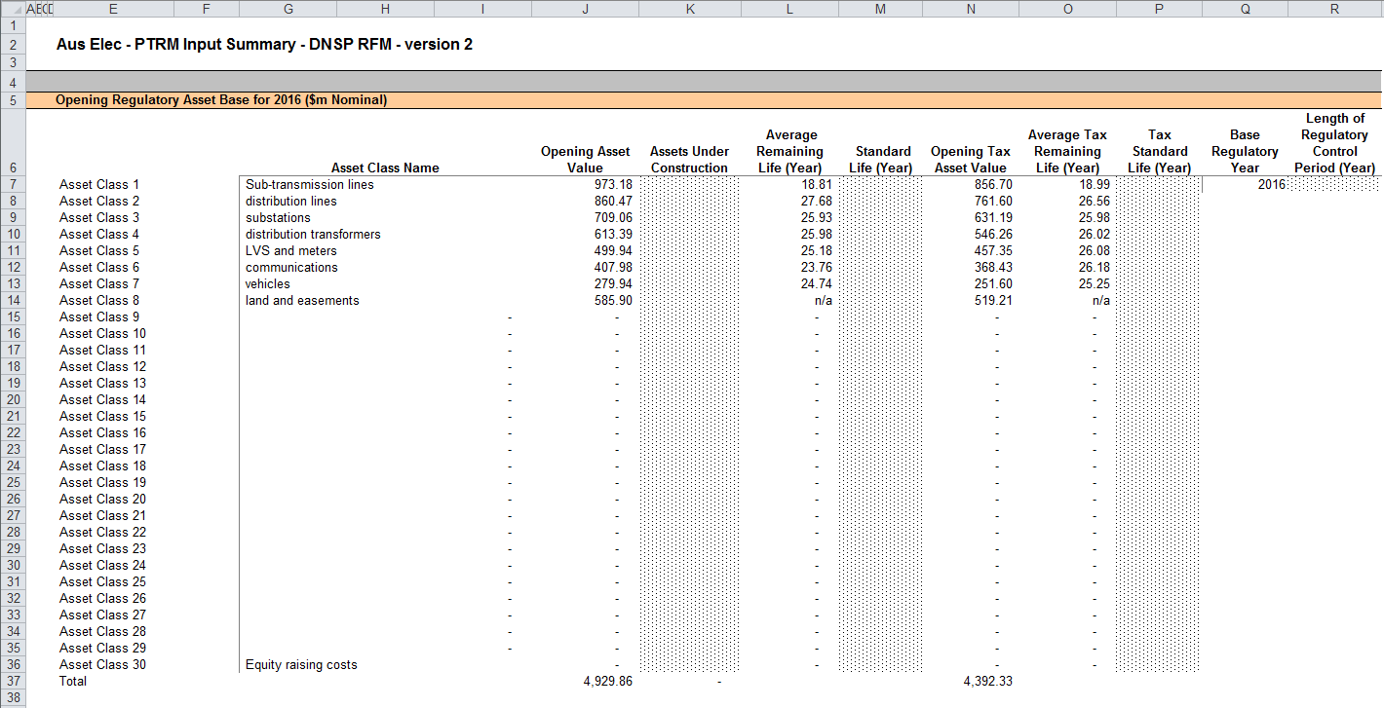

1. The set of Microsoft Excel spreadsheets which constitute the RFM were created in Microsoft Excel 2007. The AER recommends this or a later version of Microsoft Excel be used in applying these spreadsheets.
2. Customer contributions are also referred to as capital contributions.
3. Consistent with tax law, the TAB is rolled forward in nominal dollar terms and so there is no indexation required.
4. For example, whether the RFM relates to the Regulatory proposal, Draft decision, Revised regulatory proposal or Final decision.
5. The depreciation profiles would be subject to satisfying the requirements of clauses 6.5.3 and 6.5.5(b) of the NER.
6. Clause 6.8.1 of the NER sets out the requirements of the framework and approach applying to a determination.
7. The RFM can be expanded to accommodate additional asset classes, when necessary.
8. The 30th asset class in the RFM is designed to be used with the 'Equity raising costs' asset class, consistent with the PTRM.
9. Alternatively, the other final year adjustment values may be obtained from the opening RAB input in the PTRM used for the current building block determination for the DNSP.
10. Actual capex and actual asset disposals are undertaken evenly over a year and therefore the reported capex values are assumed to be in middle of the year terms. All other input values are assumed to be in end of the year terms.
11. AER, TNSP roll forward model: Final decision, September 2007. See section 4.3.1 which discusses the need for the application of a half-nominal WACC allowance.
12. The nominal vanilla WACC is based on a fixed real time varying WACC—that is, a fixed real vanilla WACC adjusted for actual inflation.
13. Regulatory depreciation is based on the nominal straight-line depreciation less the inflation applied to the opening RAB.
14. For illustrative purposes this is based on a standard five-year regulatory control period.
15. The half-nominal vanilla WACC is based on a fixed real time varying WACC—that is, a fixed real vanilla WACC adjusted for actual inflation.
16. This sheet has been configured to display the RAB roll forward for a regulatory control period of 2 to 10 years.
17. For TAB purposes net capex is inclusive of customer contributions (net of disposals).
18. For illustrative purposes this is based on a standard five-year regulatory control period.
19. The ‘Add extra year to calculation’ button included on this sheet runs a macro to extend the RAB and TAB remaining life calculations for each asset class for a further year.
20. For assets that do not depreciate, there is no remaining life, and the user should input the remaining life as “n/a”. Note that although it is possible to enter “n/a” for some years of capex and a numerical value for others, this is conceptually invalid and should not be done.
21. A capital stream represents the opening asset value, each individual year of capex, and each asset adjustment for each asset class.
22. Where the RAB value is negative, the remaining life will be set to the lower of the standard asset life for the asset class and the regulatory period length. Similarly, where the RAB value is positive but the calculated remaining life is zero, the remaining life will be set to the lower of the standard life for the asset class and the regulatory control period length.