

Proposed amendment

Electricity transmission network service providers

Roll forward model handbook

July 2015

© Commonwealth of Australia 2015

This work is copyright. In addition to any use permitted under the Copyright Act 1968, all material contained within this work is provided under a Creative Commons Attributions 3.0 Australia licence, with the exception of:

* the Commonwealth Coat of Arms
* the ACCC and AER logos
* any illustration, diagram, photograph or graphic over which the Australian Competition and Consumer Commission does not hold copyright, but which may be part of or contained within this publication. The details of the relevant licence conditions are available on the Creative Commons website, as is the full legal code for the CC BY 3.0 AU licence.

Requests and inquiries concerning reproduction and rights should be addressed to the   
Director, Corporate Communications,   
Australian Competition and Consumer Commission,   
GPO Box 4141,   
Canberra ACT 2601   
or publishing.unit@accc.gov.au.

Inquiries about this publication should be addressed to:

Australian Energy Regulator  
GPO Box 520  
Melbourne Vic 3001

Tel: (03) 9290 1444  
Fax: (03) 9290 1457

Email: [AERInquiry@aer.gov.au](mailto:AERInquiry@aer.gov.au)  
AER Reference: 56886

Amendment record

|  |  |  |  |
| --- | --- | --- | --- |
| Handbook version | Model version | Date | Pages |
| 1 | 1 | September 2007 | 24 |
| 2 | 2 | December 2010 | 30 |
| 3 | 3 | July 2015 (draft) | 37 |

Contents

Shortened forms i

1 Nature and authority 1

1.1 Introduction 1

1.2 Authority 1

1.3 Role of the model 1

1.4 Confidentiality 1

1.5 Process for revision 1

1.6 Version history and effective date 1

2 The model 2

2.1 Overview of the RFM 2

2.2 DMS input sheet 3

2.3 RFM input sheet 4

2.3.1 Opening regulatory asset base and tax asset base 7

2.3.2 Actual nominal capital expenditure—as-incurred 10

2.3.3 Actual nominal asset disposals—as-incurred 11

2.3.4 Actual real net capital expenditure—as-incurred 11

2.3.5 Actual nominal capital expenditure—as-commissioned 11

2.3.6 Actual nominal asset disposals—as-de-commissioned 11

2.3.7 Actual real net capital expenditure—as-commissioned 11

2.3.8 Inflation and rate of return 11

2.3.9 Real straight-line depreciation option 11

2.3.10 Forecast real straight-line depreciation 12

2.3.11 Forecast nominal final year asset adjustments 12

2.4 Adjustment for previous period sheet 12

2.4.1 Nominal adjustments for difference between forecast and actual net capex – as-incurred 16

2.4.2 Nominal adjustments for difference between forecast and actual net capex – as-commissioned 16

2.5 RAB roll forward sheet 17

2.5.1 Real asset values 19

2.5.2 Nominal asset values—partially as-incurred 20

2.5.3 Nominal asset values—as-commissioned 20

2.6 Total RAB roll forward sheet 20

2.6.1 Partially as-incurred RAB roll forward 21

2.6.2 As-commissioned RAB roll forward 22

2.7 TAB roll forward sheet 23

2.7.1 Opening tax asset values 25

2.7.2 Actual net capex 25

2.7.3 Actual tax depreciation 26

2.8 RAB remaining lives sheet 26

2.9 TAB remaining lives sheet 30

2.10 PTRM input summary sheet 32

Shortened forms

|  |  |
| --- | --- |
| Shortened form | Extended form |
| AER | Australian Energy Regulator |
| capex | capital expenditure |
| CPI | consumer price index |
| NEL | National Electricity Law |
| NER | National Electricity Rules |
| PTRM | post-tax revenue model |
| RAB | regulatory asset base |
| RFM | roll forward model |
| TAB | tax asset base |
| TNSP | transmission network service provider |
| WACC | weighted average cost of capital |

# Nature and authority

## Introduction

This handbook sets out the Australian Energy Regulator’s (AER) roll forward model (RFM) for electricity transmission network service providers (TNSPs). The RFM is a series of Microsoft Excel spreadsheets developed in accordance with the requirements of clause 6A.6.1 of the National Electricity Rules (NER).

## Authority

Clause 6A.6.1(b) of the NER requires the AER to develop and publish the RFM, in accordance with the transmission consultation procedures.

## Role of the model

TNSPs are required to submit a completed RFM to the AER as part of their revenue proposals. However, the AER recognises that there may be a need for some flexibility in applying the RFM in order to account for the particular circumstances a TNSP may face. A number of elements of the RFM where this may be the case have been identified in this handbook. A TNSP will need to propose and justify a departure from any element of the RFM for the purposes of addressing its specific circumstances as part of its revenue proposal, which will be considered and assessed by the AER on a case-by-case basis in making its transmission determination.

The RFM is used by the AER to determine the closing regulatory asset base (RAB) for a regulatory control period. The closing RAB value for a regulatory control period as calculated by the RFM becomes the opening RAB to be used for the purposes of making a revenue determination for the next regulatory control period. The roll forward of the opening RAB for the next regulatory control period, on a forecast indicative basis, is undertaken in the AER’s post-tax revenue model (PTRM) in accordance with the requirements of the NER.

## Confidentiality

The AER’s obligations regarding confidentiality and the disclosure of information provided to it by a TNSP are governed by the Competition and consumer Act 2010 (Cth), the National Electricity Law (NEL) and the NER.

## Process for revision

The AER may amend or replace the RFM from time to time in accordance with clause 6A.6.1(c) of the NER and the transmission consultation procedures. The AER will publish a revised version of this handbook to accompany each new version of the RFM it amends or replaces in the future.

## Version history and effective date

A version number and an effective date of issue will identify each version of this handbook.

# The model

## Overview of the RFM

The RFM is used to calculate the total value of assets for a TNSP across a regulatory control period. Specifically, the RFM is a set of Microsoft Excel spreadsheets (combined into one file, often referred to as a singular spreadsheet) that perform calculations to derive a closing RAB for the current regulatory control period from a given set of inputs.[1] The RFM allows the user to vary the inputs in order to assess their impact on the output data and other derived parameters. Figure 1 provides an overview of this process.

Figure 1 Overview of the RFM spreadsheets



In Figure 1, each box represents a spreadsheet within the RFM. Sheets are classified as primarily about inputs (left column), calculations (centre column) or outputs (right column). The flow of data is therefore from left to right, and simplified links between the sheets are shown with blue arrows.

To operate the RFM, the user enters all the required data on the RFM input sheet—for example, the opening RAB and TAB values, actual capital expenditure (capex) across the regulatory control period, or the actual consumer price index (CPI) rate. These inputs often requires reconciliation with previous models (RFM or PTRM) approved for the current revenue determination applying to the current regulatory control period, or annual information reported by the TNSPs. In this sense, the majority of inputs to the RFM will be the output from other parts the previous final decision.

The RFM then uses this data to undertake the RAB (and TAB) roll forward, consistent with the requirements of the NER. Under this approach, the RAB is rolled forward during each year of the current regulatory control by adding capex, subtracting depreciation and indexing for actual CPI in the RAB roll forward sheet. The required true-up for RAB adjustments (such as for using an estimate of capex) in the final year of the previous regulatory control period is calculated in the Adjustment for previous period sheet. The Total RAB roll forward sheet then draws the data from the RAB roll forward and Adjustment for previous period sheets to bring together the closing RAB for the current regulatory control period.

The roll forward of the TAB is undertaken in a similar, but simpler manner in the TAB roll forward sheet. Unlike the RAB, the TAB is not used to derive revenues explicitly and so the final year capex estimate true-up can be accommodated by replacing with actual capex in the relevant year of commissioning.[2]

The **RAB remaining lives** and **TAB remaining lives** sheets roll forward the weighted average remaining life of each asset class based on actual depreciation of the opening asset value and net capex commissioned in each regulatory control period.

Finally, because the outputs of the RFM become inputs to the PTRM, there is a presentation sheet which provides a summary of output data in the format required for feeding into the PTRM.

The user should not alter the names of any sheets or defined name ranges within the RFM. These RFM components are used when automatically importing into the AER’s data management system (DMS). If these elements are changed, errors may occur.

## DMS input sheet

The **DMS input** sheet captures business specific, non-financial information that is required for the AER to import the RFM into its DMS. To allow this automatic import to take place, this spreadsheet has been locked (using the Excel ‘Protect sheet’ command) so that the layout of this sheet cannot be changed.

Contact details for those responsible for preparing and submitting the RFM are recorded in rows 14 to 31. These will be stored in the DMS. These inputs also control the headings displayed at the top of other sheets in the RFM.

Context details for the RFM are recorded in the lower section. Many of these details (such as the dates of the regulatory control period) are automatically populated from the RFM input sheet and so the cells here are hidden. The stage of the regulatory process is set in cell C46 using a drop down menu.[3] If this is not enough description to uniquely identify the RFM submission, a description should be placed in cell C53 (for example, a resubmission of the Regulatory proposal RFM with revised data values after an error was corrected).

Figure 2 provides an example of the **DMS input** sheet.

Figure 2 DMS input sheet

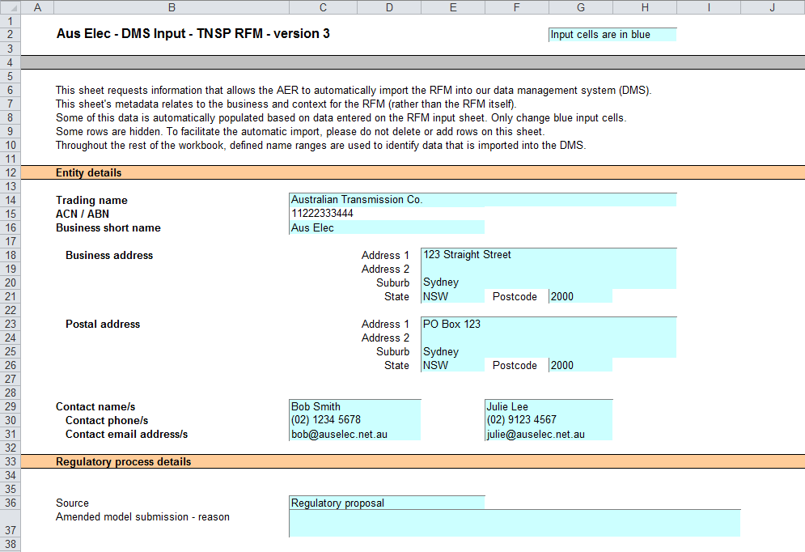

## RFM input sheet

The **RFM input** sheet provides for key input variables to be entered in the RFM. They are automatically linked to corresponding cells in the relevant sheets. Values should be entered into each cell that has light blue shading. This sheet comprises of the following sections:

* opening RAB and opening tax asset base (TAB)
* actual nominal capex—as-incurred
* actual nominal asset disposals—as-incurred
* actual real net capex—as-incurred
* actual nominal capex—as-commissioned
* actual nominal asset disposals—as-de-commissioned
* actual real net capex—as-commissioned
* inflation and rate of return
* real straight-line depreciation option
* forecast real straight-line depreciation
* forecast nominal final year asset adjustments.

The input data to be recorded in the RFM must be in a consistent format as the data collected from the TNSP in accordance with the AER’s *Information guideline* or regulatory information notice (RIN).

The RFM can accommodate input data for up to an 11-year period. This includes the final year of the previous regulatory control period, as well as up to 10 years of the current regulatory control period. Input cells outside of the relevant regulatory control period should be left blank.

The RFM is configured as follows:

* Uses the straight-line method as the default position for calculating depreciation for regulatory and tax purposes—If TNSPs intend to propose using other depreciation profiles, it is recommended that they raise this as part of pre-lodgement discussions.[4] For example, this could take place during the framework and approach process for a determination.[5]
* Recognises capex on a partially as-incurred (hybrid) approach—This method for recognising capex calculates the return on capital based on an as-incurred approach and the return of capital (regulatory depreciation) is based on an as-commissioned approach. As such, two RABs determined on the basis of as-incurred capex and as-commissioned capex are required to be calculated by the RFM. The RAB determined on the basis of as-incurred capex is referred to as the partially as-incurred RAB[6] and the other RAB determined on the basis of as-commissioned capex is referred to as the as-commissioned RAB.
* Uses the weighted average method as the default position for calculating the average remaining asset lives for the RAB and TAB by asset classes—If TNSPs intend to propose using other approaches to calculate the average remaining lives for a group of assets, it is recommended that they raise this as part of pre-lodgement discussions or as part of the framework and approach process.

Figure 3 provides an example of the **RFM input** sheet.

Figure RFM input sheet

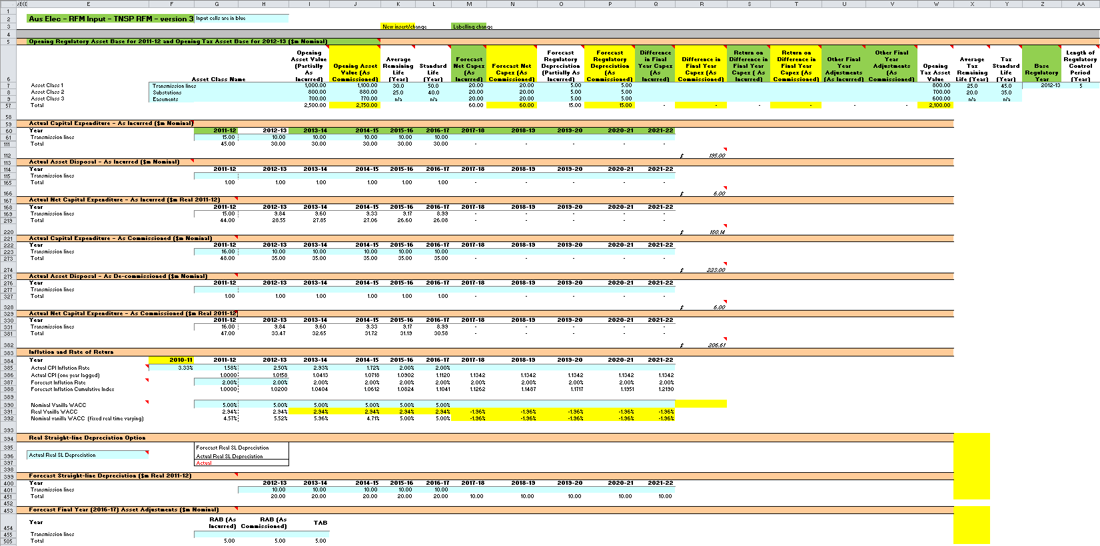

### Opening regulatory asset base and tax asset base

The opening RAB is the value of assets on which a return will be earned. The opening TAB is used to calculate the depreciation for tax purposes. The **RFM input** sheet requires values for the opening RAB (broken into asset classes in rows 7 to 56) at the start of the final year of the previous regulatory control period.[7] The values for the opening TAB, also broken into asset classes, are required at the start of the first year of the current regulatory control period. The RAB and TAB will differ each year to reflect actual capex (as-incurred for the RAB or as-commissioned for the TAB), asset disposals and regulatory depreciation (for the RAB) or tax depreciation (for the TAB).

The recorded input values are linked to subsequent sheets which calculate an annual balance of the RAB and TAB for the current regulatory control period. Notes have been included for various cells with specific comments and explanations about the relevance of the inputs.

Asset class name

The asset classes/names are recorded in column F. It is important that the number of asset classes recorded in the RAB section matches the number of asset classes identified in the capex section. This allows the RFM to model consistent depreciation across the asset classes.

The RFM is configured to accommodate up to 50 asset classes.[8] The number of asset classes used in the RFM will vary between businesses.[9] However, for each business, the number of asset classes used in the RFM must be consistent with that used in the AER’s PTRM to allow the closing RAB values determined in the RFM to be used as inputs to the opening RAB values in the PTRM.

Opening asset value (partially as-incurred)

The opening asset (partially as-incurred) values for each asset class are recorded in column I. These values should be as at the start of the final year of the previous regulatory control period and would be contained in the RFM used for the current revenue determination for the TNSP. They are linked to the **Adjustment for previous period** and **RAB roll forward** sheets.

Opening asset value (as-commissioned)

The opening asset (as-commissioned) values for each asset class are recorded in column J. These values should be as at the start of the final year of the previous regulatory control period and would be contained in the RFM used for the current revenue determination for the TNSP. They are linked to the **Adjustment for previous period** and **RAB roll forward** sheets.

Average remaining life

The remaining lives of each asset class are recorded in column K, based on the economic lives of the assets as at the start of the current regulatory control period. These values should be consistent with those contained in the PTRM used in the current revenue determination for the TNSP. They are linked to the **RAB roll forward** and RAB remaining lives sheets.

Standard life

The standard lives of each asset class are recorded in column L and measure how long the infrastructure would physically last had it just been built. These values should be consistent with those contained in the PTRM used in the current revenue determination for the TNSP. They are linked to the **RAB roll forward** and RAB remaining lives sheets.

Forecast net capex (as-incurred)

The forecast net capex (as-incurred) values for each asset class are recorded in column M. They are based on the estimates made in the final year of the previous regulatory control period. These values would be contained in the RFM used for the current revenue determination for the TNSP. They are linked to the **Adjustment for previous period** and **RAB roll forward** sheets.

Forecast net capex (as-commissioned)

The forecast net capex (as-commissioned) values for each asset class are recorded in column N. They are based on the estimates made in the final year of the previous regulatory control period. These values would be contained in the RFM used for the current revenue determination for the TNSP. They are linked to the **Adjustment for previous period** and **RAB roll forward** sheets.

Forecast regulatory depreciation (partially as-incurred)

The forecast regulatory depreciation (partially as-incurred) values for each asset class are recorded in column O. They are based on the estimates made for the final year of the previous regulatory control period. These values would be contained in the RFM used for the current revenue determination for the TNSP. They are linked to the **Adjustment for previous period** sheet.

Forecast regulatory depreciation (as-commissioned)

The forecast regulatory depreciation (as-commissioned) values for each asset class are recorded in column P. They are based on the estimates made for the final year of the previous regulatory control period. These values would be contained in the RFM used for the current revenue determination for the TNSP. They are linked to the **Adjustment for previous period** sheet.

Difference in final year capex (as-incurred)

The difference in final year capex (as-incurred) values for each asset class are recorded in column Q. They are based on the capex 'true-up' adjustment made to the closing RAB for the previous regulatory control period. These values would be contained in the RFM used for the current revenue determination for the TNSP. These values are linked to the **Adjustment for previous period** sheet.

Difference in final year capex (as-commissioned)

The difference in final year capex (as-commissioned) values for each asset class are recorded in column R. They are based on the final year capex 'true-up' adjustment made to the closing RAB for the previous regulatory control period. These values would be contained in the RFM used for the current revenue determination for the TNSP. These values are linked to the **Adjustment for previous period** sheet.

Return on final year capex (as-incurred)

The return on difference in final year capex (as-incurred) values for each asset class are recorded in column S. They are based on the accumulated return associated with the final year capex 'true-up' adjustment made to the closing RAB for the previous regulatory control period. These values would be contained in the RFM used for the current revenue determination for the TNSP. These values are linked to the **Adjustment for previous period** sheet.

Return on final year capex (as-commissioned)

The return on difference in final year capex (as-commissioned) values for each asset class are recorded in column T. They are based on the accumulated return associated with the final year capex 'true-up' adjustment made to the closing RAB for the previous regulatory control period. These values would be contained in the RFM used for the current revenue determination for the TNSP. These values are linked to the **Adjustment for previous period** sheet.

Other final year adjustments (as-incurred)

The other final year adjustment (as-incurred) values for each asset class are recorded in column U. This data may be required for TNSPs which adjusted their closing RAB by removing or adding assets (such as a change in service classification) in the final year of the previous regulatory control period. The amount of other final year adjustments (if any) would be contained in the RFM used for the current revenue determination for the TNSP.[10] These values are linked to the **Adjustment for previous period** sheet.

Other final year adjustments (as-commissioned)

The other final year adjustment (as-commissioned) values for each asset class are recorded in column V. This data may be required for TNSPs which adjusted their closing RAB by removing or adding assets (such as a change in service classification) in the final year of the previous regulatory control period. The amount of other final year adjustments (if any) would be contained in the RFM used for the current revenue determination for the TNSP.[11] These values are linked to the **Adjustment for previous period** sheet.

Tax asset values—opening tax asset value, average tax remaining life, tax standard life

The RFM includes a mechanism to roll forward tax asset values between regulatory control periods. The **RFM input** sheet requires the tax asset values comprising of the opening tax values, average tax remaining lives and tax standard lives for each asset class. The tax asset values will differ each year to reflect actual capex (as-commissioned), asset disposals and tax depreciation.

For each asset class, the opening tax values at the start of the first year of the current regulatory control period are recorded in column W, the average tax remaining lives are recorded in column X and the tax standard lives are recorded in column Y. These values are linked to the **TAB roll forward** sheet to calculate a running balance of the tax asset values for the current regulatory control period.

Base regulatory year

The regulatory year for the start of the current regulatory control period is recorded in cell Z7.

Length of the current regulatory control period

The number of years in the current regulatory control period is recorded in cell AA7.

### Actual nominal capital expenditure—as-incurred[12]

The actual capex (as-incurred) values for the current regulatory control period (including the final year for the previous regulatory control period) are recorded for each year in rows 61 to 110 (by asset class). Generally, capex falls into three broad categories:

* asset augmentation (e.g. works to enlarge a network or to increase the capability of a network)
* asset replacement (e.g. replacing assets that have passed their useful lives)
* non-network asset (e.g. support the business expenditure).

These inputs are assumed to be in middle of the year terms based on nominal dollar terms.

### Actual nominal asset disposals—as-incurred

The actual asset disposal values for each year are recorded in rows 115 to 164. These inputs are assumed to be in middle of the year terms based on nominal dollar terms.

### Actual real net capital expenditure—as-incurred

This section on actual real net capex does not require inputs to be recorded. For each asset class, actual real net capex values are calculated based on the recorded actual nominal capex values less asset disposal values, and adjusted for actual inflation. The real net capex (as-incurred) values are displayed in rows 169 to 218 and form part of the roll forward of the RAB in the **Adjustment for previous period** and **RAB roll forward** sheets and the TAB in the TAB roll forward sheet. These values are assumed to be in middle of the year terms, based on the final year of the previous regulatory control period real dollar terms.

### Actual nominal capital expenditure—as-commissioned

The actual capex (as-commissioned) values are recorded for each year in rows 223 to 272. These inputs are assumed to be in middle of the year terms based on nominal dollar terms.

### Actual nominal asset disposals—as-de-commissioned

The actual de-commissioned asset values are recorded for each year in rows 277 to 326. These inputs are assumed to be in middle of the year terms based on nominal dollar terms.

### Actual real net capital expenditure—as-commissioned

This section on actual real net capex does not require inputs to be recorded. For each asset class, actual real net capex values are calculated based on the recorded nominal capex values less the value of de-commissioned assets, and adjusted for actual inflation. The real net capex (as-commissioned) values are displayed in rows 331 to 380 and are used to calculate depreciation in the **RAB roll forward** sheet. They are also used in the TAB roll forward sheet. These values are assumed to be in middle of the year terms, based on the final year of the previous regulatory control period real dollar terms.

### Inflation and rate of return

This section records the actual annual inflation rates (based on the consumer price index) over the current regulatory control period and in the previous regulatory control period (rows 385 to 386). It also records the forecast inflation and weighted average cost of capital (WACC) rates used in the revenue determinations corresponding to the two regulatory control periods (rows 387 to 392). These parameters are linked to the **Adjustment for previous period** and **RAB roll forward** sheets.

### Real straight-line depreciation option

The RFM provides the user an option at cell E396 (drop down function) to select the RAB roll forward to be undertaken using forecast straight-line depreciation or actual straight-line depreciation. If forecast depreciation is selected, the RAB roll forward calculations will use the depreciation inputs at section 2.3.10 which reflect the approved forecasts for the current regulatory control period. If actual depreciation is selected, the RAB roll forward calculations will use actual capex to calculate depreciation.

### Forecast real straight-line depreciation

When the forecast depreciation option is selected, the approved forecast real straight-line depreciation values for each year are recorded at rows 401 to 450. Otherwise, there is no need to record any inputs in this section if actual depreciation is selected. The approved forecast depreciation values would be contained in the PTRM used for the current revenue determination for the TNSP. These values are linked to the **RAB roll forward** sheet.

### Forecast nominal final year asset adjustments

Some TNSPs may need to adjust their closing RAB at the end of the current regulatory control period for asset movements (such as a change in service classification). These values are recorded in rows 455 to 504 and are linked to the **Total RAB roll forward and TAB roll forward** sheets.

## Adjustment for previous period sheet

The **Adjustment for previous period** sheet calculates the required true-up of RAB adjustments to be made for the final year of the previous regulatory control period for forecast and actual net capex values.

This adjustment is consistent with the requirements of clause S6A.2.1(f)(3) of the NER, which specifies that a reconciliation would include adjustments that remove any benefit or penalty on the returns associated with any difference between the forecast and actual capex values for the final year of the previous regulatory control period.

This sheet calculates the difference between forecast and actual net capex (as-incurred) for the final year of the previous regulatory control period, as well as the aggregate compounded return on that difference (rows 13 to 270). This adjustment is made to the closing RAB (partially as-incurred) at the end of the current regulatory control period in the **Total RAB roll forward** sheet.

This two-step process is outlined in Box 1.

|  |
| --- |
| Box Adjusting for actual capex (as-incurred) in the final year of the previous regulatory control period |
| 1) Calculating the difference between actual and forecast net capex (as-incurred)  Nominal actual net capex (as-incurred, including a half-nominal vanilla WACC allowance) –  Nominal forecast net capex (as-incurred, including a half-nominal vanilla WACC allowance) =  Nominal difference between forecast and actual net capex (as-incurred).  2) Calculating the nominal return on the difference and compounding it for each year of the current regulatory control period  Nominal difference between forecast and actual net capex (as-incurred) x nominal vanilla WACC per annum (compounded) |
| Notes:   * Nominal forecast net capex (as-incurred) = estimated incurred net capex allowed in the final year of the previous regulatory control period. * Nominal actual net capex (as-incurred) = actual net capex incurred during the final year of the previous regulatory control period. * The nominal return on the difference between actual and forecast net capex (as-incurred) is calculated by applying the nominal vanilla WACC (adjusted for actual inflation) applicable to the current regulatory control period (as determined in the current revenue determination). * Each of these adjustments is made to the final closing RAB (partially as-incurred) for the current regulatory control period in the **Total RAB roll forward** sheet. |

This sheet also calculates the difference between forecast and actual net capex (as-commissioned) for the final year of the previous regulatory control period, as well as the aggregate compounded return on the difference associated with forecast and actual net capex (as-incurred) (rows 274 to 531). This adjustment is also made to the closing RAB (as-commissioned) at the end of the current regulatory control period in the **Total RAB roll forward** sheet.

This two-step process is outlined in Box 2.

|  |
| --- |
| Box Adjusting for actual capex (as-commissioned) in the final year of the previous regulatory control period |
| 1) Calculating the difference between actual and forecast net capex (as-commissioned), indexed by actual CPI  Nominal actual net capex (as-commissioned, including a half-nominal vanilla WACC allowance) –  Nominal forecast net capex (as-commissioned, including a half-nominal vanilla WACC allowance) =  Nominal difference between forecast and actual net capex (as-commissioned).  Nominal difference between forecast and actual net capex (as-commissioned) x Actual CPI =  Indexed nominal difference between forecast and actual net capex (as-commissioned).  2) Calculating the real return on the difference associated with actual and forecast net capex (as-incurred), and compounding it for each year of the current regulatory control period  Nominal difference between forecast and actual net capex (as-incurred) x real vanilla WACC per annum (compounded) |
| Notes:   * Nominal forecast net capex (as-commissioned) = estimated commissioned net capex allowed in the final year of the previous regulatory control period. * Nominal actual net capex (as-commissioned) = actual net capex commissioned during the final year of the previous regulatory control period. * Actual CPI = cumulative index of actual annual inflation over the current regulatory control period * The real return on the difference between actual and forecast net capex (as-incurred) is calculated by applying the real vanilla WACC applicable to the current regulatory control period (as determined in the current revenue determination). * Each of these adjustments is made to the final closing RAB (as-commissioned) for the current regulatory period in the Total RAB roll forward sheet. |

There are differences in the calculation of the true-up for the as-incurred net capex and as-commissioned net capex. This is because the as-incurred net capex difference and the return associated with that difference is made to the closing RAB (partially as-incurred) at the end of the current regulatory control period. However, for the as-commissioned net capex difference, this is made to the closing RAB (as-commissioned) at the end of the current regulatory control period along with the return associated with the difference in as-incurred net capex (the return associated with the difference in as-commissioned net capex is not relevant for capitalisation).[13]

In general, TNSPs that have other RAB adjustments made in the final year of the previous regulatory control period will not require a true-up.[14] However, in certain circumstances, a TNSP may have other final year asset adjustments for the previous regulatory control period that require a true-up.[15] In this case, the RFM calculations would need to be expanded to accommodate the true-up using the same principles set out for the final year net capex true-up.

Figure 4 provides an example of the **Adjustment for previous period** sheet.

Figure Adjustment for previous period sheet

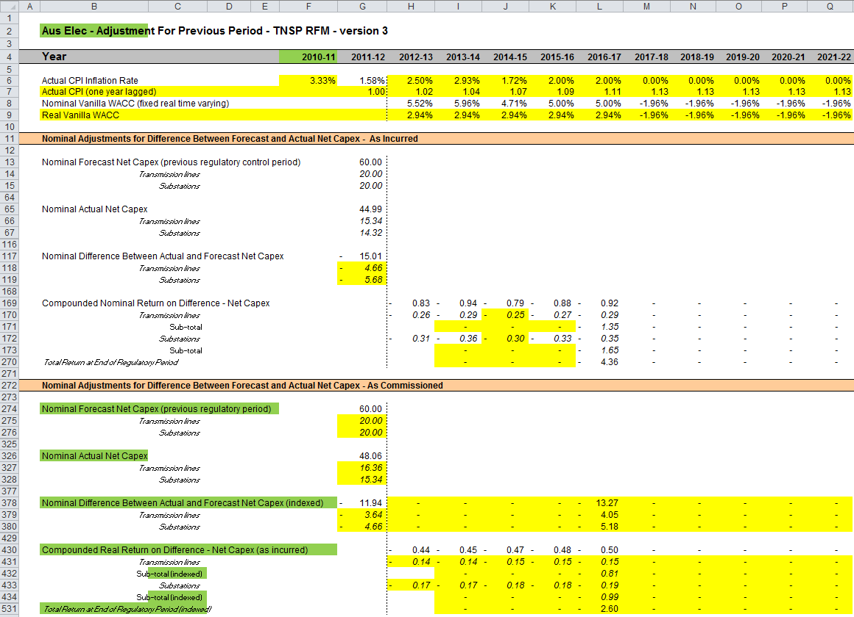

### Nominal adjustments for difference between forecast and actual net capex – as-incurred

This section calculates the difference between forecast and actual net capex (as-incurred) for the final year of the previous regulatory control period and determines the compounded return on that difference. The process involved is based on that depicted in Box 1.

The nominal forecast net capex (as-incurred) values for each asset class in the final year of the previous regulatory control period are displayed in rows 14 to 63. The values are sourced from the **RFM input** sheet. Row 13 displays the sum of each asset class values for rows 14 to 63.

The nominal actual net capex (as-incurred) values (including a half WACC allowance) for each asset class in the final year of the previous regulatory control period are calculated in rows 66 to 115. Given the timing assumption that capex on average takes place halfway through the year, a half-nominal vanilla WACC is applied to the actual net capex for each asset class to ‘gross-up’ the actual values.[16] Row 65 displays the sum of each asset class calculations for rows 66 to 115.

The differences between the actual and forecast net capex (as-incurred) values for each asset class are calculated in rows 118 to 167. Row 117 displays the sum of each asset class calculations for those rows.

Finally, in rows 169 to 269 a nominal vanilla WACC (row 8) is applied to calculate the nominal return on the difference, which is compounded to the end of the current regulatory control period.[17] The total compounded nominal return at the end of the current regulatory control period is displayed in row 270. This value is linked to the **Total RAB roll forward** sheet.

### Nominal adjustments for difference between forecast and actual net capex – as-commissioned

This section calculates the difference between forecast and actual net capex (as-commissioned) for the final year of the previous regulatory control period and determines the compounded return on the difference associated with forecast and actual net capex (as-incurred). The process involved is based on that depicted in Box 2.

The nominal forecast net capex (as-commissioned) values for each asset class in the final year of the previous regulatory control period are displayed in rows 275 to 324. These values are sourced from the **RFM input** sheet. Row 274 displays the sum of each asset class values for rows 275 to 324.

The nominal actual net capex (as-commissioned) values (including a half WACC allowance) for each asset class in the final year of the previous regulatory control period are displayed in rows 327 to 376. These values are sourced from the **RFM input** sheet. Row 326 displays the sum of each asset class values for rows 327 to 376.

The differences between the actual and forecast net capex (as-commissioned) values for each asset class are calculated in rows 379 to 428. These values are indexed by actual CPI to the end of the current regulatory control period. Row 378 displays the sum of each asset class calculations for those rows.

Finally, in rows 430 to 530 a real vanilla WACC (row 9) is applied to calculate the real return on the difference associated with forecast and actual net capex (as-incurred), which is compounded to the end of the current regulatory control period. The total compounded real return at the end of the current regulatory control period is displayed in row 531. This value is linked to the **Total RAB roll forward** sheet.

## RAB roll forward sheet

The **RAB roll forward** sheet calculates the nominal closing RAB (which becomes the opening RAB) for each year of the current regulatory control period using the partially as-incurred and as-commissioned approaches. Under clauses 6A.6.1(e) and S6A.2.1 of the NER, in rolling forward the RAB each year during the current regulatory control period, the AER must have regard to actual data such as capex and inflation outcomes. Accordingly, the opening RAB (based on either the partially as-incurred or as-commissioned approaches) for the first year of the current regulatory control period is rolled forward for:

* actual net capex (as-incurred or as-commissioned)
* regulatory depreciation values (adjusted for actual inflation).[18]

Depending on which option for depreciation has been selected in the RFM input sheet, the RAB roll forward calculations will use either forecast straight-line depreciation or actual straight-line depreciation. The option to be selected must be consistent with that set out in current revenue determination for the TNSP. Forecast straight-line depreciation refers to the amounts approved for the current regulatory control period, reflecting forecast capex used for the current revenue determination. Actual straight-line depreciation uses the amounts that are calculated based on actual capex commissioned during the current regulatory control period.

The process for rolling forward the RAB from year to year over the current regulatory control period, under the partially as-incurred approach for recognising capex, is set out in Box 3.[19] The same process applies for rolling forward the RAB under the as-commissioned approach for recognising capex.

|  |
| --- |
| Box Rolling forward the RAB (partially as-incurred) in the current regulatory control period |
| Rolling forward actual net capex and depreciation amounts into the RAB  Opening RAB (partially as-incurred) for year 1 of the current regulatory control period +  Nominal actual net capex (as-incurred) for year 1 –  Nominal regulatory depreciation (partially as-incurred) for year 1 =  Closing RAB (partially as-incurred) for year 1 of the current regulatory control period. This becomes:  Opening RAB (partially as-incurred) for year 2 of the current regulatory control period +  Nominal actual net capex (as-incurred) for year 2 –  Nominal regulatory depreciation (partially as-incurred) for year 2 =  Closing RAB (partially as-incurred) for year 2 of the current regulatory control period. This becomes:  Opening RAB (partially as-incurred) for year 3 of the current regulatory control period  … =  Closing RAB (partially as-incurred) for year 5 of the current regulatory control period =  Interim closing RAB (partially as-incurred) for the current regulatory control period. |
| Where:   * Opening RAB (partially as-incurred) for year 1 of the current regulatory control period = closing RAB (partially as-incurred) for the final year of the previous regulatory control period. * Nominal actual net capex (as-incurred) = real actual net capex (as-incurred, including half-nominal vanilla WACC allowance) adjusted for actual inflation. * Nominal regulatory depreciation (partially as-incurred) = Nominal straight-line depreciation (as-commissioned) – actual inflation adjustment on the opening RAB (partially as-incurred).   Notes:   * The interim closing RAB (partially as-incurred) for the current regulatory period plus the final adjustments for the final year of the current regulatory control period (these adjustments are made in the **Total RAB roll forward** sheet—see Box 4 for a description) becomes the opening RAB (partially as-incurred) for the next regulatory control period. * The roll forward of the RAB (as-commissioned) follows the same process, with as-commissioned actual net capex replacing as-incurred actual net capex, the as-commissioned opening/closing RAB replacing partially as-incurred opening/closing RAB, and as-commissioned regulatory depreciation replacing partially as-incurred regulatory depreciation. |

Figure 5 provides an example of the **RAB roll forward** sheet.

Figure RAB roll forward sheet

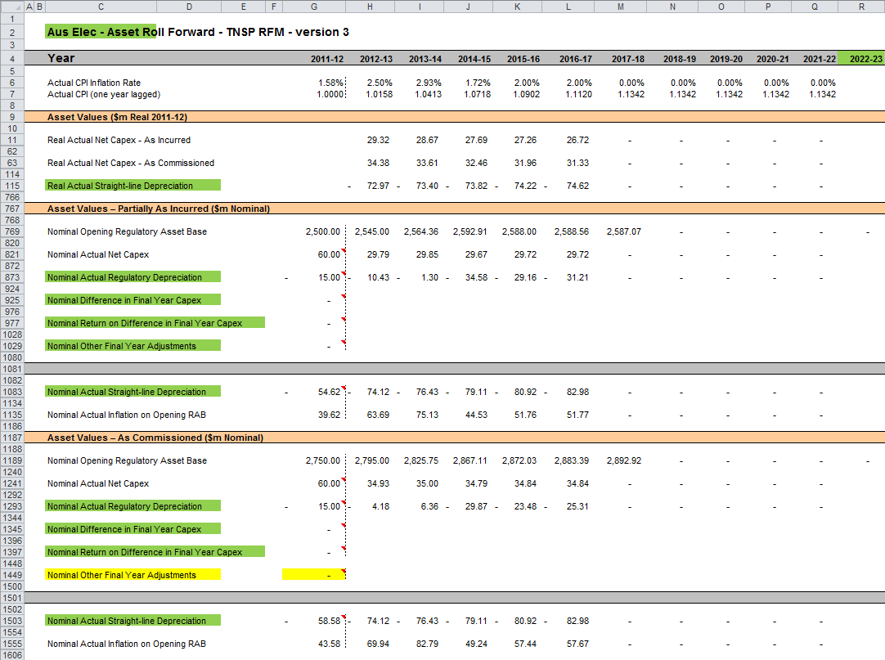

### Real asset values

Real asset values are displayed in rows 11 to 765. The real actual net capex values (as-incurred, including a half-nominal vanilla WACC allowance) for each asset class are displayed in rows 12 to 61.[20] Row 11 displays the sum of each asset class values for those rows. The real actual net capex values (as-commissioned, including a half-nominal vanilla WACC allowance) for each asset class are displayed in rows 64 to 113. Row 63 displays the sum of each asset class values for those rows.

The capex values (as-incurred and as-commissioned) for the current regulatory control period (sourced from the **RFM input** sheet) are those provided by the TNSP to the AER for the purpose of rolling forward its RAB to the end of the current regulatory control period.

The real straight-line depreciation values for each asset class are set out at rows 116 to 765. Row 75 displays the sum of each asset class calculations for those rows. If the forecast depreciation option was selected, then the forecast depreciation inputs are sourced from the RFM input sheet. If the actual depreciation option was selected, then the depreciation calculations are based on the opening RAB, actual net capex values (as-commissioned) and asset lives from the **RFM input** and RAB roll forward sheets.

### Nominal asset values—partially as-incurred

Partially as-incurred nominal asset values are displayed in rows 769 to 1185. The nominal opening RAB values for each year are displayed in row 769, based on the sum of each asset class calculations for rows 770 to 819. The nominal opening RAB for the first year of the current regulatory control period (cell H769) is calculated by taking the partially as-incurred opening RAB value for the final year of the previous regulatory control period (cell G769), adding as-incurred forecast net capex value for that year (G821), adding (typically negative) partially as-incurred regulatory depreciation value for that year (G873) and adding other as-incurred capex/asset adjustment values where relevant (cells G925, G977 and G1029). These values are all sourced from the RFM input sheet.

The partially as-incurred nominal opening RAB values for the remaining years of the current regulatory control period are calculated in accordance with Box 3. The as-incurred nominal actual net capex values for each year (row 821) are equal to the as-incurred real actual net capex values (row 11) indexed by actual inflation (row 7). The partially as-incurred nominal regulatory depreciation values (row 873) are calculated as the net total of the nominal straight-line depreciation (row 1083) and the actual inflation applied to the partially as-incurred opening RAB (row 1135).

### Nominal asset values—as-commissioned

As-commissioned nominal asset values are displayed in rows 1189 to 1605. The nominal opening RAB values for each year are displayed in row 1189, based on the sum of each asset class calculations for rows 1190 to 1239. The nominal opening RAB for the first year of the current regulatory control period (cell H1189) is calculated by taking the as-commissioned opening RAB value for the final year of the previous regulatory control period (cell G1189), adding as-commissioned forecast net capex value for that year (G1241), adding (typically negative) as-commissioned regulatory depreciation value for that year (G1293) and adding other as-commissioned capex/asset adjustment values where relevant (cells G1345, G1397 and G1449). These values are all sourced from the RFM input sheet.

The as-commissioned nominal opening RAB values for the remaining years of the current regulatory control period are calculated in accordance with Box 3. The as-commissioned nominal actual net capex values for each year (row 1241) are equal to the as-commissioned real actual net capex (row 63) indexed by actual inflation (row 7). The as-commissioned nominal regulatory depreciation values (row 1293) are calculated as the net total of the nominal straight-line depreciation (row 1503) and the actual inflation applied to the as-commissioned opening RAB (row 1555).

## Total RAB roll forward sheet

The **Total RAB roll forward** sheet brings together the relevant data from the **Adjustment for previous period** and **RAB roll forward** sheets to calculate the final closing RAB for the current regulatory control period in nominal terms.[21] The sheet is separated into two sections—the first section rolls forward the RAB under the partially as-incurred approach to recognising capex and the second section rolls forward the RAB under the as-commissioned approach to recognising capex.

### Partially as-incurred RAB roll forward

Under the partially as-incurred approach to recognising capex, row 7 displays the opening RAB values for each year of the current regulatory control period, based on the sum of each asset class calculations for rows 8 to 57. These rows are in turn based on the interim closing RAB (partially as-incurred) in row 321. The calculations at rows 8 to 57 reflect the partially as-incurred opening RAB values in the **RAB roll forward** sheet. The nominal as-incurred actual net capex (row 59), partially as-incurred regulatory depreciation (row 111) values and other as-incurred capex/asset adjustments that may be required—e.g. difference in final year capex (row 163), return on difference in final year capex (row 215) and other final year adjustments (row 267) are sourced from the **RAB roll forward** sheet.

Rows 373 to 527 represent the required adjustments to be made for the final year of the current regulatory control period and are sourced from the **Adjustment for previous period** and RFM input sheets. These adjustments include:

* the difference between as-incurred forecast and actual net capex for the final year of the previous regulatory control period (and a compounded return on that difference)
* other asset adjustments (as-incurred) for the final year of the current regulatory control period.

The process for calculating the final closing RAB (partially as-incurred) for the current regulatory control period is set out in Box 4.

|  |
| --- |
| Box Calculating the final closing RAB (partially as-incurred) for the current regulatory control period |
| Adjustments to be made for the final year of the current regulatory control period to calculate final closing RAB  Interim closing RAB (partially as-incurred) for the current regulatory control period +  Difference between nominal actual net capex and forecast net capex (as-incurred) +  Compounded nominal return on that difference for net capex (as-incurred) +  Final year asset adjustments (as-incurred, where applicable) =  Closing RAB (partially as-incurred) for the current regulatory control period =  Opening RAB (partially as-incurred) for the first year of the next regulatory control period. |
| Note:   * The opening RAB (partially as-incurred) for the first year of the next regulatory control period becomes an input into the PTRM for the purposes of determining the return on capital for the next regulatory control period. |

The closing RAB (partially as-incurred) for the current regulatory control period is shown in cell L529. This value becomes the opening RAB (partially as-incurred) for the next regulatory control period and is used as an input into the PTRM for calculating the allowed return on capital in the next revenue determination. A breakdown of the closing RAB (partially as-incurred) values by asset classes are displayed in rows 530 to 579.

### As-commissioned RAB roll forward

Under the as-commissioned approach to recognising capex, row 583 displays the opening RAB values for each year of the current regulatory control period, based on the sum of each asset class calculations for rows 584 to 633. These rows are in turn based on the interim closing RAB (as-commissioned) in row 897. The calculations at row 584 to 633 reflect the as-commissioned opening RAB values in the **RAB roll forward** sheet. The nominal as-commissioned actual net capex (row 635), as-commissioned regulatory depreciation (row 687) values and other as-commissioned asset adjustments that may be required—e.g. difference in final year capex (row 739), return on difference in final year capex (row 791) and other final year adjustments (row 843) are sourced from the **RAB roll forward** sheet.

Rows 949 to 1103 represent the required adjustments to be made for the final year of the current regulatory control period and are sourced from the **Adjustment for previous period** and RFM input sheets. These adjustments include:

* the difference between as-commissioned forecast and actual net capex for the final year of the previous regulatory control period (and a compounded return on the difference between as-incurred forecast and actual net capex for the final year of the previous regulatory control period)
* other asset adjustments (as-commissioned) for the final year of the current regulatory control period.

The process for calculating the final closing RAB (as-commissioned) for the current regulatory control period is set out in Box 5.

|  |
| --- |
| Box Calculating the final closing RAB (as-commissioned) for the current regulatory control period |
| Adjustments to be made for the final year of the current regulatory control period to calculate final closing RAB  Interim closing RAB (as-commissioned) for the current regulatory control period +  Difference between actual net capex and forecast net capex (as-commissioned) indexed forward +  Compounded real return on the difference for net capex (as-incurred) +  Final year asset adjustments (as-commissioned, where applicable) =  Closing RAB (as-commissioned) for the current regulatory control period =  Opening RAB (as-commissioned) for the first year of the next regulatory control period. |
| Note:   * The opening RAB (as-commissioned) for the first year of the next regulatory control period becomes an input into the PTRM for the purposes of determining the return of capital (depreciation) for the next regulatory control period. |

The closing RAB (as-commissioned) for the current regulatory control period is shown in cell L1105. This value becomes the opening RAB (as-commissioned) for the next regulatory control period and is used as an input into the PTRM for calculating the allowed return of capital (depreciation) in the next revenue determination. A breakdown of the closing RAB (as-commissioned) values by asset classes are displayed in rows 1106 to 1155.

Figure 6 provides an example of the **Total RAB roll forward** sheet.

Figure Total RAB roll forward sheet

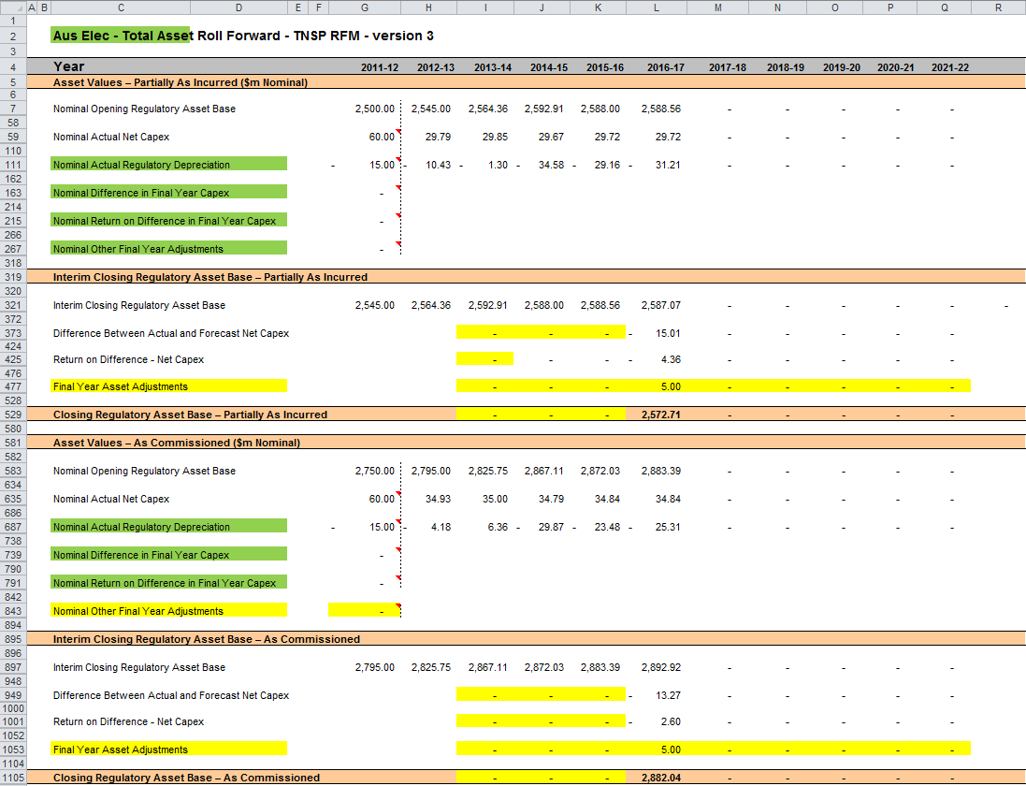

## TAB roll forward sheet

The **TAB roll forward** sheet calculates the nominal opening TAB values for each year of the current regulatory control period by taking the opening TAB value for the start of the current regulatory control period and adjusting for forecast net capex (as-commissioned), which was included in the final year of the previous regulatory control period, with actual net capex (as-commissioned) for that year. The opening TAB value is then rolled forward for actual net capex (as-commissioned) and tax depreciation values for each year of the current regulatory control period. Since the calculations are based on actual nominal data the roll forward of the TAB values does not require any adjustments for inflation. Any required adjustments to be made to the TAB for the final year of the current regulatory control period are also applied in this sheet.

The process for rolling forward the TAB for year to year over the current regulatory control period is set out in Box 6.[22]

|  |
| --- |
| Box Rolling forward the TAB in the current regulatory control period |
| Rolling forward actual net capex and depreciation amounts into the TAB  Opening TAB for the first year of the current regulatory control period –  Nominal forecast net capex (as-commissioned) for the final year of the previous period +  Nominal actual net capex (as-commissioned) for the final year of the period =  Adjusted opening TAB for year 1 of the current regulatory control period.  Adjusted opening TAB for year 1 of the current regulatory control period +  Nominal actual net capex (as-commissioned) for year 1 –  Nominal actual tax depreciation for year 1 =  Closing TAB for year 1 of the current regulatory control period. This becomes:  Opening TAB for year 2 of the current regulatory control period +  Nominal actual net capex (as-commissioned) for year 2 –  Nominal actual tax depreciation for year 2 =  Closing TAB for year 2 of the current regulatory control period. This becomes:  Opening TAB for year 3 of the current regulatory control period  … =  Closing TAB for year 4 of the current regulatory control period. This becomes:  Opening TAB for year 5 of the current regulatory control period +  Nominal actual net capex (as-commissioned) for year 5 –  Nominal actual tax depreciation for year 5 +  Final year asset adjustments (where applicable) =  Closing TAB for year 5 of the current regulatory control period =  Opening TAB for the first year of the next regulatory control period. |
| Where:   * Nominal actual net capex (as-commissioned) = nominal actual capex (as-commissioned) – nominal actual asset disposals (as-decommissioned). * Nominal actual tax depreciation = nominal actual straight-line tax depreciation.   Note:   * The closing TAB for the current regulatory control period becomes the opening TAB for the next regulatory control period. |

Figure 7 provides an example of the **TAB roll forward** sheet.

Figure Tax value roll forward sheet

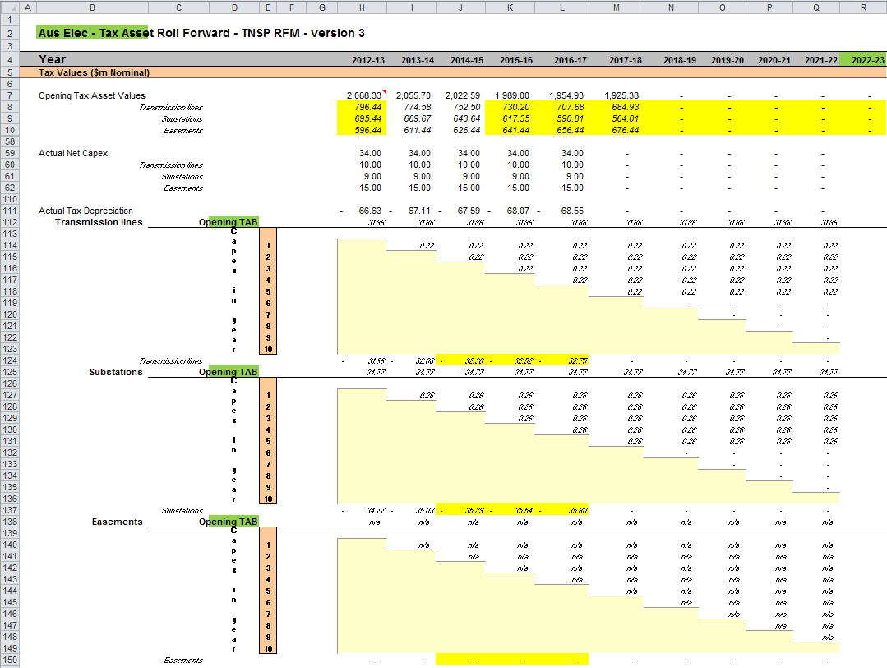

### Opening tax asset values

The opening tax asset value (cells H7 to H57) at the start of the first year of the current regulatory control period is adjusted by removing forecast net capex for the final year of the previous regulatory control period so that actual net capex for that year is included in the TAB. Rows 8 to 57 roll forward the opening TAB values for each asset class by taking the previous year’s nominal opening TAB value, then adding nominal actual net capex (as-commissioned) for the year and subtracting nominal actual tax depreciation for the year.

Based on the sum of each asset class calculations for those rows, the opening TAB value for each year of the current regulatory control period is displayed in row 7. These values are calculated in accordance with Box 6. The opening TAB value for the next regulatory control period is shown in cell M7. This value is used as an input into the PTRM for calculating the tax depreciation in the next revenue determination. A breakdown of the closing TAB values by asset classes are displayed in cells M8 to M57.

### Actual net capex

The actual net capex values for each asset class (rows 60 to 109) and each year of the current regulatory control period are calculated by taking nominal actual capex (as-commissioned) from the **RFM input** sheet (rows 223 to 272) and subtracting nominal actual de-commissioned assets from the same sheet (rows 277 to 326). Row 59 displays the sum of each asset class calculations for rows 60 to 109.

### Actual tax depreciation

The actual tax depreciation values for each asset class (rows 112 to 761) and each year of the current regulatory control period are calculated based on the nominal opening TAB values, nominal actual net capex (as-commissioned) values and tax asset lives, in accordance with the straight-line method. Row 111 displays the sum of each asset class calculations for those rows.

## RAB remaining lives sheet

The **RAB remaining lives** sheet calculates the average RAB remaining lives of each asset class using a weighted average method. The weighted average remaining lives at the end of the current regulatory control period for the RAB are used as inputs to the PTRM for the next regulatory control period to calculate the depreciation schedules in the revenue determination. The sheet is set up to accommodate asset life tracking over four five-year periods, however the calculations can be expanded to cover more if required.

For the first period that the RFM version 3 is used, the inputs for these calculations are sourced from the RFM **input** sheet. The input cells include formula references to the correct cells within the RFM. In future periods the RAB remaining lives sheet will also require inputs obtained from the RFMs for decisions relating to previous periods. The process for updating this data is set out in Box 7.

|  |
| --- |
| Box Input process required for updating RAB remaining life calculations |
| First period that RFM version 3 is used:  All inputs for the remaining life calculations are linked to the relevant value within the RFM.  No further inputs are required. |
| Subsequent period that RFM version 3 is used:  Input cells (light blue) will no longer be referencing the correct cells. These links must be replaced with the actual values approved in the previous decision RFM. These values include:   * Start period * CPI * Nominal vanilla WACC (fixed real time varying) * Value of net addition (capex) * Standard asset life.   These values can be copied from the previous decision RFM's **RAB remaining lives** sheet for each year of the preceding periods.  The original input cell formulae for CPI, WACC, capex and standard lives (columns D to H) can be replicated in the relevant year of the subsequent period to ensure automatic updates. i.e. formulae for year 1 of original RFM (column D) can be replicated for the first year of the subsequent period input cells (column I), etc. |

The process for calculating the weighted average remaining lives for the RAB is set out in Box 8.[23] A similar process applies for calculating the weighted average remaining lives for the TAB.

|  |
| --- |
| Box Calculating the RAB weighted average remaining asset lives |
| Calculating the RAB weighted average remaining asset lives by asset class  Opening RAB for start year –  Total real actual depreciation on opening RAB =  Closing capital value of opening RAB.  Real actual net capex for year 1 –  Total real actual depreciation on net capex for year 1 =  Closing capital value of net capex for year 1.  ...  Sum of closing capital values =  Total closing capital value for the asset class.  Opening RAB average remaining life – number of years of depreciation applied to opening RAB =  Closing average remaining life of opening RAB.  Asset class RAB standard life – number of years of depreciation applied to capex for year 1 =  Closing average RAB remaining life of capex for year 1.  …  Closing capital value of opening RAB ÷ Total closing capital value for the asset class ×  Closing average remaining life of opening RAB +  Closing capital value of net capex for year 1 ÷ Total closing capital value for the asset class ×  Closing average RAB remaining life of capex for year 1 +  … =  Weighted average remaining life for the RAB asset class. |
| Where:   * Opening RAB for start year = closing RAB for the final year of the regulatory control period preceding first use of version 3 of the RFM. * Total real actual depreciation on opening RAB = the sum of the real actual depreciation on opening RAB calculated for the regulatory control period. * Real actual net capex = real actual net capex (including half-nominal vanilla WACC allowance) * Total real actual depreciation on net capex = the sum of the real actual depreciation on net capex calculated for the regulatory control period * The opening RAB average remaining life is that used for the revenue determination where version 3 of the RFM is first used. * The asset class RAB standard life is that used for the current revenue determination.   Note:  The calculation of the TAB weighted average remaining lives by asset class follows the same process, with opening TAB replacing opening RAB, total actual depreciation on opening TAB replacing total real actual depreciation on opening RAB, actual net capex (excluding half-nominal vanilla WACC) replacing real actual net capex (including half-nominal vanilla WACC), total actual depreciation on net capex replacing total real actual depreciation on net capex, opening TAB average remaining life replacing opening TAB average remaining life and asset class TAB standard life replacing asset class RAB standard life. |

In calculating the weighted average remaining lives for each asset class, first the actual depreciated capital (or asset) value and remaining life of each capital stream is calculated for each year.[24] For asset class 1 these calculations in real dollar terms are set out in rows 16 to 36 and 39 to 59 respectively. For each year, the remaining life of each capital stream is then weighted by its associated closing capital value as a proportion of the total closing capital value of the asset class. The result is the weighted average remaining life for the asset class as a whole. For asset class 1, this value is shown in row 61. The weighted average remaining lives for the other asset classes in the RAB are calculated and shown at rows 111 to 2511.

In certain circumstances, a TNSP may have end of period asset adjustments that impact on the average remaining life of the asset class. The calculations in the **RAB remaining lives** sheet do not currently accommodate any end of period asset adjustments. The calculations assume that any adjustments made will not have a material impact on the average remaining life of an asset class. In the case of a material end of period asset adjustment, the calculations would need to be amended to accommodate this adjustment on a case-by-case basis.

Figure 8 provides an example of the **RAB remaining lives** sheet.

Figure 8 RAB remaining lives sheet

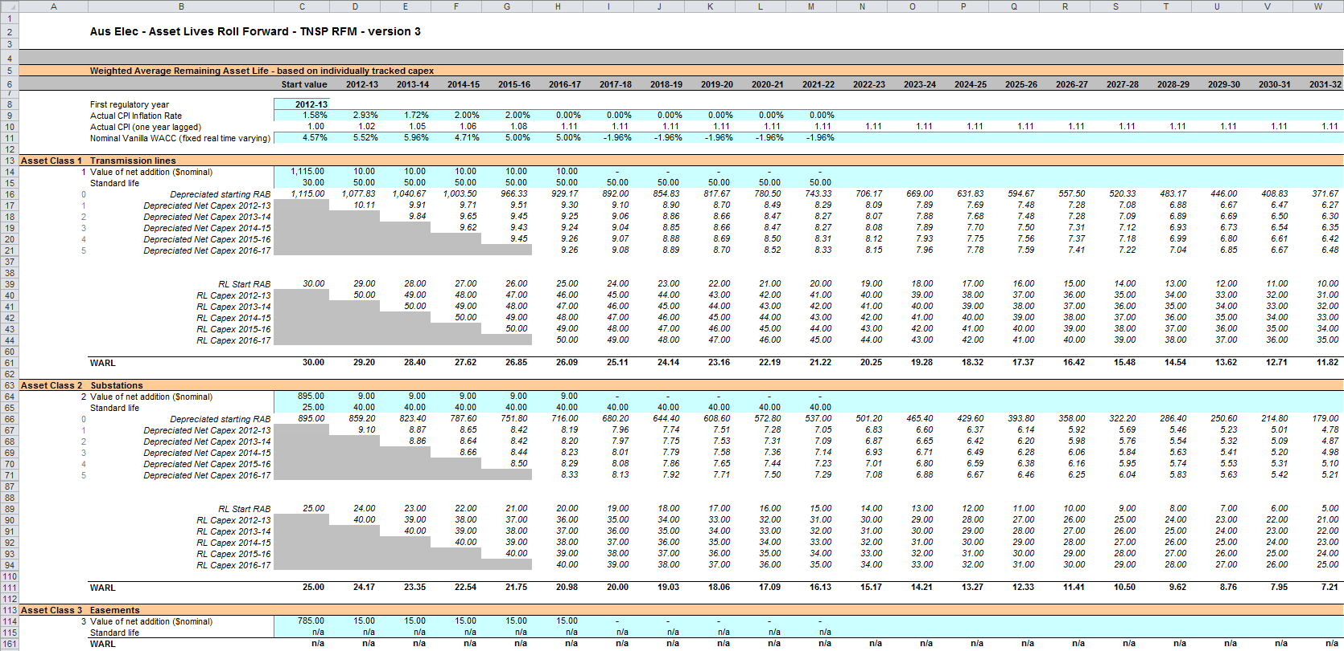

## TAB remaining lives sheet

The **TAB remaining lives** sheet calculates the average TAB remaining lives of each asset class using a weighted average method. The process for calculating the remaining asset lives for the TAB is broadly the same as described in Box 8. However, all calculations are performed in nominal dollar terms and the half-nominal vanilla WACC allowance is not included in actual net capex. The weighted average remaining lives at the end of the current regulatory control period for the TAB are used as inputs to the PTRM for the next regulatory control period to calculate the tax depreciation schedules for the purposes of tax analysis in the revenue determination.

For the first period that the RFM version 3 is used, the inputs for these calculations are sourced from the RFM input sheet and no manual updating is required. For subsequent periods the same update process as described in Box 7 is required for the TAB remaining lives sheet. However, only the opening TAB value and standard tax asset lives are required inputs for this sheet. All other TAB inputs are common with the RAB and therefore sourced from the RAB remaining lives sheet. The weighted average remaining lives for the asset classes in the TAB are calculated and shown at rows 56 to 2506.

Similar to the **RAB remaining lives** sheet, the calculations in the **TAB remaining lives** sheet do not currently accommodate any end of period asset adjustments that may impact on the average remaining life of the asset class. The calculations assume that any adjustments made will not have a material impact on the average remaining life of an asset class. In the case of a material end of period asset adjustment, the calculations would need to be amended to accommodate this adjustment on a case-by-case basis.

Figure 9 provides an example of the **TAB remaining lives** sheet.

Figure 9 TAB remaining lives sheet

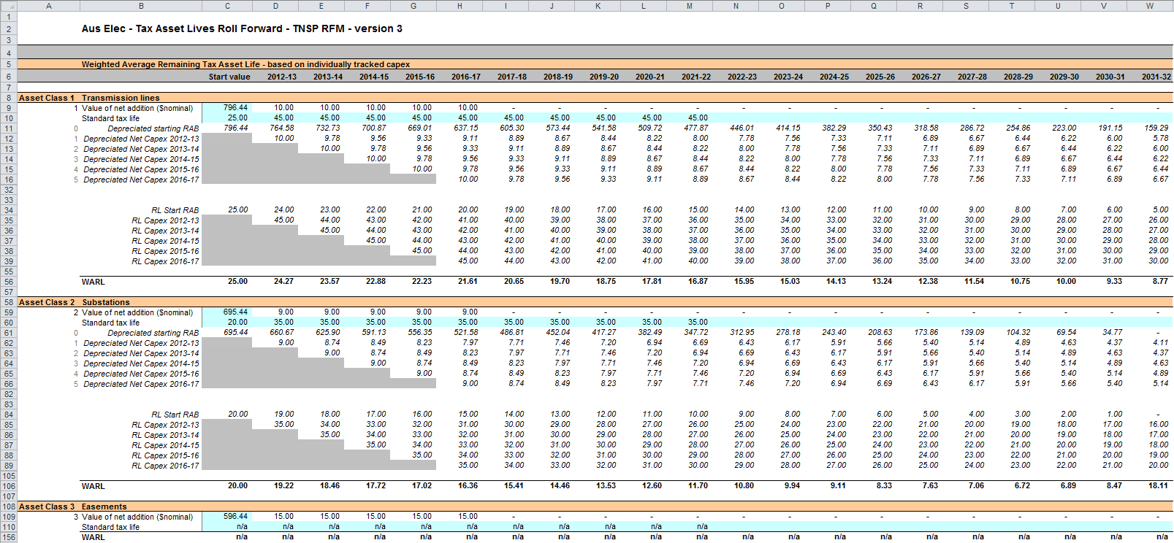

## PTRM input summary sheet

The **PTRM input summary** sheet outlines the opening RAB values (columns J for partially as-incurred and K for as-commissioned) and the opening TAB values (column N) for the next regulatory control period. These values are set out by asset classes in rows 7 to 56, based on the closing RAB and TAB values as calculated in the RFM. The average remaining lives for regulatory and tax purposes, and the base regulatory year for the start of the next regulatory control period are also displayed in columns L, O and Q respectively. All values are outputs from the RFM that need to be entered into the **PTRM input** sheet of the PTRM for the next regulatory control period. The information from the **PTRM input summary** sheet is sourced from the **RFM input**, **Total RAB roll forward**, **TAB roll forward, RAB remaining lives** and **TAB remaining lives** sheets.[25]

Figure 10 provides an example of the **PTRM input summary** sheet.

Figure PTRM input summary sheet

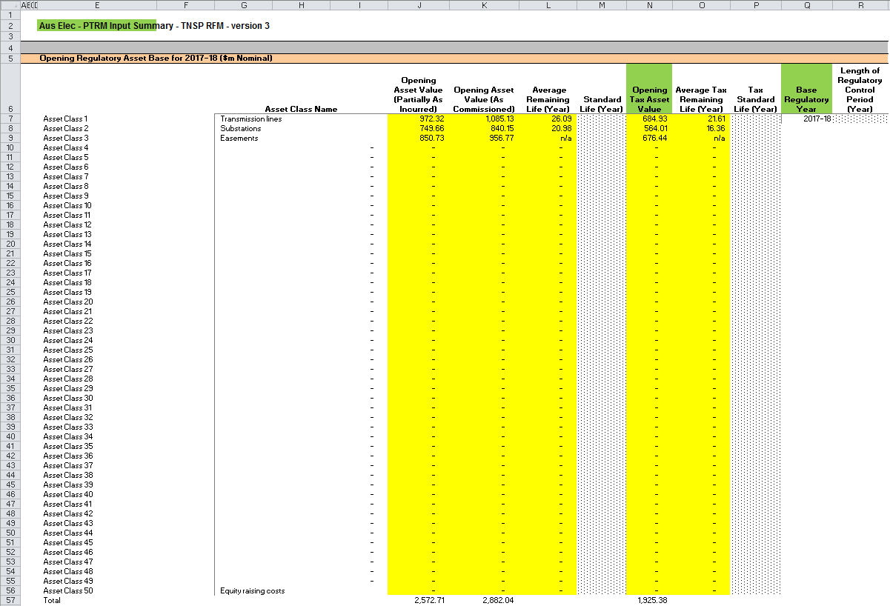

1. The set of Microsoft Excel spreadsheets which constitute the RFM were created in Microsoft Excel 2010. The AER recommends this or a later version of Microsoft Excel be used in applying these spreadsheets.
2. Consistent with tax law, the TAB is rolled forward in nominal dollar terms and so there is no indexation required.
3. For example, whether the RFM relates to the Regulatory proposal, Draft decision, Revised regulatory proposal or Final decision.
4. The depreciation profiles would be subject to satisfying the requirements of clauses 6A.6.3(b) and 6A.6.4 of the NER.
5. Clause 6A.10.1A of the NER sets out the requirements of the framework and approach applying to a determination.
6. It is a partially as-incurred RAB because the depreciation used in the roll forward is based on as-commissioned capex.
7. The button at the left of row 56 may be pressed to display/hide rows 37 to 55 (asset classes 31 to 49).
8. The RFM can be expanded to accommodate additional asset classes, when necessary.
9. The 50th asset class in the RFM is designed to be used with the 'Equity raising costs' asset class, consistent with the PTRM.
10. Alternatively, the other final year adjustment values may be obtained from the opening RAB input in the PTRM used for the current revenue determination for the TNSP.
11. Alternatively, the other final year adjustment values may be obtained from the opening RAB input in the PTRM used for the current revenue determination for the TNSP.
12. Actual capex and actual asset disposals are undertaken evenly over a year and therefore the reported capex values are assumed to be in middle of the year terms. All other input values are assumed to be in end of the year terms.
13. Consider the example where the difference in final year net capex incurred for the previous regulatory control period is positive (i.e. actual was higher than estimated). This means there is a foregone return associated with as-incurred net capex. This is the relevant amount to be capitalised and returned to the TNSP at the end of the current regulatory control period. That is, the return on difference in net capex as-incurred is to be capitalised, not the return on difference in net capex as-commissioned. The same reasoning applies for actual net capex being lower than estimated for the final year of the previous regulatory control period.
14. Based on inputs to U7:V56 of the RFM input sheet.
15. AusNet Services have Group 3 assets that are usually rolled into the RAB at the end of the regulatory control period and a true-up is required. During a regulatory control period, AEMO or a distribution business may request AusNet Services to provide augmentations to the transmission network or distribution connection services. While these Group 3 assets constructed due to these requests provide prescribed transmission services, the capex associated with these assets sit outside of the revenue determination. This is because SP AusNet is not responsible for the planning of these capex. Group 3 assets sit outside of the RAB and are governed by commercial contracts until such time as they are rolled into the RAB, usually at the end of the regulatory control period.
16. AER, Roll forward model: Final decision, September 2007. See section 4.3.1 which discusses the need for the application of a half-nominal WACC allowance.
17. The nominal vanilla WACC is based on a fixed real time varying WACC—that is, a fixed real vanilla WACC adjusted for actual inflation.
18. Regulatory depreciation is based on the nominal straight-line depreciation less the inflation applied to the opening RAB.
19. For illustrative purposes this is based on a standard five-year regulatory control period.
20. The half-nominal vanilla WACC is based on a fixed real time varying WACC—that is, a fixed real vanilla WACC adjusted for actual inflation.
21. This sheet has been configured to display the RAB roll forward for a regulatory control period of 2 to 10 years.
22. For illustrative purposes this is based on a standard five-year regulatory control period.
23. For assets that do not depreciate, there is no remaining life, and the user should input the remaining life as “n/a”. Note that although it is possible to enter “n/a” for some years of capex and a numerical value for others, this is conceptually invalid and should not be done.
24. A capital stream represents the opening asset value and each individual year of capex, for each asset class.
25. Where the as-commissioned RAB value is negative, the remaining life will be set to the lower of the standard asset life for the asset class and the regulatory period length. Similarly, where the as-commissioned RAB value is positive but the calculated remaining life is zero, the remaining life will be set to the lower of the standard life for the asset class and the regulatory control period length.