**11-1 Response to Draft Decision: Incentive Mechanism**

**1 Introduction**

The AER’s Draft Decision did not approve Envestra’s proposed carry over amounts from the 2008 to 2012 Access Arrangement period of $4.7 million ($2012) for Victoria and zero for Albury, instead calculating carry over amounts of -$8.6 million ($2012) for Victoria and -$2.3 million ($2012) for Albury. The AER also proposed to impose an incentive mechanism on the two networks for the 2013 to 2017 Access Arrangement period, rejecting Envestra’s proposal to not apply an incentive mechanism during this period.

The AER has incorrectly calculated the negative carry over amount from the 2008 to 2012 Access Arrangement period and, more importantly, erred by applying the negative carry over amount when determining the 2013 to 2017 allowed revenue for both networks. This attachment details Envestra’s calculation of the carry over amounts from the 2008 to 2012 Access Arrangement period and explains why the AER cannot apply a negative carry over to determine the 2013 to 2017 allowed revenue.

**2 Incentive Mechanism Outcomes for the 2008 to 2012 Access Arrangement Period**

Envestra has determined the carry over amount from the 2008 to 2012 Access Arrangement period to be zero for Victoria and Albury. In its Draft Decision the AER had imposed negative carry over amounts of -$8.6 million ($2012) for Victoria and -$2.3 million ($2012) for Albury. Figures 1 and 2 below comprise extracts from the post-tax revenue models used for calculating the carry over amounts to apply in Victoria and Albury, which carryover amounts are zero.

**Figure 1: Victorian Incentive Mechanism Carry Over Amounts**

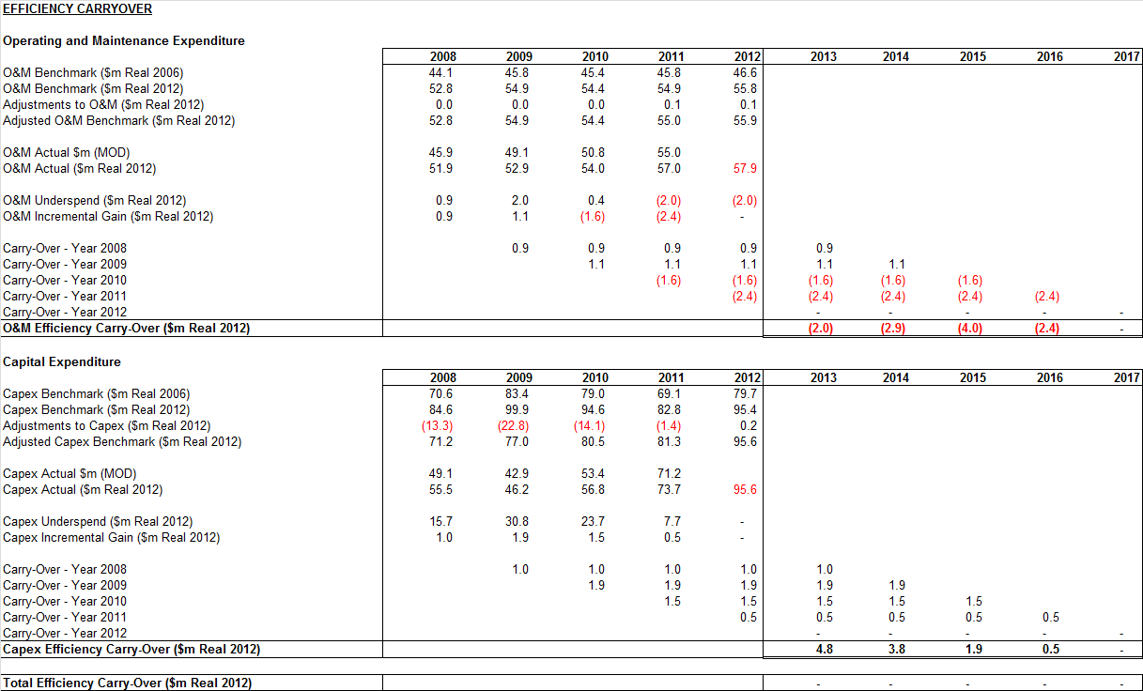

**Figure 2: Albury Incentive Mechanism Carry Over Amounts**

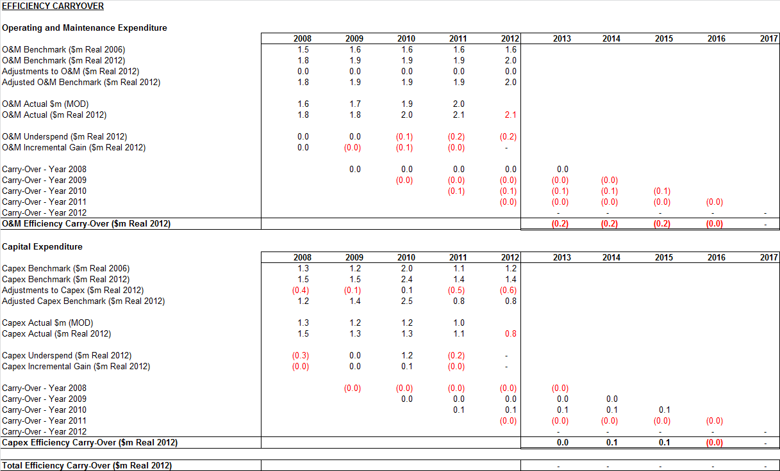

Envestra has accepted some of the changes to the calculation of the carry over amount made by the AER in the Draft Decision. This includes changes made by the AER to the benchmark amounts used in the carry over calculation, partly reflecting that Envestra did not have access to the necessary data to make the required adjustments at the time of its initial proposal. Envestra has however not accepted the following two key amendments:

1. the real pre-tax WACC to be applied (refer attachment 9-11); and
2. changes to actual operating expenditure to account for movement in provisions.

**2.1 Changes to actual operating expenditure – Victoria**

The AER amended the historic actual operating expenditure submitted by Envestra by removing an amount for movements in provisions (refer section 7.4.1 of Part 2 of the AER Draft Decision). This amendment is not required as movements in provisions are not disclosed as operating expenditure for the Victorian network in the audited Regulatory Accounts, but are instead disclosed as depreciation/impairment.[1]

For Albury however, movements in provisions are disclosed as operating expenditure and not depreciation/impairment.

The reason for the difference between the Victorian and Albury networks is due to the ownership status of the assets to which the provisions relate. Under “AASB 116 Property, Plant and Equipment”, an asset’s cost includes the costs of restoring an asset or site. In the case of Victoria, the relevant assets are owned by the business, and as such, the remediation provisions have been added to the cost of the asset.

Pursuant to “AASB 136 Impairment", costs which are required to be written-off against the asset need to be recorded in the income statement and disclosed as “depreciation/impairment”. This disclosure is in accordance with “AASB 101 Presentation of Financial Statements”, which requires classification of income statement items by either nature or function. The remediation provisions have been recorded in Envestra’s statutory accounts as “depreciation/impairment”.

Envestra’s audited Regulatory Accounts have been prepared in a manner that is consistent with the relevant accounting standards.

The actual treatment of provisions in the audited Regulatory Accounts is provided in the below table, which shows that the depreciation/impairment line of Regulatory Accounting Statement 1 (Income Statement) is the sum of Regulatory Accounting Statement 5 (Fixed Assets Depreciation) and Regulatory Accounting Statement 9 (Provisions). This reconciliation demonstrates that movements in provisions are captured as “depreciation/impairment” in Regulatory Accounting Statement 1 and not “operating expenditure” in Regulatory Accounting Statement 8.

**Table 1: Treatment of Provisions in the Audited Regulatory Accounts, 2008 to 2011**

|  |  |  |  |  |  |
| --- | --- | --- | --- | --- | --- |
|  |  | **2008**  **($m nom)** | **2009**  **($m nom)** | **2010**  **($m nom)** | **2011**  **($m nom)** |
| Statement 5 | Depreciation Expense | 19.68 | 20.56 | 21.76 | 23.04 |
| Statement 9 | Increase in Provision | 1.48 | 4.83 | 0.29 | 0.08 |
|  | **Total** | **21.16** | **25.39** | **22.04** | **23.12** |
|  |  |  |  |  |  |
| Statement 1 | **Depreciation/impairment** | **20.95** | **25.39** | **22.04** | **23.12** |
|  |  |  |  |  |  |
|  | **Variance** | **0.2** | **0** | **0** | **0** |

Note: The variance of $0.2 million in 2008 relates to a decrease in impairment in Statement 1 resulting from a revaluation of property subject to a remediation provision.

For the avoidance of doubt, the actual operating expenditure amounts ($ million nominal) from the 2008 to 2011 audited Regulatory Accounts is set out in the table below. Envestra has arrived at these operating expenditures by reversing the AER’s amendments for movements in provisions.

**Table 2: Actual Operating Expenditure from the Regulatory Accounts, 2008 to 2011**

|  |  |  |  |  |
| --- | --- | --- | --- | --- |
|  | **2008**  **($m nom)** | **2009**  **($m nom)** | **2010**  **($m nom)** | **2011**  **($m nom)** |
| **AER Draft Decision ECM Opex** | 44.64 | 44.28 | 50.48 | 54.94 |
| ***back out AER adjustment for***  **Increase in Provision (RAS 9)** | 1.48 | 4.83 | 0.29 | 0.08 |
| ***back out AER adjustment for***  **Payments from Provision (RAS 9)** | 0.22 | 0.00 | 0.00 | 0.00 |
| **Actual Opex** | **45.89** | **49.11** | **50.77** | **55.02** |

**2.2 Changes to actual operating expenditure – Albury**

The treatment of provisions is different for the Albury network as the property is not owned by Envestra but is instead owned by the Albury City Council. As there is no asset on Envestra’s balance sheet, the movement in provisions are disclosed as operating expenditure and are shown in Regulatory Accounting Statement 8 under the category “Change in Provisions”.

The AER amended the historic actual operating expenditure submitted by Envestra by adding back payments from provisions, but did so on the basis that the AER applied a negative carry over amount, which as explained in section 11.3 is not permissible under the National Third Party Access Code for Natural Gas Pipelines (the Code). Envestra has therefore removed the payment from provisions amount from the actual operating expenditure.

For the avoidance of doubt, the actual operating expenditure amounts ($ million nominal) from the 2008 to 2011 audited Regulatory Accounts is set out in the table below. Envestra has arrived at these operating expenditures by reversing the AER’s amendments for movements/payments from provisions.

**Table 3: Actual Operating Expenditure from the Regulatory Accounts, 2008 to 2011**

|  |  |  |  |  |
| --- | --- | --- | --- | --- |
|  | **2008**  **($m nom)** | **2009**  **($m nom)** | **2010**  **($m nom)** | **2011**  **($m nom)** |
| **AER Draft Decision ECM Opex** | 1.58 | 1.70 | 2.27 | 2.59 |
| ***back out AER adjustment for***  **Payments from Provision (RAS 9)** | 0.00 | 0.00 | 0.40 | 0.59 |
| **Actual Opex** | 1.58 | 1.70 | 1.89 | 2.00 |

**3 Imposition of a Negative Carry Over**

The AER in its Draft Decision has included negative carry over amounts arising from the 2008 to 2012 Access Arrangement period in determining allowed revenue for the 2013 to 2017 Access Arrangement period for both Envestra’s Victorian and Albury networks.

This is not allowed under the Code nor under the transitional provisions which deal with moving from the Code to the National Gas Rules (NGR). The AER’s decision is therefore invalid. No negative carry over amounts can be carried over from the 2008 to 2012 Access Arrangement period to the 2013 to 2017 Access Arrangement period.

The AER does not seem, in making its decision, to have accepted that the Essential Services Commission Appeal Panel (the Panel) determined that the Code does not allow the rollover between access arrangement periods of a negative carryover. In section 7.4.1 of the Draft Decision the AER has not correctly summarised the decision made by the Panel. The reasoning which supports the above submission is set out in this section.

**3.1 Requirements of the Code**

The provisions of the Code do not allow the carry over from one access arrangement period to the next of a net negative carry over amount. This was confirmed by the Essential Services Commission Appeal Panel (refer Attachment 11-2). Relevant extracts from the decision of the Panel in the 2008 appeal by the Albury Gas Company Ltd are set out below:

*“164. The other argument of the Applicant was that sections 8.44 to 8.46 of the Code provide only for positive incentive mechanisms, not for negative incentives. It was also submitted that no other section of the Code provides for negative incentives and that applying a negative efficiency carryover is inconsistent with the requirement in section 8.1(a) of the Code that a Reference Tariff should be designed to enable a distributor to recover the efficient cost of delivering the Reference Service under the Code.*

*165. The Applicant referred to nine indicators within sections 8.44 to 8.46 all relating to positive incentive. It argued that the absence of any indicator of negative incentive is a persuasive reflection of the intention of the Code. Reference was also made to the fact that the Applicant's ECM contained in its Access Arrangement for the second regulatory period provided for only a positive efficiency carryover.*

*166. Senior counsel for the Applicant submitted that section 8.49, which had been referred to in the Commission's submissions, could not be employed to enable the regulator to, in effect, "rewrite" the Code to the extent of reversing the clear intention of the preceding ECM provisions…*

*168. As to the Code interpretation argument, senior counsel for the Commission referred at length to the Commission's statements in previous regulatory decisions and consultation material making clear that it would, where appropriate and within its discretion, consider the application of negative carryovers. It argued that the assessment of carryovers was a symmetrical exercise and that, in this context, in the interests of the integrity of the ECM scheme, it was necessary to apply negative as well as positive carryovers.*

*169. The Commission disputed the Applicant's contention that sections 8.44 to 8.46 precluded negative mechanisms. It contended that section 8.49 permits the regulator to determine tests which adequately meet the overall requirements of part 8 of the Code in achieving efficient costs. Accordingly, it was argued that section 8.49, when looked at in parallel with the introductory words to section 8.45, is not restrictive in the manner suggested by the Applicant.*

*170. In the Panel's view the contention of the Applicant that the ECM provisions of the Code contemplate only positive carryover mechanisms, on its face, seems to have considerable force. Clearly, as conceded by the Commission, Sections 8.44 to 8.46 are silent as to any negative connotation. On the other hand section 8.49 is worded in fairly general terms…*

*172. Additionally, the Commission sought to emphasise in the Final Decision and its submissions to the Panel that the discretion to impose a negative carryover mechanism is necessary to preserve the integrity of the Code in this area.*

*173. The Panel acknowledges the logic of this argument in practical terms. It is also apparent that the overall intention of the Code is to provide a regulator with fairly broad discretions. The regulator is nevertheless required to comply with the language and intention of the Code. Accordingly, the practical issues raised by the Commission, whilst relevant, are not decisive in the context of interpretation.*

*174. The Panel considers that the paragraph in section 8.4 which is set out earlier in these reasons provides a strong indication of the intention of the Code in relation to efficiency gains and incentive mechanisms. It suggests that, in designing an incentive mechanism, a regulator is may allow a service provider to retain benefits only in the (positive) range of between 100% and 0%. This supports the interpretation of section 8.44 put by the Applicant.*

*175. The Panel also considers that sections 8.44 to 8.46 of the Code, when read with other sections of Part 8, including Section 8.4, indicate that only positive incentive mechanisms were contemplated and intended by the Code. Apart from there being only positive indicators within these three sections, the provisions are generally expressed in language consistent with positive incentive mechanisms whilst not consistent with negative mechanisms. The Panel believes that, notwithstanding the broad discretion given to the regulator under the Code, the intention to restrict incentive mechanisms to the positive, reflected in the natural meaning of the words of section 8.44, overrides any contrary implication to be derived from section 8.49. Indeed, this latter section itself is worded in a way which does not suggest negative mechanisms…*

*177. Accordingly, the Panel considers that there is no power or discretion provided by the Code enabling the Commission to include in the access arrangement of the Applicant a negative ECM. In the context of Section 39 (2) of the Law the Panel finds that the occasion for the Commission to exercise a discretion to this effect did not arise under the Code.”*

The reasoning of the Panel is clear: the Code did not allow negative carryovers from one access arrangement period to the next. As the Panel notes, the Code only refers to carry forward of positive amounts. Nowhere in it is there a reference to the carry forward of negative amounts. As the Code does not allow the roll forward of negative amounts, then an efficiency carryover mechanism developed under the Code clearly cannot allow the roll forward of negative amounts.

As noted above the AER’s discussion of the Appeal Panel’s decision does not correctly capture the essence of that decision. The AER in its Draft Decision (part 2, pp. 275-276) states:

*“The AER also recognises the Essential Services Commission Appeal Panel varied Envestra Albury’s Final Decision and Further Final Decision concerning the 2008-12 access arrangement to include a zero carryover between the 2003-07 and 2008-12 access arrangement periods.”*

This statement suggests that the Appeal Panel exercised some discretion to set the carryover to zero. That is not correct – the carryover was zero (or more accurately expressed there was no carryover) because the Appeal Panel determined that the Code did not allow any negative carryover. The AER then states (Part 2, pg. 276):

*“The Appeal Panel did not vary the efficiency carryover mechanism in Envestra Albury’s access arrangement.”*

The Appeal Panel did not vary the efficiency carryover mechanism because that was not the issue in argument before it. The issue was that the efficiency carryover mechanism in Envestra’s Access Arrangement did not allow a negative carryover to be rolled over from one access arrangement period to the next. The issue before the Appeal Panel did not involve varying the efficiency carryover mechanism but interpreting it.

The Appeal Panel found that the Code and the efficiency carryover mechanism did not allow the carrying forward of losses from one period to the next, therefore no amendment to the efficiency carry over mechanism was necessary.

The AER then states (Part 2, pg. 276):

*“Nor did it [the Appeal Panel] make any variations requiring any negative carryover accrued in the 2008-2012 access arrangement period be set to zero.”*

This statement is incorrect. The Appeal Panel determined a negative carryover cannot be carried forward from one access arrangement period to the next. That is the same thing as deciding that any negative carryover from the 2008-2012 access arrangement period could not be rolled forward. There was no reason to vary the efficiency carry over mechanism.

As the AER has noted, clause 5 of Schedule 1 to the National Gas Rules requires the AER to give effect to an incentive mechanism approved under section 8.44 of the Code. This means applying the mechanism in accordance with its terms and the legal framework which regulates it. That framework does not allow the carry forward of losses from the third to the fourth access arrangement period.

**3.2 Envestra’s Access Arrangements**

The efficiency carry over mechanisms which apply under Envestra’s Access Arrangements are set out in section 7 of Part B of those Access Arrangements. Clause 7.1(b) of the Access Arrangements provides:

*“No Fixed Principle can be changed by the Regulator at a review of the Access Arrangement without the approval of the Service Provider.”*

One of those fixed principles is (under clause 7.2) Envestra’s efficiency sharing mechanism. This is expressed to apply to the end of the Fourth Access Arrangement Period (i.e. the end of the 2013 to 2017 Access Arrangement period). Notably, clause 7.1(b)(5) of this fixed principle provides:

*“To the extent that the application of this clause results in a positive efficiency carryover at the end of the Third Access Arrangement Period, the reward earned in the Third Access Arrangement Period is to be added to the Total Revenue and carried forward into the Fourth Access Arrangement Period, until it has been retained by the Service Provider for a period of five years, in accordance with this clause.”*

There is no reference to the carry forward of losses from the Third Access Arrangement Period to the Fourth Access Arrangement Period. This is the same efficiency carry over that was the subject to the aforementioned decision by the Panel.

Clause 99(3) of the National Gas Rules provides:

*“A fixed principle approved before the commencement of these rules, or approved by the AER under these rules, is binding on the AER and the service provider for the period for which the principle is fixed.”*

Clause 99(4)(b) of the National Gas Rules provides:

*“However… if a rule is inconsistent with a fixed principle, the rule operates to the exclusion of the fixed principle.”*

Nothing in clause 7.2 of the Access Arrangement is inconsistent with the National Gas Rules. This is because the National Gas Rules do not mandate the carry over of losses arising from an incentive mechanism.

The AER is therefore bound by the fixed principle set out in clause 7.2.

Envestra acknowledges that the matter is different in respect of any incentive mechanism that might apply during the 2013 to 2017 Access Arrangement period. Rule 98(2) explicitly states that an incentive mechanism developed under the NGR may provide for carrying forward of losses from one access arrangement period to the next. However, rule 98(2) only applies from the commencement of the fourth access arrangement and not to rollovers between the third and fourth access arrangement.

Rule 98(2) is to be contrasted with the Code, which contains no provisions providing for roll-forward of losses.

**4 Proposed Incentive Mechanism for the 2013 to 2017 Access Arrangement Period**

The AER has rejected Envestra’s proposal to not include an additional incentive mechanism on operating and capital expenditure for the 2013 to 2017 Access Arrangement period. The AER has instead elected to impose its own incentive mechanism to apply to operating expenditure only. Envestra confirms its position that a separate/additional incentive mechanism is not required given the existing efficiency incentives included in the 2007 Operating and Management Agreement (OMA) with APA, which provides the main drivers of continuous improvement in the company.

Envestra is of the view however that if an incentive mechanism is to be imposed it should incorporate both operating and capital expenditure incentives, not operating incentives only. This is consistent with the 2007 OMA, which includes incentives on both operating and capital incentives. Importantly this view is also shared by the Productivity Commission, which in its recent review on electricity network regulatory frameworks has advised in Draft Recommendation 5.1 that:

*The Australian Energy Regulator should develop an efficiency benefit sharing scheme to apply to capital expenditure that provides consistent incentives to reduce capital expenditure, both over time and when compared with operating expenditure.[2]*

While acknowledging the AER’s reservations with regards to capital incentive schemes, the Productivity Commission stated:

*However, there is experience of capex sharing schemes that have worked, both in Australia and overseas, suggesting that any implementation problems are not insurmountable.[3]*

Envestra also notes that the AEMC in its Draft Decision on proposed changes to the National Electricity Rules broadens the scope for the introduction of capital expenditure efficiency schemes so the *“…AER can apply to provide adequate incentives for NSPs to spend capital expenditure efficiently”*[4].

The proposed rule changes, amongst other things, require the AER to publish a Capital Expenditure Incentive Guideline[5] annually.

There is therefore considerable expert consensus that capital expenditure should be included in any incentive arrangements imposed on businesses.

In section 7.4.2 of the Draft Decision, the AER infers that a capital expenditure incentive scheme would provide Envestra with a perverse incentive to defer capital expenditure at the expense of existing service levels as no service standard incentive scheme is in place. Envestra does not consider that there is any evidence to support this assertion. Envestra has maintained high levels of service over the past 10 years despite a capital incentive existing in the efficiency carry over mechanism.

The requirement to maintain a high level of service in part reflects that gas, unlike electricity, is a fuel of choice for customers. If Envestra were to provide poor service, customers have the option to shift their energy requirements away from gas to electricity. The potential loss of customers and demand provides strong motivation for Envestra to provide a safe and reliable service with high levels of customer satisfaction.

Envestra considers that, if the AER insists on imposing its own incentive scheme on Envestra, that incentives to improve capital efficiency also be provided. Envestra therefore proposes the capital expenditure efficiency mechanism that applied in the 2008 to 2012 Access Arrangement period be carried over to the 2013 to 2017 Access Arrangement period. Section 4.13 of the 2013 to 2017 Victorian and Albury Access Arrangements provide details of the incentive mechanism (operating and capital expenditure) and encompassing formulae.

1. Envestra understands the AER made the adjustments to actual operating expenditure based on incorrect advice provided by Envestra in response to Information Requests 5 and 42, which advice indicated that movements in provisions are disclosed in operating expenditure in the Victorian audited Regulatory Accounts. This is in fact not the case for Victoria but it is for Albury.
2. *Electricity Network Regulatory Frameworks – Productivity Commission Draft Report Volume 1 October 2012*, page 194.
3. *Electricity Network Regulatory Frameworks – Productivity Commission Draft Report Volume 1 October 2012, page 194.*
4. *Draft Rule Determinations - Draft National Electricity Amendment (Economic Regulation of Network Service Providers) Rule 2012 and Draft National Gas Amendment (Price and Revenue Regulation of Gas Services) Rule 2012* issued by the AEMC on 23 August 2012, page iv.
5. Refer clause 6.4A Capital expenditure incentive mechanisms of the *Draft National Electricity Amendment (Economic Regulation of Network Service Providers) Rule 2012* issued by the AEMC on 23 August 2012