

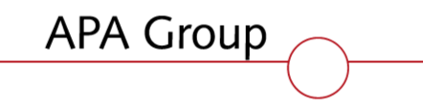

VICTORIA & ALBURY NETWORKS

FORECAST UAFG

2013-17 ACCESS ARRANGEMENT PERIOD

March 2012

Glossary

AEMO | Australian Energy Market Operator Ltd
AER | Australian Energy Regulator
AGC | The Albury Gas Company
Basic meter | A gas meter without a data recording device.
CI | Cast Iron mains
Class A Consumer | Consumer site at or exceeding 250TJ per annum consumption
Class B Consumer | Consumer site with less than 250TJ per annum consumption
Daily state average  heating value | The daily state-wide flow-weighted average heating value as prescribed in the Gas Distribution System Code.
Heating value or HV | The energy contained in a volume of natural gas (MJ/m3)
Heating value zone | A region across which the heating value is deemed the same for all meters in that region. Specified by AEMO.
Interval meter | A gas meter with a data recording device that can record hourly total gas flows
State average heating  value | Same as daily state average heating value - The daily average of the zonal heating values flow-weighted for the flow of gas into each heating value zone.
Unaccounted for Gas  (UAG or UAFG) | The difference between the gas metered into a pipeline system and the gas metered out of the same system.
UAFG benchmark | The unaccounted for gas benchmarks published in Part C of the “Gas Distribution System Code” (version 9) published by the ESC.
UPS | Steel mains without coating or cathodic protection – Unprotected Steel
Zonal heating value | The hourly average heating value applied (hourly) to all interval meters within a heating value zone.

1 Executive Summary 1
2 Introduction 2
2.1 Scope 2
2.2 UAFG Process 2
3 Network UAFG Performance 3
3.1 Actual vs Benchmark 3
4 UAFG Forecast 4
4.1 Base Year 4
5 Proposed UAFG Benchmarks 6
Attachment 1: UAFG wash-up calculations 7
Attachment 2: ESC Final Decision on UAFG related to Heating Value Allocation. 8

Executive Summary

This document summarises the UAFG performance of Envestra’s Victorian and New South Wales networks against the 2008-2012 regulatory benchmarks and provides a forecast and basis for UAFG benchmarks for the 2013-17 Access Arrangement period.

Envestra has been unable to meet the 2008-12 UAFG Access Arrangement benchmarks due to:

  - An incorrect decision by the Essential Services Commission at the time of the last Access Arrangement Review whereby it rejected Envestra’s forecast for UAFG and substituted its own forecast based on a three-year average of historical data;

  - A change in the source of gas supply to the network, which has resulted in an increasing error between actual delivered gas heating value and the AEMO calculated system average heating value used for billing.

As noted above, the current UAFG benchmarks were based on (at the time of the last access arrangement review) an average of the preceding 3 years level of UAFG. However, the methodology of averaging several years of historical data is not appropriate as it fails to adequately take into account changing conditions over time that may have impacted the level of UAFG, e.g. changes in gas heating value and deterioration of the old cast iron and unprotected steel network.

Envestra proposes that for the 2013-2017 Access Arrangement period, the 2010 year be used as the base year for UAFG forecasting. This is the most recent validated data available and therefore represents the most accurate starting point for forecasting purposes - any later period is still subject to market reconciliations and adjustments. Actual 2010 UAFG data also reflects the most recent gas heating values, which are not expected to vary over the next Access Arrangement period.

The proposed UAFG benchmarks for both the Victorian and New South Wales networks for the next Access Arrangement period (as a sendout %) are set out in the following table.

Table 1 - UAFG Proposed Benchmarks

Vic & NSW Benchmark UAFG %
Customer Class | 2013 | 2014 | 2015 | 2016 | 2017
Class A | 0.3 | 0.3 | 0.3 | 0.3 | 0.3
Class B | 3.9 | 3.9 | 3.9 | 3.9 | 3.9

Introduction

Scope
The scope of this document covers:
- Envestra’s performance against UAFG benchmarks for its Victorian and NSW (Albury) networks during the current Access Arrangement period; and
- The formulation of proposed UAFG benchmarks for the 2013-17 Access Arrangement period.

UAFG Process
UAFG refers to the difference between the quantity of gas delivered into and out of the distribution system. Key factors contributing to UAFG include:
- Network leaks - fugitive emissions
- Billing correction factors (pressure, temperature, altitude, compressibility)
- Heating value variations
- Billing and accounting errors and anomalies
- Theft
The Victorian Gas Distribution System Code (GDSC) sets out UAFG benchmarks (expressed as a percentage of gas deliveries) within which Envestra is expected to operate. Envestra’s benchmarks for the 2008-12 Access Arrangement period are set out in the following table.

Table 2 - UAFG Current Benchmarks
 | 2008 | 2009 | 2010 | 2011 | 2012
Vic Class A - % | 0.3 | 0.3 | 0.3 | 0.3 | 0.3
Vic Class B - % | 3.1 | 2.8 | 2.7 | 2.7 | 2.6
NSW Class A - % | 0.1 | 0.1 | 0.1 | 0.1 | 0.1
NSW Class B - % | 4.1 | 3.0 | 3.0 | 3.0 | 3.0

Unlike the Envestra South Australian and Queensland networks, where UAFG is purchased by Envestra, the retailers in Victoria and NSW purchase UAFG up to the benchmark amount. Second Tier retailers are deemed to purchase UAFG at the benchmark rates while the Tier One retailer purchases the remaining balance. As a result, UAFG is not a cost that is approved by the AER and recovered through network tariffs.
However, the Victorian market does provide for an annual UAFG “Wash-Up” process. If the actual level of UAFG is greater than the benchmarks, Envestra must pay a Reconciliation Amount (as defined in the GDSC) to the Tier One retailer. Conversely, where the actual level of UAFG is lower than the benchmark, the Tier One retailer makes a Reconciliation Amount payment to Envestra.
In practice, due to data integrity issues between the distributors, retailers and AEMO, reconciliation payments are also made between distributors and Second Tier retailers.
An outline of the UAFG Wash up calculation process is included at Appendix 1.

Network UAFG Performance

Actual versus Benchmark
The following table compares the actual and benchmark UAFG values. It should be noted that while different benchmarks exist for the Victorian and New South Wales portions of the distribution system, such a distinction is not practical, as some injection points service both states, i.e. there is no physical separation of the two networks. As a result, the current methodology for settling UAFG wash-ups is to sum the position for both Victoria and NSW and to settle at a combine level.

Table 3 - UAFG Actual versus Benchmarks

UAFG Performance
Category | Measure | 2008 | 2009* | 2010
Vic & NSW Total TJ | Benchmark | 1458 | 1270 | 1287
Vic & NSW Total TJ | Actual | 1776 | 1582 | 1777
Vic & NSW Total TJ | Variance | 318 | 312 | 490
Vic & NSW Total % | Benchmark | 2.37 | 2.16 | 2.06
Vic & NSW Total % | Actual | 2.86 | 2.68 | 2.85
Vic & NSW Total % | Variance | 0.49 | 0.52 | 0.79

* 2009-2010 wash ups are yet to be finalised with Retailers and are subject to change

If Class B data is extracted from the above (assuming Class A outcomes are the same as the benchmarks), the Class B UAFG outcomes are depicted in the following graph.

Fig 1 - UAFG Actual versus Benchmarks

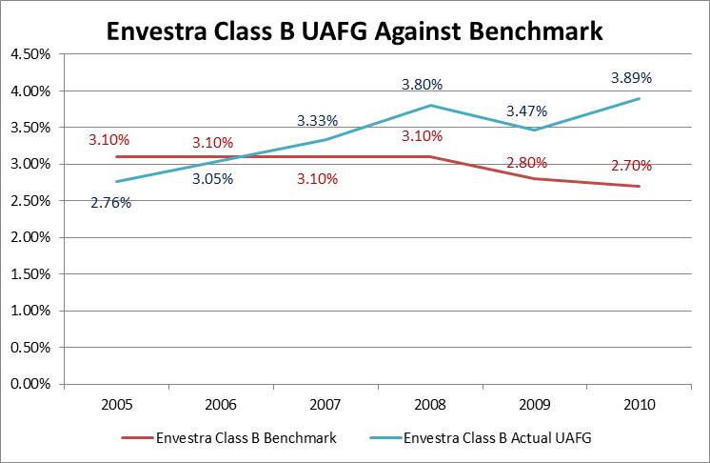

It is evident from the above data that, where there is an increasing or decreasing trend in a data series, it is inappropriate to set a forecast based on an average that extends back in time.

It is also clear from the data that Envestra has not achieved the UAFG Class B benchmarks. The cause of this is discussed in the following sections.

UAFG Forecast

Base Year
The current Access Arrangement UAFG benchmarks were determined using a three-year average of the preceding years at the time of access arrangement review. The ESC has since concurred that this failed to take into account the changing source of supply of gas in Victoria and therefore understated the benchmarks that could be achieved.

Both Envestra and AEMO’s analysis of heating values has identified an impact of approximately 0.3% - 0.5% to Envestra’s detriment over the 2008–2010 calendar years.

Going forward, this is not expected to be an issue as the 2010 AEMO Victorian Annual Planning Review forecasts gas sources in Victoria to remain relatively constant over the next 5 years.

Fig 2 – AEMO Forecast Source of Supply

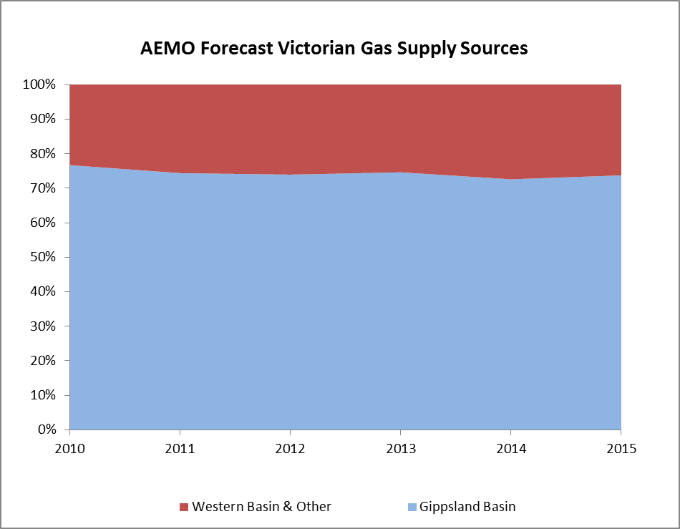

Given that forecast supply arrangements are not expected to vary materially hereon, the impact of HV on UAFG should remain constant over the next Access Arrangement period. Consequently the 2010 UAFG represents the best and most accurate basis for a UAFG starting point. Envestra therefore proposes that 2010 be used as the base year for establishing UAFG benchmarks.

However, should changing sources of gas supply occur and have a material impact on UAFG during the next Access Arrangement period, Envestra will request a review of UAFG benchmarks at that time.

The base year UAFG wash up (preliminary) for Victoria based on 2010 is summarised in the following table.

Table 7 – Vic & NSW UAFG Washup

It is important to note however that an accurate determination of sendout by state (Victoria and New South Wales) is not possible due to some injection points servicing more than one state. As a result, the current methodology for settling UAFG wash-ups is to sum the position for both Victoria and NSW and to settle at a total level. (Consequently this paper (see section 5) proposes the abolition of separate benchmarks for Envestra’s Victorian and southern NSW networks).

Proposed UAFG Benchmarks

While separate benchmarks have historically been set for Envestra’s Victorian and NSW sections of the network, the inability to determine injections on a jurisdictional basis makes it nonsensical to establish separate benchmarks. On this basis, Envestra believes that the UAFG distinction between a contiguous network on different sides of the Victorian/NSW border should be eliminated, with a single benchmark applying.

Historically a nominal 0.3% UAFG has been assigned to Class A consumers on the basis that these consumers are, in theory, mostly supplied from trunk mains that have little or no leakage. The UAFG associated with this class is therefore presumed to be associated mostly with meter accuracy. While this is questionable, it is not proposed to eliminate the Class A benchmark at this time, but to maintain it and continue a nominal benchmark of 0.3%.

In relation to the Class B benchmark, as discussed earlier, Envestra believes that the most recent validated data should be used, this being the 2010 year data - indicating a UAFG level of 3.9% (equating to 1780 TJ when combined with Class A). Envestra therefore proposes that the UAFG benchmarks be as shown in Table 10 below.

Table 10 – 2013-17 Proposed UAFG Benchmarks (%)

Vic & NSW Benchmark UAFG
Customer Class | 2013 | 2014 | 2015 | 2016 | 2017
Class A % | 0.3 | 0.3 | 0.3 | 0.3 | 0.3
Class B % | 3.9 | 3.9 | 3.9 | 3.9 | 3.9

Envestra also notes that AEMO has, for some time, been undertaking a review of alternative Victorian methods for the treatment and reconciliation of UAFG costs between distributors and retailers. That work, via the Gas Retail Consultative Forum, is on-going and at the time of writing there has been no decision to change current processes. However, should such a decision be made, Envestra and other market participants will need to assess the impact of any such change and if necessary amend its access arrangement accordingly.

ATTACHMENT 1

UAFG Wash-up Calculations

Rule 317 of the National Gas Rules sets out AEMO’s obligation to produce a procedure for the wash-up calculation of UAFG. The “Wholesale Market Distribution UAFG Procedures (Victoria)” (UAFG Procedure) has been produced pursuant to this rule.
In practice the UAFG wash-up calculation process is time-consuming and complicated. This is primarily because the UAFG Procedure requires both retailers and distributors to agree on consumption before the wash-up can proceed (clause 2.3).
Agreement with retailers may be difficult because:
- all wash-up calculations must use the latest data available published by AEMO for CTM injections (sendout), net system load and interval metered sites (both Tariff D and large Tariff V sites). AEMO publishes data on a published D+18 and D+118 schedule as well as occasional ‘revisions’. These versions must be stored and tracked and agreement reached with retailers and AEMO as to the most recent version.
- basic meter reads must be reconciled back to invoices to retailers in order to minimise disputes.
- duplicate data in the case of large Tariff V sites that appear in both raw Tariff V billing data and telemetry data needs to be stripped out.
- occasionally certain interval metered sites require an “off-market” settlement where a metering error has been detected outside the D+118 cut-off. Both AEMO and the retailer must agree with an off-market settlement.
- NSL (Net System Load) apportionment of basic meter reads, which straddle either the beginning or end of the calendar year, must be carried out.
- The above steps are the largest bottleneck to efficient agreement. This is largely due to the volume of data to be agreed and the iterative nature of the process. Final agreement with all retailers cannot be achieved until each individual retailer has agreed with their figures. Although one retailer may have agreed, this may be subject to changes because a subsequent retailer may have successfully disputed their figures.
The mathematical process of profiling meter reads to periods is also very computationally intensive because the procedure requires the distributor to profile on a NSL basis. NSL is published by AEMO each day for each distributor and is calculated by subtracting telemetered consumption from network injections (sendout). In effect this yields an average consumption profile for total un-telemetered consumption. To apply NSL profiling each meter read must be considered separately and consumption prorated to each period on the basis of the sum of NSL in that period compared to the sum of NSL over the entire meter read. The UAFG procedure requires NSL-profiling for all basic metered sites.
While Envestra now has a (largely) automated process for undertaking this NSL calculation phase, it can still take several weeks to set-up, test, calculate and confirm internally. Confirming the calculations with the relevant retailers then takes additional time due to the iterative process described and the volume of data involved. In 2008 4.1 million basic meter reads were sent to retailers of which 1.1 million reads were NSL profiled.

Attachment 2: ESC Final Decision on UAFG related to Heating Value Allocation.

