# 

**Early Engagement Plan**

EDPR 2021-25 Customer Forum

# Introduction

Alternative models are used internationally for engaging with and involving the customers of regulated utilities in the price review process. For the 2021-25 Electricity Distribution Price Review (EDPR) AusNet Services (we/us) will trial an approach that involves negotiating our regulatory proposal with a Customer Forum that has been established to, and is capable of, representing the perspective of AusNet Services’ customers. This approach has been used most notably by Scottish Water and is being considered as an option for energy network regulation in Australia.[1]

The aim of undertaking the trial is to reach a meaningful agreement with the Customer Forum on as many aspects as possible of AusNet Services’ 2021-25 revenue proposal. It is critical for the process to be of a standard that allows key internal and external stakeholders (including the AER, Energy Consumers Australia and the Victorian EDPR Consumer Challenge Panel (CCP)[2]), to have confidence in the outcomes.

The purpose of this Early Engagement Plan is to explain the detail of how we propose to implement the negotiated regulatory approach including:

* Governance arrangements for the customer representative group, which will be known as the Customer Forum;
* Recruitment of the Customer Forum members;
* The proposed operation of the Customer Forum;
* An indicative scope of issues that could be negotiated with the Customer Forum;
* How the Customer Forum integrates with AusNet Services’ broader customer engagement activities for the 2021-25 EDPR; and
* Proposed role of the AER, ECA and AusNet Services’ Customer Consultative Committee.

This document is intended to be a living document that will be updated to reflect developments and learnings as the Customer Forum process unfolds.

# Customer Forum governance

The governance arrangements for the Customer Forum are designed to support the Customer Forum to achieve its objectives and to promote its independence. These arrangements, which are discussed in the remainder of this document, are shown in the figure below. The role of the Consumer Challenge Panel in this process is currently being defined by the AER and CCP. Once this is determined, this document will be updated accordingly.

Figure 1 – Customer Forum governance arrangements



## Objectives of the Customer Forum

The primary proposed objective of the Customer Forum is to agree material elements of the regulatory proposal for the period 2021 to 2025, on the basis that they reflect the preferences and priorities of customers.

Sub-objectives within this are to:

* Ensure that AusNet Services has appropriately identified the perspective of our customers;
* Increase the transparency of the development of AusNet Services’ regulatory proposal; and
* Seek to achieve the highest possible levels of customer focus within AusNet Services in the development of our 2021-25 regulatory proposal.

## Roles and responsibilities

The Customer Forum is established to act as a key means through which customers’ views are incorporated into AusNet Services’ 2021-25 regulatory proposal.

The purpose of the Customer Forum is to be the formal counterparty in negotiation with AusNet Services and to, as far as possible, reach agreement with AusNet Services on its regulatory proposal prior to the submission of the regulatory proposal to the AER.

To achieve this, the Customer Forum will be expected to:

* Develop an understanding of our distribution business and its revenue requirements;
* Represent, 'bring' the perspectives of, and act on behalf of, all consumer voices (large and small), having regard to the long term interests of current and future consumers; and
* Negotiate with AusNet Services with a view to reaching agreement on a revenue proposal that represents the most appropriate long-term outcome for our customers.

Where possible, all members of the Customer Forum will be involved in negotiation with AusNet Services. In some cases, a subset of members may choose to engage with us on particular issues. However, the Customer Forum will seek to determine its negotiation principles and positions by consensus. Where consensus cannot be achieved, principles and positions must be agreed by a special majority of four out of five.

The Customer Forum’s role may extend beyond the submission of the regulatory proposal. For example, it may help to inform responses to information requests, particularly where these relate to consumer engagement activities undertaken.

### Equipping the Customer Forum to represent the perspectives of customers

The Customer Forum will be required to represent the perspectives of AusNet Services’ customers. The Customer Forum is independent of any other group or party, including AusNet Services, the AER and ECA. The members will not be representing a particular customer group, but should be seeking to represent the perspective of the breadth of AusNet Services customers.

AusNet Services is undertaking significant research into customer preferences to inform the development of the regulatory proposal and to assist the Customer Forum members to understand the perspectives of our customers. The customer research and other customer engagement activities are outlined in Section 6. The Customer Forum will be able to influence and have input to AusNet Services’ customer research program for the 2021-25 EDPR. Should the Customer Forum have concerns with the research program and therefore want to commission additional or different research, this will be facilitated, having regard to timing and budget considerations.

The Customer Forum will be provided with ongoing opportunities to shape our customer research and engagement activities through monthly workshops. These will involve AusNet Services’ consumer engagement team to discuss, debate and refine the issues that will be explored with customers. By helping to shape the consumer research activities planned, the Forum will be able to represent the perspectives of our customer base.

For example, AusNet Services intends to hold a number of deliberative forums during April 2018, during which specific options will be put to the participating customers to determine their preferences and priorities. The Customer Forum will inform the approach and content discussed at these sessions and will be invited to attend and participate.

Where the Customer Forum seeks to communicate directly with end-users, customer advocates or AusNet Services’ Customer Consultative Committee[3] (CCC) to understand their preferences, this will be facilitated by AusNet Services to the extent possible. This engagement is likely to be in the form of formal and/or informal meetings.

### Documenting the Agreement

At the conclusion of the negotiation process, AusNet Services and the Customer Forum will draft, agree, and submit, as part of the regulatory proposal, an Engagement Report. The Engagement Report will include the scope of matters considered and, for each matter, the agreement that has been reached or, in the event of disagreement, the positions of the parties. For the matters which have been agreed, the Report will explain why the agreements reached are consistent with, or best reflect, consumer perspectives and preferences, referencing any customer research or consultation undertaken during the process. For matters where agreement is not reached, the Report will also identify and explain the reasons these issues were unresolved.

The Engagement Report will provide a useful starting point for the AER’s assessment of the regulatory proposal.

The Customer Forum will only have a role on behalf of our customers for the development of the regulatory proposal for the 2021-25 EDPR.

## Engagement Agreement

An Engagement Agreement will be entered into by AusNet Services, the Customer Forum Chair and the AER. The Engagement Agreement will formalise the governance arrangements of the Customer Forum, and the expectations and role of the Customer Forum, the AER and AusNet Services. The Customer Forum will have the opportunity to review and provide feedback on a draft of the Engagement Agreement to ensure there is a mutual and clear understanding of the Customer Forum’s role.

A draft Engagement Agreement is provided as Attachment A to this document.

## Reference Committee

A Reference Committee will be established as an important element of the trial’s governance structure, and a key means of managing the Forum’s independence. The Committee’s role will be to provide an avenue for issue escalation by the Chair. For example, should the Chair develop concerns in respect of the Forum’s ability to fulfil its role, the Chair may elect to raise this with the Committee. However, where an issue arises, it is expected that the Chair would have sought to resolve the issue first with AusNet Services, before escalation to the Reference Committee.

The Reference Committee will comprise representatives from ECA and the AER.

## Structure

The Customer Forum will consist of one Chair and four additional members.

The Chair and each member must be capable of credibly reflecting the perspective of AusNet Services’ customers.

## Period of appointment

The Customer Forum members will be appointed for the period from March 2018 up to the submission of AusNet Services’ regulatory proposal to the AER in July 2019.

As noted above, the period of appointment may also extend beyond the submission of the regulatory proposal.

## Responsibilities of the Chair

The Chair will lead the negotiation process on behalf of the Customer Forum. The Chair will also be responsible for formally approving the payment of fees and expenses to Forum members. As discussed below, these payments will be administered by ECA.

## Funding and remuneration

The Customer Forum members will be remunerated for their time and incidental costs. Remuneration rates will be benchmarked based on similar roles, including the AER’s CCP, and set by AusNet Services.

An important consideration is also establishing funding arrangements that maintain the independence of the Customer Forum from AusNet Services. Direct payment by AusNet Services may result in real, or perceived, conflicts of interest for Customer Forum members.

AusNet Services and ECA are in the process of finalising a funding mechanism that will involve the Customer Forum being remunerated by ECA using funding provided by AusNet Services in accordance with policies, procedures and remuneration schedules agreed in advance by AusNet Services and the Forum Chair. As noted above, payments by ECA to the Customer Forum members would be subject to approval by the Chair.

# Customer Forum recruitment

The Customer Forum members will be selected through a skills-based approach.

The primary requirement for the Forum members is that they are fully independent of AusNet Services and are capable of credibly representing the perspective of the breadth of AusNet Services’ customers including large and small customers and vulnerable customers of many kinds. A skills based approach will allow us to target required analytical capacity and provide a nimble and authoritative counterparty in negotiations with AusNet Services.

Members of the Customer Forum therefore must not:

* Be currently employed or engaged by AusNet Services or the AER;
* Have criminal convictions;
* Have been disqualified from acting as a director; or
* Have undertaken activities deemed to have had major adverse consequences for consumers.

## Skills/capabilities

AusNet Service has targeted the capabilities and skills sets shown in the table below when recruiting for the Customer Forum.

Table 1 Customer Forum skill sets and recruitment sources

| Capabilities | Specific skills/qualifications |
| --- | --- |
| - Numeracy (and ability to explain to others)  - Credibility to represent the customer perspective (including vulnerable customers)  - Negotiation  - Communication  - Analytical skills  - Flexibility and willingness to develop new skills  - Chairing skills (for Chairperson) | - Consumer rights advocacy  - Market research  - Communications  - Agriculture/business  - Economics  - Law (commercial/consumer)  - Engineering |

## Recruitment sources

Potential sources of Customer Forum members are identified in the table below.

Table 2 Potential sources of Customer Forum members

| Recruitment sources |
| --- |
| - Academia/research sectors (including CSIRO)  - Financial counsellors  - Australian Institute of Company Directors/ Board Members/ Water Boards  - Retired: politician, senior bureaucrat, Chief Scientist, Big 4 accounting firm partner, CEO (e.g. energy retail, rural water)  - Market research consultancies  - Not for profit sector  - Leadership Australia  - Agriculture representation or consultant  - Consumer advocate (another sector, not energy) |

## Recruitment channels

AusNet Services used a number of recruitment channels in order to identify the Customer Forum members including:

* AusNet Services’ website;
* Members of AusNet Services’ Customer Consultative Committee;
* LinkedIn (via LinkedIn jobs, AusNet account and individual staff accounts);
* Local newspapers in AusNet Services’ service area;
* University alumni societies;
* The Age newspaper; and
* Via organisations such as Financial and Consumer Rights Council Inc.

The most effective recruitment channel for Customer Forum members appeared to be a weekend advertisement in The Age newspaper.

## Selection process

Approximately 120 applications were received for Customer Forum membership. Applicants covered a wide range of backgrounds and experiences, including consumer advocacy, public sector, market research, business, academia, local government and engineering.

Through consultation with the AER and ECA, a shortlist of 12 candidates was developed that collectively covered the key skills, and diversity, required of the Customer Forum, as shown in Table 1 above. It was also important that at least one Customer Forum member be an existing AusNet Services electricity distribution customer.

The shortlist was then tested with an independent consumer advocacy expert with significant experience establishing consumer advocacy panels. Following this, the shortlisted candidates were interviewed by a panel comprising AusNet Services’ General Manager Regulation and Network Strategy and the Chair of our Customer Consultative Committee.

The interview process tested the candidates understanding of the Customer Forum’s role, their ability to represent the perspectives of customers, their understanding of consumer issues and their analytical ability through the use of a short case study.

Five candidates emerged from this process which together comprise a Customer Forum with the right mix of skills and backgrounds, and a strong capacity to understand and represent the interests/perspectives of our customers.

# Scope of negotiation

The aim is to maximise the aspects of the revenue proposal included within the negotiation process.

The following criteria are proposed for determining the scope of the expenditure proposals and associated issues/inputs that could be subject to negotiation with the Customer Forum:

* What degree of discretion does AusNet Services have to determine the level of expenditure
  + Where there is little to no discretion this would be an area of expenditure that is not amenable to negotiation e.g. the rate of return on capital which is determined by the AER, expenditure associated with a regulatory obligation such as REFCLs which is directed by the Victorian Government.
* Where customer views are crucial
  + For example, testing customer support for and willingness to pay for new services or network capabilities or where a reduced service is acceptable for a reduction in charges.
* Materiality of expenditure
  + It is proposed that major expenditure items should fall within the scope of the negotiation process (subject to the two criteria above).
* Where there are genuine expenditure trade-offs
  + The Customer Forum should have strong input where there are genuine expenditure trade-offs. For example, alternative options for addressing network constraints including network and non-network options.
* Degree of technical information/complexity required to assess the expenditure proposal
  + There may be expenditure proposals that require either specific, expert knowledge or significant information/effort to credibly assess the proposed expenditure. In some cases, this may not be amenable to negotiation.

AusNet Services intends to agree with the Customer Forum and the AER on the scope of expenditure/issues on which they will negotiate. This will be discussed with the Forum soon after it is formed, and agreed with the AER. While the whole proposal and total revenues and prices will remain a reference point throughout the negotiations, the range of issues for negotiation will be considerably narrower owing to the criteria set out above. The reasons for arriving at the agreed scope, and the matters that are not agreed, will be clearly documented and published on AusNet Services’ website.

Topics and decisions not addressed in the negotiation process will be dealt with in the development of the regulatory proposal, and subsequently assessed by the AER through its current process.

# Customer Forum operation

## Timeline

AusNet Services will have engaged all Customer Forum members and commence by March 2018. A high level timetable for the operation of the Customer Forum is shown in the figure below. This shows that in the first half of 2018 the Customer Forum will be provided with an understanding of our business, the regulatory framework and our customer’s preferences. As noted above, the Customer Forum will be able to influence customer research to provide customer views.

A series of negotiations will be held between the Customer Forum and AusNet Services in late 2018 with the aim of reaching agreement on material elements of the revenue proposal. After this process AusNet Services intends to publish a Draft Regulatory Proposal for public consultation, alongside a draft Engagement Report, in November 2018. The Customer Forum members may be actively involved in this consultation process.

As noted above, the scope of negotiation will be initially explored with the Forum during the first week of activities in March. Once the scope has been agreed, a timeframe for AusNet Services and the AER to engage on the matters in scope will be agreed. This timeframe will provide the AER with sufficient time to analyse and respond to AusNet Services proposals on the matters in scope.

If required, there will also be time for the Customer Forum to engage with consumers or their representatives and seek further information on the matters in scope prior to the first negotiation round.

If required, the Customer Forum will be involved in a second negotiation round prior to AusNet Services’ finalising its Regulatory Proposal. The outcomes of the public consultation process will be an input into this second round of negotiation.

An indicative timeline of the Customer Forum process is below. This will be adapted as the process proceeds, through agreement with the Customer Forum and the AER. Given this is the first time this approach has been trialled in electricity regulation in Australia, there are no precedents of appropriate timeframes, so the below diagram is merely an indication.

Figure 2 Customer Forum timeline

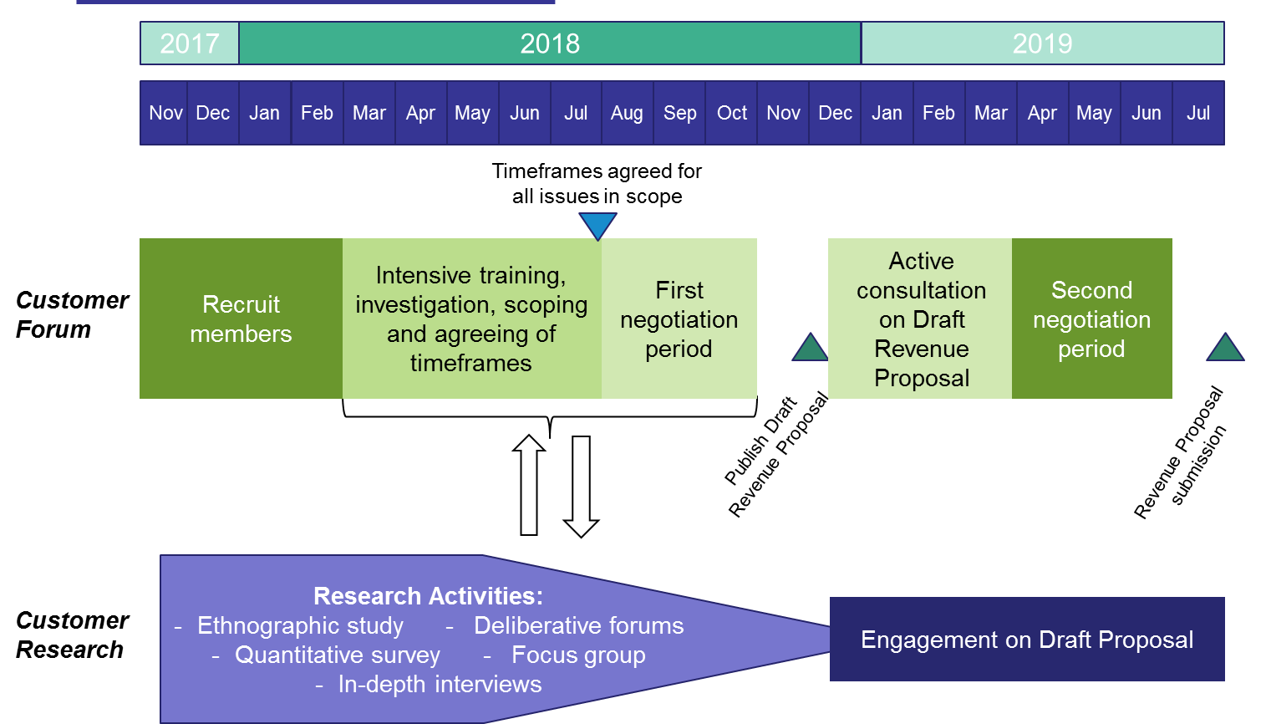

## AusNet Services’ and the AER’s engagement with the Customer Forum

### Training

Within the training stage in the first half of 2018, relevant technically qualified staff will work with the Customer Forum including key regulatory and engineering staff. This stage of the process will be characterised by intensive full-day sessions requiring a commitment of approximately one week per month (which may be scaled up or down as required) from Customer Forum members, AusNet Services staff and, where appropriate, AER staff. Time will be built into the program, and facilities provided, for the Forum to meet together.

***Agreeing on Scope***

The matters which will be in the scope of the negotiation will be agreed by AusNet Services, the AER and the Customer Forum over the period April to July 2018.

### Engaging the Customer Forum on matters in scope

As set out in section 5.1 above, AusNet Services and the AER will agree a timeframe which will set out when the Customer Forum will convene to engage on the matters in scope. For each of the matters in scope, this timeframe will:

* Identify when AusNet Services will provide its proposed approach to that matter available to the AER and the Customer Forum to review;
* Provide sufficient time for the AER to review and form a view about that matter; and
* Identify the meetings at which the AusNet Services approach and the AER’s view will be considered by the Customer Forum.

If required, there will also be sufficient time for the Customer Forum to be able to engage with customers or their representatives to seek input after these meetings.

### Negotiation

Senior AusNet Services staff with appropriate delegated authority are expected to undertake the negotiations with the Customer Forum. AusNet Services is entering into these negotiations with the intent of reaching agreement with the Customer Forum on all matters agreed as being in scope.

These discussions and agreements will be documented by AusNet Services staff, the drafting agreed by the Customer Forum, and published on AusNet Services’ website as soon as is practicable during the process. Areas of agreement and disagreement will be set out in the draft and final Engagement Reports.

## Administrative support

AusNet Services will provide administrative support for the operation of the Customer Forum. This will include:

* A permanent staff member with exclusive responsibility for supporting the Customer Forum including arranging meetings, assisting to provide information and inputs from AusNet Services, minute taking, assisting the Forum with report writing etc.; and
* Provision of meeting space for the Customer Forum members to meet independently and with AusNet Services.
* Liaising with ECA and/or other relevant parties where required, on matters relating to Forum funding and relevant payment administration matters, communicating and clarifying questions regarding approved reimbursement policies and procedures and/or changes to these and reviewing related documents on AusNet Services behalf when required.

The administrative support and resourcing needs (e.g. drafting, the facilitation of meetings with customers or the CCC) of the Customer Forum will be monitored throughout the process. Additional administrative support will be made available should further resources be required to allow the Customer Forum to fulfil its role.

# Integration with other EDPR customer engagement

## Customer research

AusNet Services has commenced a comprehensive program of customer research to generate information on customer preferences. A variety of forms of customer research are being undertaken to build insights including exploratory research (such as ethnographic interviews) and secondary research exploring trade-offs and preferences (such as deliberative forums and discrete choice modelling).

There is flexibility in the final make up and design of the customer research activities undertaken. As discussed in section 2.2, the Customer Forum will have an opportunity to provide input into the design of this research program and the themes to be tested with customers. The Forum members will also be invited to attend and/or participate (as appropriate) in all research activities.

The output of the customer research will be made available to the Customer Forum in the months leading up to June 2018 to inform it as it enters the negotiation phase. This will be in the form of presentations and briefing notes on the customer engagement activities undertaken, the insights gained, and how these pertain to the matters within the scope of negotiation. In agreeing aspects of the regulatory proposal, the Customer Forum will need to be satisfied the customer research provides sufficiently robust and clear insights into customer preferences and priorities. As noted in section 2.2, the Customer Forum will have the ability to commission additional or different research, having regard to timing and budget considerations.

The Customer Research program is shown in the figure below.

Figure 3 Customer Research input to the Customer Forum

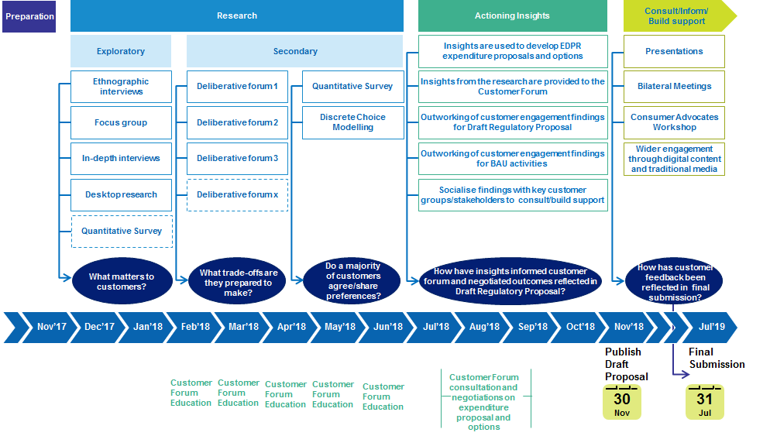

## Engagement on the draft regulatory proposal

The Customer Forum will be involved in the active engagement process on the Draft Regulatory Proposal, which we expect to issue publicly at the end of November 2018. AusNet Services will agree the form of involvement with the Customer Forum. For example, Forum members may present on their involvement in developing the draft regulatory proposal as part of engagement on the draft regulatory proposal.

A final engagement report will be prepared at the end of the first negotiation period, and published along with the draft regulatory proposal. Any further negotiating activities and outcomes following consultation on the draft regulatory proposal will be documented in addendums to the final engagement report.

As noted above, a second round of negotiation will be held with the Customer Forum at completion of the public consultation process. The Customer Forum will have access to all feedback from the consultation and will work with AusNet Services on how to account for this feedback in finalising the Regulatory Proposal for submission to the AER in July 2019.

## Engagement with AusNet Services’ Customer Consultative Committee

The Customer Forum will periodically meet with the CCC to present on their progress and activities and to seek advice or inputs from the CCC as desired, as well as conduct direct engagement with CCC members that are also customers. Interactions with the CCC may be in the form of informal or formal meetings, which AusNet Services staff may not be present at in some cases. Regular communications on the status of the Customer Forum process will also be provided to the CCC as a standing item on its agenda to ensure its continued close engagement.

# AER role

The role of the AER is critical to the success of the trial. Support from the AER will ensure that both the Customer Forum and the business have strong incentives to reach a genuine, mutually acceptable position on AusNet Services’ regulatory proposal.

We expect the AER to provide support and guidance throughout the process. In particular, the AER should use reasonable endeavours to flag any areas of concerns with the process as soon as they arise, and suggest actions that could be taken to address these concerns in a timely manner.

Specific elements of the AER’s role may include:

* The AER providing input to the recruitment process, such as providing feedback on suitable candidates, but will not be part of the selection panel. Once the Forum is established, the role of the AER will be one of informing and guiding the Customer Forum. While the AER will not be a party to the negotiation process between the Customer Forum and AusNet Services, it will be closely involved in providing background information to the Customer Forum early in the process, such as in relation to previous AER decisions, guidance on AER assessment approaches and its statutory roles and responsibilities in revenue determination processes. This context will be provided in a way that does not require Forum members to have energy industry or regulatory expertise.
* The AER helping to determine the scope of matters for negotiation, including by communicating the boundaries of the Rules and what it may consider acceptable regulatory outcomes.
* The AER may provide guidance to the Customer Forum on selected issues (i.e. through presentations or advice notes) and may also provide technical support where requested. For example, we would expect the AER to provide to the Customer Forum an indicative range of expenditure allowances that it may consider efficient, or components of these allowances.
* The AER may attend, as an observer, Customer Forum meetings where key decisions or negotiations are to take place.

As discussed above, the Engagement Report (which accompanies the regulatory proposal) may provide a useful starting point for the AER’s assessment of the regulatory proposal, including identification of areas that were explored but ultimately not agreed. The AER must have regard to the Engagement Report when making the Draft and Final Decision. Furthermore, if the AER considers it appropriate, it may expedite and/or streamline the formal revenue determination process. Were the AER to expedite its regulatory process, it may do so after the draft decision stage to allow for consultation on the outcomes of the trial.

# ECA role

ECA will have the following key roles in relation to the Customer Forum:

* *Guidance and Consultation:*
  + Consultation on skills and potential composition of the Forum.
  + As with the AER, ECA will also provide guidance and information to the Customer Forum for example, on customer views/preferences and on the regulatory framework.
* *Remuneration administration:* ECA will provide independent administration for remuneration and expense reimbursement for the members of the Customer Forum. The administration of expenses will be from funds provided by AusNet for this purpose and will be in accordance with policies, procedures and remuneration schedules agreed in advance with AusNet. These arrangements are currently being established with ECA.

# Attachment A: Draft Engagement Agreement

1. Independent of AusNet Services’ trial for the 2021-25 EDPR, the Australian Energy Regulator (AER), Energy Consumers Australia (ECA) and Energy Networks Australia (ENA) are developing a New Reg Model to test the application of the negotiated regulatory approach in Australia. AusNet Services’ trial will be heavily informed by, and link very closely to, the Model being developed by the AER, ECA and ENA.
2. The CCP advises the AER on whether network businesses’ proposals are in the long term interests of consumers and the effectiveness of network businesses’ engagement activities with their customers and how this is reflected in the development of their proposals.
3. AusNet Services’ Customer Consultative Committee comprises seven AusNet Services representatives, including the Managing Director, and eleven external representatives from a range of customer interests and community groups. External membership of the Committee collectively represents a cross-section of AusNet Services’ customers. The Committee’s purpose is to generate insights that help guide decision making within the business, and serve as a direct channel for external customer perspectives. Members provide comment on issues facing regulated energy services (electricity distribution, transmission and gas networks), and commercial energy services.