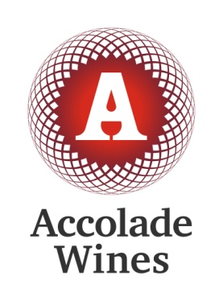

Submission

SA Power Networks Regulatory Proposal 2015-2020

June 2014

Submitted on behalf of Accolade Wines by:

Wayne Ellis

wayne.ellis”at”accolade-wines.com

****Executive Summary****

Accolade Wines’ supports the Australian Energy Regulator’s decision to limit increases as proposed by SA Power Networks.

Accolade Wines is a major energy user, our Berri winemaking operation is one of the largest in the Southern Hemisphere crushing around 200,000 tonnes of grapes each year and using around 29,506,237 kWh in the last 12 months to May 2015.

Our power use is extremely seasonal, peaking during vintage when crushing grapes, chilling the juice and pumping juice and wine around our Berri site is extremely energy intensive. Outside of the three months of vintage period our base-load is much, much lower, Jan 2015 was 5191 kVA and 4634 kVA on average (over 9 months non-vintage May to Jan) compared with the vintage peak actual demand of 7423 kVA and charged at contract demand of around 8073 kVA; however, the pricing structure imposed on our business is based on our peak load during vintage (Feb Mar April).

Our recommendations

1. The Australian Energy Regulator’s decision is implemented in full or with even further revenue cap reductions.

2. That the baseline year for Efficient Operating Expenditure should not be 2013/2014 or any year in the previous regulatory period 2010-2015. The base year should be from the more efficient Regulatory Period such as 2005/2010.

3. In a time of static or low demand basic business principles should apply which would involve finding productivity improvements by reducing operating expenditure in real terms and minimising capital expenditure.

4. We also recommend more frequent demand reviews at the very least six monthly, ideally quarterly so that pricing structures better reflect demand.

****Introduction****

**Accolade Wines**

Accolade Wines is a global wine company with a long and proud Australian heritage whose brands sell in over 100 countries. Headquartered at Reynella, South Australia, we employ more than 1500 people in Australia, the UK, North America, mainland Europe, Asia, South Africa and New Zealand. Many of our staff are located in major viticultural regions around regional Australia.

We are the number one wine company by volume in the UK and Australia.

In Australia, our wine range, led by Hardys which dates back to 1853; includes the 179 year-old Houghton label, recently acquired Barossa brand, Grant Burge Wines, as well as Banrock Station, Omni, Goundrey, Brookland Valley, Berri, Stanley, Amberley, Moondah Brook, Reynell, Renmano, Leasingham, and Tasmanian labels Bay of Fires and Eddystone Point, plus sparkling brands House of Arras and Yarra Burn.

We operate three wineries in South Australia; Hardys Tintara, Hardys historic home in McLaren Vale, the Grant Burge Winery in the Barossa Valley and the Berri Winery, near Berri.

The Berri winery is the largest in our business and one of the largest in the Southern Hemisphere, crushing around 200,000 tonnes of grapes each vintage primarily for our best-selling Berri, Stanley, Renmano, Hardys and Banrock labels.

Energy is one of the highest input costs at Berri, alongside grape purchases and labor, as such, it is a significant factor in our domestic and export competitiveness.

****Energy pricing****

Typical Energy consumption patterns at Berri

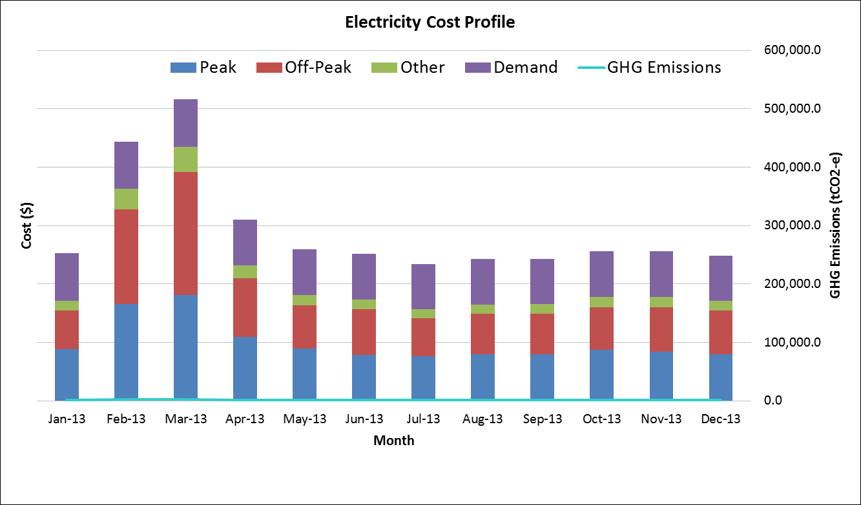

Onsite investment for Energy efficiency consumption and demand reduction

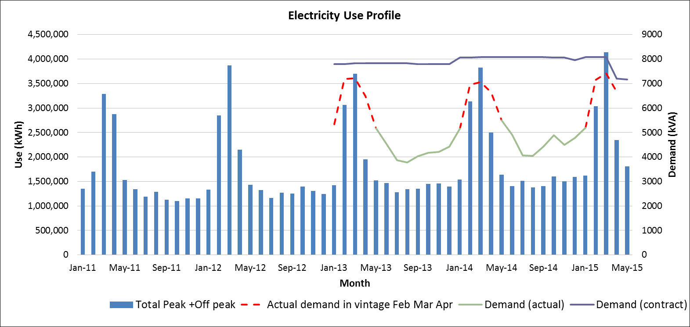

SA Power Networks review our operations and power demand only when we request a review, and then base our consumption on our peak loads during our highest consumption period during vintage.

This means that for the remaining nine months of the year we are charged on a basis well above our usage. For example: the nine month average non-vintage peak demand in 2013 was 4390 kVA, while in 2014 the average was 4696 kVA. This compares with the peak demand in just one month at 7222 kVA in March 2013, 7062 kVA in March 2014 and 7423 kVA in March 2015.

However despite the fact that for decades we have shown demand patterns that peak in a single month we have been charged for maximum contract demand around near 8000 to 8080 kVA for the last 29 months, although the Berri site only got near that in three individual months in that time period. In addition these Network fees have more than doubled (up 116%) in five years whilst annual kWh consumption has remained largely unchanged.

In contrast, our operations just across the NSW border in Buronga (on the other side of the River Murray to Mildura) are reviewed monthly and hence our energy costs more accurately reflect our consumption.

**Disproportionate changes in fee structures   
at Berri Estates Winery in South Australia**

|  |  |  |  |  |  |  |
| --- | --- | --- | --- | --- | --- | --- |
| **Annual Expense** | **F2010** | **F2011** | **F2012** | **F2013** | **F2014** | **F2015** |
| Network fees $ | 922,594 | 1,116,979 | 1,369,768 | 1,775,253 | 1,793,434 | 1,982,656 |
| Energy used $ | 1,278,662 | 1,302,485 | 1,441,730 | 1,619,474 | 1,599,606 | 1,441,835 |
| Market Participation $ | 100,366 | 208,969 | 125,576 | 30,059 | 31,725 | 80,256 |
| Renewable Fees $ |  |  | 184,968 | 247,559 | 246,651 | 228,102 |
| Demand kVa |  |  |  |  |  |  |
| **TOTAL $** | **2,301,623** | **2,628,432** | **3,122,041** | **3,672,345** | **3,671,416** | **3,732,848** |

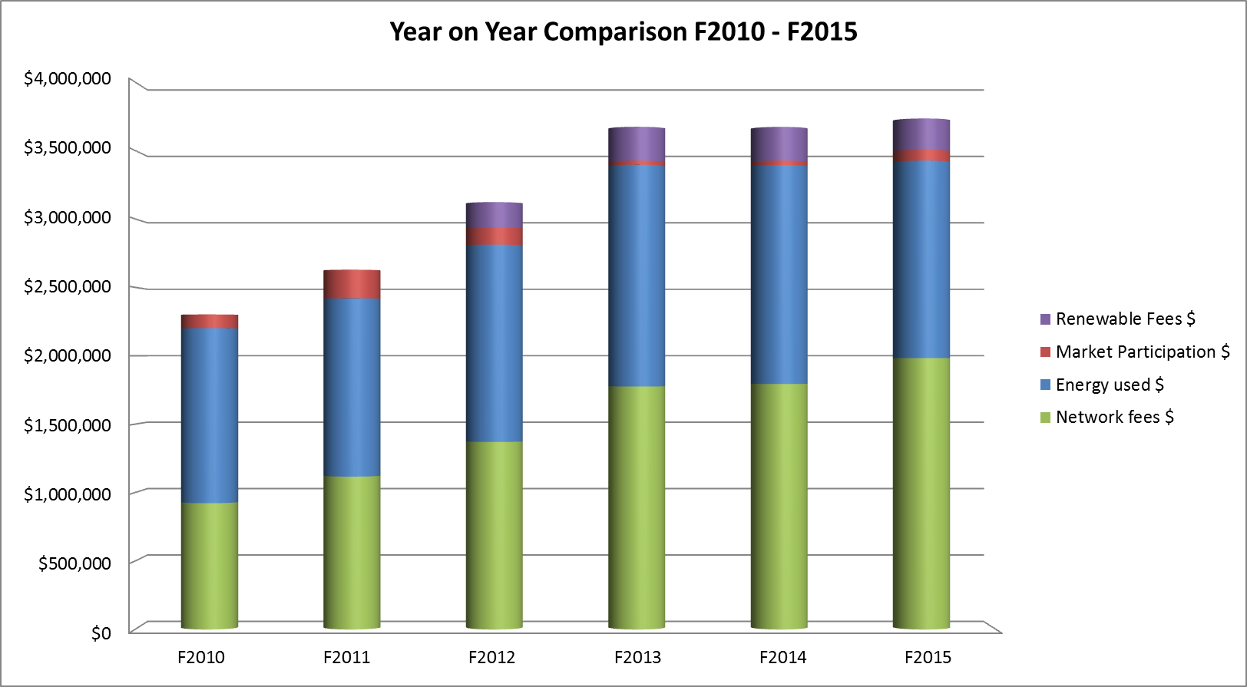

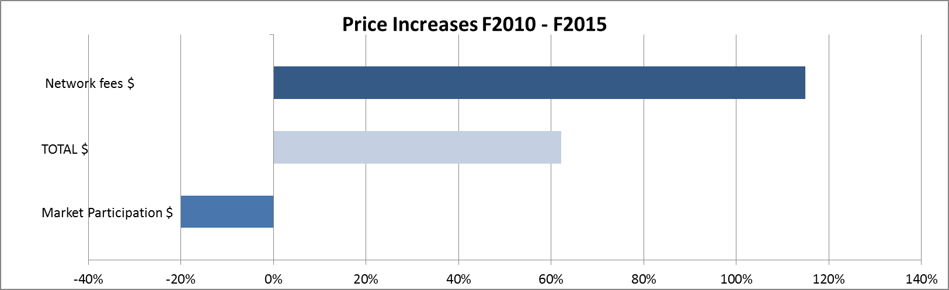

****Discussion****

AER determination implemented in full

We believe that the AER determination is the absolute minimum reduction we should see in the revenue caps for SA Power Networks. We believe that the determination is a fair and adequate review of the proposal and will allow SA Power Networks to continue to provide its highly reliable service at a lower cost than was sought.

The determination highlighted significant information that was not disclosed in the Regulatory Proposal and not available to customers such as joint programs that are already in progress with the state government. The determination also recognises the view of many consumers that distribution charges were too high and were seeking some relief from the previous price shocks.

Operating Expenditure

We disagree that the base year selected for efficient operating expenditure is 2013/2014. The 2010/2015 Regulatory proposal was one of rapidly escalating operating costs and far exceeds in real terms the operating costs from the previous regulatory periods. We believe that further reductions should occur if the base year for efficient operating expenditure was selected from a regulatory period prior to 2010 and adjusted by CPI.

Basic Business Principles

SA Power Networks is faced with a climate of static or falling demand. The optimistic demand forecasts of the 2010/2015 which saw significant increases in revenue allowances did not eventuate however we saw no corresponding revenue returned to customers.

With the eminent closure of General Motors Holden’s Salisbury operation and with it, many suppliers, South Australia’s depressing economic forecast, saturation of the residential air-conditioning market and potentially more downside to electricity demand still to come as the many homeowners who have solar power move to take advantage of the growing opportunity to store their own electricity.

In most other businesses during a time of static or falling demand the business seeks ways to improve productivity, reduce costs and only spend on essential capital. We do not see these basic business principles being applied either within the SA Power Networks Regulatory Proposal and the AER determination In fact we will see SA Power Networks productivity decline. We suggest that even further revenue reductions could occur in the Operating and Capital Budgets.

Regulated Asset Base

In this proposal the Regulated Asset Base continues to increase above inflation in an environment of falling demand. And whilst the AER’s determination sees a reduction in capital expenditure to that proposed we do not see the justification for a real continual increase in the Regulated Asset Base.

Sharing the gains evenly

Our businesses have suffered significantly with unsustainable power price increases over the 2010/2015 regulatory period. We should all now share the gains evenly.

****Conclusion****

Whilst we support the AER’s determination on the 2015/2020 Regulatory Proposal by SA Power Networks we believe that even further reductions are possible in both Operating Expenditure and Capital Expenditure without reducing the current service provided.

We also would suggest the regulator examine why SA Power Networks cannot review consumption loads on a more regular basis, given that interstate network operators can accommodate this.

We look forward to a decision that truly takes into account the long term interests of customers with the revenue reductions applied evenly to all customers.