# Risk and financial returns

DRAFT prepared for discussion with ENA on 19 February only. Nothing in this document constitutes an agreed CRG position.

## Introduction

This paper outlines the relationship between the concept of risk as faced by investors in network businesses and the return on investment that they require to compensate them for taking that risk.

Stripped of all the florid language about efficient investment, efficient financing costs and a benchmark efficient entity, the objective of the laws (as specified in the National Electricity Law (NEL) and National Gas Law (NGL)) is that investors should only receive the level of return that would induce them to make the investment. The Revenue and Pricing Principles (RPP) and the Allowed Rate of Return Objective (ARORO) do nothing more than expound that principle.

The ARORO does however require that rate of return for a [service provider] is to be commensurate with the efficient financing costs of a benchmark efficient entity with a similar degree of risk as that which applies to the [service provider] in respect of the provision of the [regulated services].

The ARORO introduces the concept from finance that the rate of return required is determined by the risk faced by the business. Importantly, it also emphasises that the risk of interest is the risk that applies to the service provider in respect of the provision of the regulated services. This latter point will be considered later in this note.

The challenge for the regulator is then to determine is what this rate of return is. There are two aspects to this challenge. The first is to determine the components that make up the rate of return; that is, what are the measures to be used. The second is to choose the method for determining the values that should be assigned to each measure.

The Rules require the first step of this by requiring the rate of return to be the weighted average of the return on equity and the return on debt. This creates three measures (or parameters) for which a value has to be determined. The values are not, however, usually simply observable facts. They must be inferred from observable data sets.

This process of inference is referred to as ‘estimating.’ ‘Estimating’ is a technical term for the use of mathematical and statistical techniques to derive these underlying values. These techniques have, in turn, usually been subject to mathematical evaluation. As a consequence of that evaluation, some of these techniques will be referred to as providing the best unbiased estimation. It is always important to remember that this conclusion is usually based on some assumption about the data set – typically that it is normally distributed.

## Project valuation

A project’s cost of capital is the minimum expected rate of return needed to attract the required capital. A project is a discrete undertaking that requires capital (in the corporate finance sense of cash tied up as equity) and that is expected to provide a positive real return on its capital, net of operating costs. The last part of the condition is that we are only interested in ‘financeable’ projects. (Armitage 2005, 4)

The simplest kind of project is one that lasts only one period and has a guaranteed return at the end of that period. The question is what rate of return is required to finance the project.

Economic analysis proceeds by analysing the preferences of an individual, an assumption is made that for any consumer there is a perfect ordering of the utility of all possible contingent states. An individual with an initial amount of money has a choice of how much to spend and how much to save for the end of the period. For each consumer the return they require on the amount saved will vary depending on their preferences. The theory of interest rates is that there is a rate of return (the interest rate) so that the amount of money people are willing to save equals the amount of money people are willing to borrow. This is the concept of an equilibrium.

The important point is that the interest rate is determined by the balance of preferences.

It is also the answer to the question of what rate of return is required for the one period guaranteed return project to be financeable—the rate of return needs to be greater than or equal to the interest rate.

## Variance and expected return

Projects however do not have a guaranteed return. In general, it can be assumed that there is a range of returns with different probabilities of their occurrence. These kinds of ranges are referred to as ‘random variables’. A random variable that is normally distributed is the familiar bell-shaped curve. This type a variable can be completely described by its mean (often referred to by the symbol *µ*) and by its standard deviation (*σ*) or variance (*σ2*).

If an investor was presented with a wide range of projects with uncertain returns, the investor could be expected to invest in that wide range of projects if the return could be expected to be higher than the interest rate. We refer to a group of investments/projects as a portfolio. The expected return from a portfolio is then the sum of the mean for each investment weighted by the proportion each investment is of the portfolio.

However, we know that humans are typically *risk averse.* They not only have regard to the expected return from the portfolio, but also the variance of the individual investments in the portfolio. If the portfolio of investments are shares, the return on those shares is the price of those shares at the end of the period plus any dividend minus the initial price all divided by the initial price.

To express this mathematically the return on each asset *j* in contingent state *s* is;

*Rjs = (**Pjs + Divjs – Pj0) / Pj0*

where

*Rjs* is the return of asset *j* in state *s*

*Pjs* is the market value of asset *j* in state *s*

*Divjs* is the dividend of asset *j* in state *s*

*Pj0* is the market value of asset *j* at date 0 (the start)

The expected return for each asset *j* is then;

E(*Rj) =* Σs *πs Rjs [1]*

where

*πs* is the probability of state *s* (and Σs *πs* =1)

The investor chooses a portfolio *H* that is a collection of assets, the expected return o the portfolio *H* is then:

E*(RH)* *=* Σj E(*Rj) =* ΣjΣs *πs Rjs*

where

E*(H)* is the return of the portfolio.

The insight that the investor’s utility from the depends on both the expected return but also the variability of that return. We express this as;

U(*H)* = U[E(*RH), σH2]*

where

*σH2* is is the expected variance of the portfolios’s return, so

*σH2 = var(RH)*

= E[RH – E(RH)]2

= ΣjΣk wj wk *σjk*

where

*σjk* is the expected covariance of the returns on assets *j* and *k* = cov(Rj,Rk)

For *j=k* *σjj* = *σj2* is the expected variance of returns on *j* = var(*Rj)*

wj is the weight (proportion) of asset *j* in the portfolio.

[Logic Jump]

## The Capital Asset Pricing Model

This framework is then used to develop the concept of an *efficient portfolio*. A portfolio is efficient if, for a given pool of assets from which portfolios can be constructed, no portfolio is feasible that has the same or higher expected return and a lower variance.

In the diagram below, the *minimum-variance frontier* for risky assets shows, for any expected return, the minimum possible variance of a portfolio that provides the expected return. That the shape of the curve is a parabola is based on two assumptions; that all portfolios have some risk and that no assets or portfolios are perfectly correlated.

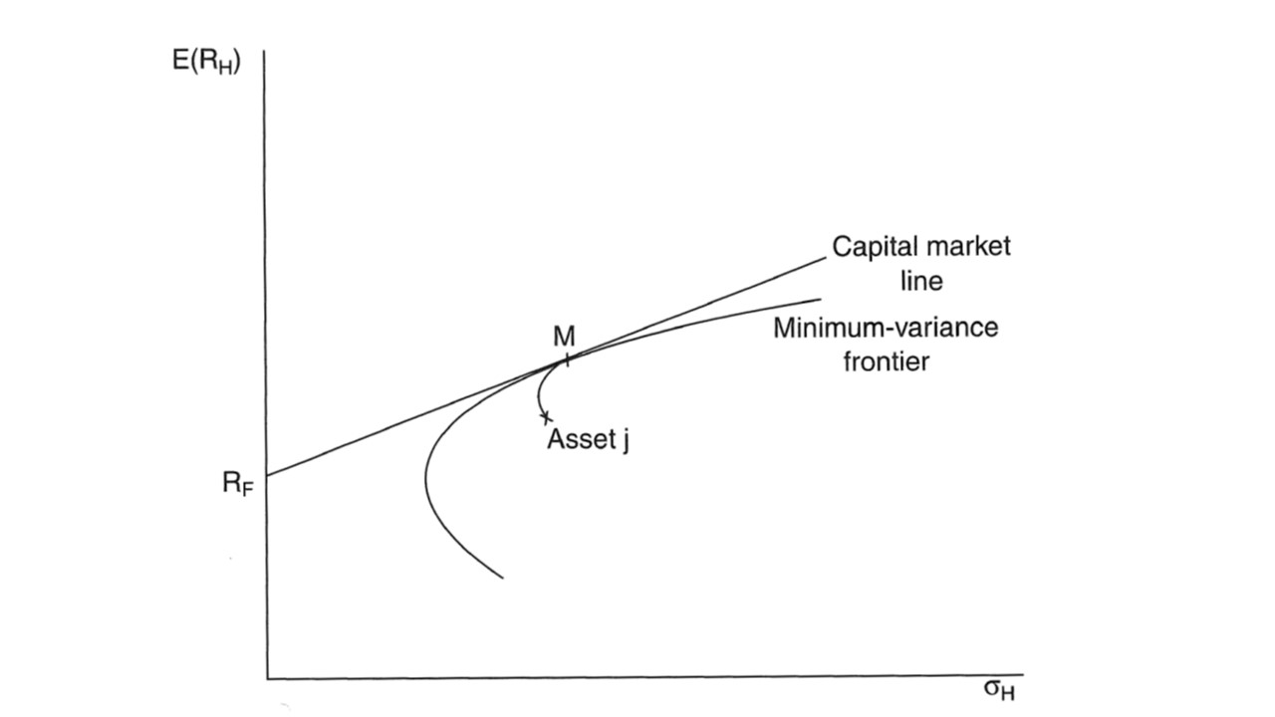

[Logic Jump]

There is one specific portfolio of special interest, which is the market portfolio M in which the weight of each asset is its share of the total value of the market. The trade-off for all investors between expected return and variance is given by;

E(RH) = RF + α[E(RM) – RF]

This is the *capital market line.* …

[Logic Jump]

We now consider an individual asset *j* that is below the efficient frontier of risky portfolios. We consider a case of a portfolio H with 1- θ in asset j and θ in the market portfolio M. As θ moves between zero and one, the portfolio H moves along the curve between j and M in the figure above. The slope of this line is the trade-off between the expected return and risk (variance) of H.

With some extra maths to calculate the slope of the line j-M where it is tangent to the capital market line, and by equating the two, we establish that

E(Rj) = RF[1-rjMσj/σM] + E(RM) rjMσj/σM

where rjM is the correlation coefficient between j and M,

and σjM = rjMσjσM

= RF + βj [E(RM) – RF]

where

βj =rjMσj/σM = rjMσjσM /σM2 = σjM/ σM2

There are three steps in this argument;

1. The risk of an efficient market portfolio (on the capital market line) is measured by its exposure to the variance of the market portfolio,
2. The marginal rate of compensation for risk required by investors in aggregate o hold an asset at its market price must be the same as the relation between the expected return and risk across efficient portfolios – that is it equals the slope of the capital market line. This is the condition for a capital market equilibrium.
3. Consequently, the risk of an asset relevant to its price and expected return is its exposure to the market variance, which is measured by its covariance with the market returns βj.

## Interpretation

The Capital Asset Pricing Model tells us that, in equilibrium, there is a linear relation between the risk premium on an asset and its ‘systematic risk’ measured by beta, which is the covariance of the returns on the asset with the returns on the market.

More generally the derivation of the CAPM tells us that the market portfolio is the efficient portfolio on the minimum-variance frontier tangential to the capital market line. The expected return on this portfolio is based on the accepted level of market risk (σM2).

The variability of total market returns that is captured by this reflects the economy wide factors that determine how well assets can perform. Principally the main driver of this overall variability of diversifiable variability are macroeconomic factors as reflected in the ‘business cycle’; that is the cycle of expansion and contraction in the economy.

It is important to recognise that what we are using is market data to assess the underlying characteristics of the assets. As McKenzie and Partington note:

*Unfortunately, the use of the securities as an instrument to measure the required return (cost of capital) has led to confusion. In particular, it can lead to the mistaken belief that it is the financing package that determines the required return. A moment’s thought will reveal that this implies that the investment inherits the characteristics of the portfolio of securities issued to finance the investment. That is, the risk of the investment (assets) is determined by the risk of the securities.*

*Clearly it is the other way around. The risk of the portfolio of securities (but not individual securities) and the risk of the portfolio of assets are the same. The portfolio of securities inherits the risk characteristics of the assets. Ultimately, all the cash flow that goes to service the securities has to be the cash flow that the assets generate. There is no cash flow from anywhere else - no assets means no cash flow. As such, the expected return and risk for the portfolio of issued securities has to match the expected cash flow and risk of the assets.* (McKenzie & Partington, 2013, p. 6)

It is possible to calculate the value of beta in the CAPM by directly comparing the returns of an asset with the overall returns of the market. That is, we can cut out the ‘middleman’ of the dividend policy and market valuation of the equity itself.

Phrased another way, it is appropriate to test the conclusion of the market estimation of beta with the sources of variation in return (the types of risk faced). We can identify non-financial and financial risk for any firm;

|  |  |
| --- | --- |
| Business risks | Financial risks |
| Demand risk | Refinancing risks |
| Input price risk | Interest rate reset risk |
| Cost volume risk | Default risk |
| Suppliers risk | Financial counterparty risk |
| Inflation risk |  |
| Competition risk |  |
| Stranding risk |  |
| Political/regulatory risk |  |
| Other business risks |  |

The structure of the regulatory regime mitigates many of these risks for an Australian regulated business. For example, under a revenue cap there is no demand risk. There is no competition or stranded asset risk. There is no default risk.

As demonstrated through the review of inflation, there is an interest rate risk born by equity holders.

Interestingly, regulatory risk can be increased by changes in the allowed rate of return.

Investors are no more perfect in their decision making than consumers and are likely to make decisions about their valuation of assets on imperfect information. For example, if there is a lot of discussion about asset stranding investors may think they are exposed to a stranding risk that does not exist. Similarly, policy changes (such as the removal of Limited Merits Review) may be considered to have a greater impact on the certainty of regulated cash flows than is warranted.

It is not clear that the incentive of management is to ensure investors are well informed about risk. Convincing shareholders that the risk of the business are higher than they really are will result in management receiving a higher remuneration to manage that perceived higher risk.

## Assets versus portfolios

In the derivation of the CAPM the point marked *j* in the return/variance map is referred to as either a portfolio or asset. It actually doesn’t matter for the purposes of the derivation. An asset is just a portfolio of one item.

Any business enterprise is actually a portfolio rather than an asset. This is clearest in so-called diversified companies participating in a number of markets. *Westfield* at one stage organised itself to provide direct share-market access to its two asset classes with different risks; the low risk ownership of shopping centres and the higher risk business of being a shopping centre developer.

It is noted that the market value of the few listed or traded networks is usually higher than the value of the Regulatory Asset Base. The explanations of that (Grey and Biggar) both note that the valuation of the firm is based on the fact that it has more than one stream of cash flows. Most specifically there are the following three cash flows, and associated assets:

|  |  |
| --- | --- |
| **Cash Flow** | **Asset** |
| Return on capital | Regulatory asset base |
| Profit from unregulated businesses | Assets used in ACS or in ring-fenced or unregulated pipelines |
| Incentive scheme payments, financial (and tax) engineering | Management team* |

* The asset value of the management team is determined by the cash flows that it is expected to generate; that is it is valued by mark-to-market.

The CAPM suggests that the return on equity of these assets can vary. The return on equity on these assets can’t be estimated if the error is made of assuming that the return measured has to be the equity return rather than the asset return.

The return on capital on the RAB is a relatively stable cash flow. In the CAPM it would attract a very low level of beta. The incentive schemes and the outcomes of financial engineering are far more variable. As a consequence, the Beta would be higher, as would the investments in unregulated businesses. In other words, if the benchmark efficient entity is indeed a pure play regulated network, the Allowed Rate of Revenue Objective **requires** the AER to apply a beta for the asset (the RAB) rather than apply the beta of the enterprise.

The approach of estimating beta on the covariance of actual returns from the regulated asset to the market portfolio also eliminates the small sample problem.

## Gearing

The same conclusion can be reached about gearing. The AER has argued that gearing should be estimated from the market value of the asset and the market value of debt. The only market value available is the market value of the enterprise, and the AER substitutes the book value of debt for market value of debt. This is the appropriate way to determine the gearing of the enterprise.

Advocates who have been concerned about this approach have noted that the relation of debt to RAB results in higher estimates of gearing. The concern of advocates is that the approach to gearing doesn’t feel right.

The above discussion about the decomposition of the enterprise into a set of assets applies as well to gearing as it does to calculation of returns. There is no reason why it has to be assumed that the three assets that contribute to firm valuation have the same gearing.

The providers of debt finance do so by making an assessment about the cash flows of the underlying assets or their resale value. The network businesses have a strong credit rating based on the cash flows from the regulated assets. They would not provide this debt finance to the other two assets if they were stand-alone businesses.

The correct gearing to be applied to the regulated asset base lies somewhere between the market value based gearing of the entity and the gearing obtained by relating debt only to the RAB.

The idea that gearing varies by asset has its most extreme version in the case of a financial lease; this is really just an asset that is 100% debt financed.[2]

Assessing gearing by observing the gearing of a small number of firms is also not an estimate of the efficient level of gearing, which is the gearing in the efficient financing cost of an efficient pure play regulated business (or business operating regulated assets). Gearing itself is a variable on which the cost of debt is determined. There is a theoretical optimum gearing ratio to keep cost of capital as low as possible.

Energy consumers are not, however, in a position to form a view on this. Network businesses have the information and resources to determine what value above actual enterprise gearing is appropriate. In the case of information asymmetry a regulator should assume the outcome that is worst from the perspective of the party who has the information, as this provides the appropriate incentive to reveal the information.

Glossary

**Covariance** is a measure of the joint variability of two variables.   
If the greater values of one variable mainly correspond with the greater values of the other variable, and the same holds for the lesser values, i.e., the variables tend to show similar behaviour, the covariance is positive.[2] In the opposite case, when the greater values of one variable mainly correspond to the lesser values of the other, i.e., the variables tend to show opposite behaviour, the covariance is negative. The sign of the covariance therefore shows the tendency in the linear relationship between the variables.   
The magnitude of the covariance is not easy to interpret because it is not normalized and hence depends on the magnitudes of the variables. The correlation coefficient is a value obtained by ‘normalising’ the covariance by dividing it by the product of the standard deviation of each variable, and shows by its magnitude the strength of the linear relation.

{More to come}

1. Σs *πs* is a notation that means the sum of the values of *πs* for every state *s.*
2. The assets that can be leased are quite large. Optus was required to have a nominated carrier declaration for its B1 satellite because it was leased from the Commonwealth bank <https://www.acma.gov.au/Home/Industry/Telco/Carriers-and-service-providers/Licensing/register-of-licensed-carriers-licensing-i-acma>