Mr Warwick Anderson
General Manager
Australian Energy Regulator
GPO Box 3131
Canberra ACT 2601
By email: NSWACT@aer.gov.au

13 February 2015

Dear Mr Anderson

Cotton Australia welcomes the opportunity to comment on Essential Energy’s revised regulatory proposal for the period 1 July 2014 to 30 June 2019.

Introduction to our industry and key issues
Cotton Australia is the key representative body for Australia’s cotton growing industry. The cotton industry is a small but integral part of the Australian economy, worth over $2 billion in export earnings and employing 10,000 people. The industry’s vision is: Australian cotton, carefully grown, naturally world’s best. Cotton Australia works with industry to achieve this vision by providing a policy and advocacy role, research direction, stewardship and building our farmer’s capacity in their own communities. We are proud of our efforts to ensure an efficient and sustainable cotton industry. Our ‘myBMP’ is a voluntary farm management system which provides self-assessment mechanisms, practical tools and auditing processes to ensure that Australian cotton is produced with in line with best practice.

Since the millennial drought, irrigators throughout NSW have made significant improvements in water use efficiency (up to 40% in a decade) through capital investments to upgrade and improve irrigation equipment. However, in many cases, the irrigation equipment is more energy intensive and there is a clear trade-off between water use efficiency and energy efficiency in irrigated production. Irrigation now represents between 40–75% of the on-farm energy use (Figure 1).

Figure 1: Average energy consumed in different areas of cotton production.
Source: National Centre for Engineering in Agriculture

Significant increases in electricity pricing (up to 300% in five years) are driving growers to either move off grid or revert to irrigation techniques that do not conserve water but minimise energy consumption. Both outcomes are unfavourable long term for our growers, Essential Energy and the broader community.

Over 60% of Australian cotton is grown within Essential’s northern and southern distribution networks. Network charges form up to 60% of an irrigators electricity cost and as such Essential Energy’s regulatory proposal directly impacts the profitability of Australia’s cotton production. Essential’s customers are already exposed to the second highest network costs in the country averaging approximately $1120 per year, however many irrigators face costs of between $10,000 –$100,000. It is our view that even an increase of CPI will have a lasting and unsustainable impact on farm profitability.

Our key issues for consideration by the AER are:
- To implore the AER to remain firm on their decision to reduce allowances for operating and capital expenditure. We would also ask the AER to consider where further cost savings may be achieved through additional changes to vegetation management operating expenditure.
- Essential Energy is driving for additional capital expenditure on the platform of reliability and safety, a decision which is largely justified by consumer feedback. We would ask that the AER continue to use the key criteria of safety and utilisation as the means to assess the need for further capital expenditure. This will shift away from pure reliability targets and towards performance based measures.
- To continue to drive the networks towards improved business efficiencies through the implementation of benchmarking
- To drive down the WACC to reflect the nominal risk free rate and the changed economic environment observed in 10 year corporate bonds
- To ensure that only urgent capital works are carried out by Essential Energy to avoid future inflation of the RAB
- To push for reform of determination of the RAB to avoid ongoing costs to all consumers for underutilised network assets
- To commit Essential Energy to network price rises under CPI for all consumers
- To require Essential Energy to maintain a dialogue with larger energy users in future such as irrigators, in recognition of the significant impact of network costs on overall business profitability; and
- To prevent Essential Energy from ‘re-assigning’ customers to new tariff classes without consultation.

Our understanding of the revised Essential Energy proposal
In the revised regulatory proposal, Essential has identified a revenue requirement of $6.8 billion over the five year period smoothed, with a capital and operating expenditure program of $2.5 billion and $2.3 billion, respectively. The proposal also provides Essential with a weighted average cost of capital of 8.85%, compared to the AER draft decision of 7.15%.

We note the following differentials between the AER draft determination and the revised Essential Energy proposal:

 | Total Revenue Requirements | Capital Expenditure | Operating Expenditure | Weighted Average Cost of Capital
Essential Energy Initial Proposal | $6.76 b | $2.57 b | $2.33 b | 8.83%
AER Draft Determination | $4.97 b | $1.89 b | $1.44 b | 7.15%
Essential Energy Revised Proposal | $6.84 b | $2.53 b | $2.33 b | 8.85%

Overall, Cotton Australia sees the revised Essential Energy proposal as a document which fails to identify how innovation will drive business improvement over the upcoming regulatory period. The revised proposal consistently falls back on the Rules as to why things should proceed under the status quo rather than looking forward to reduce costs and improve their current practice.

At a high level, our concern has been that certain constituent decisions of the AER’s draft determinations such as operating expenditure and allowed rate of return are inconsistent with the NER and have not led to a decision that satisfies the NEO [pg 217, Essential Energy Revised Regulatory Proposal].

Additionally, as presented in the table above, Essential Energy has clearly failed to heed the message coming from the AER to reduce expenditure and revenue requirements. Cotton Australia views the apparent attitude and approach of Essential Energy exceptionally poorly and is disappointed that instead of listening to the Regulator the network has in fact raised their revenue requirements beyond their initial proposal.

We note that it is key pillar of the National Electricity Objective that the ‘Law is to promote efficient investment in, and efficient operation and use of, electricity services for the long term interests of consumers of electricity’

Based on the windfall profits by Essential Energy over the previous determination period, a result not in isolation from the other Australian Distribution Network Service Providers (DNSP), it is apparent that there was significant disparity between the expenditure declared by Essential Energy and the actual costs incurred in delivery of a safe and reliable network.

Benchmarking – a tool to drive network efficiency
In recognition of the need to direct the DNSP towards improved business efficiencies the Australian Energy Market Commission (AEMC) affected new clauses within the Rules to allow for the development of benchmarking. Benchmarking allows the AER to determine the economic efficiency of a NSP by comparing its current performance to its own past performance and to the performance of other NSPs.

The Commission considers that the removal of the "individual circumstances" phrase will clarify the ability of the AER to undertake benchmarking. It assists the AER to determine if a NSP's proposal reflects the prudent and efficient costs of meeting the objectives.

The AER commissioned Economic Insights (EI), consultants with considerable experience in economic modelling and electricity distribution engineering, to conduct benchmarking of NSPs. Essential Energy within its revised proposal appears to be quite dismissive of the benchmarking process and its subsequent application to proposed capital and operating expenditure budgets.

Our analysis identified that benchmarking has inherent limitations such as the inability to conduct ‘like for like’ analysis across peer firms, data inconsistency and inaccuracy, and a failure in meeting statistical principles. [pg 107, Essential Energy Revised Regulatory Proposal]

However what failed to be made clear within the Essential Energy revised proposal was the level of consultation that EI engaged in to develop the data required to carry out the subsequent benchmarking calculations. According to EI, extensive consultation was conducted with DNSPs over the course of 2013 prior to the distribution of the economic benchmarking Regulatory Information Notices (RINs). RINs requested the supply of data relating to values and quantities of outputs, inputs and operating environment factors for the eight year period 2005–06 to 2012–13. DNSPs were given three months to supply an initial RIN draft to be signed off by the Chief Executive Officer level and a further two months to provide final data return. Results of the most recent five years of value information were required to be signed off by auditors and quantity information certified by engineering experts. DNSPs were given an additional subsequent period to lodge cross submissions in the event that there were any differences in bases of preparation identified by the network provider.

The initial results of the benchmarking analysis are provided in Figure 2. The most efficient NSP is given a score of one and according to the results presented it can be observed that while Essential Energy is not one of the worst performers it has considerable room for improvement.

Figure 2: DNSP average opex cost efficiency scores 2006–2013
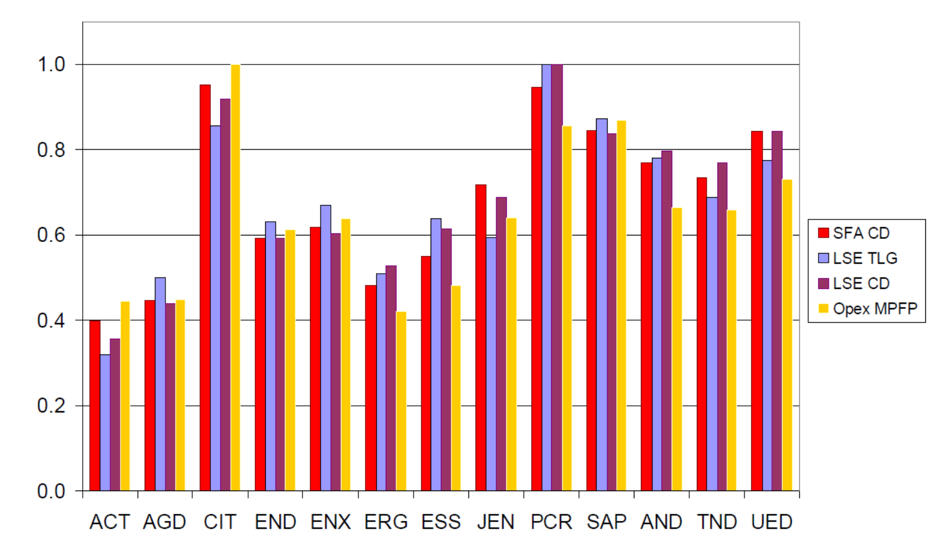

In recognition of the different operating environments in which the various NSPs operate, EI proposed a conservative allowance of a 10 per cent margin for NSW DNSPs in recognition of the system subtransmission intensiveness and OH&S regulations. This resulted in conservative efficiency targets of 78% which required a 35% reduction on 2013 level Essential Energy operating expenses. In the AER Draft Determination a reduction of 38% and 27% to the Essential Energy proposal to operating and capital expenditure, respectively. Consultation with Essential Energy has indicated that they did not feel that the AER adequately took in to account the variability within their operating environment.

The predominant issues indicated by Essential Energy with the proposed reduction in operating expenditure appears to be related to vegetation clearance and redundancy costs associated with continued improvement of business efficiency.

Operating Expenditure
Vegetation Management
We are aware that the Victorian Royal Commission following Black Saturday raised several concerns regarding the management of electricity assets. We support these recommendations and acknowledge that vegetation management and asset replacement should form a crucial component of Essential Energy’s budget. However we seek further clarification around the vegetation management strategy and question whether the current status quo in relation to vegetation management represents the most efficient and effective approach.

Essential Energy presented in their proposal that vegetation clearance is typically carried out using cyclic vegetation clearance and spot cutting of defects. However, as acknowledged within the Essential Energy proposal, ‘recent action has been to reduce spot trimming backlogs and shift resources in to cyclic trimming’. This appears to indicate that previous vegetation management was carried out on an ad hoc basis with insufficient planning and forecasting to reduce operating costs through 3 year pruning cycles.

Based on discussions Cotton Australia has held with Essential Energy it is understood that the operating expenditure for vegetation clearance will be largely the same across the previous and upcoming regulatory periods. With similar costs for vegetation management forecast, despite the apparent changes in labour use and a shift towards cyclic trimming, we would question why customers should continue to pay for historically poor vegetation management practices. We would also question whether the proposed changes to improved vegetation management have been put in place in practice by Essential Energy.

Anecdotally we have heard that more stringent vegetation management practices by the NSPs would alleviate the requirement for continuous / spot based management regimes. We believe the implementation of systems and procedures, which largely appear to be in place under ISSC3, could significantly reduce ongoing operational costs. We would also encourage a shift to a competitive tender process for vegetation management practices. This would represent a far more cost effective approach for the NSP, allowing pruning / lopping to be conducted according to predetermined work schedule that is audited by Essential Energy employees.

Redundancy costs
Essential Energy has already undertaken to implement workforce efficiencies over the previous determination period ‘steadily moving from a predominantly internal labour force to a blended model of internal and external resources ‘pg 195. As part of the upcoming Determination Deloitte undertook a review of the Essential workforce and found the EBAs to be restrictive and lead to higher comparative costs relative to their NSP peers in relation to superannuation, overtime and long service leave. While we recognise that transitioning towards a temporary / contract based workforce for certain maintenance and labour requirements takes time, we would expect to observe reduced costs in later years of the current determination. This would serve to reflect the continued drive for a blended model of internal and external resources.

It should also be noted that the AER has indicated that any redundancy costs incurred by the business should be absorbed by Essential Energy as they meet the operating expenditure criteria of efficiency and prudency. Essential Energy has disputed this reasoning that they do in fact meet the criteria of efficient costs – stating that it would be unreasonable for the AER to incorporate efficiencies but not allow the costs of any associated restructure. We would advocate that the AER remain firm in their stance that Essential Energy should fund required redundancy payments.

Capital expenditure
Despite the significant upgrades to network assets in the previous control period, Essential’s revised proposal identifies the need for continued capital investment to replace aging assets and meet “pockets of demand growth.” We accept the need for upgrades to network assets in order to maintain reliable and safe supply of electricity, but we question whether the network has invested sufficiently into demand management tools and opportunities, as an alternative to capital upgrades to augment or supplement the network for what amounts to be 4 hours per year in peak demand.

Peak demand estimates for the previous regulatory period were inaccurate by 5–23% (Figure 3), which led to over investment in the network and resulted in a higher than necessary regulated asset base ($6.5 billion). In its revised proposal Essential Energy defended the significant levels of capital investment:

The capacity installed during the 2009-14 regulatory period primarily addressed licence conditions, and we consider it inappropriate to suggest this investment was inefficient or unnecessary when it represented a regulatory obligation. [pg 126, Essential Energy Revised Regulatory Proposal]

Figure 3: Essential revenue, capital expenditure and peak demand 2009–2014
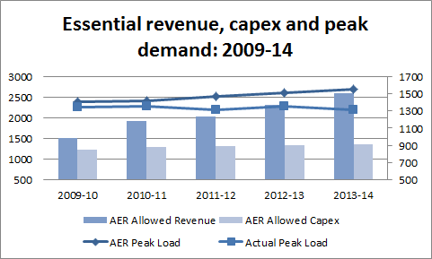

While the revised proposal delivered a 43% reduction in capital expenditure compared to the 2009-14 period, there is still significant development planned for the pockets of demand growth. We note that the AER significantly revised the capital expenditure based on network capacity due to low utilisation and reducing demand and removal of schedule 1 of the licence conditions which relates to network reliability. We would ask the AER to remain firm in their stance of a significantly reduced program of capital investment over the upcoming regulatory period.

We believe that significant over investment will only further increase the level of stranded assets and an ever growing RAB. In the lead up to the Final Determination, we suggest that the AER work closely with Essential Energy (using the network’s asset management, regional planning and investment plans) to revisit the network’s prioritisation of capital works. The AER must be assured that only genuinely urgent capital upgrades or augmentations in the network are pursued in this regulatory period, and that spending on any non-critical capital investment is deferred. We are in agreement with the AER that the Board’s approach to risk is highly conservative and that a more stringent approach to further capital expenditure is required to maintain the long term sustainability of the network.

Essential Energy in its revised proposal appears to be largely reliant on feedback received from customers as a justification for continued high levels of capital expenditure. We have reviewed the ‘Willingness to Pay Study’ prepared on behalf of Essential Energy to support their regulatory proposal. We note that this study only serves to take into account household energy users and does not accurately reflect the views and attitudes of larger energy users (such as irrigators) who face more significant impacts from large increases to network charges. We also believe that the scenarios provided to consumers may not necessarily be an accurate reflection of the actual changes that Essential Energy would face in the event of a reduction in revenue. For example, the scenarios identified increases in network blackouts and slower maintenance response times as a consequence of reduced network charges. We believe that the exact hours / number of service blackouts is hard to pin-point as revenue changes and that the exact nature of cost implications across a business are complex. As such providing consumers with numbers that correlate to altered network charges may be a misrepresentation of actual network reliability. While we understand that consumers expect a certain level of service, we do not believe that a household-based study can be used as justification for significant ongoing capital expenditure. Cotton Australia would ask that the AER continue to use the key criteria of safety and utilisation as the means to assess the need for further capital expenditure. This will shift away from pure reliability targets and towards performance based measures.

WACC
The Weighted Cost of Capital we understand can contribute up to 60% of the allowed revenue for DNSPs. We understand in the previous period the WACC was set at a whopping 10.02%, partly at the time due to the uncertainty in financial markets caused by the Global Financial Crisis.

The nominal risk free rate, which impacts upon both the debt and equity risk premiums has changed substantially since that time. As Figure 4 shows, interest rates collapsed in the wake of the crisis rather than soared, leading to significant profits for Essential Energy. Continued economic stability and downward forecasts of the cash rate and ten year bond rate forecast should lead to a reduction in the WACC.

Figure 4: Australian Cash Rate for the period 1994–2014
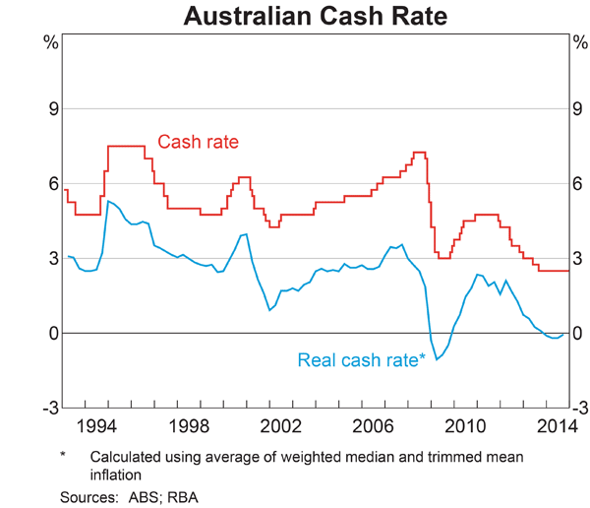

Recent WACC decisions in 2013 were 7.50% (ElectraNet) and 7.87% (SP AusNet) noting that the transitional arrangements for the cost of capital did not apply. We anticipate that the transitional arrangements, combined with the nominal risk free rate provide a strong justification for significant downward movement of the WACC.

Essential Energy in its revised proposal has particularly failed to adequately address the implications of the nominal risk free rate and changed global economic conditions on management of debt portfolios. Essential Energy has also contested that transitioning towards a trailing average and implementation of a swaps approach would result in significant hedging transaction costs or higher debt risk premiums on debt previously issued in the past. This is directly contested by the AER who consider these costs insignificant.

We would also like to make the point that we understand that the Networks consider themselves BBB credit rated organisations, reflecting what they argue is a high degree of financial risk.

We ask that the AER closely examine that claim, as it appears to us that Essential Energy represents a low risk organisation, with regulated pricing, a monopoly position with very strong payment protections. As identified by Essential Energy, the NSW DNSPs are issued debt through the NSW Treasury Corporation (TCorp) with providers required to pay a Government Guarantee Fee (GGF) or debt risk premium. We propose that while a more accurate reflection on the GGF may impact on the risk premiums collected by government, it will have significant implications on the costs incurred by customers.

The GGF is in effect the debt risk premium the NSW DNSPs would incur if they raised debt in a global debt market in the way that private firms do. [pg 228, Essential Energy Revised Regulatory Proposal].

We would implore the AER to remain firm in their current rate of return decision and indeed consider further reductions to the Final Essential Energy determination.

RAB
The regulated asset base (RAB) plays a significant role in the determination of the allowed revenue of the network. The manner in which the RAB is calculated is set out within the Rules and as such the AER has limited ability to adjust the present approach to roll-forward calculations. However, Cotton Australia would strongly advocate for an independent audit of Essential Energy network assets to gain a true appreciation of their value. We believe that our members should not continue to pay for underutilised network assets and would implore the AER to remain firm in respect to further augmentation of the Essential Energy network. Continuation of large capital expenditure on network demand that does not materialise will only serve to increase the ‘asset bank’ and result in significant ongoing costs for our members and the broader consumer base.

It is recognised that the regulatory asset valuations amongst distributors, particularly NSW and QLD, are now extremely high by international standards (Figure 5). Previous asset values should be written down to realistic levels and not continue to be subject to CPI increases which will serve to maintain ongoing value in the asset, even after it is decommissioned.

While we recognise that the excessive asset valuation is a complex issue which will require substantial effort on behalf of the regulator we do not believe this to be an insurmountable task. Cotton Australia further believes that this will indeed be a requirement to ensure the ongoing sustainability of Essential Energy and the broader networks.

Figure 5 – Regulated asset value per connection in Great Britain, New Zealand and Australia
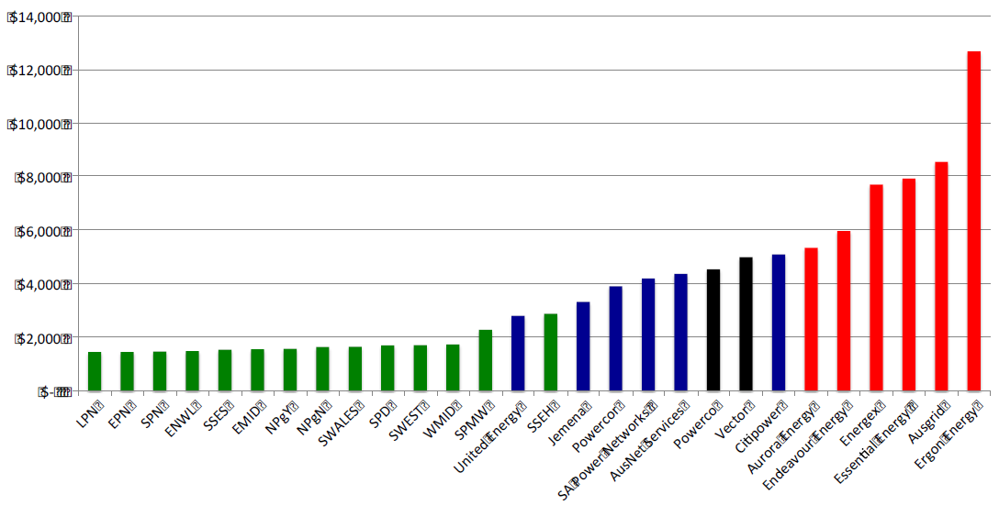
Source: Regulatory accounts (CME Analysis)

Tariffs
The key concerns relate to the high demand charges and complex structure of the tariffs irrigators are generally assigned to (BLND3AO and BLNS1AO). Both are demand tariffs comprised of seven components and offer little incentive to switch between peak/shoulder/off peak periods. We are also particularly concerned that irrigators are often transferred onto these tariffs with no consultation.

In this regulatory proposal Essential states it will undertake an annual review of the appropriateness of the tariff for connection points, with a view to re-assigning consumers between tariff classes. We would ask that the AER require Essential to provide consumers with an analysis of the costs and benefits to both the consumer and the network of any proposed changes before the consumer’s tariff class is ‘re-assigned.’ We particularly ask that Essential be prevented from ‘re-assigning’ tariff classes without first engaging with the affected consumer. Especially as the network itself has identified fair pricing and the provision of timing and accurate information as key components of its customer value strategy.

In a recent meeting between Essential Energy, Cotton Australia and the NSWIC, the network indicated interest in engaging with industry to encourage mutually beneficial utilisation of the Essential Energy network. We would ask that the AER would require such consultation as a matter of course over the upcoming regulatory period. Maintaining an ongoing dialogue with the networks we believe will result in the following outcomes:
- Avoided movement of our members off the grid that may further contribute to the ‘death spiral’
- Potential savings for Essential Energy via avoided or deferred network augmentation; and
- Potential savings for irrigators as a result of an improved understanding by Essential Energy of their customers which are significantly impacted by seasonality.

AER Rules
We are greatly appreciative of the forward steps that the AER has taken in the current regulatory determination of Essential Energy. We recognise the efforts of the AER in trying to drive improved network efficiency and curbing further unnecessary network expenditure.

Cotton Australia wishes to recognise that the AER is hamstrung by the current Rules and that only through a significant ‘rethink’ of the process will substantial reform be able to be achieved. The AER acknowledge this in their Draft Determination in relation to the RAB ‘Clause 11.56.5 of the Transitional Rules outlines that we are excluded from conducting an ex post review of capital expenditure incurred in the 2009–14 regulatory control period. This means we are not permitted to adjust the opening RAB for any inefficient capex (as assessed to reasonably reflect the capex criteria and in a manner consistent with the capex objectives) during the 2009–14 period’.

Essential Energy is well aware of the limitations placed on the AER as was presented in their revised regulatory proposal:

‘AER must start with a DNSP’s proposal’ [pg 33, Essential Energy Revised Regulatory Proposal]
and
‘The AER must accept a proposal that is ‘reasonable’’ [pg 99, Essential Energy Revised Regulatory Proposal]

Such statements which are valid under the current Rules affect the scope of the AER to implement significant change, as what is determined to be ‘reasonable’ is discretionary and does not drive efficiency and significant innovation by a NSP.

Concluding remarks
Cotton Australia and NSWIC have met with the Australian Energy Market Commission, as well as ministerial and departmental officials from NSW’s Department of Trade and Investment to highlight our concerns about the impact of rising network prices on the profitability and sustainability of irrigated food and fibre production in NSW.

We acknowledge the work of the Australian Energy Regulator (AER) in conducting their assessment of Essential Energy's revenue and addressing some areas of concern for consumers in the Draft Decision for Essential Energy's distribution determination. We welcome the reduction in Essential Energy's revenue allowance as a step in the right direction, in particular the significant recommended cuts in operating expenditure and capital expenditure. However, we remain concerned that the current levels of network charges are unsustainable for cotton growers in regional NSW. We therefore call on the AER to remain firm to resist any pressure from the networks or government to revise their determination upwards, and ask that they place even more scrutiny on the RAB and WACC.

We would further encourage the AER to work with the state and federal governments to improve the overall regulatory oversight of the entire electricity market, particularly the networks.

Thank you again for the opportunity to comment on Essential’s regulatory proposal. Please do not hesitate to contact me on 02 9669 5222 or 0405 508 280 if you wish to discuss this submission in more detail.

Yours faithfully
Felicity Muller
Policy officer

