29 January 2015

Mr Sebastian Roberts,
General Manager - Network Regulation,
Australian Energy Regulator,
GPO Box 520
Melbourne VIC 3001
QLDelectricity2015@aer.gov.au

Dear Mr Roberts,

RE: QLD Electricity Distribution Regulatory Proposals 2015-2020
Members of the Darling Downs Cotton Growers Inc (DDCGI) have been greatly affected by the spiralling cost of electricity over the past decade, and we are acutely aware that a very large proportion of this increase is due to the massive increases in network charges.
Due to the regulated nature of electricity pricing in Queensland, our members have a keen interest in both the Energex and Ergon Revenue Determinations, even though all are direct customers of Ergon.
We note the AER benchmarking studies that show that Ergon in particular has performed at a level far below its peers (with Energex not much better), and call on the AER to ensure that these network providers are not rewarded for their inefficiencies.
Over the past decade we have been appalled by the rapid escalation in the Regulatory Asset Base. In Ergon’s case it has more than doubled since 2005/06, and Ergon wants it to increase by another 27% during the coming regulatory period.
In the past we have been told that the increase was due to the need to meet soaring peak demand and high reliability standards, but that peak demand has not materialised and reliability standard requirements have lessened.
As we understand the RAB is a factor of its opening status, plus additional capital expenditure, less depreciation, plus an allowance for inflation. Therefore we call on the AER:
- To very closely examine the proposed capital expenditure of both Ergon and Energex, and only approve that which is prudent and efficient. In particular regard should be taken to the veracity of any demand forecasting, and the ability to meet any rising demand through new, cheaper technology, or through active demand management programs.
- To examine, and provide comment, around the current rules for determining the RAB. We struggle to understand the rationale around applying depreciation, but then increasing the RAB for inflation. We believe that these provides the very real possibility of long-life, low depreciation assets (such as poles), maintaining a significant value even at the time of replacement, and then having the new pole added to the RAB.
Closely related to the RAB, and what we understand can contribute up to 60% of the allowed revenue, is the Weighted Average Cost of Capital (WACC).
We understand in the previous period the WACC was set at a whopping 9.72%, partly at the time due to the uncertainty in financial markets cause by the Global Financial Crisis.
However as the following Reserve Bank Graph shows, interest rates collapsed in the wake of the crisis, rather than soared, and there is a very strong argument that the Networks have enjoyed a multi-billion dollar windfall due to this.

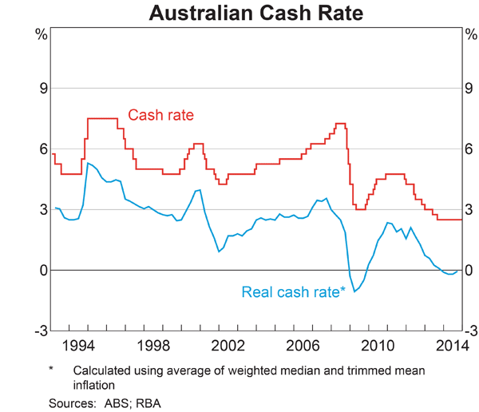
While we are not economists, a simple reading of this graph would suggest that all other things being equal, there is a strong argument for a WACC somewhere in the vicinity of three percentage points below that applied in the last regulatory period or 6.72%.
We would also like to make the point that we understand that the Networks consider themselves BBB credit rated organisations, reflecting what they argue is a high degree of financial risk.
We ask that the AER closely examine that claim, as it appears to us that the networks represent relatively low risk organisations, with regulated pricing, a monopoly position, and very strong payment protections.
While we do not have the expertise to forensically examine operational costs, we are pleased that both Ergon and Energex have made some effort to curtail these costs during the coming regulatory period. However, we expect nothing less and we call on the AER to keep close to mind the results of the Benchmarking which clearly showed that Ergon in particular had a long-way to go perform anywhere near its peers.
Finally, we call on the AER to closely examine any additional allowances provided to these organisations such as income tax equivalents.
We have heard that in cases of privately owned networks, the amount allowed for has often far exceeded the amount paid by these organisations. This should be completely unacceptable.
Thank you for this opportunity, and we look forward to the Draft Determination.

Yours sincerely,

Chris Barry
President

