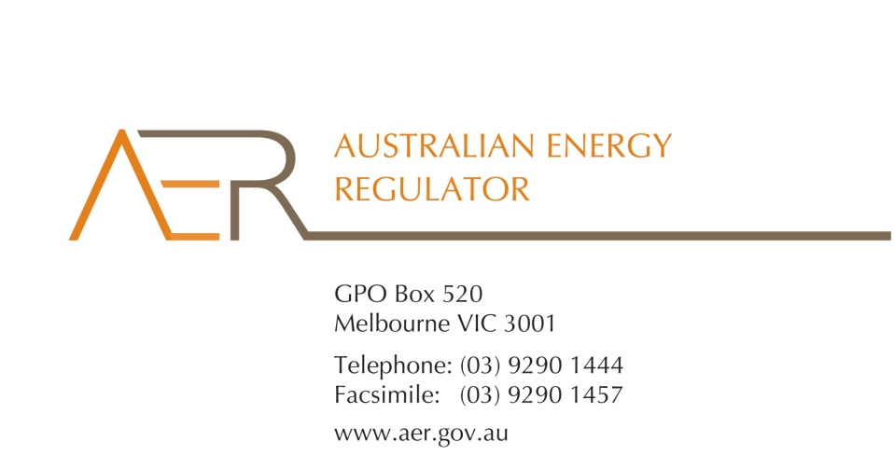

Our Ref: 53069

Your Ref:

Contact Officer: Naomi Feast

Contact Phone: 03 9290 6930

31 January 2014

Jeffery Bye

Director

Demand Manager

Suite 7.01, 66 King Street

Sydney, NSW 2000

Australia

Dear Mr Bye

**Demand Manager’s** **application for an individual exemption from the requirement to hold an electricity retailer authorisation**

I refer to your letter dated 15 November 2013, which attached an application for an individual exemption in accordance with s.110 of the National Energy Retail Law (Retail Law) by Demand Manager Pty Ltd (ABN: 64 115 850 729) (Demand Manager).

I am writing to inform you that the Australian Energy Regulator (AER) has decided to grant Demand Manager’s application for an individual exemption in accordance with s.110 of the Retail Law.

In accordance with the National Electricity Retail Rules, the AER has published the application on its website, and sought submissions from interested parties.[1] The AER received no submissions in response to Demand Manager’s application.

The AER has also considered the policy principles relating to exempt selling in s. 114 of the Retail Law, being:

1. regulatory arrangements for exempt sellers should not unnecessarily diverge from those applying to retailers,
2. exempt customers, should, as far as practicable, be afforded the right to a choice of retailer in the same way comparable retail customers in the same jurisdiction have that right,
3. exempt customers, should, as far as practicable, not be denied customer protections afforded to retail customers under this Law and Rules.

In making its decision the AER is also guided by the objective of the Retail Law[2], the exempt seller factors,[3] and the customer related factors.[4] The AER’s decision is also informed by the assessment approach outlined in the *Exempt Selling Guideline*.

On 31 January 2014, the AER considered Demand Manager’s application for an individual exemption, taking into account the matters above.

The AER is satisfied that Demand Manager should be exempt from the requirement to hold a national retailer authorisation. This individual exemption is subject to acceptance of the conditions set out at Schedule 1 to this letter.

Please be aware that the AER may vary conditions attached to an individual exemption at any time in accordance with rule 158 of the National Energy Retail Rules (Retail Rules).

Demand Manager must advise the AER in writing, by **20 February 2014,** whether it accepts these conditions.

If you have any further queries, or would like to discuss this further, please contact Naomi Feast on 03 9290 6930.

Yours sincerely

Andrew Reeves

Chairman

Australian Energy Regulator

**Schedule 1: Instrument of exemption**

**INDIVIDUAL EXEMPTION FROM THE REQUIREMENT TO HOLD A RETAIL AUTHORISATION**

The Australian Energy Regulator on 31 January 2014, decided pursuant to section 110 of the National Energy Retail Law, to grant Demand Manager Pty Ltd (ABN: 64 115 850 729) (the exempt person) an exemption from the requirement to hold a retailer authorisation under section 88 of the National Energy Retail Law, subject to the following conditions.[5]

**Condition 1 - Information provision**

The exempt seller must provide the customer in writing a plain English notice explaining that the contract is covered by Australian consumer protection laws and is separate to the customer’s contract with their retailer and distributor which are covered under the National Energy Retail Law.

1. National Energy Retail Rules, r. 155(3) and 156
2. The National Energy Retail Law objective is to “promote efficient investment in and efficient operation and use of energy services for the long term interests of energy consumers with respect to price, quality, safety, reliability and security of supply of energy”. (s. 13, Retail Law)
3. Retail Law, s. 115.
4. Retail Law , s. 116.
5. This exemption takes effect from the date of acceptance by the exempt person of the conditions.