Submission to AER Issues Paper: Customer price information

October 2017



Contents

Energy Price Fact Sheets 5

Comparison rates and reference prices 8

Technological options to facilitate offer comparison 11

Customers who are not digitally engaged 12

Version history

|  |  |  |
| --- | --- | --- |
| VERSION | DATE | COMMENTS |
| 1 | 31 November 2017 | Final edit |
|  |  |  |

This work by Energy Consumers Australia is licensed under a Creative Commons Attribution 4.0 International License.  
  
To view a copy of this license, visit <http://creativecommons.org/licenses/by/4.0/>.  
  
Where you wish to use the Report in a way that is beyond the scope of the above Creative Commons Attribution 4.0 International License, you must seek permission from Energy Consumers Australia.   
  
Requests for permission or any other enquiries relating to this copyright notice must be addressed to <mailto:info@energyconsumersaustralia.com.au>

© Copyright 2017 Energy Consumers Australia



Submission to AER Issues Paper: Customer price information

Energy Consumers Australia (ECA) appreciates the opportunity to provide comments on the Australian Energy Regulator’s (AER) Consumer Price Information Issues Paper of September 2017 (the Issues Paper).

The Issues Paper requests consumer views on issues related to how consumers can understand retail energy contracts and compare the relative benefits of their current arrangements and others in the market. As the Issues Paper notes, this AER process is taking place against a backdrop of other very significant retail reform processes, in the form of both the Prime Minister’s retail interventions and the Australian Competition and Consumer Commission’s (ACCC) Review of the Retail Electricity Market.

Our response to the Issue Paper, set out in reference to the specific questions, is provided below. In overall terms, we encourage the development of an effective Comparison Tool and Comparison Rate, supported by Energy Price Fact Sheets, all of which are both simple and appropriate to facilitate easier consumer choice in electricity offers. These tools, together with resourcing for the AER’s Energy Made Easy website are important steps to re-build confidence in the energy market. In our view, behavioural insights will be critical to achieve optimal consumer outcomes and we welcome the involvement of the Behavioural Economics Team of Australian Government (BETA) in this important work.

1. Energy Price Fact Sheets

*What information should be included on an EPFS? Is there some information currently included that could be omitted, or provided in another way?*

At the outset, ECA is encouraged that the ongoing work of BETA in testing the various fact sheets presented to the Reference Group will deliver a range of important insights into what consumers will find most useful and useable in the EPFS. As part of the AER’s Reference Group, ECA attended the BETA workshop in Melbourne on 18 October 2017 to discuss EPFS.

We also wish to generally reinforce the importance of such behavioural insights, a point made in the Issues Paper, namely that:

Behavioural economics research increasingly highlights that consumers faced with too much complex information can be overwhelmed, hindering or preventing decision making. It is important customers have sufficient information to make an informed decision, but that must be balanced with achieving a level of detail that does not overwhelm the reader.[1]

We consider that the simplicity of both the information on the EPFS, together with its presentation, will be important to its success in delivering consumers with a product that can assist in easy decision making about energy offers. In this regard, we defer to the work being undertaken by BETA to test a range of EPFS options with consumers. We encourage that the outcomes of the BETA testing be used as the basis for the information to be included or excluded on the EPFS in the future, as we understand is the AER’s intention.

|  |
| --- |
| *Consumers faced with too much complex information can be overwhelmed, hindering or preventing decision making.* |

*How should the information on an EPFS be set out to most effectively highlight price and key contract details? How should information be prioritised?*

Again, we are encouraged by the AER’s involvement of BETA in terms of the information on the EPFS. We agree that the setting out of the information on the EPFS should be determined based on the customer insights gleaned through the important work of BETA, in consultation with a range of stakeholders. In addition, we make the following points:

* ECA endorses one of the consensus points reached at the BETA Workshop, namely that the rating of an energy offer in relation to a particular consumer interest (solar, high use, smart meter) could be rated on a binary yes/no or ✓/🗶, as in the fact sheet provided by Red Energy and Lumo Energy at the workshop.
* ECA shares the concern of a number of other participants at the BETA Workshop, including retailers and consumer advocates about the use of a ‘scale’. Namely, that scales such as good, better best or ✓, ✓✓, ✓✓✓ are more difficult to compare for consumers. Therefore, such value-laden descriptions are best to be avoided on the EFPS.
* While the EPFS has a role in assisting customers make an informed decision about available offers, its role should also be contextualised in relation to the other information sources or tools that consumers may use to investigate energy offers, for example, the Energy Made Easy website.

*Is the language currently used to describe offers easy to understand? If not, how could it be improved? Are there other ways (graphics, images) to present information that would be more effective?*

Much of the language currently used to describe energy offers is not easy for consumers to understand.

This point is also reinforced in the ACCC’s Preliminary Report on Retail Electricity Prices (the ACCC’s Preliminary Report).[2]

In addition, we would encourage a closer review of the following points:

* Terms such as “tariff type” and “controlled load” are not part of everyday Australian vernacular. In particular, terms such as “controlled load” are not widely understood and their meaning cannot be easily figured out with the present information available to consumers. Accordingly, we share concerns that its use engenders confusion among consumers and may be likely to discourage further investigation of alternative offers from the existing or another retailer. Therefore, it would seem appropriate to consider whether these types of “energy specific” words could be substituted for more easily understood language or if these terms need to be used, then they should be simply defined.
* The current breadth of the EPFS may not be necessary for the consumer to understand the key elements of the offer. For example, information such as the name of the “tariff type” may not be critical for consumers. They may simply be interested to know what offer they are looking at, and what are the key terms and conditions of that offer in plain terms. Therefore, it may be more appropriate to use plain-English language for the key elements of the offer such as (using the example in the Issues Paper):

**Your offer: Residential electricity offer named “INSERT”**

**Type of offer: Time of use (DEFINED) with controlled load (DEFINED)**

**Length of offer: Ongoing with 12 months’ benefit period. Before the end of the 12 months, we will write to you to let you know the date at which your benefits expire.**

**You will get a bill: every 3 months [by mail/ electronically]**

* We agree with the AER’s suggestion that the exploration of graphics and other tools may assist consumers more easily understand their electricity offer.

Regarding specific terminology relating to discounts, we note that the ACCC in its Preliminary Report pointed out that about 80 percent of generally available offers use some kind of discount. The ACCC further states that:

… while discounts are attractive to consumers, the practice has been identified as a barrier to consumers engaging with the market successfully. A number of parties also consider that the practice of discounting has eroded trust in the retail electricity market.[3]

|  |
| --- |
| *A number of parties also consider that the practice of discounting has eroded trust in the retail electricity market.* |

On the issue of discounting, the ACCC also raised the fact that discounting is applied to offers in different ways, with the potential to unduly confuse consumers.

Therefore, as the Queensland Consumers Association states in its submission to the Issues Paper, to the extent that discounting applies to the offer as presented on the EPFS, it needs to be made very clear to what the discount applies. Simply referring to “GST exclusive usage charges” has the potential to be confusing for many consumers. The amount of the discount could be better applied at the “price”, while making clear if it is only for a certain timeframe that another “price” will apply after that period. The consumer could then see the real financial cost rather than simply a headline percentage discount to be applied to the tariff. We would encourage the AER to carefully consider the presentation of discounts, working together with BETA in terms of consumer insights as to potential alternatives on the EPFS.

1. Comparison rates and reference prices

*Is a comparison rate or reference price an effective way to facilitate meaningful comparison of different energy offers?*

ECA is supportive of the development of an appropriate comparator rate and appreciates the logic in the idea of reducing a complex energy offer to a single number. A comparison rate will more easily therefore enable simple and meaningful comparison between energy offers.

The benefits of a comparator are reinforced in the ACCC’s Preliminary Report, where the ACCC stated that it:

considers that a well-designed comparison rate could assist consumers to determine the most appropriate electricity plan for their circumstances.[4]

The ACCC does note, together with the Issues Paper however, that Tariff Comparison Rates (TCR) were a requirement in the United Kingdom’s retail energy market from 2014 to 2017. According to the ACCC, the United Kingdom’s approach calculated the price for “a particular customer”[5] and was abandoned for two reasons:

* As tariff structures became more complex, assumptions in the TCR regarding consumption for a typical user were described as being potentially misleading for consumers
* Evidence suggested the TCR was not especially effective, due to low awareness and scepticism about the applicability of the rate to individual circumstances.

|  |
| --- |
| *Australians are increasingly familiar with the concept of a comparison rate, given they have now been in place for mortgages and other financial products for a number of years and have brought greater simplicity to the financial services market.* |

While noting the experience in the United Kingdom, ECA believes that more success could be achieved by an appropriate comparison rate in Australia for the reasons set out below.

Firstly, Australians are increasingly familiar with the concept of a comparison rate, given they have now been in place for mortgages and other financial products for a number of years and have brought greater simplicity to the financial services market.

Secondly, the comparison rate could work in tandem with the use of different household types (namely, different levels of consumption). At the BETA Workshop, there was a general agreement that the EPFS could provide total cost for multiple (e.g. four) household types. In ECA’s view, taking such an approach and avoiding the use of a single ‘average’ consumer could inspire greater confidence amongst consumers in the comparator rate and the applicability of the comparator rate to them.

We also note in this regard, that many of the major retailers already use this approach of multiple households in their marketing of energy offers. For example, EnergyAustralia:[6]

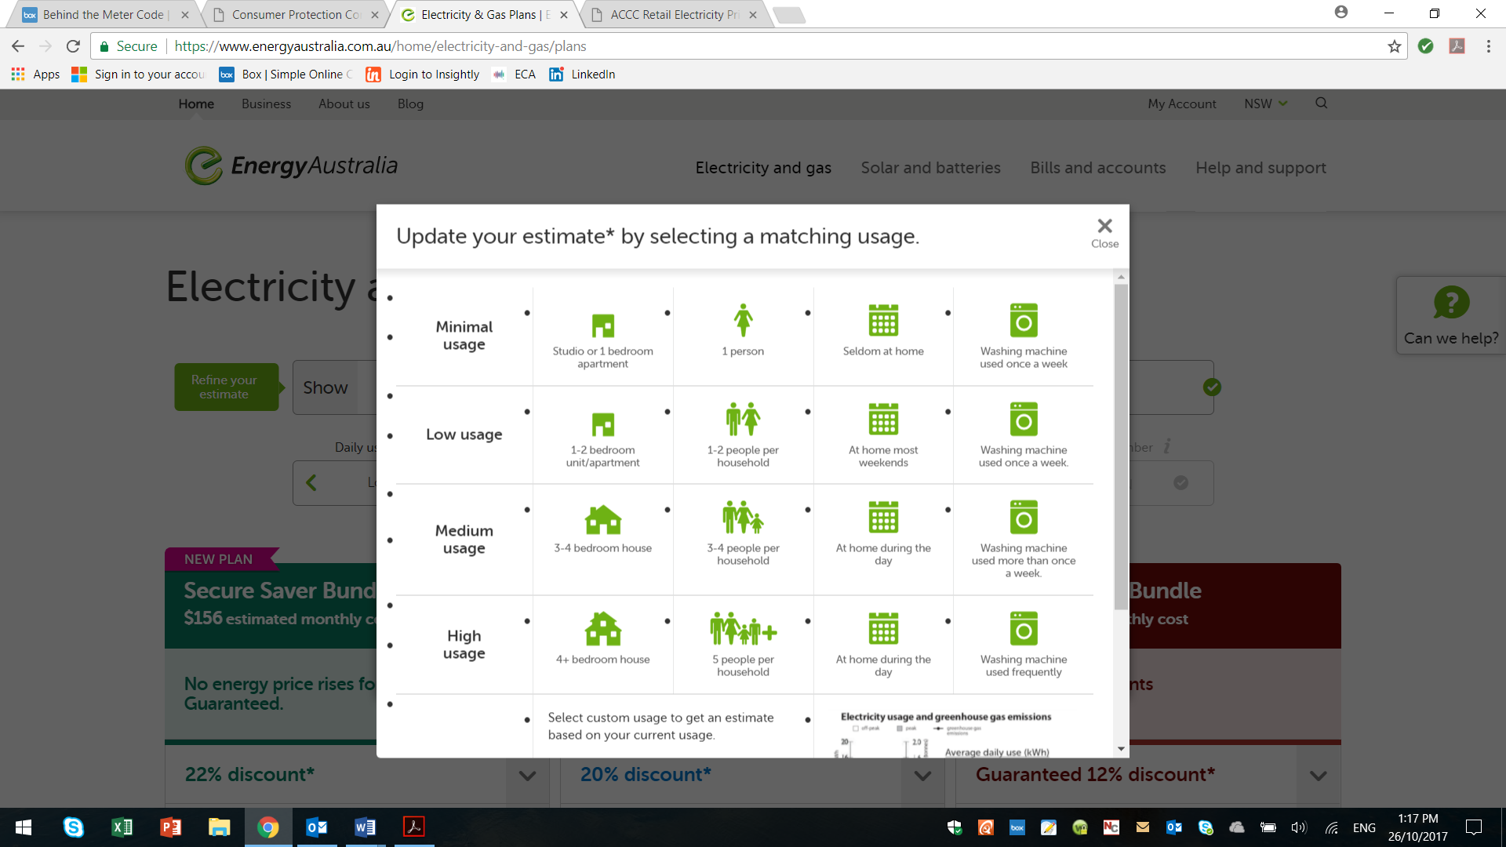

Origin similarly uses a usage estimate for three household types set out below:[7]

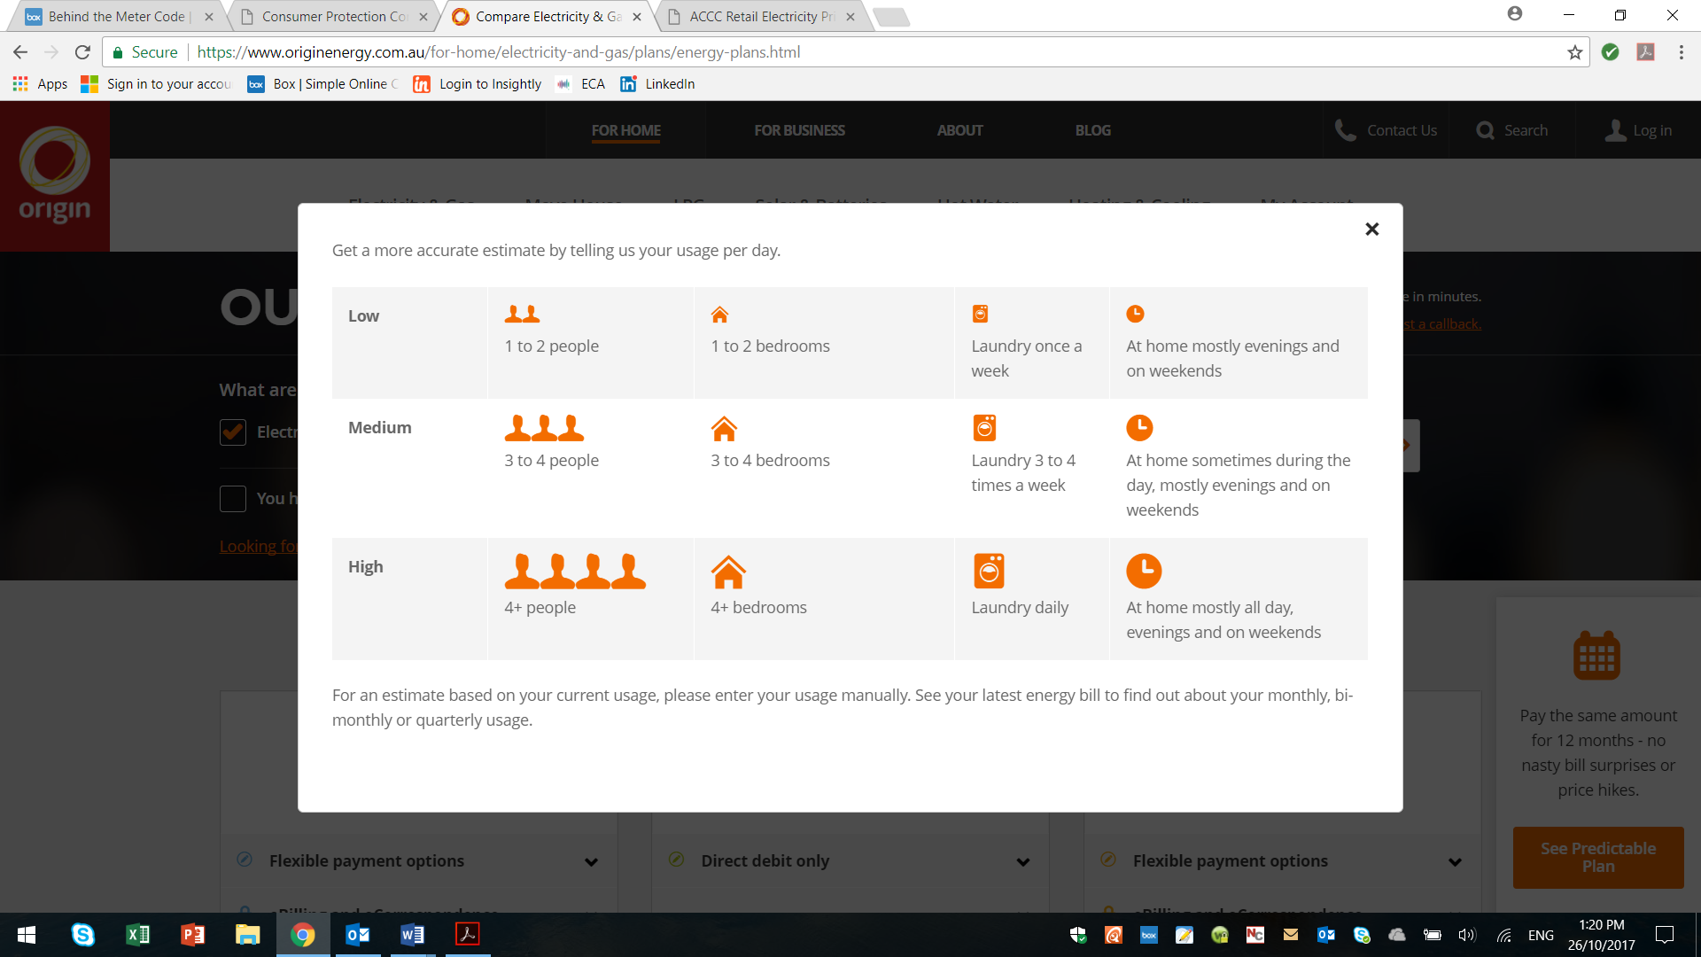

Therefore, the use of “usage estimates” based on household size appears to have already been considered by the industry as a tool to assist consumer decision making. To avoid confusion on these usage estimates the benefit of the comparison rate may also be to create some consistency in these household or consumption sizes across a range of retailers.

In terms of the comparator rate itself, we agree with the comments of the Queensland Consumers Association that broadly a comparator rate could be:

* Presented appropriately in dollar terms
* Based on kWh
* Based on the time period that is most relevant to consumers, for example the period of billing such as monthly, three-monthly, or a yearly amount.

The Queensland Consumers Association has also raised a number of important points regarding the key issues to focus on in the development on a comparator rate.

Again, we would encourage that the form of the comparison rate be determined by an appropriate expert review of existing comparison rates that are working for the benefit of consumers in other markets. Furthermore, once developed, we would again encourage that BETA should test the comparison rate with consumers to obtain appropriate consumer insights.

Finally, the formulation of the comparison rate could also take into account emerging innovation in energy offers and the complexity or simplicity of those offers to ensure that it is able to capture new tariff structures or models as they emerge in the market. A good example of this is the recent announcement of EnergyAustralia of its Secure Saver plan[8] which guarantees no energy price rises for two years. The comparator tool could ideally be flexible to take into account these sorts of offers and others to ensure that consumers are able to use the tool to compare all offers in the market.

*What are the potential benefits and risks of a comparator rate?*

ECA considers that there may be a number of consumer benefits to the use of a comparison rate to enable consumers to more easily compare energy offers and navigate the complexity of this market. As stated in the Issues paper, comparison rates are a means for consumers to quickly and easily compare products, even where the individual components of the offer may vary

|  |
| --- |
| *Comparison rates are a means for consumers to quickly and easily compare products, even where the individual components of the offer may vary.* |

As stated above, ECA welcomes the AER’s work with BETA to obtain the important behavioural insights of consumers to assist in the development and roll-out of a comparison rate. In particular, we understand that adequate consumer testing will be done to ensure that form of the comparison rate achieves the desired consumer outcomes. Furthermore, there will no doubt need to be clear guidelines about when a retailer is required to use the comparison rate and how it is presented. This is an issue we understand was looked at closely in the context of unit pricing for groceries.

1. Technological options to facilitate offer comparison

*Which customers might benefit most from these options? Is there evidence or experiences from other sectors or jurisdictions about the likely success of the options we should consider?*

ECA welcomes the use of appropriate technology to enable consumers to compare energy offers. With the increasing pace of technology, it may be appropriate to encourage a range of technologies, including QR codes as a means for consumers to obtain easy access to their meter or billing date. The key objective of the use of this technology will be empowering consumers to more easily compare energy offers through better access to their data.

Overall, we support the AER’s focus on the important task of enabling consumers to get easy access to their meter or billing data through appropriate technology and to be able to use this data seamlessly to facilitate offer comparison.

As the ACCC notes in its Preliminary Report, initiatives such as Green Button in the United States provide an application that:

lets a consumer download their energy usage information from SMT based on a nationally standardised format. The consumer can then load the information into programs obtained from third party entities to help manage their electricity use.[9]

As the AER is aware, there are a number of initiatives underway to improve consumers’ access to their data and a number of avenues utilising technologies that allow this to happen. For example, retailers such as Momentum and Powershop already use simple PDF upload technology to allow consumers to upload their bills and compare them.[10]

We encourage the issue of consumer access to data to be pursued more broadly and refer to ECA’s discussion paper on Data Portability in this regard.[11] We note that the Commonwealth Department of the Environment and Energy, on behalf of the COAG Energy Council has engaged a third-party consultant to report on the best means of making meter data available to consumers using the Energy Consumers Australia’s discussion paper as the starting point.

*Energy Made Easy*

ECA strongly supports the ACCC’s recommendation that additional funding be given to support the further development of the AER’s Energy Made Easy website as a more useful national channel for consumers to compare offers and improve their bill outcomes. The ACCC specifically stated that immediate action should be taken in this regard, stating that:

the Australian Government should provide additional resourcing to improve and promote the AER’s Energy Made Easy price comparison website as a tool to assist consumers in comparing energy offers.[12]

|  |
| --- |
| *The ACCC recommends that the Australian Government should provide additional resourcing to improve and promote the AER’s Energy Made Easy price comparison website as a tool to assist consumers in comparing energy offers.* |

1. Customers who are not digitally engaged

*How can customers who can’t, or don’t, engage online best be provided with information about their options?*

ECA agrees with the AER and other stakeholders that customers that are not digitally engaged need appropriate consideration regarding the matters contained in the Issues Paper to ensure that they too can benefit from proposals aimed at making consumer choice around energy offers easy.

In our experience, the key is trusted support networks. A very good example of this is the work done by the Queensland Council of Social Services (QCOSS) through its “Switched on Communities” work.[13]

The Switched On Communities grants funding provided targeted programs to assist people who experience disadvantage or financial hardship to get better outcomes in the competitive energy market. Grants of up to $100,000 were available for not-for-profit organisations in south east Queensland to get their community switched on. With support from AGL and the Queensland Government, we understand that $500,000 was made available for organisations to assist their clients better understand their bills, compare electricity plans and access the supports available if they experience financial difficulty.

The successful community organisations to receive Switched On Communities grants were:

* Salvation Army
* Multilink Community Services
* Queenslanders with Disability Network
* COTA Qld
* Laidley and District Community Organisation
* Coast2Bay Housing Group
* Encircle
* Mangrove Housing
* Palm Beach Neighbourhood Centre

We would encourage the AER to look at the work outlined above as a platform for engaging non-digitally engaged consumers. We would also suggest that the existing work of BETA extend to how consumers that cannot or do not engage online can best be provided with information about energy offers. This could allow for evidence-based consumer insights into how these consumers could get better outcomes in the energy market through non-online platforms and avenues.

*What information or messaging might be included on bills or fact sheets to increase the likelihood of switching?*

As we stated in our submission to the ACCC, the role that switching i.e. a customer changing energy retailers, is playing in the market is complicated both from the perspective of price dispersion and when the additional costs of acquiring and retaining customers for retailers are considered.[14]

There is a complex question about whether competition through switching is driving operating efficiencies that are delivering net overall benefits to consumers. In particular, as the ACCC says:

For competition in a market to benefit consumers overall, the increase in the costs of competition need to be offset by reductions in operating costs and/or lower retail profit margins. Analysis from Finncorn shows that operating costs per electricity customer account have been largely stable since 2009 while gross margins per electricity customer account have risen.[15]

Therefore, we are not convinced that the right metric is in fact “switching” per se, we would prefer to see more emphasis on outcomes i.e. whether the consumer is on a good energy deal (relative to the market). That is why in our recent PowerCall campaign[16] we are encouraging consumers to call their retailer and ask them to put them on a better plan:

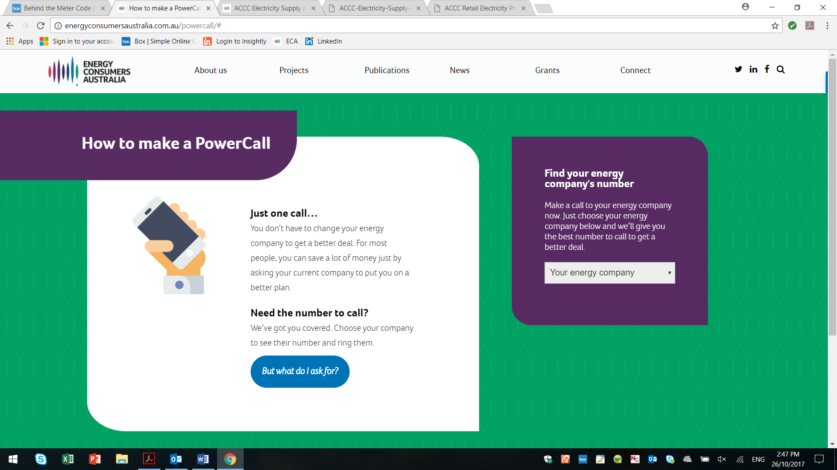

PowerCall your retailer is a simple message that we believe is a good first step in the current market to encourage consumers to get on a better deal and to start to re-build confidence in the energy market.

|  |
| --- |
| *We are not convinced that the right metric is switching per se, we would prefer to see more emphasis on outcomes.* |

*How important is it that government energy comparator websites have a phone service to assist customers?*

We agree that Energy Made Easy should have a phone line to allow consumers than cannot or do not wish to use the internet have an opportunity to nonetheless leverage the service. It is important that these people are not excluded from accessing the independent price comparator service themselves (i.e. without needing to find someone to help them). Furthermore, certain consumers who have internet access may still prefer to use the phone to speak to a person that can assist them.

Over the last couple of months ECA has been contacted by consumers who are not comfortable (or able) to use the internet, but are very happy to deal with us, retailers and others over the phone. In this context, ECA agrees that it is important for the government energy comparator to also be offered as a phone service.

*************

Once again, ECA thanks the AER for the opportunity to provide comment on the Issues Paper.

If you would like to discuss any matters related to this submission further, please do not hesitate to contact myself, Sabiene Heindl, Director, Strategic Engagement on (02) 9220 5505 or [Sabiene.heindl@energyconsumersaustralia.com.au](mailto:Sabiene.heindl@energyconsumersaustralia.com.au) or Oliver Derum, Associate Director Advocacy and Communications on (02) 9220 5514 [or oliver.derum@energyconsumersaustralia.com.au](mailto:or%20oliver.derum@energyconsumersaustralia.com.au).

1. AER, *Customer Price Information Issues Paper,* 2017, 7-8.
2. <https://www.accc.gov.au/system/files/ACCC%20Retail%20Electricity%20Pricing%20Inquiry%20-%20Preliminary%20Report%20-%2022%20September%202017.pdf>.
3. Ibid, 128
4. Ibid, 139.
5. Ibid
6. <https://www.energyaustralia.com.au/home/electricity-and-gas/plans>.
7. <https://www.originenergy.com.au/for-home/electricity-and-gas/plans/energy-plans.html>.
8. <https://www.energyaustralia.com.au/offer?intcmp=eg%7Cbanner%7Chp%7Coffer##quotepostcode>.
9. ACCC, as above, 141.
10. <http://www.powershop.com.au/energy-bill-comparison/> and <https://www.momentumenergy.com.au/switch/get-started?showBillUpload=true>.
11. <http://energyconsumersaustralia.com.au/publication/electricity-meter-data-portability-discussion-paper/>.
12. Ibid 156.
13. <https://www.qcoss.org.au/our-work/switched-communities>.
14. <http://energyconsumersaustralia.com.au/wp-content/uploads/ACCC-Electricity-Supply-and-Pricing-Inquiry-Submission.pdf>.
15. ACCC, as above, 168
16. http://energyconsumersaustralia.com.au/powercall/.