**IN THE DISPUTE RESOLUTION PANEL AT MELBOURNE**

(Constituted for a determination as to compensation under Rule 3.16.2 of the National Electricity Rules)

**JOINT SUBMISSION TO THE DISPUTE RESOLUTION PANEL**

|  |  |
| --- | --- |
| **The Claimants listed in Schedule 1** | (**Claimants**) |

and

|  |  |
| --- | --- |
| **Australian Energy Market Operator Limited**  (ABN 94 072 010 327) | (**AEMO**) |

**A. Introduction**

1. The italicised terms used in this submission are defined in the National Electricity Rules (***Rules***).[1]
2. Other terms and acronyms are defined in bold where they are first used in this submission. For convenience, they are also listed in **Schedule 2**.

**B. Application**

1. The Claimants are and were, at all material times, registered as *Market Generators* for the *generating systems* listed in **Schedule 1** (**Generating Systems**).
2. In August 2015, AEMO declared that a *scheduling error* had occurred that affected the Generating Systems from the *dispatch interval* ending 0015 hr on 5 August 2016 to the *dispatch interval* ending 2010 hr on 17 August 2016 (**Scheduling Error Period**).[2]
3. Clause 3.16.2(a) of the *Rules* permitsany *Market Generator* affected by a *scheduling error* to apply to the *dispute resolution panel* (**DRP**) for a determination as to compensation in respect of the *scheduling error*. The matters to be determined by the DRP are:
   * 1. whether compensation is payable;
     2. the amount of compensation to be paid to each Claimant from the *Participant compensation fund*;[3] and
     3. the manner and timing of that payment.[4]

**C. National Electricity Rules**

1. Version 82 of the *Rules* applied during the Scheduling Error Period.
2. The amendments made to the *Rules* since Version 82 do not alter the effect of the provisions cited in this submission in a manner that is material to the matters relevant to the DRP's determination of compensation as a result of the *scheduling error*.

**D. AEMO and the National Electricity Market (NEM)**

1. Sections D to H set out background information regarding the operation of the *NEM* and how *Scheduled* *Generators* and *Semi-Scheduled Generators* are *dispatched* in the *NEM*. This is included to provide context to the DRP.
2. AEMO operates and manages the *NEM*. The *NEM* is essentially two things: the physical infrastructure that keeps electricity flowing from producers to consumers, and a notional wholesale pool (or *spot market*) to which producers sell, and from which purchasers buy, electricity.
3. Electricity is dynamically produced to satisfy demand that varies instantaneously. The *NEM* facilitates the instantaneous matching of supply and demand through a centrally coordinated process managed by AEMO, called *central dispatch*.
4. Figure 1 depicts the relationships between different participants in the *NEM*.

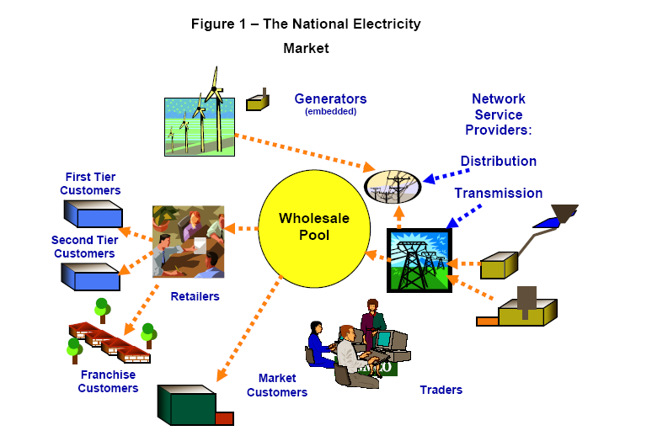

1. The *NEM* is a gross pool. This means that all *Generators* whose power output enters the grid must 'sell' their output via the *market* conducted by AEMO, unless they are embedded in a *distribution network* and have already sold their output to the *local retailer* or to a consumer located at the same *connection point*.
2. In geographic terms, the *NEM* covers the supply of electricity to southern and eastern Australia. It operates on one of the world’s longest *interconnected power systems*, a distance of more than 4,000 kilometres.
3. The *NEM* is divided into five *regions* for *market* pricing purposes:
   * 1. Queensland;
     2. New South Wales (incorporating the Australian Capital Territory);
     3. Victoria;
     4. South Australia; and
     5. Tasmania.
4. Each *region* is connected to its adjacent *regions* by *interconnectors*, which are a series of *transmission lines* that facilitate the flow of electricity between *regions*. Figure 2 shows the *interconnectors*:

**Figure 2 – Interconnectors in the NEM**

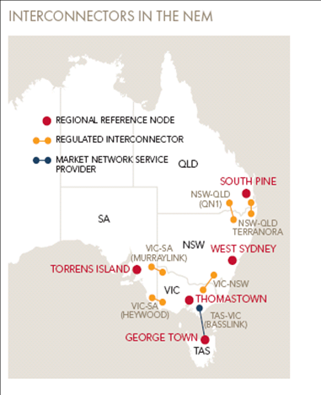

1. A number of different types of organisations can participate in the *NEM*. These are called *Registered Participants*. Some are registered in their capacity as providers of infrastructure, such as *Network Service Providers* (**NSPs**) while others participate in the wholesale electricity exchange as *Market Participants*, buying and selling electricity.
2. The *Rules* allow producers of electricity in the *NEM* to register in a number of different categories. For example:
   * 1. *Scheduled Generators* participate in the *central dispatch* process. Generally, these are *Generators* with *generating units* whose *nameplate rating* is greater than 30 MW.
     2. *Non-Scheduled Generators* are typically *Generators* with *generating units* whose *nameplate rating* is less than 30 MW and do not participate in the *central dispatch* process.
     3. *Semi-Scheduled Generators* are *Generators* in respect of which a *generating unit* is classified as a *semi-scheduled generating unit*. Typically, this occurs where:
        1. a *generating unit* has a *nameplate rating* greater than 30 MW, or a group of generating units *connected* at a common *connection point* have a combined *nameplate rating* greater than 30 MW; and
        2. the output of the relevant *generating unit* is *intermittent* (such as for wind farms).
     4. *Generators* that sell all of their electricity into the *spot market* are registered as *Market Generators*. *Market Generators* are paid the *spot price* applicable at their *network connection* for each *trading interval* during which they supply electricity to the *market*. A *Generator* that sells its entire output to either a *Local Retailer* or consumer located at the same *connection point* is classified as a *Non-Market Generator*.

**E. The Regulatory Framework**

1. The *NEM* is regulated by the National Electricity Law (**NEL**), a schedule to the *National Electricity (South Australia) Act 1996* (SA) that applies in each of the *participating jurisdictions* through a co-operative legislative scheme. The *Rules* are made and enforced under the NEL.
2. Under the NEL, AEMO has two core functions: power system operator, and wholesale market operator.
3. As power system operator, AEMO is concerned primarily with meeting standards of security and *reliability*. *Power system security* refers to the *power system's* capacity to continue operating within defined technical limits even in the event of the *disconnection* of a major *power system* element, such as an *interconnector* or large *generating* *unit*. *Power system* *reliability* refers to the *power system's* capacity to supply sufficient energy to meet consumer demand.
4. As wholesale market operator, AEMO facilitates the wholesale trading of electricity through a centrally co-ordinated *dispatch* process (*central dispatch*).

**F. Central Dispatch**

1. *Central dispatch* refers to the AEMO-managed process of *dispatching* electricity to meet demand in accordance with Chapter 3 of the *Rules*.
2. *Central dispatch* should aim to maximise the value of *spot market* trading on the basis of *dispatch offers* and *dispatch bids* (that is, the lowest cost *generating units* needed for electricity supply to meet demand are *dispatched*) subject to a number of matters, such as *network* *constraints* and *power system security* requirements.[5]
3. A *Generator* can own one or more *generating units*. Unless AEMO approves an application to aggregate these into a single entity for bidding purposes, AEMO receives bids for, and then determines loading levels (*dispatch instructions*) on an individual *generating unit* basis.
4. *Dispatch offers* are processed by a computer system called the National Electricity Market Dispatch Engine (**NEMDE**).
5. NEMDE is based on a constrained optimisation program that uses linear programming techniques that represent the *power system* as reflected in Figure 3:

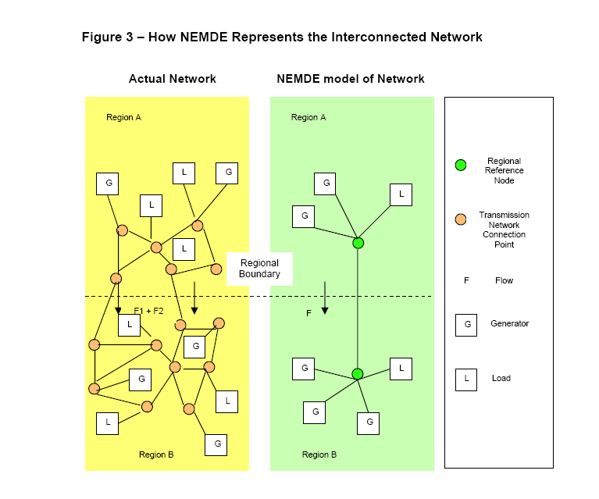

1. AEMO forecasts electricity consumption in each *region*, identifies the capability of each *transmission network* to transmit electricity and captures the present state of the *power system* from information provided by *Transmission Network Service Providers* (**TNSPs**). AEMO then determines the *generation* outputs for each *Generator* according to an optimisation process that is specified in the *Rules* and, in practice, performed by NEMDE. This process is repeated for every *dispatch interval*. A simplified form of this optimisation process, as it applies at a general level, is depicted in Figure 4.

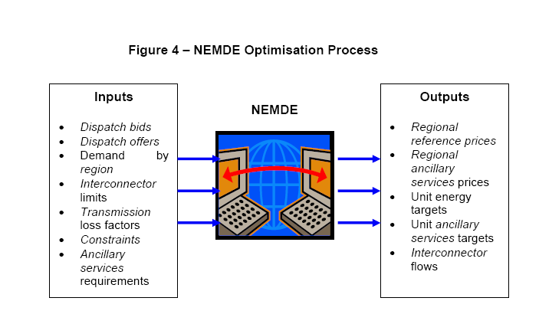

1. The *central* *dispatch* process attempts to maximise the value of electricity traded and produces a *dispatch* *price* in each *region* that represents the marginal price of producing the next increment of electricity at that location.

**G. Scheduled Generation and Central Dispatch**

1. To participate in *central dispatch*, *Scheduled Generators* must submit *dispatch offers* to AEMO to generate electricity[6]. In each *dispatch offer*, *Scheduled Generators* must make an offer to provide a certain number of megawatts (**MW**) of electricity for each of the 48 *trading intervals* in a *trading day* and may make offers for up to ten *price bands* for each *generating unit*.[7] All prices in *price bands* are locked in at 12:30 EST on the day before trading commences, but MW quantities associated with those *price bands* can be modified at any time prior to *dispatch*.
2. The highest price *Scheduled Generators* can offer is $14,000 per MWh (*market price cap*) and the lowest is -$1,000 per MWh (*market floor price*).[8] *Scheduled Generators* must specify other technical matters in their *dispatch offers*, such as their rate of change for increasing or decreasing their output in MW/minute (*ramp rate*).
3. AEMO sends *Scheduled Generators* a *pre-dispatch schedule* every 30 minutes. A *pre-dispatch schedule* is essentially a forecast that gives *Scheduled Generators* an indication of when they will be *dispatched*, and for what level of output they will be *dispatched* for the *trading intervals* in the next two days. *Scheduled Generators* have an opportunity to *rebid* the MW capacity that they can produce and other technical aspects of their capacity right up to five minutes before the event, but cannot change the prices for the *price bands* they have offered.
4. NEMDE sends *Scheduled Generators* electronic *dispatch instructions* to increase or reduce the quantity of electricity they produce for each *dispatch interval*.
5. NEMDE will process all the data it has available to achieve the lowest cost and most efficient outcome taking into account *power system* limitations. In general, and without considering the impact of *constraints*, *ramp rate* and other limitations for each *dispatch interval, Scheduled Generators* will be *dispatched* in ascending *price band* order until enough electricity has been produced to meet demand in that *dispatch interval*.
6. The *spot price* for a *trading interval* is the average of the six *dispatch interval* prices within that *trading interval*.
7. All of the *Scheduled Generators* *dispatched* during that *trading interval* will be paid the *spot price* times their *loss factor* for the energy they produced in that *trading interval*, even if their *dispatch offers* were for a lower price. Any *Scheduled Generators* whose offers were too expensive and were not needed to meet demand are not *dispatched* and, consequently, do not get paid. In this way, the wholesale exchange encourages competition between *Scheduled Generators*.

**H. Semi-Scheduled Generation and Central Dispatch**

1. A *Semi-Scheduled Generator* must operate a *semi-scheduled generating unit* in accordance with the *central dispatch* process under Chapter 3 of the *Rules*.[9]
2. The *Rules* distinguish between two different forms of *dispatch interval* for *semi-scheduled generating units,* which are treated differently in the *central dispatch* process:
   * 1. *semi-dispatch intervals*; and
     2. *dispatch intervals* that are not *semi-dispatch intervals*.
3. *Semi-Scheduled Generators* participate in the *central dispatch* process by submitting offers, but effectively operate as though they were *Non-Scheduled Generators* (and need not respond to *dispatch instructions*) unless AEMO declares a *semi-dispatch interval* for a *semi-scheduled generating unit*. During a *semi-dispatch interval,* the output for that *semi-scheduled generating unit* must not exceed a *dispatch level* specified by NEMDE.
4. In operating the *central dispatch* processunder clause 3.8 of the *Rules*, AEMO's obligation in clause 3.8.1(b) to aim to maximise the value of *spot market trading* is subject to a number of matters, including, *non-scheduled load* requirements in each *region[10]* and, in respect of *semi-scheduled generating units*, *constraints* identified by the *unconstrained intermittent generation forecast* (**UIGF**).[11]
5. The requirement for AEMO to develop a UIGF is established in clause 3.7B, which provides that AEMO must prepare a forecast of the *available capacity* of each *semi-scheduled generating unit* (to be known as the UIGF) for the purposes of, amongst other things, *dispatch*.[12]

**I. The Scheduling Error**

1. Clause 3.8.24(a) of the *Rules* provides that a *scheduling error* is any one of the following circumstances:
   * 1. the DRP determines under clause 8.2 that AEMO has failed to follow the *central dispatch* process set out in clause 3.8;[13]
     2. AEMO declares that it failed to follow the *central dispatch* process set out in clause 3.8;[14] or
     3. AEMO determines under clause 3.9.2B(d) that a *dispatch interval* contained a manifestly incorrect input.[15]
2. On 20 February 2017, AEMO declared that it failed to follow the *central dispatch* process when it applied incorrect SCADA readings from Feeder 7145 in Queensland as an input to a constraint equation that was subsequently used in *central dispatch*.
3. AEMO has *published* a report titled 'NEM Scheduling Error – 5 August 2016 to 17 august 2016 – Incorrect SCADA for 7145 Feeder in Queensland’ (**Report**). The Report describes the occurrence of the *scheduling error* and a copy is provided in **Schedule 3**.

**J. Dispatch Intervals affected by the Scheduling Error**

1. In its Report, AEMO confirms that the *scheduling error* affected a number of *dispatch intervals* between 5 August 2016 and 17 August 2016 and the output of a number of *Market Generators* with *scheduled generating units* and *semi-scheduled generating units* during those *dispatch intervals*.[16]

**K. Calculation of Compensation**

1. Clause 3.16.2 of the *Rules* provides that where a *scheduling error* occurs:
   * 1. a *Market Participant* may apply to the DRP for a determination as to compensation;[17] and
     2. the DRP may determine that compensation is payable to *Market Participants* and the amount of any such compensation payable from the *Participant compensation fund*.[18]
2. A *Scheduled Generator* or *Semi-Scheduled Generator* who receives an instruction in respect of a *scheduled generating unit* or *semi-scheduled generating unit* (as applicable) to operate at a lower level than the level at which it would have been instructed to operate had the *scheduling error* not occur is entitled to receive in compensation an amount determined by the DRP.[19]
3. The DRPmust, therefore, determine the compensation payable in respect of any *scheduled generating unit* or *semi-scheduled generating unit* that, as a result of the *scheduling error*, was *dispatched* at a lower level than it would have been had the *scheduling error* not occur*.*[20]
4. To determine the amount of this compensation payable to a Claimant,it is necessary to establish the following values for each affected *dispatch interval* or *semi-dispatch interval*:

(a) the actual output of each Generating System;

(b) the *dispatch instruction* that would have been issued by AEMO in the absence of the *scheduling error*;

(c) the applicable *intra-regional loss factor* for each Generating System; and

(d) the applicable *spot price*.[21]

1. The following compensation principles have been agreed by the parties for the purposes of quantifying each Claimant’s *spot market* losses during affected *dispatch intervals* or *semi-dispatch intervals* (as applicable) for this *scheduling error*:

(a) Calculate the difference (in MWh) between the actual output of a *generating unit* and the output that would have occurred in the absence of the *scheduling error*;

(b) Multiply the quantity calculated under paragraph (a) by the *intra-regional loss factor* to give the compensable quantity (in MWh).

(c) The *spot market* loss is the compensable quantity calculated under paragraph (b) multiplied by the applicable *spot price*.

(i) If the applicable *spot price* for an affected *dispatch interval* or *semi-dispatch interval* is negative, the calculation under paragraph (c) will result in a payment to the *market* (that is, a credit).

**L. Compensation Amounts**

1. AEMO has calculated the amount of compensation that would be payable to each Claimant, based on the principles in Part K.
2. The calculations are agreed by each Claimant. The total compensation due to each Claimant are set out below:

| **Claimant** | **Compensation** |  |  |  |
| --- | --- | --- | --- | --- |
| CS Energy Limited | $ 114,115.45 |
| Origin Energy Electricity Limited | $ 18,583.61 |
| Hydro Electric Corporation (Hydro Tasmania) | $ 15,069.00 |
| AGL SA Generation Pty Limited | $ 10,858.24 |
| Hazelwood Power | $ 10,194.23 |
| AGL Macquarie Pty Limited | $ 4,128.81 |
| AGL Loy Yang Marketing Pty Ltd | $ 3,034.70 |
| AGL Hydro Partnership | $ 2,083.30 |
| Synergen Power Pty Ltd | $ 260.62 |
| AETV Pty Ltd | $ 59.46 |
| Origin Energy Uranquinty Power Pty Ltd | $ 50.44 |
| Pelican Point Power Limited | $ 44.96 |
| IPM Australia Limited | $ 22.61 |

**M. Participant Compensation Fund**

1. AEMO is required by clause 3.16.1 of the *Rules* to 'maintain, in the books of the corporation, a fund called the *Participant compensation fund* for the purpose of paying compensation ... as determined by the *dispute resolution panel* for *scheduling error*s…'.
2. AEMO is required to pay to the *Participant compensation fund* the component of *Participant fees* attributable to the *Participant compensation fund*. The overall funding requirement for each financial year is the lesser of:
   * 1. $1,000,000; and
     2. $5,000,000 minus the amount that AEMO reasonably estimates will be the balance of the *Participant compensation fund* at the end of the *financial year*.[22]
3. Any interest paid on money held in the *Participant compensation fund* also accrues to and forms part of the *Participant compensation fund*.[23]

***Participant Fee Determination***

1. AEMO must prepare and *publish* before the beginning of each *financial year* a budget of the revenue requirements for AEMO for that *financial year*.[24] The budget must take into account and separately identify projected revenue requirements in respect of the funding requirements of the *Participant compensation fund* in accordance with clause 3.16.[25] The projected revenue requirements in respect of the funding requirements of the *Participant compensation fund* must only be recovered from *Scheduled Generators*, *Semi-Scheduled Generators* and *Scheduled Network Services Providers*.[26]
2. AEMO must also develop, review and *publish* the structure (including the introduction and determination) of *Participant fees* for such periods as AEMO considers appropriate.[27] The *Participant fees* should recover the budgeted revenue requirements for AEMO determined under clause 2.11.3.[28]
3. AEMO has determined the structure of *Participant fees* for the period 1 July 2016 to 30 June 2021.[29] AEMO determined that the budgeted revenue requirements in respect of the *Participant compensation fund* will be allocated to *Scheduled Generators, Semi-Scheduled Generators* and *Scheduled Network Service Providers* and levied using a combination of historical capacity and historical energy scheduled, where:
   * 1. 50% will be collected on the basis of MWh of energy scheduled or *metered* in the previous calendar year; and
     2. 50% will be collected on the basis of the higher of the greatest registered capacity and highest notified maximum capacity in the previous calendar year.
4. AEMO may charge a *Registered Participant* the relevant components of *Participant fees* by giving the *Registered Participant* a statement setting out the amount payable by that *Registered Participant* and the date for payment.[30] In the case of *Market Participants*, AEMO may, alternatively, include the relevant amount in the f*inal statements* described in clause 3.15.15.[31] A *Registered Participant* must pay to AEMO the net amount stated in the relevant statement by the date specified by AEMO.[32]

***Matters to be taken into account by DRP***

1. The *Participant compensation fund* balance as at 15 March 2017 is $5,115,450.
2. As a consequence, the funding requirement for the *Participant compensation fund* is nil until 30 June 2017.
3. Since the commencement of the *market* there have been 29 payments made from the *Participant compensation fund*. These are as follows:

| **Market Participant** | **Date of**  **Scheduling Error** | **Compensation** |
| --- | --- | --- |
| Snowy Hydro Limited | 31 Oct 2005 | $438,892.00 |
| Macquarie Generation | 22 Oct 2007 | $4,544,638.00 |
| AGL Hydro Partnership | 19 & 20 Nov 2009 | $571,935.06 |
| Synergen Power Pty Ltd | 19 May 2009 - 14 Jan 2010 | $246,858.78 |
| AGL Hydro Partnership  Infigen  Trustpower  Pacific Hydro  EnergyAustralia | Various | $78,585.00  $1,178,290.00  $12,031.00  $29,999.00  $11,891.00 |
| Hydro-Electric Corporation (trading as Hydro Tasmania)  AGL Loy Yang Marketing Pty Ltd  CS Energy Limited  AGL Hydro Partnership  Origin Energy Electricity Limited  AGL Macquarie Pty Limited  Callide Power Trading Pty Limited  AGL SA Generation Pty Limited  Delta Electricity  Snowy Hydro Limited  Stanwell Corporation Limited  Hazelwood Power  EnergyAustralia Pty Ltd  Aurora Energy (Tamar Valley) Pty Ltd (trading as AETV Power)  Flinders Operating Services Pty Ltd  EnergyAustralia Yallourn Pty Ltd  IPM Australia Limited  Braemar Power Project Pty Ltd  Origin Energy Uranquinty Power Pty Ltd  Pelican Point Power Limited |  | $296,661.14  (in total) |

**O. Other Applications for Compensation**

1. This *scheduling error* was declared since the last payment.
2. There are three other outstanding claims for compensation in respect of four separate *scheduling errors*:
3. The first involves two *scheduling errors* were declared by AEMO as a result of incorrect UIGFs that affected a number of *semi-dispatch intervals* between 2012 and 2016. If all possible *energy* claims are accepted by the DRP, the total paid to the claimants will be $3,082,235.85.
4. The second was declared by AEMO as a result of the application of incorrect ratings to three 66kV *transmission lines* in Victoria, which were then used in *constraint* equations that were subsequently used in *central dispatch*. If all submitted claims are accepted by the DRP, the total paid to the claimants will be $5,554,203.90.
5. The third was declared by AEMO as a result of the application of incorrect directional ratings to manage the flow on the No.1 and No.2 South East 275/132 kV transformers in South Australia. If all possible *energy* claims are accepted by the DRP, the total paid to the claimants will be $221,890.52.
6. Taking all claims into consideration, the total amount to be paid out of the *Participant compensation fund* in the current *financial year* will exceed the total amount currently deposited in it.
7. In making its determination, the DRP must:
   * 1. consider the claim for compensation by reference to the reduction in the *loading level* at which a *generating unit* operated due to the *scheduling error*;
     2. use the *spot price* determined under clause 3.9;[33]
     3. take into account the current balance of the *Participant compensation fund* and the potential for further liabilities to arise during the year;[34] and
     4. recognise that the aggregate liability in any year in respect of *scheduling errors* cannot exceed the balance of the *Participant compensation fund* that would have been available at the end of the year if no compensation payments for *scheduling errors* had been made during that year.[35]
8. In a decision of the DRPdated 24 April 2008in a claim for compensation from the *Participant compensation fund* by Macquarie Generation, it was held that the reference to 'the potential for further liabilities to arise during the year' in clause 3.16.2(h)(4) is a reference to 'the possibilities of further actual liabilities during the financial year' that will have created a clear balance in the *Participant compensation fund*.[36] The DRP also accepted that the reference to 'year' in clause 3.16.2(h) is a reference to a *financial year*.[37]
9. In a decision of the DRP dated 9 November 2016, the DRP described the further liabilities referenced in clause 3.16.2(h)(4) as 'future contingent liabilities'. Specifically in reference to a claim for compensation for losses arising from the AWEFS scheduling error, the DRP commented that the impending claim had been advised to the WEMDRA and was well known to the market. The DRP stated: 'it is more likely than not that the wind scheduling error matter will result in a liability to be met by the Participant compensation fund; and while the timing is unclear the liability may crystallise before 30 June 2017'. [38]

**P. The Need for Apportionment**

1. There are insufficient funds in the *Participant compensation fund* to cover all current claims for compensation, let alone any prospective claim.
2. Full payment of the loss of the Claimants should not be made, as this would defeat all known other known claims for compensation that would be payable by the end of the current *financial year*.
3. A more equitable distribution of the balance of funds in the *Participant compensation fund* is necessary so as not to defeat the spirit of clause 3.16.2(h) of the *Rules*.
4. The DRP must consider how to allocate available funds.
5. Most of the case law around the distribution of limited funds to claimants with claims that, in total, exceed the balance of available funds are in the areas of insolvency,[39] or breach of trust[40], but only a limited sub-set of these would appear to have any application in the present circumstances.
6. Of these, the parties submit that the most appropriate approach is allocation on a pari passu, or on a pro rata basis – the advantage of this type of allocation is that each Claimant receives some compensation based on the following formula:

$$C*\frac{B}{S}$$

Where: C = the amount of compensation sought by a claimant

B = the balance in the *Participant compensation fund*

S = Sum of all amounts of compensation sought by all claimants

1. Australian case law suggests that the pari passu rule is the preferred mode of allocating funds.[41]

**O. Costs**

1. For the purposes of this claim, the costs of these proceedings (other than the legal costs of the parties) will be as agreed between the Claimants and summarised by the *Adviser*. Each party will bear its own legal costs.

**DATED: 21 March 2017**

**SCHEDULE 1 – CLAIMANTS**

| **Affected Generator** | **ABN** | **Affected Generating System** | **Classification** | **DUID** |
| --- | --- | --- | --- | --- |
| AGL Hydro Partnership | 86 076 691 481 | West Kiewa Power Station | Scheduled | WKIEWA1 & WKIEWA2 |
| AGL Loy Yang Marketing Pty Ltd | 19 105 758 316 | Loy Yang A Power Station | Scheduled | LYA1, LYA2, LYA3 & LYA4 |
| AGL Macquarie Pty Ltd | 18 167 859 494 | Bayswater Power Station | Scheduled | BW01, BW02, BW03 & BW04 |
| AGL SA Generation Pty Ltd | 84 081 074 204 | Torrens Island Power Station "A" | Scheduled | TORRA1, TORRA3 & TORRA4 |
| Torrens Island Power Station "B" | Scheduled | TORRB1, TORRB2  TORRB3 & TORRB4 |
| Aurora Energy (Tamar Valley) Pty Ltd (Trading as AETV Power) | 29 123 391 613 | Bairnsdale Power Station | Scheduled | BDL02 |
| CS Energy Limited | 54 078 848 745 | Gladstone Power Station | Scheduled | GSTONE1, GSTONE2,  GSTONE3, GSTONE4  GSTONE5 |
| Hazelwood Power | 40 924 759 557 | Hazelwood Power Station | Scheduled | HWPS4 |
| Hydro-Electric Corporation(Trading as Hydro Tasmania) | 48 072 377 158 | Cethana Power Station | Scheduled | CETHANA |
| Devil’s Gate Power Station | Scheduled | DEVILS_G |
| John Butters Power Station | Scheduled | JBUTTERS |
| Mackintosh Power Station | Scheduled | MACKNTSH |
| Meadowbank Power Station | Semi-Scheduled | MEADOWBK |
| Poatina Power Station | Scheduled | POAT110 & POAT220 |
| Reece Power Station | Scheduled | REECE1 & REECE2 |
| Tarraleah Power Station | Scheduled | TARRALEA |
| Trevallyn Power Station | Scheduled | TREVALLN |
| Tungatina Power Station | Scheduled | TUNGATIN |
| IPM Australia Limited | 87 055 563 785 | Loy Yang B Power Station | Scheduled | LOYYB1 & LOYYB2 |
| Origin Energy Electricity Limited | 33 071 052 287 | Eraring Power Station | Scheduled | ER01, ER03 & ER04 |
| Darling Downs Power Station | Scheduled | DDPS1 |
| Ladbroke Grove Power Station | Scheduled | LADBROK2 |
| Mortlake Power Station Units | Scheduled | MORTLK12 |
| Bendeela / Kangaroo Valley Power Station | Scheduled | SHGEN |
| Osborne Power Station | Scheduled | OSB-AG |
| Quarantine Power Station | Scheduled | QPS1, QPS2 & QPS5 |
| Pelican Point Power Limited | 11 086 411 814 | Pelican Point Power Station | Scheduled | PPCCGT |
| Synergen Power Pty Limited | 66 092 560 819 | Dry Creek Gas Turbine Station | Scheduled | DRYCGT1, DRYCGT2 &  DRYCGT3 |

**SCHEDULE 2 - GLOSSARY**

|  |  |
| --- | --- |
| **TERM** | **MEANING** |
| **Affected Generator** | Any *Market Generator* impacted by the *scheduling error*. |
| **DRP** | *dispute resolution panel* |
| **DUID** | Dispatchable unit ID |
| **EMS** | AEMO’s Energy Management System |
| **EST** | *Eastern Standard Time* |
| **MW / MWh** | megawatt / megawatt hour |
| **NEL** | National Electricity Law |
| **NEMDE** | *NEM* dispatch engine |
| **NSP** | *Network Service Provider* |
| **Scheduling Error Period** | See paragraph 4. |
| **TNSP** | *Transmission Network Service Provider* |
| **UIGF** | *unconstrained intermittent generation forecast* |

**SCHEDULE 3 - SCHEDULING ERROR REPORT**

Please click on this link:

<http://www.aemo.com.au/-/media/Files/Electricity/NEM/Market_Notices_and_Events/Market_Event_Reports/2017/Scheduling-Error---Incorrect-SCADA-for-7145-Feeder.pdf>

1. Section C addresses the question of which versions of the *Rules* are relevant to the period during which the *scheduling error* impacted the Claimants.
2. AEMO may declare a *scheduling error* under clause 3.8.24(a)(2) of the *Rules*.
3. Clause 3.16.2 (b) and (d).
4. Clause 3.16.2(i).
5. Clause 3.8.1(b).
6. Clause 3.8.2(a).
7. Clause 3.8.6(a).
8. Clauses 3.9.4(b) and 3.9.6(b).
9. Clause 2.2.7(h).
10. Clause 3.8.1(b)(3).
11. Clause 3.8.1(b)(2)(ii).
12. Clause 3.7B(a)(2).
13. Clause 3.8.24(a)(1).
14. Clause 3.8.24(a)(2).
15. Clause 3.8.24(a)(3).
16. See Table 1 of the Report
17. Clause 3.16.2(a).
18. Clause 3.16.2(b).
19. Clause 3.16.2(d).
20. Clause 3.16.2(d)
21. Clause 3.16.2(h)(3) requires the *dispute resolution panel* to use the *spot price* determined under Clause 3.9 in determining compensation.
22. See clause 3.16.1(c).
23. Clause 3.16.1(e).
24. Clause 2.11.3(a).
25. Clause 2.11.3(b)(8).
26. Clause 2.11.3(b)(8).
27. Clause 2.11.1(a).
28. Clause 2.11.1(b)(2).
29. See <http://www.aemo.com.au/Datasource/Archives/Archive595>.
30. Clause 2.11.2(a).
31. Clause 2.11.2(b).
32. Clause 2.11.2(c).
33. Clause 3.16.2(h)(3)
34. Clause 3.16.2(h)(4).
35. Clause 3.16.2(h)(5).
36. See paragraphs 24 and 25 of the decision.
37. See paragraph 15 of the decision.
38. See paragraph 41 of the decision.
39. See for example, *Australian Securities and Investments Commission v Letten* (No7) [2010] FCA 1231.
40. See for example, *Hannan v Zindilis* [2016] VSC 723.
41. See *Hannan v Zindilis* [2016] VSC 723, at paragraph 25.