

Electricity distributors 2011–13 performance report

June 2015

© Commonwealth of Australia 2015

This work is copyright. In addition to any use permitted under the Copyright Act 1968, all material contained within this work is provided under a Creative Commons Attributions 3.0 Australia licence, with the exception of:

* the Commonwealth Coat of Arms
* the ACCC and AER logos
* any illustration, diagram, photograph or graphic over which the Australian Competition and Consumer Commission does not hold copyright, but which may be part of or contained within this publication. The details of the relevant licence conditions are available on the Creative Commons website, as is the full legal code for the CC BY 3.0 AU licence.

Requests and inquiries concerning reproduction and rights should be addressed to the   
Director, Corporate Communications   
Australian Competition and Consumer Commission   
GPO Box 4141   
Canberra ACT 2601   
or publishing.unit@accc.gov.au.

Inquiries about this publication should be addressed to:

Australian Energy Regulator  
GPO Box 520  
Melbourne Vic 3001

Tel: (03) 9290 1444  
Fax: (03) 9290 1457

Email: [AERInquiry@aer.gov.au](mailto:AERInquiry@aer.gov.au)  
AER Reference: 48890, D15/88781

Contents

Preface 1

1 Introduction 2

1.1 Our role 2

1.2 Priorities and objectives of performance reporting 2

1.3 Scope of the report 3

1.4 Sources of information 3

1.5 Presentation of data 4

1.6 Structure of the report 4

1.7 Comments from interested parties 5

2 Overview 6

2.1 Energy Delivered 6

2.2 Capital expenditure 6

2.3 Regulatory asset base 7

2.4 Operating expenditure 8

2.5 Revenue 8

2.6 Service performance 9

3 Electricity distribution networks 12

3.1 Electricity networks in the NEM 12

3.2 Ownership 14

3.3 Key features of distribution networks 14

4 Demand 18

4.1 Energy delivered 18

4.2 Maximum demand 19

5 Capital expenditure 21

5.1 Capital expenditure in electricity distribution 21

6 Operating expenditure 25

6.1 Operating expenditure in electricity distribution 25

7 Revenue 27

7.1 Revenue in electricity distribution 27

7.2 Revenue, 2011–13 29

8 Service performance 32

8.1 Reliability of supply 32

8.2 Service target performance incentive scheme 33

9 Distribution networks 45

9.1 ActewAGL 46

9.2 Ausgrid 55

9.3 Endeavour Energy 64

9.4 Essential Energy 73

9.5 Energex 82

9.6 Ergon Energy 92

9.7 SA Power Networks 102

9.8 TasNetworks (formerly Aurora Energy) 112

9.9 AusNet Services (formerly SP AusNet Distribution) 122

9.10 CitiPower 132

9.11 JEN (Jemena Electricity Networks) 142

9.12 Powercor 151

9.13 United Energy 161

10 Glossary 170

Preface

I am pleased to present the 2011-13 performance report for electricity distribution networks.

The performance report is the first report to cover all 13 distributors in the National Electricity Market (NEM), and provides information on recent trends in expenditures by distributors and the level of service provided to customers.

The distributors report improving service levels for distribution customers, with the number of interruptions to supply and the length of interruptions to supply both falling in every year since 2010.

Demand for electricity is reported to have declined across the NEM and was around 5 per cent less than forecast for 2011-13. Reduced demand contributed to lower than forecast expenditure by the distributors, especially on network growth projects. Total expenditure by all distributors on capital projects was $5.2 billion in 2013, 16 per cent less than forecast.

The Australian Energy Regulator is responsible for the economic regulation of electricity network service providers (NSPs). The NSPs operate in the NEM, in accordance with the National Electricity Law (NEL) and the National Electricity Rules (NER). In undertaking our economic regulatory functions we promote the National Electricity Objective, which is to:

Promote efficient investment in, and efficient operation and use of electricity services for the long term interests of consumers of electricity with respect to electricity supply and the national electricity system.

Our role includes annual performance reporting on regulated NSPs. Performance reporting increases the transparency and accountability needed to underpin efficiency based regulation. This report promotes the National Electricity Objective by better informing both regulated NSPs and other stakeholders of the NSPs’ performance. It provides comprehensive, accurate and reliable information about the services customers receive and promotes better service by comparing distribution network service providers and encouraging them to improve their performance.

This report reflects our priorities and objectives for NSP performance reporting. It has been prepared as part of our overall network reporting and information strategy. We will continue to implement the strategy aiming to include more comprehensive financial and service performance information in future DNSP performance reports.

I hope this report provides interested parties with sufficient information to enable critical evaluation of DNSPs’ performance under their distribution determinations. I encourage you to read the report and provide feedback to the AER.

**Paula Conboy, Chair**

# Introduction

## Our role

The Australian Energy Regulator (AER) is responsible for the economic regulation of electricity networks in the National Electricity Market (NEM). This role includes compliance monitoring, reporting and enforcement of our pricing determinations. In carrying out these functions, we collect annually a wide range of regulatory, financial and operational information from distribution network service providers (DNSPs). We use this information to:

* monitor the DNSPs' compliance with aspects of their distribution determination
* monitor actual outcomes against the forecasts in a DNSP's distribution determination
* prepare for a DNSP's next distribution determination
* report on a DNSP's financial and operational performance.

## Priorities and objectives of performance reporting

In April 2011, we published our statement of approach to the priorities and objectives of electricity network service providers (NSP) performance reports. Our objectives in publishing network performance reports are to educate stakeholders, promote transparency, and to enhance accountability. In this way the reports act as an incentive for NSPs to improve performance.

For us to achieve these objectives, the priorities of network performance reporting are to report:[1]

* the NSPs' compliance with approved cost allocation methods, and with elements of their regulatory determination (including service standards and incentive schemes)
* the NSPs’ forecast and actual outputs (including measures of network use and asset age), to identify areas of NSP performance we may review
* forecast and actual capital and operating expenditure, and reasons for differences between forecast and actual expenditures
* benchmark expenditure information, to allow comparison of NSP performance over time and between NSPs (including in different jurisdictions)
* the NSPs’ network operations, including service standard levels and demand management information
* comprehensive, accurate and reliable information, enabling stakeholders to analyse performance and have confidence in the results
* information over time identifying trends and comparing of changes in NSPs' performance, outputs and expenditures
* the NSPs’ financial performance, comparing NSPs within and across jurisdictions and across regulatory control periods
* information that can be used for future distribution determinations (including cost drivers, expenditure trends, service levels and variations in network performance).

Our objective in monitoring the DNSPs’ performance and publishing this report is to increase accountability for performance through greater transparency. In particular, we aim to:

* facilitate informed public input into future decisions by the AER
* allow public scrutiny of DNSPs' performance against distribution determinations
* increase transparency of the regulatory process and the outcomes that it generates.

## Scope of the report

This report focuses primarily on the years 2011 to 2013, when we commenced regulation of all DNSPs in the NEM. We have not previously published a report on the DNSPs' performance in these years. The report also contains some information relating to the previous years to provide trend information.

The report provides stakeholders and interested parties with information and comparative data on the financial and service performance of DNSPs. In particular, it details:

* actual energy delivered and maximum demand compared with forecasts
* actual capital expenditures compared with forecasts
* actual operating and maintenance expenditures compared with forecasts
* actual revenues recovered from customers compared with forecasts
* actual regulatory asset base (RAB) compared with the forecast
* network reliability outcomes compared with established targets.

The report also provides information on individual businesses earnings for three years, 2011–2013. However, we do not present comparative data on earnings because the data is inconsistent across the DNSPs, and across years. We intend to revise the annual reporting requirements to improve our ability to report on the DNSPs' future financial performance.

## Sources of information

The DNSPs must submit financial and non–financial information in accordance with annual reporting regulatory information notices (RINs). The Annual Reporting RINs were the main source of data for this report, particularly in relation to actual outcomes. We sourced forecast information from our distribution determinations, incorporating any adjustments made as the result of Australian Competition Tribunal (Tribunal) decisions, or cost pass through decisions.

Other sources of information included:

* revenue proposals DNSPs submitted to the AER
* regulatory accounts from jurisdictional regulators
* economic benchmarking and category analysis RIN responses DNSPs submitted to the AER.

## Presentation of data

The following information about the data in this report will assist in any analysis or interpretation.

### Forecast figures

This report compares actual expenditures and revenues with the forecasts in our distribution determinations. To enhance comparability, we present all financial figures in December 2012 dollars. For example, we removed forecast inflation from all forecast figures to deflate them to a base year dollar amount. We then inflated/deflated these amounts to December 2012 dollars using the consumer price index (CPI).

### Colour coding of charts

In all figures we have used colour coding to indicate the jurisdiction in which the DNSP operates.

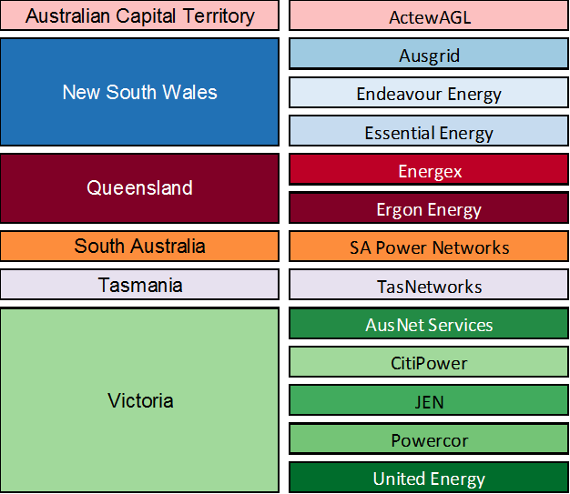

### Financial year/calendar year

The Australian Capital Territory, New South Wales, Queensland, South Australian and Tasmanian DNSPs report on a financial year basis, whereas Victorian DNSPs report on a calendar year basis. For the purposes of this report any figures, tables or statements that compare both non–Victorian and Victorian DNSPs refer to the relevant calendar year for the Victorian DNSPs. The relevant financial year for the non–Victorian DNSPs ends in the calendar year (that is, 2013 relates to the 2012–13 financial year). However, figures and tables relating to only non–Victorian DNSPs show the relevant financial year.

## Structure of the report

The report is structured as follows:

* Chapter 2 provides aggregate information on the energy delivered, capital expenditure, operating expenditure, revenue and service performance of all DNSPs in the NEM.
* Chapter 3 provides an overview of electricity distribution in the NEM, ownership of the DNSPs and key features of the networks.
* Chapter 4 compares the DNSPs' actual energy delivered and maximum demand with our approved forecasts for 2011–13.
* Chapter 5 compares the DNSPs' actual capital expenditure with our approved forecasts for 2011–13.
* Chapter 6 compares the DNSPs' actual operating expenditure with our approved forecasts for 2011–13.
* Chapter 7 compares the DNSPs' actual revenue with our approved revenue forecasts for 2011–13.
* Chapter 8 compares the DNSPs' service performance with targets for 2011–13.
* Chapter 9 provides detailed information and commentary from each DNSP.

## Comments from interested parties

We welcome comments on this report. Interested parties can be submit comments by email to [AERinquiry@aer.gov.au](mailto:AERinquiry@aer.gov.au) (marked Attn: General Manager, Finance and Reporting), or by mail to:

Warwick Anderson

General Manager, Finance and Reporting

Australian Energy Regulator

GPO Box 3131, Canberra, ACT 2601

# Overview

This chapter provides aggregate information on energy delivered, capital expenditure, operating expenditure, revenue and service performance. The data are for all DNSPs in the NEM. The data include amendments made to forecasts as a result of Tribunal orders or approved pass throughs.[2]

## Energy Delivered

In 2013, the DNSPs delivered approximately 143 terawatt hours (TWh) of energy (Figure 2-1), a fall of 1.3 per cent from the previous year, and approximately 7.3 per cent below forecast. This fall continued a trend of declining electricity consumption since 2010.

Over 2011–13, the DNSPs’ delivery of total energy fell by an annual average of 1.4 per cent. It was 5.3 per cent lower than our approved forecast for the period.

Figure 2–1 Total energy delivered by DNSPs in the NEM

## Capital expenditure

In 2013, total capital expenditure by DNSPs on standard control services[3] was approximately $5.2 billion. Over 2011–13 it was approximately 16 per cent less than our approved forecast for the period (Figure 2–2).

Figure 2–2 Total capital expenditure by DNSPs in the NEM

## Regulatory asset base

The RAB reflects a DNSP's opening capital base when it was first regulated, plus subsequent new investment, less depreciation on existing assets.

At the end of 2013, the combined RAB value of all the DNSPs in the NEM was approximately $58.7 billion (Figure 2–3). That value increased by approximately 21 per cent over 2011–13, which was less than our forecast increase of 31 per cent over the period.

Figure 2–3 Combined regulatory asset base for all DNSPs

## Operating expenditure

In 2013 total operating expenditure by DNSPs on standard control services was approximately $3.2 billion. Over 2011–13 it was within 1 per cent of our approved forecast for the period (Figure 2–4).

Figure 2–4 Total operating expenditure by DNSPs in the NEM

## Revenue

Revenues are determined by us using our building block model. This model determines the revenue that a DNSP needs to cover its efficient costs and provide a commercial rate of return on its RAB. The main revenue drivers for the DNSPs are the rate of return, the RAB (which increases with capital expenditure), depreciation and operating costs. The DNSPs are capital intensive, so even small changes to the return earned on assets can have a significant impact on revenue requirements.

In 2013 total distribution revenue that DNSPs recovered for standard control services was approximately $10.4 billion. Over 2011–13 it was comparable with our approved forecast for the period (Figure 2–5).

Figure 2–5 Total revenue recovered by DNSPs in the NEM

## Service performance

### Total interruptions to supply

In 2013 the average distribution network customer in the NEM experienced:

* 325 total minutes off supply, as measured by the system average interruption duration index (SAIDI) (Figure 2‒6)
* 1.86 interruptions to supply, as measured by the system average interruption frequency index (SAIFI) (Figure 2‒7).

Total network SAIDI for the average distribution network customer in the NEM was relatively high in both 2011 and in 2013 (Figure 2.6). In 2011, floods affected much of central and southern Queensland. In 2013 Queensland was affected by Tropical Cyclone Oswald which caused widespread storms and flooding. While these events impacted on the amount of time customers were without electricity, they did not cause a significant change in the number of interruptions experienced (Figure 2.7).

Figure 2–6 Total minutes off supply for distribution customers

Figure 2–7 Total interruptions to supply for distribution customers

### Reliability of supply (normalised)

Sometimes interruptions to supply (outages) occur through circumstances beyond the control of DNSPs. Such outages could be caused by severe weather events (storms, cyclones), natural disasters, or by outages on the transmission networks. As these outages cannot be controlled by the DNSPs, we remove their impact from the data (normalise the data) to compare network reliability.

After removing the effect of events considered to be beyond the DNSPs' control, the average distribution network customer experienced fewer unplanned minutes off supply and fewer unplanned interruptions to supply for the fourth consecutive year in 2013. In 2013 they experienced:

* 118 unplanned (normalised) sustained minutes off supply (Figure 2–8)
* 1.26 unplanned (normalised) interruptions to supply (Figure 2–9).

Figure 2–8 Unplanned (normalised) minutes off supply for distribution customers (SAIDI)

Figure 2–9 Unplanned (normalised) interruptions to supply for distribution customers (SAIFI)

# Electricity distribution networks

This chapter provides an overview of electricity distribution in the NEM and general information about the distribution networks.

## Electricity networks in the NEM

The NEM is a wholesale market in which generators sell electricity in eastern and southern Australia. The energy retailers bundle electricity with network services for sale to residential, commercial and industrial energy users.

The NEM in eastern and southern Australia provides an interconnected transmission network from Queensland through to New South Wales, the Australian Capital Territory, Victoria, South Australia and Tasmania. The NEM transmission network has a long, thin, low density structure, reflecting the location of, and distance between, major demand centres. It comprises five state based transmission networks, with cross-border interconnectors linking the grid.

Electricity is transported along transmission networks at high voltages to minimise energy losses. It must then be stepped down to lower voltages in a distribution network for safe use by customers. Most customers in Australia require delivery at around 230–240 volts. DNSPs transport electricity from transmission networks to residential and business customers.

A distribution network consists of the poles and wires that carry electricity, as well as substations, transformers, switching equipment, and monitoring and signalling equipment. The total length of distribution networks in the NEM is around 750 000 kilometres, crossing both urban and regional areas. The DNSPs need to make a substantial investment in network infrastructure.

This report focuses on the 13 major DNSPs that operate within the NEM (Figure 3–1) and that we regulate under the National Electricity Law and the National Electricity Rules. New South Wales, Queensland and Victoria each have multiple distribution businesses that are monopoly providers in designated areas. The Australian Capital Territory, South Australia and Tasmania each have one major distribution business. Some jurisdictions also have small regional networks with separate ownership.

Figure 3–1 illustrates the distribution networks in the NEM and the geographic areas in which they operate.

Figure 3–1 Distribution networks in the NEM

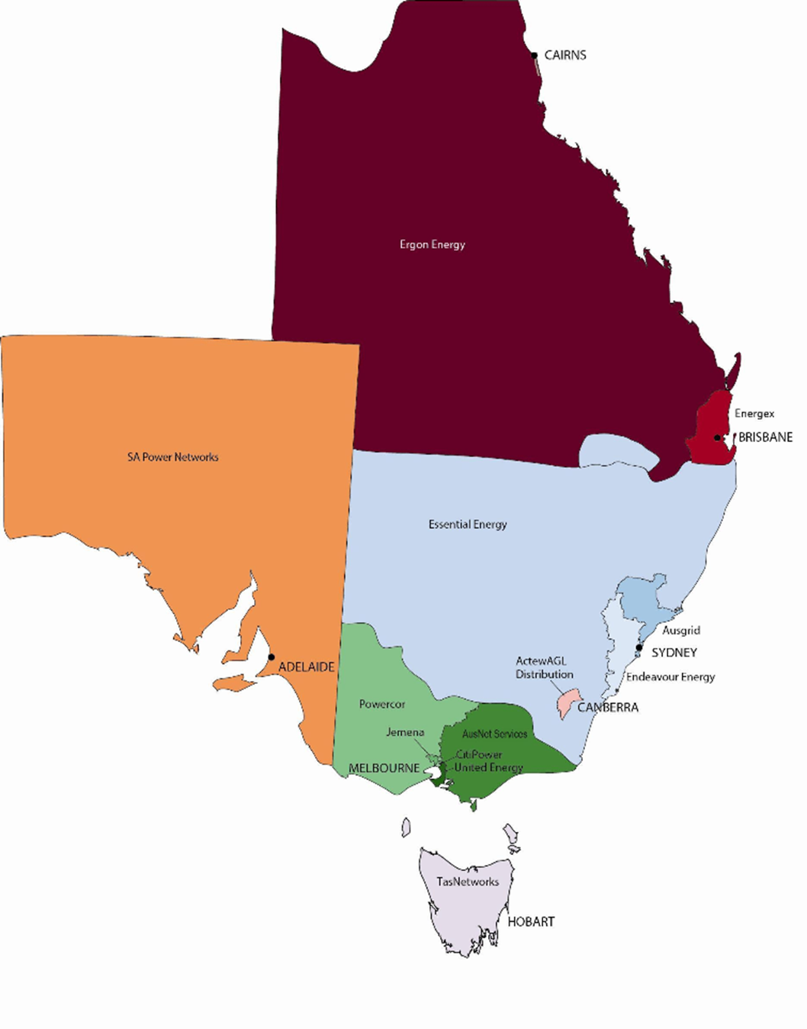

## Ownership

The New South Wales, Queensland and Tasmanian DNSPs are all government owned. The ACT DNSP has joint government and private ownership.

Queensland privatised much of its energy retail sector in 2006−07, but the state owned Ergon Energy continues to provide both distribution and retail services.

The Tasmanian Government recently merged its distribution business (Aurora Energy) with its transmission business (Transend Networks). The merged entity 'Tasmanian Networks Pty Limited' (trading as TasNetworks) commenced operations on 1 July 2014. It provides both transmission and distribution services. Aurora Energy Pty Limited continues to exist, but only provides retail services.

Victoria’s five DNSPs are privately owned, while the South Australian DNSP is leased to private interests:

* Cheung Kong Infrastructure and Power Assets jointly have a 51 per cent stake in two Victorian DNSPs (Powercor and CitiPower) and a 200 year lease of the South Australian DNSP (SA Power Networks). The remaining 49 per cent of the two Victorian DNSPs is held by Spark Infrastructure, a publicly listed infrastructure fund in which Cheung Kong Infrastructure has a direct interest. The remaining interests of Spark Infrastructure are widely held.
* In 2013 State Grid Corporation of China acquired significant stakes in electricity distribution assets from Singapore Power International. State Grid now owns 60 per cent of Jemena, and almost 20 per cent of AusNet services, previously held by SPI PowerNet Pty Ltd.
* Singapore Power International has a minority ownership in Jemena (which owns the Jemena DNSP in Victoria) and part owns the United Energy (Victoria) and ActewAGL (ACT) DNSPs (previously held a majority interest). Until 2014, Singapore Power International also had a 51 per cent stake in AusNet Services, which operates Victoria’s transmission business and the AusNet Services DNSPs. It maintains an ownership share of 31.1 per cent of AusNet Services.

## Key features of distribution networks

The operating environment faced by each DNSP is unique. This section highlights significant factors that affect operating environments, as well as each DNSP's environmental issues.

### Customers and line length

The DNSPs connect customers to the electricity supply through a network of overhead and underground lines.

Figure 3–2 shows a composite of the number of network customers served and the total line length for each DNSP. Figure 3–3 indicates the proportional composition of underground and overhead lines on each distribution network.

The profile of a DNSPs' lines affect its cost structure in the following ways:

* Underground lines:
* are sheltered from external factors (weather or human activities) so are more reliable
* generally require less maintenance (apart from cable terminations at the ends), so their maintenance cost is substantially less than that for overhead lines
* in the case of failure or damage (for example, by excavator or tree roots) generally take more time to locate and repair compared with an overhead line.
* Overhead lines:
* are substantially cheaper to build than underground cable circuits because the material is cheaper and requires less civil engineering work
* have a higher maintenance cost compared with underground lines, due to structural costs (poles, cross arms, insulators, stays etc.) and the need for clearance and safety management (relating to trees, construction activities, the public etc.).

Overhead lines are more predominant in rural areas because they are significantly cheaper to construct. Underground lines are more common in central business district and urban areas, where they are often located with other infrastructure assets such as water, telecommunications and gas. In most new residential subdivisions and customer growth areas, lines are now built underground as standard.

Figure 3–2 Total customers and line length by DNSP, 2013

Figure 3–3 Proportion of overhead and underground lines by DNSP, 2013

### Customer density

Customer density measures the average number of customers connected per kilometre of distribution line (Figure 3–4). It is used to group key drivers of both operational and capital expenditure. These drivers include, but are not limited to:

* asset spacing
* asset exposure
* travel time
* traffic management
* asset complexity
* proximity to third–party assets
* proportion of overhead/underground lines
* landscape and environment.

Generally it is more expensive to provide electricity to a customer in a rural area than in areas where customers are more closely located.

Figure 3–4 Customer density by DNSP, 2013

The number and proportion of network customers that the DNSPs classify into our standard feeder categories is useful for understanding customer density (Figure 3.5, also see Table 8–2 and Table 8–3).

Figure 3–5 Proportion of customers by feeder category and DNSP, 2013

# Demand

This chapter provides forecast and actual information on energy delivered and maximum demand for the DNSPs. Forecast growth in maximum demand is a key driver of network investment and, therefore, revenue.

## Energy delivered

Maximum demand is a measure of the peak amount of energy delivered to customers. The NEM supplies electricity to over nine million residential and business customers. In 2013 the DNSPs delivered more than 143 TWh of electricity—a 1.3 per cent reduction on the previous year's total, and approximately 7.3 per cent below forecast. This outcome continued a trend of declining electricity demand since 2010.

The decline in total electricity supplied through the distribution network reflects:

* commercial and residential customers responding to higher electricity costs by reducing energy use and adopting energy efficiency measures such as solar water heating. New building regulations on energy efficiency reinforce this behaviour
* subdued economic growth and weaker energy demand from the manufacturing sector
* the continued rise in rooftop solar photovoltaic (PV) generation (which reduces demand for electricity supplied through the grid).

Over 2011–13 the DNSPs total energy delivery fell by an average of 1.4 per cent each year. It was 5.3 per cent below our approved forecast for the period.

Figure 4–1 Average annual energy delivered by DNSP, 2011–13

Figure 4–1 compares average annual energy delivered by the DNSPs with our approved forecasts over 2011–13. For the period, it shows:

* two DNSPs (United Energy and JEN) delivered more energy than our approved forecasts
* four DNSP’s energy delivery was less than 95 per cent of our approved energy forecasts: Ergon Energy (18 per cent less than forecast), Energex (8 per cent less), Endeavour Energy (5 per cent less) and AusNet Services (5 per cent less).

Figure 4–2 shows the average annual energy delivered per customer[4] for each DNSP in the NEM over 2011–13. Energy delivered per customer reflects the customer profile on each distribution network. The average Ergon Energy customer, for example, consumes a relatively high amount of energy because its major customers include coal mining operations, coal exporting terminals, Queensland Rail, the sugar industry, beef processing facilities and resorts. These high use customers contribute to Ergon Energy being the second largest supplier of energy despite serving only the seventh most network customers of all DNSPs in the NEM. Other networks may have higher numbers of light commercial or residential customers, with high air conditioning penetration, which increases their average energy delivered compared with networks with lower air conditioning penetration.

Figure 4–2 Average annual energy delivered per customer by DNSP, 2011–13

## Maximum demand

Maximum demand for a network typically occurs on days of extreme weather, when many users use a lot of electricity at the same time. For example, on a hot day, many households and businesses simultaneously use their air conditioners, causing an increase in electricity demand. Electricity networks are designed to meet the maximum forecast demand for energy. For this reason, demand forecasts are important for understanding the need for future capital expenditure. While maximum demand capacity is used for less than 90 hours a year, the costs of having that capacity available are significant and paid by electricity customers.

Maximum demand was lower than forecast among the DNSPs over 2011–13 (Table 4–1 and Table 4–2). The actual and forecast maximum demand figures for the non-Victorian DNSPs (Table 4–1) are sourced from annual reporting information, and based on financial years. The figures for the Victorian DNSPs (Table 4–2) are sourced from Economic benchmarking RINs and based on calendar years.

Table 4–1 Maximum demand (megawatts) – Non–Victorian DNSPs

|  |  |  |  |  |  |  |
| --- | --- | --- | --- | --- | --- | --- |
|  | 2010-11 | | 2011-12 | | 2012-13 | |
|  | Forecast | Actual | Forecast | Actual | Forecast | Actual |
| ActewAGL | 672 | 614 | 684 | 674 | 697 | 583 |
| Ausgrid | 6046 | 6100 | 6254 | 5150 | 6467 | 5659 |
| Endeavour Energy | 4342 | 4002 | 4509 | 3236 | 4663 | 3708 |
| Essential Energy | 2406 | 2292 | 2515 | 2185 | 2602 | 2287 |
| Energex | 4931 | 4689 | 5089 | 4464 | 5328 | 4475 |
| Ergon Energy | 2778 | 2319 | 2907 | 2417 | 3017 | 2380 |
| SA Power Networks | 3159 | 3056 | 3274 | 2723 | 3361 | 2889 |
| TasNetworks | 1047 | 1082 | 1082 | 1042 | 1101 | 1022 |

Table 4–2 Maximum demand (megawatts) – Victorian DNSPs

|  |  |  |  |  |  |  |
| --- | --- | --- | --- | --- | --- | --- |
|  | 2011 | | 2012 | | 2013 | |
|  | Forecast | Actual | Forecast | Actual | Forecast | Actual |
| AusNet Services | 1874 | 1728 | 1959 | 1786 | 2046 | 1908 |
| CitiPower | 1510 | 1421 | 1552 | 1397 | 1593 | 1495 |
| JEN | 1099 | 1079 | 1130 | 996 | 1162 | 959 |
| Powercor | 2481 | 2263 | 2557 | 2161 | 2652 | 2321 |
| United Energy | 2359 | 2052 | 2424 | 2142 | 2495 | 2205 |

Chapter 9 contains our assessment of energy delivered and maximum demand for each DNSP in the NEM.

# Capital expenditure

This chapter describes our approach to assessing capital expenditure forecasts and the DNSPs’ actual capital expenditure on standard control services over 2011–13.

## Capital expenditure in electricity distribution

New investment in electricity networks includes augmentations (expansions) to meet demand and the replacement of aging assets. The regulatory process aims to create incentives for efficient investment. At the start of a regulatory control period, we approve an investment (capital expenditure) forecast for each DNSP. We can approve contingent projects too—that is, large projects that are planned at the time of a distribution determination, involving significant uncertainty.

The DNSPs undertake capital expenditure by investing in infrastructure. They do so for a number of reasons, including:

* augmenting (expanding) the network to meet rising demand
* replacing ageing or poorly performing assets
* maintaining or improving network performance
* meeting regulatory requirements, such as reliability standards.

As part of its regulatory proposal, a DNSP must propose a forecast that addresses the capital expenditure objectives set out in the National Electricity Rules. These capital objectives include:

* meeting the expected demand
* complying with applicable regulations
* maintaining the reliability, quality and security of supply, and the safety of the distribution system.

Capital expenditure is added to the RAB, which is used to derive the depreciation and return on investment components of the building block model. We use a building block model that includes the financing costs associated with capital expenditure, rather than the project expenditure amounts. The DNSP, not the customer, bears the additional financing costs that result from overspending on capital projects during the regulatory control period.

At the beginning of the next regulatory control period, we assess any changes to the value of the DNSPs' RAB that are associated with overspending on capital projects. If we consider this additional spending to be efficient, then we increase the opening asset base at the commencement of the next regulatory control period, and the DNSP will earn a return on this additional expenditure.

Customers do not fund the additional capital expenditure in the current regulatory control period. However, through increased electricity prices, they will fund this additional expenditure from the commencement of the next period. Conversely, when a DNSP underspends on capital projects, customers do not benefit in that regulatory control period. The less than forecast RAB will drive down prices in the next period.

Capital expenditure, 2011–13

Total capital expenditure on standard control services by DNSPs was approximately $5.2 billion in 2013. Over 2011–13, it was approximately 16 per cent less than our approved forecast for the period (Figure 5-1). The underspending was largely driven by:

* lower than forecast peak demand, resulting in augmentation projects being deferred or avoided
* initiatives to actively reduce the need for capital expenditure
* a reduced volume of works reflecting enhanced risk management requirements
* the impact of the weakened national economy on customer initiated work.

Figure 5–1 Total capital expenditure by DNSP, 2011–13

Over 2011–13 each of the following DNSPs' actual capital expenditure was less than our approved forecasts:

* Energex (–26 per cent)
* CitiPower (–23 per cent)
* Ergon Energy (–17 per cent)
* Ausgrid (–17 per cent)
* Essential Energy (–15 per cent)
* SA Power Networks (–11 per cent)
* Powercor (–11 per cent)
* TasNetworks (–10 per cent)
* Endeavour Energy (–9 per cent)
* AusNet Services (–2 per cent).

The following DNSPs' actual capital expenditure over the period exceeded our approved forecasts:[5]

* JEN (+23 per cent)
* ActewAGL (+16 per cent)
* United Energy (+6 per cent).

Regulatory Asset Base

The RAB reflects the opening capital base of a network when it was first regulated, plus subsequent new investment, less depreciation on existing assets.

The combined RAB of DNSPs in the NEM was approximately $58.7 billion at the end of 2013 (Figure 5‒2). It increased by approximately 21 per cent over 2011–13, compared with the forecast increase of 31 per cent for the period.[6]

Figure 5–2 Closing regulatory asset base by DNSP, 2013

For 2013:

* JEN (+7 per cent), United Energy (+2 per cent) and ActewAGL (+2 per cent) reported the highest positive variation in actual RAB compared with our approved forecasts
* Ergon Energy (–11 per cent) and Energex (–10 per cent) reported the highest negative variation in actual RAB compared with our approved forecasts.

These differences are caused by differences between the forecast and actual capital expenditure during the period.[7]

Chapter 9 contains our assessment of capital expenditure for each DNSP in the NEM.

# Operating expenditure

This chapter describes our approach to assessing DNSPs’ forecast and actual operating expenditure over 2011–13.

## Operating expenditure in electricity distribution

Operating expenditure is a key component in our building block model. As part of its regulatory proposal, a DNSP proposes an operating expenditure forecast. This forecast is the DNSP's estimate of its necessary expenditure to achieve the operating expenditure objectives set out in the National Electricity Rules. These objectives include:

* meeting the expected demand
* complying with applicable regulations
* maintaining the reliability, quality and security of supply, and safety of the distribution system.

We determine allowances for each DNSP to cover efficient operating and maintenance expenditure based on an assessment of the operating expenditure forecast by the DNSP. These allowances are based on individual network requirements for the relevant regulatory control period. Each DNSP's requirements depend on:

* load densities
* the scale and condition of the network
* geographic factors
* reliability requirements.

### Efficiency benefit sharing scheme

We operate the efficiency benefit sharing scheme (EBSS) as an incentive for DNSPs to improve the efficiency of their operating and maintenance expenditure in running their networks. As part of the Better Regulation program, we expanded the EBSS to cover capital expenditure. The capital and operating expenditure incentives align with incentives provided through our service target performance incentive scheme, to encourage business decisions that balance cost and service quality.

The EBSS, which applies to all DNSPs, allows a DNSP to retain efficiency gains (and to bear the cost of efficiency losses)[8] for five years after the gain (loss) is made. In the longer term, the DNSP shares its efficiency gains or losses with customers through price adjustments, passing on 70 per cent of the gain or loss.

### Operating expenditure, 2011–13

Total operating expenditure on standard control services by DNSPs was approximately $3.2 billion in 2013. Over 2011–13 it was within 1 per cent of our approved forecast for the period. Figure 6–1 compares each DNSP's forecast and actual operating expenditure over 2011–13.

Figure 6–1 Total operating expenditure by DNSP, 2011–13

Over 2011–13 the following DNSPs' actual operating expenditure was less than our approved forecast:

* Endeavour Energy (–16 per cent)
* Powercor (–6 per cent)
* AusNet Services (–4 per cent)
* Ausgrid (–3 per cent)
* CitiPower (–1 per cent).

The following DNSPs' actual operating expenditure exceeded our approved forecasts:

* JEN (+16 per cent)
* Energex (+10 per cent)
* United Energy (+8 per cent)
* ActewAGL (+8 per cent)
* SA Power Networks (+4 per cent)
* TasNetworks (+3 per cent)
* Essential Energy (+2 per cent)
* Ergon Energy (+1 per cent).

Chapter 9 contains our assessment of operating expenditure for each DNSP in the NEM.

# Revenue

This chapter discusses the role of revenue in regulating DNSPs, the main revenue control mechanisms used for standard control services, and the revenue recovered from customers for standard control services over 2011–13.

## Revenue in electricity distribution

The National Electricity Law lays the foundation for the regulatory framework governing electricity networks. In particular, it sets out the NEO: to promote efficient investment in, and operation of, electricity services for the long term interest of consumers. It also sets out revenue and pricing principles.

Regulated DNSPs must periodically apply to us to assess their forecast expenditure and revenue requirements (typically, every five years). Chapters 6 and 6A of the National Electricity Rules set out the framework that we must apply in undertaking this role for distribution and transmission businesses respectively.

We assess a DNSP's forecasts of the revenue that it requires to cover its efficient costs and provide an appropriate return. For this assessment, we use a building block model that accounts for a DNSP's:

* operating and maintenance expenditure
* RAB
* capital expenditure
* asset depreciation costs
* taxation liabilities
* rate of return on capital.

The largest component is the return on capital, which may account for up to two thirds of revenue. The size of a network’s RAB (and projected capital expenditure) and its weighted average cost of capital (the rate of return necessary to cover a commercial return on equity and efficient debt costs) affect the return on capital. An allowance for operating expenditure typically accounts for a further 30 per cent of revenue requirements. Depreciation is the next biggest revenue component. Other revenue components include;

* tax allowance
* rewards/penalties for the various service quality and performance schemes the AER applies to the DNSP
* pass through of unexpected and uncontrollable costs during the regulatory control period (if they occur).

In assessing a DNSP's proposal, we consider a number of factors, including:

* demand projections
* price stability
* the potential for efficiency gains in operating and capital expenditure
* service standards.

Based on the forecast revenues, we determine annual X factors (real revenue or price changes).[9] We combine them with the CPI to update revenue or prices each year.

We may set a ceiling on the revenue or prices that a DNSP can earn or charge during a regulatory control period. The available capping mechanisms for electricity distribution include:

* weighted average price caps, which allow flexibility for individual tariffs within an overall ceiling. These are used for the New South Wales, Victorian and South Australian DNSPs.
* maximum revenue caps, which set a ceiling on revenue that may be recovered during a regulatory control period. These are used for the Queensland and Tasmanian DNSPs.
* average revenue caps (revenue yield), which set a ceiling on average revenue per unit that may be recovered during a regulatory control period. These are used for ActewAGL in the ACT.

### Weighted average price cap

A weighted average price cap (WAPC) regulates the tariffs of a basket of services when the individual tariff for each service is not directly controlled, but the weighted average of all the tariffs in the basket are constrained. The tariffs that make up the basket in the next regulatory year of the regulatory control period are constrained by the previous regulatory year’s tariffs, adjusted for the annual percentage change in CPI and the X factor. Under the WAPC, a DNSP will earn less revenue if the weighted tariffs remain unchanged and the demand for energy falls. However, a DNSP may restructure its tariffs to maximise revenue within the constraints of the WAPC.[10]

Restructuring tariffs under the WAPC is called tariff rebalancing. DNSPs can increase prices on services subject to the greatest demand growth and reduce prices on services subject to the weakest demand growth to maximise revenue based on changes in demand.

The Victorian, NSW, and South Australian DNSPs were subject to this form of control for 2011-13

### Revenue cap

Under a revenue cap, we establish the maximum allowable revenue (MAR) that a DNSP can recover from energy customers. We do so at the time of the distribution determination. We determine the MAR for each year of the regulatory control period by adjusting the previous regulatory year's MAR for the annual percentage change in CPI, the X factor and any other annual adjustments (for example, a reward for service quality performance)..

Revenue is fixed under a revenue cap regardless of the volume of sales or demand for the services. The incentive under this mechanism is for DNSPs to reduce the costs they face for a given level of revenue. They can try to do this by discouraging demand for high cost services (by increasing prices) and encouraging the demand for relatively low cost services, (by reducing prices).

The Queensland and Tasmanian DNSPs were the only DNSPs subject to this form of control for 2011-13.

### Average revenue cap

Under an average revenue cap, the maximum allowable average revenue or revenue yield constrains the revenue that a DNSP can recover from the sale of a unit of energy (typically expressed as dollars per megawatt hour). The average revenue cap equals the maximum allowable average revenue multiplied by the quantity of energy delivered. We determine the maximum allowable average revenue for the next regulatory year of the regulatory control period by adjusting the previous regulatory year’s maximum allowable average revenue for the annual percentage change in CPI, the X factor and revised quantity for energy delivered.

Under this mechanism, increased revenues can be achieved by under forecasting demand growth. This is because a revenue cap is applied per unit sold which makes revenue receptive to changes in demand.

ActewAGL is the only DNSP subject to this form of control for 2011-13.

## Revenue, 2011–13

Total distribution revenue that DNSPs recovered from customers for standard control services was approximately $10.4 billion in 2013. Over 2011–13 it was comparable with our approved forecast. Figure 7–1 compares each DNSP's forecast and actual distribution revenue for standard control services over 2011–13.

Figure 7–1 Revenue for standard control services by DNSP, 2011–13

Over 2011–13 the following DNSPs' actual distribution revenue recovered for standard control services was less than our approved forecasts:

* Energex (–8 per cent)
* Ergon Energy (–5 per cent)
* TasNetworks (–5 per cent)
* ActewAGL (–5 per cent)
* Endeavour Energy (–2 per cent).

Over 2011–13 the following DNSPs' actual distribution revenue recovered for standard control services exceeded our approved forecasts.[11]

* JEN (+7 per cent)
* Ausgrid (+6 per cent)
* SA Power Networks (+6 per cent).

Over 2011–13 the following DNSPs' actual distribution revenue recovered for standard control services was within 2 per cent of our approved forecasts:

* Essential Energy
* AusNet Services
* CitiPower
* Powercor
* United Energy.

Figure 7–2 shows the average annual distribution revenue recovered for standard control services per customer for each DNSP in the NEM over the 2011–13 period.

Figure 7–2 Average revenue for standard control services per customer by DNSP, 2011–13

Over 2011–13:

* Ergon Energy ($1,732), Essential Energy ($1,529) and Ausgrid ($1,165) recovered the most distribution revenue for standard control services per customer.
* United Energy ($489), Jemena ($654) and Powercor ($656) recovered the least distribution revenue for standard control services per customer.

Chapter 9 contains our detailed assessment of revenue recovered by each DNSP in the NEM.

# Service performance

This chapter discusses the service performance of the DNSPs in the NEM. For this report, the measures of service performance are:

* reliability of supply
* customer service.

## Reliability of supply

Reliability of the supply of electricity is a key service performance measure for a DNSP. Distribution outages account for over 95 per cent of supply interruptions in the NEM. Interrupted supply of electricity to a DNSP's customers may be:

* planned
* unplanned
* momentary (one minute or less)
* sustained (more than one minute).

Planned interruptions occur when a DNSP needs to disconnect supply to undertake maintenance or construction works. Such interruptions can be scheduled for minimal impact, and the DNSP notifies the customer of its intention to interrupt supply.

Unplanned outages occur when equipment failure causes the electricity supply to be unexpectedly disconnected. They may result from operational error, asset overload or deterioration, or external causes such as damage caused by extreme weather, trees, animals, vehicle impacts or vandalism. Unplanned interruptions typically have a greater effect on customers than planned interruptions because they do not provide customers with sufficient warning to act to manage the impact of the interruption.

Table 8–1 shows the most common measures of distribution reliability used in Australia.

Table 8–1 Measures of network reliability

|  |  |
| --- | --- |
| Parameter | Definition |
| SAIDI (System Average Interruption Duration Index) | The sum of the duration of each sustained customer interruption (in minutes) divided by the total number of distribution customers. SAIDI excludes momentary interruptions (one minute or less). |
| SAIFI (System Average Interruption Frequency Index) | The total number of sustained customer interruptions divided by the total number of distribution customers. SAIFI excludes momentary interruptions (one minute or less). SAIFI is expressed per 0.01 interruptions. |
| MAIFI (Momentary Average Interruption Frequency Index) | The total number of customer interruptions of one minute or less, divided by the total number of distribution customers. |

### Network reliability—total interruptions to supply

Total interruptions to supply reflect the total impact of both planned and unplanned interruptions. Figure 8–1 and Figure 8–2 show the average annual duration and average annual frequency of interruptions to supply per customer over 2011‒13, using the system average interruption duration index (SAIDI) and system average interruption frequency index (SAIFI) respectively.

Figure 8–1 Annual average minutes off supply (SAIDI) – 2011–13

Figure 8–2 Annual average interruptions to supply (SAIFI) – 2011–13

## Service target performance incentive scheme

We apply our service target performance incentive scheme (STPIS) as part of our distribution determinations. With the flexibility to deal with each network's different operating environment, the STPIS applies to DNSPs in Queensland, South Australia, Tasmania and Victoria. It encourages the DNSPs to maintain or improve their service performance when customers are willing to pay for these improvements.

The capital intensive nature of distribution networks makes it prohibitively expensive to build sufficient capacity to avoid all interruptions. In addition, the impact of a distribution outage tends to be localised to part of the network, compared with the potentially widespread impact of a generation or transmission outage. For these reasons, distribution outages should be kept to efficient levels—based on the value of reliability to the community, and the willingness of customers to pay—rather than a DNSP try to eliminate every possible interruption. In some instances, compensating customers after an interruption is more efficient than building sufficient network capacity to avoid all interruptions.

While the regulatory regime encourages a DNSP to improve its operating and capital efficiency, the STPIS provides a mechanism to determine whether reductions in expenditure represent real efficiency gains, or are achieved at the expense of service performance for customers. It covers four service components:

* reliability of supply
* customer service
* quality of supply
* guaranteed service level (GSL).

To date, we have applied only the reliability of supply and customer service components of the STPIS in our distribution determinations. We have not applied the quality of service component because many networks do not have the equipment to measure the required performance parameters. We have also not applied the GSL component because all jurisdictions continue to maintain their own GSL schemes. Our scheme will apply to a jurisdiction only when a jurisdictional scheme is revoked.

Under the reliability of supply and customer service components, a DNSP's revenue is increased (or decreased) based on changes in service performance (s–factor), which we assess each year in accordance with the STPIS. Positive s–factors represent an increase in allowable revenue (rewards) while negative s–factors represent a reduction in allowable revenue (penalties). The STPIS provides financial bonuses and penalties of up to ±7 per cent of revenue to DNSPs that exceed (or fail to meet) performance targets, depending on the revenue at risk that we approve in our distribution determination.

The STPIS uses reliability of supply targets that are based on the SAIDI and SAIFI, plus the momentary average interruption frequency index (MAIFI). The targets are applied at the network level and categorised according to feeder type (Table 8–2 and Table 8–3), to accommodate network-specific circumstances. TasNetworks is unique in the NEM because its network is divided into five community categories instead of the four feeder types in Table 8–2. These community categories align with the supply reliability categories in the Tasmanian Electricity Code (Table 8–3).

Table 8–2 Network feeder categories

|  |  |
| --- | --- |
| Feeder type | Definition |
| CBD | a feeder supplying predominantly commercial, high-rise buildings, supplied by a predominantly underground distribution network containing significant interconnection and redundancy when compared to urban areas. |
| Urban | a feeder, which is not a CBD feeder, with actual maximum demand over the reporting period per total feeder route length greater than 0.3 MVA/km. |
| Short rural | a feeder which is not a CBD or urban feeder with a total feeder route length less than 200 km. |
| Long rural | a feeder which is not a CBD or urban feeder with a total feeder route length greater than 200 km. |

Table 8–3 Network feeder categories – TasNetworks

|  |  |
| --- | --- |
| Community category | Definition |
| Critical infrastructure | covers a small part of the Hobart CBD encompassing most State centres for emergency services and disaster recovery |
| High density commercial | areas of high annual consumption commensurate with the CBDs of the State’s cities |
| Urban | a city, town or other urban centre with annual electricity consumption at or higher than the electricity consumption density within the existing urban areas under the jurisdictional GSL scheme |
| High density rural | higher consumption rural areas and low-density peri-urban areas |
| Low density rural | the remaining regions of the State |

### Excluded events

The STPIS allows for the calculation of s–factor rewards (or penalties) to exclude the impact of certain events that are beyond the DNSP's control (excluded events). Excluded events include:

* load shedding due to a generation shortfall
* load interruptions caused by a failure of the shared transmission network or transmission connection assets
* days when the duration of interruptions is outside the normal range of outage duration experienced by customers on that network. This will often occur when extreme weather events or natural disasters impact the network.

The s–factors are calculated after removing the impact of excluded events from SAIDI, SAIFI and MAIFI to determine a ‘normalised’ level of DNSP reliability.

However, the normalised SAIDI and SAIFI data for AusNet Services and Powercor shown in this report, is calculated on a slightly different basis to other DNSPs. Their normalised results include events that would have been defined as excluded events for other DNSPs. Including the additional events means the normalised SAIDI and SAIFI data is higher for AusNet Services and Powercor, than it would be if calculated on the same basis for other DNSPs.

The method of identifying excluded events is discussed in detail in our STPIS.[12]

### Network reliability—unplanned interruptions to supply (normalised)

Figure 8–3 shows the average (normalised) minutes off supply per customer for each DNSP over 2011–13. If applicable, it shows an average weighted target for each DNSP, to indicate how the DNSP performed against our STPIS targets. Because the ACT and New South Wales DNSPs were not subject to the STPIS, we did not set targets for their 2009–14 regulatory control period. However, those jurisdictions were required to collect data consistent with the scheme, so we can apply the STPIS to them in the 2015-19 regulatory control period.

Note that the SAIDI and SAIFI targets shown in Figures 8-3 and 8-4 indicate the STPIS's maximum target for minutes off / interruptions to supply. Any DNSP achieving a reliability outcome below the indicated target performed well against the relative STPIS target.

Figure 8–3 Average unplanned network SAIDI (normalised) by DNSP, 2011–13

On average, over 2011–13:

* Energex, SA Power Networks, JEN, Powercor and AusNet Services outperformed their (weighted) network SAIDI target.
* TasNetworks' 2011–13 average network SAIDI result was better than its STPIS target. The target only applied in the 2013 regulatory year (that is, the first year of TasNetworks' current regulatory control period).
* Ergon Energy, CitiPower and United Energy did not meet their (weighted) network SAIDI target.
* ActewAGL, Ausgrid and Essential Energy’s 2012-13 unplanned minutes off supply outperformed or remained very close to their average previous five years results. However, Endeavour Energy underperformed against its average previous five years results in 2012-13.

Figure 8–4 Average unplanned network SAIFI (normalised), 2011–13

On average, over 2011–13:

* Energex, Ergon Energy, SA Power Networks, JEN, Powercor and AusNet Services outperformed their (weighted) network SAIFI target.
* TasNetworks' 2011–13 average network SAIFI was better than its STPIS target, but the target applied only in the 2013 regulatory year.
* CitiPower and United Energy did not meet their (weighted) network SAIFI target.
* ActewAGL, Ausgrid and Essential Energy’s 2012-13 unplanned interruptions to supply outperformed their average previous five years results. However, Endeavour Energy underperformed against its average previous five years results in 2012-13.

Aggregated network reliability for a single DNSP may mask significant variations in the experience of customers in different parts of the network. For this reason, it is useful to consider reliability by feeder type. Note that TasNetworks' network is divided into five community categories (Table 8–3) instead of the four feeder types applied to the other DNSPs.

#### CBD feeder reliability – Unplanned interruptions to supply (normalised)

The STPIS defines a central business district (CBD) feeder as a feeder supplying predominantly commercial, high rise buildings, and supplied by a predominantly underground distribution network containing significant interconnection and redundancy compared with urban areas. Customers on CBD feeders account for approximately 1 per cent of total network customers in the NEM. Only those DNSPs whose networks supply capital cities have CBD feeders, as shown in Figures 8‒5 and 8‒6. On average, over   
2011–13 Energex, SA Power Networks and CitiPower outperformed their CBD feeder STPIS targets.

Figure 8–5 Average unplanned CBD feeder minutes off supply (normalised), 2011–13

Figure 8–6 Average unplanned CBD feeder interruptions to supply (normalised), 2011–13

#### Urban feeder reliability – Unplanned interruptions to supply (normalised)

The STPIS defines an urban feeder as a feeder, which is not a CBD feeder, with actual maximum demand over the reporting period per total feeder route length greater than 0.3 MVA/km. Customers on urban feeders account for approximately 67 per cent of total network customers in the NEM. All DNSPs have urban feeders.

On average, over 2011–13 (Figures 8-7 and 8-8):

* Energex, Ergon Energy, JEN, Powercor and AusNet Services outperformed their urban feeder STPIS targets.
* TasNetworks' 2011–13 average urban community category performance was better than its STPIS target. But the targets applied only in the 2013 regulatory year.
* SA Power Networks and United Energy outperformed their urban feeder SAIFI target but did not meet their urban feeder SAIDI target.
* CitiPower did not meet either of its urban feeder SAIDI and SAIFI targets.

Figure 8–7 Average unplanned urban feeder minutes off supply (normalised), 2011–13

Figure 8–8 Average unplanned urban feeder interruptions to supply (normalised), 2011–13

#### Short rural feeder reliability – unplanned interruptions to supply (normalised)

The STPIS defines a short rural feeder as a feeder that is not a CBD or urban feeder and that has a total feeder length of less than 200 kilometres. Customers on short rural feeders account for approximately 24 per cent of total network customers in the NEM. Not all DNSPs have short rural feeders. On average, over 2011–13 (Figures 8-9 and 8-10):

* Energex, JEN and AusNet Services outperformed their short rural feeder STPIS targets.
* Ergon Energy and Powercor outperformed their short rural feeder SAIFI target but failed to meet their short rural feeder SAIDI target.
* SA Power Networks and United Energy did not meet either of their short rural feeder SAIDI and SAIFI targets.

Figure 8–9 Average unplanned short rural feeder minutes off supply (normalised), 2011–13

Figure 8–10 Average unplanned short rural feeder interruptions to supply (normalised), 2011–13

#### Long rural feeder reliability – unplanned interruptions to supply (normalised)

The STPIS defines a long rural feeder as a feeder that is not a CBD or urban feeder and that has a total feeder length greater than 200 kilometres. Customers on long rural feeders account for approximately 7 per cent of total network customers in the NEM. Not all DNSPs have long rural feeders. On average, over 2011–13 (Figures 8-11 and 8-12):

* SA Power Networks and AusNet Services outperformed their long rural feeder STPIS targets.
* Ergon Energy and Powercor outperformed their long rural feeder SAIFI target but failed to meet their long rural feeder SAIDI target.

Figure 8–11 Average unplanned long rural feeder minutes off supply (normalised), 2011–13

Figure 8–12 Average unplanned long rural feeder interruptions to supply (normalised), 2011–13

### Customer service

We applied one customer service parameter from the STPIS in our distribution determinations. The customer service parameter measures the percentage of calls to the DNSP's fault line answered in 30 seconds. The time to answer a call is measured from when the call enters the telephone system of the call centre (including that time when it may ring unanswered) to when the caller speaks with a human operator. It excludes the time that the caller is connected to an automated interactive service that provides substantive information.

On average, all the DNSPs except United Energy met their STPIS telephone answering targets over 2011‒13 (Figure 8–13). The ACT and New South Wales DNSPs do not yet apply the STPIS, so we established no telephone answering targets for their 2009–14 regulatory control period. We also did not apply the telephone answering parameter to Energex for the 2010–15 regulatory control period, because insufficient data was available to calculate targets.

Figure 8–13 Average telephone answering, 2011–13

### STPIS outcomes (s–factor)

The s–factor is the percentage revenue increase or decrease that applies in each regulatory year based on a DNSP's performance in the regulatory year two years earlier. We calculate the s–factor each year in accordance with the STPIS, based on the DNSPs' performance against its reliability and customer service targets. Positive s–factors represent an increase in allowable revenue (rewards), while negative s–factors represent a reduction in allowable revenue (penalty). The s–factor is not to exceed or fall below the upper/lower limit of the revenue at risk that we approve in our distribution determination for each DNSP.

The application of the s–factor may cause volatility in prices when service performance varies from year to year. To offset this situation, the STPIS allows a DNSP to delay the action of a revenue increment or decrement (or a portion of it) for one regulatory year using the s–bank mechanism. The s–bank mechanism means the s–factor that applies to prices/revenue for a particular year may differ from the s–factor calculated for that year.

Each year we review the s–factors proposed by the DNSPs, to check they comply with the STPIS. The s–factors in Table 8–4 are those that we approved over 2011–13. They account for each DNSP's revenue at risk, and for any application of the s bank mechanism.

Chapter 9 contains our assessment of service performance and s–factor outcomes for each DNSP in the NEM.

Table 8–4 S–factor outcomes

|  |  |  |  |  |
| --- | --- | --- | --- | --- |
| Distributor | Revenue at risk | 2011 | 2012 | 2013 |
| Energex | ± 2% | 0% | 0.02% | 3.98% |
| Ergon Energy | ± 2% | -0.99% | 0.12% | 2.00% |
| SA Power Networks | ± 3% | 0% | 2.29% | -0.74% |
| TasNetworks | ± 5% | n/a | n/a | 0% |
| CitiPower | ± 5% | 0.98% | -1.24% | 0.41 |
| JEN | ± 5% | 3.91% | 0.52% | -2.39% |
| Powercor | ± 5% | 2.49% | 1.16% | -1.41% |
| AusNet Services | ± 7% | 3.16% | 3.66% | -2.13% |
| United Energy | ± 5% | 1.46% | -5.01% | 1.05% |

# Distribution networks

## ActewAGL

Network characteristics

**Ownership:** Equally owned by the Australian Capital Territory Government and SPI (Australia) Assets Pty Ltd

**Relevant regulatory control period**: 1 July 2009 – 30 June 2014

**Network profile**

Total distribution customers: 175,221

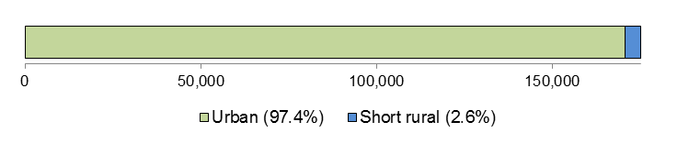

Total line (circuit) length: 5,088 km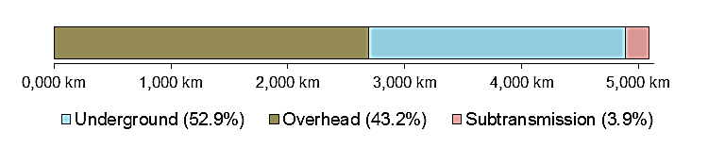

Customer density: 34.4 customers/km line (circuit)

**Network performance: 2009–10 to 2012–13**

Energy delivered: 11,598 GWh, within 1 per cent of forecast

Capital expenditure: $279 m, 13 per cent ▲ than forecast

Regulatory asset base: 16 per cent ▲ (from $687 m to $797 m)

Operating expenditure: $327 m, 6 per cent ▲ than forecast

Revenue (average revenue cap): $649 m, 4 per cent ▼ than forecast

**Network reliability (normalised):**

Unplanned minutes off supply: 2012–13: 28.7 minutes

Avg. prev. five years: 31.8 minutes

Unplanned interruptions to supply: 2012–13: 0.61 interruptions

Avg. prev. five years: 0.63 interruptions

### Regulation

From 1 July 2009 we have been responsible for the economic regulation of electricity distribution services provided by ActewAGL. Previously, the ACT's Independent Competition and Regulatory Commission was the responsible regulator.

### Energy delivered

Total energy delivered by ActewAGL over the first four years of the 2009–14 regulatory control period was comparable to our approved forecast (Figure 9–1). The forecasts for the 2009–14 regulatory control period were those submitted by ActewAGL and accepted by us in our final 2009 distribution determination. ActewAGL identified the following reasons for the decrease in energy delivered:

* a combination of seasonal influences.
* increased PV array penetration.
* consumer sensitivity to network price increases.

Figure 9–1 Energy delivered – ActewAGL

Chapter 4 contains our comparative assessment of energy delivered by all DNSPs in the NEM.

### Demand

ActewAGL's actual maximum demand in 2012–13 was the lowest since 2004–05. This low occurred despite an expectation at the time of the 2009 distribution determination of increasing system maximum demand (Figure 9–2). Weather is a major driver of ActewAGL's maximum demand and energy delivered. The ACT usually experiences warm to hot summers and cool to cold winters.

Figure 9–2 Maximum demand – ActewAGL

Chapter 4 contains our assessment of maximum demand for all DNSPs in the NEM.

### Expenditure and revenue

The following analysis of ActewAGL's expenditure and revenue includes amendments to our approved forecasts as the result approved pass throughs.

Capital expenditure

ActewAGL's total capital expenditure over the first four years of the 2009–14 regulatory control period was approximately 13 per cent higher than our approved forecast (Figure 9–3).

ActewAGL indicated in its 2013 Transitional Regulatory Proposal that overspending on capital was due to the following:

* higher than forecast customer initiated capital works, due to strong growth in commercial and industrial developments and new urban development
* the decision to acquire land and construct a warehouse office space at Greenway as an alternative to re-leasing the Fyshwick logistics site. ActewAGL’s 2008 Regulatory Proposal did not include this expenditure.
* higher than anticipated asset augmentation costs relating to the construction of the new Eastlake zone substation, augmentation of the Civic zone substations, and construction of stage 1 of the Southern Supply to ACT Project 3 as required by the Utilities (Electricity Transmission) Regulation 2006
* implementation of a major Systems Replacement Program.

Figure 9–3 Capital expenditure (excluding customer contributions) – ActewAGL

Demand related augmentation projects were the main capital expense for ActewAGL in the first four years of the 2009–14 regulatory control period (Figure 9–4). Augmentation expenditure was 22 per cent higher than forecast over 2010–11 to 2012–13. Expenditure on non–system assets was over four times higher than forecast over the period 2010–11 to 2012–13.

Chapter 5 describes how DNSPs fund their expenditure on investment projects (capital expenditure) and contains our comparative assessment of capital expenditure for all DNSPs in the NEM.

Figure 9–4 Capital expenditure by purpose (including customer contributions) – ActewAGL

Regulatory asset base

ActewAGL's RAB increased by approximately 16 per cent over the first four years of the 2009–14 regulatory control period, compared with a forecast increase of 21 per cent. It grew from approximately $687 million at the end of 2008–09 to approximately $797 million at the end of 2012–13 (Figure 9–5). The increasing difference between the forecast and actual values of ActewAGL's RAB is consistent with the DNSP's overspending on capital during the regulatory control period.

Figure 9–5 Regulatory asset base – ActewAGL

Operating expenditure

ActewAGL's total operating expenditure over the first four years of the 2009–14 regulatory control period was approximately 6 per cent higher than our approved forecast (Figure 9–6).[13] The DNSP indicated that overspending on operations and maintenance was due to:

* a restructure of the Energy Networks Division in 2011, in response to performance and safety concerns. The restructure divided the energy networks functions into two divisions (Asset Management and Network Services). It focused on strategic asset management and performance of work, which are essential to an improved safety environment and network reliability over the longer term.
* a focus on environment, health and safety issues over the 2009–14 regulatory control period, including the establishment of a dedicated Environment, Health, Safety and Quality Division.
* a change in the corporate services structure following the sale of two ActewAGL associate companies, and changes to ActewAGL's contracts management and business development functions. As a result, a greater share of corporate costs were allocated to the remaining ActewAGL divisions, including electricity distribution.
* higher than forecast expenditure on vegetation management from 2010–11. Necessitated by the breaking of prolonged drought, the spending included the introduction of helicopter surveillance of vegetation and its proximity to network assets.
* cost escalators (labour and materials) that we used in the 2009 distribution determination being lower than those proposed by ActewAGL.

Figure 9–6 Operating expenditure – ActewAGL

Chapter 6 contains our comparative assessment of operating expenditure for all DNSPs in the NEM.

Revenue

Our 2009 distribution determination applied an average revenue cap form of control to ActewAGL’s standard control services over the 2009–14 regulatory control period. An average revenue cap imposes controls over the revenues a distributor may recover for providing electricity distribution services.

ActewAGL's total revenue earned for standard control services over the first four years of the regulatory control period was approximately 4 per cent lower than our approved forecast (Figure 9–7). ActewAGL indicated it recovered less revenue than forecast mainly because energy sales were lower than forecast.

Chapter 7 contains information on the average revenue cap control mechanism, as well as our comparative assessment of revenue for all DNSPs in the NEM.

Figure 9–7 Revenue – ActewAGL

### Financial performance

ActewAGL's average earnings before interest and tax (EBIT) for standard control services was approximately 29 per cent of its total revenue earned for standard control services over 2010‒13. The EBIT in Figure 9–8 includes depreciation and amortisation and should not be used as a definitive measure of core profitability.

Figure 9–8 Earnings before interest and tax—ActewAGL

### Service performance

Total interruptions to supply

Total interruptions to supply reflect the total impact of both planned and unplanned interruptions (Figure 9–9). This measure reflects what the average ActewAGL customer experienced. It includes the impact of any interruptions considered to be excluded events under our STPIS.

Figure 9–9 Total interruptions to supply – ActewAGL

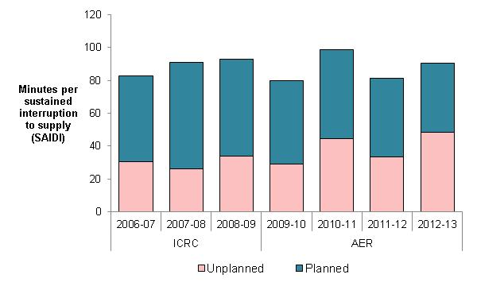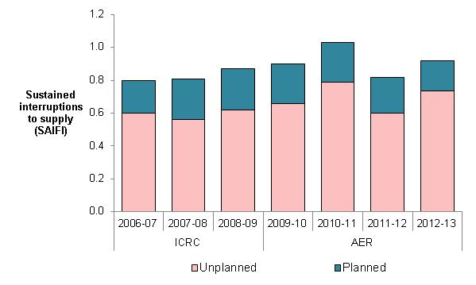



Service Target Performance Incentive Scheme

We decided to applied the STPIS to ActewAGL from 1 July 2015 as part of the 2015 distribution determination. The following section shows the effect of (normalised) unplanned interruptions to supply on customers on ActewAGL's network.

Network reliability (normalised)

In 2012–13 the average ActewAGL customer experienced:

* 10 per cent fewer unplanned (normalised) minutes off supply than over the previous five years
* comparable unplanned (normalised) interruptions to supply to the previous five years (Figure 9–11).

The reliability information in Figure 9–10 combines information from the previous jurisdictional scheme and our STPIS. The two schemes differ in detail, so the information is not directly comparable. However, we present the reliability outcomes to provide broad trend information on ActewAGL's service performance.

Figure 9–10 Unplanned interruptions to supply (normalised) – ActewAGL

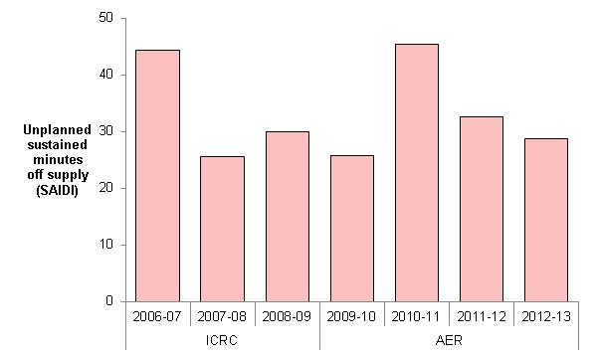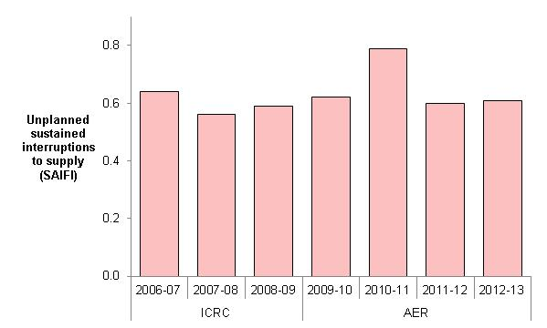



Chapter 8 contains information on our STPIS and a comparative assessment of the DNSPs' service performance.

## Ausgrid

Network characteristics

**Ownership:** New South Wales (NSW) Government

**Relevant regulatory control period**: 1 July 2009 – 30 June 2014

**Network profile**

Total distribution customers: 1,635,151

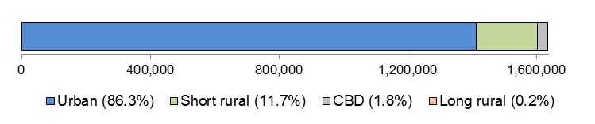

Total line (circuit) length: 40,964 km

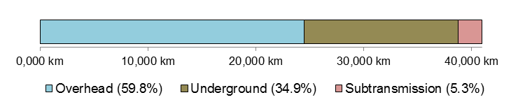

Customer density: 39.9 customers/km line (circuit)

**Network performance: 2009–10 to 2012–13**

Energy delivered: 107,634 GWh, 4 per cent ▼ than forecast

Capital expenditure: $4 bn, 15 per cent ▼ than forecast

Regulatory Asset Base: 41 per cent ▲ (from $8.3bn to $11.8bn)

Operating expenditure: $2 bn, 0.3 per cent ▼ than forecast

Revenue (WAPC): $7 bn, 6 per cent ▲ than forecast

**Network reliability (normalised):**

Unplanned minutes off supply: 2012–13: 67.6 minutes

Avg. prev. five years: 95.9 minutes

Unplanned interruptions to supply: 2012–13: 0.73 interruptions

Avg. prev. five years: 1.13 interruptions

### Regulation

From 1 July 2009 we have been responsible for the economic regulation of electricity distribution services provided by Ausgrid. Previously the Independent Pricing and Regulatory Tribunal of New South Wales (IPART) was the responsible regulator.

### Energy delivered

Total energy delivered by Ausgrid over the first four years of the 2009–14 regulatory control period was approximately 4 per cent less than our approved forecast (Figure 9–11). The forecasts for the 2009–14 regulatory control period are those submitted by Ausgrid in its revised proposal and accepted by us in our 2009 distribution determination.

Ausgrid indicated the following reasons for actual energy delivered being less than forecast during the 2009–14 regulatory control period:

* actual residential customer numbers have grown at a lower than forecast rate
* energy efficiency initiatives have reduced average annual consumption per customer.

Actual energy delivered shown in Figure 9–11 excludes loads associated with Hydro Aluminium, OneSteel Newcastle and Essential Energy transfers. Ausgrid noted this approach is consistent with the energy forecasts contained in its 2009 distribution determination.

Figure 9–11 Energy delivered – Ausgrid

Chapter 4 contains our assessment of energy delivered for all DNSPs in the NEM.

### Demand

Ausgrid's actual maximum demand in 2012–13 was below the forecast maximum demand approved us in our 2009 distribution determination. This was despite an expectation of increasing system maximum demand at the time of the 2009 distribution determination (Figure 9–12).

Ausgrid indicated the forecasts in the 2009 distribution determination were based on 2005–06 summer actual demand. Although the 2006–07 and 2007–08 summer maximum demand figures were known at the time of the distribution determination, they were considered anomalously low in comparison to the steady growth trend observed in the preceding years.

Ausgrid considers the following factors, some of which are inter–related, have influenced lower demand growth in recent years:

* onset of the global financial crisis and impacts on the manufacturing sector resulting from the high Australian dollar
* responses of consumers to electricity price increases
* cumulative impact of energy efficiency programs
* high uptake of rooftop solar PV systems
* summer 2011–12 was the fourth coolest on record.

Chapter 4 contains our assessment of maximum demand for all DNSPs in the NEM.

Figure 9–12 Maximum demand – Ausgrid

### Expenditure and revenue

Amendments made to our approved forecasts as the result of Tribunal orders or as a result of approved pass throughs are included in the following analysis of Ausgrid's financial performance.[14]

Capital expenditure

Ausgrid's total capital expenditure over the first four years of the 2009–14 regulatory control period was approximately 15 per cent lower than our approved forecast (Figure 9–13).

Ausgrid indicated the forecast capital expenditure approved by us in our 2009 distribution determination was the best forecast at the time. Ausgrid also stated it only spends the capital needed to deliver services to the level required.

Ausgrid indicated the following key drivers changed since the 2009 distribution determination:

* forecasts of peak demand were lower due to actual reductions in underlying demand growth and improvements to its forecasting methodologies, meaning augmentation projects could be deferred or even avoided
* as greater data was acquired about both the condition issues associated with various classes of aged assets, and the costs and difficulty of brownfield replacement projects, it actively re-prioritised its replacement program for major assets, enabling a deferral of several high value investments
* disruption to business activities arising from a major restructuring delayed investment approval, development and delivery processes from 2013, which created a short term dip in expenditure.

Figure 9–13 Capital expenditure (excluding customer contributions) – Ausgrid

Capital expenditure to replace existing assets, and demand related capital expenditure (augmentation) formed the bulk of Ausgrid's capital program from 2010–11 to 2012–13. Ausgrid spent less than forecast in these categories, but exceeded forecast expenditure on other system assets and non-system assets (Figure 9–14).

Chapter 5 provides a description of how DNSPs fund their expenditure on investment projects (capital expenditure) and a comparative assessment of capital expenditure for all DNSPs in the NEM.

Figure 9–14 Capital expenditure by purpose (excluding customer contributions) – Ausgrid

Regulatory asset base

Ausgrid's RAB increased by approximately 41 per cent over the first four years of the 2009–14 regulatory control period. Ausgrid's RAB was forecast to increase by 75 per cent over this period.

Ausgrid's RAB grew from approximately $8.3 billion at the end of 2008–09 to approximately $11.8 billion at the end of 2012–13 (Figure 9–15). The increasing difference between the forecast RAB and the actual value of Ausgrid's RAB is consistent with its underspending on capital over the 2009–14 regulatory control period

Figure 9–15 Regulatory asset base – Ausgrid

Operating expenditure

Ausgrid's total operating expenditure over the first four years of the 2009–14 regulatory control period was 0.3 per cent less than our approved forecast (Figure 9–16). However, this was the result of Ausgrid's underspending in 2012–13 offsetting overspending in 2009–10 and 2011–12.

Ausgrid indicated it has responded to the operating expenditure incentives within the regulatory framework. Ausgrid indicated it has actively reviewed its strategies, policies, business processes and procedures so as to contain its total operating expenditure for the 2009–14 regulatory control period within or below the benchmark allowance set by us. Ausgrid also advised it undertook a number of cost saving initiatives to contain its outturn operating expenditure over the 2009–14 regulatory control period. The main features of the cost reduction initiatives were:

* review of work practices to ensure less overtime is needed to perform core network functions
* rationalisation and centralisation of finance, human resources, procurement and business services functions
* review of fleet and procurement policies, processes and procedures to ensure value for money, including joint procurement initiatives with Networks NSW
* review of policies and procedures to eliminate any discretionary expenditure (that is, spending not essential to the running of the business).

Figure 9–16 Operating expenditure – Ausgrid

Chapter 6 contains our assessment of operating expenditure for all DNSPs in the NEM.

Revenue

Our 2009 distribution determination applied a weighted average price cap (WAPC) form of control to Ausgrid’s standard control services over the 2009–14 regulatory control period. A WAPC imposes controls over the prices a DNSP may charge for its services.

Ausgrid's total revenue earned for standard control services over the first four years of the 2009–14 regulatory control period was approximately 6 per cent higher than our approved forecast (Figure 9–17).

Ausgrid indicated its tariffs are set in accordance with the National Electricity Rules and our distribution determination. As a result, its distribution prices will, depending on volume considerations, generate revenues that cover the efficient cost of owning, maintaining, operating and augmenting the network.

Figure 9–17 Revenue – Ausgrid

Chapter 7 provides further information on the WAPC control mechanism as well as our comparative assessment of revenue for all DNSPs in the NEM.

### Financial performance

Ausgrid's average EBIT for standard control services was approximately 41 per cent of its total revenue earned for standard control services over 2010–13. The EBIT in Figure 9–18 includes depreciation and amortisation and should not be used as a definitive measure of core profitability.

Figure 9–18 Earnings before interest and tax– Ausgrid

### Service performance

Total interruptions to supply

Total interruptions to supply reflect the total impact of both planned and unplanned interruptions (Figure 9–19). This measure reflects the actual experience of the average Ausgrid customer. Total interruptions to supply include the effect of any interruptions considered to be excluded events under our STPIS.

Figure 9–19 Total interruptions to supply – Ausgrid

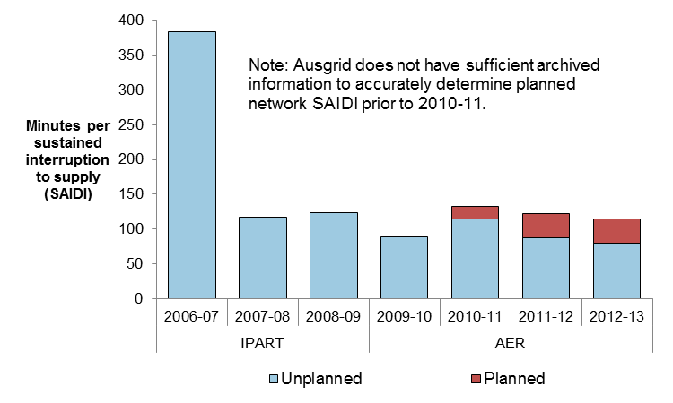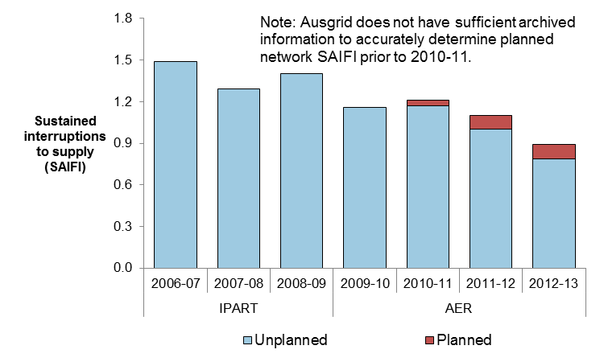



Service Target Performance Incentive Scheme

We applied the national distribution STPIS to Ausgrid from 1 July 2015 as part of the 2015 distribution determination.The following section shows the effect of (normalised) unplanned interruptions to supply on customers on Ausgrid's network.

Network reliability (normalised)

In 2012–13 the average Ausgrid customer experienced:

* 29 per cent fewer unplanned (normalised) minutes off supply than over the previous five years
* 35 per cent fewer unplanned (normalised) interruptions to supply than over the previous five years (Figure 9–20).

It should be noted the reliability information presented in Figure 9–20 combines information from the previous jurisdictional scheme and the AER's STPIS. These schemes differ in detail and therefore the information is not directly comparable. However, the reliability outcomes are presented to provide broad trend information regarding Ausgrid's service performance.

Figure 9–20 Unplanned interruptions to supply (normalised) – Ausgrid

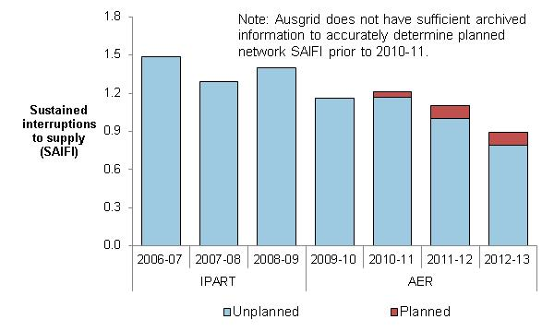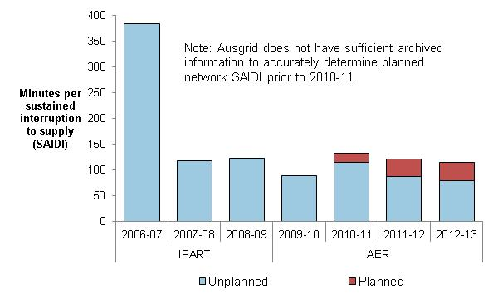



Chapter 8 contains information on our STPIS and a comparative assessment of the DNSPs' service performance.

## Endeavour Energy

Network characteristics

**Ownership:** New South Wales (NSW) Government

**Relevant regulatory control period**: 1 July 2009 – 30 June 2014

**Network profile**

Total distribution customers: 919,385

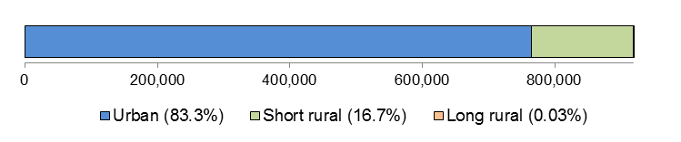

Total line (circuit) length: 35,029 km

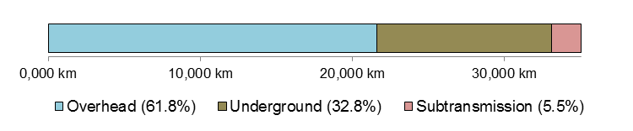

Customer density: 26.2 customers/km line (circuit)

**Network performance: 2009–10 to 2012–13**

Energy delivered: 67,419 GWh, 4 per cent ▼ than forecast

Capital expenditure: $2 bn, 15 per cent ▼ than forecast

Regulatory Asset Base: 28 per cent ▲ (from $4.2bn to $5.4bn)

Operating expenditure: $1.1 bn, 16 per cent ▼ than forecast

Revenue (WAPC): $3.8 bn, 1 per cent ▼ than forecast

**Network reliability (normalised):**

Unplanned minutes off supply: 2012–13: 104.6 minutes

Avg. prev. five years: 87.2 minutes

Unplanned interruptions to supply: 2012–13: 1.22 interruptions

Avg. prev. five years: 1.04 interruptions

### Regulation

From 1 July 2009 we have been responsible for the economic regulation of electricity distribution services provided by Endeavour Energy. Previously IPART was the responsible regulator.

### Energy delivered

Total energy delivered by Endeavour Energy over the first four years of the 2009–14 regulatory control period was approximately 4 per cent less than our approved forecast (Figure 9–21). The forecasts for the 2009–14 regulatory control period were those submitted by Endeavour Energy in its revised regulatory proposal and accepted by us in our 2009 distribution determination.

Endeavour Energy indicated it anticipates:

* energy consumption to fall by 11 per cent over the 2009–14 regulatory control period
* a final year difference between our approved forecast and Endeavour Energy's updated energy consumption projection of 14 per cent
* variances in total energy delivered and our allowances to result in an estimated revenue shortfall of $193 million.

Figure 9–21 Energy delivered – Endeavour Energy

Chapter 4 contains our assessment of energy delivered for all DNSPs in the NEM.

### Demand

Endeavour Energy's actual maximum demand in each year of the 2009–14 regulatory control period was below the forecast maximum demand accepted by us in our 2009 distribution determination. This was despite an expectation of increasing system maximum demand at the time of the 2009 distribution determination (Figure 9–22).

Endeavour Energy indicated maximum demand over the 2009–14 regulatory control period was below forecast along the eastern seaboard due to:

* the closure of large manufacturing companies
* the penetration of more energy–efficient appliances
* changing consumer behaviour in response to increasing prices.

Endeavour Energy also attributed the lower forecast maximum demand to:

* consumer confidence remaining low for prolonged periods throughout the 2009–14 regulatory control period, with consumers being more frugal amid concerns about the health of the global and Australian economies and fragile domestic job market
* weaker than expected economic conditions leading to business closures and production cut backs
* slower growth in new customer connections stemming from a slow housing market (with exception of the northwest and southwest Sydney growth sectors)
* movements in exchange rates and the strong Australian dollar resulting in a number of large companies curtailing activities or moving offshore
* relatively mild winter and summer seasons.

Chapter 4 contains our assessment of maximum demand for all DNSPs in the NEM.

Figure 9–22 Maximum demand – Endeavour Energy

### Expenditure and revenue

Amendments made to our approved forecasts as the result of Tribunal orders or as a result of approved pass throughs are included in the following analysis of Endeavour Energy's financial performance.[15]

Capital expenditure

Endeavour Energy's total capital expenditure over the first four years of the 2009–14 regulatory control period was approximately 15 per cent lower than our approved forecast (Figure 9–23). The majority of Endeavour Energy's underspending occurred in the 2009–10 and 2010–11 regulatory years.

Endeavour Energy indicated that although reductions in demand growth explain some of the underspending on capital projects (Figure 9–24), there were also a number of other relevant factors to consider.

Endeavour Energy noted its peak resourcing strategy and industry reform drove reductions to its capital program. Delivery issues also contributed to lower than forecast capital expenditure due to the significant increase in resourcing required to deliver the program.

Endeavour Energy indicated that at the beginning of the 2009–14 regulatory control period it faced the challenge of delivering a significant network capital investment program for customers that was 50 per cent larger than any program previously delivered. It stated the significant investment program placed delivery pressures on it in the early years of the 2009–14 regulatory control period and in some cases its ability to deliver the program fell behind schedule. However, it enhanced the efficiency and sustainability of its capital program delivery by improving project management and increasing the use of skilled external resources through a peak Resourcing Strategy. Endeavour Energy considered this strategy delivered peak workloads at a lower than expected cost, without increasing employee numbers to unsustainable levels in the longer term.

Figure 9–23 Capital expenditure (excluding customer contributions) – Endeavour Energy

Endeavour Energy noted maximum demand was below forecast over the 2009–14 regulatory control period right along the eastern seaboard. It stated that through its annual network planning process, it was able to reset its planning schedule and defer a number of demand–driven projects (augmentation capex, Figure 9–24). It indicated the deferral of these projects helped to reduce capital expenditure over the 2009–14 regulatory control period by $225 million.

Figure 9–24 Capital expenditure by purpose (excluding customer contributions) – Endeavour

Chapter 5 provides a description of how DNSPs fund expenditure on investment projects (capital expenditure) and a comparative assessment of capital expenditure for all DNSPs in the NEM.

Regulatory asset base

Endeavour Energy's RAB increased by approximately 28 per cent over the first four years of the 2009–14 regulatory control period. Endeavour Energy's RAB was forecast to increase by 38 per cent over this period.

Figure 9–25 Regulatory asset base – Endeavour Energy

Endeavour Energy's RAB grew from approximately $4.2 billion at the end of 2008–09 to approximately $5.4 billion at the end of 2012–13 (Figure 9–25). The increasing difference between the forecast RAB and the actual value of Endeavour Energy's RAB is consistent with its underspending on capital over the 2009–14 regulatory control period.

Operating expenditure

Endeavour Energy's total operating expenditure over the first four years of the 2009–14 regulatory control period was approximately 16 per cent lower than our approved forecast (Figure 9–26).

Endeavour Energy indicated that over the 2009–14 regulatory control period savings on operating expenditure were primarily driven by productivity based initiatives and the introduction of the Network Reform Program.

Endeavour Energy expects to achieve savings totalling an estimated $185 million over the 2009–14 regulatory control period. It also noted the savings over the 2009–14 regulatory control period are in excess of the annual reduction of 2 per cent of labour operating expenditure it committed to making in its initial regulatory proposal in 2008.

Figure 9–26 Operating expenditure – Endeavour Energy

Chapter 6 contains our assessment of operating expenditure for all DNSPs in the NEM.

Revenue

Our 2009 distribution determination applied a weighted average price cap (WAPC) form of control to Endeavour Energy's standard control services over the 2009–14 regulatory control period. A WAPC imposes controls over the prices a DNSP may charge for its services.

Endeavour Energy's total revenue earned for standard control services over the first four years of the 2009–14 regulatory control period was approximately 1 per cent lower than our approved forecast (Figure 9–27). Endeavour Energy indicated variances in annual consumption across its network over the 2009–14 regulatory control period are expected to result in an estimated revenue shortfall of $193 million. Chapter 7 provides further information on the WAPC control mechanism as well as our comparative assessment of revenue for all DNSPs in the NEM.

Figure 9–27 Revenue – Endeavour Energy

### Financial performance

Endeavour Energy's average EBIT for standard control services was approximately 46 per cent of its total revenue earned for standard control services over 2010–13. The EBIT in Figure 9–28 includes depreciation and amortisation and should not be used as a definitive measure of core profitability.

Figure 9–28 Earnings before interest and tax– Endeavour Energy

### Service performance

Total interruptions to supply

Total interruptions to supply reflect the total impact of both planned and unplanned interruptions (Figure 9–29). This measure reflects the actual experience of the average Endeavour Energy customer. Total interruptions to supply include the effect of any interruptions considered to be excluded events in our STPIS.

Figure 9–29 Total interruptions to supply – Endeavour Energy

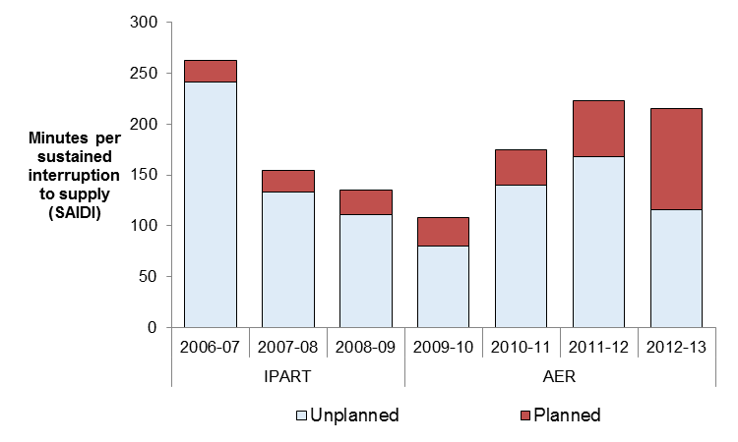 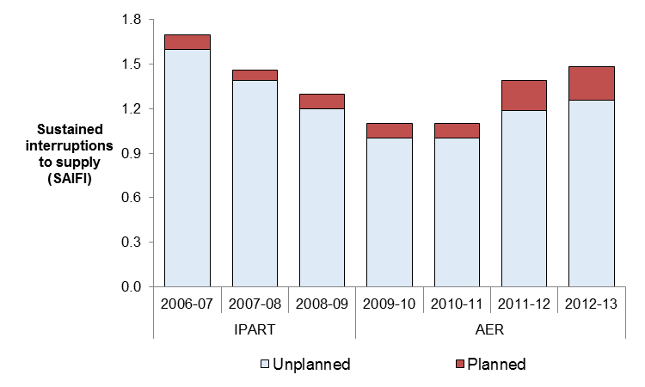



Chapter 8 provides further information on our STPIS and a comparative assessment of the DNSPs' service performance.

Service Target Performance Incentive Scheme

We applied the national distribution STPIS to Endeavour Energy from 1 July 2015 as part of the 2015 distribution determination.

The following section shows the effect of (normalised) unplanned interruptions to supply on customers on Endeavour Energy's network.

Network reliability (normalised)

In 2012–13 the average Endeavour Energy customer experienced:

* 20 per cent more unplanned (normalised) minutes off supply than over the previous five years
* 17 per cent more unplanned (normalised) interruptions to supply than over the previous five years (Figure 9–30).

It should be noted the reliability information presented in Figure 9–30 combines information from the previous jurisdictional scheme and the STPIS. These schemes differ in detail and therefore the information is not directly comparable. However, the reliability outcomes are presented to provide broad trend information regarding Endeavour Energy's service performance.

Figure 9–30 Unplanned interruptions to supply (normalised) – Endeavour Energy

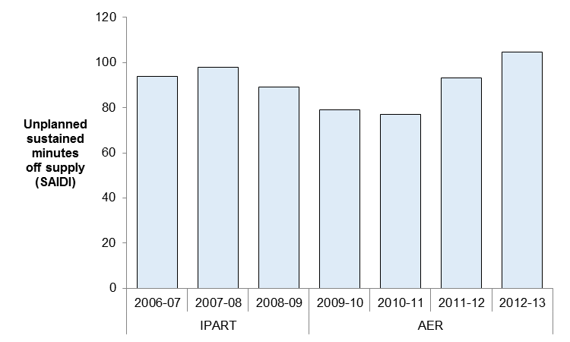 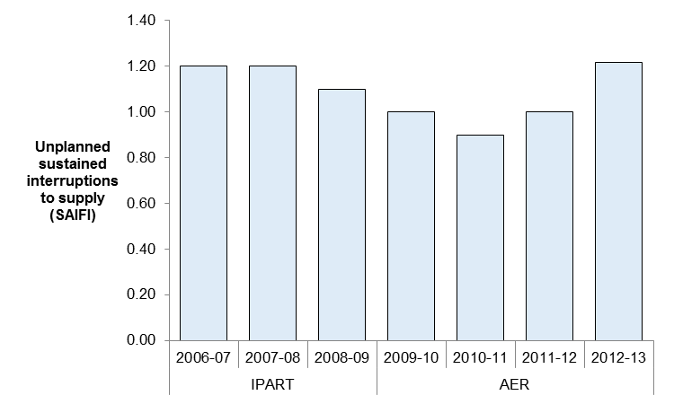



Chapter 8 contains information on our STPIS and a comparative assessment of the DNSPs' service performance.

## Essential Energy

Network characteristics

**Ownership:** New South Wales (NSW) Government

**Relevant regulatory control period**: 1 July 2009 – 30 June 2014

**Network profile**

Total distribution customers: 839,206

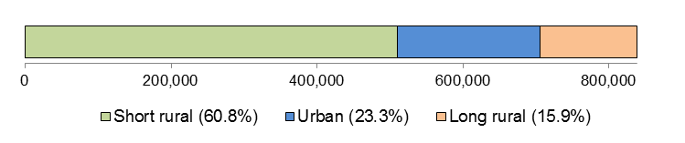

Total line (circuit) length: 191,107 km

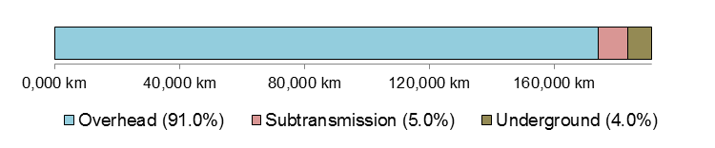

Customer density: 4.4 customers/km line (circuit)

**Network performance: 2009–10 to 2012–13**

Energy delivered: 48,191 GWh, 1 per cent ▼ than forecast

Capital expenditure: $2.8 bn, 13 per cent ▼ than forecast

Regulatory Asset Base: 34 per cent ▲ (from $4.9bn to $6.6bn)

Operating expenditure: $1.7 bn, within 1 per cent of forecast

Revenue (WAPC): $4.7 bn, within 1 per cent of forecast

**Network reliability (normalised):**

Unplanned minutes off supply: 2012–13: 232.5 minutes

Avg. prev. five years: 232.1 minutes

Unplanned interruptions to supply: 2012–13: 1.85 interruptions

Avg. prev. five years: 2.14 interruptions

### Regulation

From 1 July 2009 we have been responsible for the economic regulation of electricity distribution services provided by Essential Energy. Previously the Independent Pricing and Regulatory Tribunal of New South Wales (IPART) was the responsible regulator.

### Energy delivered

Total energy delivered by Essential Energy over the first four years of the 2009–14 regulatory control period was approximately 1 per cent less than our approved forecast (Figure 9–31). The forecasts for the 2009–14 regulatory control period are those submitted by Essential Energy and accepted by us in our 2009 distribution determination.

Essential Energy indicated that although energy delivered was close to forecast levels, small customers consumed much less than expected. However, this was offset by an increase in energy consumption by customers on larger sites such as mines.

Figure 9–31 Energy delivered – Essential Energy

Chapter 4 contains our assessment of energy delivered for all DNSPs in the NEM.

### Demand

Essential Energy's actual maximum demand was below our approved forecast in each year of the 2009–14 regulatory control period. The forecasts were proposed by Essential Energy and accepted by us in our 2009 distribution determination (Figure 9–32).

Essential Energy listed the following reasons for the decline in maximum demand:

* the global financial crisis' impact on the demand for new connections. The requirement to build new customer specific infrastructure was also been less than anticipated.
* a greater than forecast uptake of solar PV generation (driven by very attractive domestic feed in tariffs) saw a decrease in customer demand over the summer months.
* increases in retail energy prices modified customer behaviour by driving a reduction in overall demand and by focussing customers’ attention on new energy efficient appliances.

Figure 9–32 Maximum demand – Essential Energy

Chapter 4 contains our assessment of maximum demand for all DNSPs in the NEM.

### Expenditure and revenue

Amendments made to our approved forecasts as the result of Tribunal orders or as a result of approved pass throughs are included in the following analysis of Essential Energy's financial performance.[16]

Capital expenditure

Essential Energy's total capital expenditure over the first four years of the 2009–14 regulatory control period was approximately 13 per cent lower than our approved forecast (Figure 9–33).

Essential Energy indicated in its 2013 Transitional Regulatory Proposal that lower than forecast capital expenditure reflects:

* lower demand forecasts
* initiatives implemented to actively reduce the need for capital expenditure and contain average increases in its share of customers’ electricity bills at or below CPI
* reduction in the volume of works through enhanced risk management requirements for planning and reduced costs through a stronger focus at both design and delivery stages.

Figure 9–33 Capital expenditure (excluding customer contributions) – Essential Energy

Essential Energy's capital expenditure on replacing assets was higher than forecast for each year between 2010–11 and 2012–13. However its capital expenditure was lower than forecast in all other categories of expenditure (Figure 9–34). Essential Energy indicated the need for network augmentation has lessened significantly due to a lower overall system peak demand than approved by us for the 2009–14 regulatory control period.

Figure 9–34 Capital expenditure by purpose (excluding customer contributions) – Essential Energy

Chapter 5 provides a description of how DNSPs fund their expenditure on investment projects (capital expenditure) and a comparative assessment of capital expenditure for all DNSPs in the NEM.

Regulatory asset base

Essential Energy's RAB increased by approximately 34 per cent over the first four years of the 2009–14 regulatory control period. Essential Energy's RAB was forecast to increase by 75 per cent over this period. Essential Energy's RAB grew from approximately $4.9 billion at the end of 2008–09 to approximately $6.6 billion at the end of 2012–13 (Figure 9–35).

The increasing difference between the forecast RAB and the actual value of Essential Energy's RAB is consistent with its underspending on capital over the 2009–14 regulatory control period.

Figure 9–35 Regulatory asset base – Essential Energy

Operating expenditure

Essential Energy's total operating expenditure over the first four years of the 2009–14 regulatory control period was within 1 per cent of our approved forecast (Figure 9–36). However, this was the result of Essential Energy's underspending in 2009–10 and 2010–11 offsetting its overspending in 2011–12.

Essential Energy indicated the bushfires in Victoria and the resulting Royal Commission into network assets highlighted the need to focus on vegetation management and ensure clearances are being maintained. It stated this resulted in expenditure on vegetation being $40 million ($Dec 2013) above our approved 2011–12 allowance. Essential Energy advised that vegetation management activities continued to expand in 2012–13, with expenditure increasing to $70 million ($Dec 2013) above the AER approved allowance.

Figure 9–36 Operating expenditure – Essential Energy

Chapter 6 contains our assessment of operating expenditure for all DNSPs in the NEM.

Revenue

Our 2009 distribution determination applied a weighted average price cap (WAPC) form of control to Essential Energy's standard control services over the 2009–14 regulatory control period. A WAPC imposes controls over the prices a DNSP may charge for its services.

Essential Energy's total revenue earned for standard control services over the first four years of the 2009–14 regulatory control period was within 1 per cent of our approved forecast (Figure 9–37).

Figure 9–37 Revenue – Essential Energy

Essential Energy stated its tariffs are set in accordance with the National Electricity Rules and our distribution determination. It noted distribution prices will, depending on volume considerations, generate revenues that cover the efficient cost of owning, maintaining, operating and augmenting the network.

Chapter 7 provides further information on the WAPC control mechanism as well as our comparative assessment of revenue for all DNSPs in the NEM.

### Financial performance

Essential Energy's average EBIT for standard control services was approximately 38 per cent of its total revenue earned for standard control services over 2010–13. The EBIT in Figure 9–38 includes depreciation and amortisation and should not be used as a definitive measure of core profitability.

Essential Energy indicated its operating profit for the 2010–11 year was lower than expected due to lower than forecast revenue and higher than average depreciation for the year. A revaluation of system assets was done at the end of 2010 which increased the value of system assets by $1.2 billion with 2010–11 being the first full year of depreciation on the higher system asset base. Profits for the following years increased with revenue and depreciation closer to the levels expected.

Figure 9–38 Earnings before interest and tax – Essential Energy

### Service performance

Total interruptions to supply

Total interruptions to supply reflect the total impact of both planned and unplanned interruptions (Figure 9–39). This measure reflects the actual experience of the average Essential Energy customer. Total interruptions to supply include the effect of any interruptions considered to be excluded events in our STPIS.

Figure 9–39 Total interruptions to supply – Essential Energy

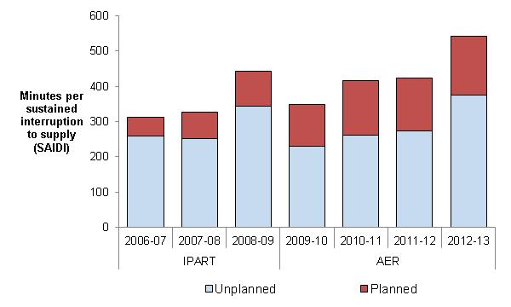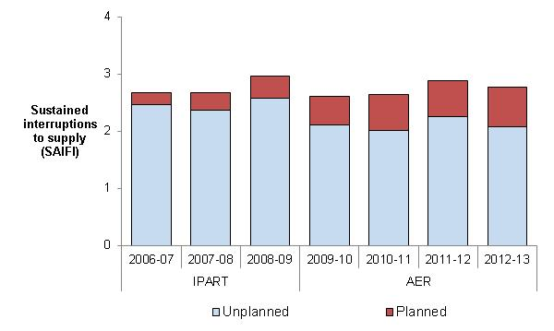 

Service Target Performance Incentive Scheme

We applied the national distribution STPIS to Essential Energy from 1 July 2015 as part of the 2015 distribution determination.

The following section shows the effect of (normalised) unplanned interruptions to supply on customers on Essential Energy's network.

Network reliability (normalised)

In 2012–13 the average Essential Energy customer experienced:

* less than 1 per cent more unplanned (normalised) minutes off supply than over the previous five years
* 14 per cent fewer unplanned (normalised) interruptions to supply than over the previous five years (Figure 9–40).

It should be noted the reliability information presented in Figure 9–40 combines information from the previous jurisdictional scheme and the AER's STPIS. These schemes differ in detail and therefore the information is not directly comparable. However, the reliability outcomes are presented to provide broad trend information regarding Essential Energy's service performance.

Essential Energy indicated its network is primarily overhead, and as such performance is heavily dependent on the weather. Storm activity generally affects its rural feeders more than its urban feeders. The main reasons for this are the increased travelling time to get to outages on rural feeders and the relative inability to provide an alternate source of supply for customers on these feeders.

Figure 9–40 Unplanned interruptions to supply (normalised) – Essential Energy

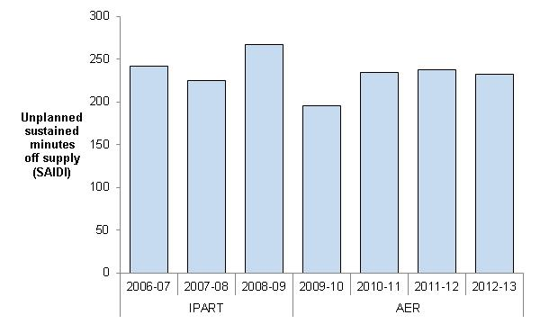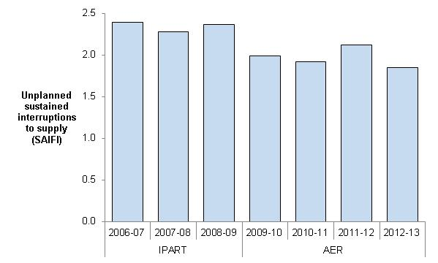



Chapter 8 contains information on our STPIS and a comparative assessment of the DNSPs' service performance.

## Energex

Network characteristics

**Ownership:** Queensland Government Owned Corporation

**Relevant regulatory control period**: 1 July 2010 – 30 June 2015

**Network profile 2012-13**

Total distribution customers: 1,342,594

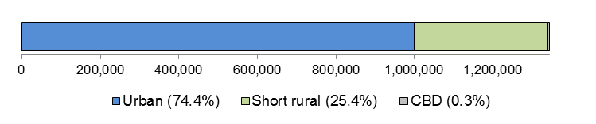

Total line (circuit) length: 51,781 km

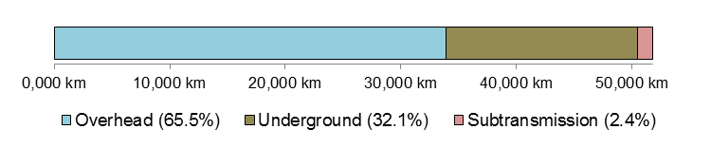

Customer density: 25.9 customers/km line (circuit)

**Network performance: 2010–11 to 2012–13**

Energy delivered: 63,920 GWh, 8 per cent ▼ than forecast

Capital expenditure: $2.7 bn, 26 per cent ▼ than forecast

Regulatory Asset Base: 20 per cent ▲ (from $8.6bn to $10.3bn)

Operating expenditure: $1.3 bn, 10 per cent ▲ than forecast

Revenue (revenue cap): $3.6 bn, 8 per cent ▼ than forecast

**Network reliability (normalised):**

Unplanned minutes off supply: 2012–13: 67.2 minutes

Avg. prev. five years: 89.0 minutes

Unplanned interruptions to supply: 2012–13: 0.88 interruptions

Avg. prev. five years: 1.24 interruptions

### Regulation

From 1 July 2010 we have been responsible for the economic regulation of electricity distribution services provided Energex. Previously the Queensland Competition Authority (QCA) was the responsible regulator.

### Energy delivered

Total energy delivered by Energex over the first three years of the 2010–15 regulatory control period was approximately 8 per cent less than our approved forecast (Figure 9–41). The forecasts are those submitted by Energex and accepted by us in our 2010 distribution determination. Our approved forecasts were marginally lower than those proposed by Energex in its regulatory proposal.

Energex provided the following reasons for energy delivered being less than forecast during the 2010–15 regulatory control period:

* customers responded to rising electricity prices by changing usage patterns and lowering consumption
* impact of in–house usage of energy generated from solar PV. The uptake of solar PV significantly exceeded expectations.

Figure 9–41 Energy delivered – Energex

Chapter 4 contains our assessment of energy delivered for all DNSPs in the NEM.

### Demand

Energex's expectation of increasing system maximum demand at the time of our 2010 distribution determination was not realised in its actual maximum demand (Figure 9–42). The difference between Energex's forecast and actual maximum demand was greater in 2012–13 than in any other year of the 2010–15 or 2005–10 regulatory control periods.

Energex attributed its less than forecast summer system peak demand for the 2010–15 regulatory control period to the following:

* a rapid increase in residential solar PV led to connected capacity increasing from 43MW at the start of the 2010–15 regulatory control period to 675MW at the end of the 2012–13 regulatory year
* slower than expected recovery from the global financial crisis resulted in a significant decline in the number of new developments in South East Queensland.
* significant weather events (i.e. the Brisbane floods in 2011 and Tropical Cyclone Oswald in 2013)
* customers responding to rapidly increasing electricity prices
* milder summer periods due to the influence of La Nina weather pattern.

Figure 9–42 Maximum demand – Energex

Chapter 4 contains our assessment of maximum demand for all DNSPs in the NEM.

### Expenditure and revenue

Amendments made to our approved forecasts as the result of Tribunal orders or as a result of approved pass throughs are included in the following analysis of Energex's financial performance.[17]

Capital expenditure

Energex's total capital expenditure over the first three years of the 2010–15 regulatory control period was approximately 26 per cent lower than our approved forecast (Figure 9–43).

Energex advised lower than forecast capital expenditure in the 2010–15 regulatory control period was due to:

* Electricity Network Capital Program (ENCAP) Review – During 2011, the Queensland Government engaged an Independent Panel to review the capital programs of Energex, Ergon Energy and Powerlink, and provide advice to the Queensland Government. This had an impact on Energex's planned capital expenditure program.  
    
  The ENCAP Review recognised the substantial improvements in reliability, network utilisation and progress towards N–1 compliance since the previous review conducted in 2003–04. In addition, the ENCAP Review revised security standards to achieve N–1 via:
* greater reliance on 11kV feeder transfers and operational measures, and
* higher single transformer substation threshold.

A further outcome of the review was the flat–lining of minimum service standard (MSS) at 2011–12 target levels. These changes resulted in a significant reduction in Energex capital programs.

* Lower than expected demand – Energex responded to a reduced demand forecast for South East Queensland. Energex's reduced demand forecast reflects both changing customer energy use and a slowing down of new developments in South East Queensland (e.g. in 2011–12 Energex connected 7,500 new subdivision lots compared with historical norms of around 25,000 per annum). Energex has deferred capital projects based on the reduction in demand.

Figure 9–43 Capital expenditure (excluding customer contributions) – Energex

Energex's capital expenditure was lower than forecast in all categories, with the most significant reduction shown in augmentation expenditure, reflecting the lower demand outcomes experienced (Figure 9–44).

Chapter 5 provides a description of how DNSPs fund their expenditure on investment projects (capital expenditure) and a comparative assessment of capital expenditure for all DNSPs in the NEM.

Figure 9–44 Capital expenditure by purpose (including customer contributions) – Energex

Regulatory asset base

Energex's RAB increased by approximately 20 per cent over the first three years of the 2010–15 regulatory control period. Energex's RAB was forecast to increase by 38 per cent over this period. Energex's RAB grew from approximately $8.6 billion at the end of 2009–10 to approximately $10.3 billion at the end of 2012–13 (Figure 9–45).

The increasing difference between the forecast RAB and the actual value of Energex's RAB is consistent with its underspending on capital over the first three years of the 2010–15 regulatory control period.

Figure 9–45 Regulatory asset base – Energex

Operating expenditure

Energex's operating expenditure over the first three years of the 2010–15 regulatory control period was approximately 10 per cent higher than our approved forecast (Figure 9–46).

Energex indicated its higher than forecast operating expenditure was primarily due to the following factors:

* feed in Tariff (FiT) payments – Actual operating expenditure includes significant solar FiT payments compared to the forecasts in the regulatory distribution determination. Energex experienced rapid growth in residential solar, and as a result an exponential rise in the level of annual FiT payments. Over the first three years of the 2010–15 regulatory control period Energex incurred FiT payments of approximately $260 million compared to a forecast of $20 million for the same period
* weather events – Cost of responding to significant weather events (i.e. the January 2011 floods and Tropical Cyclone Oswald in January 2013)
* corporate restructure costs – Actual costs, particularly 2012–13, include corporate restructure costs as Energex seeks to right–size the organisation in response to the lower than expected demand which has resulted in a significant reduction in capital expenditure.

Figure 9–46 Operating expenditure – Energex

Chapter 6 contains our assessment of operating expenditure for all DNSPs in the NEM.

Revenue

Our 2010 distribution determination applied a revenue cap form of control to Energex's distribution services over the 2010–15 regulatory control period. A revenue cap imposes controls over the revenues a distributor may recover for providing electricity distribution services.

Energex's MAR for any given year may be impacted by the following factors:

* any STPIS revenue increment (or revenue decrement) (see Energex's Service performance)
* any unders/overs adjustments related to capital contributions
* transitional adjustments
* any approved pass through amounts
* any unders and overs related to under recovery/over recovery of revenues from a previous year.

As part of its annual pricing proposals, Energex submits to the AER its proposed tariffs, which when multiplied by forecast consumption for that year result in expected revenues consistent with the MAR plus any of the factors listed above.

Energex's total revenue earned for standard control services over the first three years of the 2010–15 regulatory control period was approximately 8 per cent lower than our approved forecast (Figure 9–47).

Energex indicated revenue recovered from customers was below forecast due to lower energy sales resulting from:

* customers responding to rising electricity prices by changing usage patterns and lowering consumption
* the impact of in–house usage of energy generated from solar PV. The uptake of solar PV has significantly exceeded expectations.

This increased the amount of under recovered revenue each year which is then recovered from customers in subsequent years.

Figure 9–47 Revenue – Energex

Chapter 7 provides further information on the revenue cap control mechanism as well as our comparative assessment of revenue for all DNSPs in the NEM.

### Financial performance

Energex's average EBIT for standard control services was approximately 36 per cent of its total revenue earned for standard control services over 2010–13. The EBIT in Figure 9–48 includes depreciation and amortisation and should not be used as a definitive measure of core profitability.

Figure 9–48 Earnings before interest and tax– Energex

### Service performance

Total interruptions to supply

Total interruptions to supply reflect the total impact of both planned and unplanned interruptions (Figure 9–49). This measure reflects the actual experience of the average Energex customer. Total interruptions to supply include the effect of any interruptions considered to be excluded events in the STPIS.

Figure 9–49 Total interruptions to supply – Energex

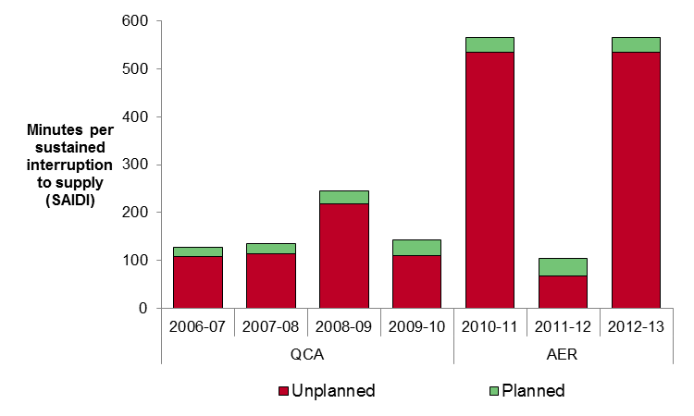 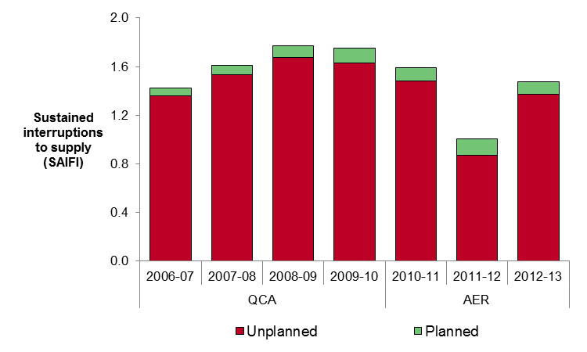



Service Target Performance Incentive Scheme

In our 2010 distribution determination we determined the STPIS would apply to Energex in the 2010–15 regulatory control period with an overall revenue at risk of ±2 per cent. We decided to not apply the telephone answering parameter to Energex because of a lack of data. We also decided to not apply the GSL component while the QCA’s GSL scheme remained in place.

The following section shows the effect of (normalised) unplanned interruptions to supply to customers on Energex's network.

Network reliability (normalised)

In 2012–13 the average Energex customer experienced:

* 25 per cent fewer unplanned (normalised) minutes off supply than they experienced over the previous five years
* 29 per cent fewer unplanned (normalised) interruptions to supply than they experienced over the previous five years (Figure 9–50).

It should be noted the reliability information presented in Figure 9–50 combines information from the previous jurisdictional scheme and the AER's STPIS. These schemes differ in detail and therefore the information is not directly comparable. However, the reliability outcomes are presented to provide broad trend information regarding Energex's service performance.

Figure 9–50 Unplanned interruptions to supply (normalised) – Energex

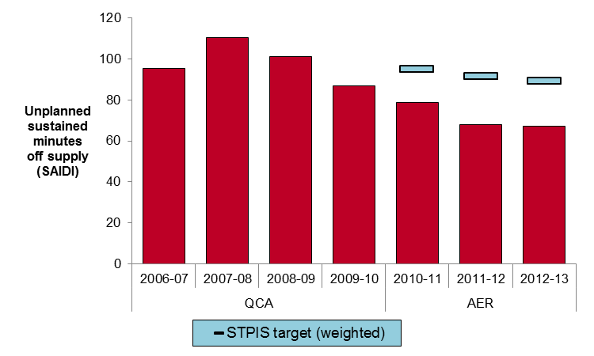 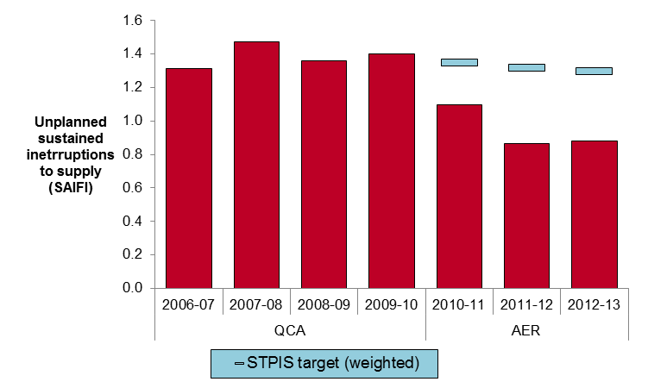



S–factor

Table 9–1 compares Energex's service performance against its STPIS targets over the first three years of the 2010–15 regulatory control period. On the whole, Energex performed well against its service performance targets in each year since the STPIS was applied.

It is important to note STPIS targets are applied to normalised network reliability. In 2010–11, floods affected much of central and southern Queensland. In 2012–13 Queensland was hit by Tropical Cyclone Oswald causing widespread impact including severe storms and flooding. As a result of these natural events, Energex experienced a number of days in which its daily unplanned SAIDI exceeded the major event day boundary. For any day in which unplanned SAIDI exceeds the major event day boundary the impact of that day's SAIDI and SAIFI is removed from the calculation of the annual normalised service performance measures. By removing the impact of events occurring on major event days we exclude from the operation of the scheme events we consider to be outside the DNSP's control.

The s–factor is incorporated into Energex's control mechanism as a multiplier in the calculation of its MAR. The MAR is incremented when service performance is better than performance targets and decremented when service performance is worse than performance targets. Details on how the s–factor is incorporated into Energex's control mechanism are set out in the 2010 distribution determination.

Note there is a two year lag between the regulatory year in which service performance outcomes are assessed and the regulatory year in which the s–factor outcome is applied to the DNSP's allowed revenue.

Table 9–1 S–factor – Energex

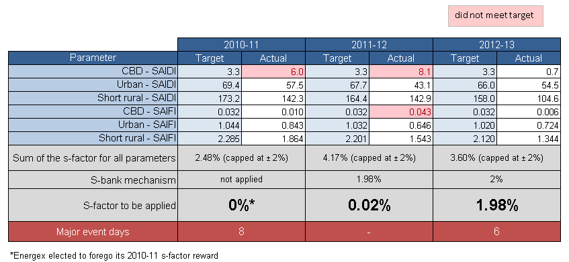

Chapter 8 contains information on our STPIS and a comparative assessment of the DNSPs' service performance.

## Ergon Energy

Network characteristics

**Ownership:** Queensland Government Owned Corporation

**Relevant regulatory control period**: 1 July 2010 – 30 June 2015

**Network profile 2012-13**

Total distribution customers: 674,045

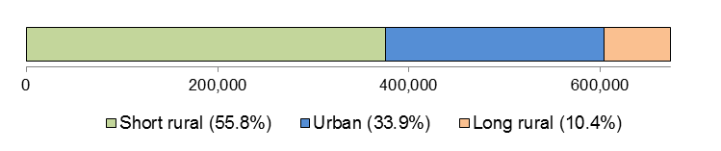

Total line (circuit) length: 160,110 km

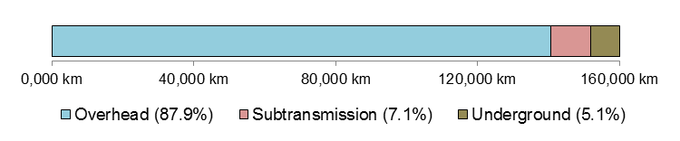

Customer density: 4.2 customers/km line (circuit)

**Network performance: 2010–11 to 2012–13**

Energy delivered: 40,238 GWh, 18 per cent ▼ than forecast

Capital expenditure: $2.2 bn, 17 per cent ▼ than forecast

Regulatory Asset Base: 14 per cent ▲ (from $7.8bn to $8.9bn)

Operating expenditure: $1.2 bn, 1 per cent ▲ than forecast

Revenue (revenue cap): $3.6 bn, 5 per cent ▼ than forecast

**Network reliability (normalised):**

Unplanned minutes off supply: 2012–13: 267.6 minutes

Avg. prev. five years: 317.6 minutes

Unplanned interruptions to supply: 2012–13: 2.43 interruptions

Avg. prev. five years: 2.95 interruptions

### Regulation

From 1 July 2010 we have been responsible for the economic regulation of electricity distribution services provided Ergon Energy. Previously, the QCA was the responsible regulator

### Energy delivered

Total energy delivered by Ergon Energy over the first three years of the 2010–15 regulatory control period was approximately 18 per cent less than our approved forecast (Figure 9–51). The forecasts for the 2010 15 regulatory control period are those submitted by Ergon Energy and accepted by us in our 2010 distribution determination.

Figure 9–51 Energy delivered – Ergon Energy

Chapter 4 contains our assessment of energy delivered for all DNSPs in the NEM.

### Demand

Ergon Energy's expectation of increasing system maximum demand at the time of the 2010 distribution determination was not realised in its actual maximum demand (Figure 9–52). The difference between Ergon Energy's forecast and actual maximum demand was greater in 2012–13 than in any other year in the 2010–15 or 2005–10 regulatory control periods.

Ergon Energy notes the lower than expected maximum demand measures reflect the impact of the global financial crisis on the Queensland economy, the rate of growth in solar PV system connections, growth in solar hot water systems, higher electricity prices and Government programs such as Climate Smart and insulation.

Chapter 4 contains our assessment of maximum demand for all DNSPs in the NEM.

Figure 9–52 Maximum demand – Ergon Energy

### Expenditure and revenue

Amendments made to our approved forecasts as the result of Tribunal orders or as a result of approved pass throughs are included in the following analysis of Ergon Energy's financial performance.[18]

Capital expenditure

Ergon Energy's total capital expenditure over 2011–13 was approximately 17 per cent lower than our approved forecast (Figure 9–53). Ergon Energy stated lower capital expenditure reflects changes to market conditions and deferral of networks investment due to demand management initiatives.

Figure 9–53 Capital expenditure (excluding customer contributions) – Ergon Energy

Ergon Energy indicated it was able to reduce equipment rating uncertainty due to changes to design and security of supply criteria, and the use of improved load forecasting. Consequently some of its augmentation projects were deferred. It also indicated there was a deferral of the construction and redevelopment of some augmentation projects due to the reduction in demand growth and as a result of alternative energy solutions (Figure 9–54).

Ergon Energy stated spending on customer initiated augmentation projects was less than forecast due to:

* increased uptake of solar PV
* suppressed demand for customer network connections
* mild weather conditions reducing the number of projects or deferring projects.

Figure 9–54 Capital expenditure by purpose (including customer contributions) – Ergon Energy

Chapter 5 provides a description of how DNSPs fund their expenditure on investment projects (capital expenditure) and a comparative assessment of capital expenditure for all DNSPs in the NEM.

Regulatory asset base

Ergon Energy's RAB increased by 14 per cent over the first three years of the 2010–15 regulatory control period. Ergon Energy's RAB was forecast to increase by 37 per cent over this period. Ergon Energy's RAB grew from approximately $7.8 billion at the end of 2009–10 to approximately $8.9 billion at the end of 2012–13 (Figure 9–55).

The increasing difference between the forecast RAB and the actual value of Ergon Energy's RAB is consistent with its underspending on capital over the first three years of the 2010–15 regulatory control period.

Figure 9–55 Regulatory asset base – Ergon Energy

Note: Forecasts for the 2008-09 and 2009-10 include estimated data.

Operating expenditure

Ergon Energy's total operating expenditure over the first three years of the 2010–15 regulatory control period was within 1 per cent of our approved forecast (Figure 9–56).

Figure 9–56 Operating expenditure – Ergon Energy

Chapter 6 contains our assessment of operating expenditure for all DNSPs in the NEM.

Revenue

Our 2010 distribution determination applied a revenue cap form of control to Ergon Energy's distribution services over the 2010–15 regulatory control period. A revenue cap imposes controls over the revenues a distributor may recover for providing electricity distribution services.

The MAR for any given year may also be impacted by the following factors:

* any STPIS revenue increment (or revenue decrement) (see Service performance)
* any unders/overs adjustments related to capital contributions
* transitional adjustments, and
* any approved pass through amounts
* any unders and overs related to under recovery/over recovery of revenues from a previous year.

As part of its annual pricing proposals, Ergon Energy submits to the AER its proposed tariffs, which when multiplied by forecast consumption for that year result in expected revenues consistent with the MAR plus any of the factors listed above.

Ergon Energy's total revenue earned for standard control services over the first three years of the 2010–15 regulatory control period was approximately 5 per cent lower than our approved forecast (Figure 9–57).

Figure 9–57 Revenue – Ergon Energy

Chapter 7 provides further information on the revenue cap control mechanism as well as our comparative assessment of revenue for all distribution networks in the NEM.

### Financial performance

Ergon Energy's average EBIT for standard control services was approximately 34 per cent of its total revenue earned for standard control services over 2010–13. The EBIT in Figure 9–58 includes depreciation and amortisation and should not be used as a definitive measure of core profitability.

Figure 9–58 Earnings before interest and tax – Ergon Energy

### Service performance

Total interruptions to supply

Total interruptions to supply reflect the total impact of both planned and unplanned interruptions (Figure 9–59). This measure reflects the actual experience of the average Ergon Energy customer. Total interruptions to supply include the effect of any interruptions considered to be excluded events in the STPIS.

Figure 9–59 Total interruptions to supply – Ergon Energy

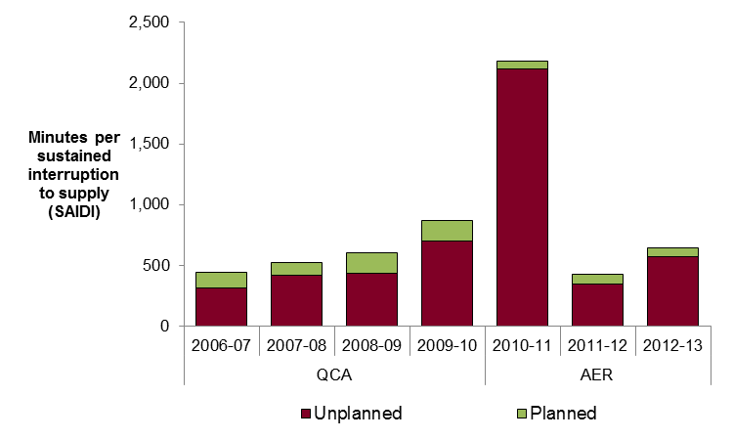 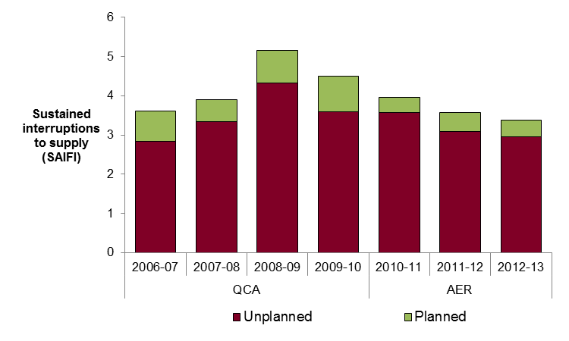



Service Target Performance Incentive Scheme

In our 2010 distribution determination we determined the STPIS would apply to Ergon Energy in the 2010–15 regulatory control period with an overall revenue at risk of ±2 per cent. It also decided to not apply the GSL component while the QCA’s GSL scheme remained in place.

The following section shows the effect of (normalised) unplanned interruptions to supply to customers on Ergon Energy's network.

Network reliability (normalised)

In 2012–13 the average Ergon Energy customer experienced:

* 16 per cent fewer unplanned (normalised) minutes off supply, than they experienced over the previous five years
* 18 per cent fewer unplanned (normalised) interruptions to supply than they experienced over the previous five years (Figure 9–60).

It should be noted the reliability information presented in Figure 9–60 combines information from the previous jurisdictional scheme and the AER's STPIS. These schemes differ in detail and therefore the information is not directly comparable. However, the reliability outcomes are presented to provide broad trend information regarding Ergon Energy's service performance.

Figure 9–60 Unplanned interruptions to supply (normalised) – Ergon Energy

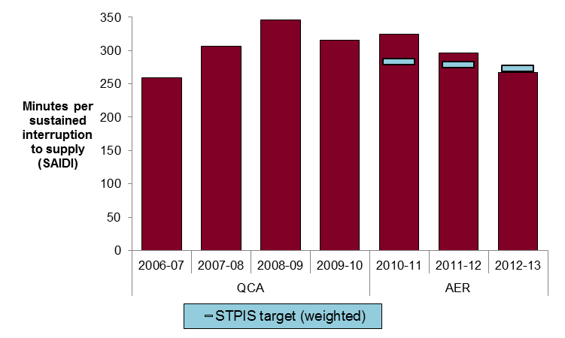 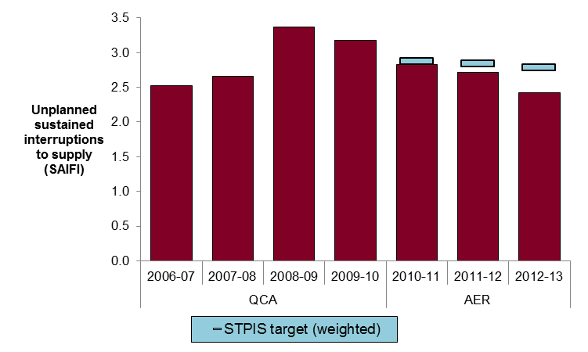



S–factor

Table 9–2 compares Ergon Energy's service performance against its STPIS targets over the first three years of the 2010–15 regulatory control period. Ergon Energy has improved its service performance against its targets in each successive year since the STPIS was applied.

It is important to note STPIS targets are applied to normalised network reliability. In 2010–11, floods affected much of central and southern Queensland. In 2012–13 Queensland was hit by Tropical Cyclone Oswald causing widespread impact including severe storms and flooding. As a result of these natural events, Ergon Energy experienced a number of days in which its daily unplanned SAIDI exceeded the major event day boundary. For any day in which unplanned SAIDI exceeds the major event day boundary the impact of that day's SAIDI, SAIFI and telephone answering is removed from the calculation of the annual normalised service performance measures. By removing the impact of events occurring on major event days we exclude from the operation of the scheme events we consider to be outside the DNSP's control.

The s–factor is incorporated into Ergon Energy's control mechanism as a multiplier in the calculation of its MAR. The MAR is incremented when service performance is better than performance targets and decremented when service performance is worse than performance targets. The way in which the s–factor is incorporated into Ergon Energy's control mechanism is set out in the 2010–15 distribution determination.

Note there is a two year lag between the regulatory year in which service performance outcomes are assessed and the regulatory year in which the s–factor outcome is applied to the DNSP's allowed revenue.

Table 9–2 S–factor – Ergon Energy

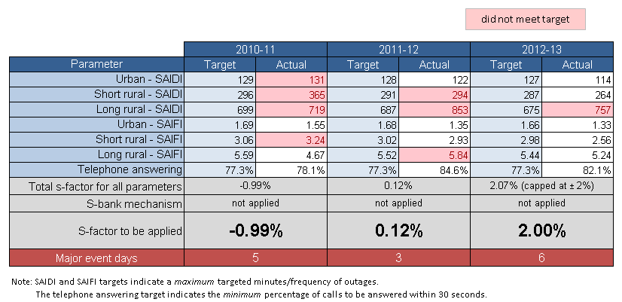

Chapter 8 contains information on our STPIS and a comparative assessment of the DNSPs' service performance.

## SA Power Networks

Network characteristics

**Ownership:** A partnership of Cheung Kong Infrastructure/Power Assets (51 per cent) and Spark Infrastructure (49 per cent)

**Relevant regulatory control period**: 1 July 2010 – 30 June 2015

**Network profile 2012-13**

Total distribution customers: 847,766

Total line (circuit) length: 87,882 km

Customer density: 9.6 customers/km line (circuit)

**Network performance: 2010–11 to 2012–13**

Energy delivered: 33,318 GWh, 3 per cent ▼ than forecast

Capital expenditure: $914 m, 11 per cent ▼ than forecast

Regulatory Asset Base: 11 per cent ▲ (from $3.2bn to $3.5bn)

Operating expenditure: $653 m, 4 per cent ▲ than forecast

Revenue (WAPC): $2.2 bn, 6 per cent ▲ than forecast

**Network reliability (normalised):**

Unplanned minutes off supply: 2012–13: 143.3 minutes

Avg. prev. five years: 143.8 minutes

Unplanned interruptions to supply: 2012–13: 1.33 interruptions

Avg. prev. five years: 1.42 interruptions

### Regulation

From 1 July 2010 we have been responsible for the economic regulation of electricity distribution services provided by SA Power Networks. Previously the Essential Service Commission of South Australia (ESCOSA) was the responsible regulator.

### Energy delivered

Total energy delivered by SA Power Networks over the first three years of the 2010–15 regulatory control period was approximately 3 per cent less than the forecasts approved by us in our 2010 distribution determination (Figure 9–61).

SA Power Networks indicated the principal variations in energy delivered arose in the Major Business category from:

* timing of the commissioning of a major new plant, and
* subsequent commissioning requiring less energy than originally forecast.

These factors had a particular impact on energy delivered in 2010–11 and 2011–12, but also had an impact in 2012–13. The decline in major business energy requirements compared to forecast was about 250GWh in each of the three years.

SA Power Networks indicated energy delivered in 2012–13 was impacted by downsizing operations at a major customer’s site. SA Power Networks notes the major customer’s annual energy will reduce further in 2013–14 when the on–site co–generation facilities are commissioned.

Chapter 4 contains our assessment of energy delivered for all DNSPs in the NEM.

Figure 9–61 Energy delivered – SA Power Networks

### Demand

SA Power Networks' actual maximum demand over the first three years of the 2010–15 regulatory control period was below the forecasts approved by us in our 2010 distribution determination (Figure 9–62).

SA Power Networks indicated that in 2010–11, weather close to 10 per cent PoE did occur. However, the weather in the two subsequent years was mild, particularly during the critical work days from Australia Day to mid–March when its maximum demand can occur.

Demand was also reduced in 2010–11 and 2011–12 by delays in the commissioning of the new plant, and in 2012–13 from the reduction in demand at a major customer’s site arising from commissioning of a co–generation facility.

Figure 9–62 Maximum demand – SA Power Networks

Chapter 4 contains our assessment of maximum demand for all DNSPs in the NEM.

### Expenditure and revenue

Amendments made to our approved forecasts as a result of Tribunal orders or as a result of approved pass throughs are included in the following analysis of SA Power Networks' financial performance.[19]

Capital expenditure

SA Power Networks' total capital expenditure over the first three years of the 2010–15 regulatory control period was approximately 11 per cent lower than our approved forecast (Figure 9–63).

SA Power Networks indicated:

* over the 2005–09 regulatory control period, high levels of customer driven capital works resulted in its gross expenditure allowances being exceeded, offset by higher customer contributions
* lower customer demand over the 2010–15 regulatory control period has resulted in a reduction in capacity and new customer augmentation expenditure
* economic recovery post global financial crisis was slower than anticipated combined with higher penetration of solar panels. However, this was somewhat offset by increased asset renewal expenditure, significantly above allowances, to replace priority risk assets.

Figure 9–63 Capital expenditure (excluding customer contributions) – SA Power Networks

SA Power Networks also indicated it optimised its capital investment programs to meet future growth and to maintain network performance standards. (Figure 9–64)

Figure 9–64 Capital expenditure by purpose (excluding customer contributions) – SA Power Networks

Chapter 5 provides a description of how DNSPs fund their expenditure on investment projects (capital expenditure) and a comparative assessment of capital expenditure for all DNSPs in the NEM.

Regulatory asset base

SA Power Networks' RAB increased by approximately 8 per cent over the first three years of the 2010–15 regulatory control period. SA Power Networks' RAB was forecast to increase by 10 per cent over this period.

SA Power Networks' RAB grew from approximately $3.2 billion at the end of 2009–10 to approximately $3.5 billion at the end of 2012–13 (Figure 9–65).

Figure 9–65 Regulatory asset base – SA Power Networks

The increasing difference between the forecast RAB and the actual value of SA Power Networks' RAB is consistent with its underspending on capital over the first three years of the 2010–15 regulatory control period.

Operating expenditure

SA Power Networks' total operating expenditure over the first three years of the 2010–15 regulatory control period was approximately 4 per cent higher than our approved forecast (Figure 9–66).

SA Power Networks indicated network maintenance works have continued to be a major contributor to overall operating costs, particularly in the areas of asset inspection and emergency response and supply restoration. Guaranteed service level payments in particular, largely attributable to more frequent severe weather events, significantly exceeded regulatory allowances.

Vegetation management costs for the 2010–15 regulatory control period were also above those originally allowed by the AER. SA Power Networks indicated this was due to increased and sustained tree growth since the breaking of the South Australian drought. In approving SA Power Networks' vegetation clearance pass through application in July 2013, we recognised this to be an ongoing issue, the magnitude of which could not have been forecast at the last reset. However, SA Power Networks indicated the vegetation clearance pass through amounts did not allow for recovery of all costs incurred by following the breaking of the drought. In particular, SA Power Networks noted it absorbed the higher vegetation clearance costs experienced in 2011–12.

SA Power Networks also indicated that in the first three years of the 2010–14 regulatory control period it absorbed the higher costs associated with administration of the State Government’s solar PV FiT scheme.

Figure 9–66 Operating expenditure – SA Power Networks

Chapter 6 contains our assessment of operating expenditure for all DNSPs in the NEM.

Revenue

Our 2010 distribution determination applied a weighted average price cap (WAPC) form of control to SA Power Networks’ distribution services over the 2010–15 regulatory control period. A WAPC imposes controls over the prices a DNSP may charge for its services.

SA Power Networks' total revenue recovered for standard control services over the first three years of the 2010–15 regulatory control period was approximately 6 per cent higher than our approved forecast (Figure 9–67).

SA Power Networks indicated the weather in the first three years of the 2010–15 regulatory control period impacted on its actual revenue being higher than our approved forecasts. SA Power Networks estimated the possible incremental impacts associated with customer response to weather represent $15.6 million of revenue. It also indicated other variations would account for the estimated balance of $34.7 million, which is approximately 1.6 per cent of the amended AER forecast for the period.

Chapter 7 provides further information on the WAPC control mechanism as well as our comparative assessment of revenue for all DNSPs in the NEM.

Figure 9–67 Revenue – SA Power Networks

### Financial performance

SA Power Networks' average EBIT for standard control services was approximately 43 per cent of its total revenue earned for standard control services over 2010–13. The EBIT in Figure 9–68 includes depreciation and amortisation and should not be used as a definitive measure of core profitability.

For SA Power Networks EBIT margin is shown as EBIT divided by both gross and net revenue, reflecting different treatment of revenues received and expenditures made for transmission services (TUoS revenue). Gross EBIT margin (including TUoS revenue) is consistent with reporting in the 2012–13 Annual Reporting RIN and SA Power Networks' statutory financial accounts.

Figure 9–68 Earnings before interest and tax– SA Power Networks

SA Power Networks indicated its EBIT margin increased in the 2010–15 regulatory control period due to additional revenue from:

* higher capital allowances which were approved by us: additional EBIT is required to service increased levels of debt and investment
* higher WACC which was approved by us due to the higher cost of funds in the post–global financial crisis environment
* additional allowed revenues starting from 2011–12 for outcomes from the Tribunal decision following our 2010 distribution determination, noting five years of this additional revenue is being recovered over the final four years of the regulatory control period
* SPS incentive revenue
* interest on PV under–recovery.

### Service performance

Total interruptions to supply

Total interruptions to supply reflect the total impact of both planned and unplanned interruptions (Figure 9–69). This measure reflects the actual experience of the average SA Power Networks customer. Total interruptions to supply include the effect of any interruptions considered to be excluded events in the STPIS.

Figure 9–69 Total interruptions to supply – SA Power Networks

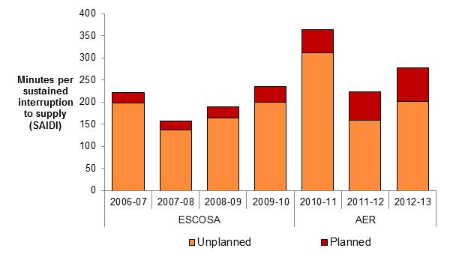 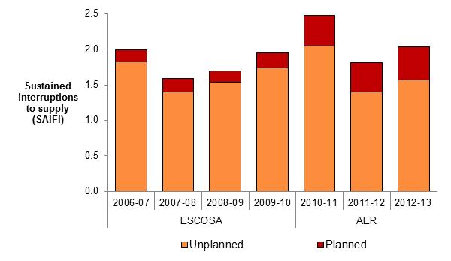



Service Target Performance Incentive Scheme

In our 2010 distribution determination we determined the STPIS would apply to SA Power Networks in the 2010–15 regulatory control period with an overall revenue at risk of ±3 per cent. We also decided to not apply the GSL component while the ESCOSA’s GSL scheme remained in place.

The following section shows the effect of (normalised) unplanned interruptions to supply to customers on SA Power Networks' network.

Network reliability (normalised)

In 2012–13 the average SA Power Networks customer experienced:

* <1 per cent fewer unplanned (normalised) minutes off supply than over the previous five years
* 6 per cent fewer unplanned (normalised) interruptions to supply than over the previous five years (Figure 9–70).

It should be noted the reliability information presented in Figure 9–70 combines information from the previous jurisdictional scheme and the AER's STPIS. These schemes differ in detail and therefore the information is not directly comparable. However, the reliability outcomes are presented to provide broad trend information regarding SA Power Networks' service performance.

Figure 9–70 Unplanned interruptions to supply (normalised) – SA Power Networks

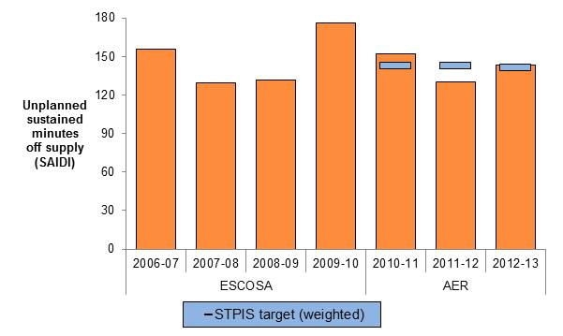 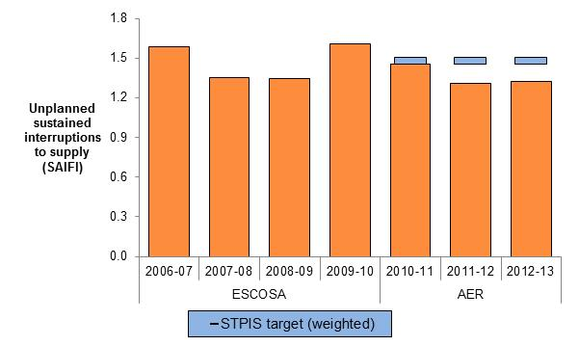



S–factor

Table 9–3 compares SA Power Networks' service performance against its STPIS targets over the first three years of the 2010–15 regulatory control period. SA Power Networks generally performed well against its service performance targets in 2011–12 and 2012–13 after underperforming in 2010–11.

It is important to note STPIS targets are applied to normalised network reliability. In each of the first three years of the 2010–15 regulatory control period SA Power Networks experienced between three and nine days where its daily unplanned SAIDI exceeded the major event day boundary. For any day in which unplanned SAIDI exceeds the major event day boundary the impact of that day's SAIDI, SAIFI and telephone answering is removed from the calculation of the annual normalised service performance measures. By removing the impact of events occurring on major event days we exclude from the operation of the scheme events we consider to be outside the DNSP's control.

The s–factor is incorporated into SA Power Networks' control mechanism as a multiplier in its WAPC. Allowed revenue is incremented when service performance is better than performance targets and decremented when service performance is worse than performance targets. The way in which the s–factor is incorporated into SA Power Networks' control mechanism is be set out in the 2010–15 distribution determination.

Note there is a two year lag between the regulatory year in which service performance outcomes are assessed and the regulatory year in which the s–factor outcome is applied to the DNSP's allowed revenue.

Table 9–3 S–factor – SA Power Networks



Chapter 8 contains information on our STPIS and a comparative assessment of the DNSPs' service performance.

## TasNetworks (formerly Aurora Energy)

Network characteristics

**Ownership:** Tasmanian Government Owned Corporation

**Relevant regulatory control period**: 1 July 2012 – 30 June 2017

**Network profile 2012-13**

Total distribution customers: 279,130

Total line (circuit) length: 22,336 km

Customer density: 12.5 customers/km line (circuit)

**Network performance: 2012–13**

Energy delivered: no approved forecast of energy consumption

Capital expenditure: $91 m, 22 per cent ▼ than forecast

Regulatory Asset Base: 0.4 per cent ▼ (from $1.48bn to $1.47bn)

Operating expenditure: $70 m, 3 per cent ▼ than forecast

Revenue (revenue cap): $266 m, 5 per cent ▼ than forecast

**Network reliability (normalised):**

Unplanned minutes off supply: 2012–13: 160.9 minutes

Avg. prev. five years: 176.0 minutes

Unplanned interruptions to supply: 2012–13: 1.59 interruptions

Avg. prev. five years: 1.70 interruptions

### Regulation

From 1 July 2012 we have been responsible for the economic regulation of electricity distribution services provided by TasNetworks (previously Aurora Distribution). Previously the Office of the Tasmanian Economic Regulator (OTTER) was the responsible regulator.

### Energy delivered

TasNetworks has delivered progressively less energy in each year since 2008–09 (Figure 9–71). We did not include a forecast of energy consumption in our 2012 distribution determination.

TasNetworks indicated the declining trend in energy delivered is due to customers responding to price rises by reducing consumption. It also noted the growing contribution from solar PV, increased customer awareness, and an uptake of energy efficient appliances has contributed to the decline in energy delivered.

Figure 9–71 Energy delivered – TasNetworks

Chapter 4 contains our assessment of energy delivered for all DNSPs in the NEM.

### Demand

TasNetworks has reported a lower maximum demand in each successive year since 2008–09 (Figure 9–72). Despite this declining trend, maximum demand was forecast to increase in each year of TasNetworks' 2012–17 regulatory control period.

TasNetworks assumed customers have reduced consumption in response to successive price rises in previous years. Major industrial and commercial customers have also responded through investment in new technologies. Higher prices in recent years have increased overall customer awareness and uptake of energy efficient appliances.

TasNetworks noted the availability of Time of Use (TOU) pricing to commercial and irrigation customers contributed to a shift in consumption during non–peak periods.

Figure 9–72 Maximum demand – TasNetworks

Chapter 4 contains our assessment of maximum demand for all DNSPs in the NEM.

### Expenditure and revenue

Capital expenditure

TasNetworks' total capital expenditure in the first year of the 2012–17 regulatory control period was approximately 22 per cent lower than our approved forecast (Figure 9–73).

Figure 9–73 Capital expenditure (excluding customer contributions) – TasNetworks

TasNetworks indicated that in 2010 it developed a new strategy in response to internal and external drivers and the public response to Tasmania’s increasing electricity prices. The distribution business submitted a regulatory proposal to us driven by the strategic objective of no price increases to customers. As a result the distribution business embarked on cost savings and finding non–network solutions to resolving any network constraints. The business had also entered a new phase given the prior year’s investment in its network, which allowed the business to focus on network asset productivity, and maintenance based on condition assessments.

TasNetworks stated its customer focussed approach has seen it investigate every reasonable opportunity to reduce capital expenditure. Further, falling economic conditions and a more 'user pays' approach to building new customer connections, resulted in a reduction of customer generated capital expenditure.

TasNetworks indicated the following reasons for its underspending on capital projects in 2012–13 (Figure 9–74):

* customer initiated work impacted by the weakened state economy
* Bellerive Zone Location of Eastern Shore zone substation changed to Rosny and construction deferred one year
* deferral of zone substation land purchase by one year
* HV feeder and distribution transformer upgrades reduced due to steady/slightly lower demand.

Figure 9–74 Capital expenditure by purpose (including customer contributions) – TasNetworks

Chapter 5 provides a description of how DNSPs fund their expenditure on investment projects (capital expenditure) and a comparative assessment of capital expenditure for all DNSPs in the NEM.

Regulatory asset base

TasNetworks' RAB decreased slightly in the first year of the 2012–17 regulatory control period. TasNetworks' RAB was forecast to increase by 9 per cent in this period. TasNetworks' RAB contracted from approximately $1.48 billion at the end of 2011–12 to approximately $1.47 billion at the end of 2012–13 (Figure 9–75).

Figure 9–75 Regulatory asset base – TasNetworks

The difference between the forecast RAB and the actual value of TasNetworks' RAB is consistent with its underspending on capital in the first year of the 2012–17 regulatory control period.

Operating expenditure

TasNetworks' total operating expenditure in the first year of the 2012–17 regulatory control period was approximately 3 per cent lower than our approved forecast (Figure 9–76).

TasNetworks indicated as with its capital expenditure, every effort was made to reduce operating expenditure, given its more direct correlation to customer electricity prices. TasNetworks' distribution business went through a number of significant restructures and redundancy costs have added to prior years' operating expenditure. TasNetworks stated it will continue to explore opportunities to reduce operating expenditure and operate in the most efficient manner.

Chapter 6 contains our assessment of operating expenditure for all DNSPs in the NEM.

Figure 9–76 Operating expenditure – TasNetworks

Revenue

Our 2012 distribution determination applied a revenue cap form of control to TasNetworks' distribution services over the 2012–17 regulatory control period. A revenue cap imposes controls over the revenues a distributor may recover for providing electricity distribution services.

TasNetworks' revenue earned for standard control services in the first year of the 2012–17 regulatory control period was approximately 5 per cent lower than our approved forecast (Figure 9–77).

Figure 9–77 Revenue – TasNetworks

TasNetworks indicated its distribution business failed to achieve its revenue forecasts primarily as a result of the challenge of accurately forecasting energy consumption, particularly during a period of rising electricity prices.

As prices have increased energy consumed has consistently failed to meet forecasts, which has impacted revenue recovered. The revenue cap mechanism has meant efforts to recover any under–recoveries have led to further increased prices in subsequent years impacting the customers’ price sensitivity and therefore consumption forecasts.

Chapter 7 provides further information on the revenue cap control mechanism as well as our comparative assessment of revenue for all DNSPs in the NEM.

### Financial performance

TasNetworks' average EBIT for standard control services was approximately 26 per cent of its total revenue earned for standard control services over 2011–13 . The EBIT in Figure 9–78 includes depreciation and amortisation and should not be used as a definitive measure of core profitability.

Figure 9–78 Earnings before interest and tax – TasNetworks

TasNetworks indicated increased profitability in 2012–13 was due to:

* reductions in operating expenditure through operational cost reductions and mild weather
* reduction in capital expenditure.

### Service performance

Total interruptions to supply

Total interruptions to supply reflect the total impact of both planned and unplanned interruptions (Figure 9–79). This measure reflects the actual experience of the average TasNetworks customer. Total interruptions to supply include the effect of any interruptions considered to be excluded events in the STPIS.

Figure 9–79 Total interruptions to supply – TasNetworks

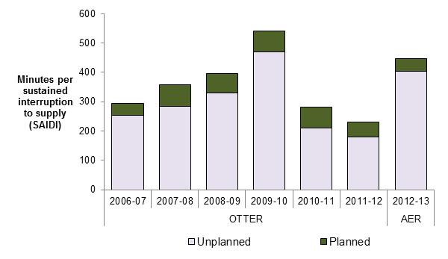 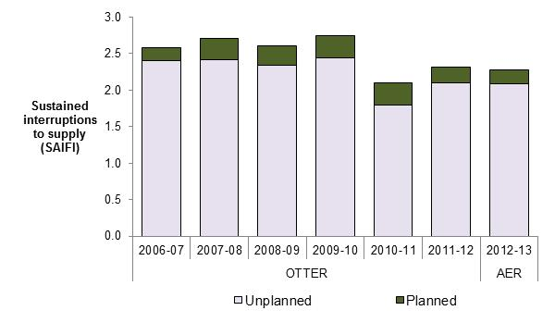



Service Target Performance Incentive Scheme

In our 2012 distribution determination we determined the STPIS would apply to TasNetworks in the 2012–17 regulatory control period with an overall revenue at risk of ±5 per cent. We decided to not apply the GSL component while the OTTER's GSL scheme remained in place.

The following section shows the effect of (normalised) unplanned interruptions to supply to customers on TasNetworks' network.

Network reliability (normalised)

In 2012–13 the average TasNetworks customer experienced:

* 9 per cent fewer unplanned (normalised) minutes off supply than they experienced over the previous five years
* 7 per cent fewer unplanned (normalised) interruptions to supply than they experienced over the previous five years (Figure 9–80).

It should be noted the reliability information presented in Figure 9–80 combines information from the previous jurisdictional scheme and the STPIS. These schemes differ in detail and therefore the information is not directly comparable. However, the reliability outcomes are presented to provide broad trend information regarding TasNetworks' service performance.

Figure 9–80 Unplanned interruptions to supply (normalised) – TasNetworks

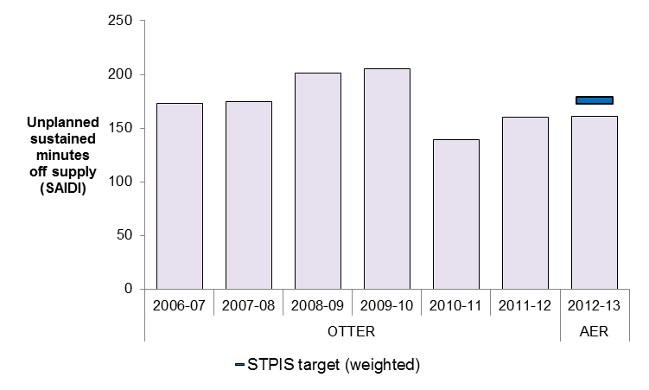 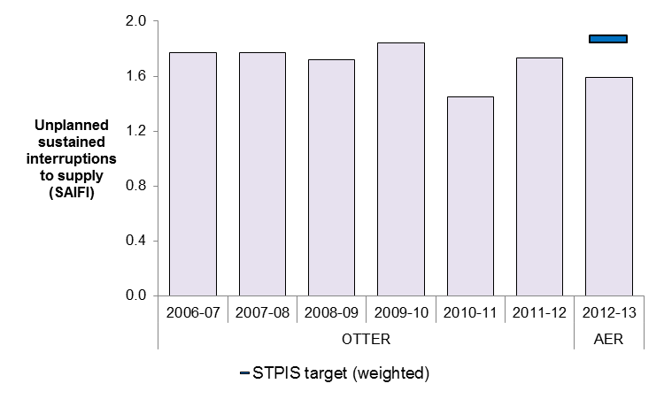



S–factor

Table 9–4 compares TasNetworks' service performance against its STPIS targets over the first year of the 2012–17 regulatory control period. TasNetworks performed well against all but one of its service performance targets in 2012–13 which was the first year since the STPIS was applied.

It is important to note STPIS targets are applied to normalised network reliability. In 2012–13 TasNetworks experienced three days where its daily unplanned SAIDI exceeded the major event day boundary. For any day in which unplanned SAIDI exceeds the major event day boundary the impact of that day's SAIDI, SAIFI and telephone answering is removed from the calculation of the annual normalised service performance measures. By removing the impact of events occurring on major event days we exclude from the operation of the scheme events we consider to be outside the DNSP's control.

The s–factor is incorporated into TasNetworks' control mechanism as a multiplier in the calculation of its MAR. The MAR is incremented when service performance is better than performance targets and decremented when service performance is worse than performance targets. The way in which the s–factor is incorporated into TasNetworks' control mechanism is set out in the 2010–15 distribution determination.

Note there is a two year lag between the regulatory year in which service performance outcomes are assessed and the regulatory year in which the s–factor outcome is applied to the DNSP's allowed revenue.

Table 9–4 S–factor – TasNetworks



Chapter 8 contains information on our STPIS and a comparative assessment of the DNSPs' service performance

.

## AusNet Services (formerly SP AusNet Distribution)

Network characteristics

**Ownership:** Listed company (Singapore Power International (31 per cent), State Grid Corporation (20 per cent)

**Relevant regulatory control period**: 1 January 2011 – 30 December 2015

**Network profile 2013**

Total distribution customers: 660,229

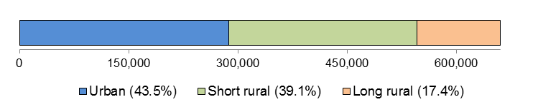

Total line (circuit) length: 43,822 km

Customer density: 15.1 customers/km line (circuit)

**Network performance: 2011–2013**

Energy delivered: 22,656 GWh, 5 per cent ▼ than forecast

Capital expenditure: $914 m, 2 per cent ▼ than forecast

Regulatory Asset Base: 25 per cent ▲ (from $2.2bn to $2.7bn)

Operating expenditure: $505 m, 4 per cent ▼ than forecast

Revenue (WAPC): $1.3 bn, within 1 per cent of forecast

**Network reliability (normalised):**

Unplanned minutes off supply: 2012–13: 133.1 minutes

Avg. prev. five years: 191.3 minutes

Unplanned interruptions to supply: 2012–13: 1.90 interruptions

Avg. prev. five years: 2.10 interruptions

### Regulation

From 1 January 2011 we have been responsible for the economic regulation of electricity distribution services provided by AusNet Services (formerly SP AusNet). Previously the Essential Services Commission of Victoria (ESCV) was the responsible regulator.

### Energy delivered

Total energy delivered by AusNet Services over the first three years of the 2011–15 regulatory control period was approximately 5 per cent less than our approved forecast (Figure 9–81). The forecasts for the 2011–15 regulatory control period are those submitted by AusNet Services and accepted by us in our 2010 distribution determination.

AusNet Services indicated the key drivers of the recent decline in energy delivered were:

* the reduction in energy usage by water utilities due to the reduction in pumping associated with the drought ending in 2010
* solar uptake (approximately 10 per cent of AusNet Services’ customers have installed solar, and system sizes are getting larger)
* energy efficiency (household appliances, business processes and building designs are becoming increasingly energy efficient)
* increasing prices have changed consumer behaviour with respect to energy consumption.

Figure 9–81 Energy delivered – AusNet Services

Chapter 4 contains our assessment of energy delivered for all DNSPs in the NEM.

### Demand

AusNet Services' actual maximum demand in each of the first three years of the 2011–15 regulatory control period was lower than the forecast maximum demand accepted by us in our 2010 distribution determination (Figure 9–82).

AusNet Services indicated its maximum demand did not reduce in line with energy delivered due to:

* population increases
* the growing penetration of air conditioners (amplified by consumers’ preferences towards energy intensive refrigerated cooling).

AusNet Services also indicated that in any particular year, weather can contribute to maximum demand outcomes.

Figure 9–82 Maximum demand – AusNet Services

Chapter 4 contains our assessment of maximum demand for all DNSPs in the NEM.

### Expenditure and revenue

Amendments made to our approved forecasts as the result of Tribunal orders or as a result of approved pass throughs are included in the following analysis of AusNet Services' financial performance.[20]

Capital expenditure

AusNet Services' total capital expenditure over the first three years of the 2011–15 regulatory control period was approximately 2 per cent lower than our approved forecast (Figure 9–83).

Figure 9–83 Capital expenditure (excluding customer contributions) – AusNet Services

AusNet Services indicated its capital expenditure was less than forecast in 2011 due to lower spending on demand related categories including reinforcement and customer connections (Figure 9–84).

Figure 9–84 Capital expenditure by purpose (excluding customer contributions) – AusNet Services

Chapter 5 provides a description of how DNSPs fund their expenditure on investment projects (capital expenditure) and a comparative assessment of capital expenditure for all DNSPs in the NEM.

Regulatory asset base

AusNet Services' RAB increased by approximately 25 per cent over the first three years of the 2011–15 regulatory control period. AusNet Services' RAB was forecast to increase by 43 per cent over this period.

AusNet Services' RAB grew from approximately $2.2 billion at the end of 2010 to approximately $2.7 billion at the end of 2013 (Figure 9–85).

The marginal difference between the forecast and actual value of AusNet Services' RAB is consistent with its marginal underspending on capital over the first three years of the 2011–15 regulatory control period.

Figure 9–85 Regulatory asset base – AusNet Services

Operating expenditure

AusNet Services' total operating expenditure over the first three years of the 2011–15 regulatory control period was approximately 4 per cent lower than our approved forecast (Figure 9–86).

AusNet Services indicated underspending on actual operating expenditure in 2011 and 2012 was primarily driven by efficiencies in maintenance spend.

Chapter 6 contains our assessment of operating expenditure for all DNSPs in the NEM.

Figure 9–86 Operating expenditure – AusNet Services

Revenue

The AER’s 2010 distribution determination applied a weighted average price cap (WAPC) form of control to AusNet Services' distribution services over the 2011–15 regulatory control period. A WAPC imposes controls over the prices a DNSP may charge for its services.

AusNet Services' total revenue earned for standard control services over the first three years of the 2011–15 regulatory control period was within 1 per cent of our approved forecast (Figure 9–87). AusNet Services’ revenue earned was impacted by STPIS reliability payments, which increased actual revenues relative to forecasts.

Figure 9–87 Revenue – AusNet Services

Chapter 7 provides further information on the WAPC control mechanism as well as our comparative assessment of revenue for all DNSPs in the NEM.

### Financial performance

AusNet Services' average EBIT for standard control services was approximately 38 per cent of its total revenue earned for standard control services over 2011–13. The EBIT in Figure 9–88 includes depreciation and amortisation and should not be used as a definitive measure of core profitability.

Figure 9–88 EBIT margin – AusNet Services

### Service performance

Total interruptions to supply

Total interruptions to supply reflect the total impact of both planned and unplanned interruptions (Figure 9–89). This measure reflects the actual experience of the average AusNet Services customer. Total interruptions to supply include the effect of any interruptions considered to be excluded events in the STPIS.

AusNet Services indicated the increases in planned SAIDI are attributable to the large increases in replacement and safety programs associated with bushfire mitigation.

Figure 9–89 Total interruptions to supply – AusNet Services

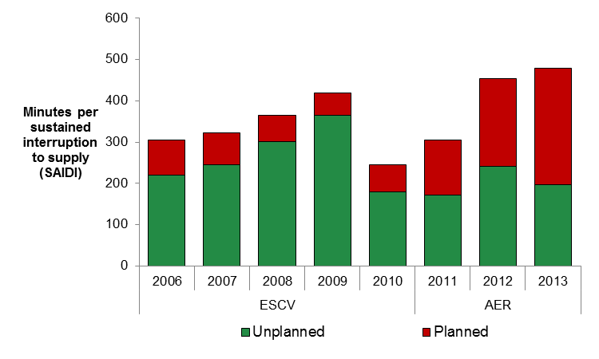 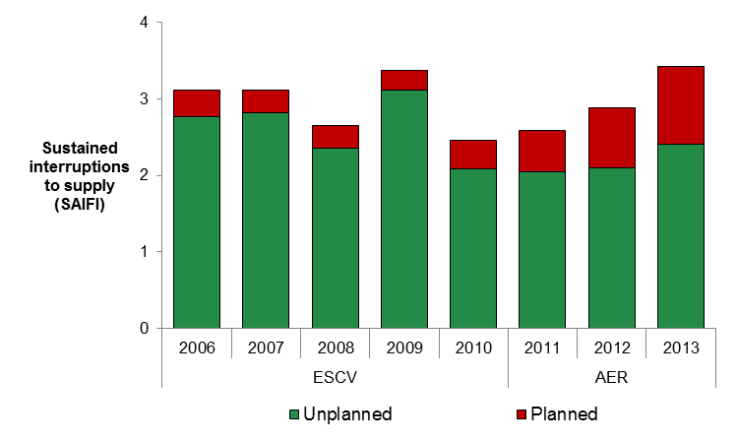



Service Target Performance Incentive Scheme

In our 2010 distribution determination we determined the STPIS would apply to AusNet Services in the 2011–15 regulatory control period with an overall revenue at risk of ±7 per cent.

The following section shows the effect of (normalised) unplanned interruptions to supply on customers on AusNet Services' network.

Network reliability (normalised)

In 2012–13 the average AusNet Services customer experienced:

* 30 per cent fewer unplanned (normalised) minutes off supply than over the previous five years
* 10 per cent fewer unplanned (normalised) interruptions to supply than over the previous five years (Figure 9–90).

It should be noted the reliability information presented in Figure 9–90 combines information from the previous jurisdictional scheme and the AER's STPIS.[21] These schemes differ in detail and therefore the information is not directly comparable. However, the reliability outcomes are presented to provide broad trend information regarding AusNet Services' service performance.

AusNet Services indicated the reasons for the improving unplanned SAIDI and SAIFI include:

* a substantial investment in distribution feeder automation – this increases the network’s ability to self‐heal during outage events.
* undertaking reliability reviews on key feeders
* targeted vegetation management – additional expenditure was spent on clearing trees along the first section of feeders to reduce the number of full feeder faults.

Figure 9–90 Unplanned interruptions to supply (normalised) – AusNet Services

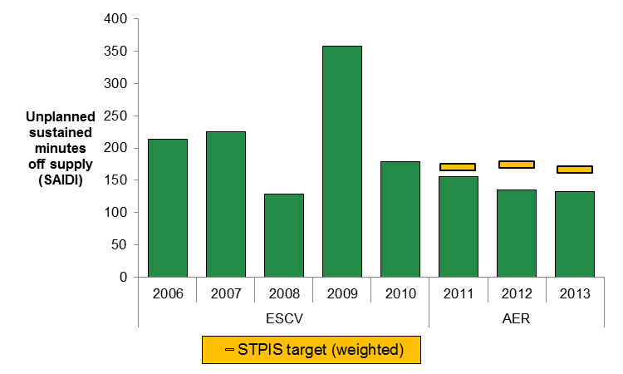 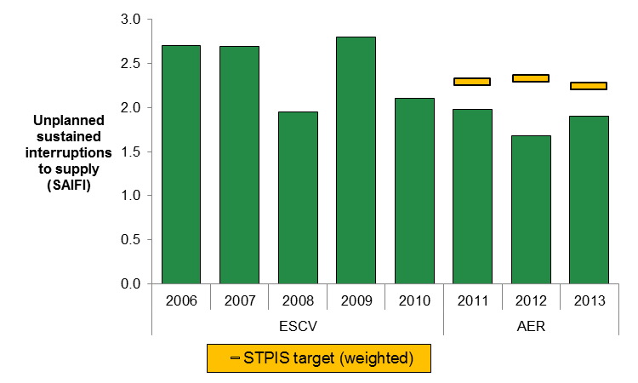



S–factor

Table 9–5 compares AusNet Services' service performance against its STPIS targets over the first three years of the 2011–15 regulatory control period. AusNet Services performed well against its SAIDI and SAIFI service performance targets in each year the STPIS was applied. However, AusNet Services did not meet any of its MAIFI performance targets and has only once met its telephone answering target (2011).

It is important to note STPIS targets are applied to normalised network reliability. In each of the first three years of the 2011–15 regulatory control period AusNet Services experienced between one and five days where its daily unplanned SAIDI exceeded the major event day boundary. For any day in which unplanned SAIDI exceeds the major event day boundary the impact of that day's SAIDI, SAIFI, MAIFI and telephone answering is removed from the calculation of the annual normalised service performance measures. By removing the impact of events occurring on major event days we exclude from the operation of the scheme events we consider to be outside the DNSP's control.

The s–factor is incorporated into AusNet Services' control mechanism as a multiplier in its WAPC. Allowed revenue is incremented when service performance is better than performance targets and decremented when service performance is worse than performance targets. The way in which the s–factor is incorporated into AusNet Services' control mechanism is set out in the 2011–15 distribution determination.

Note there is a two year lag between the regulatory year in which service performance outcomes are assessed and the regulatory year in which the s–factor outcome is applied to the DNSP's allowed revenue.

Table 9–5 S–factor – AusNet Services

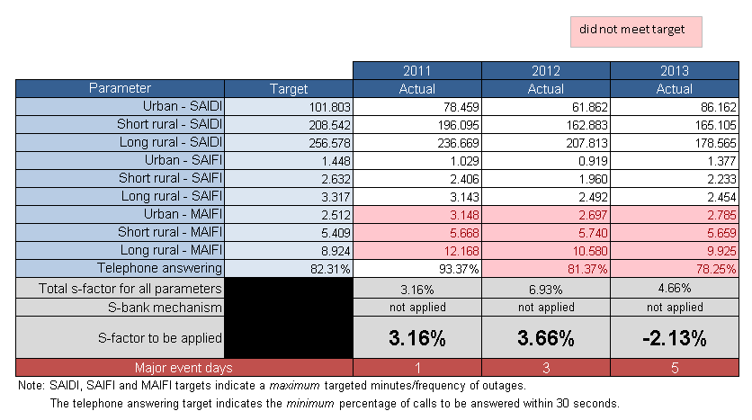

Chapter 8 contains information on our STPIS and a comparative assessment of the DNSPs' service performance.

## CitiPower

Network characteristics

**Ownership:** Cheung Kong Infrastructure/Power Assets (51 per cent); Spark Infrastructure (49 per cent)

**Relevant regulatory control period**: 1 January 2011 – 30 December 2015

**Network profile 2013**

Total distribution customers: 319,812

Total line (circuit) length: 4,318 km

Customer density: 74.1 customers/km line (circuit)

**Network performance: 2011–2013**

Energy delivered: 18,171 GWh, 2 per cent ▼ than forecast

Capital expenditure: $367 m, 23 per cent ▼ than forecast

Regulatory Asset Base: 15 per cent ▲ (from $1.4bn to $1.6bn)

Operating expenditure: $147 m, 1 per cent ▼ than forecast

Revenue (WAPC): $660 m, 1 per cent ▼ than forecast

**Network reliability (normalised):**

Unplanned minutes off supply: 2012–13: 26.9 minutes

Avg. prev. five years: 28.7 minutes

Unplanned interruptions to supply: 2012–13: 0.39 interruptions

Avg. prev. five years: 0.47 interruptions

### Regulation

From 1 January 2011 we have been responsible for the economic regulation of electricity distribution services provided by CitiPower. Previously the ESCV was the responsible regulator.

### Energy delivered

Total energy delivered by CitiPower over the first three years of the 2011–15 regulatory control period was approximately 2 per cent less than our approved forecast (Figure 9–91). The forecasts for the 2011–15 regulatory control period are those submitted by CitiPower and accepted by us in our 2010 distribution determination.

CitiPower indicated the energy volumes submitted as a part of its 2011–15 price reset process were more accurate than those used by us to determine the final price path.

Figure 9–91 Energy delivered – CitiPower

Chapter 4 contains our assessment of energy delivered for all DNSPs in the NEM.

### Demand

CitiPower's actual maximum demand in each of the first three years of the 2011–15 regulatory control period was lower than the forecast maximum demand accepted by us in our 2010 distribution determination (Figure 9–92).

CitiPower indicated the general economic slowdown associated with the global financial crisis was a significant factor in actual maximum demand being lower than forecast.

Chapter 4 contains our assessment of maximum demand for all DNSPs in the NEM.

Figure 9–92 Maximum demand – CitiPower

### Expenditure and revenue

Amendments made to our approved forecasts as the result of Tribunal orders or as a result of approved pass throughs are included in the following analysis of CitiPower's financial performance.[22]

Capital expenditure

CitiPower's total capital expenditure over the first three years of the 2011–15 regulatory control period was around 23 per cent lower than our approved forecast (Figure 9–93).

Figure 9–93 Capital expenditure (excluding customer contributions) – CitiPower

CitiPower indicated the following components have driven the underspending on capital projects in the 2011–15 regulatory control period (Figure 9–94):

* demand forecasts lower than forecast in the Melbourne docks area due to delays in a number of key expected developments, impacting the timing of the augmentation of the Docks Area zone substation.
* delays in the 2012 stages of the CBD Security Project as a result of more detailed testing revealing the poor condition of the substation building.
* delays in the replacement of the Customer Information System while regulatory obligations are determined.
* delays to the commencement of replacement projects at Richmond Terminal Station as a result of changes to the scope of the project by another distributor.

Figure 9–94 Capital expenditure by purpose (excluding customer contributions) – CitiPower

Chapter 5 provides a description of how DNSPs fund their expenditure on investment projects (capital expenditure) and a comparative assessment of capital expenditure for all DNSPs in the NEM.

Regulatory asset base

CitiPower's RAB increased by approximately 15 per cent over the first three years of the 2011–15 regulatory control period. CitiPower's RAB was forecast to increase by 14 per cent over this period.

CitiPower's RAB grew from approximately $1.4 billion at the end of 2010 to approximately $1.6 billion at the end of 2013 (Figure 9–95).

The increasing difference between the forecast and the actual value of CitiPower's RAB is consistent with its underspending on capital over the first three years of the 2011–15 regulatory control period.

Figure 9–95 Regulatory asset base – CitiPower

Operating expenditure

CitiPower's total operating expenditure over the first three years of the 2011–15 regulatory control period was approximately 1 per cent lower than our approved forecast (Figure 9–96).

CitiPower indicated there were no material differences between actual operating expenditure and forecasts in 2012 or 2013. However, CitiPower identified the following factors as drivers behinds its underspending on operating and maintenance in 2011:

* routine maintenance: expenditure was lower than the benchmark regulatory allowance due to less environment management project work being undertaken in 2011 than was forecast
* condition based maintenance: increased expenditure is related to additional safety compliance and property maintenance costs not included in the regulatory allowance. Overhead line and underground line maintenance and road management costs were also higher than anticipated due to increased activity flowing from the inspection program
* emergency maintenance: fault activity for 2011 was higher than that assumed in the regulatory benchmarks
* SCADA network control: no regulatory allowance was provided for maintaining the SCADA network however actual costs were incurred
* operating expenditure: actual expenditure was lower than the regulatory benchmark due to expenditure being reallocated to maintenance activities.

Chapter 6 contains our assessment of operating expenditure for all DNSPs in the NEM.

Figure 9–96 Operating expenditure – CitiPower

Revenue

The AER’s 2010 distribution determination applied a weighted average price cap (WAPC) form of control to CitiPower's distribution services over the 2011–15 regulatory control period. A WAPC imposes controls over the prices a DNSP may charge for its services.

CitiPower's total revenue earned for standard control services was approximately 1 per cent lower than our approved forecast over the first three years of the 2011–15 regulatory control period (Figure 9–97).

CitiPower indicated lower than forecast energy sales were the main reason for it recovering less revenue than was forecast.

Figure 9–97 Revenue – CitiPower

Chapter 7 provides further information on the WAPC control mechanism as well as our comparative assessment of revenue for all distribution networks in the NEM.

### Financial performance

CitiPower's average EBIT for standard control services was approximately 56 per cent of its total revenue earned for standard control services over 2011–13. The EBIT in Figure 9–98 includes depreciation and amortisation and should not be used as a definitive measure of core profitability.

Figure 9–98 EBIT – CitiPower

CitiPower noted it only reports negligible financing charges (used in the calculation of EBIT in Figure 9–98). This is because CitiPower I Pty Ltd is the financing entity for CitiPower, but it is not part of the licensed distribution business on which the AER's Annual Reporting RIN is issued.

CitiPower also indicated it allocates 'other revenue' to standard control services in its RINs, but this revenue is not revenue from distribution customers. ‘Other revenue’ comprises largely intercompany interest revenue relating to an intercompany loan.

We have excluded ‘other revenue’ from the calculation of EBIT.

### Service performance

Total interruptions to supply

Total interruptions to supply reflect the total impact of both planned and unplanned interruptions (Figure 9–99). This measure reflects the actual experience of the average CitiPower customer. Total interruptions to supply include the effect of any interruptions considered to be excluded events in the STPIS.

Figure 9–99 Total interruptions to supply – CitiPower

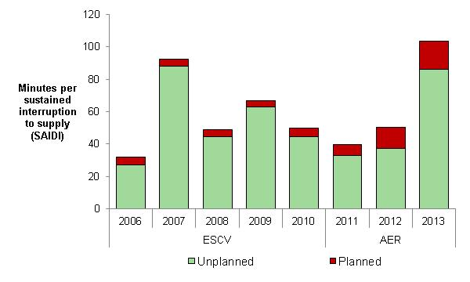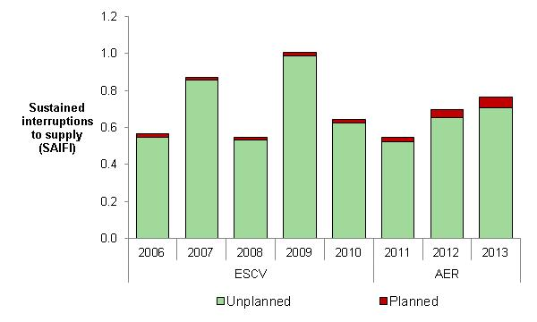



Service Target Performance Incentive Scheme

In our 2010 distribution determination we determined the STPIS would apply to CitiPower in the 2011–15 regulatory control period with an overall revenue at risk of ±5 per cent.

The following section shows the effect of (normalised) unplanned interruptions to supply to customers on CitiPower's network.

Network reliability (normalised)

In 2012–13 the average CitiPower customer experienced:

* 6 per cent fewer unplanned (normalised) minutes off supply than over the previous five years
* 15 per cent fewer unplanned (normalised) interruptions to supply than over the previous five years (Figure 9–100).

It should be noted the reliability information presented in Figure 9–100 combines information from the previous jurisdictional scheme and the AER's STPIS. These schemes differ in detail and therefore the information is not directly comparable. However, the reliability outcomes are presented to provide broad trend information regarding CitiPower's service performance.

Figure 9–100 Unplanned interruptions to supply (normalised) – CitiPower

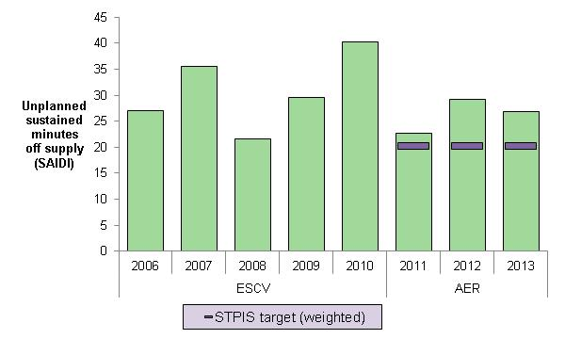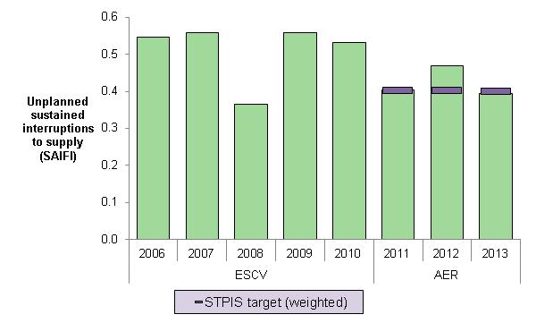



S–factor

Table 9–6 compares CitiPower's service performance against its STPIS targets over the first three years of the 2011–15 regulatory control period. Over this period CitiPower has consistently performed well against its CBD feeder and telephone answering targets but has underperformed against its urban feeder targets.

The STPIS stipulates the incentive rate applied to service performance provided to customers on CBD feeders is greater than the incentive rate applied to customers on other feeders. This weighting is based on the higher value CBD customers place on reliability. The relative weighting of CitiPower's service performance on CBD feeders has allowed it to achieve positive s–factor outcomes in 2011 and 2013.

It is important to note STPIS targets are applied to normalised network reliability. In each of the first three years of the 2011–15 regulatory control period CitiPower experienced between two and four days where it’s daily unplanned SAIDI exceeded the major event day boundary. For any day in which unplanned SAIDI exceeds the major event day boundary the impact of that day's SAIDI, SAIFI, MAIFI and telephone answering is removed from the calculation of the annual normalised service performance measures. By removing the impact of events occurring on major event days we exclude from the operation of the scheme events we consider to be outside the DNSP's control.

The s–factor is incorporated into CitiPower's control mechanism as a multiplier in its WAPC. Allowed revenue is incremented when service performance is better than performance targets and decremented when service performance is worse than performance targets. The way in which the s–factor is incorporated into CitiPower's control mechanism is set out in the 2011–15 distribution determination.

Note there is a two year lag between the regulatory year in which service performance outcomes are assessed and the regulatory year in which the s–factor outcome is applied to the DNSP's allowed revenue.

Table 9–6 S–factor – CitiPower

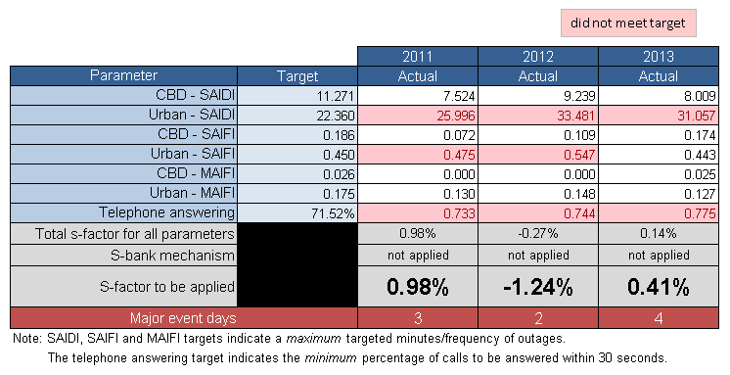

Chapter 8 contains information on our STPIS and a comparative assessment of the DNSPs' service performance.

## JEN (Jemena Electricity Networks)

Network characteristics

**Ownership:** State Grid Corporation of China (60 per cent); Singapore Power International (40 per cent)

**Relevant regulatory control period**: 1 January 2011 – 30 December 2015

**Network profile 2013**

Total distribution customers: 318,830

Total line (circuit) length: 6,135 km

Customer density: 52.0 customers/km line (circuit)

**Network performance: 2011–2013**

Energy delivered: 13,033 GWh, 1 per cent ▲ than forecast

Capital expenditure: $351 m, 23 per cent ▲ than forecast

Regulatory Asset Base: 26 per cent ▲ (from $0.8bn to $1bn)

Operating expenditure: $211 m, 16 per cent ▲ than forecast

Revenue (WAPC): $621 m, 7 per cent ▲ than forecast

**Network reliability (normalised):**

Unplanned minutes off supply: 2012–13: 59.8 minutes

Avg. prev. five years: 63.7 minutes

Unplanned interruptions to supply: 2012–13: 1.11 interruptions

Avg. prev. five years: 0.99 interruptions

### Regulation

From 1 January 2011 we have been responsible for the economic regulation of electricity distribution services provided by JEN. Previously the ESCV was the responsible regulator.

### Energy delivered

Total energy delivered by JEN over the first three years of the 2011–15 regulatory control period was approximately 1 per cent more than our approved forecast (Figure 9–101). However, energy delivered has declined in line with forecasts in each year of the 2011–15 regulatory control period. The forecasts for the 2011–15 regulatory control period are those submitted by JEN and accepted by us in our 2010 distribution determination.

JEN indicated energy consumption is driven by a number of factors such as economic activity, weather, government policies, etc. In 2011, the higher energy consumption compared to our approved forecasts was partially driven by the increase in large business customers. JEN believes the increase in energy was attributable to improvements in economic activity after the global financial crisis.

Figure 9–101 Energy delivered – JEN

Chapter 4 contains our assessment of energy delivered for all DNSPs in the NEM.

### Demand

JEN's actual maximum demand in each of the first three years of the 2011–15 regulatory control period was lower than the forecast maximum demand accepted by us in our 2010 distribution determination (Figure 9–102). JEN's actual maximum demand has declined in each regulatory year since 2009.

JEN indicated actual maximum demand over the 2011–15 regulatory control period has been lower than forecast due to the impact of the global financial crisis and closures of some large industrial customers on its network.

Figure 9–102 Maximum demand – JEN

Chapter 4 contains our assessment of maximum demand for all DNSPs in the NEM.

### Expenditure and revenue

Amendments made to our approved forecasts as the result of Tribunal orders or as a result of approved pass throughs are included in the following analysis of JEN's financial performance.[23]

Capital expenditure

JEN's total capital expenditure over the first three years of the 2011–15 regulatory control period was approximately 23 per cent higher than our approved forecast (Figure 9–103).

JEN indicated its actual capital expenditure over the first three years of the 2011–15 regulatory control period was more closely aligned with the forecasts submitted to the AER in its revised regulatory proposal than our approved forecasts.

JEN noted the following key reasons for its overspending on capital (Figure 9–104):

* network replacement and major reinforcement—necessary to ensure security of supply was not compromised and network peak demand was met
* new customer connections activity in business and residential sectors and special capital works
* JEN’s Northern Depot re–development project
* customer initiated multi occupancy and medium density real estate development business supply
* IT projects, such as SAP upgrades and refurbishment of data centres data to mitigate significant business risks.

Figure 9–103 Capital expenditure (excluding customer contributions) – JEN

Figure 9–104 Capital expenditure by purpose (excluding customer contributions) – JEN

Chapter 5 provides a description of how DNSPs fund their expenditure on investment projects (capital expenditure) and a comparative assessment of capital expenditure for all DNSPs in the NEM.

Regulatory asset base

JEN's RAB increased by approximately 26 per cent over the first three years of the 2011–15 regulatory control period. JEN's RAB was forecast to increase by 25 per cent over this period.

JEN's RAB grew from approximately $799 million at the end of 2010 to approximately $1 billion at the end of 2013 (Figure 9–105).

Figure 9–105 Regulatory asset base – JEN

The increasing difference between the forecast RAB and the actual value of JEN's RAB is consistent with its overspending on capital over the 2011–15 regulatory control period.

Operating expenditure

JEN's total operating expenditure over the first three years of the 2011–15 regulatory control period was approximately 16 per cent higher than our approved forecast (Figure 9–106).

Figure 9–106 Operating expenditure – JEN

JEN indicated its overspending on operating and maintenance in the first three years of the 2011–15 regulatory control period was due to:

* higher maintenance costs related to vegetation control and zone substation maintenance
* Broadmeadows depot being damaged by a storm event on 25 December 2012
* loss of synergies from large range of services previously provided to United Energy
* increased regulatory costs due to a substantial increase in regulatory activity by policy makers, rule makers and regulators
* a more onerous regulatory reporting through RINs.

Chapter 6 contains our assessment of operating expenditure for all DNSPs in the NEM.

Revenue

The AER’s 2010 distribution determination applied a weighted average price cap (WAPC) form of control to JEN's distribution services over the 2011–15 regulatory control period. A WAPC imposes controls over the prices a DNSP may charge for its services.

JEN's total revenue earned for standard control services over the first three years of the 2011–15 regulatory control period was approximately 7 per cent higher than our approved forecast (Figure 9–107).

Figure 9–107 Revenue – JEN

Chapter 7 provides further information on the WAPC control mechanism as well as our comparative assessment of revenue for all DNSPs in the NEM.

### Financial performance

JEN's average EBIT for standard control services was approximately 35 per cent of its total revenue earned for standard control services over 2011–13. The EBIT in Figure 9–108 includes depreciation and amortisation and should not be used as a definitive measure of core profitability.

Figure 9–108 EBIT – JEN

### Service performance

Total interruptions to supply

Total interruptions to supply reflect the total impact of both planned and unplanned interruptions (Figure 9–109). This measure reflects the actual experience of the average JEN customer. Total interruptions to supply include the effect of any interruptions considered to be excluded events in the STPIS.

Figure 9–109 Total interruptions to supply – JEN

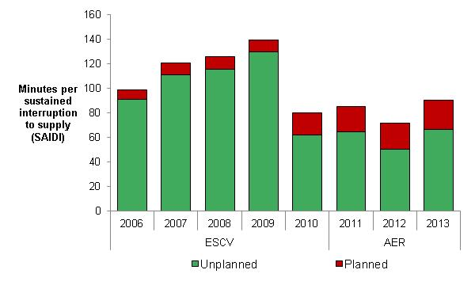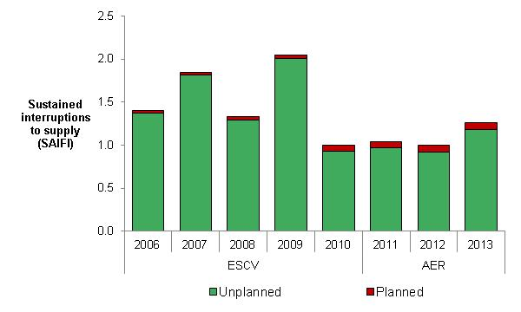



Service Target Performance Incentive Scheme

In our 2010 distribution determination we determined the STPIS would apply to JEN in the 2011–15 regulatory control period with an overall revenue at risk of ±5 per cent.

The following section shows the effect of (normalised) unplanned interruptions to supply to customers on JEN's network.

Network reliability (normalised)

In 2012–13 the average JEN customer experienced

* 6 per cent fewer unplanned (normalised) minutes off supply than over the previous five years
* 12 per cent more unplanned (normalised) interruptions to supply than over the previous five years (Figure 9–110).

It should be noted the reliability information presented in Figure 9–110 combines information from the previous jurisdictional scheme and the AER's STPIS. These schemes differ in detail and therefore the information is not directly comparable. However, the reliability outcomes are presented to provide broad trend information regarding JEN's service performance.

Figure 9–110 Unplanned interruptions to supply (normalised) – JEN

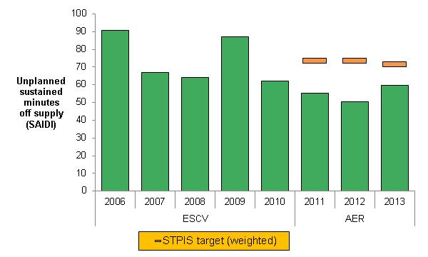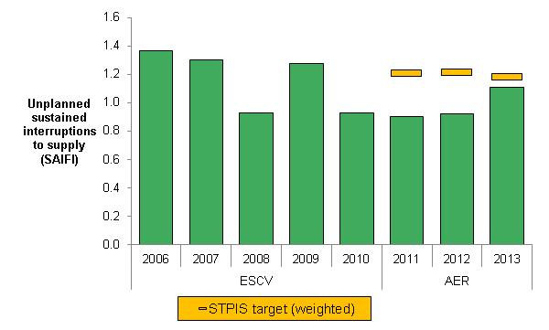



S–factor

Table 9–7 compares JEN's service performance against its STPIS targets over the first three years of the 2011–15 regulatory control period. JEN has generally performed well against its service performance targets in each year the STPIS was applied.

It is important to note STPIS targets are applied to normalised network reliability. Over the first three years of the 2011–15 regulatory control period JEN only experienced two days where its daily unplanned SAIDI exceeded the major event day boundary. For any day in which unplanned SAIDI exceeds the major event day boundary the impact of that day's SAIDI, SAIFI, MAIFI and telephone answering is removed from the calculation of the annual normalised service performance measures. By removing the impact of events occurring on major event days we exclude from the operation of the scheme events we consider to be outside the DNSP's control.

The s–factor is incorporated into JEN's control mechanism as a multiplier in its WAPC. Allowed revenue is incremented when service performance is better than performance targets and decremented when service performance is worse than performance targets. The way in which the s–factor is incorporated into JEN's control mechanism is set out in the 2011–15 distribution determination.

Note there is a two year lag between the regulatory year in which service performance outcomes are assessed and the regulatory year in which the s–factor outcome is applied to the DNSP's allowed revenue.

Table 9–7 S–factor – JEN

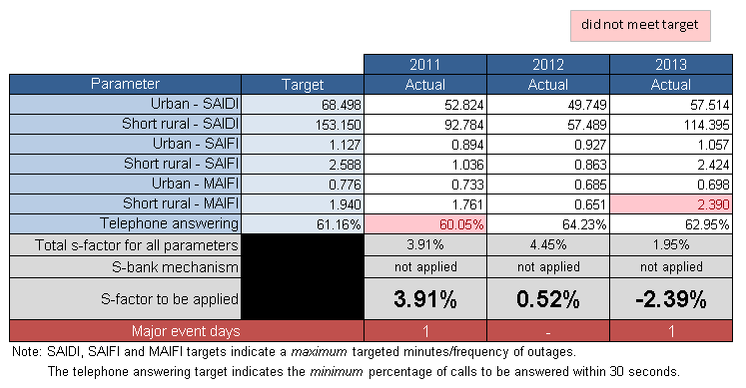

JEN indicated it has consistently outperformed its STPIS targets due to:

* stringent vegetation management practices
* a continued focus on end-of-life asset replacement
* prudent network augmentation
* well established routine maintenance regimes.

Chapter 8 contains information on our STPIS and a comparative assessment of the DNSPs' service performance.

## Powercor

Network characteristics

**Ownership:** Cheung Kong Infrastructure/Power Assets (51 per cent); Spark Infrastructure (49 per cent)

**Relevant regulatory control period**: 1 January 2011 – 30 December 2015

**Network profile 2013**

Total distribution customers: 744,799

Total line (circuit) length: 73,889 km

Customer density: 10.1 customers/km line (circuit)

**Network performance: 2011–2013**

Energy delivered: 31,770 GWh, 2 per cent ▼ than forecast

Capital expenditure: $760 m, 11 per cent ▼ than forecast

Regulatory Asset Base: 20 per cent ▲ (from $2.3bn to $2.8bn)

Operating expenditure: $491 m, 6 per cent ▼ than forecast

Revenue (WAPC): $1.4 bn, within 1 per cent of forecast

**Network reliability (normalised):**

Unplanned minutes off supply: 2012–13: 139.2 minutes

Avg. prev. five years: 152.1 minutes

Unplanned interruptions to supply: 2012–13: 1.44 interruptions

Avg. prev. five years: 1.61 interruptions

### Regulation

From 1 January 2011 we have been responsible for the economic regulation of electricity distribution services provided by Powercor. Previously ESCV was the responsible regulator.

### Energy delivered

Total energy delivered by Powercor over the first three years of the 2011–15 regulatory control period was approximately 2 per cent less than our approved forecast (Figure 9–111). The forecasts for the 2011–15 regulatory control period are those submitted by Powercor and accepted by us in our 2010 distribution determination.

Powercor indicated the energy volumes submitted as a part of the 2011–15 price reset were more accurate than those used by the AER in its processes to determine the final price path.

Figure 9–111 Energy delivered – Powercor

Chapter 4 contains our assessment of energy delivered for all DNSPs in the NEM.

### Demand

Powercor's actual maximum demand in each of first three years of the 2011–15 regulatory control period was lower than the forecast maximum demand accepted by us in our 2010 distribution determination (Figure 9–112).

Powercor indicated the general economic slowdown associated with the global financial crisis was a significant factor in actual maximum demand being lower than forecast.

Chapter 4 contains our assessment of maximum demand for all DNSPs in the NEM.

Figure 9–112 Maximum demand – Powercor

### Expenditure and revenue

Amendments made to our approved forecasts as the result of Tribunal orders or as a result of approved pass throughs are included in the following analysis of Powercor's financial performance.[24]

Capital expenditure

Powercor's total capital expenditure over the first three years of the 2011–15 regulatory control period was approximately 11 per cent lower than our approved forecast (Figure 9–113).

Figure 9–113 Capital expenditure (excluding customer contributions) – Powercor

Powercor indicated expenditure on capital projects (Figure 9–114) was less than forecast due to:

* Waurn Ponds to Torquay 66kV line project being deferred until later in the regulatory control period due to lower than expected growth in peak demand in the area
* land purchase negotiations for Wyndham Vale, Rockbank East and Tarneit zone substation sites not being completed in 2011.
* slower than anticipated housing developments in key growth areas of Geelong and Western Melbourne resulting in lower than forecast demand growth.

Figure 9–114 Capital expenditure by purpose (excluding customer contributions) – Powercor

Chapter 5 provides a description of how DNSPs fund their expenditure on investment projects (capital expenditure) and a comparative assessment of capital expenditure for all DNSPs in the NEM.

Regulatory asset base

Powercor's RAB increased by approximately 20 per cent over the first three years of the 2011–15 regulatory control period. Powercor's RAB was forecast to increase by 16 per cent over this period.

Powercor's RAB grew from approximately $2.3 billion at the end of 2010 to approximately $2.8 billion at the end of 2013 (Figure 9–115).

Figure 9–115 Regulatory asset base – Powercor

Operating expenditure

Powercor's total operating expenditure over the first three years of the 2011–15 regulatory control period was approximately 6 per cent lower than our approved forecast (Figure 9–116).

Figure 9–116 Operating expenditure – Powercor

Powercor indicated there were no material differences between actual operating expenditure and forecasts in 2013. However, Powercor noted the following factors were drivers behind its underspending on operating and maintenance in 2011:

* routine maintenance: actual expenditure is below the regulatory allowance as a consequence of time taken to ramp up the vegetation management program with Powercor’s contractor
* condition based maintenance: increased expenditure related to safety compliance and property maintenance costs was not included in regulatory allowance. Overhead line maintenance costs were also higher
* emergency maintenance: increased expenditure due to increased storm and flood activity and higher than anticipated fault rates compared to the regulatory benchmark for 2011
* operating: actual expenditure is lower than the regulatory benchmark due to expenditure being reallocated to maintenance activities.

Chapter 6 contains our assessment of operating expenditure for all DNSPs in the NEM.

Revenue

The AER’s 2010 distribution determination applied a weighted average price cap (WAPC) form of control to Powercor's distribution services over the 2011–15 regulatory control period. A WAPC imposes controls over the prices a DNSP may charge for its services.

Powercor's total revenue earned for standard control services over the first three years of the 2011–15 regulatory control period was within 1 per cent of our approved forecast (Figure 9–117).

Figure 9–117 Revenue – Powercor

Chapter 7 provides further information on the WAPC control mechanism as well as our comparative assessment of revenue for all DNSPs in the NEM.

### Financial performance

Powercor's average EBIT for standard control services was approximately 42 per cent of its total revenue earned for standard control services over 2011–13. The EBIT in Figure 9–118 includes depreciation and amortisation and should not be used as a definitive measure of core profitability.

Powercor noted it only reports negligible financing charges (used in the calculation of EBIT in Figure 9–118). This is because Powercor I Pty Ltd is the financing entity for Powercor, but it is not part of the licensed distribution business on which the AER's Annual Reporting RIN is issued.

Powercor also indicated it allocates 'other revenue' to standard control services in its RINs, but this revenue is not revenue from distribution customers. ‘Other revenue’ comprises largely intercompany interest revenue relating to an intercompany loan.

Figure 9–118 Earnings before interest and tax – Powercor

We considered Powercor's request and excluded ‘other revenue’ in the calculation of EBIT.

### Service performance

Total interruptions to supply

Total interruptions to supply reflect the total impact of both planned and unplanned interruptions (Figure 9–119). This measure reflects the actual experience of the average Powercor customer. Total interruptions to supply include the effect of any interruptions considered to be excluded events in the STPIS.

Figure 9–119 Total interruptions to supply – Powercor

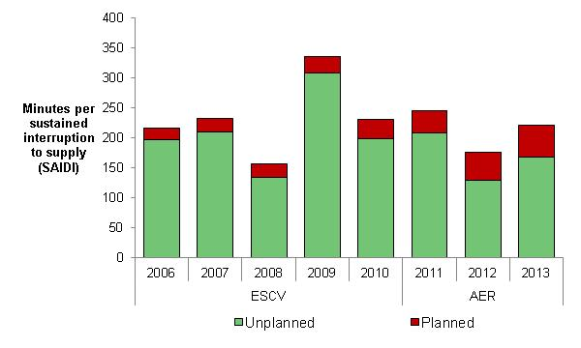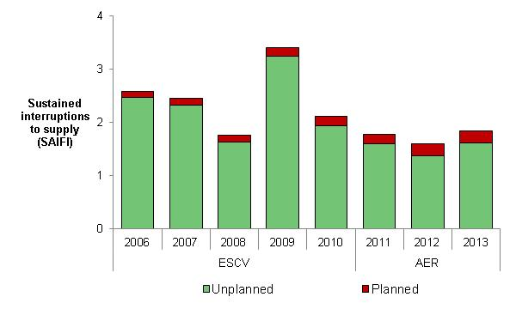



Service Target Performance Incentive Scheme

In our 2010 distribution determination we determined the STPIS would apply to Powercor in the 2011–15 regulatory control period with an overall revenue at risk of ±5 per cent.

The following section shows the effect of (normalised) unplanned interruptions to supply to customers on Powercor's network.

Network reliability (normalised)

In 2012–13 the average Powercor customer experienced:

* 8 per cent fewer unplanned (normalised) minutes off supply than over the previous five years
* 11 per cent fewer unplanned (normalised) interruptions to supply than over the previous five years (Figure 9–120).

It should be noted the reliability information presented in Figure 9–120 combines information from the previous jurisdictional scheme and the AER's STPIS.[25] These schemes differ in detail and therefore the information is not directly comparable. However, the reliability outcomes are presented to provide broad trend information regarding Powercor's service performance.

Figure 9–120 Unplanned interruptions to supply (normalised) – Powercor

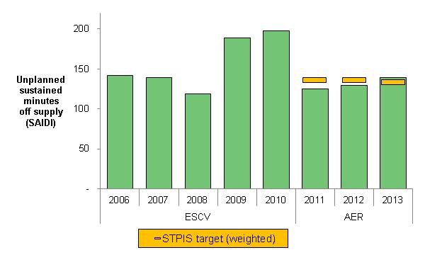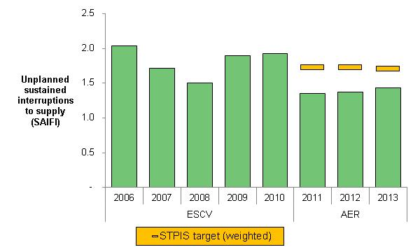



S–factor

Note there is a two year lag between the regulatory year in which service performance outcomes are assessed and the regulatory year in which the s–factor outcome is applied to the DNSP's allowed revenue.

Table 9–8 compares Powercor's service performance against its STPIS targets over the first three years of the 2011–15 regulatory control period. Powercor has generally outperformed its service performance targets in each year the STPIS was applied.

It is important to note STPIS targets are applied to normalised network reliability. In each of the first three years of the 2011–15 regulatory control period Powercor experienced between zero and three days where its daily unplanned SAIDI exceeded the major event day boundary. For any day in which unplanned SAIDI exceeds the major event day boundary the impact of that day's SAIDI, SAIFI, MAIFI and telephone answering is removed from the calculation of the annual normalised service performance measures. By removing the impact of events occurring on major event days we exclude from the operation of the scheme events we consider to be outside the DNSP's control.

The s–factor is incorporated into Powercor's control mechanism as a multiplier in its WAPC. Allowed revenue is incremented when service performance is better than performance targets and decremented when service performance is worse than performance targets. The way in which the s–factor is incorporated into Powercor's control mechanism is set out in the 2011–15 distribution determination.

Note there is a two year lag between the regulatory year in which service performance outcomes are assessed and the regulatory year in which the s–factor outcome is applied to the DNSP's allowed revenue.

Table 9–8 S–factor – Powercor

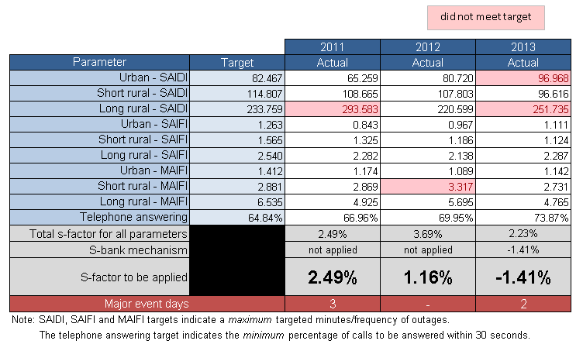

Chapter 8 contains information on our STPIS and a comparative assessment of the DNSPs' service performance.

## United Energy

Network characteristics

**Ownership:** DUET Group (66 per cent); Singapore Power International (34 per cent)

**Relevant regulatory control period**: 1 January 2011 – 30 December 2015

**Network profile 2013**

Total distribution customers: 647,271

Total line (circuit) length: 12,835 km

Customer density: 50.4 customers/km line (circuit)

**Network performance: 2011–2013**

Energy delivered: 23,999 GWh, 1 per cent ▲ than forecast

Capital expenditure: $542 m, 6 per cent ▲ than forecast

Regulatory Asset Base: 20 per cent ▲ (from $1.5bn to $1.8bn)

Operating expenditure: $369 m, 8 per cent ▲ than forecast

Revenue (WAPC): $942 m, 1 per cent ▼ than forecast

**Network reliability (normalised):**

Unplanned minutes off supply: 2012–13: 73.6 minutes

Avg. prev. five years: 77.4 minutes

Unplanned interruptions to supply: 2012–13: 1.01 interruptions

Avg. prev. five years: 1.09 interruptions

### Regulation

From 1 January 2011 we have been responsible for the economic regulation of electricity distribution services provided by United Energy. Previously ESCV was the responsible regulator.

### Energy delivered

Total energy delivered by United Energy over the first three years of the 2011–15 regulatory control period was 1 per cent more than our approved forecast (Figure 9–121). The forecasts for the 2011–15 regulatory control period are those submitted by United Energy and accepted by us in our 2010 distribution determination.

United Energy indicated higher than expected energy usage by large customers was the main reason for it delivering more energy than forecast in 2011 and 2012.

Figure 9–121 Energy delivered, United Energy

Chapter 4 contains our assessment of energy delivered for all DNSPs in the NEM.

### Demand

United Energy's actual maximum demand in each of the three years of the 2011–15 regulatory control period was lower than the forecast maximum demand accepted by us in our 2010 distribution determination (Figure 9–122).

United Energy reported an increase in actual maximum demand in each year since 2010. However, actual maximum demand has been consistently below forecast in each of these years.

United Energy indicated the growth in maximum demand could be explained by an increase in the number of customers and therefore the number of appliances connected to its network.

Figure 9–122 Maximum demand – United Energy

Chapter 4 contains our assessment of maximum demand for all DNSPs in the NEM.

### Expenditure and revenue

Amendments made to our approved forecasts as the result of Tribunal orders or as a result of approved pass throughs are included in the following analysis of United Energy's financial performance. [26]

Capital expenditure

United Energy's total capital expenditure over the first three years of the 2011–15 regulatory control period was approximately 6 per cent higher than our approved forecast (Figure 9–123).

United Energy indicated its capital overspend in the first three years of the 2011–15 regulatory period is due to the impact of the AER applying a large tariff increase in 2011. The tariff increase impacted customer contributions and has caused the net capital overspend, whereas total capital expenditure was underspent.

Chapter 5 provides a description of how DNSPs fund their expenditure on investment projects (capital expenditure) and a comparative assessment of capital expenditure for all DNSPs in the NEM.

Figure 9–123 Capital expenditure (excluding customer contributions) – United Energy

Figure 9–124 Capital expenditure by purpose (excluding customer contributions) – United Energy

Regulatory asset base

United Energy's RAB increased by approximately 20 per cent over the first three years of the 2011–15 regulatory control period. United Energy's RAB was forecast to increase by 6 per cent over this period.

United Energy's RAB grew from approximately $1.5 billion at the end of 2010 to approximately $1.8 billion at the end of 2013 (Figure 9–125).

Figure 9–125 Regulatory asset base, United Energy

The increasing difference between the forecast RAB and the actual value of United Energy's RAB is consistent with its overspending on capital over the first three years of the 2011–15 regulatory control period.

Operating expenditure

United Energy's total operating expenditure over the first three years of the 2011–15 regulatory control period was approximately 8 per cent higher than our approved forecast (Figure 9–126).

Figure 9–126 Operating expenditure – United Energy

United Energy indicated its overspending on operating and maintenance in 2011 and 2012 was the result of a number of factors, including:

* the transition from the Jemena fixed fee operational Services Agreement
* increased tree clearing as a result of new regulations
* the establishment of new contracting arrangements.

Chapter 6 contains our assessment of operating expenditure for all DNSPs in the NEM.

Revenue

The AER’s 2010 distribution determination applied a weighted average price cap (WAPC) form of control to United Energy's distribution services over the 2011–15 regulatory control period. A WAPC imposes controls over the prices a DNSP may charge for its services.

United Energy's total revenue earned for standard control services was approximately 1 per cent lower than our approved forecast over the first three years of the 2011–15 regulatory control period (Figure 9–127).

Figure 9–127 Revenue – United Energy

Chapter 7 provides further information on the WAPC control mechanism as well as our comparative assessment of revenue for all DNSPs in the NEM.

### Financial performance

United Energy's average EBIT for standard control services was approximately 26 per cent of its total revenue earned for standard control services over 2011–13 period. The EBIT in Figure 9–128 includes depreciation and amortisation and should not be used as a definitive measure of core profitability.

Figure 9–128 EBIT – United Energy

### Service performance

Total interruptions to supply

Total interruptions to supply reflect the total impact of both planned and unplanned interruptions (Figure 9–129). This measure reflects the actual experience of the average United Energy customer. Total interruptions to supply include the effect of any interruptions considered to be excluded events in the STPIS.

Figure 9–129 Total interruptions to supply – United Energy

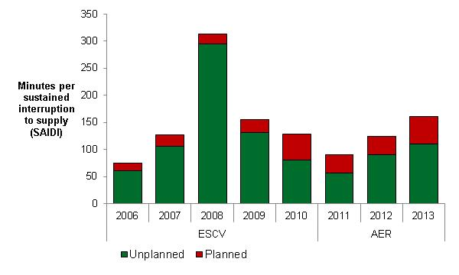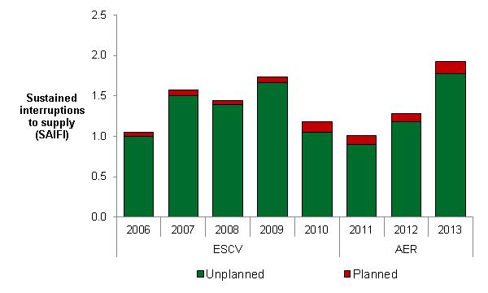



Service Target Performance Incentive Scheme

In our 2010 distribution determination we determined the STPIS would apply to United Energy in the 2011–15 regulatory control period with an overall revenue at risk of ±5 per cent.

The following section shows the effect of (normalised) unplanned interruptions to supply to customers on United Energy's network.

Network reliability (normalised)

In 2012–13 the average United Energy customer experienced:

* 5 per cent fewer unplanned (normalised) minutes off supply than over the previous five years
* 7 per cent more unplanned (normalised) interruptions to supply than over the previous five years (Figure 9–130).

It should be noted the reliability information presented in Figure 9–130 combines information from the previous jurisdictional scheme and the AER's STPIS. These schemes differ in detail and therefore the information is not directly comparable. However, the reliability outcomes are presented to provide broad trend information regarding United Energy's service performance.

Figure 9–130 Unplanned interruptions to supply (normalised) – United Energy

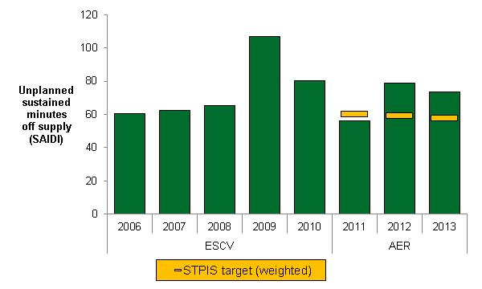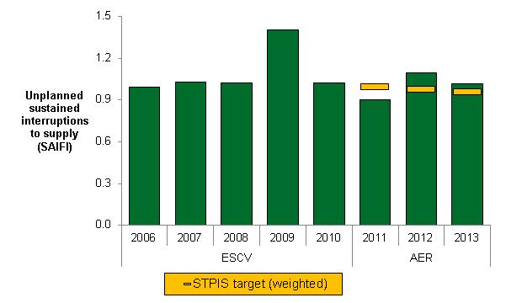



S–factor

Note there is a two year lag between the regulatory year in which service performance outcomes are assessed and the regulatory year in which the s–factor outcome is applied to the DNSPs' allowed revenue.

Table 9–9 compares United Energy's service performance against its STPIS targets over the first three years of the 2011–15 regulatory control period. United Energy failed to meet any of its reliability targets in 2013 after failing to meet all but one of its reliability targets in 2012.

It is important to note STPIS targets are applied to normalised network reliability. In each of the first three years of the 2011–15 regulatory control period United Energy experienced between one and four days where its daily unplanned SAIDI exceeded the major event day boundary. For any day in which unplanned SAIDI exceeds the major event day boundary the impact of that day's SAIDI, SAIFI, MAIFI and telephone answering is removed from the calculation of the annual normalised service performance measures. By removing the impact of events occurring on major event days we exclude from the operation of the scheme events we consider to be outside the DNSP's control.

The s–factor is incorporated into United Energy's control mechanism as a multiplier in its WAPC. Allowed revenue is incremented when service performance is better than performance targets and decremented when service performance is worse than performance targets. The way in which the s–factor is incorporated into United Energy's control mechanism is set out in the 2011–15 distribution determination.

Note there is a two year lag between the regulatory year in which service performance outcomes are assessed and the regulatory year in which the s–factor outcome is applied to the DNSPs' allowed revenue.

Table 9–9 S–factor – United Energy

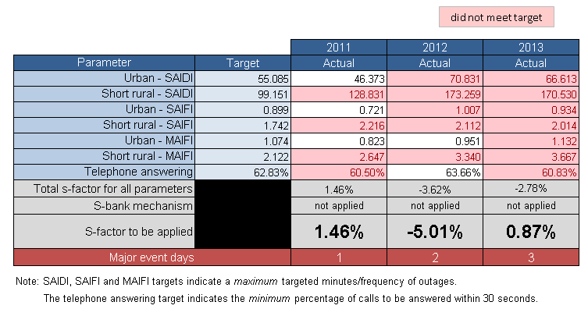

Chapter 8 contains information on our STPIS and a comparative assessment of the DNSPs' service performance.

# Glossary

|  |  |
| --- | --- |
| Abbreviation | Extended Name |
| AER | Australian Energy Regulator |
| ARC | Average Revenue Cap |
| CPI | Consumer Price Index |
| DNSP | Distribution Network Service Providers |
| EBIT | Earnings Before Interest and Tax |
| EBSS | Efficiency Benefit Sharing Scheme |
| GSL | Guaranteed service level |
| GWh | Gigawatt hour |
| MAR | Maximum Allowable Revenue |
| MAIFI | Momentary Average Interruption Frequency Index |
| MVA | Megavolt ampere |
| NEL | National Electricity Law |
| NEM | National Electricity Market |
| NEO | National Electricity Objective |
| NER | National Electricity Rules |
| NSP | Network Service Provider |
| RAB | Regulatory Asset Base |
| RIN | Regulatory Information Notice |
| SAIDI | System Average Interruption Duration Index |
| SAIFI | System Average Interruption Frequency Index |
| STPIS | Service Target Performance Incentive Scheme |
| the Tribunal | Australian Competition Tribunal |
| WAPC | Weighted Average Price Cap |

1. AER, Priorities and objectives of electricity network service provider performance reports, April 2011, p. 3.
2. The AER’s final decision may be amended after review by the Tribunal, and may also be amended if a regulated business seeks to pass through costs that were not included in the AER’s final decision.
3. Standard control service is defined in the National Electricity Rules as a direct control service, which is not an alternative control service, that is subject to a control mechanism based on a NSP’s total revenue requirement.
4. The average energy per customer is based is derived by dividing average energy delivered by total customer numbers.
5. Customers do not fund any additional capital expenditure in the current regulatory control period. However, through increased electricity prices, they will fund the expenditure from the commencement of the next period, if it is considered efficient by the AER. Conversely, when a DNSP underspends on capital projects, customers do not benefit in that regulatory control period. However, the RAB will be lower in the next period and therefore prices will be lower compared to prices if the full capex forecast been spent during the current period.
6. The less than forecast RAB will drive down prices in the next period.
7. Depreciation is also impacted by capital expenditure. For example, lower than forecast capital expenditure also leads to lower than forecast depreciation. The reduction in capital expenditure has a greater impact on the RAB than the reduction in actual depreciation. The net impact being the RAB is lower than otherwise forecast.
8. Efficiency gains (losses) are derived from opex being less (more) than the operating expenditure forecast by the AER for that regulatory control period.
9. The X factors are largely set during the reset process that occurs (typically) every five years. However, from 2015 onwards a time varying weighted average cost of capital (WACC) will apply, and the X factors will be updated annually for changes in the cost of debt.
10. There are other constraints that are applied to groups of tariffs (side constraints). These constraints are wider than the overall price cap, but limit the rebalancing of tariffs.
11. JEN, Ausgrid and SA Power Networks’ revenue for the 2011-13 period was higher than forecast, although actual demand had mostly decreased, possibly because of tariff rebalancing. This is where prices are increased on services subject to the greatest demand growth and reduced on services subject to the weakest demand growth. This maximises revenue based on changes in demand under the weighted average price cap which is the mechanism that applies to these DNSPs.
12. AER, Electricity Distribution Network Service Providers - service target performance incentive scheme, November 2009.
13. The EBSS, which applies to all DNSPs, allows a DNSP to retain efficiency gains (and to bear the cost of efficiency losses) for five years after the gain (loss) is made. In the longer term, the DNSP shares its efficiency gains or losses with customers through price adjustments, passing on 70 per cent of the gain or loss.
14. For more information see the AER website at [www.aer.gov.au/node/2696](http://www.aer.gov.au/node/2696).
15. For more information see the AER website at [www.aer.gov.au/node/2697](http://www.aer.gov.au/node/2697).
16. For more information see the AER website at [www.aer.gov.au/node/2758](http://www.aer.gov.au/node/2758).
17. For more information see the AER website at [www.aer.gov.au/node/4461](http://www.aer.gov.au/node/4461).
18. For more information see the AER website at [www.aer.gov.au/node/3811](http://www.aer.gov.au/node/3811).
19. For more information see the AER website at [www.aer.gov.au/node/4](http://www.aer.gov.au/node/4).
20. For more information see the AER’s website at [www.aer.gov.au/node/7211](http://www.aer.gov.au/node/7211).
21. AusNet Services normalised data has a higher threshold for excluded events than all other DNSPs except Powercor. That is it includes the impact of some events that would have been excluded from the data of other DNSPs.
22. For more information see the AER website at [www.aer.gov.au/node/7208](http://www.aer.gov.au/node/7208).
23. For more information see the AER website at [www.aer.gov.au/node/7209](http://www.aer.gov.au/node/7209).
24. For more information see the AER website at [www.aer.gov.au/node/7210](http://www.aer.gov.au/node/7210).
25. Powercor’s normalised data has a higher threshold for exclusions than all other DNSPs except AusNet Services. That is it includes the impact of some events that would have been excluded from the data of other DNSPs.
26. For more information see the AER website at [www.aer.gov.au/node/7212](http://www.aer.gov.au/node/7212).