ESSENTIAL ENERGY – LIGHTNING ANALYSIS

Contents

1. Introduction 3

2. Background 3

3. Analysis 3

3.1. Empirical Peer Comparison 3

3.2. Historical Lighting Data 6

# Introduction

Essential Energy has performed empirical analysis of the lighting impacts on its network in comparison to peers based on Bureau of Metrology (BOM) data. The analysis shows Essential Energy’s footprint is the worst network for lighting strike related outages in the NEM by a significant factor. Essential Energy can expect to have approximately 15,000 lighting strikes per annum, its’ nearest peer has approximately 9,000, with the next nearest experiencing approximately 2,600. With the Essential Energy network clearly affected by lightning strikes it is also evident from the data analysis that network performance is also influenced by lightning activity. Periods of high lightning activity result in increased outages and as evidenced in the 2009-14 RCP periods of low storm activity correlate to improved network performance.

# Background

* Data from all lightning strikes in NSW was obtained from GPATS lightning tracking systems[1].
* BOM geographical thunderday maps and ground strike formulas were obtained from the BOM.[2]
* Overhead network length data from the RIN notices was obtained for NEM utilities

# Analysis

## Empirical Peer Comparison

Using BOM data the average thunderday figures for various geographical parts of Australia can be derived as shown in Figure 3‑1

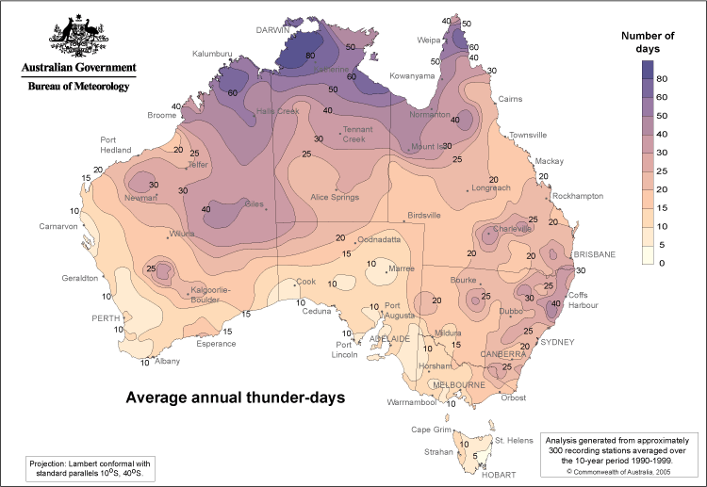

Figure 3‑1: BOM Annual Average Thunderday Map

Utilising this intelligence the Mean Ground Flash density (Ng) can be determined for a geographical area via;

$$Ng=0.012 {Td}^{1.4}$$

Where Td is the thunderday figure obtainable from Figure 3‑1

Essential Energy has its highest customer density on the eastern seaboard which also happens to have the highest thunderday figures in NSW (40 days). However in order to model the entire network Essential Energy has used a highly conservative average thunderday figure of 25.

To quantify the effect of direct lighting strikes on the overhead HV network a lightning susceptibility radius of 45m from the overhead HV network was selected to model the geographical area covered by the overhead HV network.

A figure of 45m for the susceptibility radius has been selected based on the rolling sphere method of lightning protection (IEC 62305) where the size of the sphere required to protect from a lightning strike is directly correlated to the amplitude of the lighting strike via the following formula;

$$D=10*I^{2/3}$$

Where:

D is the radius of the sphere in metres

I is the amplitude of the lightning strike in kA

Lightning strikes in Australia are frequently above 10kA using 10kA as the lightning model input a radius of 46 metres is obtained (45 metres has been used as a conservative measure)

Table 3‑1: Lightning Strike per annum by Utility

|  |  |  |  |  |  |  |  |  |
| --- | --- | --- | --- | --- | --- | --- | --- | --- |
| Utility | | | Overhead HV (km) | Suceptability Radius (m) | Calculated Suceptable area (sq km) | Thunderdays (pa) | Mean Ground Flash Density (Ng)/sq km | Calculated Strikes per annum |
| ActewAGL | | | 1,210 | 45 | 109 | 20 | 0.80 | 87 |
| Aurora | | | 14,957 | 45 | 1,346 | 7.5 | 0.20 | 271 |
| Ausgrid | | | 13,012 | 45 | 1,171 | 22.5 | 0.94 | 1,099 |
| CitiPower | | | 595 | 45 | 54 | 10 | 0.30 | 16 |
| Endeavour | | | 14,559 | 45 | 1,310 | 25 | 1.09 | 1,425 |
| Energex | | | 20,771 | 45 | 1,869 | 30 | 1.40 | 2,623 |
| Ergon | | | 132,144 | 45 | 11,893 | 20 | 0.80 | 9,460 |
| **Essential** | | | **157,482** | **45** | **14,173** | **25** | **1.09** | **15,409** |
| JEN | | | 1,924 | 45 | 173 | 10 | 0.30 | 52 |
| Powercor | | | 59,145 | 45 | 5,323 | 12.5 | 0.41 | 2,193 |
| SAPN | | | 51,946 | 45 | 4,675 | 12.5 | 0.41 | 1,926 |
| SP Ausnet | | | 31,537 | 45 | 2,838 | 15 | 0.53 | 1,509 |
| United | | | 4,227 | 45 | 380 | 10 | 0.30 | 115 |
|  |  |  |  |  |  | |  | |

Figure 3‑2: Empirical Lighting Strikes by Utility

From the data presented in Figure 3‑2 it is clear that even when utilising conservative parameters for calculations Essential Energy operates the most lightning exposed network in the NEM. This fact is reflected in the performance of the network and associated costs for fault and emergency. During a storm the network is mechanically and electrically stressed, failures of the network due to lightning occurs during the storm and sometime thereafter due to latent asset damage of the network. (i.e. asset damage due to the storm that results in failure sometime after due to nominal operating stresses)

Essential Energy has a unique operating environment that makes direct comparisons to peers without input adjustments or normalisation of the factors inequitable. One aspect of this operating environment is shown in Figure 3‑2.

## Historical Lighting Data

Given Essential Energy’s networks exposure to lightning as demonstrated in Figure 3‑2 and Table 3‑2 it is evident that outages and asset performance are correlated to the lightning activity year to year for the 2009 – 2014 regulatory period. Figure 3‑3 is constructed from GPATS data for all lightning strikes in NSW, this clearly shows for years of low lighting activity the reliability figures are correspondingly low.

Figure 3‑3: Number of Lighting Strikes in NSW - GPATS Data

Table 3‑2: Essential Energy SAIDI Results 2009 - 2014

|  |  |  |  |  |  |
| --- | --- | --- | --- | --- | --- |
| Fiscal Year | 2009/10 | 2010/11 | 2011/12 | 2012/13 | 2013/14 |
| Total sustained minutes off supply after removing excluded events (Overall SAIDI) | 196 | 235 | 237 | 233 | 181 |

1. GPATS (Global Position and Tracking Systems) lighting detection http://www.gpats.com.au/
2. http://www.bom.gov.au/jsp/ncc/climate_averages/thunder-lightning/index.jsp