ESSENTIAL ENERGY – WIND ANALYSIS

# Contents

Contents 2

1. Introduction 3

2. Background 3

3. Analysis 3

4. Wind Speed Occurrence 6

# Introduction

Essential Energy has correlated network outages to the nearest recorded wind speed derived from Bureau of Meteorology (BOM) data.

# Background

* Data from 50 Bureau of Meteorology stations was obtained covering Essential Energy’s footprint.
* Every outage in the outage database is related to a circuit breaker or recloser that controls the segment the outage occurred on, this is how the segment affected is identified.
* The spatial coordinates of the reclosers or circuit breakers that operated was obtained
* Using a calculation the nearest (crow flight) weather station to every recloser or circuit breaker was determined
* In the weather data wind speeds are recorded at 9am and 3pm local time along with the maximum wind gust recorded for the day
* Once a relationship to a recloser / circuit breaker and weather station had been arrived at and the reclosers or circuit breakers that operated during the outage is known a correlation to weather close to the time of the outage could be determined.
* To correlate the weather at the time of the outage the outage time is matched to the nearest recorded time for a wind event to the nearest weather station for the reclosers or circuit breakers that operated.

# Analysis

The following figures demonstrate Essential Energy’s network experiences an increase in the average CML (Customer Minutes Lost) per outage as wind speed increases. Essential Energy’s rural distribution network is designed for a minimum 50 year wind return period which is the equivalent of 925 Pa (140km/hr)[1]. Given the design parameters of the network the following figures demonstrate a venerable network in poor condition with equipment failure occurring at approximately 60km/hr (170 Pa) and ramping up with wind speed. If the network was performing as designed one could expect to see a reasonably flat average CML per outage figure till approximately 140km/hr[2].

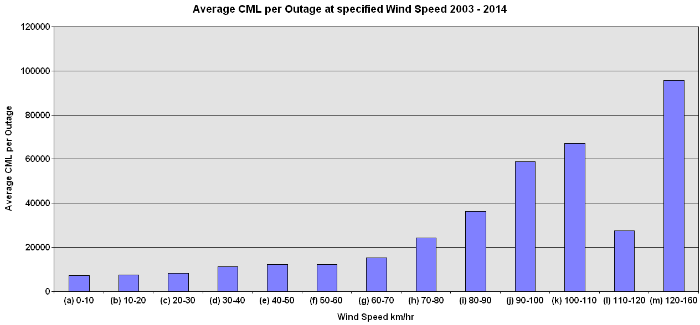.

Figure ‑: Wind Speed by Average CML per Outage

Wind return periods as per AS 7000 / AS 1170.2 has been calculated from the wind speed figures provided by the BOM and is presented in Figure 3‑2.

$$Vr=67-41R^{-0.1}$$

Where:

Vr is the wind speed in m/s

R is the return period in years

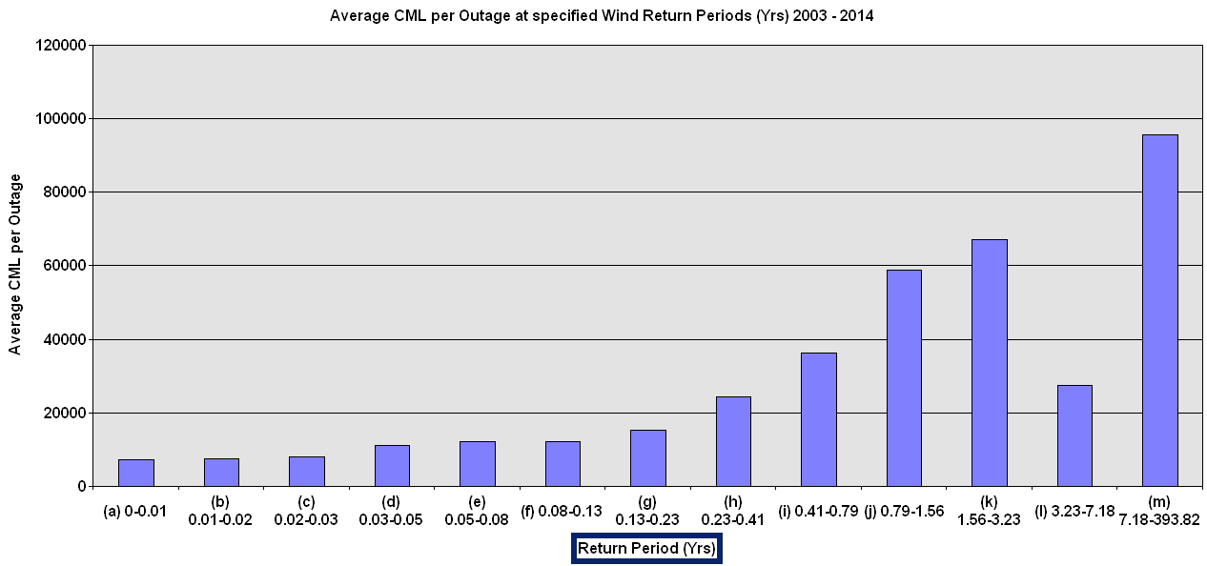

Figure ‑: Wind Return Periods by Average CML

Similarly to allow for direct comparison to the minimum design standard of 925 Pa the wind speed figures have been converted to Pascals as per Figure 3‑3.

$$Pascal={WindSpeed}^{2}*0.613$$

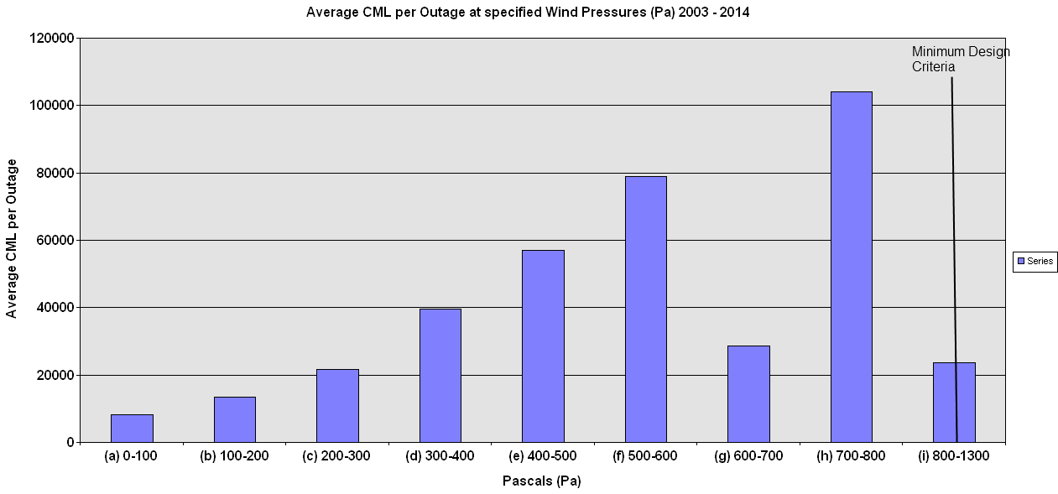

Figure ‑: Average CML by Wind Speed Pressure

Additional analysis was performed to determine the probability of specific equipment related failure as wind speed increased.

Figure ‑: Equipment Failure Probability by Wind Speed (Outage Data 2003 – 2004)

As can be determined by Figure 3‑4 as wind speed increases the following applies;

* Probability of conductor failures increase with wind speed
* Probability of Pole failures increases with wind speed.
* Probability of Tie / Joint failures are constant
* Probability of Blown Arresters are constant
* Probability of the outage being due to blown fuses decrease (ie there is a lower probability that as wind increases the outage will have been caused by a blown fuse) Though it would seem that at higher wind speeds (100km – to 120km) fuses are the big player overtaking conductors and poles. At wind speeds above 120km it would appear that conductors again are more likely to be at fault.

The results of Figure 3‑4 are understated as it is assumed that one outage equates to one equipment failure. Practically this is not the case as wind speed increases the likelihood of multiple assets being involved is much higher. For example a wind gust can result in multiple pole failures, the above chart assumes there is only one.

# Wind Speed Occurrence

The occurrence of damaging winds on Essential Energy’s varies from year to year as shown in Figure 4‑1.

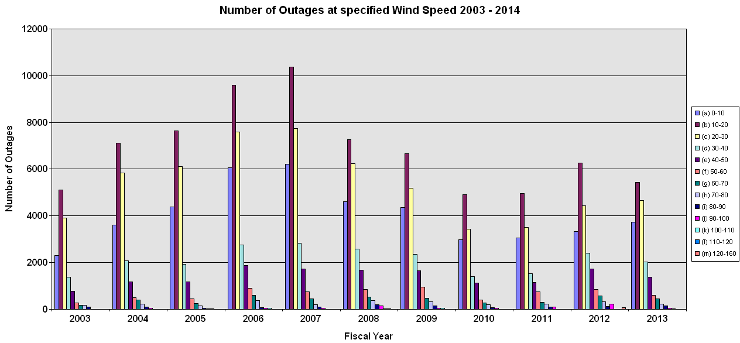

Figure ‑: Wind Speed by Outage 2003 - 2014

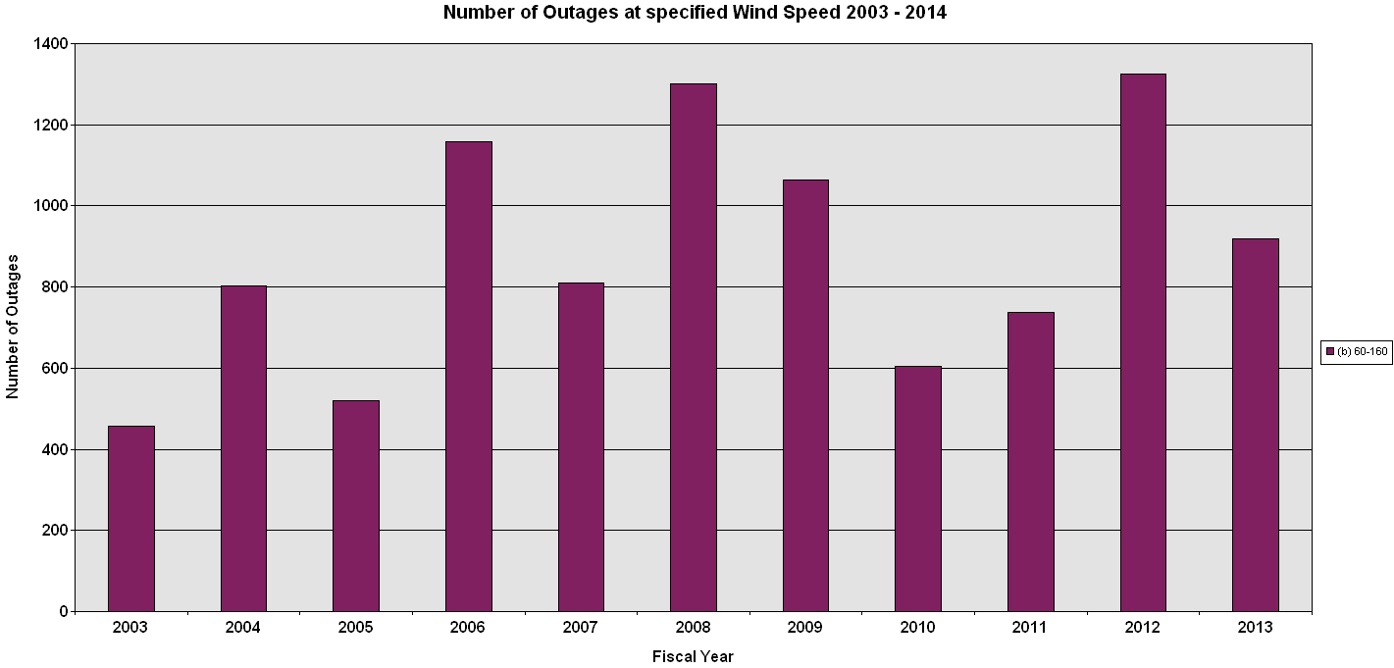

Figure ‑ Number of Wind Events above 60km/hr by Fiscal Year

On Essential Energy’s network increasing damage to the network is sustained at 60km/hr wind speeds Essential Energy’s network experiences wind related damage year to year which is variable as shown in Figure 4‑2. However wind damage is not the only climate related damage that occurs on the network. In Essential Energy’s footprint lightning related incidences are significant contributors to overall performance.

1. CEOM7097 Overhead Design Manual table 3.5.6.8.2: Essential Energy
2. Whilst in theory one could expect a flat CML per outage profile with wind till the design limit of the feeder was reached in practice this is not the case. During wind events wind blown debris and the like due to storm activity will mean that outages will occur and the average CML per outage may go up with wind speed due to the larger number of outages caused by debris and storm activities that slow Essential Energy’s response time leading to a higher average CML per outage. It is the case however that the rise in average CML with wind as shown in the figures cannot be explained solely by wind blown debris, Essential Energy experiences equipment failures such as poles and conductors that cannot be attributed to debris during wind events as demonstrated by the equipment failure probability analysis chart Figure 3‑4.