Further information on the AER’s review of gas network prices in Victoria
Key differences between the gas distribution and transmission businesses’ proposals and the AER’s final decisions are highlighted below. We have also set out the impact of the final decision on each businesses’ forecast revenue in more detail, including for the various cost categories.

Key drivers of gas network prices
In general, the key differences between the gas businesses’ proposals and the AER’s final decisions were for capital expenditure (capex) and the rate of return. Also, we did not accept Multinet's operating expenditure (opex) proposal or APA GasNet’s proposal to change its depreciation calculation.

Capital expenditure
The AER has lowered the forecasts for capital costs over the five-year forecast period based on lower expectations of what capex is needed by the businesses.
A substantial proportion of the gas distribution businesses' proposed capex is for distribution mains replacement. The AER recognises the importance of this to ensure a safe and efficient network.
The AER considers that the gas distribution businesses have not established the necessity or efficiency of some parts of the mains replacement programs for the 2013–17 period. That said, if circumstances change, for example, if the risk profile of the network were to change such that additional mains replacement was warranted, the gas distribution businesses can apply to us with a request that we consider extra expenditure.
The reductions in capex for APA GasNet were more modest compared to its revised proposal, and largely reflect a small decrease in spending for the refurbishment and upgrade of the network. It should be noted that APA GasNet reduced its proposed capital expenditure by 46 per cent after the AERs draft decision.
Table 1 shows our final decision on capex and the impact of this on the gas networks' proposed total revenue. The AER also made a decision on Envestra Albury, a significantly smaller network. Only Envestra Victoria has been included in the tables.
Table 1 Final decision and business revised proposal for capital expenditure
($ nominal)
 | APA GasNet | Envestra Victoria | SP AusNet | Multinet
AER final decision | $186 million | $444 million | $512 million | $265 million
Business revised proposal | $190 million | $588 million | $555 million | $331 million
Difference (per cent) | –3% | –23% | –8% | –20%
Impact on total revenue | –$1 million | –$30 million | –$1 million | –$8 million
Impact on total revenue (per cent) | –0.2% | –3% | –0.1% | –1%

Rate of return
The rate of return measures the cost of financing capital assets. In the final decision the AER approved a lower rate of return than that proposed by the gas businesses. This reflects the historically low interest rates in the current market.
Table 2 shows our decision on the rate of return and the impact of this on the gas businesses' proposed total revenue.
Table 2 Our final decision and business revised proposal for the rate of return (per cent)
 | APA GasNet | Envestra Victoria | SP AusNet | Multinet
AER final decision | 7.22% | 7.39% | 7.07% | 7.03%
Business revised proposal | 8.09% | 7.96% | 7.96% | 7.96%
Difference | –0.87% | –0.57% | –0.89% | –0.93%
Impact on total revenue ($nominal) | –$40 million | –$51 million | –$81 million | –$66 million
Impact on total revenue | –8% | –5% | –8% | –7%

Operating expenditure
Our opex forecast for SP AusNet is very similar to its revised forecast. The AER expects that APA GasNet, Multinet and Envestra will require less opex than they have forecast.
The AER has based our forecasts on the recent historical opex of each of the businesses and then made changes for the cost of some new programs and projects, growth, and labour cost increases. This is the same approach proposed by each of the businesses. The exception is Multinet which proposed a ‘bottom-up’ approach—whereby it submitted a detailed budget of the forecast cost of each of the individual services it expects to provide. The AER considered a forecast based on Multinet’s historical opex was a better basis for forecasting its future opex.
Table 3 shows our final decision on opex and the impact of this on the gas businesses' proposed total revenue.
Table 3 The final decision and business revised proposal for operating expenditure (including incentive carryover) ($ million, nominal)
 | APA GasNet | Envestra Victoria | SP AusNet | Multinet
AER final decision | $163 | $345 | $297 | $334
Business revised proposal | $170 | $366 | $295 | $365
Difference (%) | –4% | –6% | – | –8%
Impact on total revenue | –$2 | –$21 | – | –$31
Impact on total revenue (%) | –0.3% | –2% | – | –3%

Depreciation
Depreciation represents the amount of the original capital expenditure (as opposed to the interest on the capital) that a business pays back to its investors each year.
The AER did not approve APA GasNet’s depreciation approach. APA GasNet proposed to change its depreciation approach to one that brings forward its cash flows, by requiring customers to pay a greater proportion of an asset's costs earlier in its life. The AER considers that this approach would not lead to tariffs varying, over time, in a way that promotes efficient growth in the market. The AER considers that APA GasNet's depreciation approach is not needed to address capacity issues on its network or to support its reasonable cash flow needs, as APA GasNet had submitted. The AER’s decision not to accept the proposed change reduced APA GasNet’s total revenue requirement by $80 million, or 13 per cent.
In addition, changes to other building block components of APA GasNet's proposal (including the capital base and capex) impact on the proposed regulatory depreciation allowance.
The AER final decision is to allow a forecast regulatory depreciation allowance of $56 million ($ nominal)—a reduction of 59 per cent to APA GasNet's revised proposed regulatory depreciation allowance.
Changes to the other gas businesses' depreciation allowance were smaller by comparison. The changes for these networks reflect our decision to reduce other capital costs, most notable forecast capital expenditure.

Impact on the gas businesses' revenue and regulated tariffs
The AER's final decisions on revenue as compared to the businesses' proposed forecast total revenue is shown in table 4.
Table 4 Impact of the final decision and business proposal on forecast total revenue ($ million, nominal)
 | APA GasNet | Envestra Victoria | SP AusNet | Multinet
AER final decision | $484 | $913 | $952 | $864
Business revised proposal | $622 | $1 010 | $1 035 | $1 004
Difference | –$138 | –$97 | –$83 | –$140
Difference (%) | –22% | –10% | –8% | –14%
AER draft decision | $464 | $854 | $928 | $782
Business initial proposal | $766 | $1 221 | $1 181 | $1 145

As can be seen in table 4, the final decisions allow for lower forecast revenues than those proposed by the businesses. This has resulted in lower reference tariffs in nominal dollar terms for pipeline services, compared with the businesses' proposals. Further, for all businesses except Envestra, tariffs will actually decrease slightly compared with tariffs for the 2008–12 period. Table 5 shows the impact of our final decision on average to the gas businesses’ reference tariffs.
Table 5 Impact of the final decision on average reference tariffs (per cent, nominal)
 | APA GasNet | Envestra Victoria | SP AusNet | Multinet
AER final decision effect on average reference tariffs compared with 2008–12 period average reference tariffs | –9.0% | 25.5%ª | –5.3% | –14.0%
Average difference between AER final decision and business revised proposal on reference tariffs | –19.0% | –9.5% | –9.4% | –1.5%
(a) Although the AER has reduced Envestras forecast revenue in real terms, the effects of inflation and lower forecast demand for the network during 2013–17 contribute to higher overall average reference tariffs in nominal terms.
Table 6 shows the impact of the final decision on the change to average reference tariffs in 2013 and on the average change to reference tariffs for the remaining years from 2014 to 2017.
Table 6 Annual impact of the final decision on average reference tariffs (per cent, nominal)
 | APA GasNet | Envestra Victoria | SP AusNet | Multinet
AER final decision – change in average reference tariffs for 2013 | –10.6% | 4.2% | –8.7% | –6.1%
Business revised proposal – change in average reference tariffs for 2013 | –4.60% | 6.8% | –4.8% | 2.0%
AER final decision – change in average reference tariffs for 2014–17 | –0.8% | 5.9% | 1.0% | 1.9%
Business revised proposal – change in average reference tariffs for 2014–17 | –0.3% | 9.1% | 1.7% | 3.0%
Note: The calculated change in average reference tariffs for 2013 is based on 1 July 2013 for all businesses except for APA GasNet, which is based on 1 January 2013.
Figures 1–4 show average reference tariffs for each of the businesses for the last five years and the next five years—as proposed by each of the businesses and as a result of the final decision.
Figure 1 APA GasNet average reference tariffs Figure 2 Envestra Victoria average reference tariffs

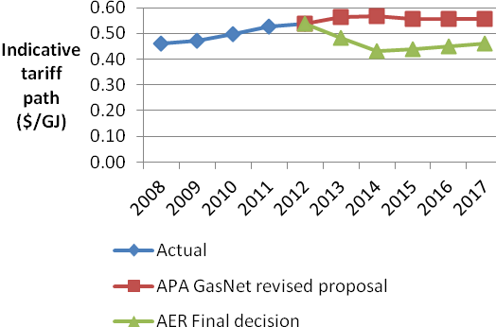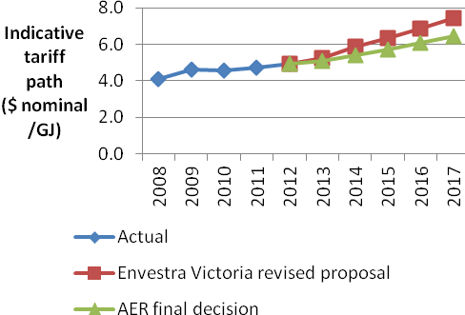
Figure 3 SP AusNet average reference tariffs Figure 4 Multinet average reference tariffs
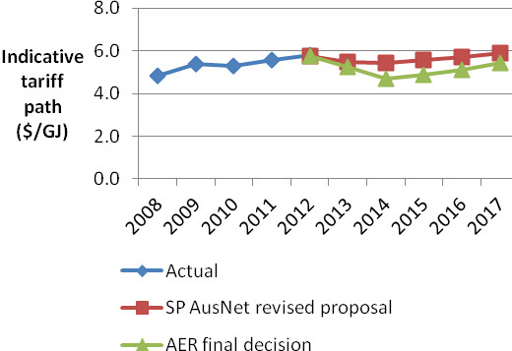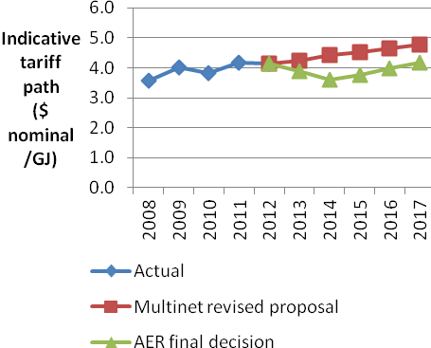

Impact on an average residential gas bill
For all businesses except Envestra, the final decisions will result in lower tariffs both compared with current tariffs and the businesses’ proposed tariffs. All other things being equal, if retailers pass these lower tariffs on to end consumers, gas bills will go down. However, whether consumers actually get a real decrease in their bill will depend on various things including what happens to the wholesale price of gas.
In the case of Envestra, tariffs are likely to increase marginally as a result of the final decision, compared with current levels. While this could result in small bill increases, any bill increase will be lower than if the AER had accepted Envestra's proposal. The increase in bills is largely attributable to inflation.
Table 7 estimates the impact on an average residential bill if retailers pass on to residential consumers the full decrease or increase in reference tariffs. This has been calculated with reference to current average residential bills. The table shows that the estimated impact of the decision on an average residential bill varies by business. For all businesses, the impact of the final decision on an average bill is more favourable for customers than what would have resulted if we had accepted the businesses' proposals.
Table 7 Impact of the final decision and business proposal on an average residential bill ($ nominal, average per annum)
 | APA GasNet | Envestra Victoria | SP AusNet | Multinet
Average residential bill | $1 243 | $1 212 | $1 190 | $1 055
AER final decision effect on annual bill per annum | –$5 | +$16 | –$5 | $0
Business revised proposal effect on annual bill per annum | +$1 | +$28 | +$1 | +$9
Note: The calculated change in average residential bill is based on 1 July 2013 for all businesses except for APA GasNet, which is based on 1 January 2013.

