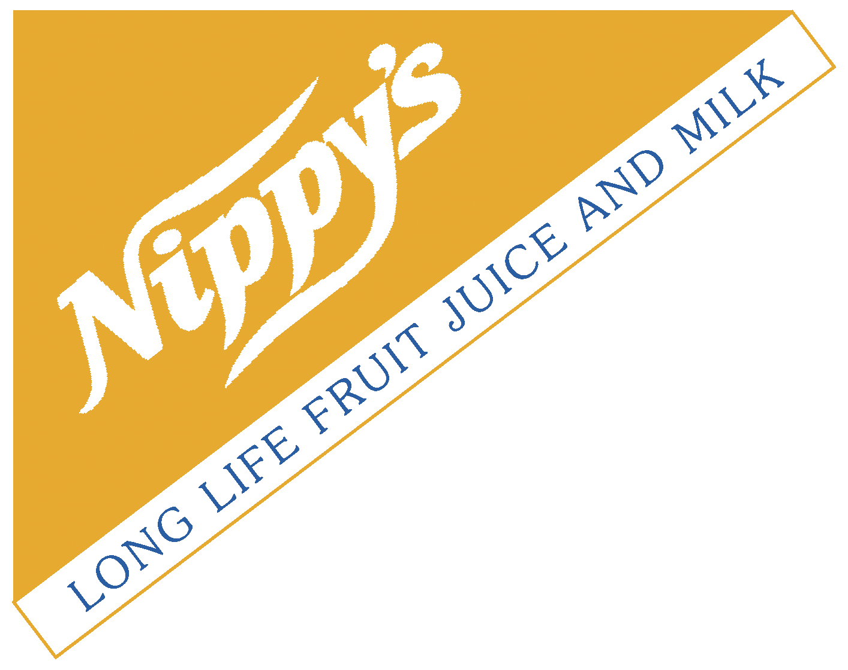
KNISPEL BROS. PTY LTD
A.B.N 81 008 207 832

CITRUS GROWERS AND PROCESSORS
Telephone: (08) 8583 9251
(08) 8583 9259
Fax: (08) 8583 9388
Email: tina@nippys.com.au
153 LOXTON DRIVE MOOROOK
SOUTH AUSTRALIA 5332
100% AUSTRALIAN OWNED

22/06/2015

Mr. Sebastian Roberts
Australian Energy Regulator
GPO Box 520
Melbourne 3001

As a participating member of the Riverland Energy Association, Knispel Bros supports the Australian Energy Regulator on its determination of the SA Power Networks Regulatory Proposal for the period 2015-2020. We are of the strong view that the determination made by AER will provide Riverland businesses with a much fairer price base for SA Power Networks charges over the next regulatory period.
The unsustainable SA Power Network charges for the current period have been a huge financial burden for ours and many other businesses, which cannot realistically be justified.
While we do recognise that SA Power Networks provide a good and reliable service, the extravagant expenditure proposal put forward by them for the next regulatory period is unfair to its customers and does not truly reflect the actual expenditures required to provide this essential service to its customers.
In an anti-competitive environment, it is common place to see highly inflated pricing used to justify proposed expenditure, which is certainly the case with the proposal that has been submitted by SA Power Networks.
We believe that the determination made by AER is a fair one and one that still provides SA Power Networks with ample fat in their expenditure proposal to achieve a financial outcome that would be the envy of all of our businesses.

Kind Regards

Kevin Brand
Site Manager
Knispel Bros Pty Ltd
153 Loxton Drive
Moorook 5332

