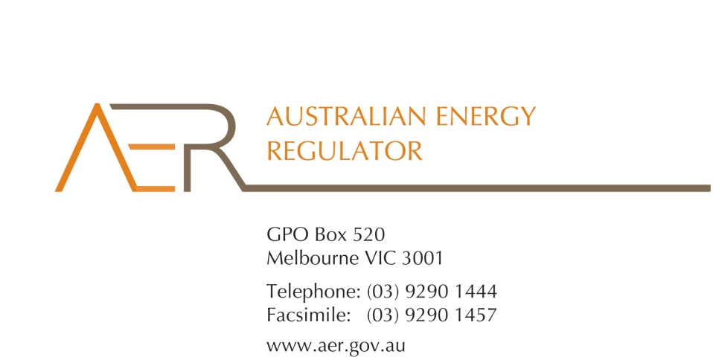

Our Ref: D15/185722

Your Ref:

Contact Officer: Susan Faulbaum

Contact Phone: (08) 8213 3643

5 January 2016

Mr Mark Adams

Director

PO Box 973

Townsville QLD 4810

Dear Mr Adams

**Power Savings Australia Pty Ltd’s application for an individual retail exemption**

I refer to your application from August 2015, for an individual exemption under the National Energy Retail Law (Retail Law) for Power Savings Australia Pty Ltd (ABN 50 603 620 079).

I am writing to inform you that the Australian Energy Regulator (AER) has considered Power Savings Australia’s application for an individual exemption and that it decided, on 5 January 2016, to grant an individual exemption in accordance with s.110 of the Retail Law. This letter constitutes notice of intention to grant an individual exemption. Please note, the individual exemption does not come into effect until Power Savings Australia advises the AER that it accepts the conditions of this exemption.

In accordance with the National Electricity Retail Rules (Retail Rules), the AER has published the application on its website, and sought submissions from interested parties.[1] The AER did not receive any submissions to Power Savings Australia’s application.

The AER has considered the policy principles relating to exempt selling in s. 114 of the Retail Law, being:

1. regulatory arrangements for exempt sellers should not unnecessarily diverge from those applying to retailers,
2. exempt customers, should, as far as practicable, be afforded the right to a choice of retailer in the same way comparable retail customers in the same jurisdiction have that right,
3. exempt customers, should, as far as practicable, not be denied customer protections afforded to retail customers under this Law and Rules.

In making its decision the AER is also guided by the objective of the Retail Law[2], the exempt seller factors,[3] and the customer related factors.[4]

The AER is satisfied that Power Savings Australia should be exempt from the requirement to hold a national retailer authorisation, having regard to the above considerations. If Power Savings Australia wishes to change the way it sells electricity it should contact the AER as it may need to apply for an authorisation or another exemption. If these activities are not covered by this exemption Power Savings Australia may be in breach of s. 88 of the Retail Law and we may take enforcement action or otherwise seek to ensure compliance.

This individual exemption is subject to acceptance of the conditions[5] set out at Schedule 1 to this letter. One of these conditions relates to information disclosure. Specifically, this condition is intended to ensure that your customers understand the nature of the service that you are providing and the protections they are entitled to (as opposed to the service and protections your customers would receive from their energy retailer).

For the individual exemption to come into effect, Power Savings Australia must advise the AER in writing, by 3 February 2016**,** whether it accepts the attached conditions. Power Savings Australia cannot commence energy selling under its individual exemption until it has done so. Please be aware that the AER may vary conditions attached to an individual exemption at any time in accordance with rule 158 of the Retail Rules.

If you have any further queries, or would like to discuss this further, please contact Susan Faulbaum on (08) 8213 3463.

Yours sincerely

Sarah Proudfoot

General Manager, Retail Markets

**Schedule 1: Instrument of exemption**

**INDIVIDUAL EXEMPTION FROM THE REQUIREMENT TO HOLD A RETAILER AUTHORISATION**

The Australian Energy Regulator on 5 January 2016, decided pursuant to section 110 of the National Energy Retail Law, to grant Power Savings Australia Pty Ltd (ABN 50 603 620 079) (the exempt person) an individual exemption from the requirement to hold a retailer authorisation under section 88 of the National Energy Retail Law, subject to the following conditions.

**Condition 1 - Information provision**

The exempt person must provide the customer in writing a plain English notice explaining that the contract is covered by Australian consumer protection laws and is separate to the customer’s contract with their retailer and distributor which are covered under the National Energy Retail Law.

**Condition 2 – Exemption limited to the sale of electricity through solar power purchase agreements**

This exemption is conditional upon the exempt person:

* refraining from registering in the wholesale market for the purposes of purchasing energy;
* not being the financially responsible retailer for the premises (rather, this must be an authorised retailer); and
* only selling to premises that are connected to the interconnected national electricity system.

1. r. 155(3) and 156, National Energy Retail Rules.
2. The National Energy Retail Law objective is to “promote efficient investment in and efficient operation and use of energy services for the long term interests of energy consumers with respect to price, quality, safety, reliability and security of supply of energy”. (s. 13, Retail Law)
3. s. 115, Retail Law.
4. s. 116, Retail Law.
5. r. 158 (1), Retail Rules.