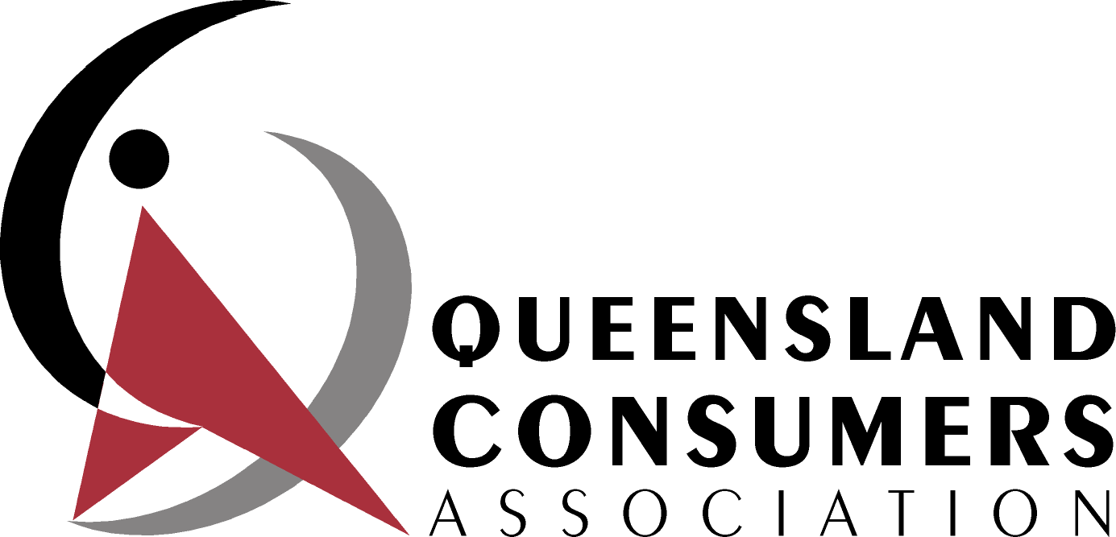 | A non-profit, volunteer organisation, advocating to advance the interests of consumers in Queensland  Secretary:  Max Howard  PO Box 261  Corinda Q 4075
20 March 2019

SUBMISSION ON AER DRAFT DETERMINATION ON DEFAULT MARKET OFFER PRICE - FEBRUARY 2019

BACKGROUND
The Queensland Consumers’ Association (the Association) is a non-profit organisation established over 40 years ago and which exists to advance the interests of Queensland consumers. The Association’s members work in a voluntary capacity and specialise in particular policy areas.

The Association is a member of the Consumers’ Federation of Australia, the peak body for Australian consumer groups, and works closely with many other consumer and community groups.

The Association has been especially active for many years on energy issues in Queensland and nationally and is currently represented on the:
- Queensland Competition Authority’s Consumer Consultative Committee
- Energy and Water Queensland Ombudsman’s Advisory Council.

The Association is also a member of the Queensland Council of Social Service’s Essential Services Consultative Group.

The Association has participated in, and made numerous submissions to inquiries etc. on energy issues conducted at national level, in Queensland, and in other states.

The contact person is Ian Jarratt, email ijarratt@australiamail.com

GENERAL COMMENTS
Given the short amount of time to determine DMOs for 2019-20, we support the use of a “top down” approach, but only for this year. In subsequent years, on which there should be further consultation, the approach should be “bottom up”.

We also support the use of an annual price to indicate the DMO.

We consider that this determination should take account of the number of each retailers’ customers on all offers i.e. there should weighting of standing and market offers by customer numbers.
Figure 2 on page 20 seems to show the Goondiwindi – Texas area in Queensland serviced by Essential Energy as being a distribution zone with deregulated retail prices. Our understanding is that this area is subject to the regulated retail prices that apply to the Ergon distribution area.
We emphasise the need for the AER to monitor (and report publicly on) the impacts, and effectiveness, of the DMOs and the reference bill prices.

