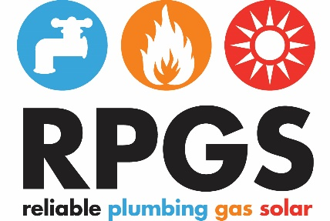

ABN : 20 119 014 327 QBCC : 1096899

Date: 8th November 2016

To: *General Manager, Retail Markets Branch”*

*Australian Energy Regulator*

AERAuthorisations@aer.gov.au

Re: **Ultium Energy Pty Ltd application for a electricity retailer authorisation***.*

Re: **RPGS Serviced Hot Water – Supporting Letter**

Dear Sir/Madam,

We would like to register a submission as an interested stakeholder in respect to Ultium Energy Pty Ltd's application lodged with the Australian Energy Regulator on the 8th November 2016.

We would like it noted that we support this application for Ultium Energy to sell energy under the National Energy Retail Law (Retail Law).

We support this application to encourage the expansion of companies that will offer competition in the retail electricity market, especially providing alternatives in product and service to:

• Strata Management Companies;

• Commercial Real Estate Agencies; and

• Residential Strata Developers.

Reading this application by Ultium Energy the application demonstrates that Ultium Energy:

• has the necessary organisational and technical capacity to operate as a retailer; and

• seems suitable to hold a retailer licence.

We look forward to having the opportunity to working with Ultium Energy (as a retailer) and its key staff once Ultium Energy Pty Ltd has received their electricity retailer authorisation.

If there are any questions in relation to this letter of support, please call.

Yours Sincerely

Allan J Ramsay

*Allan Ramsay*

General Manager - Technical and Development.

RPGS - Serviced Hot Water Pty Ltd

M      0404 410 981 E  [allanramsay@servicedhotwater.com.au](mailto:allanramsay@servicedhotwater.com.au)

