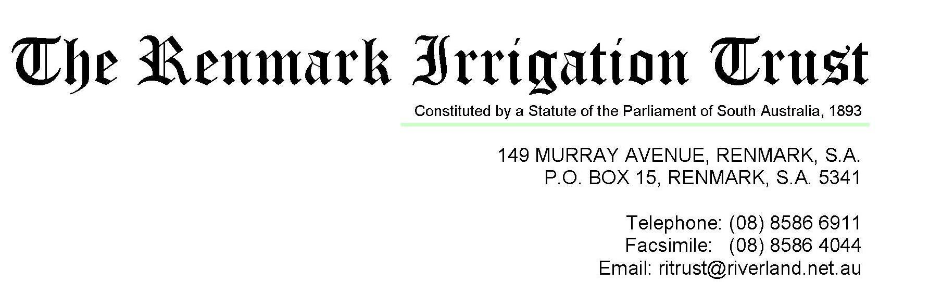

24 July 2015

Mr Sebastian Roberts

General Manager, Network Regulation

Australian Energy Regulator

GPO Box 520

Melbourne 3001

Sent by email to [SAelectricity2015@aer.gov.au](mailto:SAelectricity2015@aer.gov.au)

The Renmark Irrigation Trust thanks the Australian Energy Regulator for the opportunity to make a submission regarding the AER’s Preliminary Decision and the SA Power Networks Revised Proposal 2015-2020.

The Renmark Irrigation Trust is an Irrigation Infrastructure Service Provider that distributes irrigation water pumped from the River Murray through a fully piped network to over 550 family farms within the Renmark Irrigation District. Renmark was founded on the irrigated horticulture that still underpins the economy of the Renmark community.

Given the very large rises in electricity costs that have been imposed over the last 5 years, the Trust is quite concerned and very disappointed in both SA Power Networks first proposal and now the revised version that offer only continued and substantial tariff increases. The negative economic impact of continual electricity tariff increases way above CPI is being felt across the whole irrigation industry.

The Trust believes that the AER conducted a very comprehensive analysis of SAPN’s first proposal and arrived at preliminary decision that despite setting a revenue cap considerably less than SAPN proposed has retained much of the revenue increases occurring over the last 5 years. Currently enforced tariff reductions resulting from the preliminary decision have brought much needed relief to water pumping costs for the Trust and irrigators, although even further reductions were hoped for.

SAPN’s revised proposal provides no convincing evidence that the AER determination is as flawed as they suggest or that the preliminary decision should be adjusted to allow for further SAPN revenue. The Trust robustly supports the already well expressed and presented points of view on SAPN’s original proposal by the AER in its determination and those of the Consumer Challenge Panel. We do not believe that the arguments presented by SAPN in the revised proposal are sufficient enough to warrant a change of those views.

As the monopoly distribution network in the state, SAPN should recognise their responsibility to provide a service at the lowest feasible cost. While SAPN must certainly remain a sustainable business, it must also support the viability of all businesses in South Australia by playing its part in keeping electricity costs down.

The Renmark Irrigation Trust remains strongly supportive of the AER preliminary decision and encourages the AER to take every opportunity available to bring about further reductions in tariffs while importantly restraining the unsustainable tariff increases proposed by SAPN.

Yours Sincerely

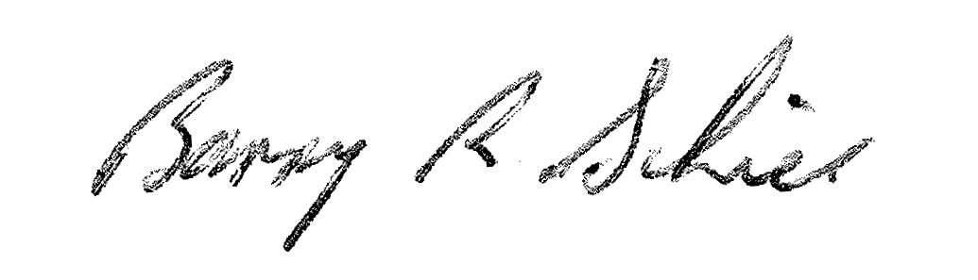

Barry Schier

General Manager