13 October 2016

Mr Warwick Anderson

General Manager – Networks Finance and Reporting Branch

Australian Energy Regulator

GPO Box 3131

Canberra ACT 2601

By email: [AERInquiry@aer.gov.au](mailto:AERInquiry@aer.gov.au)

Dear Mr Anderson

**Proposed Amendment to the Roll Forward Model**

Please see attached a submission on behalf of CitiPower, Powercor and SA Power Networks, in response to the AER’s consultation on proposed changes to the electricity distribution roll forward model.

We would be pleased to clarify any aspect of the attached submission. We look forward to continuing to work constructively with the AER and other stakeholders to address the important matters raised in this submission.

Yours sincerely

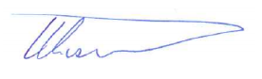 

|  |  |  |
| --- | --- | --- |
|  |  |  |
| **Wayne Lissner *A/General Manager Corporate Strategy SA Power Networks*** | **Brent Cleeve *General Manager Regulation CitiPower & Powercor*** |  |
| (08) 8404 5391 | (03) 9683 4465 |  |

# Overview

CitiPower, Powercor and SA Power Networks (collectively, the **Businesses**) appreciate the opportunity to comment on changes proposed by the Australian Energy Regulator (**AER**) to the distribution roll-forward model (**RFM**). The Businesses wish to take this opportunity to comment specifically on one aspect of the AER’s proposed changes to the RFM, before raising a more significant issue in relation to the treatment of inflation across the RFM and post-tax revenue model (**PTRM**).

*Proposed amendment to incorporate remaining asset life calculation*

The Businesses consider that the proposed change to the RFM to incorporate the AER’s preferred method for calculating remaining asset lives is unnecessary and inappropriate.

The proposed change is inappropriate as the National Electricity Rules (**NER**) provide flexibility for service providers to adopt their preferred method of calculating depreciation, provided that this complies with the NER requirements. This is not an area in which the AER can impose its preferred approach on service providers, as could be inferred by that approach being embedded in the RFM workings.

If any change is to be made to the RFM to incorporate asset life calculations, the AER should at least acknowledge within the RFM that alternative approaches are available (noting indeed that alternative approaches have recently been approved by the AER), and the RFM should thus explicitly allow for these alternative approaches to be implemented.

*Treatment of inflation*

The Businesses agree with the AER that there is no need to depart from the current approaches to the application of actual inflation (“partially lagged” for most businesses, “fully lagged” for the Victorian businesses).

However, in dealing with the issue of lagged inflation measures, the AER’s consultation paper highlights some very important issues regarding the treatment of inflation in the RFM and the PTRM.

The AER’s modelling of revenue impacts associated with differences between actual and forecast inflation assumes that actual inflation outcomes will fall in a normal distribution with an average of 2.5% (in line with the historic average). Thus, the AER’s modelling assumes an inflation outcome that is broadly consistent with the assumption underpinning its current forecasting method – i.e. that while there may be deviations from year to year, over time average inflation will revert to the middle of the Reserve Bank of Australia (**RBA**) target band.

The AER also assumes that the forecast of inflation and nominal WACC are jointly estimated and therefore “correctly matched”. The AER does not consider the possibility that its forecast of inflation may not reflect market expectations of inflation, contrary to market expectations being clearly reflected in the nominal WACC.

The much more significant issue in relation to the treatment of inflation is that, going forward, there is a real risk that actual inflation outcomes will be persistently below historic average levels, and therefore below what is forecast by the AER based on its current forecasting method. Under the AER’s current forecasting method, forecast inflation is based primarily on RBA targets. However, over the past 18 months it has become apparent that, at least over the short to medium term, actual inflation is likely to be well below the RBA target band for some time.

Where actual inflation outcomes deviate materially from forecasts, this can give rise to a significant revenue shortfall (or windfall) for businesses due to the inconsistent use of actual and forecast inflation across the PTRM and RFM. Whereas the regulatory asset base (**RAB**) is rolled forward at the end of each period based on actual inflation, the offsetting adjustment to cash flows is based on forecast inflation. Evidently, where inflation outcomes deviate materially from forecasts, these two adjustments will not entirely offset each other, leading to either a revenue shortfall or a windfall.

This inconsistency within the AER’s modelling can have very significant impacts on businesses’ ability to recover their efficient costs and provide appropriate returns to investors. The Attachment to this letter illustrates that this inconsistency can have a material impact on the effective return on equity. On the debt side, the businesses enter into contracts that require nominal interest payments and a potential for forecasting error on inflation compromises the ability of businesses to meet their contractually binding promises to pay nominal interest payments. In other words, where actual inflation is below the AER’s forecast, the overall return can be materially below what the AER has deemed (in its revenue determination) necessary to promote efficient investment in, and efficient operation and use of, electricity services for the long-term interests of consumers.

Such an outcome is clearly in tension with the national electricity objective (**NEO**) and the revenue and pricing principles. The potential financial impact can completely negate the efforts of network service providers in managing costs and improving efficiency. The current mechanism results in a risk that the Businesses can do nothing to manage and which has the effect of nullifying the benefit from the work that goes into managing the risks they can influence. It thus undermines the very essence of an ‘incentive based’ regime.

Conversely, if actual inflation were consistently higher than forecast, it would deliver the opposite outcome, with higher returns than intended and higher costs to customers.

The Businesses are keen to work with the AER to come up with a workable solution. In the interests of facilitating a constructive discussion, this submission identifies some possible remedies for consideration and consultation. The Businesses request a meeting with AER staff to discuss these issues and possible remedies.

# Proposed amendment to incorporate remaining asset life calculation

The AER proposes to insert two new worksheets into the RFM to provide for the calculation of remaining asset lives. The AER’s proposed new distribution RFM incorporates what the AER refers to as its “standard approach” to calculating remaining asset lives, known as the weighted average remaining life (**WARL**) method.[1]

For reasons set out below, the Businesses consider that this proposed change is unnecessary and inappropriate.

The change is unnecessary, in that no problem or deficiency has been identified with the current RFM in this regard. As noted by the AER, the current version of the distribution RFM does not incorporate a remaining asset life calculation. This has not created any problem for DNSPs or the AER, so far as we are aware. DNSPs have simply included their own calculation of remaining asset lives in the RFM submitted with their regulatory proposals.

Moreover, this change is inappropriate in circumstances where the NER provide flexibility for service providers to adopt their preferred method for calculating remaining asset lives, provided that this complies with the requirements set out in the NER.[2] This is not an area in which the AER can impose its preferred approach on service providers[3].

The flexibility afforded to businesses under the NER is entirely appropriate, given that there may be good commercial or other reasons for businesses adopting different depreciation schedules. For example, the Businesses adopt what is known as the “year-by-year tracking approach” (rather than the WARL approach) because this approach produces a depreciation schedule that more accurately reflects the remaining lives of the individual assets in each class.[4]

The AER has approved alternative approaches in recent determinations, on the basis that these alternative approaches are capable of complying with the requirements of the NER. In its recent distribution determinations for SA Power Networks, CitiPower and Powercor, the AER adopted the “year-by-year tracking approach” proposed by the Businesses, on the basis that this approach complied with the NER.[5] This approach does not require calculation of remaining lives, or the use of the WARL method.

Whilst incorporating the AER’s preferred approach (the WARL method) will assist service providers that adopt this approach, it does not assist other service providers, such as the Businesses and many others, that adopt alternative approaches.

We are content for the “RAB remaining lives” and “TAB remaining lives” worksheets to be added to the RFM to keep a register of capital additions by year and by asset class. However, for reasons set out above, these worksheets should not prescribe any particular method of calculating remaining asset lives, such as the WARL method. Rather, these worksheets should provide flexibility for service providers to adopt their preferred method for calculating remaining asset lives, provided that this method complies with the NER requirements.

At a minimum, the AER should acknowledge in the RFM Handbook and Explanatory Statement that there are a number of previously approved alternative approaches to calculating depreciation. If the RFM is not suitable for a service provider’s proposed depreciation methodology, the Handbook should make clear that a service provider may adjust the workings in the remaining lives section of the RFM so as to be compatible with their proposed methodology.

# Treatment of inflation

## Use of the “partially lagged” or “fully lagged” methods for actual inflation

The Businesses agree with the AER that there is no need to depart from the current “partially lagged” or “fully lagged” approaches to calculating actual inflation that the Businesses currently apply. As the AER’s analysis shows, the potential impact of moving to alternative approaches is relatively minor. In addition, any change in approach would require consideration of transitional issues. Therefore on balance, the Businesses are happy to maintain the current approach.

In recent determinations the AER agreed to amend the CitiPower and Powercor RFMs from “partially lagged” to “fully lagged”. Under “partially lagged” an adjustment was required to ensure each asset depreciated to zero over its life. Using “fully lagged” inflation removed the inconsistency and consequently the need to adjust depreciation, which is a simpler and more transparent approach.

## The Businesses’ broader concerns regarding the treatment of inflation

In dealing with the issue of “partially lagged” inflation measures, the AER’s consultation paper highlights some very important issues regarding the treatment of inflation in the RFM and the PTRM.

The AER’s modelling of revenue impacts associated with differences between actual and forecast inflation assumes that actual inflation outcomes will fall in a normal distribution with an average of 2.5%.[6] The AER’s conclusion that revenue impacts are relatively small relies heavily on this assumption. Although the AER notes that “there are grounds for considering that the distribution of inflation outcomes is not normally distributed”[7], the implications of this are not explored in the AER’s modelling. The AER also does not consider the possible implications of inflation averaging less than 2.5% going forward; rather, it is assumed that average inflation outcomes in future periods will reflect historic average outcomes.

The AER also assumes that the forecast of inflation and nominal WACC are jointly estimated and are therefore “correctly matched”.[8] The AER does not consider the possibility that its forecast of inflation may not reflect market expectations of inflation, contrary to market expectations being clearly reflected in the nominal WACC determination.

The much more significant issue in relation to the treatment of inflation is that, going forward, there is a real risk that actual inflation outcomes will be well below historic average levels, and well below what is forecast by the AER based on its current forecasting method. Moreover, given the way in which the AER forecasts inflation, there is a growing divergence between the forecasts of inflation used by the AER in the PTRM and market expectations of inflation, as reflected in the nominal WACC. As will be explained below, this creates a risk that businesses will be materially under-compensated for their efficient costs, an outcome that is neither consistent with the NEO nor the revenue and pricing principles.

Across the PTRM and RFM, there are three separate inflation adjustments, intended to have the net effect of compensating the service provider only once for the effects of inflation. Use of a nominal WACC means that the service provider is compensated for the effects of inflation through the rate of return.[9] Compensation for inflation is also provided through indexation of the RAB by actual CPI, but this is intended to be offset by a deduction from cashflows in each regulatory period that is set equal to the amount by which the RAB is forecast to be adjusted for inflation in that period.[10]

Since these last two adjustments are supposed to offset each other, problems will arise where they are not determined on a consistent basis.

What the Explanatory Statement fails to acknowledge is that there is an inconsistency between how businesses are compensated for inflation and how offsetting cashflow deductions are calculated. Whereas businesses are compensated based on actual inflation outcomes and market expectations of those outcomes (as incorporated in the nominal market interest rates within the WACC), the offsetting deduction is based on the AER’s forecast of inflation. Where the AER’s forecast of inflation is out of step with market expectations and actual inflation outcomes, this will lead to either a windfall gain for businesses (if the forecast is too low) or a revenue shortfall (if the forecast is too high).

The AER’s current approach to forecasting inflation is to adopt the RBA forecast for the first two years of a regulatory period, then take the midpoint of the RBA’s target range for the remaining term of the forecast. This approach is generally sound in circumstances where inflation is expected to be around the middle of the RBA’s target range, on average, over the term of the inflation forecast.

However where it is expected that inflation will be materially above or below the midpoint of the RBA’s target range over the medium term, this method will not produce a forecast that is consistent with actual inflation outcomes or current market expectations of inflation.

Over the past 18 months it has become apparent that, at least over the short to medium term, the RBA targets will not reflect either actual inflation outcomes, or market expectations. Since early 2015, actual inflation has been well below the bottom of the RBA’s target range (see Figure 1 below). The general consensus among market experts and financial authorities is that this is not just a short-term issue. Rather, many experts and authorities now believe that we may be entering a sustained period of low inflation.[11] The RBA, for example, expects inflation to remain low “for some time”.[12] It is therefore no longer reasonable to assume that, over a five or ten-year period, inflation will be around the middle of the RBA’s target range, on average. Rather, the risk of inflation being below the bottom of the RBA target band is now much greater than the likelihood of it being above this band.

Figure 1: Inflation outcomes 2012-2016[13]

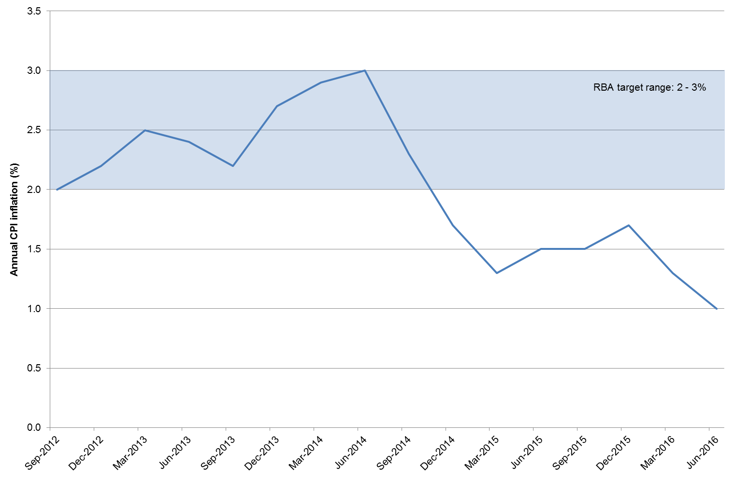

Analysis conducted by the Businesses demonstrates that this inconsistency within the AER’s modelling can have very significant impacts on businesses’ ability to recover their efficient costs and provide an appropriate return to investors. Where actual inflation is materially below what has been forecast by the AER for a regulatory control period, businesses face a significant revenue shortfall due to the inconsistency between how the RAB is rolled forward at the end of the period (based on actual inflation) and how the offsetting deduction from cashflows during the regulatory period is calculated (based on the AER’s forecast of inflation).

Where businesses face such a shortfall, there is a clear prospect that this will either lead to under-spending (relative to what may be considered prudent and efficient) and/or returns to shareholders that are below what is necessary to promote efficient investment. Neither outcome is in the long-term interests of consumers.

# The Attachment to this letter provides an example of the effect of inconsistent treatment of inflation and the potential impact.

## Possible solutions

The growing divergence between actual inflation outcomes and AER forecasts, and the cost recovery issue that this creates for businesses as a result of inconsistencies in the AER’s modelling, are issues of fundamental importance that can no longer be ignored. As noted above, the evidence suggests that we are now in a medium term low inflation environment, as has been, and continues to be, experienced in much of the developed world.

Sustained low inflation (or sustained high inflation) should not create an issue for the regulatory framework, in and of itself. Rather, the issue arises due to the inconsistent treatment of inflation across the PTRM and RFM, as explained above.

The Businesses are keen to work with the AER to come up with a workable solution, to ensure that sustained periods of low inflation (or high inflation) do not give rise to outcomes that are contrary to the long-term interests of consumers. In the interests of facilitating a constructive discussion, this section identifies some possible remedies for consideration and consultation. This should not be seen as an exhaustive list of all possible remedies. Rather, we provide some possible remedies below in order to start the discussion.

*End of period true-up*

A remedy would be to adjust the RAB at the end of each period to account for the effect of any difference between actual and forecast inflation in that period. This adjustment could be made when the RAB is escalated for actual inflation over the regulatory period and would simply involve adding to (or subtracting from) the RAB the amount of revenue in the prior period attributable to the difference between forecast and actual inflation.

This is likely to require some modifications to the NER. However, such modifications would be relatively simple and should be (in our view) fairly uncontroversial. The rules providing for calculation of the RAB as at the commencement of each new regulatory period would simply need to provide for one further adjustment, being an adjustment for any revenue benefit or penalty in the prior period associated with any difference between forecast and actual inflation.

It should be noted that this ex post true up for the difference between forecast and actual inflation would not be inconsistent with the principles of incentive regulation. It is true that the NER do not provide for true ups in other areas, such as in respect of actual operating expenditure or actual financing costs, because to do so would undermine incentives for the business to seek out efficiencies. However, inflation is not something that is within the control of businesses, and so there can be no incentive for efficiency that would be affected by providing for a true up

*Annual updating of PTRM for out-turn inflation*

A relatively simple way of avoiding problems associated with differences between actual and forecast inflation would be to update the PTRM each year for actual (out-turn) inflation. This update could occur at the same time as the PTRM is updated for the return on debt, and would simply require the inflation forecast value for the relevant year to be replaced with the (lagged) actual value that will be used to index the RAB for that year at the end of the regulatory period. The PTRM would then update calculations of required revenue and X factors for the remainder of the regulatory period.

This is likely to require some modifications to the PTRM. However, such modifications are likely to be relatively minor, and similar to those made to facilitate updating of the return on debt.

We note that an annual inflation update mechanism was recently proposed by the APA Group in its access arrangement submission for the Roma to Brisbane Pipeline.[14] The Businesses would support an update mechanism similar to that proposed by the APA Group.

*Use of better methods for forecasting inflation*

At a minimum, it is the Businesses’ view that the AER should review its method for forecasting inflation and adopt a method that better reflects market expectations of inflation over the medium term.

The Businesses have raised this issue with the AER in their recent price/revenue reset processes. However, the AER has expressed a view that it cannot (or should not) change its forecasting method from the method referred to in the PTRM.[15]

The Businesses do not agree that the AER cannot alter its approach to forecasting inflation in an individual price/revenue reset process. However, if the AER feels so constrained and considers that some other process needs to be pursued (such as a PTRM amendment), then we would encourage the AER to start this process. The deficiencies in the AER’s current forecasting approach – in particular its heavy reliance on RBA targets – cannot be ignored any longer.

.

* * * * * *

The Businesses would be keen to discuss options with the AER, to address the issue of forecast inflation differing materially from actual inflation, as is occurring in line with the low inflation environment which is expected to continue for some time. Given the materiality of the issue and potential impact on investment, the issue must be addressed.

# Attachment

|  |
| --- |
| Example of the effect of inconsistent treatment of inflation **[CONFIDENTIAL INFORMATION REDACTED]** |

# 

1. Explanatory Statement, p 7.
2. Specifically, clause 6.5.5(b) of the NER sets out the requirements for depreciation schedules.
3. NER, cl 6.5.5(a)(2). Where the depreciation schedules nominated in a DNSP’s proposal conform with the requirements of NER cl 6.5.5(b), depreciation for each regulatory year must be calculated using those schedules. The AER cannot substitute its preferred or “standard” approach in circumstances where the DNSP’s proposed approach conforms with the relevant NER requirements.
4. For an explanation of the “year-by-year tracking approach” and the advantages of this approach over the WARL approach, refer to SA Power Networks Revised Regulatory Proposal 2015-2020 (July 2015), section14.4.
5. AER, Final Decision: SA Power Networks determination 2015−16 to 2019−20, Attachment 5 − Regulatory depreciation, October 2015, pp 5-10 – 5-17; AER, Final Decision: CitiPower distribution determination 2016 to 2020, Attachment 5 – Regulatory depreciation, May 2016 pp 5-12 – 5-15; AER, Final Decision: Powercor distribution determination 2016 to 2020, Attachment 5 – Regulatory depreciation, May 2016 pp 5-12 – 5-15.
6. Explanatory Statement, p 26.
7. Explanatory Statement, p 26 (footnote 64).
8. Explanatory Statement, p 26.
9. NER, cl 6.5.2(d)(2); NGR rule 87(4)(b).
10. NER, cl 6.4.3(b)(1)(ii).
11. For example: IMF, Combating Persistent Disinflation: A Challenge for Many Central Banks, 27 September 2016.
12. Phillip Lowe, Reserve Bank Governor, Opening Statement to the House of Representatives Standing Committee on Economics, Sydney, 22 September 2016.
13. ABS, Consumer Price Index, Australia, June 2016 (ABS cat no 6401.0).
14. APA, Roma to Brisbane Pipeline Access Arrangement Submission, September 2016, section 10.3.1.
15. AER, Final Decision: SA Power Networks determination 2015−16 to 2019−20, October 2015, Attachment 3, pp 3-252 – 3-256.