

Gas market significant price variation report

17 October 2014, Brisbane STTM

© Commonwealth of Australia 2014

This work is copyright. Apart from any use permitted by the Copyright Act 1968, no part may be reproduced without permission of the Australian Competition and Consumer Commission. Requests and inquiries concerning reproduction and rights should be addressed to the Director Publishing, Australian Competition and Consumer Commission, GPO Box 3131, Canberra ACT 2601.

Inquiries about this document should be addressed to:

1. Australian Energy Regulator
2. GPO Box 520
3. Melbourne Vic 3001
4. Tel: (03) 9290 1444
5. Fax: (03) 9290 1457
6. Email: [AERInquiry@aer.gov.au](mailto:AERInquiry@aer.gov.au)

AER reference: 56130-D14/143046

1. Contents

1 Background 4

1.1 The AER's reporting role 4

1.2 Brisbane STTM 4

2 Brisbane Hub – 17 October 2014 gas day 6

3 Conclusion 10

# Background

## The AER's reporting role

The AER published the [Short Term Trading Market (**STTM**) Significant Price Variation (**SPV**) Guideline](http://www.aer.gov.au/node/18400) on 21 December 2012.[1]

The guideline provides an SPV has occurred when:

* the difference between the D-2 provisional price and the D-1 ex ante price is greater than $7/GJ
* the difference between the D-1 ex ante price and the D+1 ex post price is greater than $7/GJ
* the ex ante price is three times the average price for the previous 30 days and greater than $15/GJ

On 17 October 2014 in the Brisbane STTM gas hub (Brisbane hub) each of these thresholds were triggered:

* the difference between the D-2 provisional price and the D-1 ex ante price was $28.82/GJ
* the difference between the D-1 ex ante and the D+1 ex post price was $29.40/GJ
* the ex ante price was $29.90/GJ, exceeding three times the average price of $1.30/GJ for the previous 30 days and set higher than $15/GJ

The AER is required to publish this report in accordance with rule 498(3)(b) of the National Gas Rules.

## Brisbane STTM

The Brisbane STTM commenced operation on 1 December 2011. The STTM provides a market-based mechanism to transport gas on the Roma to Brisbane Pipeline (**RBP**) to and from the Brisbane hub. In contrast to the Adelaide and Sydney hubs, which are serviced by two main pipelines, the Brisbane hub relies on gas delivered by the RBP. Accordingly, gas can only be scheduled by AEMO up to the capacity of the RBP as determined by APA, the pipeline operator.[2]

Users participate in the Brisbane STTM by submitting bids[3] or offers for the purchase or supply of gas. Users also submit bids to withdraw gas from the hub such as for gas fired power stations located along the RBP. Most of the gas supplied is understood to originate from the Queensland coal seam gas facilities in the Roma region.[4]

Figure 1 below illustrates the RBP and the Brisbane gas supply system, and shows where some of the participants are located. Figure 2 shows participation in the Brisbane STTM on 17 October. For example AGL submitted offers to supply the hub, and price taker bids to withdraw from the hub but unlike some participants did not submit any non-price taker bids.

Figure 1 – The Roma Brisbane Pipeline connected facilities and the Brisbane hub

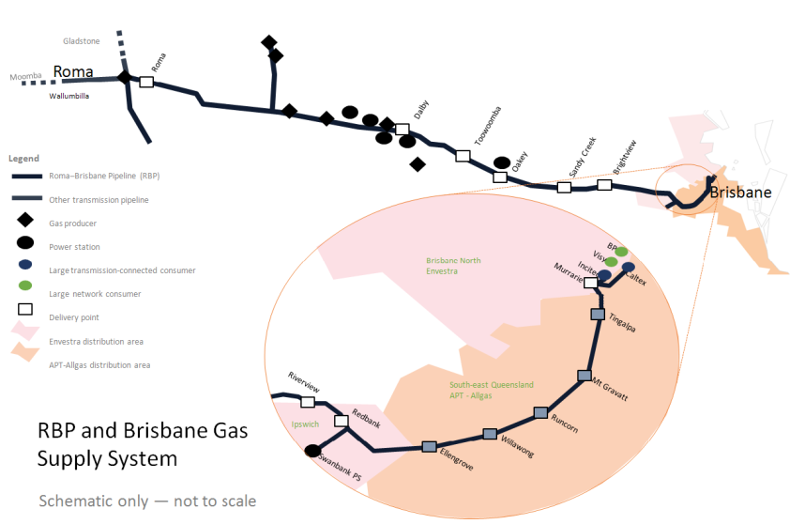

Figure 2 – STTM Brisbane hub participation (17 October)

|  |  |  |  |  |  |  |  |
| --- | --- | --- | --- | --- | --- | --- | --- |
| Participant / Offer-Bid type | AGL | Alinta | BP | Incitec | Origin | Stanwell | Visy |
| Offers | Y | Y | Y | Y | Y | Y | N |
| Price taker bids (uncontrollable demand) | Y | Y | Y | Y | Y | N | Y |
| Withdrawal bids/non price taker bids | N | Y | Y | N | Y | Y | N |

# Brisbane Hub – 17 October 2014 gas day

1. On 17, 18, and 19 October the capacity to deliver gas to the Brisbane hub was reduced from 186 TJ to 121.3 TJ because of planned maintenance on the Dalby compressor station. [5] APA notified STTM participants of this reduction in capacity on 14 October when it submitted its D-3 forecast capacity data for 17 October.

Figure 3 – Reduced pipeline capacity limiting scheduled deliveries to the Brisbane STTM hub



As shown in figure 3 above, on 17 and 19 October offers (and bids) were scheduled up to the capacity of the RBP. On these days, the lower RBP capacity prevented the scheduling of further gas despite some bids being priced higher than some offers.[6] Market rules do not allow volumes of gas to be scheduled to the Brisbane hub beyond the physical forward haul capacity of the pipeline even if there are parties willing to trade more gas. On both days it resulted in prices being set at the price of the last non-price taker bid which could be scheduled given constrained capacity (see below). However, this only led to a significant price variation event on 17 October (circled).

Stanwell has advised the AER that APA notified it that the capacity reduction would limit its ability to supply gas to its gas powered generator, Swanbank E, due to reduced pressure during the maintenance period. In response to this information, Stanwell lowered its price taker and non-price taker bid quantities from 17 October. This is shown in the reduction in price taker bids in figure 3 above. If Stanwell had not reduced its price taker bids, the ex ante price would have likely been set at $400/GJ (the market price cap) whereby offers could not have been scheduled to meet all price taker bids.

As shown in figure 4, on 17 October across the three schedules:

* Given the capacity constraint, 121.3 TJ of offers were scheduled across all three schedules with the marginal offer price at 121.3 TJ changing slightly across schedules.
* For each schedule these offers were matched by price taker bids between 107.8 and 111.8 TJ
* For each schedule an additional small quantity of non-price taker bids was scheduled bringing the total bids to 121.3 TJ
* The marginal bid price for each schedule changed markedly compared to the marginal offer

Figure 4 – Capacity, offer, bid and pricing information

|  |  |  |  |  |  |
| --- | --- | --- | --- | --- | --- |
| 1. Schedule | 1. Capacity & Scheduled Offers (TJ) | 1. Price taker bids (TJ) | 1. Non price-taker bids (TJ) | 1. Marginal offer (MO) price at capacity ($/GJ) | 1. Marginal bid (MB) price at capacity ($/GJ) |
| 1. D-3 | 121.3 | 109.3 | 11.99 | **$0.95** | **$29.90** |
| 1. D-2 | 121.3 | 108.3 | 12.99 | **$0.40** | **$1.08** |
| 1. D-1 | 121.3 | 111.8 | 9.46 | **$0.00** | **$29.90** |
| 1. D+1[7] | 121.3 | 107.8 | 13.50 | **$0.00** | **$ 0.50** |

*D-3, D-2 and D-1 schedules*

Figure 5 illustrates how the capacity constraint impacted on prices throughout the D-3, D-2 and D-1 schedules. The supply and demand balance for each schedule is represented using a different colour (D-3 is blue, D-2 is red, and D-1 is green). The supply line for each schedule is made up using offers.[8] The demand line for each schedule is made up using price taker bids and non-price taker bids.[9] The capacity constraint is represented with the grey dotted vertical line.

The capacity constraint line intersects the demand line for both the D-3 and D-1 schedules at $29.90/GJ (a Stanwell bid). This set the price for these schedules. A small reduction in price taker bids (demand) during the D-2 schedule (shown by the red demand line moving to the left) meant the capacity constraint intersects with the demand line at $1.08/GJ (an Alinta bid). This set the price for the D-2 schedule.

For the D-1 schedule, price taker bids increased by 3.5 TJ (shown by the green demand line moving to the right). Because of this, only part of the $29.90/GJ non-price taker bid was able to be scheduled, which again set the price.

One of the contributing factors to the increase in price taker bids was the bidding behaviour of Visy. Visy did not submit price taker bids for the D-3 and D-2 schedules. However it did submit a price taker bid for the D-1 schedule. Visy explained that the reason it did not submit price taker bids for the D-3 and D-2 schedules is because it did not expect its plant would require gas on 17 October at the time of provisional data submission (14 and 15 October). However, Visy later became aware that its plant would require gas and submitted a price taker bid for the D-1 schedule on 16 October. The change was related to an on-going issue it was having with running the plant on its primary fuel source, coal.

Figure 5 – Reduced pipeline capacity and steep bid curve affecting D-3, D-2, D-1 prices *



*Not all offers and bids shown

*Ex post price*

Figure 6 illustrates why the ex post schedule’s price lowered to $0.5001/GJ.

Alinta rebid its non-price taker bid from $1.08/GJ (which set the D-2 price) to $0.50/GJ for the D‑1 schedule. While this had no impact on the D-1 price, it did set the price for the ex post schedule because there was a negative imbalance quantity of 4.048 TJ. A negative imbalance means less gas was required on the day than forecast in the D-1 schedule. Therefore a new price is calculated based on this level of demand to show what the price would have been with accurately forecast demand.[10] The new price is calculated by moving the demand curve to the left to reflect the lower demand). The solid green line in figure 6 illustrates this change. After the shift, the constraint line no longer intersects it at $29.90/GJ. Instead the intersection point is $0.50/GJ.

All participants slightly over forecast demand for the D-1 schedule. Therefore, the negative imbalance can be attributed to all participants. The over forecast is not particularly large based on historical fluctuations between forecast and actual demand.

Figure 6 – Effect of over forecast price taker bids on the ex post price for 17 October*



*Not all offers and bids shown

**A note on capacity prices and payments**

There were capacity prices set due to the pipeline constraint. However, as only firm gas was scheduled, there were no capacity payments. The capacity price and payment mechanism is described in more detail in the AER’s 7 July STTM Brisbane hub significant price variation report.[11]

# Conclusion

Gas can only be scheduled to Brisbane up to the capacity of the RBP determined by APA. As a result of a constraint on 17 October, pipeline capacity was insufficient to service all demand including non- price taker bids.

Some volumes of non-price taker bids were not scheduled despite being priced higher than offers. This is in line with market rules which do not allow forward haul gas to be scheduled beyond the capacity of the pipeline (non-price taker bids require matching offers).

For the D‑2 provisional schedule, the lower price ($1.08/GJ) appears to have been caused by a slight reduction in price taker bids. The D-1 ex-ante ($29.90/GJ) price returned to a much higher level when price taker bids increased. The ex post price was lower ($0.50/GJ) because demand was over-forecast.

The high ex ante price for 17 October and the variation of the ex ante price to provisional and ex post prices appears to be largely the result of three interrelated factors:

* pipeline capacity constraints which set prices at the bid price of the last non price taker bid which could be scheduled
* small aggregate changes to price taker bids between schedules influencing which non-price taker bids set the price and
* steep price steps between non-price taker bids.

1. Rule 498(2) of the National Gas Rules (Gas Rules)
2. Rule 405 of the Gas Rules
3. There are two types of bids – price taker bids and non-price taker bids. Price taker bids are used by participants to reflect uncontrollable demand. Non-price taker bids reflect controllable demand.
4. Based on flows on the natural gas services bulletin board, there is no gas flowing east from gas facilities to the south at Moomba. www.gasbb.com.au
5. Previous pipeline capacity for Brisbane STTM hub gas deliveries on the RBP had been 206.3 TJ since mid-May, reduced to 186 TJ in late June due to the detection and isolation of a defect in the RBP 10” pipeline.
6. Both days (Friday 17 October and Sunday 19 October) saw the scheduling of further offers/bids restricted by the capacity constraint, and resulted in capacity constraint pricing across the provisional and ex ante schedules.
7. Values for ex post quantities and prices are derived by offsetting the ex ante bids by the imbalance quantity (-4.048 TJ).
8. The supply line stretches from the bottom left corner to the top right
9. The demand line stretches from the top left corner to the bottom right
10. The ex post price is one of several parameters used in the calculation of deviation charges and payments. The ex post imbalance price is calculated the day after the gas day to determine a price that reflects the impact that deviations on the gas day would have had on the ex ante market price if they had been included in the original schedule. On the day all participants over-forecast their demand (they used less gas than scheduled). This led to deviation payments. Deviation payments are calculated on the basis of the deviation quantity, using the lesser of the ex ante and ex post price (after considering variations to the market schedule).
11. <http://www.aer.gov.au/node/27587>