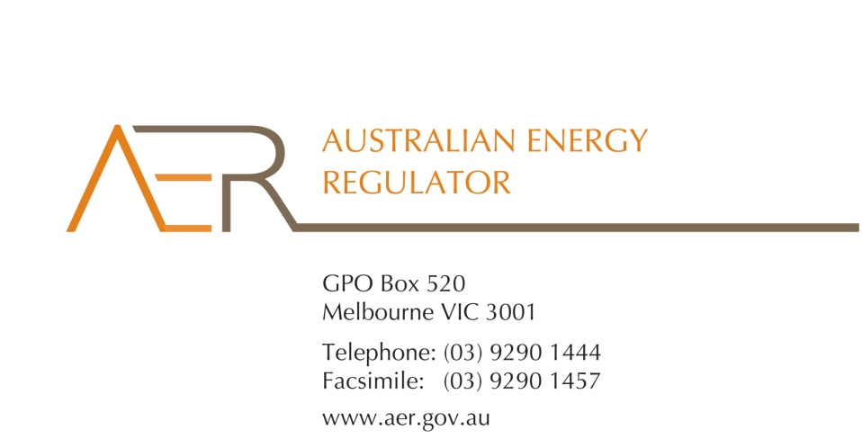

Our Ref: D17/127329

Your Ref:

Contact Officer: Tom Stevens-Downie

Contact Phone: (03) 9290 6984

29 September 2017

Mr Jim Tatsis

National Manager, Group Asset Management and Operations

C/- Stockland

Level 25, 133 Castlereagh Street

Sydney NSW 2000

Dear Mr Tatsis

**Notice of Acceptance and eligibilty to register network exemption – Stockland Trust Management Limited**

I refer to your application submitted 8 September 2017, for eligibility to register a network exemption under the requirements of section 4.9 of the Network Service Provider Registration Exemption Guideline (Network Guideline) in relation to the proposed creation of an embedded network at **Stockland Green Hills Shopping Centre, East Maitland NSW 2323**.

I am writing to inform you that your application satisfactorily addresses the requirements of section 4.9.7 of the Network Guideline. We therefore issue this Notice of Acceptance effective from **29 September 2017** and confirm that you are now eligible to register the relevant network exemption(s) for publication on the Australian Energy Regulator (AER) public register of exemptions.

**Eligibility for exemption in relation to conversions of existing networks**

In accordance with condition 4.1.12.1 of the Network Guideline, an embedded / private network must not be created without the express written consent of existing energy consumers who will be included within the proposed network (affected energy consumers).[1] Parties intending to create such a network without the written consent of all affected energy consumers must meet the requirements stipulated in section 4.9 of the Network Guideline to be eligible for network exemption.

In addition, section 4.9.7 of the Network Guideline stipulates that a network must not be converted until the effective date specified in this notice.

Parties who are issued with a Notice of Acceptance under section 4.9 are eligible to register and hold network exemptions for the network at that particular site according to the appropriate activity class. Activity classes are detailed under section 3 of the Network Guideline and are subject to the observance of the further conditions detailed in section 4 of the Network Guideline.

Failure to observe the conditions of exemption may render an exemption invalid. Owning, operating or controlling a network without registration with the Australian Energy Market Operator (AEMO) or holding a valid exemption from the AER constitutes a breach of section 11(2) of the National Electricity Law.

**Additional conditions applicable to the network exemption class(es) registered**

In addition to the conditions usually applicable to the network exemption class(es) held in relation to the embedded network at this site, the applicant must also comply with the conditions of section 4.9 of the Guideline. These conditions concern:

retaining consent records for a period of at least 2 years;

facilitating the continuation of a customer’s energy contract with their current retailer;

maintaining a customer’s direct connection to the registered distributor;

offer matching;

avoidance of duplicated network charges;

liability of the costs of metering/network changes; and

the ability of metering arrangements to allow for access to retail competition.

For the full list of conditions and their detail, refer to the Guideline.

If you have any further queries, or would like to discuss this further, please contact Tom Stevens-Downie on (03) 9290 6984.

Yours sincerely

Paul Dunn

Director

Networks

1. This condition applies wherever an exempt customer is eligible under State or Territory legislation to purchase energy from a retailer of their choice.