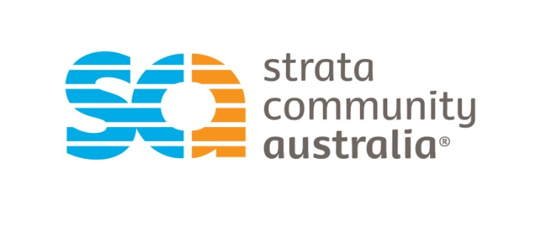

Head Office / NSW/ ACT/ SA/ NT
PO Box 347
North Sydney NSW 2059
T: (02) 8904 0450
F: (02) 8904 0490

QLD
PO Box 1280
Spring Hill, QLD, 4004
T: (07) 3839 3011
F: (07) 3832 4680

VIC / TAS
Suite 106,
134-136 Cambridge Street,
Collingwood VIC 3066
T :(03) 9416 4688
F :(03) 9416 4788

WA
PO Box 968
Victoria Park WA 6979
T: (08) 9361 0411
F: (08) 9361 0433

Email
info@stratacommunity.org.au
ACN
151 156 357

Submission on Australia Energy Regulator (AER)'s Exempt Selling Guidelines- Consultation on Additional Protection for Customers with Financial Difficulties.
Strata Community Australia (SCA) is the peak sector body for the strata and community titled industry. SCA was formed in July 2011, when six state boards, (formerly the National Community Titles Institute), came together to form one national body under one brand. Our mandate is to promote professional standards and advocate on behalf of our members- the people who live, invest and work in various forms of strata and community title property around Australia. In particular, our role is promoting awareness of specific needs of the sector and ensuring our stakeholder concerns are well represented. The strata industry is often overlooked when developing policy in Australia thus disadvantaging a quarter of all Australian households who do not live in standard detached housing.
Strata Community Australia welcomes the proposed changes to the Exempt Selling Guidelines which provide protection for customers experiencing financial difficulty. The move allows customers of exempt sellers to access similar protections as those provided for their counterparts utilising energy retailers governed by the National Energy Retail Law.
Strata Community Australia applauds this move to protect individuals within residential housing. We would, however, like to bring to the forefront the communal nature that is part and parcel of living within a strata scheme. A unit owner has obligations to pay their individual bill as well as the common bill for energy used to power common property such as foyers, parking spaces, lifts, central heating and cooling, as well as communal hot water systems. The proposed guidelines make provision for the individual without accounting for how their share of the communal bill will be paid.

We propose that the overarching policy reads;
"Disconnection of premises of a customer who has identified themselves as experiencing financial difficulty due to inability to pay energy bills should be a last resort. This includes disconnection of common property areas where the exempt customer resides in a Strata or Community Title property".

Condition 3- Billing and Payment Arrangements
We propose that the flexible payment terms be extended to Owner Corporations where a lot owner within a strata scheme has indicated they are experiencing financial difficulty.
These proposals are made considering the nature of an Owners Corporation which is funded through strata levies and is not considered a company under the Corporations Act of 2001. All lot owners within a strata scheme are members of the Owners Corporation and share responsibility for the maintenance of all common areas on the property.

Sincerely,

Ruby Zhou
Research and Policy Officer.
Strata Community Australia
ruby.zhou@stratacommunity.org.au

