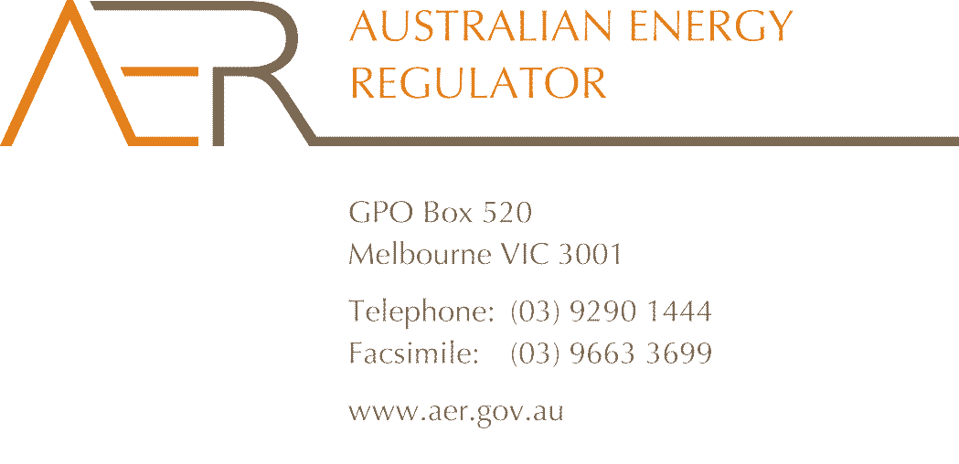

Contact Officer: Dale Johansen
Contact Phone: 07 3835 4679

June 2013

Mr Richard Khoe
Australian Energy Market Commission
PO Box A2449
Sydney South NSW 1235

Dear Mr Khoe

AEMC draft determination – Changes to cost allocation method (ERC0150)
I refer to the AEMC’s draft determination on proposed changes to National Electricity Rule (the Rules) provisions for cost allocation methods (CAMs) and negotiated service pricing. The AER supports the AEMC’s draft determination.
If approved by the AEMC, the proposed rule change would require:
- adoption of the distribution consultation procedures for changes to CAMs
- inclusion of numeric values for each cost allocator, and
- negotiated service prices having to be (‘must be’) based on the cost of supplying those services.
I note that the AEMC’s draft determination is to reject each of the three elements listed above. Consistent with my previous submission on this issue, I consider the AEMC’s draft decision to be appropriate. I take this opportunity to reiterate my view that the proposed rule change would do little to improve outcomes for negotiated service applicants, but would increase administrative costs for regulated businesses and the AER.
As the AEMC’s draft determination sets out, the Rules’ negotiated service provisions provide significant opportunity for commercial information sharing by network service providers with negotiated service applicants. What’s more, I consider that the proposed rule change in respect of adopting the distribution consultation procedures for CAM approval would not assist applicants further than the existing negotiated service provisions already provide for.
The rule change proponent appears to seek a more deterministic outcome for negotiated services than the negotiated service classification is intended to provide. Again as the AEMC’s draft determination indicates, were negotiated service applicants to seek such an interventionist approach to price setting, it would appear to be evidence that the negotiated service classification may not be appropriate for the service in question. If so, this is a matter that should be considered in the context of the classification decision itself rather than by changing the essential character of the negotiated services provisions.
The AER’s approval of a proposed cost allocation method (CAM) is strictly based on an assessment of its consistency with cost allocation provisions of the Rules and with the AER’s cost allocation guidelines. Customer consultation on the content of the guidelines is already mandated as they can only be materially varied consistent with the distribution consultation procedures.
My previous submission indicated that I was not opposed to the third element of the rule change proposal, to tighten up articulation of the Rules’ provision that negotiated service prices be based on cost. Nominal support for that element was based on it clarifying the provisions’ intent. I appreciate, however, the AEMC’s rationale for not approving this element, that the proposed change would reduce the AER’s flexibility in the context of arbitrating a pricing outcome.
Yours sincerely

Chris Pattas
General Manager – Network Operations and Development

