Attachment 2: Submission on Energex’s regulatory proposal 2015-2020 – Demand Management Strategy.

Purpose

This Attachment provides Sunshine Coast Council’s strong support for Energex’s Demand Management Program 2015-2020 (see appendix 14 of their Regulatory Proposal 2015-2020).

Executive Summary

Council and our community have benefitted substantially from the residential demand management program that Energex has been building for the past four years on the Sunshine Coast. We endorse the finding in their customer research that it is an important community initiative that Energex should lead. Further, we contend that it provides our community with the power to choose additional options in managing their electricity bills, yet maintain the comfort of hot water, air-conditioning and the recreational use of their pools. In our view Energex’s leadership in implementing demand management programs should be continued and enhanced.

In October 2010 Council was invited to partner with Energex in its residential demand management program. Since then:

* More than 10,000 Sunshine Coast households are participating in the program;
* These households have collectively received more than $2.5 million in incentives and have, spent their incentives on nearly 6,000 purchases or job requests. This has sustained local electricians and appliance retailers during periods of slow economic growth in the region;
* The program is funded and administered by Energex (2010-2015) with Council assisting Energex’s facilitation of it on the Sunshine Coast. Energex regards the Sunshine Coast Council as one of its most effective and leading local government partners as a result of:
  + Mayor, Councillor and Chief Executive Officer support;
  + Substantial in kind support from Council officers who assisted with initial program design, planning, media launches, and promotion through Council’s corporate communication channels;
  + Providing local knowledge of community characteristics/demographic profiles and facilitating contact with local stakeholders and community groups.
* The program has achieved more than 12 MVA of load control on the Sunshine Coast (as of January 2015). This is the result of more than 12,000 air-conditioners, pool pumps and hot water systems being connected to the load control network on the Sunshine Coast.
* The program has seen genuine and ongoing engagement between Energex, Council and the community. It has resulted in a raised level of awareness in the community about the peak demand challenge and has established substantial goodwill between Energex and Council that is now benefitting Council’s other key energy projects - the construction of a utility scale solar farm (15MW) and the management of its public lighting network.

Demand Management on the Sunshine Coast

Rising electricity prices

Households on the Sunshine Coast have been increasingly exposed to rising electricity bills. A household’s power bill is made up of two charges (i) an electricity consumption charge for the electricity used (typically tariff 11) and (ii) a service fee for connection to the electricity grid. Figure 1 shows these two charges increasing over the past seven years with the service fee tripling in the past two years.

*Figure 1 - Electricity tariff 11 consumption charge and service fee from 2007-08 to 2014-15*

**Consumption charge (cents per KWh) Service fee (cents per day)**

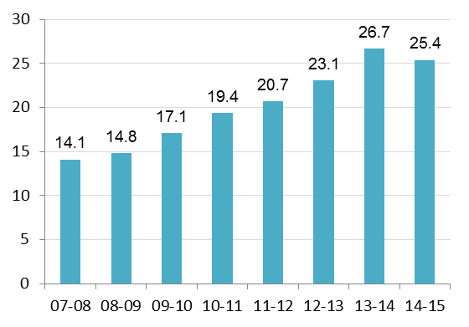 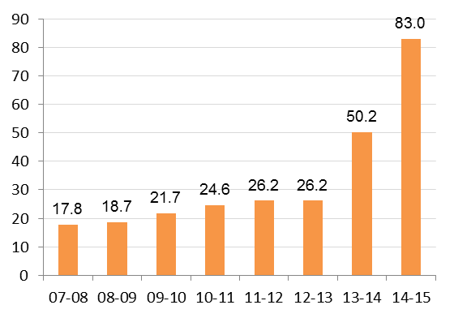

Source: Queensland Competition Authority

The impact on a typical Sunshine Coast household (that uses 6,000 KWh of electricity per year) can be seen in Table 1. The bottom line sees residential power bills double from $911 in 2007-08 to $1,827 in 2014-15, a 101% increase.

*Table 1 – Impact on Sunshine Coast residents of increasing electricity consumption charges and service fees from 2007-08 to 2014-15*



Source: Sunshine Coast Council Commercial Analysis Estimates

In 2014, the Queensland Government stated in its “PowerQ” strategy that:

*“In response to significant supply failures in 2004, very large investments in network infrastructure have delivered more reliable electricity during infrequent periods of high peak demand. This has caused network costs to more than double since 2007–2008.”*

Peak demand on the South East Queensland electricity grid

Rising electricity prices have been generally recognised as predominantly being the result of increasing expenditure on the electricity network to accommodate rising peak demand from consumers (including residential, commercial and industrial). According to the Productivity Commission “the magnitude of peak demand has risen over the last decade, driven primarily by growth in residential air conditioning” which is illustrated in figure 2.

*Figure 2 - The increase in household air conditioning nationally and by State (percent of households with air conditioning)*



Source: Productivity Commission Inquiry Report No. 62 – Electricity Network Regulatory Frameworks

Peak demand events on the South East Queensland electricity network occur on the very hottest days of the year and typically between 4pm and 8pm. This is when commercial and industrial electricity loads are still high and residential electricity loads spike due to families returning home from school and work.

Energex estimates 16 per cent of its network has been built to service a demand that only occurs for the equivalent of three days a year. They recognised that growth in peak demand events wasn’t sustainable and began to implement demand management programs in 2007 to try and curtail or shift the peak demand events to other time periods.

Their first residential peak demand management program in South East Queensland was called “Cool Change - Energy Smart Suburbs Peak Demand Trial”. This initiative led to the “Energy Conservation Community” program in 2010 and subsequently to the current “Positive Payback” program. Energex’s current objective for these programs is to reduce peak demand on its entire South East Queensland electricity network by 144 MVA by 2015. As of June 2014 it has achieved 126 MVA of load control.

This is a solid foundation for the continuation of the demand management program in 2015-2020. In Council’s view it would be unfortunate if the investment over the past 7 years that has led to this achievement was not recognised.

Council's policy response to rising electricity costs

Councillors unanimously adopted an “Energy Transition Plan 2010-2020” in December 2010 which identified the challenge of rising electricity costs for our residents over the decade 2010-2020. It stated in 2010 that:

*“The current residential electricity tariff of 19.41 c/KWhr is now nearly double what it was ten years ago and Simshauser, Nelson and Doan (2010) have forecast potential rises to 25-30 c/KWhr in 2015.”*

Council’s Energy Transition Plan set an objective to assist Sunshine Coast “households reduce their energy costs”. To achieve that objective one of the actions (Action 47) in the Energy Transition Plan states “Council to expand its partnership with Energex in implementing energy conservation and demand management programs across the Sunshine Coast.”

To help drive uptake of the program by residents the Energy Transition Plan also included two targets for the program which sought “to establish an Energy Demand Management Region of 6,000 dwellings which will allow ENERGEX to control 6 Megawatts load during peak demand periods by 2015. To expand that to 10,000 dwellings (control of 10 Megawatts) by 2020.”

This demonstrates the formal policy support from Council for Energex’s demand management initiatives.

Council’s strategic partnership program with Energex

Council officers provided Energex in late 2009 with an Expression of Interest submission that argued for the Sunshine Coast Council region to be the location of the first “Energy Conservation Community”. Energex accepted and launched the first “Energy Conservation Community” program in South East Queensland on the Sunshine Coast in March 2010.

Council facilitated, and continues to facilitate the program, through in-kind support including:

* Mayor, Councillor and Chief Executive Officer support;
* Council providing a dedicated program web page on Council’s website;
* Council officers assisting Energex officers with initial program design and planning;
* Council officers assisting Energex staff at media launches;
* Program promotion through a range of Council’s corporate communication channels;
* Providing local knowledge of community characteristics/demographic profiles and facilitating contact with local stakeholders and community groups.

The successful delivery and uptake of the Sunshine Coast Energy Conservation Community program combined with the political and policy support of the Sunshine Coast Council in the program’s first 18 months meant that Energex considered Sunshine Coast Council as one of their most effective and leading local government partners in their demand management initiatives.

Initially confined to four suburbs the program was expanded to all suburbs/localities on the Sunshine Coast in September 2011. At that time Energex’s Chief Executive Officer stated in correspondence to Council’s Chief Executive Officer that:

*“Energex hopes that through expanding the geographical area and offers available, the Sunshine Coast energy conservation community will grow in strength … I look forward to Energex and Sunshine Coast Council continuing to build on our positive partnership to help create a more sustainable energy future that will benefit the community on the Sunshine Coast for years to come.”*

The re-branding of the “Energy Conservation Community” program into the “Positive Payback” program occurred during 2012-2013 and currently offers households the opportunity to receive up to $950 in cash rewards including:

* $200 for connecting a hot water system to an economy (off peak) tariff; and
* Up to $250 for connecting an existing pool pump to an economy (off peak) tariff; and
* Up to $500 for installation of “peak smart” energy efficient air conditioners.

These offers are contingent on the householder employing a local electrician to complete the installation (or connection) and also results in new appliances being purchased from local appliance stores and businesses.

Genuine community engagement has been ongoing and a range of engagement strategies were/are being used. This includes: promotion through media launches; advertising in the media; advertising on roadside billboards; promotional material in retail appliance stores; community barbeques/sausage sizzles; manned shopping centre stalls; website information; and through seminars and forums with local electricians and holiday unit managers.

Council has been witness to the gradual refinement of the engagement strategies for the program over the past four years to make delivery of the program more efficient. Anecdotally it supports Energex’s contention that “the demand reduction target is being delivered at a lower cost than originally budgeted for in the AER Regulatory Submission for Energex for 2010-2015”.

Program Outcomes

The program attracted 1,600 households in its initial phase (2010-11). By March 2012 more than 3,500 households were taking part. Further opportunities were identified in the program including providing incentives to holiday unit apartment managers in order to attract their unit owners to participate. By August 2012, more than 7,000 households were participating on the Sunshine Coast. The program has continued to be very successful locally and has surpassed the 2015 target set in Council’s Energy Transition Plan (6,000 participants). It currently has more than 10,000 households participating on the Sunshine Coast.

This uptake of the program by Sunshine Coast residents means that collectively they have received over $2.5 million in cash rewards from the program. In the longer term residents who connect their hot water systems and pool pumps to off peak tariffs create the scope to reduce their power bills.

The program has driven nearly 6,000 purchases or job requests through local electricians and local retailers at a time when both the construction sector and the retail sector have experienced slow growth in the Sunshine Coast region.

According to Energex the program has successfully allowed the additional load control of 12 MVA of diversified load during peak electricity demand events on the Sunshine Coast electricity network. This is the result of more than 12,000 air-conditioners, pool pumps and hot water systems being connected to the load control network on the Sunshine Coast.