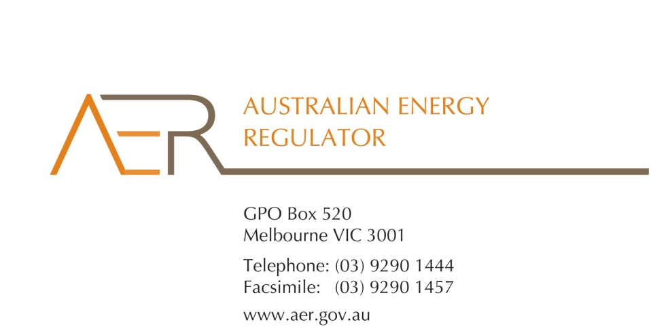

Our Ref: D16/2355

Your Ref:

Contact Officer: Susan Faulbaum

Contact Phone: (08) 8213 3643

13 January 2016

Mr Tynan Coles

CEO

Unit 1, 194 Military Road

Guildford, NSW 2161

Dear Mr Coles

**Applications for individual retail exemptions from:**

* **The Trustee for Citisolar NSW Unit Trust**
* **The Trustee for Citisolar Unit Trust**
* **The Trustee for Citisolar South Australia Unit Trust**
* **The Trustee for Citisolar Townsville Unit Trust**

I refer to your applications from November 2015, for individual exemptions under the National Energy Retail Law (Retail Law) for

* The Trustee for Citisolar NSW Unit Trust (ABN 62 803 712 338)
* The trustee for Citisolar Unit Trust (ABN 96 147 096 137)
* The Trustee for Citisolar South Australia Unit Trust (ABN 25 621 335 461)
* The trustee for Citisolar Townsville Unit Trust (ABN 89 312 929 922)

I am writing to inform you that the Australian Energy Regulator (AER) has considered the applications from the above named entities for individual exemptions and that it decided, on 8 January 2016, to grant an individual exemption to each entity in accordance with s.110 of the Retail Law. This letter constitutes notice of intention to grant individual exemptions.

In accordance with the National Electricity Retail Rules (Retail Rules), the AER has published the applications on its website, and sought submissions from interested parties.[1] The AER did not receive any submissions to the applications.

The AER has considered the policy principles relating to exempt selling in s. 114 of the Retail Law, being:

1. regulatory arrangements for exempt sellers should not unnecessarily diverge from those applying to retailers,
2. exempt customers, should, as far as practicable, be afforded the right to a choice of retailer in the same way comparable retail customers in the same jurisdiction have that right,
3. exempt customers, should, as far as practicable, not be denied customer protections afforded to retail customers under this Law and Rules.

In making its decision the AER is also guided by the objective of the Retail Law[2], the exempt seller factors,[3] and the customer related factors.[4]

The AER is satisfied that the above mentioned entities should be exempt from the requirement to hold a national retailer authorisation, having regard to the above considerations. If any of the above mentioned entities wishes to change the way they sell electricity they should contact the AER as they may need to apply for an authorisation or another exemption. If these activities are not covered by the exemption the above mentioned entities may be in breach of s. 88 of the Retail Law and we may take enforcement action or otherwise seek to ensure compliance.

These individual exemptions are subject to acceptance of the conditions[5] set out at Schedules 1 to 4 to this letter. One of these conditions relates to information disclosure. Specifically, this condition is intended to ensure that your customers understand the nature of the service that is provided and the protections they are entitled to (as opposed to the service and protections your customers would receive from their energy retailer).

For the individual exemptions to come into effect, each of the above mentioned entities must advise the AER in writing, by 10 February 2016**,** whether they accept the attached conditions. The above mentioned entities cannot commence energy selling under their respective individual exemptions until they have done so.

Please also be aware that the AER may vary conditions attached to an individual exemption at any time in accordance with rule 158 of the Retail Rules.

If you have any further queries, or would like to discuss this further, please contact Susan Faulbaum on (08) 8213 3463.

Yours sincerely

Sarah Proudfoot

General Manager, Retail Markets

**Schedule 1: Instrument of exemption**

**INDIVIDUAL EXEMPTION FROM THE REQUIREMENT TO HOLD A RETAILER AUTHORISATION**

The Australian Energy Regulator on 8 January 2016, decided pursuant to section 110 of the National Energy Retail Law, to grant The Trustee for Citisolar NSW Unit Trust (ABN 62 803 712 338) (the exempt person) an individual exemption from the requirement to hold a retailer authorisation under section 88 of the National Energy Retail Law, subject to the following conditions.

**Condition 1 - Information provision**

The exempt person must provide the customer in writing a plain English notice explaining that the contract is covered by Australian consumer protection laws and is separate to the customer’s contract with their retailer and distributor which are covered under the National Energy Retail Law.

**Condition 2 – Exemption limited to the sale of electricity through solar power purchase agreements**

This exemption is conditional upon the exempt person:

* refraining from registering in the wholesale market for the purposes of purchasing energy;
* not being the financially responsible retailer for the premises (rather, this must be an authorised retailer); and
* only selling to premises that are connected to the interconnected national electricity system.

**Schedule 2: Instrument of exemption**

**INDIVIDUAL EXEMPTION FROM THE REQUIREMENT TO HOLD A RETAILER AUTHORISATION**

The Australian Energy Regulator on 8 January 2016, decided pursuant to section 110 of the National Energy Retail Law, to grant The trustee for Citisolar Unit Trust (ABN 96 147 096 137) (the exempt person) an individual exemption from the requirement to hold a retailer authorisation under section 88 of the National Energy Retail Law, subject to the following conditions.

**Condition 1 - Information provision**

The exempt person must provide the customer in writing a plain English notice explaining that the contract is covered by Australian consumer protection laws and is separate to the customer’s contract with their retailer and distributor which are covered under the National Energy Retail Law.

**Condition 2 – Exemption limited to the sale of electricity through solar power purchase agreements**

This exemption is conditional upon the exempt person:

* refraining from registering in the wholesale market for the purposes of purchasing energy;
* not being the financially responsible retailer for the premises (rather, this must be an authorised retailer); and
* only selling to premises that are connected to the interconnected national electricity system.

**Schedule 3: Instrument of exemption**

**INDIVIDUAL EXEMPTION FROM THE REQUIREMENT TO HOLD A RETAILER AUTHORISATION**

The Australian Energy Regulator on 8 January 2016, decided pursuant to section 110 of the National Energy Retail Law, to grant The Trustee for Citisolar South Australia Unit Trust (ABN 25 621 335 461) (the exempt person) an individual exemption from the requirement to hold a retailer authorisation under section 88 of the National Energy Retail Law, subject to the following conditions.

**Condition 1 - Information provision**

The exempt person must provide the customer in writing a plain English notice explaining that the contract is covered by Australian consumer protection laws and is separate to the customer’s contract with their retailer and distributor which are covered under the National Energy Retail Law.

**Condition 2 – Exemption limited to the sale of electricity through solar power purchase agreements**

This exemption is conditional upon the exempt person:

* refraining from registering in the wholesale market for the purposes of purchasing energy;
* not being the financially responsible retailer for the premises (rather, this must be an authorised retailer); and
* only selling to premises that are connected to the interconnected national electricity system.

**Schedule 4: Instrument of exemption**

**INDIVIDUAL EXEMPTION FROM THE REQUIREMENT TO HOLD A RETAILER AUTHORISATION**

The Australian Energy Regulator on 8 January 2016, decided pursuant to section 110 of the National Energy Retail Law, to grant The trustee for Citisolar Townsville Unit Trust (ABN 89 312 929 922) (the exempt person) an individual exemption from the requirement to hold a retailer authorisation under section 88 of the National Energy Retail Law, subject to the following conditions.

**Condition 1 - Information provision**

The exempt person must provide the customer in writing a plain English notice explaining that the contract is covered by Australian consumer protection laws and is separate to the customer’s contract with their retailer and distributor which are covered under the National Energy Retail Law.

**Condition 2 – Exemption limited to the sale of electricity through solar power purchase agreements**

This exemption is conditional upon the exempt person:

* refraining from registering in the wholesale market for the purposes of purchasing energy;
* not being the financially responsible retailer for the premises (rather, this must be an authorised retailer); and
* only selling to premises that are connected to the interconnected national electricity system.

1. r. 155(3) and 156, National Energy Retail Rules.
2. The National Energy Retail Law objective is to “promote efficient investment in and efficient operation and use of energy services for the long term interests of energy consumers with respect to price, quality, safety, reliability and security of supply of energy”. (s. 13, Retail Law)
3. s. 115, Retail Law.
4. s. 116, Retail Law.
5. r. 158 (1), Retail Rules.