1. 

Final decision

Amendment

Electricity transmission network service providers

Post-tax revenue model handbook

29 January 2015

© Commonwealth of Australia 2015

This work is copyright. In addition to any use permitted under the Copyright Act 1968, all material contained within this work is provided under a Creative Commons Attribution 3.0 Australia licence, with the exception of:

* the Commonwealth Coat of Arms
* the ACCC and AER logos
* any illustration, diagram, photograph or graphic over which the Australian Competition and Consumer Commission does not hold copyright, but which may be part of or contained within this publication.

The details of the relevant licence conditions are available on the Creative Commons website, as is the full legal code for the CC BY 3.0 AU licence.

Requests and inquiries concerning reproduction and rights should be addressed to the Director, Corporate Communications, ACCC, GPO Box 3131, Canberra ACT 2601, or [publishing.unit@accc.gov.au](mailto:publishing.unit@accc.gov.au).

1. Inquiries about this decision should be addressed to:

Australian Energy Regulator

GPO Box 520

Melbourne Vic 3001

Tel: (03) 9290 1444

Fax: (03) 9290 1457

Email: [AERInquiry@aer.gov.au](mailto:AERInquiry@aer.gov.au)

1. AER reference: 55444
2. Amendment record

|  |  |  |  |
| --- | --- | --- | --- |
| Handbook version | Model version | Date | Pages |
| 1 | 1 | September 2007 | 24 |
| 2 | 2 | December 2010 | 29 |
| 3 | 3 | January 2015 | 35 |

1. Contents

Contents 3

Shortened forms 5

1 Nature and Authority 6

1.1 Introduction 6

1.2 Authority 6

1.3 Role of the Model 6

1.4 Confidentiality 6

1.5 Process for revision 6

1.6 Version history and effective date 6

2 The model 7

2.1 Overview of the PTRM 7

2.2 DMS input sheet 8

2.3 PTRM input sheet 9

2.3.1 Opening regulatory asset base and opening tax base 12

2.3.2 Forecast real capital expenditure—as-incurred 13

2.3.3 Forecast real asset disposals—as-incurred 13

2.3.4 Forecast real net capital expenditure—as-incurred 13

2.3.5 Forecast real capital expenditure—as-commissioned 14

2.3.6 Forecast real asset disposals—as de-commissioned 14

2.3.7 Forecast real net capital expenditure—as-commissioned 14

2.3.8 Forecast real operating expenditure 14

2.3.9 Revenue adjustments 14

2.3.10 Tax 14

2.3.11 Cost of capital 15

2.3.12 Debt and equity raising costs—transaction costs 15

2.3.13 Maximum allowed revenue for the current year 15

2.3.14 Energy delivered forecast 15

2.4 WACC sheet 16

2.5 Assets sheet 17

2.5.1 Rolling forward the RAB and depreciation 17

2.6 Analysis sheet 18

2.6.1 Building block approach to deriving cash flows 21

2.6.2 Taxation and related costs and benefits 22

2.6.3 Cash flow analysis 22

2.7 X factors sheet 24

2.8 Revenue summary sheet 26

2.9 Equity raising costs sheet 27

2.10 Chart 1—Revenue 30

2.11 Chart 2—Price path 31

2.12 Chart 3—Building blocks 33

3 Process for annual return on debt update 34

3.1 Setting X factors for the final decision before the start of the regulatory control period 34

3.2 Updating X factors to incorporate the annual update to the trailing average portfolio return on debt……………… 35

1. Shortened forms

|  |  |
| --- | --- |
| 1. Shortened form | 1. Extended form |
| ABBRR | annual building block revenue requirement |
| AER | Australian Energy Regulator |
| ATO | Australian Tax Office |
| capex | capital expenditure |
| CPI | consumer price index |
| DMS | data management system |
| IRR | internal rate of return |
| MAR | maximum allowed revenue |
| NEL | National Electricity Law |
| NER | National Electricity Rules |
| NPV | net present value |
| opex | operating expenditure |
| PTRM | post-tax revenue model |
| PV | present value |
| RAB | regulatory asset base |
| RFM | roll forward model |
| TAB | tax asset base |
| TNSP | transmission network service provider |
| WACC | weighted average cost of capital |

# Nature and Authority

## Introduction

1. This handbook sets out the Australian Energy Regulator’s (AER) post-tax revenue model (PTRM) for electricity transmission network service providers (TNSPs). The PTRM is a series of Microsoft Excel spreadsheets developed in accordance with the requirements of clause 6A.5.1 of the National Electricity Rules (NER).

## Authority

1. Clause 6A.5.2(a) of the NER requires the AER to develop and publish the PTRM, in accordance with the transmission consultation procedures.

## Role of the Model

1. TNSPs are required to submit a completed PTRM to the AER as part of their revenue proposals. However, the AER recognises that there may be a need for some flexibility in applying the PTRM in order to account for the particular circumstances a TNSP may face. A number of elements of the PTRM where this may be the case have been identified in this handbook. A TNSP will need to propose and justify a departure from any element of the PTRM for the purposes of addressing its specific circumstances as part of its revenue proposal, which will be considered and assessed by the AER on a case-by-case basis in making its transmission determination.
2. The PTRM is used by the AER to determine the TNSP's annual building block revenue requirement (ABBRR) and maximum allowed revenue (MAR) for each regulatory year of a regulatory control period. The TNSP uses the MAR to calculate the transmission prices to be paid by network users at each connection point in its network.

## Confidentiality

1. The AER’s obligations regarding confidentiality and the disclosure of information provided to it by a TNSP are governed by the Competition and Consumer Act 2010 (Cth), the National Electricity Law (NEL) and the NER.

## Process for revision

1. The AER may amend or replace the PTRM from time to time in accordance with clause 6A.5.2(b) of the NER and the transmission consultation procedures in clause 6A.20 of the NER. The AER will publish a revised version of this handbook to accompany each new version of the PTRM it amends or replaces in the future.

## Version history and effective date

1. A version number and an effective date of issue will identify each version of this handbook.

# The model

## Overview of the PTRM

1. The PTRM is used to calculate the allowed revenue for a given regulatory control period. Specifically, the PTRM is a set of Microsoft Excel spreadsheets (combined into one file, often referred to as a singular spreadsheet) that perform iterative calculations to derive the ABBRR, MAR and X factors for each regulatory year of the regulatory control period from a given set of inputs.[1] The PTRM allows the user to enter these inputs and then displays the outputs. Figure 1 provides an overview of this process.

Figure 1 Overview of the PTRM spreadsheets

**CALCULATIONS**

**OUTPUTS**

**INPUTS**

User enters all data required by the PTRM on this sheet. This includes:

• Opening RAB values and lives

• Opening TAB values and lives

• Forecast capex, both as incurred and as commissioned

• Forecast asset disposals

• Forecast opex

• Revenue adjustments

• Tax rates

• Return on equity

• Return on debt (varies year by year)

• Forecast inflation

• Capital raising costs

• Forecast demand

• Current revenue and price

**PTRM input**

Calculates the weighted average cost of capital for each year of the period.

**WACC**

Calculates the values of the RAB and TAB across the period, and regulatory depreciation (return of capital) for each year.

**Assets**

Cash flow analysis for each year of the period, shows all building blocks and calculates tax payable.

**Analysis**

Converts unsmoothed revenues to smoothed revenues, using a revenue cap form of control. User sets the profile of the X factors via an iterative smoothing process.

**X factors**

Tables showing building blocks, unsmoothed revenue, smoothed revenue, X factors, demand and indicative price paths.

**Revenue summary**

Graphs of key data including revenue and price path.

**Graphs**

Calculates benchmark equity raising costs, from building blocks and smoothed revenue.

**Equity raising costs**

Metadata that controls the automatic import of the PTRM into the AER system.

**DMS input**

1. In Figure 1, each box represents a spreadsheet within the PTRM. Sheets are classified as primarily about inputs (left column), calculations (centre column) or outputs (right column). The flow of data is therefore from left to right, and simplified links between the sheets are shown with grey arrows.
2. To operate the PTRM, the user enters all the required data on the **PTRM input** sheet—for example, forecast capital expenditure (capex) across the regulatory control period, or the rate of return on equity. Determination of these inputs often requires considerable analysis, but this occurs outside the PTRM. In this sense, the input to the PTRM will be the output from all the other parts of the regulatory proposal (or final decision).
3. The PTRM then uses this data to undertake the building block derivation of total revenue, consistent with the requirements of the NER. Under this approach, total revenue is set to equal the total costs of the benchmark network service provider. Total costs are derived by adding up a number of different types of costs, labelled building blocks. The **Analysis** sheet sets out each of these building blocks, and calculates the tax building block (since the PTRM explicitly models the effect of corporate taxes). This gives total unsmoothed revenue (the ABBRR) for the service provider.
4. The **X factors** sheet is where smoothed revenue (MAR) is derived from unsmoothed revenue. This process will require user input, as they numerically define the percentage change from year to year within the period (these values are labelled ‘X factors’).[2] This process is known as ‘smoothing’ and makes use of the inbuilt Excel programming language (macros).[3]
5. Finally, there are a number of presentation sheets which include summary output tables and graphs.
6. The PTRM is configured to:

* perform interim calculations automatically whenever an input is recorded
* perform revenue smoothing calculations and equity raising costs updates manually via buttons that will trigger built in macros.

The user should not alter the names of any sheets or defined name ranges within the PTRM. These PTRM components are used by macros and when automatically importing into the AER’s data management system (DMS). If these elements are changed, errors may occur.

## DMS input sheet

1. The **DMS input** sheet captures business specific, non-financial information that is required for the AER to import the PTRM into its DMS. To allow this automatic import to take place, this sheet has been locked (using the Excel ‘Protect sheet’ command) so that the layout of this sheet cannot be changed.
2. Contact details for those responsible for preparing and submitting the PTRM are recorded in rows 14:31. These will be stored in the DMS. These inputs also control the headings displayed at the top of other sheets in the PTRM.
3. Context details for the PTRM are recorded in the lower section. Many of these details (such as the dates of the regulatory control period) are automatically populated from the **PTRM input** sheet and so the cells here are hidden. The stage of the regulatory process is set in cell D46 using a drop down menu.[4] If this is not enough description to uniquely identify the PTRM submission, a description should be placed in cell C53 (for example, a resubmission of the Regulatory proposal PTRM with revised data values after an error was corrected).
4. Figure 2 provides an example of the **DMS input** sheet.

Figure 2 DMS input sheet

1. 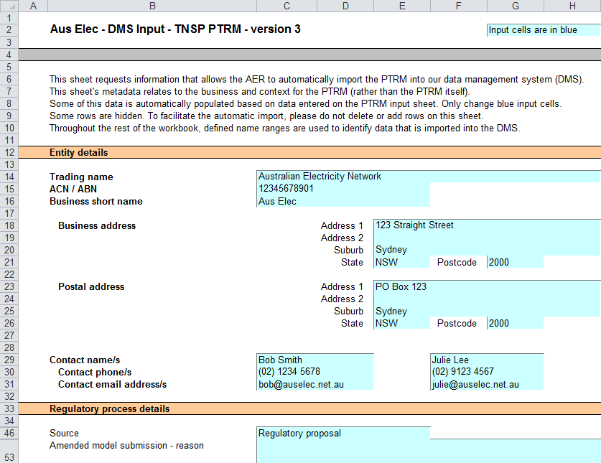

## PTRM input sheet

1. The **PTRM** input sheet provides for key input variables to be entered in the PTRM. They are automatically linked to corresponding cells in the relevant sheets. Values should be entered into each cell that has light blue shading. This sheet comprises of the following sections:

* opening regulatory asset base (RAB) and opening tax asset base (TAB)
* forecast real capex—as-incurred
* forecast real asset disposals—as-incurred
* forecast real net capex—as-incurred
* forecast real capex—as commissioned
* forecast real asset disposals—as-de-commissioned
* forecast real net capex—as-commissioned
* forecast real operating expenditure (opex)
* revenue adjustments from other use of prescribed transmission assets
* expected taxation rate
* cost of capital
* debt and equity raising costs—transaction costs
* MAR for the current year
* energy delivered forecast.

1. The only inputs specified outside of the **PTRM** **input** sheet are:

* inputs related to the automatic import into the DMS (on the **DMS input** sheet)
* inputs used when deriving smoothed revenue (on the **X factors** sheet).

1. These cells are also marked with light blue shading and are addressed when they arise.
2. Figure 3, Figure 4 and Figure 5 provide examples of the **PTRM** input sheet.

Figure 3 PTRM input sheet–first screenshot

1. 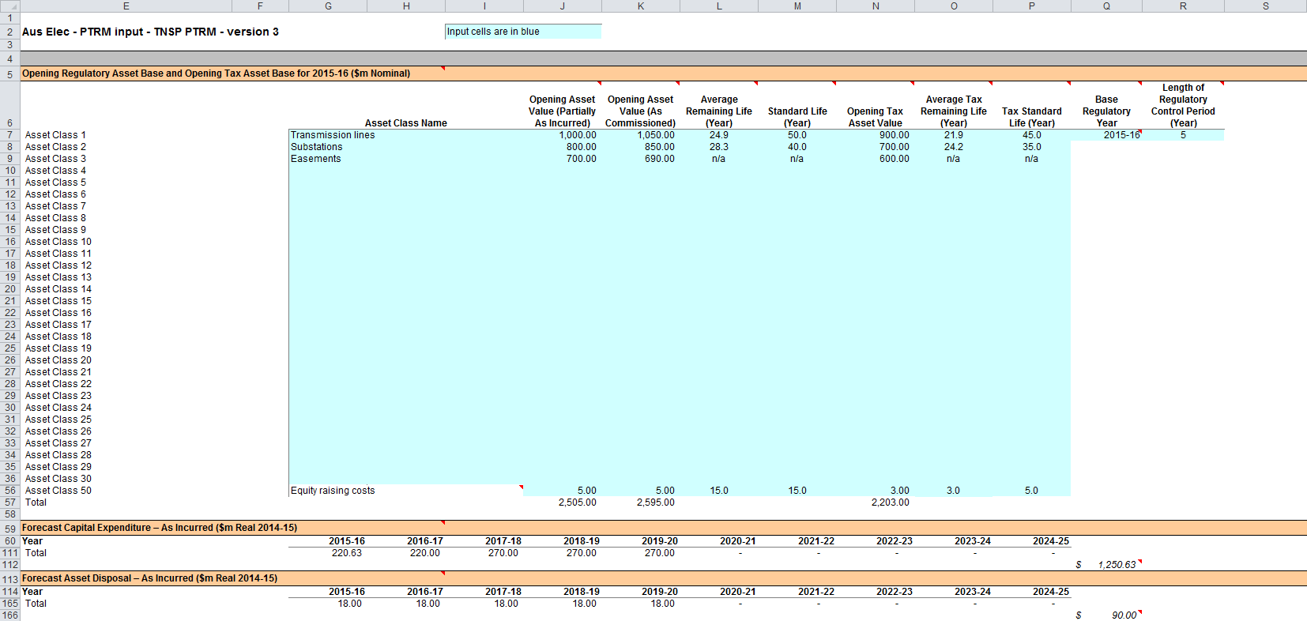

Figure 4 PTRM input sheet–second screenshot

1. 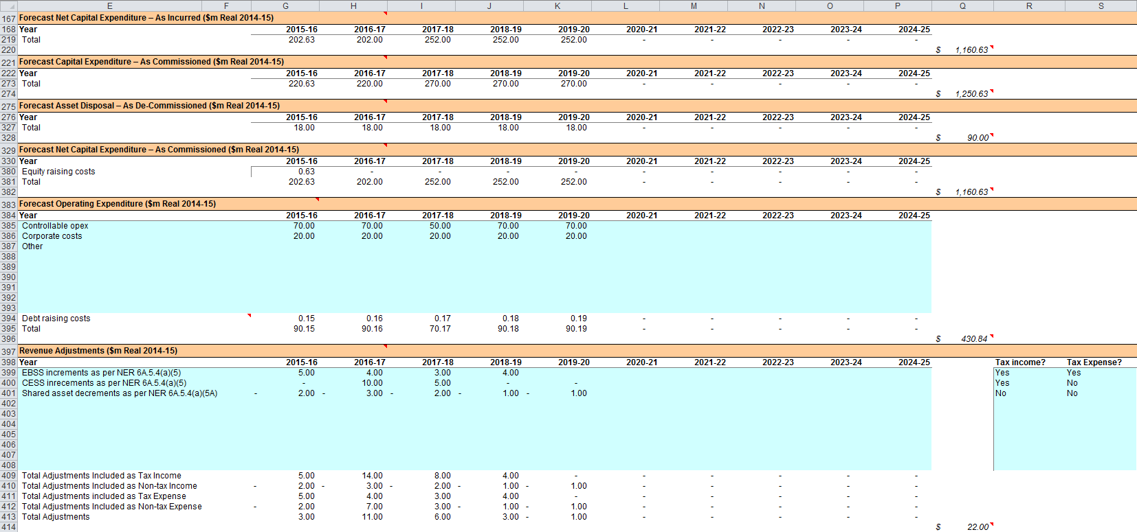

Figure 5 PTRM input sheet—third screenshot

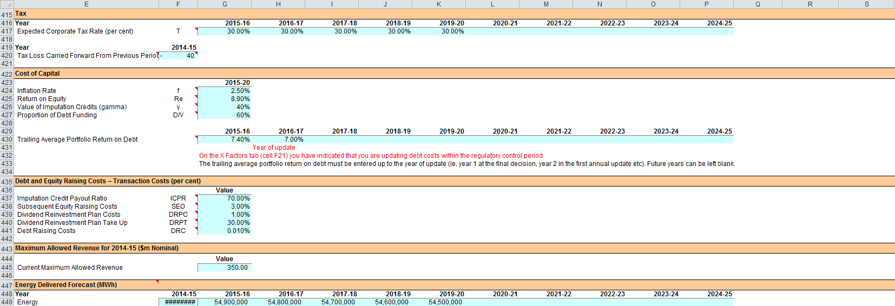

1. The PTRM can accommodate input data for up to a 10-year regulatory control period. Input cells outside of the relevant regulatory control period should be left blank.
2. The PTRM is configured to use the straight-line method as the default position for calculating depreciation for regulatory and tax purposes. If TNSPs intend to propose using other depreciation profiles, it is recommended that they raise this as part of pre-lodgement discussions.[5] For example, this could take place during the framework and approach process for a determination.[6]
3. The PTRM is also configured to recognise capex on a partially as-incurred (hybrid) approach.[7] As such, two RABs determined on the basis of as-incurred capex and as-commissioned capex are required to calculate the return on capital and the return of capital respectively.

### Opening regulatory asset base and opening tax base

1. The opening RAB is the value of assets on which a return will be earned. The opening TAB is used to calculate depreciation for tax purposes. The **PTRM** input sheet requires values for the opening RAB (broken into asset classes in rows 7 to 56) and opening TAB at the start of the first year of the next regulatory control period.[8] The RAB and TAB will differ each year to reflect forecast capex (as-incurred for the RAB or as-commissioned for the TAB), asset disposals and regulatory depreciation (for the RAB) or tax depreciation (for the TAB).
2. The recorded input values are linked to the Assets sheet, which also calculates depreciation for the next regulatory control period. Notes have also been included for various cells with specific comments and explanations about the relevance of the inputs.
3. Asset class name
4. The asset classes/names are recorded in column G. It is important that the number of asset classes recorded in the RAB section matches the number of asset classes identified in the capex section. This allows the PTRM to model consistent depreciation across the asset classes.
5. The PTRM is configured to accommodate up to 50 asset classes.[9] The number of asset classes used in the PTRM will vary between businesses.[10] However, for each business the number of asset classes used in the PTRM must be consistent with that used in the AER’s roll forward model (RFM) to allow the closing RAB values determined in the RFM to be used as inputs to the opening RAB values in the PTRM. RAB values by asset class derived from the RFM may be aggregated or disaggregated when forming inputs for the PTRM where this demonstrably improves the accuracy or administrative convenience of asset calculations.
6. Opening asset value (partially as-incurred)
7. The opening asset values for each asset class are recorded in column J and are manually sourced from the closing asset values (partially as-incurred) for each asset class determined in the RFM.
8. Opening asset value (as commissioned)
9. The opening asset values for each asset class are recorded in column K and are manually sourced from the closing asset values (as-commissioned) for each asset class determined in the RFM.
10. Average remaining life
11. The average remaining lives of each asset class are recorded in column L, based on the economic lives of the assets, and are manually sourced from the closing remaining lives for each asset class determined in the RFM (using a weighted average method).
12. Standard life
13. The standard lives of each asset class are recorded in column M and measure how long the infrastructure would physically last had it just been built.
14. Opening tax asset value
15. The opening tax asset values for each asset class are manually sourced from the closing tax asset values which have been determined in the RFM and are recorded in column N.
16. Average tax remaining life
17. The average tax remaining lives of each asset class for taxation purposes are recorded in column O based on the tax lives specified by the Australian Tax Office (ATO) for the category of assets and commissioning dates.
18. Tax standard life
19. The tax standard lives of each asset class are recorded in column P.
20. Base regulatory year
21. The regulatory year for the start of the next regulatory control period is recorded in cell Q7.
22. Length of regulatory control period
23. The number of years in the next regulatory control period is recorded in cell R7.

### Forecast real capital expenditure—as-incurred

1. The forecast capex (as-incurred) values for the next regulatory control period are recorded for each year in rows 61 to 110 (by asset class).[11] Capex is rolled into the RAB when spending is incurred. Generally, capex falls into three broad categories:

* asset augmentation (e.g. works to enlarge a network or to increase the capability of a network)
* asset replacement (e.g. replacing assets that have passed their useful lives)
* non-network asset (e.g. support the business expenditure)

1. These inputs must be reported in real terms based on start of year one dollar terms.

### Forecast real asset disposals—as-incurred

1. The forecast asset disposal (as-incurred) values are recorded for the year in which the disposal is expected to take place, in rows 115 to 164 (by asset class). These inputs must be reported in real terms based on start of year one dollar terms.

### Forecast real net capital expenditure—as-incurred

1. This section on forecast net capex does not require inputs to be recorded. For each asset class, forecast net capex is calculated based on the recorded forecast capex less forecast asset disposals. Forecast net capex (as-incurred) values are displayed in rows 169 to 218 and form part of the roll forward of projecting the RAB in the Assets sheet. These inputs are assumed to be in real terms based on start of year one dollar terms.

### Forecast real capital expenditure—as-commissioned

1. The forecast capex (as-commissioned) values are recorded for each year in rows 223 to 272 (by asset class). These inputs must be reported in real terms based on start of year one dollar terms.

### Forecast real asset disposals—as de-commissioned

1. The forecast de-commissioned asset disposal values are recorded for each year in rows 277 to 326 (by asset class). These inputs must be reported in real terms based on start of year one dollar terms.

### Forecast real net capital expenditure—as-commissioned

1. This section on forecast net capex does not require inputs to be recorded. For each asset class, forecast net capex is calculated based on the recorded forecast capex less the value of de-commissioned assets. Forecast net capex (as-commissioned) values are displayed in rows 331 to 380 and are used to calculate depreciation in the Assets sheet. These inputs are assumed to be in real terms based on start of year one dollar terms.

### Forecast real operating expenditure

1. Opex typically includes items such as wages and salaries, leasing costs, costs associated with maintaining transmission assets, input costs and other service contract expenses paid to third parties. The forecast opex values for each year are recorded in rows 385 to 393, including any carryover amounts determined according to the efficiency benefit sharing scheme developed by the AER. Row 394 displays benchmark debt raising costs and does not require inputs to be recorded because the calculation is formula-driven, and is based on the practice of treating the allowance as an opex line item. Additional opex inputs can be recorded by adding rows to this section—click on the button labelled **'**Insert new opex row'.
2. These inputs must be reported in real terms based on start of year one dollar terms.
3. The forecast total opex values (row 395) are linked to the Analysis sheet to calculate the ABBRR.

### Revenue adjustments

1. Any additional revenue adjustments applying to this regulatory control period are recorded in rows 399 to 408.[12] These are linked to the total building block revenue calculations in the **Analysis** sheet. Each line item in this section can be set to be treated as a tax income and/or a tax expense. These settings are determined by the drop down options in cells R399:S408. Totals for each combination of tax income and tax expense settings are in rows 409:413.

### Tax

1. The expected corporate tax rates are recorded for each year in row 417. The tax rates are linked to the WACC sheet to calculate the average tax rate and to the Analysis sheet to estimate the tax payable, as part of calculating the ABBRR.
2. Any tax losses carried forward from the previous period are included in cell F420.

### Cost of capital

1. The cost of capital section (rows 424 to 427 and row 430) records the following parameters:

* inflation rate[13]
* return on equity
* gamma—value of imputation (franking) credits
* proportion of debt funding
* trailing average portfolio return on debt for each year of the regulatory control period.

1. Each of these parameters is linked to the WACC sheet to calculate the weighted average cost of capital (WACC). The approach or method for determining each parameter is specified in clause 6A.6.2 of the NER or the AER Rate of return guideline.[14] Rows 431 to 432 contain content driven help which will display cautions or guidance based on input to this sheet and the **X factors** sheet.

### Debt and equity raising costs—transaction costs

1. The transaction cost of financing section (rows 437 to 441) records the following parameters:

* imputation credit payout ratio
* subsequent equity raising costs
* dividend reinvestment plan costs
* dividend reinvestment plan take up
* debt raising costs.

1. The values for the imputation credit payout ratio, equity raising and dividend reinvestment costs, and the dividend reinvestment take up are linked to the Equity raising costs sheet to calculate the allowance for benchmark equity raising costs associated with capex. The debt raising costs value represents the unit allowance and is linked to row 394 of the **PTRM** input sheet to calculate the overall benchmark debt raising costs to be included in the opex allowance.

### Maximum allowed revenue for the current year

1. Cell G445 records the current MAR for a TNSP. It is linked to the X factors and Revenue summary sheets, and helps provide historical comparisons for forecast revenues over the next regulatory control period.

### Energy delivered forecast

The energy delivered forecast values are recorded in row 449 and are linked to the X factors and Revenue summary sheets. Energy delivered forecasts may be obtained from the most recent Australian Energy Market Operator’s National electricity forecasting report, a TNSP’s annual planning report or other relevant industry sources.

## WACC sheet

1. The WACC sheet determines for each year of the next regulatory control period the required return on equity, return on debt and the WACC using the relevant cost of capital parameters from the **PTRM** input sheet. Some of these will be constant across the regulatory control period, but the return on debt (and therefore the overall WACC) may now vary year-by year.
2. The effective tax rates derived from the cash-flow analysis are also reported in the WACC sheet, including various measures of the WACC calculated from the forecast cash-flows in the **Analysis** sheet.[15] The nominal pre-tax return on debt (row 14) and the nominal post-tax cost of equity (row 10) are multiplied by the debt and equity components of the RAB (partially as-incurred) to determine the return on capital building block.[16]
3. In addition, there is a button labelled 'Set Te and Td' which is linked to a macro that should be pressed after all inputs have been finalised for establishing the ABBRR at the start of the next regulatory control period. This will copy the cash-flow derived effective tax rates for equity and debt from the **Analysis** sheet to the appropriate location in the **WACC** sheet (cells G27 and G28). The cash-flow derived rates shown in column R are designed as checks to ensure certain parameters are internally consistent with those derived by formula at the time of the final decision. Because the cash-flow derived rates are based on the use of a constant WACC, there is no need to press the 'Set Te and Td' button again as part of the annual return on debt update process during the regulatory control period. This process is discussed further in chapter 3.
4. Figure 6 provides an example of the WACC sheet.

Figure 6 WACC sheet

1. 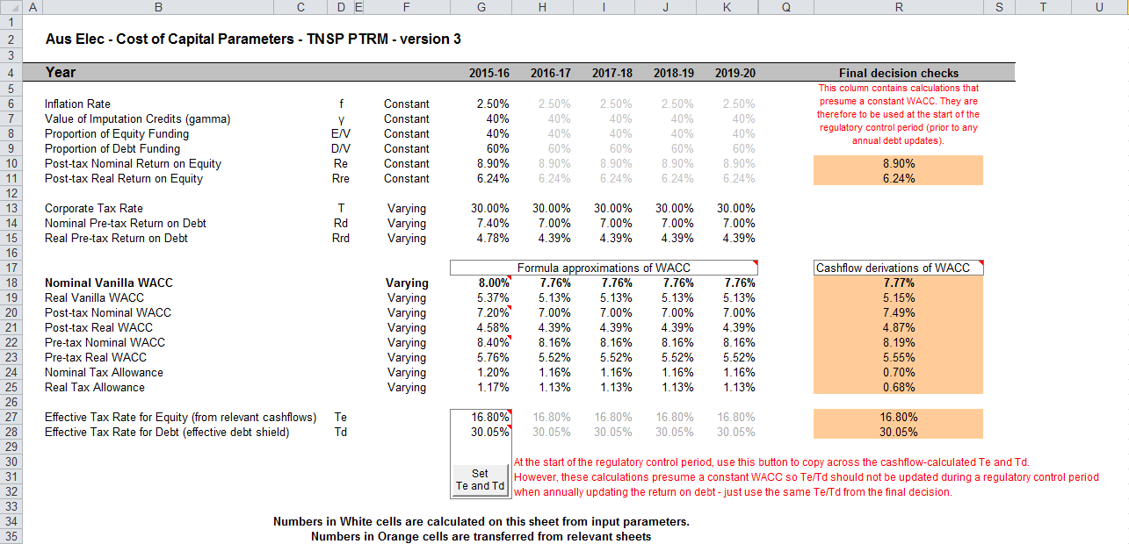

## Assets sheet

1. The Assets sheet calculates the value of the RAB for each year of the next regulatory control period in real (start of year one) and nominal dollar terms. It also calculates both regulatory and tax depreciation. The Assets sheet displays 55 years of data so that the effective tax rate can be estimated.
2. Figure 7 provides an example of the Assets sheet.

Figure 7 Assets sheet

1. 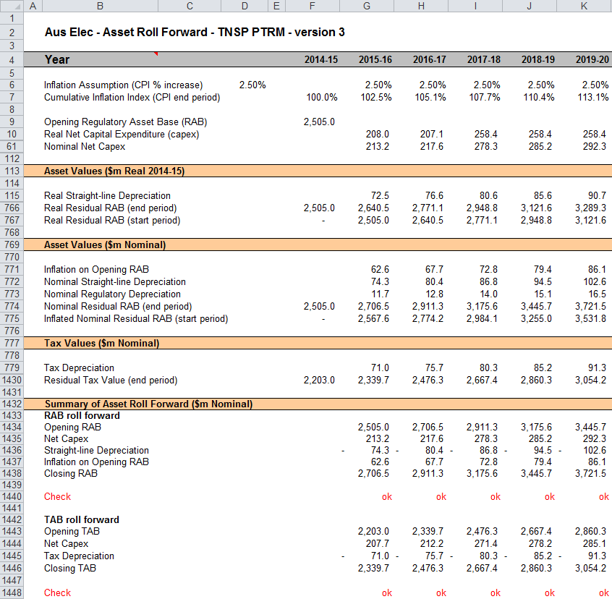

### Rolling forward the RAB and depreciation

1. For consistency, depreciation in a period must equal the difference between the asset value at the start and end of the period. Further, as depreciation is intended to represent the return of capital over the life of the asset, accumulated depreciation should not exceed the initial actual capital cost of the infrastructure.
2. The opening RAB (cell F9) and real forecast net capex (rows 10 to 60) values displayed in this sheet are sourced from the **PTRM** input sheet. Nominal forecast net capex values are displayed in rows 61 to 111. The modelling of capex in the PTRM is based on a partially as-incurred approach. Under this approach the return on capital is calculated based on as-incurred forecast net capex and the return of capital (depreciation) is calculated based on as-commissioned forecast net capex.
3. Capex is assumed to be incurred evenly throughout the regulatory year and therefore a timing assumption is adopted that on average places capex half-way through the year. However, the PTRM calculates the return on capital based on the opening RAB for each year and capex is not added to the RAB until the end of the year in which the expenditure on the asset is incurred. To address this timing difference in modelling the real capex, a half-real vanilla WACC is provided (capitalised and recovered over the life of the assets) to compensate for the six-month period before capex is included in the RAB (rows 11 to 60).[17] This is calculated using the specific half-real vanilla WACC applying to the year in which the expenditure is incurred.
4. Real asset values are displayed in rows 115 to 767. Real straight-line depreciation is calculated in rows 115 to 765. It uses the opening RAB, forecast capex (as-commissioned) values and asset lives from the **PTRM** input sheet. The individual depreciation profiles for each asset class can be viewed by expanding rows 116 to 765. The roll forward of the closing RAB in real dollar terms (start of year one) for each year is calculated in row 766.
5. Nominal asset values are displayed in rows 771 to 775. To compensate the TNSP for inflation, the residual value of the RAB at the end of each year is adjusted upwards for the amount of expected inflation in that year. This adjustment is calculated in row 771. The change in the nominal value of the RAB from year to year in nominal dollar terms is calculated by adjusting the closing RAB (row 774) for forecast net capex (as-incurred) and the regulatory depreciation allowance. Regulatory depreciation (row 773) is calculated as the nominal straight-line depreciation (row 772), less the inflation adjustment on the opening RAB (row 771).
6. Depreciation for tax purposes and the tax asset value over time is calculated in rows 779 to 1430 based on the tax asset values, net capex (as-commissioned) values and tax asset lives from the **PTRM** input sheet. The individual tax depreciation profiles for each asset class can be viewed by expanding rows 780 to 1429. Tax depreciation is calculated separately because asset values and asset lives for tax purposes generally differ from those for regulatory purposes.
7. A summary of the roll forward of the RAB is set out in rows 1434 to 1438. A summary of the roll forward of the TAB is set out in rows 1443 to 1446.

## Analysis sheet

1. The Analysis sheet itemises the basic costs, or building blocks of the TNSP, which are then added together to calculate the ABBRR. In other words, the Analysis sheet is where the data from the **PTRM** input sheet is combined with the calculations in the Assets and WACC sheets to estimate a TNSP’s revenue requirement. The Analysis sheet displays 55 years of data so that the effective tax rate can be estimated.
2. The Analysis sheet also includes an analysis of the forecast cash flows. This analysis provides rate of return measures estimated from forecast revenues and costs, including: expected pre and post-tax returns on equity, effective tax rates, the effective cost of debt and selected measures of the WACC.
3. Figure 8, Figure 9 and Figure 10 provide examples of the Analysis sheet.

Figure 8 Analysis sheet–first screenshot

1. 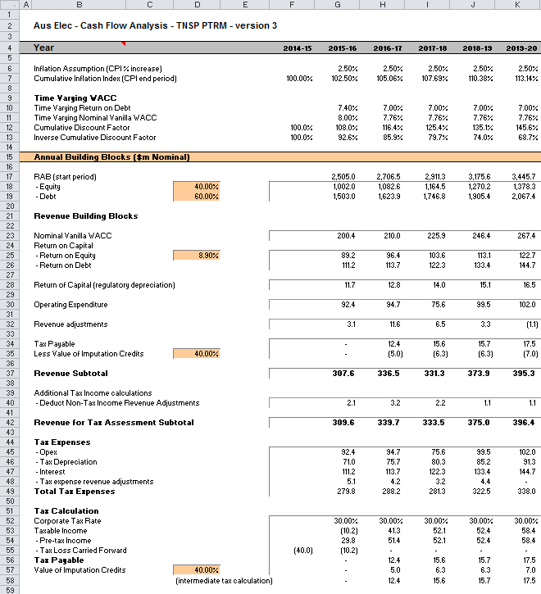

Figure 9 Analysis sheet–second screenshot

1. 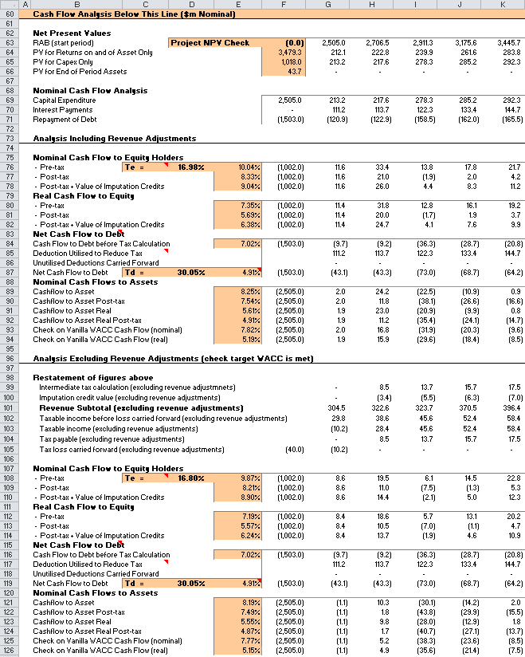

Figure 10 Analysis sheet—third screenshot

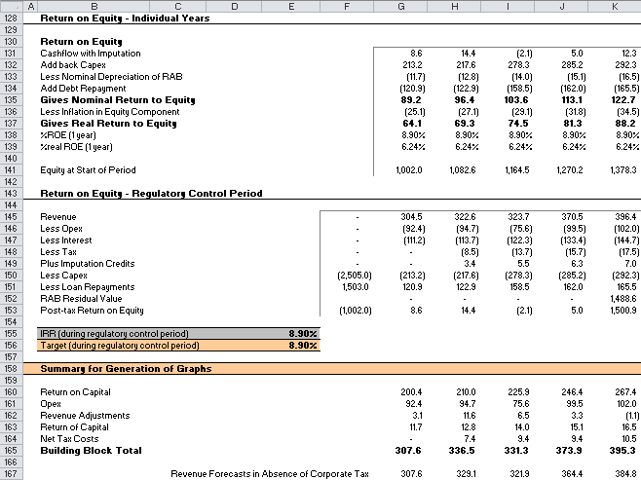

### Building block approach to deriving cash flows

1. Clause 6A.5.4 of the NER requires the AER to apply the building block approach to assess the revenues required by a TNSP to recover the full cost of providing the regulated transmission (prescribed) service. The revenue requirement includes a commercial return on its investment.
2. The key building blocks are:

* the return on capital comprising (row 23) :
* the post-tax return on equity (row 25)
* the return on debt (or the interest payments incurred) required to service borrowings (row 26)
* the regulatory depreciation or return of capital (row 28)
* opex including carry-over amounts (row 30)
* revenue adjustments (row 32)
* net tax liabilities payable—the figure is net in the sense that it is the annual tax payable by the TNSP (row 34) less the value of imputation credits available to investing shareholders (row 35).

1. The costs are determined for each year of the next regulatory control period to derive the building block subtotal (row 37). There is an additional adjustment to reflect the taxation implications of non-tax income revenue adjustments (row 40). Because the costs can fluctuate from year to year, the ABBRR (which includes the additional revenue adjustments) is smoothed over the next regulatory control period to give the MAR (see section 2.7).
2. As a result of the PTRM’s particular timing assumptions, i.e. all cash flows with exception of capex are assumed to occur at the end of each regulatory year, there is no need to provide TNSPs an allowance for working capital in the modelling.[18]

### Taxation and related costs and benefits

1. Tax is payable on revenue less tax costs recognised by the ATO. Tax-deductible costs include interest or debt servicing, depreciation allowances, opex and tax expense revenue adjustments (rows 45 to 48).
2. Spreadsheet calculations
3. Tax payable by the TNSP for each year is calculated in rows 40 to 53, in three steps:
   1. Pre-tax income (row 54) is calculated as the revenue subtotal less non-tax income revenue adjustments (row 40) less total tax expenses (row 49).
   2. Tax loss carried forward is calculated (row 55).
   3. Taxable income (row 53) is then the sum of the above.
4. The tax costs (rows 45 to 48) used in calculating the pre-tax income for the year are the same as those in the building blocks (rows 26 to 32) with the exception of depreciation and revenue adjustments. In the case of the revenue building blocks, regulatory depreciation (row 28) is calculated based on the economic life of the asset (see rows 115 to 765 and 771 to 773 of the **Assets** sheet). Tax depreciation is generally based on a much shorter tax life or calculated in a different way (see rows 779 to 1429 of the **Assets** sheet). For revenue adjustments, the tax implications of each individual adjustment are set on the **PTRM input** sheet. Those revenue adjustments which are treated as taxable income will add to pre-tax income (the net effect of rows 32 and 40). Similarly, those revenue adjustments which are treated as a tax expense will reduce pre-tax income (row 48). Where there are revenue adjustments that are taxable income but not a tax expense, the two effects will not be equal.
5. The tax payable is recognised as a building block cost and added to the revenue building blocks (row 34). Offsetting this tax cost is the benefit shareholders receive from the value of imputation credits (gamma). This offsetting benefit is equal to the value of imputation credits multiplied by the tax payable and is recorded in rows 35 and 57.

### Cash flow analysis

1. Calculations in the cash flow analysis section provide a comprehensive check on the validity of revenue determinations to ensure that the outcomes are consistent with the assumptions forming the basis of the building block approach. The Analysis sheet is designed to check the desired rate of return on equity that can be expected from the regulated revenue stream.
2. Net present values
3. The total returns on and of capital (comprising the RAB and capex) is calculated in row 64. The present value (PV) for these cash flows at the start of the first year of the next regulatory control period is calculated in cell F64. The PV for capex is calculated in cell F65, and the PV of end of period assets in cell F66. The sum of the PV of the returns on and of the RAB and capex, less the residual value of assets is calculated in cell F63. This project net present value (NPV) for the RAB check cell should be equal to zero, which indicates that the asset is receiving the correct returns.
4. Rows 73 to 176 set out cash flow analysis including (rows 76 to 94) and excluding (rows 98 to 126) revenue adjustments. Cash flow analysis excluding revenue adjustments allows the user to ensure that the target rate of return is being met. Cash flow analysis including revenue adjustments can be used to identify the incremental effects of revenue adjustments, which will cause the return on equity outcome to differ from the base return on equity. To enable the analysis excluding revenue adjustments, several cash flows terms must be restated, including the tax payable calculation. This takes place in rows 98 to 105. Aside from the different base data (including or excluding revenue adjustments), the mechanics of the calculations in each section are identical, and so they are discussed together.
5. Net cash flows available to equity holders
6. Net nominal pre-tax cash flows to equity holders (row 76 and row 108) are represented by nominal revenues less:

* opex
* capex
* interest payments
* any repayment of debt in the period

1. Net nominal post-tax cash flow to equity holders (row 77 and 109) is obtained by further deducting the tax expense of the business. Rows 78 and 110 add back the value of imputation credits to calculate the net post-tax benefits available to equity holders in a period.
2. The internal rate of return (IRR) of the net cash flows over the life of the assets is calculated in column E. The key IRR is the net post-tax returns to equity holders inclusive of imputation credits (re). The determined re should be validated by the estimated cash flows (rows 78 and 110).
3. The corresponding real cash flows and the respective IRRs are calculated in rows 80 to 82 and 112 to 114.
4. The difference in the IRR applying to pre-tax and post-tax cash flows to equity allows the effective rate of tax (Te = 1 – rpost/rpre) to be calculated (cells D76 and D 108). This can then be used as an input to the formula-based WACC calculations.
5. It is important to note that the formula-based WACC calculations will only provide an approximation of the actual WACC outcomes implied by the cash flow calculations. In practice, Te is substantially below the corporate tax rate for assets that can be depreciated at a faster rate for tax purposes.
6. Net cash flows necessary to service debt and the effective debt shield
7. The cost of debt is reduced by the value of the ‘debt shield’ (rows 85 and 117) in calculating tax liabilities. Where the interest expense in a year reduces taxable income by a corresponding amount, the net cost of debt for investors is reduced by the corporate tax rate.
8. However, where the taxable income is so low that the full interest deduction is not required to reduce tax liabilities to zero, the value of the debt shield benefit is deferred to a later period. This effect is analysed in rows 85 to 87 and rows 117 to 119. That part of interest expense used to defer tax is calculated in each year (rows 85 and 117) and the unused part carried forward is embodied in the tax loss carried forward calculation (row 86 and 118). This allows the net cost to the firm of paying debt holders, after taking account of the tax concession, to be calculated.
9. The IRR calculation (cells E87 and E119) represents the effective cost of debt, which is generally well below the nominal cost of debt based on the current interest rates.
10. Nominal cash flows to assets and calculation of WACC estimates
11. The cash flows to the different sources of capital (debt and equity) have been presented above, but the cash flows to the assets as a whole are of interest since these aggregate numbers characterise the nature of the regulated business.
12. The IRRs from these cash flows are the WACC estimates expected from the application of the regulatory framework and have greater validity than any formula-based approximations. The cash flow calculations from the section excluding revenue adjustments are then reported on the WACC sheet. These are the relevant IRRs for comparison against the formula-based approximations derived from the return on equity and return on debt inputs. It should be noted that the WACC outcomes are calculated for reporting purposes only. They are not required for setting revenues since the modelling already provides the requisite revenue forecasts.
13. Return on equity analysis
14. The next two sections demonstrate that the desired return on equity is being achieved in each year of the regulatory control period, and across the regulatory control period as a whole. In accordance with this aim, they use the cash flows after removal of revenue adjustments. In essence they expand on the calculations presented in row 110.
15. The first section (rows 130 to 139) demonstrates the return to equity holders on an annual basis. The second section (rows 145 to 156) demonstrates the return to equity holders across the entire regulatory control period.
16. Summary for generation of graphs
17. Rows 160 to 165 provide a summary table presenting total revenue components in accordance with the categories listed in the NER. These values are referred to in the **Chart 3–Building blocks** sheet.

## X factors sheet

1. It is common for the revenue stream resulting from the building block approach to be lumpy over the regulatory control period (e.g. because of a lumpy capex profile). The lumpy revenues, designed to deliver expected cost recovery, is regarded as undesirable because it can lead to price shocks for end users. Accordingly, chapter 6A of the NER requires the AER to smooth the time profile of revenues by constraining it to follow a CPI–X path.
2. The X factor is simply a price adjustment mechanism, and deriving the X factors is usually called smoothing. It does not relate to actual productivity improvements in the operations of a TNSP. However, this does not mean that the AER ignores productivity improvements when assessing a TNSP’s revenue proposal. Instead, the AER includes any expectation of productivity gains directly into the forecasts of costs.
3. The X factors sheet applies the smoothing methodology to the unsmoothed nominal forecast revenues—that is, the ABBRR. The ABBRR (rows 35 and 39) is sourced from the Analysis sheet. Under this approach, revenues are increased annually by CPI–X where the smoothing X factor is set so that the NPV of the smoothed revenue stream is equivalent to the NPV of the unsmoothed revenue stream. This allows some of the cost recovery to be diverted to adjacent years within the regulatory control period.
4. A TNSP may nominate the X factor to apply for each year (inputs at row 47) of the next regulatory control period. These X factors may differ from year to year subject to satisfying the requirements of the NER.
5. Clause 6A.6.8 requires X factors to be set such that:
   1. The NPV of the expected smoothed MAR (cell R44) must equal the NPV of the expected ABBRR (cell R39).
   2. The expected smoothed MAR for the final year of the regulatory control period must be as close as reasonably possible to the ABBRR for that year.[19]
6. When smoothing across the regulatory control period, it is necessary to iteratively update equity raising costs as well. This is because the estimate of equity raising costs is dependent on the smoothed revenue (MAR) profile, but in turn the MAR is dependent on the estimate of equity raising costs. Hence, there are a number of macros built into the PTRM which jointly smooth revenues while iteratively updating equity raising costs. It is possible to stop the automatic updating of equity raising costs using the drop down menu in cell G16.
7. The first macro has been set up to automatically calculate the default smoothing path. First, this entails setting the smoothed MAR for the first year equal to the ABBRR for that year (this will show as a change to the X factor in year 1, sometimes referred to as P0). Next, the macro calculates the single (constant) X factor which can be applied to all remaining years of the next regulatory control period so that the NPV of smoothed (MAR) and unsmoothed (ABBRR) revenue is the same. To implement this macro, click on the button labelled 'Apply default smoothing'. After the calculation is completed, the required X factors will show in row 47.
8. Alternatively, it might be necessary (including during the annual debt update) to adjust the X factor for a specific year only. The buttons at rows 49 to 50 can be used to ensure that the NPVs of the smoothed and unsmoothed revenue streams are equal—that is, the difference between the NPVs is zero (cell R49). These buttons will iteratively update equity raising costs while smoothing (unless this default option is turned off, as noted above).The nominal smoothed MAR, based on either employing the default smoothing that uses a single constant X factor or nominated set of X factors, is displayed in row 44. The difference between the final year ABBRR and MAR is presented in cells R41 (nominal dollars) and R42 (percentage of unsmoothed revenue).
9. All NPV calculations in this sheet now reflect the time varying WACC (row 7) which arises as a result of the return on debt (potentially) varying each year. The cumulative discount rate is calculated in row 8. When the return on debt is updated within the regulatory control period, these discount rates will change as a result, and so too will the NPV of the ABBRR and MAR.[20]
10. The process for annually updating the return on debt is described further in chapter 3. There is a drop down menu in cell F21 which allows the user to input the year of the annual return on debt update. This drop down menu will not affect underlying calculations, but instead drives the presentation of content-sensitive help in this sheet (and in the **PTRM input** sheet). Rows 23 to 26, and row 51, will display caution notes/guidance based on logical tests of the PTRM.
11. Figure 11 provides an example of the X factors sheet.

Figure 11 X factors sheet

1. 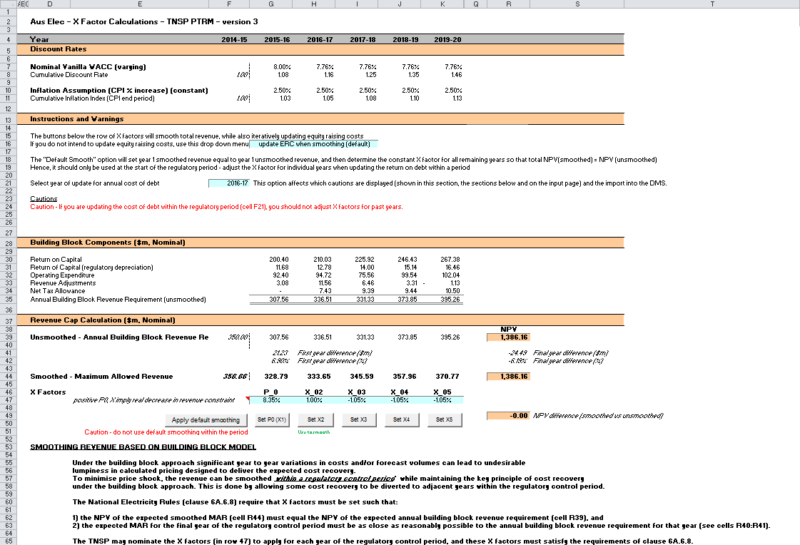

## Revenue summary sheet

1. The Revenue summary sheet outlines the various building blocks, the unsmoothed (ABBRR) and smoothed (MAR) nominal forecast revenues for the next regulatory control period. The building blocks and unsmoothed ABBRR are summarised in rows 7 to 12. The smoothed MAR and the X factors for the next regulatory control period are summarised in rows 16 and 17 respectively. The equivalent building blocks, unsmoothed and smoothed revenues, and X factors for the next regulatory control period in real dollar terms (start of year one) are also summarised in rows 21 to 31. All this information is sourced from the Analysis and X factors sheets.
2. The price path analysis section presents summary values for the forecast price path, derived from consideration of both forecast energy demand and revenue. These are broad indicators provided for illustrative purposes only.[21] Rows 38 to 43 present values in nominal dollar terms, and rows 50 to 55 present equivalent values in real dollar terms (start of year one). In each section, the forecast energy consumption is presented (sourced from the **PTRM input** sheet), together with the MAR (in nominal or real dollar terms, respectively). Total revenue divided by forecast energy demand provides the indicative price path. There are also calculations showing the percentage change year-on-year (again, in nominal or real dollar terms) and the average yearly change across the regulatory control period.[22]
3. Figure 12 provides an example of the Revenue summary sheet.

Figure 12 Revenue summary sheet

1. 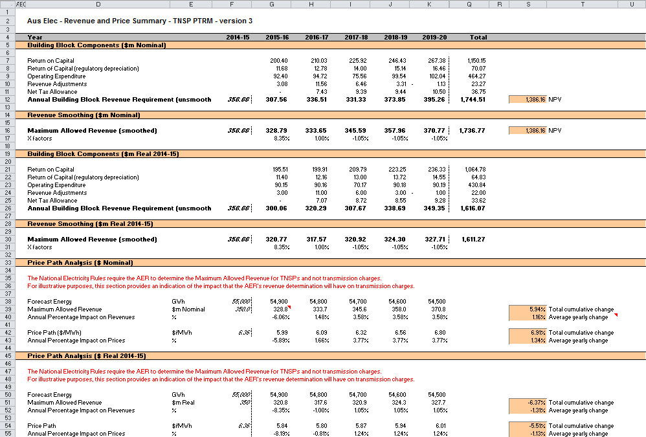

## Equity raising costs sheet

1. In raising new equity capital a business may incur costs such as legal fees, brokerage fees, marketing costs and other transaction costs. These are upfront expenses, with little or no ongoing costs over the life of the equity. While the majority of the equity a firm will raise is typically obtained at its inception, there may be points in the life of a firm—for example, during significant capital expansions—where it chooses additional external equity funding (instead of debt or internal funding) as a source of equity capital, and accordingly may incur equity raising costs.
2. The benchmark cash flow analysis applied by the AER to determine the extent to which equity raising associated with capex is required has been discussed in detail in previous transmission determinations.[23] Broadly, the analysis uses the PTRM cash flows to calculate the amount of retained earnings (taking account of cash flows such as revenue, opex, interest payment, tax payment dividends, and dividend reinvestment plans). The amount of retained earnings is deducted from the equity component of forecast capex (while maintaining the benchmark level of gearing) to determine any external equity requirement. The Equity raising costs sheet sets out the benchmark cash flow analysis.
3. The opening RAB and capex values (rows 7 and 8) are sourced from the Assets sheet. Based on this information the capex rate is calculated and displayed in row 9. The capex rate indicates the proportion of the capex relative to the opening RAB but does not affect the calculation of equity raising costs by itself.
4. The tax payable values (row 13) are sourced from the Analysis sheet and are used in combination with parameters (such as the corporate tax rate and imputation credit payout ratio) from the Inputs sheet to calculate the dividends payable (row 14). A proportion of dividends that are paid out to investors are assumed to be reinvested in the business. The amount of dividends reinvested by investors is displayed at row 16 and is used in the benchmark cash flow analysis to determine retained cash flows.
5. The benchmark cash flow analysis set out in rows 19 to 34 are undertaken in nominal dollar terms and is used to determine the equity raising costs as follows:

* The revenues (row 19) sourced from the X factors sheet less expenses such as opex, interest payments, tax payable and other revenue adjustments (rows 20 to 23) sourced from the Analysis sheet provides the internal cash flow (row 24).
* The internal cash flow less dividends paid out to shareholders (row 25) provides the retained cash flow (row 26).
* The capex funding requirement (row 30) is sourced from row 8, adjusted to remove the gross-up for the WACC provided in the PTRM to account for the assumed timing of the incurrence of capex, which is not relevant for financing purposes. The debt component (row 31) represents the increase in debt funding and is sourced from the Analysis sheet, whereby to maintain the benchmark level of gearing, the level of debt must equal 60 per cent of the RAB rather than capex. The residual of capex funding requirement less the increase in debt funding gives the equity component (row 32), which represents the amount of capex that must be funded through retained earnings and then new equity.
* The equity component less retained cash flow (row 33), where it is insufficient, indicates the additional equity requirement (row 34).[24]

1. Rows 38 to 40 displays the equity component, retained cash flow and additional equity requirement in real dollar terms (based on start of year one) by converting the nominal dollar equivalents set out in rows 32 to 34. Dividend reinvestment also in real dollar terms is displayed in row 42 by converting the nominal dollar equivalent as set out in row 15.
2. If the total equity requirement over the next regulatory control period is above zero, cell Q46 calculates the total dividend reinvestment plan requirement based on the total amount set out at Q42. The total external equity requirement over the next regulatory control period is calculated at cell Q47 by taking the difference between the total equity requirement and the total dividend reinvestment. Cell Q48 displays the sum of the total dividend reinvestment plan requirement and the total external equity requirement. This is the total equity requirement.
3. Based on the total amount of dividends reinvested (cell Q46) and the external equity requirement (cell Q47) the cost for each of these component (sourced from the **PTRM** input sheet) is calculated in cells Q50 and Q51 respectively. The sum of these components provides the total equity raising costs in real dollar terms (start of year one) and is displayed at cell Q52. A positive value for the total equity raising costs over the next regulatory control period indicates that the calculated benchmark equity raising costs should be allowed and recovered by the TNSPs.
4. The equity raising costs calculations must be performed iteratively because they are both an input to and an output from the building block calculation.[25] In other words, a change in the equity raising costs will change the ABBRR and MAR, which in turn changes the equity raising costs. Further, the equity raising costs calculation depends on both unsmoothed building block components (for instance, the outgoing cash flows each year) and the smoothed total revenue (for instance, the available revenue each year). Accordingly, changes to the smoothed revenue profile (the MAR) can change the required equity raising costs, starting the cycle again.
5. By default, the smoothing macros in the **X factors** sheet perform these iterative calculations for equity raising costs at the same time. However, this function can be disabled using the drop-down menu in cell G16 of the **X factors** sheet.[26]
6. Figure 13 provides an example of the Equity raising costs sheet.

Figure 13 Equity raising costs sheet

1. 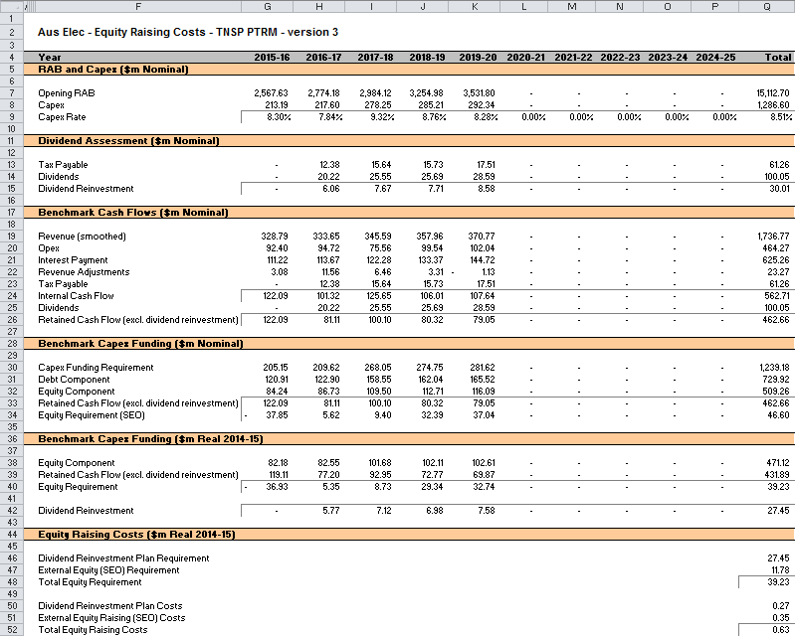

## Chart 1—Revenue

1. The Chart 1–Revenue sheet displays a chart that incorporates the:

* nominal and real ABBRR
* nominal and real MAR derived under the revenue cap.

1. This information is sourced from the Revenue summary sheet.
2. Figure 14 provides an example of the Chart 1–Revenue sheet.

Figure 14 Chart 1–Revenue sheet

1. 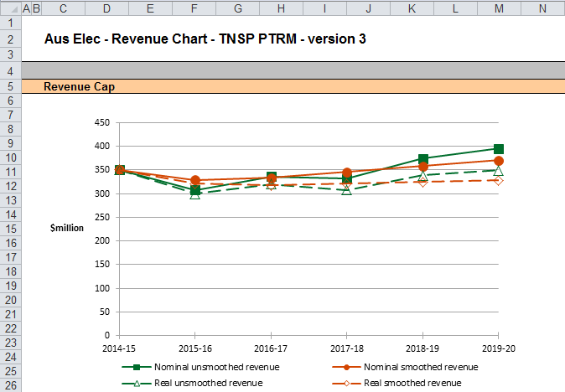

## Chart 2—Price path

1. The Chart 2–Price path sheet displays a chart that presents the indicative price path (approximated by total revenues divided by total energy demand forecast) in nominal and real dollar terms (start of year one).
2. This information is sourced from the Revenue summary sheet.
3. Figure 15 provides an example of the Chart 2–Price path sheet.

Figure 15 Chart 2–Price path sheet

1. 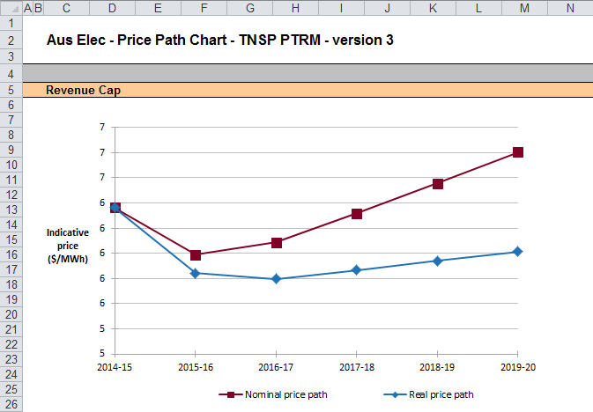

## Chart 3—Building blocks

1. The Chart 3–Building blocks sheet displays the various building block cost components making up the ABBRR:

* return on capital
* regulatory depreciation
* opex (excluding any carry-over amounts)
* net tax costs
* carry-over and other revenue adjustments.

1. This information is sourced from the Analysis sheet.
2. Figure 16 provides an example of the Chart 3–Building blocks sheet.

Figure 16 Chart 3–Building blocks sheet

1. 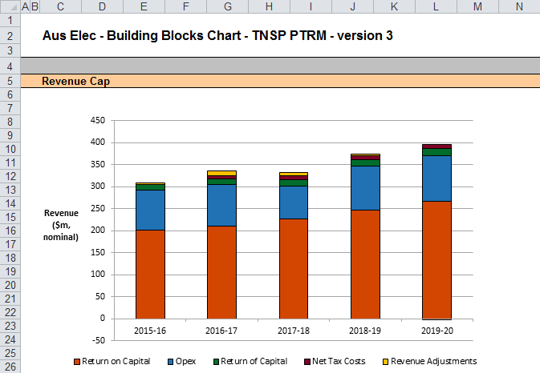

# Process for annual return on debt update

1. This section sets out the default process to set X factors at the time of the final decision, and the default process for annual updates of the return on debt. Some aspects of this approach will be guided by policy decisions to be made during individual determinations. However, following the process set out below will likely result in the basis for calculations that is consistent with the requirements of clauses 6A.6.2(h)–(l) of the NER.

## Setting X factors for the final decision before the start of the regulatory control period

* 1. Complete all inputs in the **PTRM** **input** sheet. This requires a trailing average portfolio return on debt value only in G412.[27] By default, the PTRM approach adopts the most recent trailing average portfolio return on debt that is entered, where there is no further forecast values entered for other years in the regulatory control period. Accordingly, it is not necessary to enter the cost of debt for later years in the regulatory control period at this stage.[28]
  2. In the **X factors** sheet, ensure that the equity raising costs update option (cell G16) is set to 'update ERC when smoothing (default)'. This will ensure that the equity raising costs calculations are iteratively updated as part of setting the X factors.[29]
  3. In the **X factors** sheet, check that cell F21 is set to the first year of the next regulatory control period. This will ensure the correct checks and warnings operate for the model.
  4. In the **X factors** sheet, apply revenue smoothing:
     1. If applying the default X factor path (year 1 ABBRR = year 1 MAR; X2=X3=X4=X5; NPV(ABBRR) = NPV(MAR)), press the button labelled 'Apply default smoothing'.
     2. If applying an alternative smoothing path, manually enter values for all X factors (cells G47:P47) except one, then press the relevant button to calculate the final remaining X factor (so that NPV(ABBRR) = NPV(MAR)). This final X factor can be any of the X factors in the regulatory control period (including the first year, which is also labelled as 'P0')
     3. In either case, it is necessary to consider the resulting difference between the final year ABBRR and MAR (shown in cells R41 and R42). If this difference would not meet the requirements of NER clause 6A.6.8, return to step (b) and manually adjust one or more X factors again (ensuring that the final X factor adjustment uses the relevant button so as to jointly smooth the revenue and equity raising costs calculations).
  5. In the **WACC** sheet, press the 'Set Te and Td' button to copy the cash-flow derived effective tax rates for equity and debt from the **Analysis** sheet to the appropriate cells in the **WACC** sheet.

## Updating X factors to incorporate the annual update to the trailing average portfolio return on debt

* 1. In the **X factors** sheet, select the relevant year of update in cell F21.
  2. In the **PTRM input** sheet (row 412), enter the trailing average portfolio return on debt values up to and including the relevant year of update, consistent with that selected in cell F21 of the **X factors** sheet.[30] Caution notes will appear in rows 413 to 414 of the **PTRM** **input** sheet to show which inputs are necessary. No other inputs should be changed.
  3. In the **X factors** sheet, ensure that the equity raising costs update option (cell G16) is set to 'update ERC when smoothing (default)'.
  4. In the **X factors** sheet, apply smoothing to recalculate the X factor using the button for the relevant year as identified in step 1. The correct year for update will be identified by a caution note in row 51 under the smoothing X factor buttons. It is important that the X factors for past years in the regulatory control period are not altered, since these X factors reflect the revenue (and price) outcomes from those years. Further, the default approach is that only the X factor for the year of update should be altered (rather than multiple X factors, for this year and remaining years within the regulatory control period).[31] This means that the impact of increases/decrease in that year's return on debt will be fully reflected in price changes in that year. For example, to re-smooth for a return on debt update in year 2 the button labelled 'Set X2' would be used, and all other X factors as determined during the final decision process would remain unaltered.

1. The set of Microsoft Excel spreadsheets which constitute the PTRM were created in Microsoft Excel 2010. The AER recommends this or a later version of Microsoft Excel be used in applying these spreadsheets.
2. This requires the total smoothed and unsmoothed revenues to be equal in net present value (NPV) terms.
3. Note that this is an iterative process, because changing smoothed revenue alters equity raising costs, changing equity raising costs alters unsmoothed revenue, and changing unsmoothed revenue alters smoothed revenue.
4. For example, whether the PTRM relates to the Regulatory proposal, Draft decision, Revised regulatory proposal or Final decision.
5. The depreciation profiles would be subject to satisfying the requirements of clauses 6A.6.3(b) and 6A.6.4 of the NER.
6. Clause 6A.10.1A of the NER sets out the requirements of the framework and approach applying to a determination.
7. The partially as-incurred method for recognising capex calculates the return on capital based on an as-incurred approach and the return of capital (regulatory depreciation) is based on an as-commissioned approach.
8. The button at the left of row 56 may be pressed to display/hide rows 37 to 55 (asset classes 31 to 49).
9. The PTRM can be expanded to accommodate additional asset classes, when necessary.
10. The 50th asset class is designed to be used only with the 'Equity raising costs' asset class. Several defined name ranges use this asset class to implement the iterative equity raising costs update when smoothing total revenue.
11. Row 110 (asset class 50) is designed to be used for equity raising costs only.
12. The PTRM templates include sample revenue adjustments line items, which should be treated as basic examples of the type of revenue adjustments (and tax treatments) that might be included. The examples should not be read as indicating the AER’s position on the tax implications of these particular revenue adjustments.
13. Clause 6A.5.3(b)(1) of the NER requires the AER to specify in the PTRM a methodology that is likely to result in the best estimate of expected inflation. The AER uses an approach that calculates the geometric average based on the inflation forecasts for two years sourced from the latest available Reserve Bank of Australia’s (RBA’s) Statement of monetary policy and the mid-point of the RBA’s target inflation band for eight years (see AER, Final decision, TransGrid transmission determination 2009–10 to 2013–14, 28 April 2009, pp. 60–64).
14. AER, Better regulation: Rate of return guideline, December 2013.
15. These link to the cash-flow analysis excluding the effect of revenue adjustments, which is the relevant basis for checking that the target return on equity has been met.
16. See rows 24 to 27 in the Analysis sheet, which calculate the return on capital and provide a breakdown of the return on equity and return on debt.
17. The half-real vanilla WACC is calculated as the square root of (1 + real vanilla WACC) – 1 to account for the compounding effect on an annual rate.
18. The timing of the capex cash flow is assumed to be mid-year.
19. The AER in its regulatory determinations has considered a divergence of up to 3 per cent between the expected MAR and ABBR for the final year of the regulatory control period to be reasonable if this can achieve smoother price changes for customers over the regulatory control period.
20. This is not the only change that flows from a change to the return on debt – the return on capital and return of capital building blocks will change, and therefore so will the tax building block.
21. These price paths are also presented for comparability with the distribution PTRM, where they relate to additional alternative forms of control (specifically, the weighted average price cap and revenue yield cap) which are available to DNSPs but not TNSPs.
22. The average yearly change is calculated as the geometric mean (not the arithmetic mean), and therefore reflects the cumulative impact of year-on-year percentage changes across the regulatory control period. In other words, the value shown in cells S40, S43, S52 and S55 is the percentage change that, if applied to every year in the regulatory control period, would arrive at the total cumulative change across the period.
23. AER, Final decision, Powerlink transmission determination 2012–13 to 2016–17, April 2012, pp. 145–147.
24. Where there is sufficient retained cash flow to cover the equity component of capex, the amounts shown in row 34 would be negative.
25. This does not mean that the calculation method for the entire workbook needs to be set to manual or iterative (under Options -> Formulas -> Calculation options). The implementation in the PTRM is such that direct values are entered on the **PTRM** **input** sheet, so there is no circular reference, and the iterative updates are managed via macros when smoothing. Hence, the calculation option can be left as automatic, without iteration.
26. In that case, the equity raising costs entered (in two places) in the **PTRM** **input** sheet will not be updated to reflect the calculation in the **Equity raising costs** sheet. A caution will appear in the **X factors** sheet (cell D26) when the relevant values do not align.
27. Also, the year-by-year tax rates (row 402) only require the first year (cell G402) to be entered; the PTRM will apply this tax rate to later years where there is no explicit tax rate entered.
28. The PTRM will use the return on debt for a given year if entered, so if forecasts were entered for later years in the regulatory control period (and these values differ from the year 1 return on debt), this will be reflected in the building block calculations. However, this is not intended to be the default operation of the PTRM. If a TNSP was to propose (at the time of making the final decision) return on debt forecasts for year 2 onwards this would need to be assessed as part of an individual determination.
29. The ‘do NOT update ERC when smoothing’ option can be selected for certain analysis that seeks to isolate the impact of equity raising costs from the revenue requirement.
30. By default, the PTRM will use the most recent return on debt value as the forecast for later years (where the return on debt is not yet known). Hence, at each annual update the forecast for the remaining years in the regulatory control period will be updated.
31. If a TNSP was to propose an alternative approach (for instance, where multiple X factors were changed in response to a given year's annual return on debt update) this would need to be assessed as part of an individual determination and approved as part of the final decision.