**Submission**

**To: Australian Energy Regulator**

**From: Uniting Care Australia**

**Subject: Expenditure Incentive Draft Guidelines**

**Introductory Comments**

Uniting Care Australia again commences this submission by commending the AER for their commitment to consumer engagement as demonstrated particularly through the Better Regulation Program and we recognise the outstanding contribution that staff have made in assisting to unpack a number of quite complex issues. Certainly there is a mixture of art and science that is required to deal with the issues associated with expenditure incentive regulation.

**What Consumers Want**

Before going into specific comments about the Expenditure Incentive Draft Guideline, we re-iterate some comments we made earlier about what we understand consumers want from energy regulation. WE present this as a context for incentive regulation

Firstly, it is crucial that the AER is independent, is able to provide leadership and ultimately is able to make strong and clear decisions. Secondly, consumers want an AER that encourages consumer engagement, not just arms length consultation but consumer engagement that is integrated into all aspects of regulatory work, as has been demonstrated through the “Better Regulation” program

We recognise that there have been a number of comments made during the Better Regulation process about consumers wanting certainty – this has been prominent in Rate of return discussions, and others Consumers recognise that there are risks associated with regulatory process and some volatility for consumers is accepted as long as a couple of conditions are met:

1. Firstly that consumers are not hit with big price shocks. This is deleterious to consumers and particularly low and modest income consumers whose incomes don’t rise with big shocks in prices.
2. We also need to have a system where consumers both win and lose over time, not always losing.

Consumers also expect:

1. Acceptable levels of reliability of supply
2. Safety
3. Transparency and integrity (They want to be able to trust their utility providers)
4. Prudent spending on capex and opex

**Context for Incentive based regulation**

Another contextual observation for this guideline is the declining multifactor productivity for the utilities sector (Electricity, Gas, Water and waste services), over the past decade. This is summarised in chart 1. We suggest that this steady decline in multifactor productivity reflects an industry of declining efficiency and consequently one where consumers are paying more than they should be paying

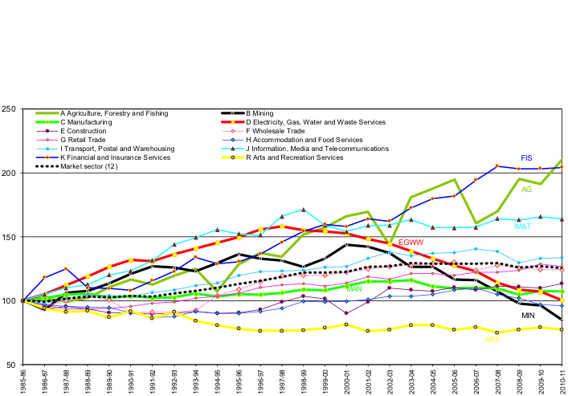

Chart 1. Source: Productivity Commission. An overview of Australia’s Productivity Performance, Nov 2012

The following responds to some aspects of the Expenditure Incentive Guideline

**3. The Capital Expenditure Sharing Scheme (CESS)**

Uniting Care Australia supports the comprehensive nature of the proposed CESS, with one overarching incentive scheme covering all electricity network service providers, both transmission and distribution businesses, across the country of Australia.

Continuous Incentive

We support the notion of “equal power” of incentive across each year of a five year regulatory period. Whilst we recognise that there is some nuance in this position, we recognise that there may be some need to review this in the future as part of reviewing actual CAPEX on a year by year basis and comparing actual with regulated CAPEX.

Cumulative

We support the notion that both over and under expenditure is assessed across the whole of the five year regulatory period and not considered on an annual basis. We believe that this is in keeping with the longer term notion of many network assets and the notion of network assets being developed and managed in the long term interest of consumers.

Symmetry

This is the core element of concern that we have with the CESS where we believe that the notion of symmetry is alluding to fairness and reasonableness, but in fact is not an appropriate response to the fundamentally asymmetrical nature of network business and consumer interest in CAPEX.

We simply do not accept that consumers should bear the majority risk for over expenditure on CAPEX.

We note that whilst regulatory reset periods are for five years and that there a lack of precision for forecasting, regulated network businesses have a number of options to deal with unforeseen circumstances that occur over the five year period of a regulatory determination. There are a number of pass through and reset options that networks can take to a regulator and consequently to consumers at any point of time during a regulatory period, assuming that the matter has some materiality. (It is recognised improved forecasting is a significant addition to the regulatory tool kit, as an element of the Better Regulation program)

We believe that the draft guideline fails to adequately consider the two-part impacts of capital over expenditure, namely;

* Impacts of capital over expenditure within the regulatory period
* The ongoing impact of capital over expenditure going into the regulated asset based (RAB) and consequently placing a burden on consumers for extended periods of time. This being because the regulated asset base is a significant component of determining network returns and therefore costs consumers.

We propose an “asymmetrical” response to cost sharing for capex overspend and underspend. We accept the current proposal from the draft guidelines for underspend arrangements, but for overspend arrangements we believe that a 50/50 split between consumers and network businesses for any overspend is more appropriate. We recognise that any overspend which is deemed inefficient should not be borne by the consumer, nor should any element of that over expenditure capital be included in the RAB for future determination purposes.

We recognise that the AER’s views have changed from earlier drafts of this guideline to the draft guideline with stated reasons including that NSP’s have claimed that there is little evidence of over forecasting for CAPEX and therefore little evidence of inefficient spending. We are not convinced with this argument. We do not believe that the location of the efficiency frontier for network businesses is known in Australia and generally believe that network businesses are operating somewhere behind the efficiency frontier., as suggested by declining multifactor productivity in chart 1. We recognise that the expenditure forecasting work stream with better regulation is laying a very solid foundation that will help with improved understanding of efficiency of network businesses into the future. For now it is not a sound reason for the ‘symmetrical’ penalties suggested by NSP’s, where consumers overpay There is also an argument that not all NSPs overspend on their CAPEX allowance, again this is not appropriate because good regulation is about rules and processes that apply to everybody, with consumer benefit the overarching objective.

There is also a view that ex post reviews and better forecasting will improve the effectiveness and efficiency of network business operation and so there is unlikely to be an issue with overspending. This may be the case in the future, but certainly these arguments don’t hold for the immediate future at the very least and therefore are not sound reasons for moving from an asymmetrical to a symmetrical approach for penalties for overspend of CAPEX.

Uniting Care Australia strongly supports an asymmetrical approach to cost sharing regarding capital over-expenditure and believes that at least 50% of any overspend should be borne by network businesses even if those expenditures are subsequently deemed to be efficient. We also believe that ex-post assessments need to very carefully consider the proportion of overspend that is allowed into the RAB for coming periods.

**5. Ex-post Measures for Efficient Capital Expenditure**

Uniting Care Australia recognises the value of ex post reviews as a disincentive for over expenditure; however we question the amount of weight that should reasonably be applied to ex post reviews in the short to medium term.

We are concerned that ex post reviews can effectively be happening some 6 to 7 years after an inefficient over expenditure may have occurred, this allows plenty of time for what may have been inefficient expenditure to be recast in terms of more efficient expenditure and therefore puts consumers at greater risk of higher than necessary costs. Another problem with ex post reviews is that any rebalancing of costs particularly going back towards consumers, is happening a very long time after consumers have borne the costs of inappropriate or inefficient overspending. We believe that this time delay in itself is a significant reason for limiting the scope and weight of ex post reviews. We believe that the strength of the incentive regime should be at the front of end of regulatory processes with ex post reviews really being a “backstop” to review processes that may have not been in the interests of consumers which have not been picked up elsewhere in the regulatory process.

**6. Efficiency Benefit Sharing Scheme**

Uniting Care Australia is supportive of the thrust of the Efficiency Benefit Sharing Scheme (EBSS) for operating expenditures. We support the continuous nature of the schemes proposed and the rolling yearly process. We also recognise that along with other aspects of the Better Regulation program, there needs to be close monitoring of the actual practice of application of the Efficiency Benefit Sharing Scheme. Monitoring and review also needs to apply to ex post reviews. Other Better Regulation developments will also need review, including expenditure forecasting outcomes and the extent to which consumer engagement effectively occurs over next round of regulatory resets.

**Concluding Comments**

As with some other submissions that we have made to aspects fo the Better Regulation program, we have appreciated the collegiality of other consumer groups and consultants in the this process. We draw attention the submission on this topic by PIAC, the Public Interest Advocacy Centre of NSW, and support the additional detail that their submission has provided

We also thank the AER for the opportunity to participate in the Better Regulation Program. We look forward to seeing the final guidelines later this year.

Further Information

Mark Henley

Ph: 0404067011

Email: MarkH@unitingcommunities.org