

Submission

**To: Australian Energy Regulator**

[AERInquiry@aer.gov.au](mailto:AERInquiry@aer.gov.au)

Topic: Topic: ElectraNet Electricity Transmission Revenue Proposal

- 1 July 2018 to 30 June 2023

**Issues Paper**, **May 2017**

**Date: July 2017**

**Contact:**

**Mark Henley**

**E:** [**MarkH@unitingcommunities.org**](mailto:MarkH@unitingcommunities.org)

**P: (08) 82020 5135**

**Uniting Communities Incorporated trading as Uniting Communities ABN 33 174 490 373**

[**www.unitingcommunities.org**](http://www.unitingcommunities.org)

**Uniting Communities Experience in Working With ElectraNet**

Uniting Communities was invited to be a member of the ElectraNet consumer advisory panel in July - August 2015, and we were pleased to accept the invitation. We advised ElectraNet of our willingness to participate and also informed them of the recently released, at the time, report dealing with network regulatory reform that has just been released through uniting care Australia. The report was titled “the DNA approach to network regulation,” where DNA was an acronym for deliberation, negotiation and agreement. We told ElectraNet that we were keen to explore some of the ideas raised in this paper. They also signalled an interest in developing the regulatory proposal in a manner that gave it a high likelihood of being accepted by stakeholders, including the Regulator.

The collegiality demonstrated by ElectraNet in developing their regulatory proposal has been deeply appreciated by Uniting Communities and we are accepting of their regulatory proposal as reasonable and certainly developed in good faith with significant efforts being made to engage consumer and stakeholder views. We certainly feel that we been taken seriously over the nearly 2 years since we first talked about this particular regulatory proposal.

We think it important to share something of the journey that we have taken with ElectraNet, and other stakeholders, over the past couple of years. The journey that we have been a part of, and indeed believe we’ve helped to shape is summarised by the graphic below, Figure 1, has been developed by ElectraNet.

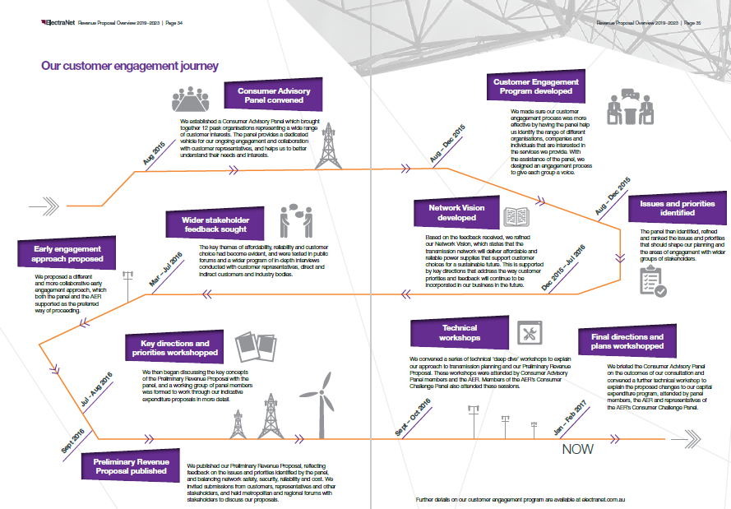

*Figure 1, Source ElectraNet revenue proposal*

**Definitions of Terms**

Before telling our version of the ElectraNet engagement process, we clarify some terms that we have used in this submission, regarding aspects of approaches to consumer engagement. This is our understanding of some important terms.

1. Deliberation: a process spanning over at least a couple of weeks where a group of people from a range of consumer perspectives are brought together at least twice and take in to facilitate a process, not from the network business, to consider an important topic of some complexity. Citizen juries are one form of such deliberative processes.
2. Negotiated agreement: documentation about the negotiation undertaken to reach areas of agreement, between the network business and relevant stakeholders
3. Agreement: some form of documentation of areas of agreement between accepted consumer interests and network business, which is presented to the regulator with lodgement of a regulatory proposal.

We have described these 3 terms as the “DNA approach to network regulation”

1. Deliberative forum: a gathering of at least 50 people from a range of consumer perspectives were guided through a process of open questions and discussion for at least four hours. We observe that some network businesses are utilising this approach now, though it was not a formal part of the ElectraNet process. (this is not a criticism, purely an observation)
2. Deep dive. Detailed consideration of a more complex or contentious issue that is part of a regulatory proposal. In the ElectraNet context, this has been a part of the “Front ended” approach that has been applied.
3. No surprises proposal: regulatory proposal lodged under the rules where no stakeholder, including the Regulator, finds any aspect that they were not expecting. Note that ‘no surprises’ does not mean agreement, it means that where there are points of disagreement between any parties, these have been identified and fully explored.
4. Fast track: consideration of a regulatory proposal by the Regulator, that takes less time than a standard process. The decision making being fast tracked due to extensive engagement with stakeholders, including consumers, prior to lodgement. We note that fast tracking is currently not possible under the electricity rules in Australia, but is an option for Ofgem, in the UK. We also note that there is movement away from using this term in Australia at time of writing, but the term was important in this ElectraNet journey
5. Front loaded: this is an emerging term for a process whereby a network business releases details of their intended regulatory proposal four - six months before lodgement, in order to engage with stakeholder interests and the Regulator, including ‘deep dive’ sessions for ElectraNet, to lead to a ‘no surprises’ proposal on lodgement. ElectraNet talked about the Preliminary revenue Proposal (PRP) as their ‘front loaded’ process. We have also used the term “early reveal’ to describe the same process.
6. Consumer Engagement: The term ‘consumer engagement’ is widely used and has many interpretations.

The Canadian Tamarack Centre for Community Engagement[1] is recognised as a leader in developing and documenting community engagement practice. They define community engagement as:

*“people working collaboratively, through inspired action and learning, to create and realize bold visions for their common future.”*

This is what we mean by the term “Consumer engagement” as applied to energy markets. Using this definition we further understand consumer engagement in energy markets to be **“end consumers and network businesses working collaboratively, through inspired action and learning, to create and realise bold visions for their common future.”**

Stakeholder Engagement: While stakeholder engagement means “all relevant parties and network businesses working collaboratively, through inspired action and learning, to create and realize bold visions for their common future.” Note that we understand retailers to be a significant stakeholder.

**The Journey – Our Perspective**

The starting point for ElectraNet’s regulatory proposal is that it was due to be lodged with the Australian Energy Regulator (AER) at the end of January 2017.

It should also be noted that ElectraNet was one of the last Australian energy network businesses that would be lodging its revenue proposal under the revised network regulatory rules that were finalised by the AEMC late 2012 and which led to the AER developing a series of “better regulation” guidelines during 2013.

With the January 2017 timeline set, ElectraNet commenced their consumer engagement approach internally in mid-2014 with the Board “signing off” on the approach in December 2014. They then appointed an independent consultant, Anne, to assist with their engagement in April 2015. (We observe that the role played by Anne in facilitating the consumer engagement process was exceptional)

The following consumer engagement plan, figure 2, was developed by ElectraNet with Anne in time for a first consumer advisory panel meeting in August 2015, 17 months before the regulatory proposal was due to be lodged.

UnitingCare Australia encouraged ElectraNet to apply greater levels of consumer engagement than were practised at the time, arguing that by the time ElectraNet proposal was lodged, the financial parameters (WACC, equity beta, risk-free rate, return on equity, return on debt etc) would effectively have been set by previous AER decisions. It was also proposed that since ElectraNet is not planning major capital expenditure, there was unlikely to be a large number of contentious issues between network business and consumer interests. UnitingCare Australia’s “DNA approach to network regulation” was suggested as providing some useful approaches.

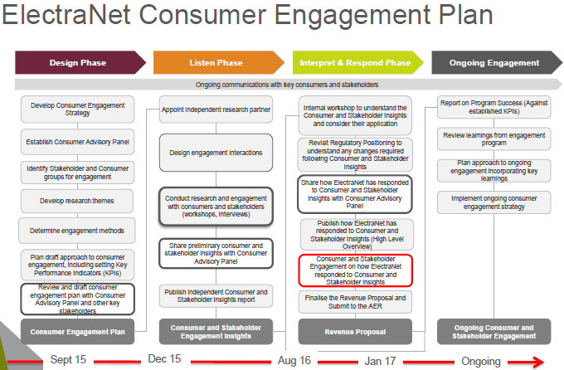

*Figure 2, Source ElectraNet revenue proposal*

The second meeting of the consumer advisory panel occurred in November 2015 where a full range of potential issues for ElectraNet and consumer discussion /agreement was brainstormed and prioritised. This list of issues and relative priorities, indicated by dots, is given below.

Nov 2015

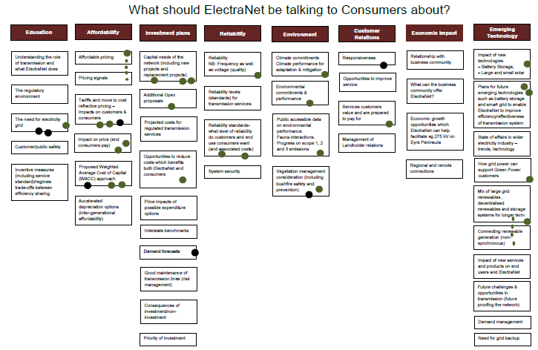

*Figure 3, Source ElectraNet Consumer Advisory Panel*

As participants in this process, we observed that there was good energy from the range of consumer representatives in the process itself encouraged debate and built on trust particularly as there was no attempt to block or dismiss any issues that were raised.

Meanwhile ElectraNet had continued to consider stronger / more transparent consumer engagement approaches and engaged consulting firm Harding Katz to provide advice. They produced a discussion paper “An improved approach to network regulation[2]” for the February 2016 meeting of the consumer advisory panel. The executive summary include the following:

*“We consider two other options to improve the current framework and address the issues raised by UnitingCare Australia.*

*One credible approach (Option 1) is to maintain the Status Quo and improve its operation by:*

* *Reinvigorating the AER’s ‘first pass assessment’ of the company’s expenditure forecasts. This approach would enable the AER to adopt ‘fast track’ regulation if the forecasts were well-justified; and*
* *Enhancing the consumer engagement process, ensuring that customer perspectives are fully reflected in the company’s plans.*

*This approach has merit, but it partly relies on the AER having sufficient time to conduct a ‘first pass assessment’ early in the review process.*

*To address this issue, an alternative approach (Option 3) is to publish a Preliminary Revenue Proposal 2 months prior to the formal submission date as a Fast Track Approach. While this option may present challenges to ElectraNet and the Consumer Advisory Panel in shortening the time available to finalise the expenditure forecasts, it may better facilitate the fast tracking process. On balance, this approach is recommended as the most achievable option to deliver on the objectives identified by UnitingCare Australia.”*

Following some debate, ElectraNet and the consumer advisory panel supported pursuing a “fast track approach” as suggested by Harding Katz, with key elements of this approach being:

*“Subject to the views of the relevant parties, this option would proceed as follows:*

* *A draft Preliminary Revenue Proposal would be developed during the consumer engagement process.*
* *The Preliminary Revenue Proposal would focus primarily on expenditure forecasts, and would demonstrate compliance with the Rules. It would be informed by extensive consultation, including advice from the CAP.*
* *The Preliminary Revenue Proposal would be published in, say, early November 2016, at least 2 months in advance of ElectraNet formally submitting its Revenue Proposal.*
* *It is expected that the expenditure forecasts in the Revenue Proposal would be consistent with those provided in the Preliminary Revenue Proposal (unless unforeseen circumstances arise).*
* *The AER’s Issues Paper (scheduled for March 2017) would apply its ‘first pass assessment’ and determine whether the expenditure forecasts should be ‘fast tracked’ – which means that they would be subject to limited additional scrutiny.*
* *Stakeholders would be invited to lodge submissions in response to the Issues Paper.*
* *The AER may consider early publication of its Draft Decision and Final Decision.”*

Harding Katz said that the advantages of this approach and some of the rationale for it being referred to as a fast track approach were:

* *Reduce resources engaged in the regulatory process;*
* *Increase certainty in regulatory outcomes, with ‘no surprises’; and*
* *Faster resolution by delivering an acceptable regulatory outcome sooner.*

So the approach is “fast tracked” in the sense that the time taken to finalise the revenue decision by the Australian Energy Regulator is reduced because the analysis (and we would suggest that at least some of the debate and ideally negotiation) has happened before the “no surprises” (for consumers, other stakeholders and the regulator) proposal is lodged. This also gives scope for the Regulator’s ‘first pass’ of the proposal that leads to an issues paper being released publicly, being able to ‘flag’ more areas of agreement than had been the recent energy network regulation experience in Australia.

The consumer advisory panel supported the thrust of the Harding Katz proposal but indicated that two months, particularly over Christmas and the New Year, was not enough time for adequate consideration of the preliminary revenue proposal. It was also thought that there would be merit in having the capacity for some deeper engagement between consumers and ElectraNet during the preliminary revenue proposal period. These augmentations were agreed.

ElectraNet wrote to the AER in May 2016 to ask how the AER would respond to the “fast track” approach revolving around the preliminary revenue proposal. The AER agreed that they would read the preliminary revenue proposal and discuss issues of interest with ElectraNet, on a “without prejudice” basis meaning that the AER would need to follow the rules once the revenue proposal was lodged, however they could give advice or make comments on aspects of the preliminary revenue proposal and saw there was potential for a final determination to occur with less effort than would otherwise be the case as matters of concern would be resolved more quickly through earlier engagement and informal resolution.

ElectraNet released their preliminary revenue proposal (PRP) in August 2016, six months before intended lodgement and established a working group, a subgroup the consumer advisory panel, to undertake ‘deep dive’ considerations of key issues identified by the advisory panel and ElectraNet.

The issues discussed by the working party were:

* indicative depreciation forecast
* exploring the implications of greater interconnection
* review the regulated asset base profile
* CAPEX, including overview of of the forecasting framework and methodology, economic evaluation and risk assessment framework. This discussion was focused by considering four “case studies”, Eyre Peninsula, Templers reactor installation, protection systems replacement and line reinstallation project.
* Business & Operational IT Capital Programs

ElectraNet also met with Australian Energy Regulator representatives during this period and shared information on the following subjects:

* CAPEX, jointly with Working group members all
* Business & Operational IT Capital Programs

Major storms hit the South Australia on 28 September 2016, resulting in a state-wide blackout. This major event involved ElectraNet in initial and subsequent network repair and a suite of enquiries, leading to ElectraNet asking the AER for approval to delay lodging their proposal by two months, this was granted, meaning the final lodgement date would be 28th March 2017

During 2016, ElectraNet had also advised the advisory panel of two significant projects that were being considered outside of the intended regulatory proposal, namely an upgrading of the line between Port Lincoln and Whyalla and later in the year the potential for an additional interconnector between the ElectraNet grid and East coast markets. It should be noted that there was substantial public, business and political interest in the reliability of the South Australian electricity market during 2016, initially in response to the closure of northern power station and therefore reduction in ‘baseload’ generation capacity in the state. Concerns about system reliability were high, exacerbated by the September 28th storms and price rises for electricity being flagged for many businesses in excess of 100% of what they had been paying. We will not say much more about 28 September 2016, there have been many, many reports written about what happened and what should be done. Suffice to say that this particular extreme weather event and ensuing reviews, reports and deliberations impacted on ElectraNet and some of the thinking that had gone into the preliminary revenue proposal.

Uniting Communities made a submission to ElectraNet in response to their PRP.

We commenced our response to the PRP with the following comments:

***“Response to ElectraNet, Preliminary Revenue Proposal***

*Uniting Communities welcomes the opportunity to respond to the preliminary revenue proposal, 2019 – 2023 that has been released by ElectraNet. We believe that the process of consumer engagement leading up to and incorporated in the release of this preliminary proposal demonstrates significant leadership by ElectraNet.*

*Process and acknowledgements*

*In responding to this preliminary revenue proposal we place on record our congratulations to ElectraNet for their sincere attempts to actively engage with a range of stakeholders, including small end use consumers, in planning to lodge their regulatory proposal early in 2017. We regard this “early engagement” approach to be a significant development in approaches to consumer engagement for regulatory proposals by utility network businesses in Australia. Uniting Communities has played an active role on the consumer advisory panel that was established by ElectraNet in the mid-2015 and has been a member of the working group that has been set up to look at some aspects of the revenue proposal, in greater detail.*

*Uniting Communities notes that we are committed to seeing a shift in regulatory processes in Australia from adversarial and litigious approaches to processes involving deliberation and negotiation directly between consumer interests and networks, within the national electricity rules. We supported UnitingCare Australia to release a discussion paper in June 2015 titled “Towards a DNA approach[3]”, where DNA refers to “deliberation”, “negotiation” and “agreement”. We have received funding through energy consumers Australia to further explore application of what we have termed DNA approaches. This has included us participating as a consumer group in engagement with ElectraNet.*

*The following brief notes respond to the preliminary revenue proposal, September 2016.*

***Section 2: leadership in consumer engagement***

*We agree that ElectraNet is “leading the industry with (their) early engagement approach” and believe that the approach is highly constructive. It is our opinion that ElectraNet has engaged with sincerity and goodwill which we regard as extremely important. Of course it does not mean that we will agree with all findings or proposals that ElectraNet puts in its final revenue proposal. But we believe that the early engagement and broader consumer engagement approaches have reduced the number of areas where differences of opinion are likely and as such has saved ElectraNet and consumer’s; time, money and some ‘angst’!”*

Now that ElectraNet has lodged their regulatory proposal, we continue to stand by these comments and our belief that ElectraNet has made a concerted effort to engage with and hear stakeholders including consumer interests.

In January 2017 the consumer advisory panel met and was briefed by ElectraNet on progress regarding the revenue proposal and variations that were being proposed as a result of stakeholder engagement through the preliminary revenue proposal (PRP) and as a result of the unprecedented weather event from September.

Figure 4 is a summary of the information presented to the consumer advisory panel.

While ElectraNet did not take on board all of the recommendations that we made, including alternative views to inflation and gamma, we have been part of extensive discussions with ElectraNet about these points of difference through “deep dive” discussions and well understand each other’s positions.

We remain satisfied that ElectraNet listened carefully to responses it received to its PRP and made substantial efforts to incorporate such responses in the regulatory proposal that was lodged.

We did not expect to reach consensus through the frontloaded process but reiterate our strong belief that ElectraNet heard and valued our input and also note that we agreed with ElectraNet on most aspects of their regulatory proposal.

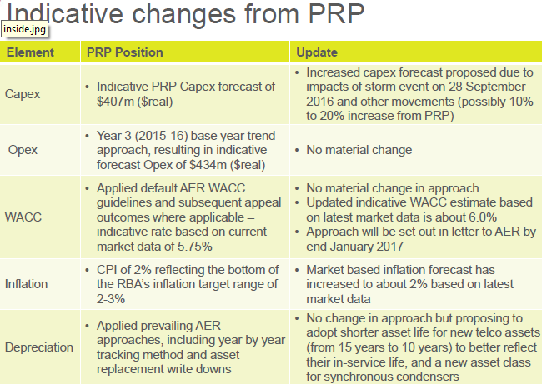

*Figure 4, Source ElectraNet Consumer Advisory Panel*

**AER Consumer engagement questions**

1. How far has ElectraNet's early engagement process gone towards achieving its intended benefits?

2. Has the early engagement process enhanced the regulatory process?

3. If you have been involved with other TNSP reviews, are there any aspects of ElectraNet's process so far that are better or less well developed than other TNSP consumer engagement processes?

4. Is ElectraNet's process likely to have improved its understanding of customer concerns and taken these into account in determining its revenue proposal for the long term interest of consumers?

We recognise that the following outcomes have been achieved by the ElectraNet approach in preparation for lodging their regulatory proposal in March 2017 :

* an active consumer engagement strategy was planned and initiated by ElectraNet at least 18 months before the regulatory proposal was due to be lodged
* ElectraNet followed through on their initial commitments to establish a reference group to which they would listen carefully and to other consumer engagement strategies
* ElectraNet went to the effort of engaging a consulting firm (Harding Katz) to specifically advise on consumer engagement strategies. The recommendations from this firm were implemented, specifically the ‘fast track’ approach which required ElectraNet to release their preliminary revenue proposal six months before is to be lodged, creating extra work pressure earlier in their regulatory proposal development.
* ElectraNet adjusted their processes in response to advisory panel advice, including the establishment of a working group to ‘deep dive‘ into some of the more detailed aspects of the revenue proposal.
* We suggest that when circumstances beyond the control ElectraNet eventuated (28 September storms) the level of goodwill generated by ElectraNet with both stakeholders and the Regulator meant that the request for an extension of time was seen as reasonable, and accepted, despite such requests being rare.
* We also suggests that ElectraNet’s integrity and reputation has remained intact throughout what has been difficult and politicised public debate. The lack of strong negative comment or commentary has been quite remarkable. We attribute this significantly to the trust and goodwill generated through an extended consumer and stakeholder engagement process.

We will go a little further in our assessment of ElectraNet’s consumer engagement in preparing its regulatory proposal in saying that we believe that ElectraNet has been at the forefront of high quality consumer engagement and has continued to think, engage, listen and adapt throughout two years of regulatory proposal development. For the record we note that the AER has affirmed many aspects of the AGN (Victoria and Albury) access arrangement proposal, which we have also strongly endorsed. It is our observation that ElectraNet started developing their consumer engagement approach earlier than AGN, which is why we suggest that ElectraNet has also been at the forefront in developing high quality consumer engagement.

To summarise the above commentary, following quite extensive involvement with ElectraNet in their consumer engagement we are satisfied that ElectraNet’s consumer engagement process has met expectations in achieving intended benefits, indeed we believe that ElectraNet’s consumer engagement process has exceeded expectations. The engagement has been focused on sound regulatory outcomes despite the difficulties of major storms and a dynamic political context.

We strongly believe that ElectraNet has a better understanding of consumer and stakeholder interests and concerns as a result of their active engagement process. They made considerable effort to reach a variety of stakeholders and to find ways of informing them and enabling input across the full extent of the regulatory proposal.

We conclude by again commending ElectraNet on what we regard as an outstanding effort to engage with consumers, to hear what a range of consumer interests and stakeholders had to say and most importantly to incorporate these to a significant extent, in the final regulatory proposal.

**Capex questions**

1. Do you consider that ElectraNet has adequately justified the need for the proposed investment in measures to improve network security and the ability of the network to withstand the impact of extreme weather events?

2. Do you consider that ElectraNet's approach in proposing an ex ante capex project to refurbish transmission lines on the Eyre Peninsula, while at the same time exploring alternative options through a formal RIT-T process is reasonable?

3. Do you consider that ElectraNet's risk assessment methodology and its application support its proposed replacement and refurbishment capex against the capex criteria?

Contingent projects questions

1. Do you consider that the trigger event proposed by ElectraNet for each proposed contingent project is probable during the 2018-23 regulatory control period? If not, why?

2. With respect to the Upper North-East and Upper North-West Line Reinforcement load-driven contingent projects, can you provide any evidence of investments which may increase demand for electricity such that ElectraNet's current load limits for these two regions are likely to be exceeded during the 2018-23 regulatory control period?

Before responding to both the capital expenditure and contingent projects questions, we highlight the significance of extreme weather events in the period in which ElectraNet was actively engaging with consumer and interests and completing their regulatory proposal. The extreme weather events, including those of 28 September 2016 have had substantial consequences for ElectraNet (and many others).

The statewide system black event triggered by the collapsing of ElectraNet transmission towers due to cyclonic winds has arguably had more impact on the Australian national electricity market than any other single event. The system black event triggered by the storms was the catalyst for a major review of Australia’s national electricity market by chief scientist Alan Finkel, and resulted in a significant number of reports being prepared to try and understand what happened. The politics of the event was also difficult with all manner of wild claims being made about renewable energy, government failure, market failure, institutional failure et cetera.

As an actively engaged consumer organisation, before 28th of September, we thought that the ElectraNet process was all going very smoothly and predictably without any major issues. While engagement remained after 28th September, there were many new challenges for ElectraNet to consider with limited time before the regulatory proposal was to be lodged. There were clearly a whole set of new issues that they had to think about in a hurry.

ElectraNet is also at the leading edge of integration of non-synchronous, intermittent renewable electricity generation into the grid. The International interest in how ElectraNet operates its transmission network is substantial. The unique circumstances in South Australia also mean that there is no guidebook that ElectraNet can utilise to easily sort out the technical (and dare we say political) challenges that they confront.

As a strong consumer advocate organisation we are not ‘going soft’ on this transmission business, but through detailed engagement believe we have a very good understanding of the businesses’ unique and unpredicted challenges that 28 September provided and indeed the unique situation of the South Australian energy market. These are pertinent and important matters that have impacted on our understanding of both capital expenditure and contingent project proposals.

Returning to the **Capex** questions:

1. We do not doubt that some network hardening is required in order for the network to withstand extreme storms, of the likes seen on 28th September 2016. We are not in a position to comment on the technical aspects that all need to be sorted out by engineers with a mind to the most cost-effective solutions.
2. Having discussed the Eyre Peninsula transmission line upgrade proposals with ElectraNet, we are minded to support cost-effective network upgrade both to increase reliability to Eyre Peninsula towns and regional centres while also providing more reliable infrastructure for economic expansion. We believe that ElectraNet will need to continue to engage actively with consumers and other stakeholders and that the formal RiT-T process is the most effective way of achieving this.
3. We are also minded to be supportive of ElectraNet’s risk assessment methodology, based on discussions that we have had with them. We are open to more detailed engineering advice before being any more definitive.

**Contingent projects**

We are aware of concerns that exist in parts of the community about contingent projects happening outside of the full scrutiny of a regulatory process and believe that contingent projects should be minimised. However we are prepared to accept that the unique circumstances surrounding the ElectraNet situation make prediction about weather and even shifting demand difficult, out to 2023.

We note AEMO’s projections for declining demand for SA, as shown in the graph below

AEMO South Australian annual consumption forecast (GWh)

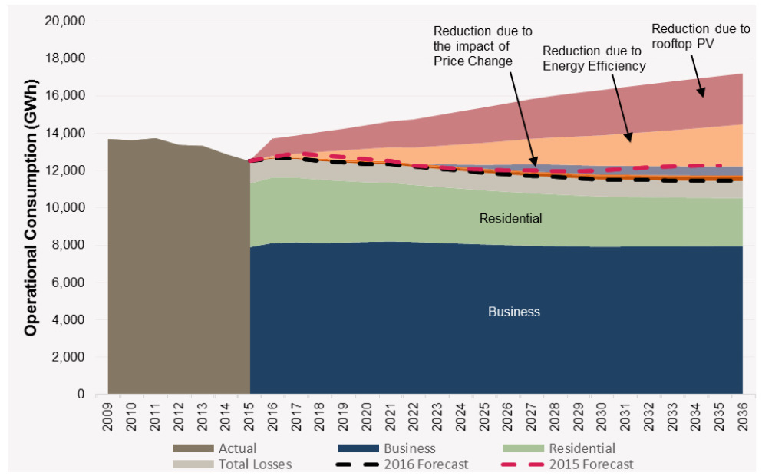

*Figure 5 Source: AEMO,* 2016 National Electricity Forecasting Report Chart Pack

AEMO’s approach forecasts that demand on ElectraNet's network will continue to decline at 0.5 per cent annually over the next 20 years, driven by high levels of growth in rooftop PV, which continues to be at a rate higher than seen in other regions [4] 5 shows the actual and forecast energy consumption in South Australia broken down by category.

We are less certain about local and regional variation in loads, consequently we consider that the trigger events proposed by ElectraNet for each proposed contingent project are possible, maybe probable during the 2018-23 regulatory control period.

With respect to the Upper North-East and Upper North-West Line Reinforcement load-driven contingent projects, we are unable to provide any evidence of investments which may increase demand for electricity such that ElectraNet's current load limits for these two regions are likely to be exceeded during the 2018-23 regulatory control period.

Gamma question

1. Do you agree with ElectraNet's proposal to use a gamma value of 0.25 in valuing imputation credits, and if so, why?

In our response to the ElectraNet Preliminary Revenue Proposal, we said:

*“10.3 Corporate Tax imputation credits: gamma*

*We believe that the value for gamma should be 0.5 rather than the 0.25 proposed in the PRP, but others have argued this case and we will not repeat the arguments here, recognising that this is a contentious issue which is being considered by the limited merits review and is currently being considered by the Federal Court.”*

We remain strongly of the opinion that tax allowances should be regarded as a pass-through costs based on actual tax payments. However given the current regulatory process, we have not changed our view that gamma should be a higher value than 0.25. We are satisfied that limited merits review and Federal court appeals have landed on a value for gamma of 0.4. We think that this is the appropriate value for gamma and it should be written into the final decision with no further debate - it’s been “done to death.”

Return to Capital

In our response to the PRP, we also made the following comments about rate of return parameters:

*“10.2 Return on capital*

*We assumed that ElectraNet is applying the SL-CAPM approach for return on capital as per the AER better regulation guidelines. We support the application of this CAPM approach.*

*We suggest that the financial parameters proposed by ElectraNet are “around the mark” however we would be looking for the following, preferable parameters; ElectraNet’s PRP values are given in brackets:*

* *risk-free rate (2.32) we suggest 2.00*
* *equity beta (0.7) we suggest 0.5, this being the midpoint of the range of values for*

*beta, estimated by Olan Henry, 0.3-0.7 in his analysis for AER[5]*

* *market risk premium (6.5) we suggest 6.0*
* *return on debt (4.98%) we accept this figure*
* *gearing ratio (60%) we accept this figure*

*Note: return on equity and nominal vanilla WACC will change from those proposed in the PRP, but we haven’t calculated them.”*

We are aware that the AER is in the process of embarking on a review of rate of the return guideline, outside of specific business regular trip proposals. We strongly support this development.

1. See Tamarack Centre for Community Engagement at http://tamarackcommunity.ca/
2. Harding Katz, An Improved Approach to Network Regulation, Paper for discussion, 18 February 2016
3. Now available on <http://noshockenergy.org/changing-dna-network-tariff-setting-australia/>
4. AEMO, National Electricity Forecasting Report, 2016, p. 23.
5. <https://www.aer.gov.au/system/files/Henry%20%E2%80%93%20%20Estimating%20Beta%20%E2%80%93%20An%20update%20%E2%80%93%20April%202014_0.PDF>