




SUBMISSION

In response to

AER Draft Regulatory Investment Test for Distribution (RIT-D) Application Guidelines

(Part of the “Better Regulation” Program)

Contact:

Mark Henley
Energy Advocate
UnitingCare Australia
08 8202 5135
0404067011
MarkH@unitingcommunities.org

July 2013

UnitingCare Australia

UnitingCare Australia is the Uniting Church’s national body supporting community services and advocacy for children, young people, families, people with disabilities and older people.
The UnitingCare network is one of the largest providers of community services in Australia, providing services and supports to more than 2 million Australians each year in urban, rural and remote communities. The network employs 35,000 staff and 24,000 volunteers.
UnitingCare Australia works with and on behalf of the UnitingCare network to advocate for policies and programs that will improve people’s quality of life. UnitingCare Australia is committed to speaking with and on behalf of those who are the most vulnerable and disadvantaged for the common good.
Stewardship of our environment is a fundamental responsibility of societies both in the short-term and for the benefit of future generations. We strongly support the notion of the triple bottom line for government community and business organisations whereby economic stewardship, environmental stewardship and the nurture of citizens (social stewardship) are equally valued and reported on publicly.
UnitingCare Australia’s principle interest in energy regulation arises because energy is an essential service with rising costs that are putting inordinate financial pressure on growing numbers of households in Australia.
In the following document, when the term ‘consumers’ is used, we are speaking of household and small business consumers, including family farms and family businesses.
Uniting Care Australia’s energy vision is that by 2030 energy in Australia will be plentiful, renewable and affordable for all citizens.

Draft Regulatory Investment Test - Distribution (RIT-D) Guidelines

Uniting Care Australia Involvement.
Uniting Care Australia has been involved with forums on this aspect of the better regulation / power of choice implementation process within the Australian Energy Regulator. We commend the AER for their effort to engage with consumer groups in a number of processes including forums and dialogue, and the Consumer Reference Group, as well as written submissions and we support the notion that input in each of these areas should carry equal weight. This short statement is in support of our contribution through the “Better Regulation” consumer reference group and our participation in relevant forums.

We also commend the AER on the work done to draft these application guidelines. We are satisfied with the general thrust and direction of these guidelines so the following comments are more clarification and points of emphasis, rather than seeking any changes in direction.

General Responses
Specific reference to ‘small consumers’
Our main point in response to this draft RIT-D application guidelines is to encourage a greater specificity in describing “interested parties”, “non network providers” and terms of this ilk within the document. Uniting Care Australia seeks that direct mention is made, wherever such terms are used, to specifically use a phrase similar to “household and small business consumers and community groups representing these consumers”. We believe that a term like this adds greater detail and is in line with the intent of the guidelines, and the Better Regulation and Power of Choice processes overall – to increase consumer engagement in energy regulation and market issues.

This specific reference to small consumers would apply particularly to sections 3.1 – “Stakeholder Consultation” and section 5 – “Disputes and Dispute Resolution.” With regard to 5.1 it is crucial that there is recognition that small consumers and community groups representing small consumers are able to make a RIT-D dispute and are regarded as equal parties with other stakeholders in this process.

Consumer Engagement
We also note that an emerging question is the extent to which consumer engagement has occurred in developing a RIT-D application. We would expect that any RIT-D application that is lodged with the AER would include documentation of appropriate levels of Consumer Engagement (as per the Consumer Engagement Guideline, currently in draft form). This should be reflected in the RIT-D guidelines under section 2.1, “Identified Need”

Section 4. Material and adverse Market Impacts
This is an important part of the guideline and we would encourage the drafters to specifically require that consideration of material and adverse market impacts must include adverse impacts on sub groups of consumers and not simply respond to the notion of the “average consumer”. We are well aware of the substantial variation in impact of energy pricing decisions on different groups of household consumers, including low income, families with children, households in regional and remote communities etc. So the guidelines need to specifically refer to the RIT-D addressing adverse impacts on sub groups within broader consumer classes, which are more likely to experience greater than average adverse impact. The importance of having regard to dispersion as well as average or median measures of impacts for consumers is summarised in figure 1.

This figure shows the proportion of household income spent by income decile and shows the range, 5th to 95th percentile observations (black dots) within each range, as well as the median observation value (white dot). There is a substantial spread in the income assigned to energy costs in each income decile range, with the greatest variation for lower income households. So to consider point estimates of mean or median energy spend, for example, as representing the average consumer and by implication all consumers, is unhelpful in understanding what is really happening.

Proportion of Income spend on Energy, by income decile, Australia
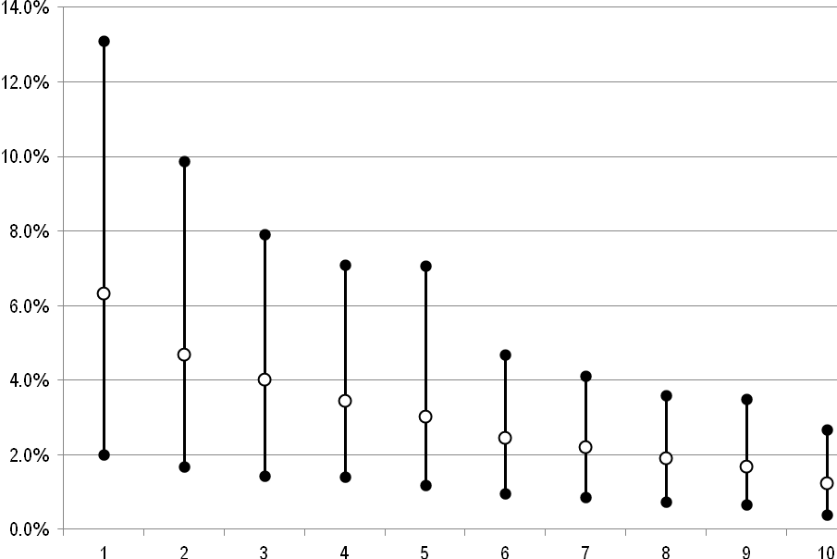
Source: ABS Household Expenditure Survey 2009-10 CURF files, unpublished

Section 5 – Dispute Resolution
As indicated previously, it is crucial that household and small business consumers, as well as groups representing them are specifically included in section 5.1 amongst those that can make a RIT-D dispute under 5.8, material that the AER may consider.

Section 10 – Valuing Marketing Benefits
We would recommend that the dot points in the first paragraph specifically include non network solutions as part of the list of credible options that must be considered in undertaking a regulatory impact test for transmission or distribution, gas or electricity. The section makes reference to demand management options which we believe, in many circumstances, are likely to provide better alternatives, better outcomes for consumers and better network augmentation options.

Section 13 – Sensitivity Analysis
The requirement is supported for a RIT-D proponent to include ‘an additional set of reasonable scenarios’ when “for example, a demand-modified central reasonable scenario may be significantly different from that calculated under the associated central reasonable scenario.” That these additional scenarios will need to reflect varying levels of forecasting demand is particularly important, particularly given the emerging evidence that demand has fallen steadily across much of the NEM over the last couple of years. This is a very new situation for the Australian electricity market, for which growing demand has been a near century long reality.

Section 14 – Uncertainty and Risk
We have made comments in Better regulation ‘Rate of Return’ and more recently ‘Shared Assets’ guideline responses about the sharing of uncertainty and risk and re-emphasise the point here that consumers and network businesses need to reasonably share risk and uncertainty. Consumers cannot be expected to bare an unreasonable burden from costs arising from uncertainty, poor market projections and poor risk management from network firms.

We appreciate the recognition given to “demand side participation” in the example 12.1 of the draft guidelines.

Further comment

Mark Henley
Energy Advocate
UnitingCare Australia
08 8202 5135
0404067011
MarkH@unitingcommunities.org

