16/03/2016

Australian Energy Regulator

GPO Box 520

Melbourne VIC 3001

Attn: Retail Markets Branch

To: Australian Energy Regulator

**Re: Application for Individual Retail Exemption – Bathurst City Centre Shopping Centre**

Vicinity Funds RE Ltd (ABN 33 084 098 180) as responsible entity for Vicinity Enhanced Retail Fund (ABN 70 942 816 077) wishes to apply for an Individual Retail Exemption for the Bathurst City Centre Shopping Centre embedded network.

The original application for the Retail Exemption was first submitted by Energy Intelligence on 14 July 2015. The original application was submitted on behalf of Novion Property Group – however since this application was submitted Novion have merged with Federations Centres, resulting in the new entity Vicinity Centres (Vicinity).

As per the AER (Retail) Exempt Selling Guideline version 3 (April 2015), we provide the following information to furnish our original application:

**General information requirements:**

1. Your legal name. If you are a body corporate or community corporation, please indicate this

Vicinity Funds RE Ltd as responsible entity for Vicinity Enhanced Retail Fund managed by Vicinity Asset Operations Pty Ltd.

1. Your trading name if different to your legal name.

Bathurst City Centre Shopping Centre

1. Australian Business Number (ABN) or Australian Company Number (ACN).

Vicinity Funds RE Ltd ABN 33 084 098 180

Vicinity Enhanced Retail Fund ABN 70 942 816 077

1. Registered postal address for correspondence. We may verify this information with the Australian Securities and Investments Commission (ASIC) or other relevant agency.

Level 28, 35 Collins Street, Melbourne Vic 3000

1. Nominated contact person, including position in the organisation and contact details:

Craig Swift

Electricity Onselling Manager

Phone: 03 9936 1204

Email: craig.swift@vicinity.com.au

1. Why you are seeking an individual exemption, and why you believe that an exemption (rather than a retailer authorisation) is appropriate to your circumstances.

Vicinity are seeking an individual exemption as per the AER requirements that all embedded networks retrofitted after 1 January 2015 require an individual exemption.

We are seeking an exemption, rather than a retail authorisation, as the on-selling authorisation relates to one site and is incidental to Vicinity’s primary business (refer question 8).

1. The address of the site at which you intend to sell energy, including a map of the site and a brief description of this site and its current and future use/s.

The site address is 210 Howick St, Bathurst, NSW 2795 – see map below.

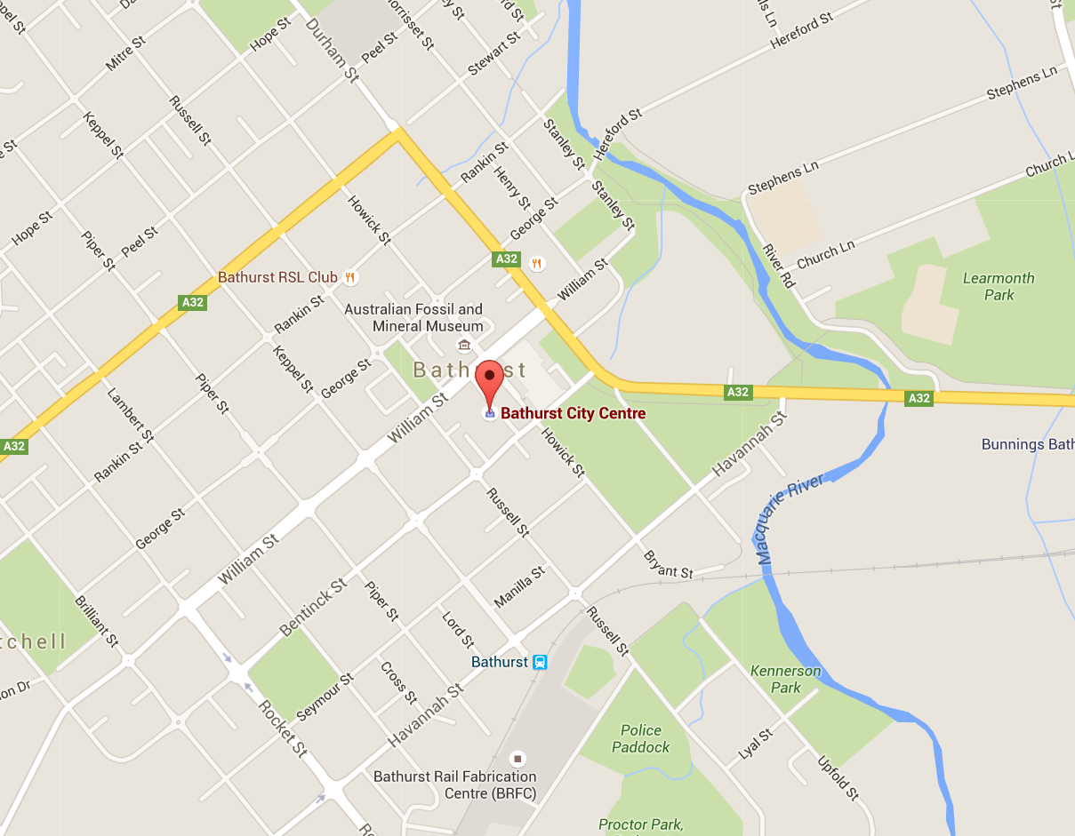

Bathurst City Centre Shopping Centre is a multi-tenanted retail shopping centre that opened in 2009. There are no current plans for extension.

1. The primary activity of your business (for example, managing a shopping centre).

Provide private retail leasing space and management of the shopping centre facilities.

1. The form of energy for which you are seeking the individual exemption (electricity or gas). For electricity, please state whether the network you propose to sell is directly or indirectly connected to the main grid or is (or will be) an off-grid network.

Electricity – the embedded network will be directly connected to the local network service provider (Essential Energy).

1. Are you establishing, or have you established, energy supply in an area where there are no other viable energy supply arrangements available.

No.

1. The date from which we intend to commence selling energy.

April 2016.

1. Mailing addresses for premises at the site (where applicable). We may use this information to ensure that potential customers are able to participate in our consultation process:

210 Howick St, Bathurst, NSW 2795

1. Details of any experience in selling energy, for example:   
   - date/s and location/s of previous operations  
   - form/s of energy sold  
   - scale of operations (that is, the number, size and type of customers)  
   - an explanation of which activities will be conducted in-house and which will be contracted out to third parties.

There are 54 embedded networks in the Vicinity portfolio, of which 26 were formerly in the Novion Property Group portfolio and 28 formerly in the Federation Centres portfolio.

For Bathurst City Centre Shopping Centre, Vicinity have contracted out the embedded network billing to Energy and Plant Management, while the tenant management has been contracted out to Energy Intelligence.

1. Whether you currently hold, or have previously held or been subject to, an energy selling exemption or a retail licence (retailer authorisation) in any state or territory. If so, please provide details.

Vicinity does not hold a retail license/authorisation.

1. What arrangements you have made in the event that you can no longer continue supplying energy (e.g., has the retailer that sells to you agreed that they will service the customers).

If Vicinity could no longer supply energy to tenants in the embedded network, the metering configuration allows tenants to enter into a supply arrangement with an authorised retailer of their choice.

**Particulars relating to the nature and scope of the proposed operations:**

1. Will your customers be your tenants? If so, are they residential or commercial/retail? Are they covered by residential or retail tenancy, or other legislation governing accommodation that is a person’s principal place of residence (for example, retirement village legislation, residential parks or manufactured home estates legislation) in your state or territory?

Yes – the customers will be tenants of Bathurst City Centre Shopping Centre. The tenants are retail and are covered by the Retail Leases Act. There are no residential tenants inside the embedded network.

1. Are you providing other services (for example, accommodation/leasing of property) to persons on the site who you intend to sell energy to? Or will your only commercial relationship to persons on the site be the sale of energy? If you are providing other services, please specify what these services are, and the contractual or leasing arrangements under which these services are being provided

Yes – retail leased premises. All leases to those tenants are covered by the Retail Leases Act.

1. What is the total number of dwellings/premises at the site? Please provide a breakdown between residential and business customers (and whether they are small or large as defined for the jurisdiction in which you intend to operate).

The total number of tenants is 47, all of which are small business.

1. Will you be onselling energy (that is, selling energy purchased from an authorised retailer) or purchasing it directly from the wholesale market?

Vicinity will be on-selling energy from an authorised electricity retailer.

1. If purchasing from an authorised retailer, have you formed, or do you intend to form, a bulk purchase contract with the energy retailer, and how far into the future does this, or will this, contract apply? If you have formed, or intend to form, a contract, please provide a brief summary of this arrangement.

Vicinity currently have recently entered into an electricity supply agreement for the embedded network gate meters with Red Energy. This contract expires 30 June 2018, and Vicinity will procure from a licensed retailer prior to the expiry of this agreement.

1. What is the estimated aggregate annual amount of energy you are likely to sell (kilowatt hours or megawatt hours for electricity and mega joules or gigajoules for gas) and the average expected consumption of customers for each type of customer you service (that is, residential customers and retail or commercial customers)?

The total estimated annual consumption for tenants at Bathurst City Centre Shopping Centre is 1.7GWh.

The estimated average expected consumption for small business tenants is 36 MWh.

1. Will your customers be wholly contained within a site owned, controlled or operated by you? (For the purposes of this question, a body corporate may be taken to ‘operate’ premises it oversees)

Yes, all tenants will be wholly contained inside the shopping centre.

1. Will each premises/dwelling be separately metered? If the application is for a new development or a redevelopment and customers will not be separately metered, please explain why not.

Yes.

1. What types of meters will be used? For example, basic/accumulation meters, manually read interval meters or remotely read interval meters? Will these meters allow your customers to change retailers (i.e. not source their energy from you)?

The meters will all be capable of recording interval reads, and may either be manually or remotely read.

The electrical infrastructure at site allows all tenants to change retailers at their choosing. The cost of all metering works that result from the implementation of the embedded network will be borne by Vicinity, not the tenant.

1. What accuracy standards apply to the meters? Do the meters comply with Australian Standards? If so, specify which Standard or Standards. For electricity meters, will the meters comply with National Measurement Act 1960 (Cth) requirements for electricity meters installed from 1 January 2013?

The electricity meters installed at site are compliant with the National Measurement Act 1960 (Cth), and compliant with the NMI M-6 pattern approval requirements as stipulated by the National Measurement Institute[1]. The meters are supplied by an accredited meter provider, and are classified as “billing class” (can be used for on-market metering).

1. If customer dwellings/premises are separately metered, how often do you propose the meters to be read and by whom?

The meters will be read monthly by a third party meter reading agent.

1. How will you determine energy charges if customers are not separately metered?

Not applicable as all tenants are separately metered.

1. In what form and how often will customers be billed? Will you be issuing bills yourself or through a billing agent?

Bills will be issued monthly from Energy and Plant Management (Vicinity’s billing agent).

1. What dispute resolution procedures do you intend to put in place to deal with energy related complaints and issues?

Vicinity (or their authorised agent) will attempt to resolve the tenant’s dispute immediately. If we are not able to resolve straight away, we will advise the tenant of the expected timeframe for a resolution.

If the dispute is not resolved to the tenant’s satisfaction, a senior manager from Vicinity will contact the tenant to discuss the dispute further.

After speaking to the senior manager, if the tenant is still not satisfied the dispute has been resolved, the tenant may have the matter heard by the appropriate Ombudsman, Court or Tribunal in the State where available.

1. What energy rebates or concessions are available for your customers and, if applicable, how can customers claim these?

Not applicable to the tenants at site.

1. Will you make energy efficiency options available to your customers? Will your network incorporate solar or other generation options for sustainability purposes? If so, will you use gross or net metering?

Vicinity have a formal energy efficiency program implemented across the entire portfolio which aims to identify energy efficiency ideas and to implement cost effective solutions to drive continual cost improvements. We liaise with tenants in the tenancy design review process to integrate energy efficiency into their fit out design. With our embedded network portal we provide the tenants with their electricity consumption for visibility on their energy consumption and cost.

1. Please provide any further information that you consider would assist us to assess your application.

Sales process:

The sales process is robust and transparent:

* Vicinity educate tenants on the embedded network process, ensuring they are making an informed decision about whether to join the embedded network
* The marketing material and correspondence highlights that tenants have a right to select an authorised retailer of their choice
* For those tenants who wish to retain their current supply arrangements, Vicinity provide information on the recovery of shadow regulated network charges that will result in the tenant receiving two invoices
* Contact details for any further queries

Tenants who wish to purchase from an authorised retailer:

If a tenant chooses to remain with their authorised retailer upon the installation of the embedded network, and pay separate energy and network charges, the price they pay for energy charges should remain unchanged. This is because Vicinity will ensure that tenants who choose to stay with their authorised retailer will be charged the appropriate regulated network charges.

Should tenants choose to purchase electricity from an authorised retailer, they will be requested to sign a letter of authority:

* Acknowledging that their premises are located inside an embedded network and that they have chosen to purchase electricity from an authorised retailer; and
* Authorising Vicinity and their contracted service providers to receive the relevant meter data held under their name for the purpose of calculating and recovering the regulated network charges

No disadvantage:

To ensure existing tenants are not disadvantaged by sitting within the embedded network, where a tenant’s existing authorised retailer is unable or unwilling to provide a tenant with an energy only invoice, Vicinity will offer to match the price the tenant was paying prior to the creation of the embedded network for the life of the tenant’s lease.

For large customers, Vicinity have agreed to reimburse any additional fees associated with additional bill validation costs, provided those costs are transparent and proven.

For tenants that were trading at the point of the embedded network creation, and where a tenant has chosen to purchase energy from an authorised retailer, during the life of the tenant’s lease Vicinity will ensure the is no double charging from the tenant’s authorised retailer. This is reliant on the tenant brining these instances to Vicinity’s attention and providing the appropriate authorisation document(s).

Tenant Consent:

Vicinity proposes that by entering into an agreement with a tenant, by signing a letter of authority or by authorising Vicinity’s nominated representative to receive relevant meter data the tenants are providing fully informed consent to join the embedded network.

The Letter of Authority clearly states the tenant is agreeing to participation in the embedded network and that they authorise the energy usage data can be sent to Vicinity’s authorised representative.

If the tenant does not sign an agreement or a Letter of Authority then Vicinity will attempt to enter into an agreement with the tenant’s retailer for the payment of network charges.

Additional tenant benefits:

* Monthly invoices, which greatly assist with cash flow management for small businesses
* Dedicated customer service line, where calls are answered promptly and issues resolved efficiently

Variation sought from 100% consent requirement (Condition 12)

In offering the above conditions, we hope to assure the AER that the implementation of the embedded network will result in benefits to the majority of residents (as indicated by the signup rate so far). Furthermore, for the minority of residents that choose to maintain their existing supply arrangements, the above conditions ensure they are no worse off.

In light of this, we request a variation or relief from Condition 12 of the Electricity Network Service Provider Registration Exemption Guideline, which mandates that the consent of all residents is required for the implementation of a retrofitted embedded network. We expect only minimal cases of residents not providing consent, and even if consent is not provided, the above conditions will ensure that non-consenting residents are not negatively impacted by the embedded network creation.

We are happy to discuss any of these further points with the AER.

Kind Regards,

Craig Swift

Electricity Onselling Manager

Vicinity

1. http://www.measurement.gov.au/publications/parequirements/Pages/default.aspx