

Queensland
Access Arrangement Information
(Public Version)

1 October, 2010
(as revised on 23 March 2011)
TABLE OF CONTENTS
Page
1. INTRODUCTION 8
1.1 Purpose of this Document 8
1.2 The Network 8
1.3 Interpretation 10
1.4 Contact Details 10

2. BUSINESS OVERVIEW 11
2.1 Introduction 11
2.2 Queensland Network History 12
2.3 Vision for Envestra’s Gas Networks 2010 – 2020: Sustainability 16
2.4 Key Issues for 2012-2016 19
2.5 Conclusion 22

3. ANALYSIS OF PAST PERFORMANCE 24
3.1 Revenue Past Performance 24
3.2 Demand 26
3.3 Operating Expenditure 29
3.4 Capital Expenditure 33

4. PIPELINE SERVICES 41
4.1 Haulage Reference Services 41
4.2 Ancillary Reference Services 41
4.3 Non-Reference Services 42
4.4 Service Standards and Quality 42
4.5 Rules Compliance 43

5. OUTSOURCING ARRANGEMENT 44
5.1 Introduction 44
5.2 Relevant Assessment Criteria 45
5.3 Overview of Outsourcing Arrangement 46
5.4 Relevance of APA Shareholding 46
5.5 History of Outsourcing Arrangements 48
5.6 The 2007 OMA Cost Management Provisions 52
5.7 AER’s Tests 57
5.8 KPMG Counterfactual (In-house) Cost Test 58
5.9 Benchmarking Evidence 60
5.10 Historical Approaches by Regulators to Assessing Envestra’s Outsourcing
Arrangement 64
5.11 AER Analysis of Margins 67
5.12 Conclusion 72

6. OPERATING EXPENDITURE 73
6.1 Summary 73
6.2 Categories of Opex 74
6.3 Base Year 76
6.4 UAFG 77
6.5 Network Development 78
6.6 Non Base-Year Costs 79
6.7 Incremental Growth Opex 84
6.8 Escalators 84
6.9 Forecast Costs 85
6.10 Expert Review of Opex 86
6.11 Compliance with National Gas Rules 86

7. CAPITAL EXPENDITURE 87
7.1 Summary 87
7.2 Capital Expenditure Forecast Elements 88
7.3 Capital Expenditure Planning And Approval Process 90
7.4 Capital Expenditure Execution 91
7.5 Key Investment Drivers 91
7.6 Forecast Capital Expenditure 88
7.7 Overheads 102
7.8 Capital Expenditure Forecast 102
7.9 Expert Review Of Capital Expenditure 103
7.10 Compliance With National Gas Rules 103

8. CAPITAL BASE 105
8.1 NGR Requirements 105
8.2 Summary 105
8.3 2011 Regulatory Asset Base 105
8.4 Projected Capital Base in the Third Access Arrangement Period 112
9. RATE OF RETURN 118
9.1 Introduction 118
9.2 Regulatory Framework 119
9.3 National Electricity Law 124
9.4 Deficiencies in the Standard AER Method for Determining the Rate of Return 125
9.5 Methodology for Determining the Rate of Return 127
9.6 Estimating the Cost of Equity 127
9.7 CAPM Input Parameter Values 131
9.8 Risk Free Rate 131
9.9 Market Risk Premium 131
9.10 Equity Beta – CAPM 132
9.11 CAPM Cost of Equity 134
9.12 Outcomes from Alternative Asset Pricing Models 134
9.13 Cost of Debt 135
9.14 Other Parameter Values 138
9.15 Proposed Rate of Return 139
9.16 Credit Rating and Rate of Return Analysis 140
9.17 Proposed Rate of Return 143
9.18 Derivation of the WACC 144

10. COST OF TAX 145
10.1 Introduction 145
10.2 NGR Requirements 145
10.3 Methodology 146
10.4 Setting the Tax Asset Value 148
10.5 Tax Losses Carried Forward 152
10.6 Value of Imputation Credits (Gamma) 153
10.7 Calculating the Cost of Tax 167

11. INCENTIVE MECHANISM 168
11.1 General 168
11.2 Regulatory Framework 168
11.3 Proposed Incentive Mechanism for the Third Access Arrangement Period 168

12. TOTAL REVENUE 170

13. DEMAND FORECASTS 174
13.1 Introduction 174
13.2 NGR Requirements 174
13.3 Past Performance 175
13.4 NIEIR Forecasting Approach 179
13.5 Residential Forecasts 184
13.6 Commercial and Small Industrial Forecasts 187
13.7 Demand Customer Forecast 188
13.8 Envestra Forecast 188
13.9 Use of Demand Forecasts 189
13.10 A note on Confidence Intervals 190

14. REFERENCE TARIFFS 191
14.1 Introduction 191
14.2 NGR Requirements 192
14.3 Haulage Reference Service Tariff Classes 193
14.4 Ancillary Reference Services 195
14.5 Avoidable and Stand-Alone Costs 196
14.6 Long Run Marginal Costs 198
14.7 Grouping of Reference Tariffs on an Economically Efficient Basis 202
14.8 Transaction Costs 202
14.9 Response to Price Signals 203

15. TARIFF VARIATION MECHANISM 204
15.1 Haulage Reference Services 204
15.2 Ancillary Reference Services 207
15.3 Trigger Events 208

16. NON-TARIFF COMPONENTS 211
16.1 Capacity Trading 211
16.2 Network Extensions 211
16.3 Terms And Conditions 212

LIST OF ATTACHMENTS

Attachment
1-1 | Queensland RIN Index
1-2 | Queensland RIN Template (spreadsheet)
1-3 | Queensland Post Tax Revenue Model 30 September 2010 (spreadsheet) (confidential)
5-1 | Statements and Expert Reports Relied Upon by Envestra
5-2 | Affidavit of John Ferguson, dated 29 September 2010 (confidential)
5-3 | Affidavit of Ian Little, dated 29 September 2010 (confidential)
5-4 | Affidavit of Peter Cain, dated 29 October 2007 (confidential)
5-5 | APA Group Assets/Activities
5-6 | KPMG – The Cost of Gas Distribution Services When Capabilities are Retained Internally (confidential)
5-7 | Economic Insights – The Productivity Performance of Envestra’s South Australian and Queensland Gas Distribution Systems
5-8 | Marksman Consulting Services – Gas Distributor Benchmarking Report, Envestra South Australia and Queensland
5-8A | Draft Decision Response: Marksman Consulting – Further Gas Distributor Benchmarking Report Envestra Queensland (21 March 2011)
5-9 | NERA Economic Consulting – Benchmarking Study of Contractor Profit Margins
5-10 | AER RIN Requirements Outsourcing (confidential)
6-1 | Opex & Capex Business Cases and Attachments (confidential)
6-2 | UAFG (confidential)
6-3 | Incremental Growth – Customer Operating Cost (confidential)
6-3A | Draft Decision Response: Incremental Growth – Cost per Customer Analysis – Appendix A (confidential)
6-4 | Real Cost Escalation BIS (August 2010)
6-4A | Draft Decision Response: Economic Insights – Review of AER Draft Decision on Envestra Queensland Base Year Opex (22 Mar 2011)
6-4B | Draft Decision Response: Professor Jeff Borland – Labour Cost Escalation Report for Envestra Limited (March 2011)
6-4C | Draft Decision Response: BIS Shrapnel – Real Cost Escalation Forecasts to 2015-16 – Queensland and South Australia (March 2011)
6-4D | Draft Decision Response: Economic Insights – Review of AER Draft Decision on Envestra Qld and Envestra SA Input Price Escalators (March 2011)
6-5 | Network Development Plan (confidential)
6-6 | Zincara Letter
6-6 | Draft Decision Response: Correct Application of Qld Efficiency Adjustment
6-7 | Opex Forecast - September 2010 (Spreadsheet) (confidential)
6-7A | Draft Decision Response: Opex Forecast (23 March 2011) (confidential)
6-8 | Opex Non Base Year Costs - September 2010 (Spreadsheet) (confidential)
6-8A | Draft Decision Response: Opex Non Base Year Costs (23 March 2011) (confidential)
6-9 | Draft Decision Response: Operating Expenditure
6-10 | Draft Decision Response: Core Energy Group Response to the AER’s Draft Decisions on Envestra Networks (22 March 2011) (confidential)
6-11 | Draft Decision Response: UAFG Prices Tendering Process (23 March 2011) (confidential)
6-11A | Draft Decision Response: Affirmed Affidavit of Geoffrey Walter Barton 22 March 2011 and Annexures (confidential)
6-12 | Draft Decision Response: Marsh Letter Forecast Methodology and Reforecast (March 2011) (confidential)
6-15 | Draft Decision Response: Natural Gas Powered Air Conditioning
6-16 | Draft Decision Response: NERA Economic Consulting - An Innovation Funding Scheme for Network Businesses (31 August 2009)
7-1 | Capex and Unit Rates (confidential)
7-2 | Asset Management Plan (confidential)
7-3 | Capacity Management Plan (confidential)
7-4 | Mains Replacement Plan (confidential)
7-5 | Unit Rates (Spreadsheet) (confidential)
7-6 | Capex Forecast - September 2010 (Spreadsheet) (confidential)
7-6A | Draft Decision Response: Capex Forecast (23 March 2011) (confidential)
7-7 | Draft Decision Response: Capital Expenditure
7-8 | Draft Decision Response: PB Australia – Application of contingencies in cost estimating (March 2011)
7-9 | Draft Decision Response: PB Australia – Level of Overheads (March 2011)
8-1 | Capital Projects Audit 2009
9-1.1 | CEG Estimating the cost of capital under NGR (Sep 10)
9-1.2 | Professor Grundy: The Calculation of the Cost of Capital
9-2 | SFG Report - The Relationship between Theta And MRP (2010)
9-3 | SFG Report - The Required Return On Equity Commensurate With Current Conditions In The Market For Funds (2010)
9-4 | Deloitte - Debt Financing Costs (2010)
9-5 | Credit Ratings Implied by Regulatory Decisions
9-6 | Draft Decision Response: Risk Free Rate Averaging Period Response to Draft Decision (21 March 2011)
9-7 | Draft Decision Response: Debt Risk Premium Response to Draft Decision (21 March 2011)
9-8 | Draft Decision Response: Equity beta Response to the Draft Decision
9-9 | Draft Decision Response: Market Risk Premium Response to Draft Decision (21 March 2011)
9-10 | Draft Decision Response: Other Rate of Return Issues Response to the Draft Decision
9-11 | Draft Decision Response: Value of Imputation Credits Response to the Draft Decision
9-12 | Draft Decision Response: Confidential Submission in Response to Draft Decision (21 March 2011) (confidential)
9-13 | Draft Decision Response: Overall Rate of Return for the Final Decision
9-14 | Draft Decision Response: SFG Reasonable return on equity
9-15 | Draft Decision Response: Energy Australia ACT decision
9-16 | Draft Decision Response: SFG – MRP Response (21 March 2011)
9-17 | Draft Decision Response: McKinsey_Farewell_to_cheap_capital_full_report
9-18 | Draft Decision Response: ACT Energex No 2
9-19 | Draft Decision Response: ACT Energex No 3
9-20 | Draft Decision Response: VAA Comments on MRP in Draft Decision for Envestra (March 2011)
9-21 | Draft Decision Response: Grundy Comment on Cost of Capital (March 2011)
9-22 | Draft Decision Response: WACC Estimation CEG (March 2011)
10-1 | PwC – Post Tax Revenue Model Methodology – Review of Initial Taxation Asset Base
10-1 | Envestra Initial Tax Asset Base Model (Spreadsheet) (confidential)
10-2 | SFG Report “The Best Available Empirical Estimate of Theta” (2010)
10-3 | JWS Memorandum
10-4 | Gamma Documentation Sept 2010
11-1 | Draft Decision Response: Incentive Mechanism
12-1 | Prudent Discounts Summary - September 2010 (confidential)
12-2 | Prudent Discounts Calculations - September 2010 (Spreadsheet) (confidential)
12-3 | Draft Decision Response: Prudent Discounts Neg Tariff Revenue calc Qld (23 March 2010) (confidential)
12-4 | Draft Decision Response: Total Revenue Qld
13-1 | NIEIR Natural Gas Forecast for the Queensland Envestra Distribution Regions to 2020
13-1A | Draft Decision Response: NIEIR Update on Qld Demand Forecast
13-2 | Draft Decision Response: Demand Forecasts
13-3 | Draft Decision Response: PKF Validation of Customer Reclassification methodology
14-1 | Envestra Pricing Modelling Paper – South Australia and Queensland
14-1 | Queensland Cost Allocation Model (spreadsheet)
14-1 | Queensland Tariff Impact Assessment Model (spreadsheet) (confidential)
14-2 | Proposed Queensland Tariff Schedule 2011-12
14-3 | Draft Decision Response: Reference Tariffs
15-1 | Calculation of Queensland Residential Block Forecast Proportions (Spreadsheet) (Confidential)
15-2 | Draft Decision Response: Tariff Variation Mechanism
16-1 | Draft Decision Response: Non-Tariff Components
Q60A | Leak Repair savings (confidential)
Q62A | Insurance Cost Increase – Opex (confidential)
 | Qld Terms and Conditions

8-1 | Capital Projects Audit 2009
9-1.1 | CEG Estimating the cost of capital under NGR (Sep 10)
9-1.2 | Professor Grundy: The Calculation of the Cost of Capital
9-2 | SFG Report - The Relationship between Theta And MRP (2010)
9-3 | SFG Report - The Required Return On Equity Commensurate With Current Conditions In The Market For Funds (2010)
9-4 | Deloitte - Debt Financing Costs (2010)
9-5 | Credit Ratings Implied by Regulatory Decisions
10-1 | PwC – Post Tax Revenue Model Methodology – Review of Initial Taxation Asset Base
10-1 | Envestra Initial Tax Asset Base Model (Spreadsheet) (confidential)
10-2 | SFG Report “The Best Available Empirical Estimate of Theta” (2010)
10-3 | JWS Memorandum
10-4 | Gamma Documentation Sept 2010
12-1 | Prudent Discounts Summary - September 2010 (confidential)
12-2 | Prudent Discounts Calculations - September 2010 (Spreadsheet) (confidential)
13-1 | NIEIR Natural Gas Forecast for the Queensland Envestra Distribution Regions to 2020
14-1 | Envestra Pricing Modelling Paper – South Australia and Queensland
14-1 | Queensland Cost Allocation Model (spreadsheet)
14-1 | Queensland Tariff Impact Assessment Model (spreadsheet) (confidential)
14-2 | Proposed Queensland Tariff Schedule 2011-12
15-1 | Calculation of Queensland Residential Block Forecast Proportions (Spreadsheet) (Confidential)

Part A – Background

- INTRODUCTION

  - Purpose of this Document

This document is the Access Arrangement Information in relation to the Access Arrangement revision for the Envestra Limited (‘Envestra’) Queensland Network (‘the Network’) and is submitted by Envestra (ABN 19 078 551 685) to the Australian Energy Regulator (AER)(‘the Regulator’) together with the revised Access Arrangement, in accordance with Rule 52 of the National Gas Rules (the “Rules”).

The purpose of this document is to set out such information as is necessary to enable Users and Prospective Users to understand the derivation of the elements of the Access Arrangement and to form an opinion as to the compliance of the Access Arrangement revisions with the provisions of the Rules. The AER has served Envestra with a Regulatory Information Notice (RIN) that specifies information that Envestra is required to supply, in order for the AER to understand the derivation of elements of the Access Arrangement. That information requirement is set out in Attachment 1-1. That attachment sets out the references to where the information is contained in Envestra’s submission. Some of that information is in a template supplied by the AER, which has been populated and contained in Attachment 1-2. Accompanying the attachment are a number of spreadsheets containing supporting data.

The original version of this Access Arrangement Information was submitted to the AER on 1 October 2010. The AER released its Draft Decision on 24 February, which decision required certain amendments to be made to the original Access Arrangement Information for the AER to approve the proposal. This revised version of the Access Arrangement Information addresses those issues raised by the AER in its Draft Decision. Responses to the Draft Decision amendments are set out as attachments to this Access Arrangement Information. Those attachments are identified with the words “Draft Decision Response” in the title. Data, tables, information and proposals contained in those attachments supersede, to the extent of any conflict, any similar data contained elsewhere in the Access Arrangement Information.

  - The Network

The main centres served by the Network are Brisbane (north of Brisbane River), Ipswich, Rockhampton and Gladstone. Maps outlining the areas covered by the Network are available from Envestra’s website “www.envestra.com.au”.

The Network has been constructed over a period of more than 100 years and consequently consists of a variety of pipe materials. Up until the 1970s, cast iron and unprotected steel (UPS) was predominantly used for gas mains. Subsequent to this, polyethylene (PE) and nylon have been used as the predominant pipe material, with polyethylene pipes up to 100mm diameter being commonly used. With recent advances in polyethylene technology, PE is now also being used in sizes above 100mm diameter and in higher pressure applications.

The type of pipe material dictates the maximum operating pressure of the constituent parts of the Network. Since cast iron can only be operated at relatively low pressures compared to polyethylene, the continual replacement of cast iron pipe with polyethylene pipe means that the capacity of the Network is improving with time in many areas. The following table sets out the composition of the Network by pipe material.
Table 1.1 Network Composition by Pipe Material as at 30 June 2010

 | Cast Iron-UPS | PE-Nylon | Coated Steel | Total
Length (km) | 312 | 1,904 | 158 | 2,375

System capacity and operating conditions are monitored via a telemetry system, which records pressures at various locations in the Network and relays information back to a central station. This information is used to regularly review the capacity of the system. This review is an important tool in identifying system improvements and facilitating long term planning.

It is noted that under the AER’s Regulatory Information Notice requirement 2.2.3, Envestra is required to provide in its Access Arrangement proposal submission, to the extent that it is practicable, a forecast of pipeline capacity and utilisation of pipeline capacity over the Access Arrangement period. As previously indicated to the AER, such parameters are not relevant or have no meaning in the context of a distribution network, because a distribution network is comprised of a multitude of pipes, each with its own capacity.

The table below describes the composition of the Network by location with respect to length of mains. As indicated below, the assets used to service metropolitan Brisbane constitute the major part of the Network.

Table 1.2 Network Composition by Location as at 30 June 2010

Location | Km | %
Brisbane | 1,812 | 76%
Ipswich | 278 | 12%
Rockhampton | 229 | 10%
Gladstone | 56 | 2%
Total | 2,375 | 100%

The Network is characterised by four pressure tiers - low, medium, high and transmission. It should be noted that the term ‘transmission’ in this context refers to distribution mains operating in the pressure range of 1,050 kPa to 1,750 kPa.

The following table sets out the Network length by pressure tier.

Table 1.3 Summary of Network Composition by Pressure Tier at 30 June 2010

 | Low  Pressure | Medium Pressure | High Pressure | Transmission Pressure | Total
Length (km) | 373 | 1,812 | 179 | 10 | 2,375

The capacity of the Network is analysed through computerised network analysis programmes. Pressures and flows are simulated in order to ensure that the network has adequate capacity for consumer needs. Where modelling or field data (e.g. telemetry or pressure recorders) indicate that potential capacity or pressure problems exist, mains reinforcement projects or other required actions are instigated to address the issue.

The capacity of the Network is continually being increased through the replacement of low pressure cast iron mains with high pressure polyethylene mains. In addition, the ability of the Network to maintain supply in instances of failure is being enhanced through security of supply projects (see section 7.2). These typically ensure that redundant supply options exist for all major parts of the Network.

  - Interpretation

Terms used in this Access Arrangement Information have the same meaning as they have in the Access Arrangement (see clause 2 of the Access Arrangement).

In this document:

- Monetary values shown in tables are in real dollars 2009-10, unless indicated otherwise.

- Numerical values in tables may not add due to arithmetic rounding.

- a reference to opex is a reference to operating expenditure, and a reference to capex is a reference to capital expenditure

- a reference to a “Rule” is a reference to a National Gas Rule.

In the Access Arrangement Information, unless the context otherwise requires, where a word or meaning is capitalised it has:

- the meaning given to that word or phrase in the Rules; or

- the meaning given to that word or phrase in the glossary contained in the Access Arrangement.

  - Contact Details

The contact person for further details in relation to this Access Arrangement Information and the Access Arrangement to which it relates is:

Andrew Staniford
Group Manager - Commercial
Envestra Limited
Level 10, 81 Flinders Street
Adelaide SA 5000
Phone: (08) 8418 1111

- BUSINESS OVERVIEW

2.1 Introduction

Envestra is the largest gas distribution company in Australia, serving over 1,000,000 households and industrial-commercial enterprises. Envestra owns approximately 20,000 kilometres of natural gas distribution networks and 1,000 kilometres of transmission pipelines in South Australia, Victoria, Queensland, New South Wales and the Northern Territory. Envestra’s key operating areas are shown in the map below.

Figure 2.1 Envestra’s Operating Territory

Natural gas is also Australia's fastest growing energy source, currently accounting for 22% of the country's primary energy consumption. It is estimated that the natural gas share of primary energy consumption will increase to 33% by 2030.. Australia has significant reserves of natural gas. Geoscience Australia estimated that the ratio of Economic Demonstrated Resources to production of sales gas in 2008 was 63.

The majority of growth in gas usage will occur upstream of gas networks, ie for power generation. However, Envestra believes that gas networks will play an important role in increasing the utilisation of gas at the residential and commercial level, further assisting in minimising carbon emissions. The use of natural gas for cooking, water heating and space heating can reduce carbon dioxide emissions by up to 60% compared with other forms of energy, particularly electricity generated in coal fired power stations. It is expected that environmental pressure has potential to increase use of natural gas in homes, commercial business and industry. There are also a number of natural gas technologies that have the potential to increase gas consumption, e.g. gas air conditioning and natural gas vehicles (NGV). With appropriate funding and marketing, use of these technologies can play an important role in gas utilisation over the next 10 years.

2.2 Queensland Network History

Envestra’s business dates back to 1861 when a private company, the South Australian Gas Company, began producing towns gas in Adelaide. The gas was manufactured from coal and distributed through local reticulation networks. In 1988, the assets of the South Australian Gas Company and the South Australian Oil and Gas Corporation were merged to become Sagasco Holdings. Boral acquired Sagasco Holdings in 1993. In 1971, Boral had purchased the Brisbane Gas Company, a public company that was originally incorporated in 1864. Envestra was formed in September 1997 when it acquired Boral’s natural gas distribution networks in South Australia, Queensland and the Northern Territory.

The purpose of this chapter is to provide an overview of the history of Envestra and key events impacting the business. Envestra’s history can be broken into five key stages:

- Formation

- Establishment

- Contestability

- Consolidation

- Global Financial Crisis.

2.2.1 Formation of Envestra (1997)

Envestra was formed as a specialised natural gas distribution company in September 1997. It was the first publicly listed company to be established focusing on energy networks. Other companies that owned network assets at this time were vertically integrated with retail activities.

The concept of establishing a specialised network company was widely recognised at the time as being innovative. A specialised network company would ensure that management’s attention was focused solely on network issues rather than being influenced by either upstream or retail market strategies. This was seen as a necessary focus given the impending competition reforms in the energy sector, and was soon replicated by other Australian network companies.

As noted above, Envestra initially acquired the natural gas distribution assets owned by Boral and located in South Australia, Queensland and Northern Territory. It was envisaged at that time that continued deregulation and privatisation of the Australian energy industry would be likely to present opportunities for Envestra to grow its business through acquisition of similar assets.

At the time of Envestra’s formation, Envestra entered into an agreement with Boral Energy Asset Management to operate the network in return for a management fee. The relationship of Boral Energy Asset Management to Envestra was that of an independent contractor. Under the terms of the agreements, Envestra set an annual operating budget, and paid Boral Energy Asset Management its reasonable costs and expenses, a network management fee, capital costs, and incentive fees, consistent with an annual budget plan.

The agreement negotiated was an ongoing agreement that could only be terminated by mutual agreement or on the grounds of unremedied or uncompensated material breach. The benefit to Envestra from entering into this agreement was that, despite its relatively small size (market capitalisation of around $350m), it would benefit from economies of scale available to Boral Energy Asset Management, a fully owned subsidiary of Boral. In 1998, Envestra reported an operating revenue of $117.4m compared to Boral’s revenue of $4.7b, demonstrating the potential for scale economies from this arrangement. Envestra was also able to access know-how and expertise available in Boral Energy Asset Management, an experienced network operator.

2.2.2 The Establishment Phase (1997-2002)

When Envestra was formed, the networks purchased from Boral were run using Boral systems, e.g. procurement, IT systems, market development. A key advantage of using Boral Energy Asset Management to operate the networks at this time was that existing systems could continue to be used under an agreement with Boral with minimal additional investment. Furthermore, investment in new systems could be undertaken in an orderly and efficient manner in accordance with the remaining economic life of the existing systems. Between 1997 and 2002, Envestra progressively developed its own systems and operating model, and replaced those obtained from Boral.

In 2000, Boral demerged to create Origin Energy. Origin Energy Asset Management (a subsidiary of Origin Energy) continued to provide operating and management services to Envestra in accordance with the operating and maintenance agreement negotiated with Boral. The creation of Origin Energy as a publicly listed energy company further assisted Envestra by ensuring that its operating and management contractor provided a specialised energy focus for the business, rather than being an energy business within a diversified industrial corporate, as was the case with Boral.

During this time, the Envestra Board also developed and implemented an improved business plan. Key priorities were:

- To grow the business to become a national player in gas infrastructure. This objective was achieved through the purchase of the Palm Valley pipeline from Hollyman in 1998 and Stratus network from the Victorian Government in 1999. In addition, Envestra developed a more targeted network development strategy, relative to that implemented by Boral, to increase organic growth on the network.
- To improve the condition of the assets. Approximately 45% of the networks Envestra purchased from Boral were comprised of cast iron or unprotected steel. At the time the largest single maintenance cost was the repair of leaks and gas lost from those leaks. Despite significant investment since then in mains replacement, this continues to be a material issue.

- To develop long term financial arrangements. Envestra was initially established with a debt profile based on term debt facilities and capital indexed bonds. A priority was to have long-term financing arrangements to increase the term of debt, reduce the amount of debt that needed to be refinanced in any one year and to diversify sources of debt.

- To enhance Envestra’s skill base. Envestra was originally established with a small executive team. In the establishment stage, additional resources were taken on to increase Envestra’s in-house capability in treasury, regulation and asset management functions.

- To rationalise regulatory arrangements. In 1999, Envestra owned and operated eight Covered Pipelines. Some of these pipelines were small such that the costs of preparing access arrangements would have resulted in increased tariffs for customers served. Envestra applied to the National Competition Council to have a number of the smaller networks “uncovered”. It also applied to have the NSW Covered Network cross-vested to Victoria to increase regulatory efficiency. As a result of these changes, Envestra was able to reduce the number of access arrangements it administered to effectively three (South Australia, Queensland and Victoria). By 2001, various state regulators had approved access arrangements in each of the three jurisdictions in which Envestra operated (South Australia, Queensland and Victoria). The terms of the approved access arrangements were then incorporated into haulage agreements with users of the networks.

With these changes, Envestra had transformed the network business it had purchased from Boral to an appropriately resourced and efficient gas network business.

2.2.3 Contestability (2002-2005)

Governments throughout Australia progressively introduced contestability into retail gas markets throughout the period from 2002-2005. Contestability was part of the ongoing energy market reform program that provided customers with choice of who they could use to supply energy.

The introduction of contestability had significant implications for networks like Envestra. Prior to contestability, IT network systems used were elementary, and had been developed primarily to facilitate efficient operation of the network. With the introduction of full retail contestability (FRC), there was a need for new IT systems to allow retail competition. Envestra was therefore required to update its network systems and integrate them more fully across the business.

The FRC systems developed included asset management, billing and geographic information systems. These new systems replaced legacy systems and allowed Envestra to improve service levels, as well as comply with retail market rules. The increased automation of the business also assisted to improve network control and management, metering and billing accuracy, leak management and repairs and reduce transaction costs.
2.2.4 Consolidation: 2005 – 2007

With contestability systems bedded down, Envestra’s attention then moved to consolidating the business. Business plans were developed through the access arrangement reviews in South Australia and Queensland in 2005 and Victoria in 2006 to grow the network, replace aging assets and generally improve network performance. This included:

- Upgrading asset management planning to guide investment decision making to enhance security of supply to customers;

- Continuation of the mains replacement program;

- Identifying opportunities to grow the network and expand availability of natural gas;

- Developing network development strategies to increase natural gas connections; and

- Working with governments to shape energy policy to optimise the opportunity for natural gas to contribute to economic development.

Envestra commenced implementing these revised plans in 2005-06.

In July 2007, Origin Energy sold its network assets to the APA Group (“APA”). Envestra took this opportunity to amend the operating and maintenance agreement (OMA) governing how APA would operate Envestra’s gas networks.

[C-I-C]

2.2.5 Global Financial Crisis: 2007 - 2009

Late in June 2007, what is now known as the ‘Sub-Prime Crisis’ first came to the attention of global financial markets when losses on investments in US$800 million of securities backed by US sub-prime mortgage loans resulted in the financiers to a Bear Sterns hedge fund threatening to withdraw lines of credit. The deterioration in the health of financial markets continued and eventually resulted in the fall of Lehman Brothers, with Lehman Brothers filing for Chapter 11 bankruptcy protection on 15 September, 2008. This date is commonly acknowledged as the beginning of the Global Financial Crisis (GFC). The effect of the GFC was to dramatically increase the cost of capital, and to reduce its availability to levels not anticipated at the time business plans and access arrangements in place were approved. This made refinancing of debt and the raising of new capital to fund investment both difficult and expensive relative to regulator-approved rates of return.

Envestra responded to these financial pressures by deferring opex and capex where it was able to do so but still operate the network in a prudent manner. The key decisions made were to:

- Temporarily curtail expenditure on network development. This was justified on the basis that the immediate impact of making these reductions would be small. However, it was recognised that over the longer term, the impact of such reductions would accumulate, and require additional investment to maintain new connections and gas load; and

- Reduce capital expenditure. The adverse financial conditions required Envestra to reduce capital spend below planned levels. The reduction in capital expenditure was necessary to contain spend within the available amounts, and in response to the cost of capital for new investment being significantly higher than the return approved by regulators in various access arrangements. For example, the cost of debt in South Australia was set by ESCOSA to be 7%. Actual interest costs at the height of the GFC increased to around 10%. Despite the capital constraint, the extent to which capex was curtailed in Queensland was small relative to South Australia because the equity beta approved by the QCA (1.1) was higher than that approved by ESCOSA in SA (0.9) providing better returns on investment. Indeed across the Second Access Arrangement Period, capex in Queensland was almost 20% greater than approved by the QCA.

Envestra considered that, while it would have preferred not to have curtailed expenditure, the actions it took were prudent, and represented a rational response to the cost pressures imposed by the GFC. Internally, the changes made were seen as temporary, to be reversed once financial markets reverted to more normal conditions.

In addition to these operational changes, Envestra also actively worked to minimise the impact of the GFC on its business by:

    - rearranging financing arrangements to reflect the closure of bond markets, the departure of many foreign banks and the capital limitations of the major Australian banks;

    - restructuring the balance sheet (raising equity and consolidating its financing arrangements); and

    - Implementing general business improvement initiatives through the budget process to improve efficiency.

As a result of these initiatives, Envestra is now better placed to grow and expand the natural gas network business in the future. However, Envestra was unable to fully achieve the investments it forecast at the commencement of the Second Access Arrangement Period, thereby restricting customer benefits from network improvements and expansions in the short term.

2.3 Vision for Envestra’s Gas Networks 2010 – 2020: Sustainability

In preparing for this access arrangement review, Envestra has reconsidered its market position and vision for the gas networks over the next 10 years in order to define its next stage of development. Envestra expects that over the next 10 years, the energy sector will transition to become more environmentally sustainable by:

  - Moving to low carbon generation technologies

  - Improving energy efficiency

  - Allowing customers increased choice over when and how they will use energy.

Natural gas is a low carbon fossil fuel, in abundant supply, with potential to substantially contribute to a sustainable energy future. Therefore, an essential component of a sustainable energy future will be the increased use of natural gas.

During this period, the electricity industry will be evolving towards a smart grid. This has potential in the long term to create increased opportunities for natural gas through greater interconnectivity between gas and electricity networks, e.g. micro-generation, combined heat and power systems, embedded generation, increased use of biogas and fuel cells, etc.

Envestra’s vision is to own and reliably operate natural gas networks, pipelines and related services that generate attractive returns to our shareholders. Over the next ten years, Envestra will continue to build the current natural gas business into an economically efficient business, that is sustainable with improved environmental outcomes, and equipped to meet the future energy needs and long term interests of customers. Key priorities will be to:

- Deliver reliable and high quality services to customers supplied with energy via Envestra’s networks;

- Protect the environment by encouraging more efficient and increased use of natural gas and reducing gas leakage; and

- Ensure returns to shareholders are sufficient to attract debt and equity required to efficiently fund capital expenditure to meet the needs of both existing and new gas customers.

Implementation of this vision will assist natural gas to achieve its potential as part of the solution to climate change and a sustainable energy future. This will also benefit customers by providing economically efficient access to natural gas services. Envestra’s vision has been encapsulated in a business strategy as set out in Figure 2.1.


Figure 2.2 Envestra’s Vision and Objectives
2.4 Key Issues for 2012-2016

The South Australian and Queensland networks are an important part of Envestra’s business, together accounting for approximately 46% of its customers and total gas delivered.

In line with the vision and business strategy, a key objective of Envestra is to ensure that the network is developed and operated to enhance sustainability and to increase the quantity and quality of services provided to existing and future customers. To achieve this objective, there are a number of challenges that need to be addressed in the Third Access Arrangement Period. These are outlined below:

2.4.1 Recognising the Role of Natural Gas in Contributing to Improved Environmental Outcomes

While natural gas is a fossil fuel, it is more greenhouse efficient than either coal or oil. Consequently, natural gas is widely recognised as a fuel with potential to contribute significantly to lower greenhouse gases (GHGs). For example:

- Gas hot water systems produce about one third of the GHGs compared with electric systems;

- Gas heaters produce less than half of the GHGs of equivalent electric models;

- Gas cook tops produce less than half of the GHG emissions of standard electric units;

- Gas heat pump air conditioners produce approximately 30% less GHGs than electric units;

- The carbon intensity of natural gas electricity production in Australia is less than three quarters of that of coal;

- The life cycle GHG emissions of natural gas passenger vehicles and long distance transport vehicles are significantly lower than those for petrol-diesel vehicles; and

- Natural gas can be economically used for congeneration and trigeneration, reducing the cost of electricity transmission and providing efficient sources of electricity and heat.

In order to realise the potential for natural gas, and to achieve Envestra’s vision for gas networks, there is a need to expand the footprint and the capacity of the network, and the manner in which the network is used. This is necessary so that natural gas optimises its contribution to the solution to climate change and a sustainable energy future, as well as meeting the demands of consumers. Successfully meeting this challenge will require increased investment and increased research and development.
2.4.2 Repairing the Damage Caused by the GFC

It was noted above that the GFC reduced the availability of credit and increased the cost of capital. Envestra responded to this challenge by rationing capital expenditure and reducing operating costs. However, operating costs were reduced to unsustainably low levels, and the reduction in capex means that there is now a significant backlog of projects that will need to be funded in the Third Access Arrangement Period.

Both capex and opex need to increase in the 2012-16 period relative to that actually incurred in 2009-10 to meet the future demands that will faced by the business. The justification for these capital projects are provided in chapter 7 of this submission.

A critical part of repairing the damage caused by the GFC will be to ensure that rates of return that will apply in the Third Access Arrangement Period are sufficient to encourage increased investment, and to provide reasonable economic rewards to network owners so that the long–term interests of gas consumers, including reliability of supply and potential environmental benefits, are protected. As noted above, one of the impacts of the GFC was that regulated rates of return determined prior to the crisis were insufficient to match prevailing costs of capital. The result of this mismatch was that investment was curtailed relative to that forecast at the time of the last review.

The AER’s current approach to setting cost of capital is providing an insufficient return to equity holders. For example in the most recent Draft Decision on the Victorian electricity distributors, the AER approved a cost of debt of 8.9% whereas the approved return on equity was 10.85%. The equity return premium relative to the cost of debt is insufficient to incentivise investment in infrastructure to the level required.

Further evidence that the rate of return being allowed by the AER is too low (taking into account current market conditions) is provided in reports recently released by credit rating agencies. For example, on 2 September 2010, Standard & Poor’s revised its rating for WA Gas Networks Holding Pty Ltd from BBB-stable to negative. The revision was attributed to the Economic Regulation Authority’s recent draft access arrangement decision. On 15 September 2010, Standard & Poor’s also placed United Energy Distribution on negative watch referring to uncertainty around the AER’s draft regulatory decision.

Envestra also notes that while the impacts of the GFC are beginning to abate, with capital becoming more accessible in recent times, the cost of capital remains high relative to the pre-GFC era reflecting uncertainty that still pervades world capital markets. Further evidence that markets have not returned to normal is provided by the current low yield on Commonwealth Government bonds, a critical parameter used by the AER to determine rate of return. These yields are artificially depressed due to the so called “flight to quality”, i.e. the increased risk in capital markets has increased demand for government bonds, reducing market yields.

The rate of return approved by the AER in the Third Access Arrangement Period must provide sufficient compensation for businesses to acquire equity and debt to fund the substantial capital program required. If the approved returns are inadequate, investment will be stifled and customers will be worse off than they would be otherwise.
2.4.3 Ensuring Demand Forecasts are set at “Reasonable” Levels

Historically, Envestra has been unable to achieve the demand forecasts approved by regulators. This is illustrated in the graphs below.

Graph 2.1 SA – Actual Less Approved Domestic Gas Demand

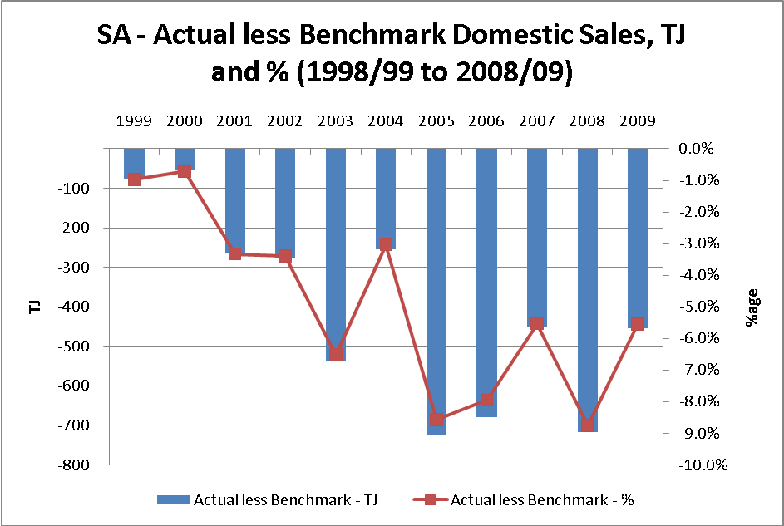

Graph 2.2 Qld – Actual Less Approved Gas Demand

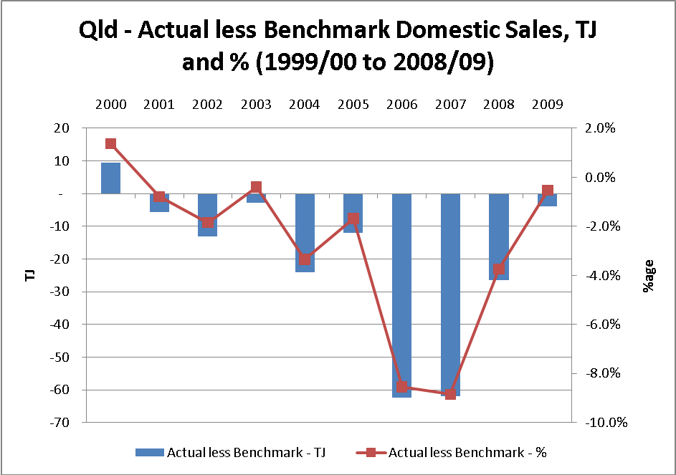

Data for Victoria, whilst not relevant to this review and therefore not provided, presents an analogous trend.
In contrast to electricity, there has been a long term trend of declining average consumption in Envestra’s gas distribution businesses. Over the last 10 years average consumption per domestic connection has declined by around 16% in both South Australia and in Queensland. This trend reflects a number of factors, including warmer weather, increasing penetration of reverse cycle air conditioning displaying gas space heaters, increasing appliance efficiency and changes in government policy and incentives aimed at distorting consumer behavior (for example, towards solar gas or electric water heaters). Previous regulatory decisions have underestimated the extent to which average consumption per connection has been declining.
Demand forecasts approved in this review must be set at a realistic level to give Envestra a reasonable opportunity of recovering the efficient costs of operating the network as required under the National Gas Law and to underpin the future investment in the network. There is also a need for increased research and development expenditure to create new uses of natural gas that will offset the persistent decline in average consumption.

2.4.4 Renew the Network

Since the last access arrangement review, physical deterioration of the network has accelerated relative to that previously forecast. More specifically the length of mains that needs to be replaced to maintain gas leakage levels at constant levels has increased. There is now an urgent need to invest to reverse the deterioration in the network quickly to ensure that the network remains safe, the quality of supply to customers is maintained, and the impact of gas leakage on global warming is reduced. This need has also been recognised by Technical Regulators throughout Australia, who are requiring Envestra to reduce gas losses.

Envestra is proposing to arrest the increased physical deterioration of the network by accelerating the mains replacement program which has been in place since the establishment of the Company. The accelerated mains replacement program has been incorporated in updated asset management plans which have been endorsed by various State Technical Regulators. A large component of the expanded capital program proposed in this submission (around one-third) is required to implement the mains replacement plan.

Furthermore, as customers move to a more energy efficient and sustainable world, they will exercise increased choice over when and how they use natural gas (e.g. solar and renewable energy with natural gas as a back-up). The trend to replace existing appliances with high demand energy efficient appliances will continue. Choices made by consumers will reduce average consumption, but at the same time, increase the peakiness of demand. In order to meet the increased demand for capacity, Envestra will be required to replace the old parts of the network so that they can operate at higher gas pressure.

2.5 Conclusion

A major focus over the Third Access Arrangement Period is to improve Envestra’s gas networks to enable it to meet the future needs of customers in a cost effective and sustainable manner. This objective has been captured in a business strategy which will allow natural gas to fully realise its potential to be part of the solution to climate change and a sustainable energy future in South Australia and Queensland.

Achievement of this vision will require Envestra to enter a new period of investment and development of its gas network.
The AER decisions on the South Australian and Queensland networks will be pivotal to providing the commercial parameters to facilitate these developments. The remaining chapters of this submission provide further detail on specific initiatives that will be required, and the costs of putting in place the necessary natural gas distribution infrastructure to facilitate the realisation of the vision.

- ANALYSIS OF PAST PERFORMANCE

3.1 Revenue Past Performance

Envestra’s Queensland gas network actual revenue for 2006-07 to 2008-09 and forecasts for 2009-10 and 2010-11 are shown in the following table.

Table 3.1 Actual-forecast revenue for Second Access Arrangement Period

$ million (2009-10) | 2006-07  actual | 2007-08  actual | 2008-09  actual | 2009-10  forecast | 2010-11  forecast | Total
Haulage Revenue | 39.2 | 40.6 | 43.0 | 43.2 | 45.6 | 211.1
Ancillary Services | 0.3 | 0.2 | 0.2 | 0.2 | 0.2 | 1.1
Total Revenue | 39.5 | 40.8 | 43.2 | 43.4 | 45.8 | 212.2

The following table shows revenue approved by the QCA for the Second Access Arrangement Period.

Table 3.2 QCA approved revenue for Second Access Arrangement Period

$ million (2009-10) | 2006-07 | 2007-08 | 2008-09 | 2009-10 | 2010-11 | Total
Haulage Revenue | 39.9 | 41.3 | 42.8 | 44.3 | 45.6 | 214.0
Ancillary Services | 0.1 | 0.1 | 0.1 | 0.1 | 0.1 | 0.6
Total Revenue | 40.1 | 41.4 | 42.9 | 44.4 | 45.8 | 214.6

The following graph shows the comparison between the actual - forecast and approved revenue for the Second Access Arrangement Period.

Graph 3.1 Comparison between actual-forecast and approved revenue for the Second Access Arrangement Period.

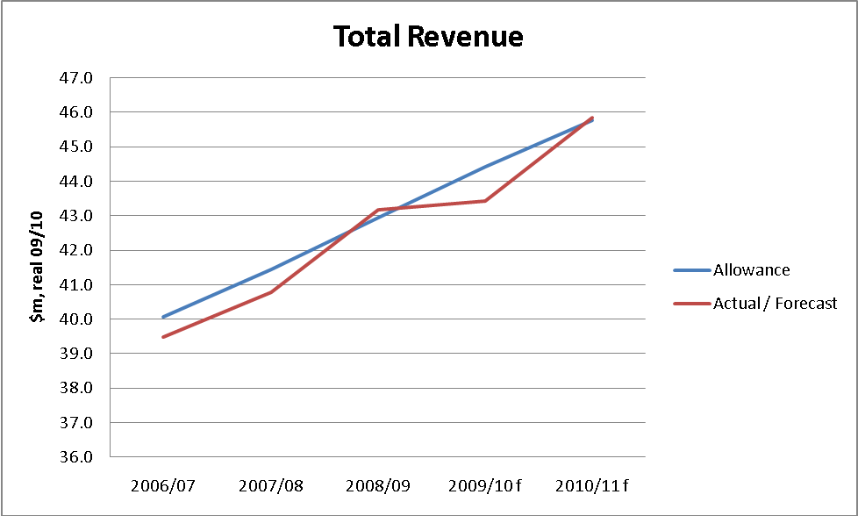

Actual-forecast total revenue will be $2.4 million less than that allowed by the QCA.

The following graph shows the comparison between actual-forecast and approved haulage revenue for the Second Access Arrangement Period.

Graph 3.2 Comparison between the actual - forecast and approved haulage revenue for the Second Access Arrangement Period.

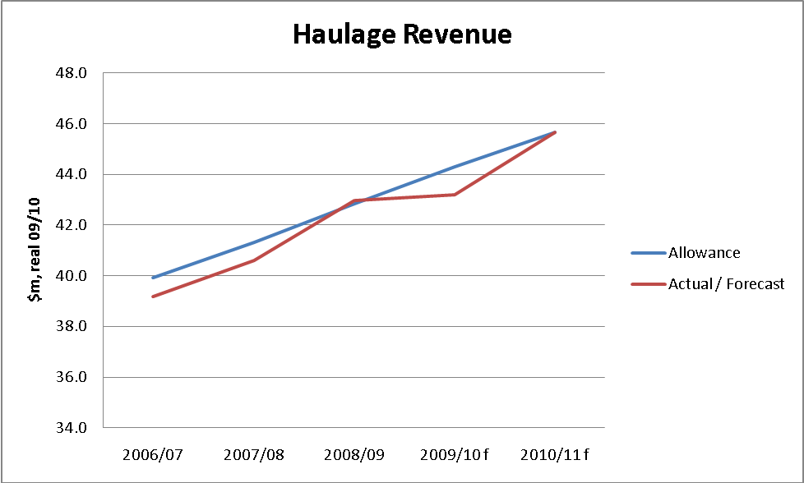

Actual - forecast haulage revenue will be $2.9 million less than that allowed by the QCA.

The following graph shows the comparison between the actual - forecast and approved Ancillary Reference Services revenue for the Second Access Arrangement Period.

Graph 3.3 Comparison between the actual - forecast and approved Ancillary Services revenue for the Second Access Arrangement

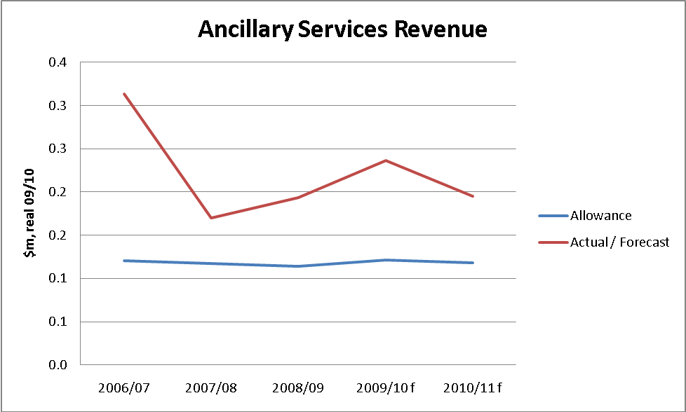

Actual - forecast Ancillary Reference Services revenue will be $0.5 million more than that allowed by the QCA. The higher Ancillary Reference Services revenue partially offsets the shortfall in haulage revenue.

3.2 Demand

Envestra has only once achieved the benchmark volumes set by the Regulator for the domestic market, which is where Envestra recovers a significant amount of its Queensland regulatory revenue allowance. This reflects, in part, the difficulty in forecasting domestic volumes given the uncertainty often surrounding the impact of the many factors on domestic sales (particularly the impact of weather and government policy).

Figure 3.4 shows the difference between actual and approved volumes for the domestic market between 2000 and 2010. This shows that, on average, actual volumes have been three per cent lower than the approved volumes. Actual volumes of gas delivered vary through the decade, however there is a consistent trend of not achieving the approved volumes, with 2005-06 and 2006-07 being particularly poor years.

Graph 3.4 Actual less Approved Volumes for Domestic Customers

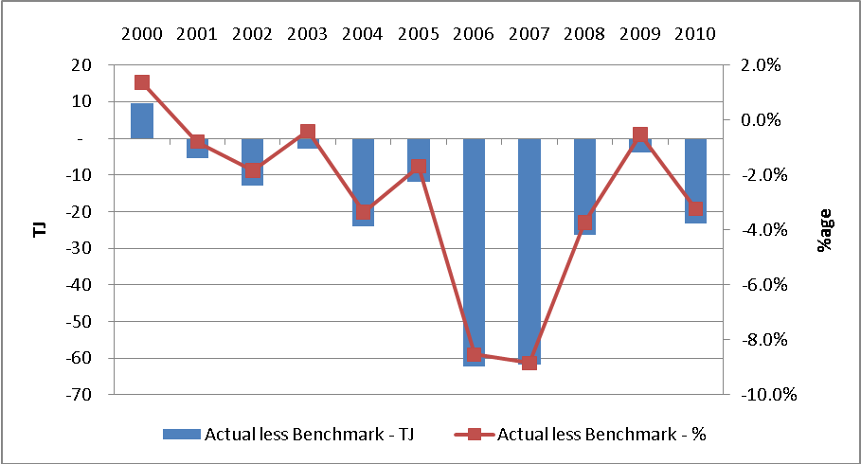

There are two primary reasons explaining this ongoing gap between actual and benchmark volumes. The first is actual customer numbers not achieving benchmark in the first five years of the decade (refer Graph 3.5 below). It is however worth noting that in the Second Access Arrangement Period, Envestra has connected more residential customers than the regulatory allowance, at a lower than approved average consumption.

Graph 3.5 Actual less Approved Domestic Customer Connections (2000 to 2010)

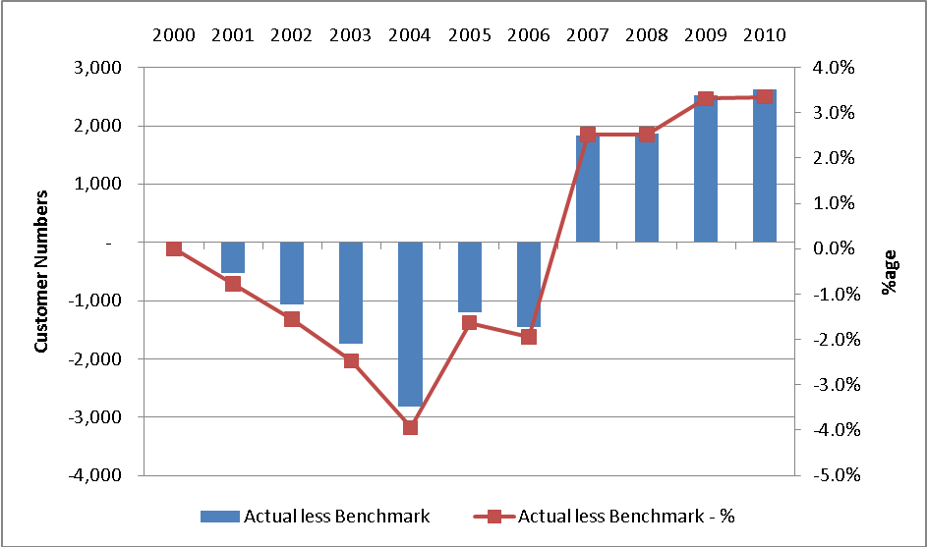

The second factor is average consumption per domestic connection has fallen at a faster rate than that allowed for by the regulator (see Graph 3.6). Between 2006 and 2010, actual average consumption for domestic connections has been six per cent lower than that allowed for by the regulator.

Graph 3.6 Actual less Approved Average Consumption for Domestic Customers % (2000 to 2010)

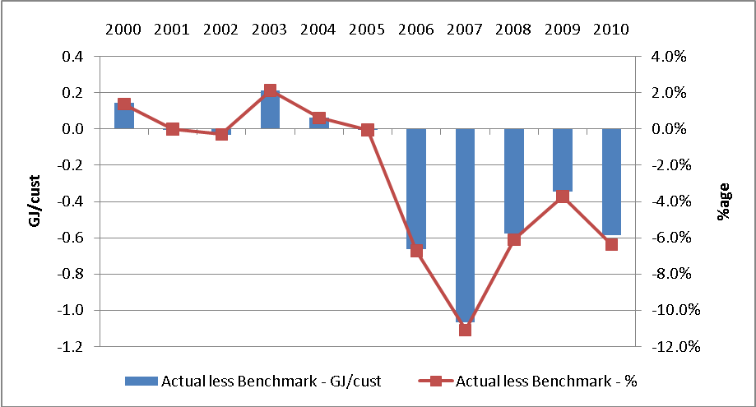

The data show that there has been a long term trend towards declining average consumption for domestic connections (see Graph 3.7). Average consumption has fallen from 10.7 gigajoules per annum (GJ-pa) in 2000 to 8.6 GJ-pa in 2010, reflecting an average annual decline of two per cent (as opposed to the one per cent decline allowed for by the regulator over this period).

Graph 3.7 Actual and Approved Domestic Average Consumption (2000 to 2010)

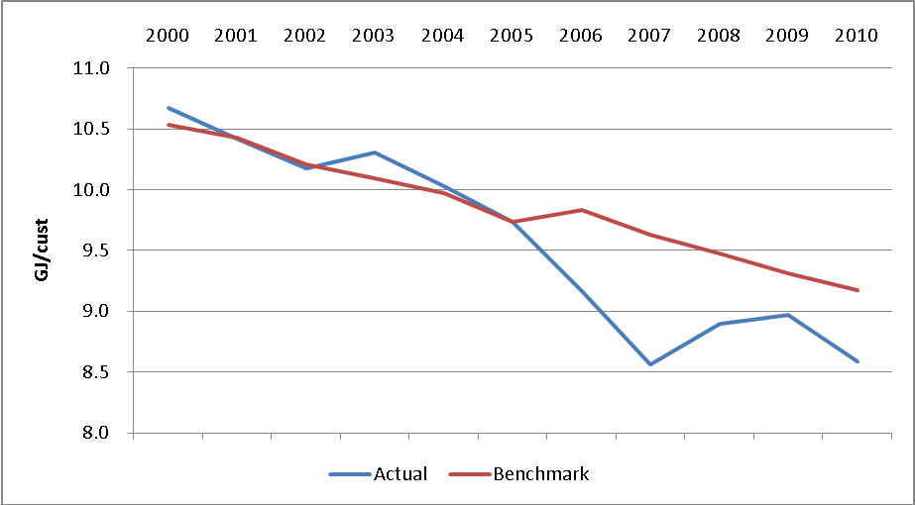

The data shows that average consumption for domestic connections has:

- declined since 2000; and

- declined at a faster rate than forecast by the regulator in the current Access Arrangement Period.

These trends are also apparent in Envestra’s Victorian and South Australian networks.
3.3 Operating Expenditure

This section addresses the requirement of rule 72(1)(a)(ii) for the Access Arrangement Information to include “operating expenditure (by category) over the earlier access arrangement period”.

3.3.1 General

Actual opex for 2006-07 to 2008-09 and forecasts for 2009-10 and 2010-11 are shown in the following table.

Table 3.3 Operating costs 2006-07 to 2010-11

$ m (2009-10) | 2006-07  actual | 2007-08  actual | 2008-09  actual | 2009-10  forecast | 2010-11  forecast | Total
Operating & Maintenance | 13.37 | 12.25 | 13.19 | 13.11 | 13.24 | 65.17
Administration & General | 2.27 | 1.57 | 2.57 | 3.28 | 3.30 | 13.00
Network Development -Marketing | 1.00 | 0.96 | 0.93 | 1.16 | 1.17 | 5.22
FRC Operating Costs | 0.00 | 1.85 | 1.07 | 0.99 | 1.00 | 4.90
UAFG | 1.65 | 1.63 | 0.37 | 0.40 | 0.45 | 4.50
Total | 18.29 | 18.26 | 18.14 | 18.94 | 19.16 | 92.79

The following table shows opex approved by the QCA, including approved FRC costs.

Table 3.4 QCA-approved opex 2006-07 to 2010-11

$ million (2009-10) | 2006-07 | 2007-08 | 2008-09 | 2009-10 | 2010-11 | Total
Operating & Maintenance | 11.09 | 10.87 | 10.38 | 10.45 | 10.24 | 53.04
Administration & General | 2.23 | 2.29 | 2.66 | 2.67 | 2.67 | 12.52
Network Development -  Marketing | 1.02 | 1.00 | 0.99 | 0.99 | 0.97 | 4.97
FRC Operating Costs | 0.11 | 1.75 | 1.42 | 1.42 | 1.42 | 6.13
UAFG | 1.47 | 1.37 | 1.28 | 1.20 | 1.11 | 6.43
Total Material Changes | 3.07 | 2.91 | 3.10 | 2.94 | 3.05 | 15.07
Total | 18.99 | 20.19 | 19.84 | 19.68 | 19.46 | 98.16

The following graph shows the comparison between the actual - forecast and approved opex for the Second Access Arrangement Period.

Graph 3.8 Comparison between the actual - forecast and approved opex

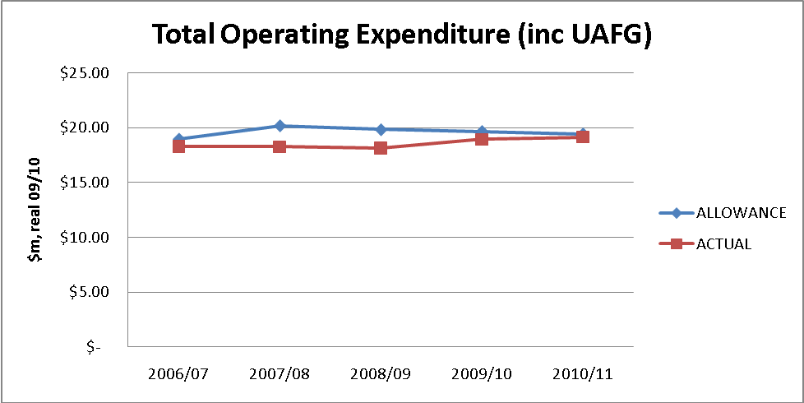

Actual operating expenditure will be $5.38 million (or 5.5%) less than that allowed by the QCA.

Expenditure has been under the regulatory allowance due mainly to a material reduction in UAFG cost and lower than expected FRC costs.

3.3.2 Material Variations from Regulatory Allowances

Material variations from the regulatory allowances are discussed in this section.

Operating and Maintenance

The following graph shows the comparison between the actual - forecast and approved operating and maintenance expenditure for the Second Access Arrangement Period.

Graph 3.9 Comparison between the actual - forecast and approved operating and maintenance expenditure

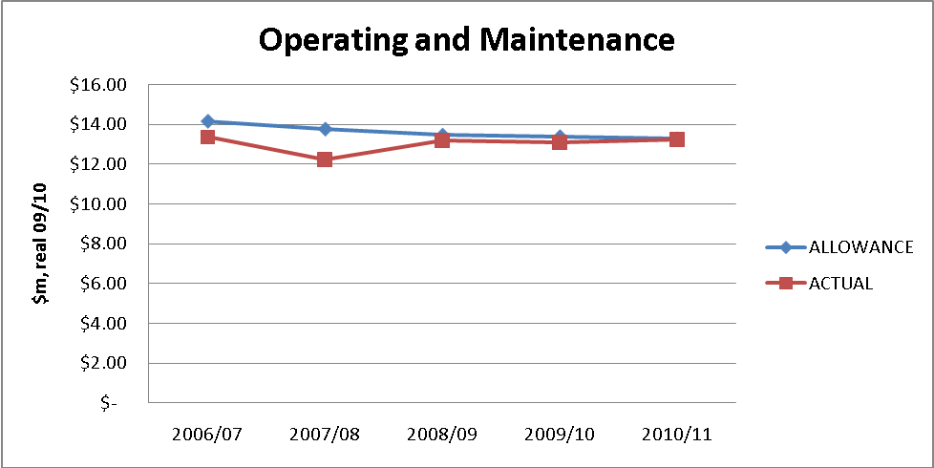

Actual Operating and Maintenance expenditure will be $2.94 million (or 4.3%) less than that allowed by the QCA.

Operating and Maintenance expenditure has trended towards the regulatory allowance and is forecast to remain around that level.

Administration & General

The following graph shows the comparison between the actual - forecast and approved Administration & General expenditure for the Second Access Arrangement Period.

Graph 3.10 Comparison between the actual - forecast and approved Administration & General expenditure

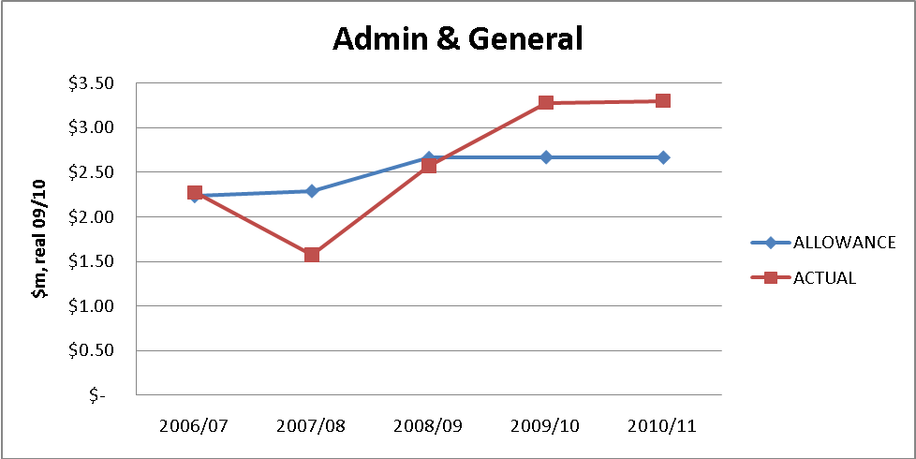

Actual Administration & General expenditure will be $0.48 million (or 3.8%) more than that allowed by the QCA.

UAFG

The following graph shows the comparison between the actual - forecast and approved UAFG expenditure for the Second Access Arrangement Period.

Graph 3.1 Comparison between the actual - forecast and approved UAFG expenditure

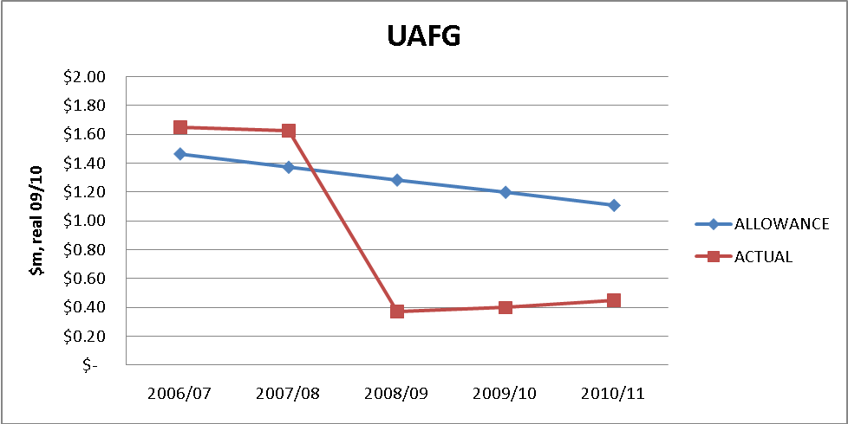

The Access Arrangement UAFG expenditure was set in 2005 based on well established and, at the time, persistent trends. As is apparent from the graph, an abrupt transition occurred in 2008-09, primarily associated with UAFG figures in Brisbane, and the net result is that actual UAFG expenditure is projected to be $1.94m (30.1%) under the five-year allowance of $6.4m. Some of the reduction in UAFG is attributed to the mains replacement program in Queensland, however it is believed that the majority of this step change cannot be associated with physical alteration of the network, and as such is presumed to be the result of other unidentified and potentially temporary factors related to gas volume accounting. Investigations are continuing to identify what factors are causing this outcome.

Network Development - Marketing

The following graph shows the comparison between the actual - forecast and approved Network Development - Marketing expenditure for the Second Access Arrangement Period.

Graph 3.12 Comparison between actual - forecast and approved Network Development - Marketing expenditure

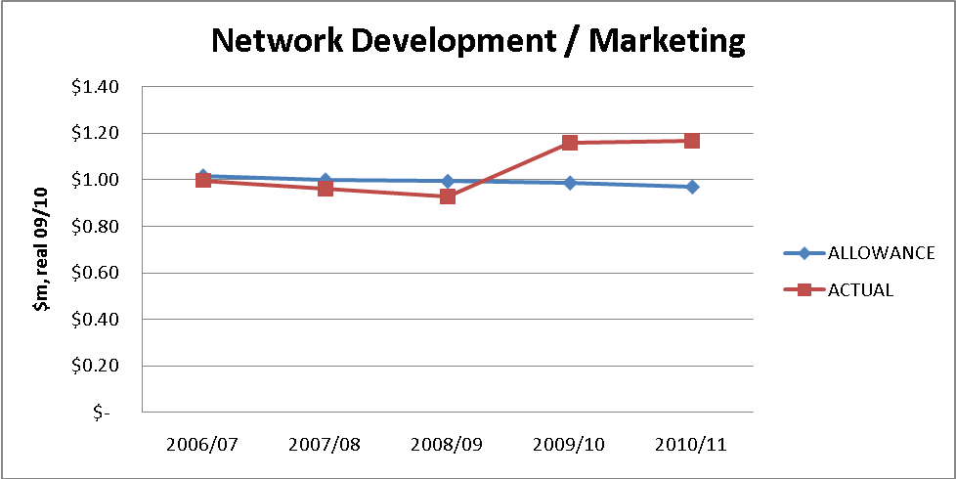
Actual Network Development - Marketing expenditure will be $0.24 million (or 5%) more than that allowed. While the annual spend was generally in line with the regulatory allowance in the first three years, this was largely due to an increase in Operations Support expenditure in response to higher connections to the Network (see Section 6.5). Envestra has recognised that the level of Network Development expenditure needs to be increased if gas demand and penetration is to be maintained.

FRC

The following graph shows the comparison between the actual - forecast and approved FRC expenditure for the Second Access Arrangement Period.

Graph 3.13 Comparison between the actual - forecast and approved FRC expenditure

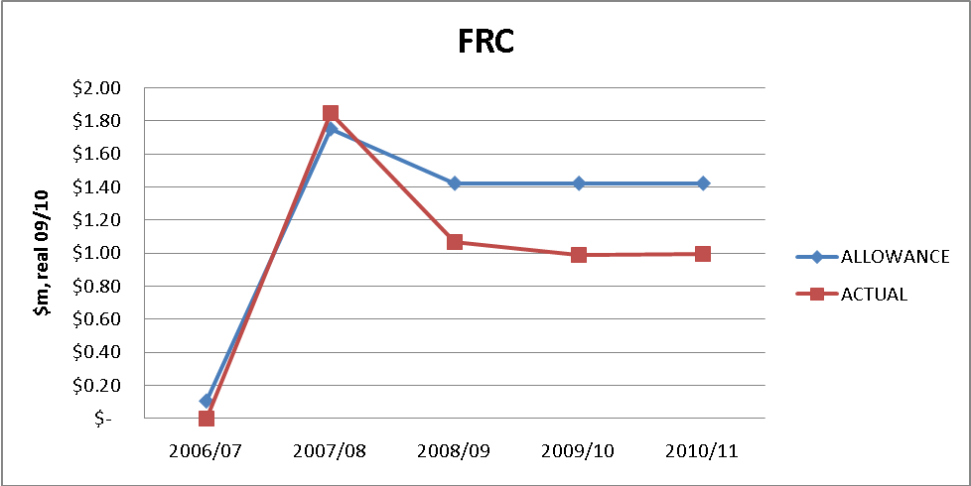

Actual FRC expenditure will be $1.22 million (or 20%) less than that allowed by the QCA.

3.4 Capital Expenditure

This section compares actual - forecast capital expenditure with that approved by the QCA.

3.4.1 General

Actual Capex for 2006-07 to 2008-09 and forecasts for 2009-10 and 2010-11 are shown in the following table.

Table 3.5 Capex 2006-07 to 2010-11

$ million (2009-10) | 2006-07  actual | 2007-08  actual | 2008-09  actual | 2009-10  forecast | 2010-11  forecast | TOTAL
Telemetry | 0.00 | 0.00 | 0.21 | 0.02 | 0.03 | 0.27
Regulators | 0.00 | 0.06 | 0.06 | 0.23 | 0.30 | 0.65
PMC - Domestic | 0.26 | 0.23 | 0.33 | 0.30 | 0.40 | 1.52
PMC - I&C | 0.11 | 0.13 | 0.17 | 0.27 | 0.36 | 1.04
Odorising | 0.00 | 0.00 | 0.00 | 0.00 | 0.00 | 0.00
Corrosion Protection | 0.00 | 0.00 | 0.00 | 0.00 | 0.00 | 0.00
Mains Renewal - Services | 0.19 | 0.11 | 0.61 | 0.40 | 0.53 | 1.84
Mains Replacement | 4.82 | 3.21 | 3.84 | 3.88 | 5.03 | 20.78
IT Systems | 2.12 | 0.00 | 0.01 | 0.00 | 0.15 | 2.28
Other | 1.72 | 1.67 | 4.81 | 4.85 | 2.24 | 15.29
Total Stay-In-Business | 9.22 | 5.41 | 10.04 | 9.95 | 9.04 | 43.66
Large Consumers | 0.00 | 0.00 | 0.00 | 0.00 | 0.00 | 0.00
Improved Supply | 0.00 | 0.00 | 0.00 | 0.02 | 0.71 | 0.74
General Mains | 2.68 | 2.29 | 3.02 | 3.50 | 3.86 | 15.36
Regulators | 0.00 | 0.00 | 0.27 | 0.00 | 0.00 | 0.27
Meters | 1.25 | 1.84 | 1.44 | 1.12 | 1.48 | 7.12
Services | 3.24 | 5.00 | 4.09 | 3.42 | 4.50 | 20.24
Other | 0.02 | 0.00 | 0.00 | 0.00 | 0.00 | 0.02
Total Growth | 7.19 | 9.12 | 8.81 | 8.07 | 10.56 | 43.74
FRC | 6.14 | 2.27 | 0.00 | 0.00 | 0.00 | 8.40
Total | 22.55 | 16.80 | 18.85 | 18.02 | 19.60 | 95.81

Table 3.6 shows capex approved by the QCA for the Second Access Arrangement Period, including FRC allowances in 2006-07, 2007-08 and 2008-09.

Table 3.6 QCA approved capital expenditure for Second Access Arrangement Period

$ million (2009-10) | 2006-07 | 2007-08 | 2008-09 | 2009-10 | 2010-11 | TOTAL
Telemetry | 0.12 | 0.12 | 0.12 | 0.12 | 0.14 | 0.63
Regulators | 0.34 | 0.34 | 0.35 | 0.35 | 0.35 | 1.72
PMC - Domestic | 0.66 | 0.66 | 0.68 | 0.69 | 0.69 | 3.38
PMC - I&C | 0.14 | 0.15 | 0.15 | 0.15 | 0.15 | 0.72
Odorising | 0.05 | 0.06 | 0.06 | 0.06 | 0.06 | 0.27
Corrosion Protection | 0.02 | 0.03 | 0.03 | 0.03 | 0.03 | 0.16
Mains Renewal | 5.58 | 5.58 | 5.58 | 5.58 | 5.58 | 27.89
IT Systems | 0.00 | 0.00 | 5.92 | 0.00 | 0.11 | 6.03
Other | 0.47 | 0.47 | 0.33 | 0.37 | 0.33 | 1.97
Total Stay-In-Business | 7.38 | 7.41 | 13.21 | 7.35 | 7.43 | 42.77
Large Consumers | 0.11 | 0.11 | 0.11 | 0.11 | 0.11 | 0.56
Improved Supply | 0.82 | 0.45 | 0.25 | 0.42 | 0.25 | 2.19
General Mains | 1.80 | 1.89 | 1.72 | 1.85 | 1.99 | 9.26
Regulators | 0.06 | 0.06 | 0.06 | 0.07 | 0.07 | 0.30
Meters | 0.99 | 1.00 | 0.88 | 0.97 | 1.06 | 4.90
Services | 1.63 | 1.75 | 1.65 | 1.67 | 1.69 | 8.38
Major Projects | 1.41 | 1.41 | 1.41 | 1.41 | 1.41 | 7.04
Total Growth | 6.83 | 6.67 | 6.07 | 6.49 | 6.58 | 32.64
Total FRC | 8.21 | 1.75 | -5.03 | 0.00 | 0.00 | 4.92
Total Material Changes | 0.59 | 0.10 | 0.00 | 0.00 | 0.00 | 0.69
Total | 23.00 | 15.94 | 14.25 | 13.84 | 14.01 | 81.03

Graph 3.14 shows the comparison between the actual - forecast and approved total capex for the Second Access Arrangement Period.

Graph 3.14 Comparison between the actual - forecast and approved capex

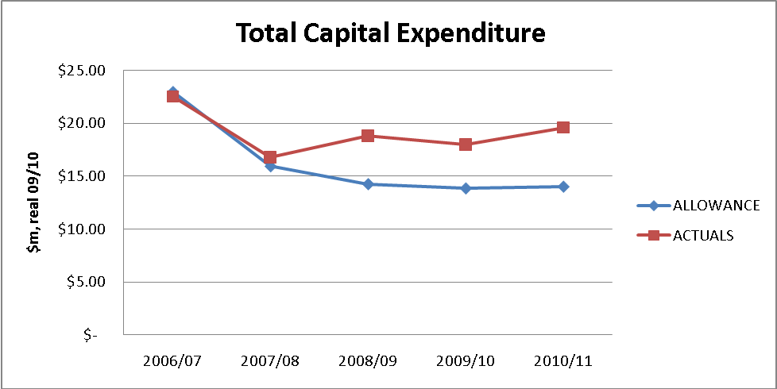

Actual total capital expenditure will be $14.78 million (or 18.2%) more than that allowed by the QCA.

The overall level of capex has been at a level higher than the benchmarks, with under-expenditure in some areas (mainly due to the GFC) offset by over-expenditure in growth capex, the latter reflecting a green energy policy of the Queensland government which has provided support for natural gas and contributed to higher numbers of new connections.

3.4.2 Material variations from regulatory allowances

Material variations from the regulatory allowances are discussed in this section.

Stay in business capital expenditure

The following graph shows the comparison between the actual - forecast and approved stay in business capex for the Second Access Arrangement Period.

Graph 3.15 Comparison between the actual - forecast and approved stay in business capex

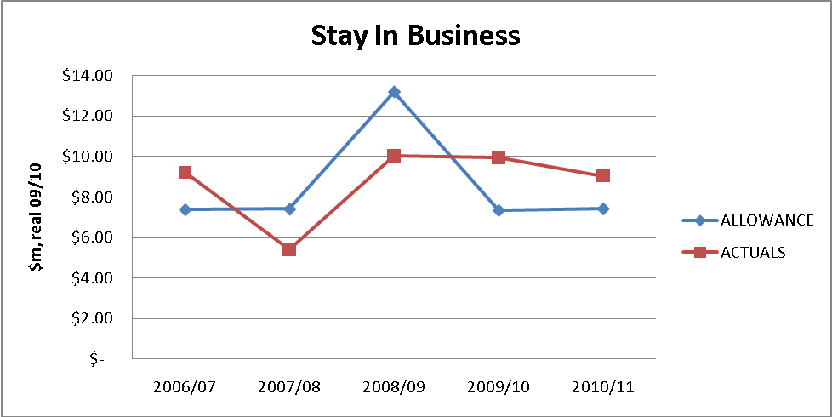

Actual stay in business capital expenditure will be $0.89 million (or 2.1%) more than that allowed by the QCA.

Mains renewal

The following graph shows the comparison between the actual - forecast and approved mains renewal capex.

Graph 3.16 Comparison between the actual - forecast and approved mains renewal capex

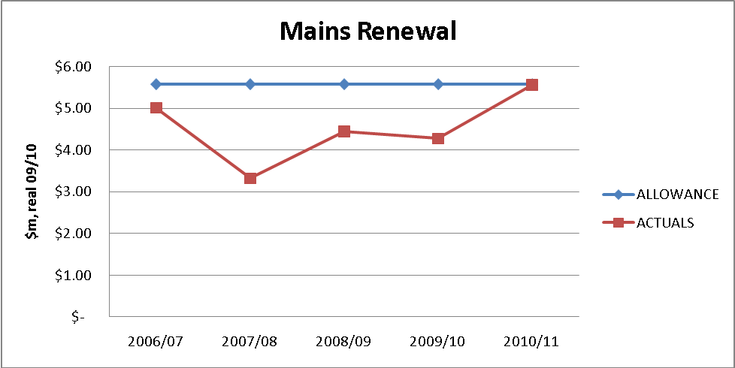

Actual mains renewal capex will be $5.27 million (or 18.9%) less than that allowed by the QCA across the access arrangement period.

Mains renewal capex was temporarily curtailed from 2007-08 2009-10 due to increased funding costs and the need to curtail capital expenditure due to the GFC.

While Envestra spent less than the allowance on mains renewal, the length of mains able to be renewed was further impacted by the fact that the unit rate approved by the QCA was lower than that necessary to undertake the work. The following Graph 3.17 shows the comparison between the actual - forecast and approved mains renewal unit rate.

Graph 3.17 Comparison between the actual - forecast and approved mains renewal unit rate

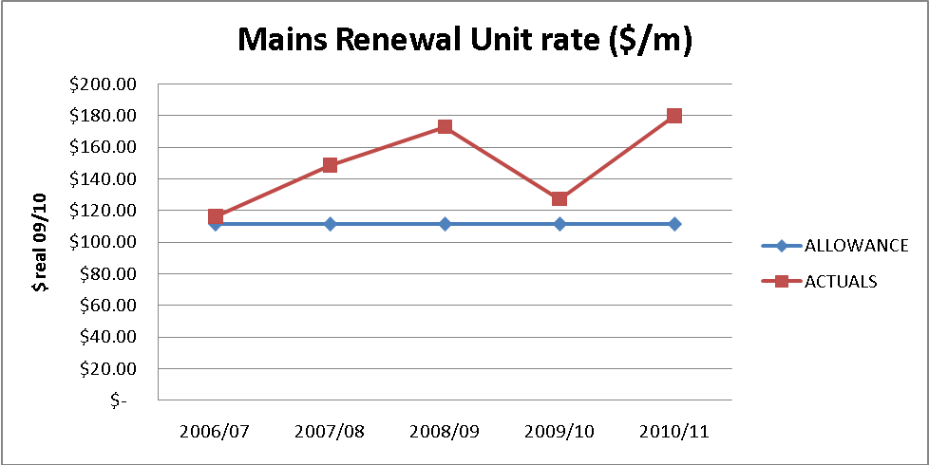

Unit rates for mains renewal are generally increasing due to higher costs of undertaking works in the remaining inner suburban areas, where field work is more complex and subject to onerous constraints due to urban congestion.

Growth capital expenditure

The following graph shows the comparison between the actual - forecast and approved growth capex for the Second Access Arrangement Period.

Graph 3.18 Comparison between the actual - forecast and approved growth capex

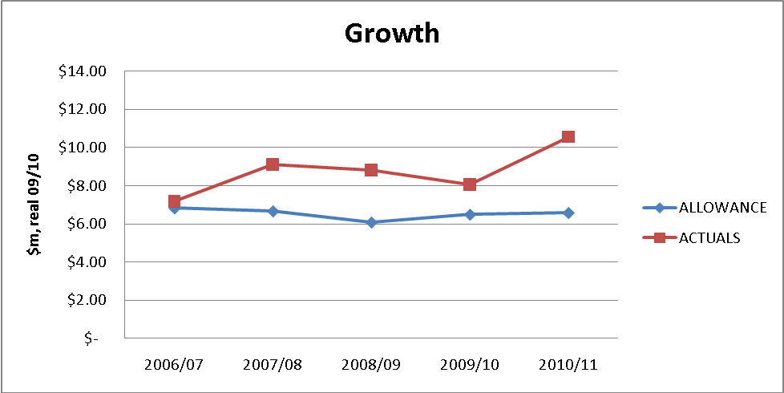

Actual growth capital expenditure will be $11.1m (or 34%) more than that allowed by the QCA.

Despite the effects of the GFC, demand for new connections has remained strong due to continued population growth in south-east Queensland, support by Queensland government policy and active marketing of natural gas. This strong growth has contributed to actual capex being greater than that approved by the QCA.

Part B – Derivation Of Total Revenue
4. PIPELINE SERVICES

4.1 Haulage Reference Services

Envestra is proposing to provide three Haulage Reference Services:

- Demand Haulage Reference Service – this service currently provides for the forward haulage of Gas to Delivery Points (DPs) with an annual consumption that exceeds 10TJ per year, but an additional criterion of 50 GJ per day will apply;

- Commercial Haulage Reference Service – this service applies to all DPs that are not Demand DPs or Domestic DPs; and

- Domestic Haulage Reference Service – this service provides for the haulage of Gas to DPs where Gas is used primarily for domestic purposes.

The “daily demand” criterion for the Demand Haulage Reference Service was previously in place, but was dropped for the Second Access Arrangement Period in order to simplify administrative arrangements. However, it is now clear that capacity management will be an increasingly important issue for the Network. From time to time, there may be a small number of customers that do not meet the annual 10 TJ threshold but which may draw large volumes of gas over a short period of several hours, with such a peak load eclipsing that of some smaller Demand customers. Such sites must be managed akin to Demand sites.

In reality, network design and management is dictated by hourly demand rather than daily or annual demand. Annual demand has been used as a proxy for hourly demand due to its simplicity and the fact that widespread use of interval metering data was not available prior to the introduction of full retail contestability in the gas market. In due course Envestra will be examining the pros and cons of transitioning to a Demand tariff that is predicated solely upon hourly demand.

For the Third Access Arrangement Period, Envestra has split the existing Volume Haulage Service into a Domestic and Commercial Haulage Service, thereby mirroring the arrangement in place in South Australia. This reflects the importance attributed to this part of the market and recognises the different characteristics of this market segment.

Envestra believes that the Haulage Reference Services are the haulage Services that are likely to be sought by a significant part of the market during the Third Access Arrangement Period, as these Services are materially those currently being provided to Users.

4.2 Ancillary Reference Services

In addition to the Haulage Reference Services, Envestra recognises that additional services may be requested by a significant part of the market. Envestra is proposing to continue with the existing Special Meter Reading Ancillary Reference Service, but to include Disconnection and Reconnection as Ancillary Reference Services as they are also commonly demanded by Users on a daily basis. This also aligns the Ancillary Reference Services with those in South Australia. The proposed services are therefore:

- Special Meter Reading – a meter reading for a DP and provision of the associated meter reading data, that is in addition to the scheduled meter readings that form part of the Haulage Reference;

- Disconnection – installing locks or plugs at the Metering Installation of a Domestic DP in order to prevent the withdrawal of Gas at the DP;

- Reconnection – restoring the ability to withdraw Gas at a Domestic DP, following previous Disconnection, i.e. the removal of any locks or plugs used to isolate supply, performance of a safety check and the lighting of appliances where necessary.

4.3 Non-Reference Services

Users may require services that are different from the Reference Services and Envestra will negotiate such services on a case-by-case basis. Where the same non-reference service is provided to more than one Network User, Envestra will not discriminate between Network Users.

The tariff for a Reference Service takes into account the corresponding service levels and business risks associated with providing the service in accordance with the agreed terms and conditions. Users are able to negotiate different service levels or different terms and conditions, and the delivery of such a service will be priced accordingly (as a Negotiated Service).

4.4 Service Standards and Quality

In addition to the terms and conditions applicable to the provision of a Service (Annexure G of the Access Arrangement), Envestra will provide Services in accordance with certain service standards and quality levels. Where Envestra does not provide adequate levels of service or meet customers’ expectations, systems are in place to act upon any complaints received. It is noted that very low numbers of complaints are lodged with the Energy Ombudsman Queensland in respect of the gas network.

Apart from those areas where Envestra interacts with consumers and Users, Envestra must comply with numerous standards that pertain to the operation and maintenance of the Network. Such standards ensure that gas consumers receive a high level of service and reliability. The safety issues associated with the distribution of a gaseous and flammable hydrocarbon mean that maintenance practices and response times to maintenance issues must be of a high standard.

For example, Envestra is required to:

- odorise gas to prescribed levels;

- maintain gas pressure within the Network above a set level;

- survey the Network regularly for gas leakage; and

- respond to reports of gas leakage within certain timeframes, and repair gas leaks within certain timeframes.

All of the above standards contribute to a safe and uninterrupted gas transportation service to consumers, resulting in a low number of gas outages and a low number of complaints from consumers.

As outlined above, the applicable service standards result in an inherent high level of reliability and high level of service. Envestra is aware that in some jurisdictions, notably in relation to electricity distribution, that sophisticated reporting systems have been implemented to record and report on detailed aspects of service delivery. Envestra is of the view that, given the current high levels of service, the introduction of more onerous reporting systems is not warranted.

Should Envestra be required, for example through licence requirements or other Regulatory Instruments, to implement systems to collect and monitor information for a more rigorous set of reliability indicators or to provide a higher level of service, it is expected that such costs will be ‘passed through’ in accordance with section 4 of the Access Arrangement.

4.5 Rules Compliance

Rule 101 states that:

- A full access arrangement must specify all reference services;

- A reference service is a pipeline service that is likely to be sought by a significant part of the market.

Sections 2.2 and 2.3 of the Access Arrangement specify all of the reference services. Those services have been either sought by a significant part of the market or are likely to be sought by a significant part of the market in the Third Access Arrangement Period.

- OUTSOURCING ARRANGEMENT

5.1 Introduction

Envestra has included within its forecast cost profile the costs incurred in operating its South Australian (SA) and Queensland (Qld) networks. Those costs include a network management fee (NMF) to be paid to the APA Group under an operating and management agreement entered into between Envestra and APA in July 2007 (the 2007 OMA). Under the 2007 OMA, Envestra has outsourced its network operating activities to APA for the SA and Qld networks.

The costs payable under the 2007 OMA, including the NMF, satisfy the test for recovery of operating expenditure as set out in Rule 91(1) of the National Gas Rules. This is because the costs will be incurred by Envestra acting efficiently, in accordance with accepted industry practice, to achieve the lowest sustainable cost of delivering pipeline services in SA and Qld.

More specifically, the payments made under the OMA satisfy Rule 91(1) of the National Gas Rules because outsourcing to APA enables Envestra to access the economies of scale (efficiencies arising due to the size and scope of operations of the APA Group) available to the APA Group that are not available to Envestra, at a cost to Envestra (the NMF) which is less than the value of benefits derived from those economies. The APA Group has twice the assets of Envestra and three times the revenue.

From its inception Envestra was structured so that it would be able to benefit from accessing the economies of scale from outsourcing to a larger entity. In 1997, Envestra entered into an operating and management agreement with the Boral Limited Group for its South Australian and Queensland networks (the 1997 OMA). The 1997 OMA needed to meet the requirements of the Envestra Board (and its expert advisers), the share market and Envestra’s financiers for operational efficiency.

The efficiency of Envestra’s outsourcing structure and the ability of that structure to effectively capture economies of scale was demonstrated when Envestra successfully purchased the Victorian ‘Stratus’ gas distribution business in what was a highly competitive bid process. Envestra successfully acquired that network on the basis of costs derived under an equivalent outsourcing arrangement with Boral for the Victorian network.

The relevant consideration under the National Gas Rules, as affirmed in the 2008 Victorian review process, is whether the outsourcing contract is likely to lower overall costs as compared to alternative arrangements. In respect of this issue KPMG found that annual costs are likely to be, in respect of Envestra’s SA and Qld networks, around $4.54 million lower than would have been the case had Envestra operated the network itself. This finding is consistent with a KPMG report prepared in respect of Envestra’s Victorian operations. The efficacy of the methodology employed by KPMG was recognised in the Victorian review by the Victorian appeal panel.

Comparative cost benchmarking and productivity analysis confirms that Envestra is operating efficiently when compared to other service providers, thereby demonstrating that the 2007 OMA enables Envestra to perform as an efficient operator. This analysis is performed taking into account all of the payments made by Envestra to APA under the 2007 OMA.

The above conclusions are consistent with those reached in five of the past six regulatory decisions regarding Envestra’s outsourcing arrangements. In the one case where the NMF was not approved, the framework applied by the Regulator (ESCOSA) has no precedent value. The reasons for this are discussed in this chapter.

In support of the above conclusions, Envestra has provided a body of lay evidence (by way of affidavit) and expert reports, which evidence is outlined in attachment 5-1 and attached to Envestra’s revised Access Arrangement Information.

This chapter outlines the relevant tests in the National Gas Rules for assessing Envestra’s outsourcing arrangement and provides an overview of the outsourcing arrangement and its operation. This chapter then sets out the reasons why, as has been the case in five out of the past six regulatory reviews, the NMF satisfies the relevant tests set out in the National Gas Rules (which in short is because it is a payment made by Envestra to achieve lower overall costs).

5.2 Relevant Assessment Criteria

The test for recovery of operating expenditure is set out in Rule 91(1) of the National Gas Rules. That rule provides:

“Operating expenditure must be such as would be incurred by a prudent service provider acting efficiently, in accordance with accepted good industry practice, to achieve the lowest sustainable cost of delivering pipeline services.”

Rule 91(2) provides that the AER’s discretion under Rule 91(1) is limited. This means the AER may not withhold its approval to an element of an access arrangement proposal (to which Rule 91 relates) if the AER is satisfied that the element:

“(a) complies with applicable requirements of the Law; and

(b) is consistent with applicable criteria (if any) prescribed by the Law.”

If an item of claimed operating expenditure is expenditure which would be incurred by a prudent service provider acting efficiently in accordance with accepted good industry practice to achieve the lowest sustainable cost of delivering pipeline services then it satisfies the applicable requirements and criteria of Rule 91. The AER must therefore approve that item of operating expenditure.

Rule 91(1) does not state that operating expenditure must be the lowest sustainable cost of delivering pipeline services. Expenditure falls within the rule if it is incurred by a prudent service provider acting efficiently to achieve the lowest sustainable cost of delivering pipeline services. The use of the word “achieve” is significant. If a service provider has undertaken expenditure which is consistent with what would be undertaken by a prudent service provider acting efficiently to achieve lowest sustainable cost then the expenditure is recoverable. The service provider does not have to show that the expenditure is in fact the lowest sustainable cost achievable.

The test for recovery of capital expenditure in Rule 79(1)(a) is consistent with Rule 91.

5.3 Overview of Outsourcing Arrangement

In 1997, Envestra was floated on the Australian Securities Exchange (ASX). It purchased the gas distribution business operations of the Boral Group in SA, Qld and the Northern Territory (NT). Envestra entered into an outsourcing arrangement with the Boral Group, under which Boral would manage and operate the Envestra networks in SA, Qld and the NT (the 1997 OMA).

In 1999, Envestra purchased the Victorian gas distribution business, Stratus, for [C-I-C]. Envestra again entered into an outsourcing arrangement with the Boral Group for the operation of the Victorian network (the 1999 OMA). The efficiencies yielded by the outsourcing arrangement were one reason Envestra won the competitively tendered business. The circumstances of the above transactions are dealt with further later in this chapter.

In 2007, Origin Energy (previously Boral Energy) decided to sell various assets and operations, including its operating functions under the 1997 OMA and 1999 OMA. The APA Group was the successful acquirer. The acquisition included the assignment/novation of the 1997 OMA (for SA, Qld, and NT) and the 1999 OMA (for Victoria) to APA. This was done by restating each of the 1997 OMA and the 1999 OMA as two new agreements (2007 OMA for SA, Qld and NT and 2007 OMA for Victoria) and then novating them to APA. The circumstances of the above transactions are also dealt with further later in this chapter.

Under the 2007 OMA, Envestra makes the following payments to the APA Group:

(a) re-imbursement of reasonable costs;

(b) payment of the NMF, being 3% of the total revenue derived by Envestra across the networks; and

(c) incentive payments payable to APA for achieving reductions in costs of new connections and controllable costs per GJ (Incentive Payments).

The above payments are dealt with further later in these submissions.

The NMF is, consistent with past regulatory practice, treated as operating expenditure. The Incentive Payments paid to APA under the 2007 OMA are classified by Envestra as either operating or capital expenditure depending on the nature of the incentive.

5.4 Relevance of APA Shareholding

The AER has indicated that a relevant consideration in assessing whether a regulated entity is able to satisfy the test under Rule 91(1) is whether the service provider is related to the contractor. In particular, in two recent decisions in 2010, the AER has set out a number of principles for the assessment of outsourcing contracts. These include asking:
(a) whether the service provider has or had an incentive to agree non-arms length terms; and

(b) if so, whether the outsourcing contract was subject to a competitive tender.

According to the AER, if the answer to (a) is ‘no’ or the answer to (a) is ‘yes’ but the answer to (b) is also ‘yes’, the AER will presume the price under the contract, including any margin payment, reflects efficient costs. Put differently, the contract will in these circumstances pass the AER “presumption threshold” that the costs under the contract are efficient.

According to the AER, where parties are related this may indicate the existence of an incentive to agree ‘non-arms length’ terms, and therefore the costs may not pass the presumption threshold. The AER has stated that if the contract does not pass the presumption threshold, the AER will undertake a more detailed examination of the contract to assess whether a margin above the contractor’s costs is an efficient cost.

Envestra and the APA Group are related for financial reporting purposes by reason of the following events:

- in 2007 when the APA Group acquired from Origin Energy Limited its pipeline and network businesses it acquired Origin Energy Limited’s 17% shareholding in Envestra;

[C-I-C]

[C-I-C]

APA’s shareholding does not affect the operation of the 2007 OMA, which is administered between Envestra and APA on an arm’s length basis reflecting the fact that:

(a) while APA is a large shareholder in Envestra, its influence over Envestra is balanced by the large shareholding also held by the CKI Group which currently has a 19% ownership interest in Envestra;

(b) Envestra has eight Board members, four of whom are independent directors (including the Managing Director), two of whom are APA appointed Directors (who are also directors of APA entities) and two of whom are CKI appointed Directors. Therefore APA is not in a position to control the Board of Envestra and can be out-voted on any issue by the other members of the Board;

(c) the two APA Directors do not participate in any decisions relating to the operation of the 2007 OMA;

(d) neither Envestra nor the APA Group (nor the CKI Group for that matter) are part of the same group of companies. That is, Envestra is not part of the same corporate group as its major shareholders.

As set out in section 5.6 below and in the affidavits of John Ferguson (see Attachment 5-2) and Ian Little (see Attachment 5-3), the 2007 OMA is subject to strict cost management protocols and budgeting processes.

In summary, Envestra and APA operate as independent arms’ length entities in administering the terms of the 2007 OMA. The AER should consider the 2007 OMA and costs payable by Envestra under it in that light. The AER’s ‘presumption’ threshold, even if justifiable under Rule 91(1), is therefore not relevant to the specific circumstance of Envestra for the purposes of the current regulatory review process.

5.5 History of Outsourcing Arrangements

Envestra’s outsourcing arrangements across its networks are efficient because they have enabled Envestra to access economies of scale of larger and well established operators at a cost which has been, and will continue to be, substantially less than the cost Envestra would incur in operating the networks itself without the efficiencies derived by Envestra from those arrangements. This is dealt with in this section.

5.5.1 1997 Outsourcing Arrangements – SA, Qld, NT

Since its inception Envestra has been a dedicated asset owner with operations outsourced to a third party.
The key motivation for this structure was, and still is, to ensure that Envestra would continue, following its split from Boral, as a low cost operator by accessing the economies of a larger organisation. The outsourcing structure is therefore a fundamental part of Envestra’s business strategy.

There were a number of possible strategies that could have been adopted in determining the appropriate manner in which to structure Envestra in 1997, including establishing:

(a) separate entities, one to own and operate the SA network and one to own and operate the Qld network; or

(b) a single entity with the internal resources to operate the SA and Qld networks; or

(c) a single entity that owned the SA and Qld networks but with the operation of those networks outsourced to an external provider.

The third strategy above was adopted and BEAM, a Boral subsidiary, (later changing its name to OEAM) was selected as the external service provider.

There were no other service providers at the time who could offer the experience or economies of scale, scope and size of Boral. Boral was a much larger entity than Envestra and much better able to access economies of scale and scope than Envestra. This was considered the most effective way in which to create a viable, cost-efficient new business that could successfully acquire assets in the deregulated energy market (which did occur). If all operational staff for the two networks (plus the NT) had been transferred to Envestra, the effect of this would have been to deny Envestra access to the economies of scale and scope and “know-how” of the significantly larger and more experienced Boral group.

The operating structure has also allowed the asset management arm to grow its intangible assets above that which would be available from servicing only Envestra’s networks. This was the case with Boral (and later Origin Energy), which both had substantial operations well beyond the scale of the networks managed and operated by BEAM/OEAM for Envestra. This is also now the case with APA, who provides significant asset management services across a range of infrastructure (including operating the entire south-east Queensland gas network system).

5.5.2 1999 Outsourcing Arrangements - Victoria

The 1999 OMA was entered into, on terms equivalent to the 1997 OMA, at the time Envestra purchased the ‘Stratus’ business from the Victorian Government.

The 1999 OMA was entered into by Envestra on the basis that this would best assist Envestra in the highly competitive bid process for the ‘Stratus’ business in Victoria. Envestra management considered that the 1997 OMA was working efficiently and would assist Envestra to be price competitive in the bidding process. It was proposed that the terms of the 1999 OMA would mirror the terms of the 1997 OMA.
The decision as to how to structure the 1999 OMA was made by Envestra as an arm’s length entity from Boral. Envestra had a majority independent Board and majority independent shareholders (Boral had a then 19.97% shareholding). Envestra had no incentive other than to agree to a structure which would yield for it the greatest cost efficiencies.

As a result of these arrangements, Envestra successfully acquired the Victorian ‘Stratus’ business in 1999. The successful acquisition affirmed the efficiency of the outsourcing arrangements under the 1997 OMA for SA, Qld and NT.

In respect of the 1999 OMA:

(a) the tender for Stratus Networks was a competitive bid process and the cost structure of Envestra’s outsourcing arrangement had to be competitive to allow Envestra to make a successful bid;

(b) Envestra considered BEAM’s operation of the SA and Qld networks, pursuant to an agreement with largely the same terms as the 1999 OMA, was working efficiently. The demonstrated efficiency of the outsourcing structure to BEAM meant that the structure proposed for the Victorian network was readily apparent and proven by experience to be the best structure for Envestra;

(c) the perpetual term of the 1997 OMA and 1999 OMA reflected the need to provide Envestra with stability and the certainty it would have a long term operator of its assets and avoid the potentially substantial costs involved in changing operators; and

(d) in negotiating the 1999 OMA, Envestra’s management considered the 3% NMF was an appropriate cost for accessing Boral’s economies of scale.

The purchase of the Stratus Network was in part funded by a rights issue. Through that rights issue the CKI Group, being a major Hong Kong-based owner/operator of energy assets, acquired a 19.97% shareholding in Envestra. The fact that such a major investor was prepared to take up a major shareholding in Envestra is further affirmation of the efficiency of Envestra’s outsourcing arrangements.

The events of 1999 demonstrated that:

(a) the earlier 1997 OMA was an efficient structure;

(b) Envestra was able to win a highly competitive bid process in 1999 by using the same form of contracting model as used in the 1997 OMA;
(c) Envestra (and its expert advisors), investors and financiers all continued to consider that the payment of the NMF would optimise Envestra’s operational efficiencies through the Boral Group operations; and

(d) Envestra was able to access significant intangible assets available to BEAM/OEAM and therefore also access far greater economies of scale and scope than those ever conceivably available to Envestra.

5.5.3 2007 Outsourcing Arrangements – SA, Qld, NT, Victoria

In 2007 Origin Energy decided to divest its network operations business and related interests, which included OEAM, its shareholding in Envestra and 33.3% interest in the SEA gas pipeline. These assets were acquired by the APA Group in 2007. With that acquisition, the APA Group proposed to acquire the operating activities of OEAM, including those under the 1997 OMA and 1999 OMA with Envestra. This required the consent of Envestra.

In July 2007, Envestra consented to a transfer of its outsourcing arrangements from OEAM to the APA Group. Under the OMAs, Envestra could not unreasonably withhold its consent to the transfer.

Clearly, Envestra would not have given its consent if there had been any real risk that the operation of its assets through the APA Group would have been at a higher cost, or if the APA Group had been less experienced or not able to access substantial economies of scale and scope.

Those risks however did not exist. Envestra considered that the APA Group would be a cost efficient operator. By 2007, the APA Group had extensive infrastructure assets of its own as well as assets owned by third parties which APA operated on their behalf. Indeed the scope of APA’s operations (particularly in gas pipelines) is more aligned to Envestra’s business of gas distribution, providing an opportunity for more targeted efficiency gains through using APA as the operator.

The transfer was effected by restating the 1997 OMA and 1999 OMA in a revised form (the 2007 OMAs), which reflected amendments required by Envestra, and then novating the OMAs to the APA Group. The 2007 OMA is in similar terms to those of the earlier OMAs but with two key adjustments, namely:

[C-I-C]

At the time the APA Group became the outsource provider it also acquired from Origin Energy a 17% equity interest in Envestra. At the time of the 2007 OMA, Envestra’s other major shareholder was the CKI Group, holding a 19.97% equity interest in Envestra.

The APA Group is a dedicated and significant gas infrastructure company, delivering more than half of Australia’s annual gas usage. APA has interests in more than 12,000km of natural gas pipeline infrastructure, over 2,800km of gas distribution networks and is the owner of various gas plants and facilities and interconnector systems. The key metrics of the APA Group and Envestra are shown in table 5.1.

Table 5.1 Envestra and APA Group Key Operating Metrics, 30 June 2010

 | Envestra Limited | APA Group
Annual Revenue | $383m | $990m
Total Assets | $2,706m | $4,982m
Annual Capital Expenditure | $98m | $333m

Unlike Envestra, the APA Group provides very substantial asset management services across Australia in respect of a range of gas and electricity infrastructure assets in addition to those owned by APA or Envestra (see attachment 5.5). APA operates assets with a value in excess of $8 billion. The APA Group as operator of Envestra’s assets therefore brings significant economies of scale from its operations which Envestra cannot match.

This significance of economies of scale was recognised by the Essential Services Commission of Victoria (ESCV) in its 2008 regulatory review of Envestra’s Victorian operations. The ESCV accepted evidence submitted by Envestra that it was likely to gain from the economies of scale available to the contractor for Envestra’s operations and that the direct costs of that contractor would be lower than the direct costs that Envestra would be able to achieve had it performed the services in-house.

John Ferguson, General Manager Networks for APA lists some examples of the types of economies provided by APA to Envestra under the 2007 OMA. These are highlighted in the following section and explained further in his affidavit.

5.6 The 2007 OMA Cost Management Provisions

Under the 2007 OMA, APA's primary obligation to Envestra is to operate the gas networks owned by Envestra. Envestra must provide APA with access to pipelines and networks and relevant information needed to allow APA to meet its obligation.

The service provided by APA under the 2007 OMA is provided at the direction of Envestra. This direction is facilitated through strict cost management provisions set out in the 2007 OMA, including the preparation and continual monitoring of Envestra’s annual budget.

The key cost management provisions included in the 2007 OMA are as follows:

[C-I-C]

The affidavits of Ian Little and John Ferguson demonstrate that the relationship between Envestra and APA in relation to management of costs under the OMA is a robust and sometimes abrasive relationship marked by the constant pressure to drive down costs and increase efficiency.

Around 500 staff within APA discharge the obligations under the 2007 OMAs. In addition, APA sub-contracts the provision of certain services under the 2007 OMAs.

Subcontracting is undertaken for areas of work which are seasonal or which are highly specialised (for example road maintenance and restoration, underground boring, concrete cutting, civil excavation works and intelligent pigging). In the case of both seasonal work and specialised work it would be economically inefficient for APA to retain resources internally: in the case of seasonal work because it would result in resources sitting idle for large parts of a year and in the case of specialised operations because of the high cost of internally resourcing such activities.

The following procedures are employed by APA to ensure efficient subcontracting:

[C-I-C]

(c) APA uses its extensive knowledge of market costs to ensure that subcontractor costs are competitive;

(d) subcontracts are only awarded to members of the APA Group in limited circumstances where doing so will generate cost efficiencies for Envestra. One example is GasNet who has extensive expertise in the interface between transmission and distribution networks and can therefore offer a lower cost solution than contractors outside the APA Group. In such cases GasNet provides its services at cost with no mark up or margin.

5.6.1 Economies of Scale Accessed by Envestra

Envestra’s outsourcing arrangement is structured so as to enable Envestra to access the economies of scale, scope and know-how available to a larger corporate group. The NMF is the consideration paid by Envestra to access such economies.

John Ferguson in his affidavit provides, amongst others, the following examples of efficiencies derived under the 2007 OMA:

(a) APA is able to use the combined projects of the APA Group and Envestra to purchase pipe in bulk and at lower prices than if the pipe were individually purchased by the APA Group and Envestra;

(b) by combining the APA Group’s and Envestra’s intelligent pigging schedule, savings on the cost of shipping pigging tools to Australia are able to be achieved (i.e. because the pigging tools are only required to be shipped once rather than on two separate occasions);
(c) the standards for design, construction, operation and maintenance for transmission and distribution pipelines are the same (given both types of pipeline need to comply with AS 2885) and so Envestra benefits from the costs of such activities being spread over a broader range of pipeline projects;

(d) Envestra is also able to benefit from the allocation of costs of easement management and pipeline surveillance activities over a greater range of such activities;

(e) by bulk purchasing metering equipment, meter control equipment and fittings and bulk purchasing plant and labour required for activities such as traffic control, concrete cutting, under-road boring and excavation, APA is able to achieve savings which could not be achieved if APA and Envestra individually purchased such items;

(f) by obtaining goods from suppliers and services from subcontractors jointly for Envestra and the remainder of the APA Group, such suppliers and subcontractors are able to offer lower prices:

(i) because they avoid the cost of needing to tender twice;

(ii) as they will, if successful, have greater volumes and certainty of supply.

5.6.2 Costs Payable by Envestra under the 2007 OMA

Under the 2007 OMA, in respect of the services provided, Envestra pays APA:

- all costs and disbursements reasonably incurred or outlaid by APA in the performance of its obligations under the agreement;

- the NMF, being 3% of network revenue;

- Incentive Payments in respect of a completed financial year for real reductions in the average capital cost of connecting new consumer sites and controllable costs per gigajoule of gas. The Incentive Payments are equal to one third of the reduction in costs from the immediately preceding financial year, after these costs have been adjusted for inflation;

- costs and expenses incurred by APA consequent upon employees being made redundant.

The remuneration provisions, when taken together, provide important incentives to the APA Group to reduce Envestra’s operating costs and to promote higher volumes and network utilisation.

In particular, the cost pass through nature of the 2007 OMA removes the incentive for APA to artificially reduce expenditure to maximise earnings; the potential risk under fixed price contracts. The transparency of costs incurred under the 2007 OMA enables Envestra to determine whether costs have been reasonably incurred. If there is a dispute about this, Envestra may refer it to independent expert opinion under the OMA.
The cost pass-through provisions under the 2007 OMA and the continuous scrutiny by Envestra of those costs ensure that Envestra automatically benefits from the economies of scale and scope and the “know-how” available to the APA Group. Equally, as APA may only charge Envestra for costs and disbursements reasonably incurred and because Envestra can and does audit and challenge costs incurred, Envestra removes the risk of being charged (or incurring) unreasonable costs.

Setting the NMF on revenue (rather than as a mark-up on costs) provides an incentive to APA to promote higher volumes and network utilisation (as opposed to higher costs). The structure of the NMF in this way also avoids the incentives that exist on a cost mark-up contract for APA to perform services itself where subcontracting that service would result in lower costs. The Incentive Payments further encourage APA to continually seek out more efficient work practices.

The structure of the 2007 OMA, including the Incentive Payments and strict cost management provisions, acts to encourage the APA Group to both efficiently operate and to grow Envestra’s networks.

5.6.3 The NMF

The NMF as a matter of business reality encompasses:

- A cost recovery component in respect of costs attributable to operating the network but not recovered as direct costs;

- A margin for operating the networks;

- An incentive payment to conduct the business in a way which would increase Envestra’s total revenue, for example by expanding the networks.

It is neither practicable nor appropriate to attempt to dissect the NMF into component parts covering any particular item, nor is it necessary to do so to determine whether or not the NMF is a cost recoverable under Rule 91 of the National Gas Rules. Provided the NMF represents operating expenditure that would be incurred by a prudent service provider acting efficiently to achieve the lowest sustainable costs, it is recoverable under Rule 91.

5.6.4 Incentive Payments

The Incentive Payments made by Envestra to APA are made to achieve, over time, lower controllable costs per GJ and lower connection costs.

In respect of the connection cost incentive payment, if the average capital cost of connecting new customer sites to the networks in a financial year is less than the average capital cost of connecting new customer sites to the networks in the prior year, then a payment equal to one third of the reduced average cost multiplied by the number of new customer sites is made by Envestra to APA (with the sites weighted to reflect domestic, commercial and industrial connection costs).

In respect of the controllable cost per gigajoule incentive payment, if the operating costs per gigajoule in a financial year are less than the costs for the preceding year, a payment equal to one third of the reduction in those costs from the preceding year multiplied by the total amount of gas delivered for that financial year to consumers whose consumption in that year was less than 10TJ of gas is made by Envestra to APA.

These Incentive Payments drive lower costs, ultimately benefiting end-users of the networks. BEAM/OEAM and APA regularly achieved cost reductions earning them an Incentive Payment.

The analysis in the KPMG report (see section 5.8), the NERA margin benchmarking report (see section 5.9.3) and the Marksman Benchmarking report (see section 5.9.2) is undertaken after taking into account the Incentive Payments. Therefore the margin represented by the sum of the NMF and the Incentive Payments is comparable with margins in comparable industries and Envestra’s costs after taking into account these payments are lower than the costs it would incur operating as a stand alone operator.

Given the above, the Incentive Payments clearly satisfy the criteria in rule 91 of the National Gas Rules, a fact which has been accepted by every previous regulator who has reviewed the Incentive Payments.

5.6.5 Summary

The 2007 OMA was essentially a continuation of the 1997 OMA and 1999 OMA with a different but still substantial operator. The factors which indicated that the 1997 OMA and 1999 OMA were efficiently structured and designed to enable the achievement of lowest sustainable cost also apply to the 2007 OMA as an efficiently structured and designed arrangement to enable achievement of lowest sustainable cost.

5.7 AER’s Tests

As set out in section 5.4, the AER has recently developed a presumption test which it proposes to use to assess outsourcing contracts. As set out in that section, the presumption test is not relevant to Envestra’s circumstances but, in any event, a detailed examination of the 2007 OMA (as contemplated in that test) shows that the 2007 OMA is an efficiently structured contract and that the NMF and Incentive Payments are recoverable costs as they are paid to access the efficiencies and cost benefits available under that contract (and which efficiencies and cost benefits would not be accessible in the absence of those payments). A similar detailed examination carried out in the 2008 Victorian review led to this conclusion.

Dr Tom Hird of Competition Economists Group advised Envestra, after considering the tests applied by the AER in the Victorian electricity distribution review, that a more appropriate test is whether:

“The contract was reasonably expected to lower the present value of future expenditures given the specific circumstances of the firm at the time the outsourcing contract was entered into.”

Envestra notes that this test is more consistent with the framework applied in the 2008 Victorian review and accepted by the Appeal Panel in that State.

Dr Hird’s test does not mean that one automatically accepts the recoverability of all payments made under the outsourcing contract. Under his framework, if his test is satisfied, then one undertakes traditional cost benchmarking analysis to determine the recoverability of total payments under the outsourcing contract.

Envestra does not accept that the AER’s presumption test threshold represents a correct application of the National Gas Rules. Envestra does not consider there is a need for it to consider the issue further as a detailed analysis of the payments under the 2007 OMA reveals that the payments meet the criteria in Rule 91.

5.8 KPMG Counterfactual (In-house) Cost Test

The efficiency of the 2007 OMA referred to above has been validated by a detailed costing exercise performed by Mr Keith Lockey of KPMG (see attachment 5-6). Mr Lockey was engaged to undertake a similar exercise to that prepared for Envestra as part of the Victorian regulatory review process in 2008.

The 2008 exercise was undertaken in response to a test put forward by the ESCV as a means by which a distributor could demonstrate that the costs incurred under an outsourcing arrangement were prudent and efficient. KPMG found, in respect of Envestra’s Victorian operations, that outsourcing was likely to lower costs by around $7.2 million relative to the case where Envestra provided services itself.

The KPMG report was criticised by the ESCV in 2008, however, the Victorian Appeal Panel in respect of Envestra’s appeal from the ESCV’s Final Decision stated:

“The Panel does not accept the Commission’s criticisms of the Lockey report as well founded. The report is comprehensive and, in the view of the Panel, adequately addresses the requirements set out in the Draft Decision and re-iterated in the Final Decision.”

The key objective of the most recent exercise by KPMG has been to determine whether APA delivered, or was more likely to have delivered, lower costs in the operation of Envestra’s SA and Qld networks than would have been the case had Envestra undertaken the operation of those networks itself.

To answer this question, Mr Lockey estimated the 2009 costs that a notional efficient service provider would have incurred if it were operating Envestra’s SA and Qld gas distribution networks and then compared them to the costs actually incurred by Envestra under the 2007 OMA. Specifically, Mr Lockey’s methodology:

    - defines the activities that the notional business would need to undertake to fulfil its obligations as a network service provider in SA and Qld;

    - identifies the resources required to undertake the above activities; and
    - determines the costs associated with the above identified resources.

Under (a) above, Mr Lockey has determined the costs of the notional service provider as the sum of:

- national corporate costs –which reflect the corporate, commercial and operational costs held centrally by the organisation (and shared across jurisdictions); and

- jurisdictional costs –which reflect the operational costs specific to each State.

Mr Lockey’s engineering-related assumptions have been reviewed by WorleyParsons, particularly in regard to the jurisdictional costs. After reviewing the KPMG report, WorleyParsons agreed with the key assumptions and findings in the KPMG report. Specifically, WorleyParsons has concluded:

“WorleyParsons considers the KPMG report to have been developed in a systematic and analytical manner and the report presents a robust and reliable set of outcomes…Based on WorleyParsons’ gas utility experience and considering the size of the gas distribution networks and associated customer bases WorleyParsons considers the pro-forma structure developed by KPMG to be consistent with that of an efficient network gas business.”

And:

“Given that:

- WorleyParsons has considered the HGDB to be consistent with that of an efficient network gas business,

- KPMG has compared the cost of the HGDB against Envestra’s actual costs for 2008/9, and

- KPMG found the current costs to be approximately $4.5m lower

WorleyParsons considers the conclusions made by KPMG to be consistent with a conclusion that Envestra is an efficient network gas distribution business.”

The methodology developed by KPMG required a share of the national corporate costs to be allocated to the SA and Qld networks in order to determine the likely in-house costs of servicing those two states. This approach captured the synergies associated with operating in three jurisdictions (as opposed to assuming standalone SA and Qld businesses). This approach is consistent with considering the specific circumstance of Envestra.

The determined in-house costs were then compared with Envestra’s actual costs, which were taken from the 2008/09 audited regulatory accounts for each State. The sum of Envestra’s actual operating and capital expenditure of $124.5 million for SA and Qld was found by Mr Lockey to be $4.54 million lower than the determined likely in-house cost of service provision. This led Mr Lockey (pg. 3) to conclude that:

“…APA has delivered costs in the operation and management of those [South Australian and Queensland] networks that are less than the prudent and efficient costs Envestra would be likely to incur if it operated and managed the networks in-house.”

As set out in the KPMG report, the methodology used by Mr Lockey has been utilised in the preparation of reports for the Office of the Regulator-General (predecessor regulator to the ESCV) and by Queensland Treasury.

5.9 Benchmarking Evidence

5.9.1 TFP and PFP Productivity

Envestra has obtained an expert report from Economic Insights Pty Ltd titled “The Productivity Performance of Envestra’s South Australia and Queensland Gas Distribution Systems” which considers the total factor productivity (TFP) and partial factor productivity (PFP) of Envestra’s South Australian and Queensland networks (see attachment 5-7).
In respect of SA, the report concludes:

“Envestra SA comes very close to matching JGN and the Victorian GDBs in terms of overall productivity levels. Its TFP level is comparable to that of JGN and SP AusNet for the years 1999 to 2005. This is despite Envestra SA having the lowest overall energy density in 2010 and a domestic energy density that is comparable to JGN’s but less than 40 per cent those of the three Victorian GDBs. Furthermore, Envestra SA is relatively small compared to JGN and the three Victorian GDBs. In terms of throughput it is less than half the size of each of the three Victorian GDBs and just over a quarter the size of JGN and in terms of customer numbers it is less than three quarters the size of each of the three Victorian GDBs and around 40 per cent the size of JGN.

While its operating environment conditions could be expected to place Envestra SA at a moderate disadvantage in comparisons of productivity levels, it performs relatively well by almost matching the performance of the larger included GDBs. Taking the differences in network density and size into account, the results of this study indicate that Envestra SA is likely to be a relatively efficient performer compared to the three Victorian GDBs.”

In respect of Qld the report concludes:

“Being a small GDB operating in a subtropical climate Envestra Qld would be likely to be at a significant disadvantage relative to the other included GDBs in comparisons of productivity levels as it is by far the smallest, has low overall energy density, and by far the lowest domestic energy density and customer density. In 2006 Envestra Qld achieved 76 per cent the TFP level of Envestra SA, 70 per cent that of JGN and between 60 and 70 per cent of those of the three Victorian GDBs. However, its operating environment conditions are so different to those of the other included GDBs that it is difficult to establish whether or not Envestra Qld is operating efficiently based on this comparison.”

Envestra notes that in the 2008 Victorian Gas Access Arrangement Review, Meyrick and Associates concluded Envestra was the most efficient of the three Victorian distributors and had the highest rate of productivity growth over the 1998-2006 period.

Therefore even though it is not possible to reach a conclusion in respect of the operating efficiency of the Qld network, when assessed using productivity tools, due to the characteristics of that network, such analysis demonstrates that in respect of Victoria and SA the outsourcing arrangement enables Envestra to achieve efficient performance.

5.9.2 Cost Benchmarking

In holding that the NMF was recoverable, the Victorian Appeal Panel relied on the fact that Envestra benchmarked well and found that the benchmark evidence submitted by Envestra provided persuasive evidence as to Envestra’s overall cost performance. That is, it was clear that the outsourcing structure enabled Envestra to perform efficiently and that the NMF was clearly a payment being made by Envestra to its outsourcing contractor as consideration for enabling Envestra to achieve efficient cost outcomes.

In the current review, Envestra has obtained an expert report from Marksman Consulting (see attachment 5-8). Marksman concludes in respect of South Australia that:

“Based on the relative position of Envestra SA over the range of indicators, Marksman concludes that the levels of Capex and Opex by Envestra SA over the current Access Arrangement period are reasonable, from a cost perspective only. This analysis does not take service levels into account (service levels were outside the scope of this consultancy). It is not expected that differences in service levels would significantly impact costs of gas distribution businesses.”

In respect of Queensland the report concludes:

“It is difficult to draw meaningful conclusions in regard to the efficiencies of Envestra Queensland’s historical Capex and Opex, as Envestra Queensland’s operating conditions are so different. The most comparable gas business is Allgas, and for some measures Envestra compares favourably with Allgas, for other measures it is the other way round or they are much the same. Marksman concludes that Envestra Queensland’s Capex and Opex has historically been commensurate with that of Allgas.”

5.9.2.1 Summary on Comparative Benchmarking

In summary, the benchmarking evidence demonstrates that under the 2007 OMA Envestra achieves efficient cost outcomes in South Australia. This is consistent with the evidence from the Victorian review (which was accepted by the Appeal Panel in that review) which showed Envestra achieved efficient cost outcomes in Victoria. In respect of Queensland it is very difficult to draw conclusions due to the different characteristics of that network, particularly its small customer numbers, low usage by those customers and sub-tropical climate.

However to the extent that an assessment of Envestra’s performance across its networks can be made from the benchmarking evidence, such evidence points to Envestra being an efficient performer. This is further evidence that the payments made by Envestra under the 2007 OMA meet the criteria in Rule 91(1) of the National Gas Rules.

In respect of cost benchmarking, the AER made the following comments in the Victorian Electricity Distributors Draft Decision:

“Another way service providers attempt to justify the payment of margins and the overall size of the contract in general is through the comparative cost benchmarking of the service provider’s overall capex or opex costs with those of other service providers.

...where the contract essentially outsources the operation of the entire network, then comparative cost benchmarking may be more valid. However, given the difficulties in comparing different service providers (e.g. due to differences in network characteristics or capitalisation policies), while the AER has had regard to overall comparative cost benchmarking the AER has not previously placed significant weight on this type of benchmarking”.

In respect of the issue of comparative cost benchmarking:

(a) Envestra notes that benchmarking was accepted by the Victorian Appeal Panel as a legitimate means to assess Envestra’s cost performance and supported a conclusion that Envestra was an efficient operator with the result that the entire NMF should be recoverable;

(b) benchmarking is a desirable and necessary mechanism for assessing the efficiency or otherwise of costs given that there is no one single test which can be applied to determine efficiency of costs.

5.9.3 Margin Benchmarking Report

NERA has been engaged by Envestra to update a benchmarking study on contractor EBIT margins initially prepared by NERA as part of the Victorian regulatory process (see attachment 5-9).

The NERA report tests whether the NMF and Incentive Payments are reasonable having regard to EBIT margins earned by other contractors. The report also outlines reasons why an EBIT margin in excess of a contractor’s direct costs would prudently be paid (including to recover the contractor’s intangible assets or ‘know-how’).

The methodology developed by NERA was designed to ensure that the EBIT margin was calculated in a standardised manner for all contractors and that the sample only included those contractors that provide similar services to the service provided by APA to Envestra under the OMA. In doing so, NERA:

- developed a framework for ensuring the comparability of businesses included in the sample; and
- applied a standard measure of company EBIT divided by revenue as the basis for benchmarking margins across the sample.

The sample used by NERA included 15 comparable contractors. The EBIT margins for the majority of those contractors were measured over the 2002 to 2009 period (in a limited number of cases data were not available for certain contractors for a variety of reasons). The results of the study were that:

- over the entire sample period (2002-2009), the average EBIT margin earned by contractors included in the sample was 5.7% while the 95% confidence interval for the true population mean ranged from 4.8% to 6.6%. Over this period the mean EBIT margin paid by Envestra was [C-I-C] higher than the sample average but within the 95% confidence interval for the true population mean; and

- over the last five years (2005-2009), the average EBIT margin earned by contractors included in the sample was 6.4% while the 95% confidence interval for the true population mean ranged from 5.4% to 7.4%. Over this period, the mean EBIT margin paid by Envestra was [C-I-C] lower than the sample average and toward the lower end of the 95% confidence interval.

This led NERA to conclude that:

“… these results demonstrate that the OMA payments are in line with those being received by other comparable contract service providers that supply contract services to third parties.”

In respect of margin benchmarking, the AER commented in its Victorian Electricity Distributors Draft Decision:

“It is common practice for service providers to provide consultants reports which benchmark the margins it pays to its related parties with margins earned by contractors in the energy and other industries. However, the AER agrees with the ESC’s views on this matter and considers that it is the overall cost of providing the service which much be prudent and efficient, rather than simply the margin earned.”

“Whether or not a margin should be allowed, and the magnitude of that margin if allowed, should not simply be a matter of comparing the margin earned by a related party against industry benchmarks. Rather, the AER considers this is a case-by-case issue and includes consideration of the issues raised in the previous section. For example, whether or not a related party’s corporate overhead is already included in the reported expenditure and whether it is utilising assets already in the service provider’s RAB has an impact on the appropriate margin for that specific contract.”

It has never been Envestra’s submission that whether an outsourcing contract meets the criteria in Rule 91 is to be determined solely by reference to the benchmarking of the margin. Rather Envestra’s submission is that one has to look at the totality of the evidence, of which how the margin benchmarks is an important element.
In Envestra’s submission if the outsourcing contract results in both efficient overall costs and margins that benchmark within the ranges observed in the market, then this supports a conclusion that the costs under the outsourcing contract ought to be recoverable expenditure.

Envestra does not claim that on its own the NERA benchmarking report demonstrates that the NMF and Incentive Payments are efficient costs. What the NERA benchmarking report shows is that the payments Envestra makes are in line with industry benchmarks for operating costs and are therefore consistent with those incurred at a prudent and efficient level.

5.10 Historical Approaches by Regulators to Assessing Envestra’s Outsourcing Arrangement

As noted above, the 2007 OMA is founded on the two predecessor agreements Envestra entered into in 1997 (for Qld, SA and the NT) (the 1997 OMA) and in 1999 (for Victoria) (the 1999 OMA) with OEAM. These predecessor agreements have been extensively reviewed and approved (except in one case) by various state regulators between 2001 and 2008. In undertaking these reviews, the regulators have applied tests which are the same as those which apply under the National Gas Rules.

In each regulatory review to which the 1997 OMA and 1999 OMA have been subject, the Incentive Payments have been held to be recoverable. In five out of six reviews, the NMF has been held to be recoverable. In the most recent Victorian review, 50% of the NMF was held to be recoverable by the regulator (the ESCV) whose decision was overturned on appeal as being unreasonable. The Appeal Panel allowed recovery of 100% of the NMF.

This section outlines the two most recent regulatory reviews into Envestra’s outsourcing arrangement:

- the review undertaken by the Essential Services Commission of South Australia (ESCOSA) in 2006; and

- the comprehensive review undertaken by the ESCV in 2008.

5.10.1 2006 South Australian Review Process

The test applied by ESCOSA in 2006, which was first set out in its Draft Decision, stated that any margin paid to a contractor is not consistent with the requirement set out in clause 8.37 of the Code for costs to reflect ‘lowest sustainable costs’, regardless of whether total costs were found to be lower through outsourcing. Specifically, ESCOSA stated in its Draft Decision (pg. 154):

“The Commission agrees that there is scope for significant efficiencies in outsourcing operations to a contractor. The question as to whether the costs incurred by OEAM are lower than the costs that would be incurred by Envestra if it were to conduct its operations in-house is not the principal concern to the Commission. Rather, the Commission is concerned that a profit margin in addition to the costs incurred by OEAM may be inconsistent with Code requirement for Non Capital Costs to represent the “lowest sustainable cost” of providing Reference Services.”
ESCOSA held that payments under an outsourcing contract were only recoverable to the extent they were reimbursements for costs incurred under that contract.

However, a margin is consistent with the concept of lowest sustainable cost if it is paid to achieve lower overall cost outcomes. If ESCOSA’s reasoning were correct no service provider would ever subcontract any function because the margin component of the price would be irrecoverable. This is not only inconsistent with real world markets but would lead to higher costs to consumers.

ESCOSA wrongly disallowed recovery of the NMF. No distribution network owner, manager and/or operator carries all of the staff and all of the equipment required to manage and operate the distribution network. There are numerous matters in respect of which even the largest network owner, manager and/or operator would sub-contract out specialised, infrequent or one-off work.

Indeed, as has consistently been the case with Envestra (other than the ESCOSA decision), the contracting out on a transparent cost pass-through and 3% NMF basis to a significantly larger organisation that accesses economies of scope and scale not available to Envestra has been found to be efficient and consistent with the requirements of the predecessor to the National Gas Rules.

Envestra’s appeal against ESCOSA’s disallowance of the NMF was dismissed by the South Australian Appeal Panel on procedural grounds only. As set out in paragraph 218 of the decision, no opinion was expressed by the Appeal Panel as to the recoverability of the NMF:

“It must also follow that our decision with respect to the Network Management fee is based entirely on procedural grounds, which do not lend themselves to an examination of the merits. In that state of affairs we are neither able to endorse nor disapprove of the 3% fee in this particular matter, as there is no basis for us to do so in the proper discharge of our statutory remit.”

The SA Appeal Panel decision therefore provides no precedent value as to the appropriate treatment of the NMF.

As outlined below, ESCOSA’s view that clause 8.37 did not allow the recovery of margins is inconsistent with the 2008 Victorian Appeal Panel’s views. Both the ESCV and the Appeal Panel accepted that if a margin allows a service provider to lower its overall costs (or to be more precise would be paid by a service provider seeking to lower its overall costs) then the margin is recoverable.

5.10.2 2008 Victorian Review Process

The ESCV had initially signaled that it would adopt a case-by-case approach to examine outsourcing arrangements with a view to:

    - ascertaining whether the provision of services was subject to full market testing through an open tender process;

    - determining how the costs incurred under the contract compare with the cost of similar arrangements elsewhere (including any margin paid under the outsourcing);
    - identifying the incentive arrangements within the contracts and establishing whether they provide incentives for cost reductions to ultimately be shared with customers; and

    - comparing the level and nature of other fees and associated payments made between the parties.

The ESCV however ultimately moved away from these matters.

This was primarily because the ESCV agreed with Envestra’s submission that the important consideration was whether the costs are likely to be lower under the outsourcing arrangement than would otherwise be the case. In its Draft Decision (pg. 40) the ESCV stated:

“Where the Commission can be satisfied that the costs incurred under an outsourcing contract are lower than those costs that would be likely to be incurred by the distributor in undertaking those activities, then the payments made under those contracts are likely to meet the specific requirements in relation to the approval of operating and capital expenditure under the Code and be consistent with other Code objectives as well.”

These comments were made in the course of applying tests under the Gas Code which are in the same terms as rule 91.

The ESCV indicated that it would be able to apply its test by reference to estimated economies of scale which might be available to a service provider which would not otherwise be available to Envestra. This was a key test applied by the ESCV in its most recent review. In response, and as noted in section 5.8, Envestra provided expert evidence from KPMG demonstrating that the cost of in-house provision of services was likely to be materially higher (around $7.2 million) than the cost of outsourcing.

The ESCV accepted that Envestra was likely to gain from the economies of scale available to the contractor for Envestra’s operations and that the direct costs of that contractor would be lower than the costs that Envestra would be able to achieve had it performed the services in-house. However, the ESCV did not consider that the evidence put forward by Envestra established by how much Envestra’s costs were reduced, and as such, allowed recovery of only one half of the NMF.

The ESCV in its Final Decision (2008, pg. 67) found that:

- the features of the 1999 OMA were consistent with the operator having an incentive to incur a prudent and efficient level of costs and “would appear generally prudent”;

- the operator was entitled to be reimbursed only its actual costs in operating and managing the network;

- the operator shares in superior performance against cost benchmarks under the contract, providing it with an incentive to incur an efficient level of cost;

- there is periodic review of the cost benchmarks;

- the contract provided transparency of the operator’s costs to Envestra.
Envestra sought a review of that decision, as it considered the overall evidence it had produced during the course of the review established that the NMF was efficient and in compliance with the Gas Code. This evidence included benchmarking of Envestra’s total cost performance, benchmarking of the NMF (inclusive of incentive payments) against other industry margins, a comparative cost analysis of Envestra’s costs against those of an in-house service provider and evidence as to the commercial considerations which drove the negotiation of the operating arrangement.

On appeal the ESCV’s decision was reversed by the Appeal Panel, on the basis that it was unreasonable. The Panel allowed recovery of the entire NMF.
In particular, the Appeal Panel found:

(a) the ESCV’s expectations as to the amount of evidence and analysis which should have been produced as at the time of entry into the operating arrangement to justify entry into it and the savings which would be achieved by it were unreasonable. The Appeal Panel stated “to the extent that disallowance of half of the NMF was based upon a view that the applicant had failed in 1999 to adequately compare the proposed cost of outsourcing to that of in house management, this is unreasonable. It should be noted that the 1999 process seems to have been subject to little, if any, criticism during the 2002 regulatory review and certainly was not regarded as a basis for disallowance of the NMF at that time.”;

(b) that Envestra had benchmarked well and the Commission was incorrect to dismiss the benchmarking evidence on the basis the benchmarking “does not provide persuasive evidence as to its [Envestra’s] overall cost performance”; and

(c) that the model prepared by KPMG to test Envestra’s costs against those of a hypothetical stand-alone operator was “comprehensive” and “adequately addresses the requirements set out in the Draft Decision and re-iterated in the Final Decision”. The ESCV’s various criticisms of the report were considered not to be well-founded.

5.11 AER Analysis of Margins

This final section addresses certain principles developed by the AER in its analysis of margins, which Envestra believes represent incorrect applications of the National Gas Rules.

Specifically in the AER 2010 Final Decision in respect of the NSW gas distribution network and the AER Draft Decision in respect of the Victorian Electricity Network Distribution businesses, the AER seeks to develop several principles which it considers would justify disallowance of recovery of a margin even if such a margin is a payment made by a prudent service provider acting efficiently to achieve lowest sustainable cost.

    - “Double-Counting”

First, the AER 2010 Victorian electricity decision refers to the necessity of ensuring there is no “double-counting of certain risks or costs between the (efficient) contract price and other elements of the building block proposal.”

The AER states:

“Reasons put forward to justify the inclusion of margins in contracts above direct costs include that the margin:

- reflects the transfer of risk (e.g. systematic or asymmetric) to the contractor; or

- reflects an allowance for working capital.

The AER acknowledges that an efficiently priced contract may include a margin to compensate for these issues. However, even with an efficiently priced contract it does not automatically follow that the contract price in addition to the other elements of a service provider’s particular building block proposal result in an overall revenue requirement that reflects efficient costs. This is because of the possibility of a ‘double-counting’ of certain risks or costs between the contract price and other elements of the building block proposal”.

If applied in the context of the National Gas Rules, this principle would reflect an error of law. Under the National Gas Rules, the test for recovery of operating expenditure is that it would be incurred by a prudent service provider seeking to achieve efficient costs. If payments under an outsourcing contract satisfy this test there is no basis for their exclusion.

In determining whether payments under an outsourcing contract satisfy Rule 91 the key question is whether they are expected to lower overall costs. If so then the margin payable under the outsourcing contract should be recoverable because it is the price payable to access the lower costs.

The test is incorrect as a matter of economic theory because it does not take into account that any supplier or contractor must, to continue to operate as a solvent entity, ensure that their prices are sufficient to enable adequate allowance for risk and cover working capital requirements. Therefore if a pipeline service provider wishes to engage any supplier or contractor it must make a contribution to their risks allowance and working capital requirements. Not to allow recovery of such a contribution is to refuse to allow the pipeline service provider a necessary cost of sourcing goods and services.

Finally the test proposed by the AER is unworkable in any practical sense. Commercial contracts do not identify separate components for margins. This reflects the practical reality that entities negotiating contracts would not seek to analyse what sits behind a margin. What they are interested in is whether the overall benefits gained from the contract outweigh the costs arising under the contract. It is not practicable to take contracts and dissect the margins paid under them into, for example, components covering working capital allowances and components covering risks.

    - Return on and return of assets

In the Draft Decision in respect of the Victorian Electricity Distributors the AER states:

“The AER considers a central issue in relation to whether a ‘profit margin’ in an outsourced contract is justified is whether or not the assets used by the contractor to deliver the service – regardless of whether it is a construction or maintenance service – are already included in the service provider’s RAB.

For example, the assets used by a contractor to deliver a construction or maintenance service may include depots, vehicles, equipment and other such assets. Where all of these assets are already in the service provider’s RAB, and at the same time the service provider’s capex or opex forecast is built on a contract that includes a profit margin (where that profit margin is to compensate for the return on/return of capital associated with assets used by the contractor) – then this would clearly be a ‘double-counting’ of the same assets.

A non-related party contractor would own a certain amount of assets used to deliver construction or maintenance services. It would be highly [un]usual (and perhaps an error) if these assets were already included in the service provider’s RAB. Accordingly, it can be expected that an efficiently priced contract with a non-related party would include a profit margin above the direct and common costs of the contractor to compensate for the return on/return of capital associated with these assets.”

None of the payments made by Envestra to APA are to recover a return on assets included in the regulatory asset base and therefore the considerations in the above paragraph are irrelevant to Envestra and this access arrangement review.

It is incorrect to state that a central issue in assessing a margin is whether the assets used by the contractor are included in the RAB (or capital base) because this assumes that if the contractor is using assets included in the RAB the margin is being paid to recover a return on these assets. Unless the contract with the contractor expressly provides this, or documentation relating to the contract makes it clear, there is no basis for this assumption. If, for example, a firm hires an IT consultant to work on the firm’s computer systems it is not appropriate to assume that the margin being paid to the IT consultant is being paid to give a return on the firm’s computer systems. The margin, amongst other things, is being paid to access the IT consultant’s expertise (intangibles).

Therefore as a matter of economic analysis the test proposed by the AER is in error. It is also in error as a matter of law because it is not considering the fundamental question (whether a payment is being made to lower overall costs or otherwise deliver efficient services) and does not correctly apply Rule 91.

Finally the test is unworkable because margins cannot be broken down into component parts in the manner the AER envisages.

    - Know-How

In respect of know-how the AER’s Victorian Electricity Distributors Draft Decision states:
“The AER considers that given the cost-based nature of the regulatory regime, consumers have already funded that know-how and so should now receive a share of the benefit when that know-how leads to efficiencies. Accepting a margin that fully reflects the value of that know-how would mean that consumers do not share in the benefit of the know-how, despite previously having funded its acquisition.”

Envestra notes the following:

(a) Envestra’s customers have not funded the vast majority of the know-how, economies of scale and scope of APA. These arise from the substantial number of gas infrastructure assets APA owns and operates and not from its operating the three Envestra networks. Envestra’s customers have not contributed to APA acquiring these additional assets and its know-how;

(b) Envestra’s customers receive the benefits of APA’s know-how and access to economies of scale and scope because they pay lower overall costs due to Envestra contracting with APA. As APA’s costs are directly passed through to Envestra, Envestra’s customers automatically receive the benefit of any reduction in those costs over time. The NMF is the fee payable to access these benefits – it is not the case that costs would be lower if there were no NMF as without a NMF these benefits would not be available;

(c) It would be an incorrect starting point to assume that the margin paid to a contractor reflects the full value of the contractor’s know-how (including access to economies of scale and scope) to the principal, because in such circumstances there would be no reason to engage the contractor. The value of a contractor’s know-how, to its principal, is the amount by which the contractor can lower the principal’s costs (before taking into account the margin) by giving the principal access to that know-how. Obviously a contract on terms where the margin equals the full value of the know-how leaves the principal in a neutral position – to make the outsourcing contract worthwhile to the principal the principal must pay the contractor less than the value of the know-how to the principal. As discussed above, the report prepared by Keith Lockey for Envestra shows that Envestra lowers its overall costs by $4.5 million per annum by the use of APA.

5.11.4 Margins on Margins

In the Draft Decision made for the NSW gas distributor, the AER states:

“applying a margin where the underlying activity is not undertaken by the party that is charging a margin, is inconsistent with the requirements of r 91 of the NGR. The AER does not consider that such cost structures can be demonstrated to be cost efficient.”

In its 2010 Final NSW decision, the AER states:

“The AER considers that providing a margin to a service provider that does not undertake the activity cannot be substantiated as consistent with the lowest sustainable cost.
This is because the lowest sustainable cost of that outsourced activity is the third party contract price as the service provider has not performed any value adding activity to earn that margin.”.

It is incorrect both as a matter of law and a matter of economic theory to deem that where a margin paid to a head contractor is expressed as a margin on subcontracted costs of that head contractor that the margin is inefficient.

The error arises because this test fails to consider the key question, which is whether the payments made to the head contractor represent a payment which would be made by a service provider acting in accordance with Rule 91. This in turn depends on whether the payment lowers overall costs (in a sustainable manner). How the payment is expressed is not relevant to this consideration. What is relevant is whether the quantum of the payment is appropriate having regard to the benefits received that is lower costs.

The AER’s comment assumes that the third party contract price would have been available to the pipeline owner. There is no basis to start with this assumption. Indeed a key economic driver for engagement of head contractors is to access the lower prices and efficiencies they are able to achieve through their economic relationships.

A head contractor provides services through the negotiation and administration of third party contracts. A head contractor needs to be remunerated for the provision of those services. Indeed as Envestra understands it this was accepted by the AER in its 2010 NSW decision. However whether that remuneration is via a margin on only the head contractor’s costs or the sum of the head contractor’s and subcontractor’s costs is not the issue – the issue is whether the overall quantum of the margin is a price for the head contractor’s services which would be paid by a prudent service provider.

Envestra acknowledges that entry into a contract where the consideration is expressed on the basis of costs plus margin may be potentially imprudent, if there are not sufficient mechanisms in the contract to control costs. This is because such a mechanism encourages the contractor to increase its own costs, and thereby increase its margin. For this reason, amongst others, Envestra’s contract with APA is not structured on the basis of a margin which is a percentage of costs – rather the margin is a percentage of revenue and full transparency of the underlying costs of APA is provided.

Envestra notes that the levying of a margin on a margin is a common practice in real world markets. In any supply chain a margin is added to a margin – a wholesaler adds its margin to the manufacturer’s price (which includes a margin) and the retailer then adds its own margin. The AER’s approach would mean that if it were determining the price a retailer could charge it would need to deduct any margin of the manufacturer and wholesaler and determine the retailer’s price on the assumption it was a manufacturer or wholesaler selling direct to the public. In the building industry the head contractor charges its margin to the principal, in addition to making sure it covers the costs of sub-contractors engaged by it, which costs will include the sub-contractors margin.

In the absence of a margin, the capital required to undertake an economic activity would not earn a return.
If there is no expected return from investing capital in an economic activity, no capital would be invested and that economic activity would not be undertaken. This applies along the value chain in economic activity.

5.12 Conclusion

The 1997, 1999 and 2007 OMAs were entered into for the purpose of enabling Envestra to incur efficient operating costs. This is shown by the extensive evidence relating to their negotiation as set out in Section 5.5. The efficiency of the outsourcing structure employed by Envestra was demonstrated when in 1999 it enabled Envestra to successfully bid for the Stratus Network assets.

The structure of the OMAs has been acknowledged as efficient by regulators (the ESCV), an appeal panel (the Victorian appeal panel) and, as evidenced by their investing in Envestra, financiers and major investors (CKI). The OMA is subject to strict cost monitoring procedures as set out in the affidavits of John Ferguson and Ian Little.

In both Victoria and South Australia Envestra benchmarks (after taking into account all payments made under its outsourcing arrangement) as an efficient service provider. The characteristics of the Queensland network make it difficult to make a clear assessment of Envestra’s performance. However the South Australian and Victorian benchmarking evidence clearly shows that the outsourcing arrangement allows Envestra to perform as an efficient operator.

The NMF and Incentive Payments benchmark consistently with margins paid in competitive markets for comparable services. What this demonstrates is that Envestra is paying an appropriate amount for the services APA provides to it.

The Lockey report demonstrates that Envestra achieves significant cost savings through having pursued an outsourcing structure as compared to an alternative of in-house service provision. The affidavit of John Ferguson demonstrates that APA enables substantial savings on market tested costs which would not have been available to Envestra had it operated its three networks in house.

In summary, by the 2007 OMA Envestra seeks to achieve (and achieves) efficient cost outcomes and at a lower cost than the costs which would have been incurred had Envestra not entered into the arrangement.

As in the 2008 Victorian review, the evidence put forward by Envestra shows that the outsourcing contract enables Envestra to achieve costs which are consistent with those that would be incurred by a prudent service provider acting efficiently, in accordance with accepted good industry practice, to achieve the lowest sustainable cost of delivering pipeline services.

The NMF and the Incentive Payments therefore meet the criteria in Rule 91 of the National Gas Rules. Envestra has therefore included the NMF and the incentive payments made to APA pursuant to the 2007 OMA in the expenditure benchmarks used to calculate Total Revenue under the National Gas Rules.

Attachment 5-10 provides certain information regarding the 2007 OMA not elsewhere provided in this chapter.

- OPERATING EXPENDITURE

6.1 Summary

The table below summarises Envestra’s forecast of operating expenditure (excluding debt raising costs). In accordance with Rule 91, Envestra believes the forecast is that which Envestra would incur as a prudent service provider acting efficiently, in accordance with accepted good industry practice, to achieve the lowest sustainable cost of delivering pipeline services.

There have been no material changes to the operations of the network during the Second Access Arrangement Period that has resulted in material changes to operating expenditure categories and total expenditure in the Third Access Arrangement Period.

Table 6.1 Opex Forecast

Opex Summary  $m (real 09-10) | 2011-12 | 2012-13 | 2013-14 | 2014-15 | 2015-16 | Total
Operating & Maintenance | 13.47 | 13.69 | 13.96 | 14.19 | 14.39 | 69.70
Admin & General | 3.33 | 3.41 | 3.51 | 3.60 | 3.67 | 17.52
UAFG | 1.70 | 1.46 | 1.20 | 0.92 | 0.62 | 5.89
Network Development | 1.67 | 1.68 | 1.71 | 1.74 | 1.76 | 8.56
FRC | 1.01 | 1.02 | 1.03 | 1.05 | 1.07 | 5.18
Non Base Year Costs | 0.35 | 0.63 | -0.39 | -0.82 | -1.27 | -1.49
Total $m | 21.64 | 22.12 | 21.35 | 21.13 | 20.80 | 107.04

Envestra has derived the above forecast essentially using the “base year roll-forward approach”, on the basis that there is a core of operating expenditure that is generally of a static and recurrent nature, and that given the incentive nature of the regulatory regime, the latest year of verifiable costs should reveal a service provider’s efficient core operating costs.

There are two significant components of Envestra’s opex, however, that have not been static in nature and which are forecast to change considerably over the next period – UAFG (Unaccounted for Gas) and Network Development. For these items, as the base year (2009-10) is not representative of the future, Envestra has forecast these items on a year-by-year basis.

The following summarises the steps used in determining the forecast opex:

- Opex, excluding UAFG and Network Development, for the base year was determined. Because the base year had not ended at the time of preparation of the forecasts, the base year opex is based on 9 months of actual results and 3 months of forecast.

- Opex items to be incurred in the forecast period that were not reflected in the base year were identified (Non Base Year Costs).

- UAFG and Network Development costs, which were segregated from the base year, were then forecast for each year.

- The incremental cost of operating the network in accordance with customer growth was calculated.

- All forecast costs except for UAFG were split into respective labour and materials components, and escalated to account for expected changes in labour and material cost over the forecast period.

Where assumptions have been made in relation to deriving each of the above, the assumptions (as well as how the relevant forecast has been derived) are noted in the relevant section or business case.

6.2 Categories of Opex

The opex categories set out in this Access Arrangement Information are broadly in line with those used at the last Access Arrangement review, the latter being:

- Operating and Maintenance;

- Administration and General;

- UAFG;

- Network Development; and

- FRC (full retail contestability).

For the forecast period, a new category of “Non Base Year Costs” has been introduced in order to provide transparency of those costs described in category (2) further above (i.e. costs to be incurred in the forecast period that were not incurred in the base year).

Following is an explanation of the costs included in each of the six forecast categories.

Operating and Maintenance

Operating and Maintenance costs are those generally concerned with operating and maintaining the gas distribution system. These costs include the following:

- network operations management;

- network maintenance (leak repairs, cathodic protection, piecemeal replacement etc);

- meter reading and retailer billing;

- network engineering and planning;

- SCADA operating and maintenance;

- training;

- facilities management;

- network management fee; and

- licence fees.

Administration and General

This category includes the following costs:

- accounting and finance;

- human resource management and administration;

- treasury;

- regulatory functions; and

- insurance costs.

UAFG

This category covers the cost of purchasing gas that comprises UAFG (see also section 6.4).

Network Development

These costs are those that are incurred to maintain and grow gas demand throughout the network and comprise:

- gas connection processing costs, such as processing connection orders and mains extension requests, site visits to determine gas meter locations, coordinating inlet and meter installation with customers and other ancillary work required to connect new customers; and

- network marketing costs, which relates to activities and programs that are necessary to maintain and improve gas penetration, such as:

- performance-based incentives to encourage consumers to increase natural gas consumption. Envestra has developed programs under which it provides a financial incentive to consumers if they choose to connect to natural gas or increase gas load. The incentive payments are set at a level such that the cost of making the payments is less than the benefit that consumers on the network receive through lower prices as a result of the additional load. In this way, these programs are performance based, where every dollar spent generates a benefit to all customers.

- representation to identify, build and maintain channels to market through customers and key influencers (e.g. working with appliance retailers to ensure that gas appliances are available for sale).
- strategic partnerships to optimise outcomes from key influencers over which Envestra has no direct control (e.g. with builders and housing developers to ensure that gas appliances are specified in their developments).

- targeted marketing campaigns, aimed at specific market segments.

- generic marketing activity (eg television advertising), to promote and position natural gas, which is essential because all houses and businesses are connected to electricity, whereas the decision to connect to natural gas is discretionary.

Full Retail Contestability (FRC)

These costs are those incurred by Envestra on the ongoing systems, processes and people required to provide the internal and external functions of retail competition (ie choice of retailer). Envestra relies on numerous IT systems, processes and people that enable the business to perform its functions under the Retail Market Procedures and to interface with retailers and AEMO.

Non Base Year Costs

This category has been introduced in order to provide transparency and facilitate comparison of historical and forecast opex. Included in this category is any expenditure which is forecast to be incurred over the forecast period, but which has not been incurred in the base year. There are essentially three reasons why such expenditure may not be reflected in the base year:

- The opex is associated with delivery of a capital project that is to be undertaken in the forecast period;

- The cost arises from a one-off (opex) project that is to be undertaken in the forecast period; or

- The cost represents a step change, i.e. a permanent increase in operating cost. Step changes can be associated with a change in service standard or regulatory obligation, or simply necessary to address a safety issue or in order to continue to provide the network services in accordance with prudent and good industry practice.

These costs are explained in further detail in section 6.6.

6.3 Base Year

Envestra will submit regulatory accounts for the 2009-10 year to the AER by the end of October, and proposes that the AER replace the forecast.

Envestra has selected 2009-10 as the base year, as this represents the most recent year for which the AER will have full year results when conducting its review. However, in order to prepare its revisions in time, it has been necessary for Envestra to rely on 9 months of actual results and 3 months (April to June 2010) of forecast results. The 3 months forecast represents Envestra’s best estimate of costs to be incurred during that period, with actual results in preparing its Draft Decision.

Envestra considers that, subject to the adjustments made to the base year as previously discussed, it is appropriate to use 2009-10 costs as the most recent indicator of the prudent costs necessary to operate the network.

6.4 UAFG

UAFG is the difference between the amount of gas injected into the network and the amount billed to customers. There will always be a level of UAFG due to metering error, heating value measurement, billing factors, a number of other variables and also due to leakage. The leakage component will depend predominantly upon the age and composition of pipes in the network. Networks around the world were initially constructed of cast iron and bare steel pipes. Whilst steel pipe is subject to general deterioration over many decades, cast iron pipes were particularly susceptible to leakage following the use of natural gas as a replacement fuel to previously manufactured towns gas. Consequently network owners around the world have undertaken mains replacement programs in the last several decades to eliminate leaky cast iron mains from networks. Due to the immense capital expenditure involved in such programs, they generally have been undertaken over many years, attempting to strike a balance between risk, repair cost and replacement cost.

Envestra similarly has undertaken a replacement program over many years, with the rate of replacement varying depending primarily upon:

- outcomes, i.e. the impact of the rate of replacement upon the level of UAFG is the primary indicator of its effectiveness. Various studies to-date indicate that the component of UAFG due to leakage is in the order of 80%, meaning that the tracking of UAFG provides a reasonable proxy to the level of leakage within the network (assuming other factors are stable);

- availability of capital.

Envestra believes that it has managed the level of mains replacement prudently, in that it has appropriately balanced the use of resources and capital to achieve the best outcomes possible. At the previous price review, the Queensland Competition Authority’s Final Decision was that Envestra should plan to replace its aged mains over the period ending 2014-15. Envestra plans to complete its replacement program by the end of 2015-16.

Because the cost of UAFG is a material component of overall opex for the Queensland network, and its level is peculiar to the characteristics of the network in question, to facilitate transparency and benchmarking this component of opex has been separated. Furthermore, because the level of UAFG is tied to the level of mains replacement, it is not possible to evaluate this cost-forecast in the same fashion as other generic operating costs. That is, where UAFG has a material leakage component, and the amount of leakage is forecast to decrease materially, the base year cost of UAFG cannot be used as an accurate basis for forecasting.

The Mains Replacement Plan (Attachment 7-4) sets out in detail, amongst other things, the:

- historic level of UAFG;

- the basis for forecasting the level of UAFG over the forecast period; and

- the forecast level of UAFG, which is commensurate with the planned level of mains replacement.

Envestra currently has a contract in place (expiry 30 April 2011) for the purchase of gas for UAFG. That contract was entered into following a tender. Envestra will again be testing the market to obtain an efficient price for the supply of UAFG gas for the next Access Arrangement Period.

In order to provide a best estimate of the forecast of the price of gas for the next Access Arrangement period, Envestra sought expert advice from Core Energy Group (“Core”). Core was engaged to provide an assessment of the expected market price that Envestra would be expected to pay for gas delivered into Adelaide and Brisbane for the period up to 2016. That confidential advice and the derivation of the forecast cost of UAFG is contained in Attachment 6-2. The forecast cost of UAFG is as shown in the following table.

6.5 Network Development

Network Development activity is undertaken to optimise the utilisation of Envestra’s network by:

- maximising the number and average volume of prudent network connections; and

- retaining the number, and increasing the average volume of existing customer connections.

Network Development activity is intended to achieve Envestra’s long term objectives of:

- prudent expansion of its network;

- maximising gas volumes delivered and therefore revenues;

- improving the price competitive position of natural gas against alternative fuels; and

- building and maintaining the long term sustainable position for natural gas.

Average residential gas consumption in Queensland has been falling for the last 10 years. This has occurred because of demographic trends, improved appliance efficiency, increased use of reverse cycle air conditioning and improved dwelling thermal efficiency. In recent times this trend has accelerated as a result of government policy that favours heat pump and solar hot water appliances through the provision of Renewable Energy Certificates (RECs) and subsidies.

If the trend of falling average residential gas consumption is not reversed, or at least mitigated, it will be necessary to increase residential gas tariffs. Over time the effects of any increase in gas tariffs will be to further reduce demand, resulting in a loss of market share to competitor fuels, which will in turn require further gas tariff increases. Eventually, under this scenario, all residential connections in new home estates would require contribution payments to meet the economic feasibility test. If developers decline to pay the contribution then the economics of connecting new developments would be less favourable. At that point, the expansion of the gas network in that location would likely cease. If this occurs, eventually there may be no role for natural gas as a fuel for new residential applications.

Envestra’s Network Development Strategy for the 2011-12 – 2015-16 Access Arrangement Period was developed after undertaking a strategic review of the opportunities and challenges for natural gas in the energy market.

The objective of the strategy is to create an environment where customers demand natural gas so that the number of connections to Envestra’s network, and total gas load, increase. A key input into the strategy is a detailed understanding of the competitive forces in the market in which Envestra operates. Strategies and tactics are then developed to leverage off the strengths of natural gas, and to address adverse competitive forces.

Envestra’s Network Development strategy and activities comply with Rule 91 of the National Gas Rules in that they act to achieve the “lowest sustainable cost of delivering the Reference Service”. An economic evaluation of the proposed Network Development activities demonstrates that the value of the increased gas volumes that would be transported through the network through the programs generates a positive net present value. This analysis confirms that the programs are prudent and will result in lower delivered gas prices for customers (see Attachment 6-5, Network Development Plan).

6.6 Non Base-Year Costs

As discussed in section 6.2, it is necessary to adjust the base year for costs that a prudent operator would incur in the forecast period but which are not reflected in the base year expenditure. These costs are detailed further below but fall into one of the following categories:

- Opex related to capex projects;

- One-off opex projects; and

- Step changes.

In making adjustments to base year costs, Envestra is cognisant of the statement made by “Wilson Cook and Co” in their review of Jemena’s opex for the AER:

“businesses are dynamic, with variations occurring from year to year. Such variations ought not to form the basis of a proposal for a step change as the effect would be to allow costs to be passed on readily in contravention of the efficiency objective of the regulatory framework.”

This statement is correct if taken in the proper context. Businesses are rarely static, and usually are subject to:

- Static recurrent activities - businesses undertake a wide range of activities classified as opex. Some of these activities are recurrent in nature and generally independent of output, e.g. finance and accounting, purchasing, operating IT systems, treasury, etc.

- Fluctuating recurrent activities - some of the opex activities are recurrent in nature, but:

- fluctuate from year to year in proportion to output, eg leak repairs, regulator repairs-maintenance, vehicle operating and maintenance costs, job processing and dispatch, etc.; or

- fluctuate marginally from year to year for generic reasons – increased or decreased productivity-efficiency, increased or decreased use of contractor-casual staff, etc.

- Other activities (non-recurrent activities) – these are generally activities of a project-nature, i.e. that do not occur on an annual basis or occur on a vastly different scale from year to year, (e.g. pigging of a major pipeline might occur once every 5 years).

Step changes may occur in relation to any of the above three categories, and consideration must be given to each category when determining forecasts. Only after such consideration is it possible to determine whether a change in cost ought to be passed on to consumers. It is Envestra’s view that the statement by Wilson Cook referred to earlier is only applicable in relation to:

- Static recurrent activities; and

- Fluctuating recurrent activities that fluctuate marginally from year to year, i.e. such recurrent activities ought not to form the basis for step changes.

The aim of establishing efficient base year costs is to identify the cost associated with categories (a) and (b) above. Once this core cost has been established, any other prudent and necessary costs-changes to be incurred in the forecast period must be established. Such costs must necessarily be justified on a case by case basis, and included in the forecast, if the cost meets the criteria of Rule 91 (and not on any other criterion, e.g. whether the cost should have been incurred in the base year or any other year).

In deriving the opex forecast, Envestra has necessarily focussed on non-recurrent activities and expenditure of a material or project nature. Similarly, in assessing non-recurrent expenditure in the base year, Envestra has reviewed that expenditure but not identified any such expenditure. This is not unexpected, since as explained in section 2.1 of this submission, Envestra was required to avoid-defer non-essential expenditure in 2009-10.

6.6.1 Cost Change – Opex Related to Capex Projects

There are three capex projects planned for the forecast period that will have an opex impact (compared to base year opex). The projects are summarised below. The respective business case (and all other business cases referenced in this Chapter) are contained in Attachment 6 - 1.

- IT Costs (Business Case Q32)

While the majority of the IT projects entail capital expenditure, an amount of operating expenditure will be incurred as part of the IT Road Map suite of projects.

- Fringe Point Pressure Monitoring (Business Case Q17)

This project relates to the expansion of the SCADA (Supervisory Control and Data Acquisition) system for improved network pressure surveillance within the growing Queensland network.
It is planned to install an additional 20 data loggers (4 per year) to complete a total of 59 installations at key strategic locations in the network. The outcome will be improved pressure performance data that will facilitate optimal network augmentation decisions and ensure reliability of supply to all sections of the network, particularly in times of emergency or extreme events.

The capex portion of the project relates to the installation of equipment, while the opex portion relates to the on-going maintenance of that equipment.

- Leak Repair Cost Saving (Business Case Q60)

This cost change is a cost saving that arises from the diminishing number of leak repairs as the mains replacement program progresses. This cost saving is forecast to be over $4m over the Access Arrangement Period.

6.6.2 Cost Change - One-off Opex Projects

There are two opex projects where the expenditure is predominantly of a ‘one-off’ nature (and where the expenditure did not occur in the base year). The projects are as follows:

- Brisbane River Crossing Inspection (Business Case Q49)

It is planned to conduct an integrity assessment (by in-line inspection) of the Brisbane River crossing pipeline required for the successful completion of a “Maximum Allowable Operating Pressure” review in accordance with Australian Standard AS2885.3 Pipelines – Gas and Liquid Petroleum. This standard requires that the pipeline MAOP and risk assessment be reviewed every 5 years including an inspection of the integrity of the pipeline. The steel transmission pipeline has a maximum operating pressure (MAOP) of 4.200kP and is 1.8 km in length, but approximately 300m of this pipeline is beneath the Brisbane River and is inaccessible for direct integrity assessment, thereby requiring inspection internally.

- Nil Gas Consumption (Business Case Q38)

A program will be undertaken to attend, maintain and make safe properties identified as having nil gas consumption over a 12-month period based on meter read analysis. Properties with nil gas consumption may involve an unoccupied dwelling, a non functioning supply meter or some other anomaly. In each instance, investigation is required to check that the meter is functioning correctly and that the metering installation has not been tampered with. This may involve meter work and safety tests to be carried out.

This program is predominantly a one-off project, however minor provision has been made to provide such checks annually for any new emerging “nil consumption” properties.

6.6.3 Cost Change - Step Changes

A step change cost is a cost that businesses will be required to incur in order to continue to provide services or goods and that is not include in one particular year (in this instance, in the base year).
Firms in a competitive market do not willingly incur additional cost for no benefit. Similarly, Envestra will not incur a step change in cost without assessing the need, obligation or benefit accruing from a step change.

Envestra considers that in determining whether a step change is appropriate, a business should be able to demonstrate that:

- it is related to a change in the business environment arising from external factors, e.g. attributable to the imposition of new or changed obligations including, if relevant, mandated improvements in service levels;

- it is of a type that will improve (as opposed to maintain) service levels voluntarily as opposed to being mandated – in respect of which the need or willingness of customers for the improved service should be demonstrated; or

- it will bring cost savings or benefits to customers;

or alternatively, if it does not meet any of the above criteria, that

(d) it is necessary in order for the business to be able to deliver the distribution services in a safe and prudent manner, e.g. to maintain or improve public safety.

Each step change for the forecast period is described below, with reference to the above criteria.

- Gas Market Administration (Business Case Q20)

The national framework for gas market arrangements governs the wholesale and retail gas market in Queensland. The Australian Energy Market Operator (AEMO), the gas market operator, has introduced the Short Term Trading Market (STTM) in South Australia and will implement a rollout in Queensland in 2011.

The STTM increases commercial risk for market participants, both for those trading in the market and for those supplying data into the market. Consequently, there needs to be a greater emphasis on the quality and reliability of the metering data delivered to the market on a daily basis by service providers, including Envestra. This requires additional resources to allow the implementation of remote monitoring of gas day data, seven days per week, in order to manage the increased risk.

To meet all the obligations imposed on Envestra, it has been necessary to devote part of a position, supported by appropriate systems, to manage and co-ordinate the needs and challenges presented by the establishment and commencement of the STTM and other market issues. For example, Envestra does not currently support a 7-day market (Envestra does not monitor the end of gas day data reporting process on weekends or public holidays).

This step change meets criteria (a), in that it is related to a change in the business environment arising from external factors.

- Meter Change Notification (Business Case Q39)

This step change is for setting up and maintaining a process for providing domestic consumers with advance notification of an interruption to their gas supply due to their gas meter requiring replacement.

Periodic replacement and testing of gas meters is a regulatory requirement, with replacement occurring after the meter has been in the field for a period of time (usually between 10-15 years).

While Envestra notifies customers in advance of planned interruptions to supply, the changing of gas meters is not scheduled as planned work but as “fill-in” work. This optimises the use of resources and minimises the cost of providing services. However, it is recognised that lack of prior notification leads to consumer dissatisfaction. Consequently, Envestra plans to provide notification to customers, consistent with the level of service provided or planned to be provided to consumers in other states. In addition to the cost of arranging notification, the increased service level will result in a loss of productivity in the operations part of the business.

This step change meets criteria (b), in that it is of a type that will improve (as opposed to maintain) service levels.

- Knowledge Management (Business Case Q45)

The changing environment in which Envestra operates necessitates a need to better document the business knowledge held by employees and to develop a more formal process to manage the documentation developed. This project includes the following deliverables:

- Scoping of the requirements and approach required by Envestra to manage knowledge across the business;

- Documentation of end to end business processes of the whole business; and

- Development and implementation of a document-records management system.

To drive a consistent core process focus throughout the business, it is necessary that quality (not quantity) of information and knowledge are more easily and effectively utilised in decisions, business processes and projects.

This step change meets criteria (d), in that it is necessary in order for the business to be able to deliver the distribution services in a safe and prudent manner.

- Real Increase in Insurance Costs (Business Case Q62)

In order to forecast its cost insurance, Envestra commissioned its insurance broker to provide an estimate of Envestra’s insurance costs for property and public liability (the major insurance costs) through to 2016. Those estimates indicate a real increase in premiums, and this has been reflected in the forecasts.

This step change meets criteria (d), in that it is necessary in order for the business to be able to deliver the distribution services in a safe and prudent manner.

6.6.4 Summary of Non Base Year Costs

The following table sets out all of the non base year costs by year for the forecast period (direct costs unescalated).

Table 6.2 Non Base-Year Costs Forecast

Non Base-Year Costs ($m Direct) | 2011-12 | 2012-13 | 2013-14 | 2014-15 | 2015-16 | Total
Related to Capex Projects | -0.03 | -0.26 | -0.69 | -1.10 | -1.54 | -3.62
One-off Opex Projects | 0.25 | 0.57 | 0.01 | 0.01 | 0.01 | 0.85
Step Changes | 0.12 | 0.30 | 0.32 | 0.35 | 0.39 | 1.47
Total $m | 0.34 | 0.61 | -0.36 | -0.75 | -1.14 | -1.30

6.7 Incremental Growth Opex

Envestra has examined the cost drivers of the business at a departmental activity level. The results indicate that in the short-term the majority of opex is fixed and does not vary with incremental usage or throughput. However, some costs (meter reading, maintenance, etc) vary with incremental network expansion and increasing number of customers.

In order to adjust its cost base to account for forecast growth, Envestra has used an estimate of $38.57-customer, as detailed in Attachment 6-3.

6.8 Escalators

BIS Shrapnel was engaged by Envestra to provide an expert opinion regarding the level of anticipated movements in labour (net of productivity gains), material and contract costs in the Third Access Arrangement Period (see Attachment 6-4), so that base year and forecast costs could be escalated accordingly.

In order to escalate costs, each forecast item has been split into the appropriate input cost category, those categories being:

- General labour – this includes mainly clerical-administration, professionals and managerial staff providing mainly administration and corporate services. The escalator chosen for this category is the movement in average weekly ordinary time earnings (AWOTE) in the Property and Business Services (PBS) sector.

- EGW labour – represents gas network-related labour, which includes a range of skilled labour involved in construction, maintenance, design and operation of the gas network. The escalator is movements in AWOTE for the electricity, gas and water (EGW) sector.

- Network materials - mainly polyethylene piping. BIS Shrapnel derived an escalator based on movements in the international crude oil price (in US$ per barrel) and the US$-A$ exchange rate. Crude oil is a key ingredient in the manufacture of thermoplastic resins, which is the main material used in polyethylene pipe.

- General materials – applicable to general materials, ie other than network-specific materials.

In relation to capex, an additional escalator was used, due to capex involving a significant degree of contractor resources:

- Contract labour - construction sector AWOTE was chosen for contractor related labour costs. (It should be noted that Envestra supplies material (pipe and fittings) for contracted works).

Forecast costs were split into the above categories in accordance with an average of historical breakdown of spend where that data was available. Depending on the available data, the average was taken over a two or three year period. For example, the historical opex spend on odorisation activities was split into respective labour and materials components for each of the last two years, and the average for each category used in splitting the forecast cost, with the relevant escalator then applied to each category. The same process was used in respect of the capex forecast. Where historical data was not available, component splits were made by reasonable estimation.

The following table sets out the escalators as determined by BIS Shrapnel.

Table 6.3 Labour and Materials Escalators

 | 2010-11 | 2011-12 | 2012-13 | 2013-14 | 2014-15 | 2015-16
EGW Lab | 1.1% | 1.6% | 1.7% | 2.3% | 2.5% | 2.1%
General Lab | 0.8% | 1.2% | 2.7% | 3.3% | 3.0% | 2.3%
N-W Materials | 0.1% | 2.5% | 1.5% | -0.2% | -3.1% | -2.4%
General Materials | 0% | 0% | 0% | 0% | 0% | 0%
Construction (capex only) | 1.0% | 1.8% | 2.1% | 3.9% | 3.2% | 2.0%

6.9 Forecast Costs

The following graph shows the total escalated opex forecast.

Graph 6.1 Annual Opex Forecast

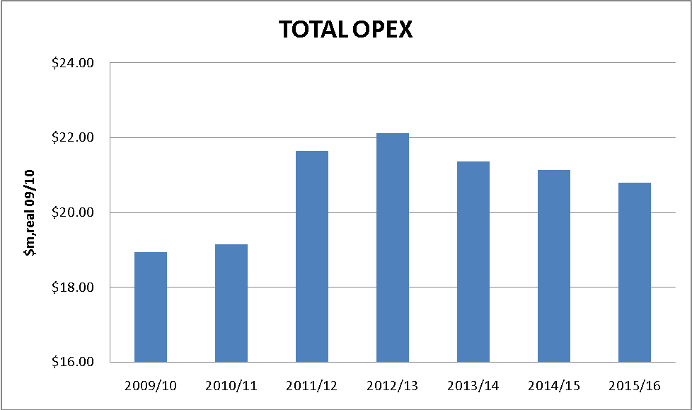

Refer to Attachments 6-7 and 6-8 for spreadsheets showing the derivation of these forecasts.
6.10 Expert Review of Opex

Envestra engaged Zincara Pty Ltd (“Zincara”) to review current and forecast opex. In particular, Zincara examined in detail the Non-Base Year costs and the respective underlying assumptions and parameters supporting those changes.

As a result of that analysis, Zincara concluded that Envestra’s forecasts are consistent with those of a prudent and efficient operator (see Attachment 6-6).

6.11 Compliance with National Gas Rules

Rule 91 requires operating expenditure to be such as would be incurred by a prudent service provider acting efficiently, in accordance with good industry practice, to achieve the lowest sustainable cost of delivering pipeline services. Envestra submits that its operating expenditure meets these criteria.

As mentioned in section 6.1, in the current Access Arrangement period Envestra has had an incentive to minimise its overall costs by virtue of the regulatory regime.

In addition, due to the Global Financial Crisis, Envestra has been subject to not only the normal commercial pressures in operating a business efficiently, but subject to additional pressure that caused Envestra to review expenditure at every level to ensure maximum efficiency. For this reason, the base-year roll-forward approach used by Envestra provides an efficient basis for the forecast expenditure. The expenditure variations from the base year are itemised in this Chapter 6 and detailed further in various business cases supplied.

Those business cases contain itemised costs, options considered and assumptions where relevant. In each case, sufficient information is provided that demonstrates that the expenditure is prudent, efficient and in accordance with good industry practice.
7. CAPITAL EXPENDITURE

  - Summary

Capital expenditure that is forecast to occur within the Third Access Arrangement Period is based on the level necessary to allow Envestra to meet the forecast growth in demand for Services, to meet system augmentation and replacement requirements and to generally deliver the Reference Services.

This section details the capital expenditure forecast for the Third Access Arrangement Period and provides relevant background information in relation to that forecast.

Capital expenditure has been forecast according to the categories set out in the table below. Further detail on the categories is provided in subsequent sections.

The AER has requested (as part of the RIN) that Envestra identify the materiality threshold used for forecasting capital expenditure. Envestra advises that it has not set a defined materiality threshold, in the same way that it does not set a materiality threshold in formulating its annual budgets. Rather it relies upon the common sense judgement of persons providing such inputs. In some cases, projects contain a combination of opex and capex, either of which may be incidental to the other component, so while the overall project may be material, either the opex or capex component might be considered immaterial. However, consideration of all aspects of a material project is necessary to demonstrate that it has been forecast on a prudent and considered basis. Hence Envestra has adopted its normal and prudent business practice and has not applied a defined materiality threshold.

Table 7.1 Forecast Capital expenditure

Capital Expenditure  $m, real 09-10 | 2011-12 | 2012-13 | 2013-14 | 2014-15 | 2015-16 | Total
Mains Replacement | 14.2 | 14.4 | 15.0 | 15.4 | 15.6 | 74.5
Meter Replacement | 1.3 | 1.3 | 1.4 | 1.4 | 1.4 | 6.8
Augmentation | 0.6 | 4.3 | 0.1 | 0.3 | 0.4 | 5.6
Telemetry | 0.5 | 0.3 | 0.3 | 0.4 | 0.3 | 1.9
Regulators | 0.5 | 0.4 | 0.4 | 0.3 | 0.3 | 1.9
IT | 2.6 | 1.4 | 1.0 | 0.1 | 0.1 | 5.2
Growth Assets | 12.34 | 13.12 | 12.70 | 12.57 | 13.78 | 64.52
Other Dist. System | 1.7 | 1.8 | 1.4 | 1.4 | 1.5 | 7.7
Other Non-Dist. System | 0.2 | 0.3 | 0.2 | 0.2 | 0.2 | 1.0
Total Capex | 33.9 | 37.4 | 32.4 | 32.0 | 33.5 | 169.1

Where the forecasts are dependent upon forecasts of gas demand and number of connections, the forecast expenditure is based on Envestra’s demand forecasts for the Third Access Arrangement Period as contained in Chapter 13 of this document.

As explained in the following sections, capital expenditure in the Third Access Arrangement Period is forecast to be materially higher than in the Second Access Arrangement Period. This is predominantly due to increased replacement of aged mains.

  - Capital Expenditure Forecast Elements

Envestra’s capital expenditure forecast has been developed using a “bottom-up” approach, by examining each facet of the business and assessing the requirements for the business in order for it to:

- comply with regulatory obligations governing the provision of services;

- maintain acceptable levels of safety and to minimise risk to persons and property;

- maintain levels of reliability and customer service (ie maintain integrity of services), and where levels have been identified as requiring improvement, to improve levels to the appropriate standard;

- meet forecast demand to ensure that services can continue to be delivered without compromising integrity of services; and

- maintain acceptable levels of business risk.

Capital expenditure mostly falls into three categories of activity – that associated with:

- Repetitious tasks of a standard nature – these forecasts are derived on the basis of (multiplying) unit rates and forecast demand for the particular activity (eg new inlets, mains renewal);

- Recurrent spend-projects – activities that vary in scope or nature but recur on an annual basis or from time to time, which are somewhat predictable and for which the historical spend is usually indicative of future spend (eg replacement of plant and equipment, ad-hoc network reinforcement);

- Non-recurrent projects – projects that require individual costing due to their size, scope or uniqueness (eg IT projects).

Expenditure on tasks that are of a repetitive nature is more easily forecast due to the availability of historical unit rate data, however an important consideration is the degree with which historical cost is a reliable predictor for the forecast period. Factors which may affect-alter unit rates in the future include:

- Labour and material costs - High level, industry-wide cost escalators are commonly used to account for general increases in labour and material costs. However, there may also be changes arising from changes in work mix between contractors and direct labour, or increases arising from skills shortages, etc.

- Changes in work content, processes or geography, such that the unit of work (or the mix of work) being undertaken is not identical (eg laying mains or services in new estates versus established suburbs). This is an important consideration in the context of new connections, where increasing numbers of connections are taking place in in-fill areas. This is relevant because connections associated with urban consolidation (in brownfield conditions) are more costly than those taking place in new sub-divisions (in greenfield conditions).

- Volume of work (eg where volumes of work are lower, economies of scale may be lost). Conversely, if volumes of work are more than what the existing contractor base is able to handle, this may lead to higher prices.

Historical unit costs have been used as the default starting point for deriving forecast unit costs. This is justified on the basis that Envestra has a regulatory incentive to reduce costs. In addition, Envestra is subject to the usual commercial incentives to reduce costs and improve returns to shareholders.

In most cases, however, historical unit rates are not constant since there are inherent costs in any activity that vary from task to task and which result in unit rates varying in magnitude from year to year. Consequently, choosing the latest unit rate, or one particular year’s unit rate may not provide the best estimate for forecasting, in which case an average over 2-3 years may be more accurate. This has been done in establishing the base for many of the unit rates for the forecast period.

Once appropriate historical unit costs were determined, any factors materially affecting those costs going forward (as per the examples described above) were identified and an adjustment applied to the historical unit rate, thereby providing a forecast unit rate direct cost.. Attachment 7-1 sets out the unit rates relevant to the capital expenditure forecast, their historical level and any factors impacting unit rates going forward. Where applicable, recent tendering results have been used to ensure that forecast costs represent best estimates.

Finally, consideration was then given to labour and material cost escalation for the forecast period. Envestra engaged BIS Shrapnel to provide an independent assessment of labour and material cost escalators to apply in the forecast period (see Attachment 6-4). The output of this work is discussed in section 6.8, but in summary the escalators shown in Table 6.3 were determined appropriate for Envestra’s business. Those escalators have been applied to the respective input cost components of the capital forecast.

Forecasts of unit demand for respective categories of expenditure and other detailed information relating to the formulation of prudent forecasts are contained within the respective expenditure categories as set out in the following sections and in Attachments 7-1 and 7-5. Forecasts have been developed to incorporate any changes in circumstances over the next Access Arrangement period where they are known, or where factors such as demand growth, network reliability-performance or asset condition require Envestra to take action in order to continue to provide Reference Services in a manner consistent with that of a prudent operator.

Where relevant, Envestra has taken into account possible trade-offs between capital expenditure and operating expenditure in the formulation of forecasts. The areas where substitution can be material are:

- mains renewal – increased mains renewal will result in decreasing leak repairs and maintenance, and decreased cost of UAFG; and
- augmentation – if augmentation projects are not carried out, this can result in decreasing reliability and hence increased reactive maintenance and rectification costs.

The forecasts are consistent with the overarching Asset Management Plan for the Network and its subordinate plans, such as the Mains Replacement Plan, Capacity Management Plan and Gas Measurement Management Plan. Such plans not only detail the prudent processes established to design and maintain assets to appropriate standards, but provide direction for asset replacement and-or augmentation that is necessary to ensure the safety and integrity of services on a long term basis.

Once forecasts were developed, they were reviewed by an independent consultant (Zincara Pty Ltd) in order to verify their reasonableness both from an engineering perspective and from the perspective of compliance with the Rules. The forecasts were then reviewed by Envestra’s executive management and endorsed by the Envestra Board.

In approving the forecast, the Envestra Board is cognisant of the material increase in capital expenditure in the forecast period, but is also cognisant of the need to ensure that safety of gas distribution is paramount. Replacement of all remaining cast iron and base steel mains will eliminate the risk associated with these aged mains.

  - Capital Expenditure Planning And Approval Process

Envestra has a process in place to ensure that its capital expenditure is prudent, efficient, justified and adequately monitored and controlled. It rigorously applies technical, managerial and financial governance processes to ensure that expenditure meets its legal, regulatory and operational obligations in a cost-effective manner and in accordance with good industry practice.

A range of controls, procedures and management mechanisms are applied to expenditure on investments throughout the life-cycle of a project or works program. In initial design phases, alternatives for projects are explored and life-cycle asset management principles employed to determine an appropriate balance of key factors (project timing, risk, reliability, etc). Gas demand and network modelling is used extensively to update network requirements, and where it can be demonstrated that investment can be prudently deferred, this is done accordingly.

Cost estimators liaise closely with operations personnel to ensure that costing of projects takes account of trends in costs, and audits of projects combined with accounting system outputs ensures a feedback loop so that a reasonable degree of confidence can be placed on estimating-forecasting processes.

In accordance with best practice, projects have been allocated contingency to account for uncertainties in project scope or execution. The amount of contingency determined is consistent with a matrix based on the “AACE (Association for the Advancement of Cost Engineering) International Recommended Practice 17R-97 –Cost Estimate Classification System TCM Framework 7.3 – Cost Estimating and Budgeting”, with the majority of projects requiring a 10-20% contingency.

Where possible, network alterations and extensions are timed to coincide with works undertaken by road authorities and other utilities, in order to minimise cost and disruption to the public.
For extensions of the network, economic modelling ensures that all investment occurs in accordance with the Rules. Where extensions do not pass the economic test under the Rules (Rule 79(2)(b)), capital contributions are sought from the new customer(s) concerned. (It is noted the AER has requested details of contractual agreements with parties where capital contributions are made, however there are no on-going contracts with consumers insofar as capital contributions are concerned, as these are one-off payments).

As part of normal business cost control protocols, project approval takes place at various levels within the business, taking into account whether the expenditure has been budgeted as well as the value of the project, with larger projects (i.e. more than $1m) requiring Envestra Board approval.

  - Capital Expenditure Execution

Once underway, projects and other expenditure are the subject of monthly financial and project management reporting. Material variances between budgeted, and actual spend are investigated and if necessary corrective action is undertaken.

The Envestra Board Audit and Risk Committee oversees an internal audit program to ensure compliance obligations are met, business risks are appropriately managed and cost controls are functional and effective.

Whilst the longevity of gas distribution assets requires long term planning, Envestra’s annual budgeting process provides an opportunity to re-assess priorities of longer term projects and expenditure to ensure that:

- investment is aligned with the company’s funding availability;

- project parameters have not changed and thereby altered the project’s feasibility or timing; and

- financial covenants for the business (set by its financiers) continue to be met.

This process, together with the planning and approval processes described in section 7.3, ensures the prudency of expenditure and its compliance with the Rules, from the point of approval to project completion for:

- capital expenditure undertaken in the current Access Arrangement period; and

- capital expenditure to be undertaken in the next Access Arrangement period.

  - Key Investment Drivers

In the forecast period, the level of capital expenditure is driven predominantly by the following key drivers:

- Asset condition – this is derived from an engineering assessment of an asset’s (or class of assets’) physical and functional characteristics to determine its suitability for continued service. Past reliability, likelihood of asset failure, and consequence of asset failure are all considered as part of this assessment. Investment is required when the asset condition is such that the ability to maintain the reliability, safety and security of the network is compromised or begins to impair the ability to supply services of sufficient quality, reliability and security (irrespective of the expected useful life of the asset).
Particularly in relation to gas distribution, assets that fail in service may place the public and consumers at risk of injury or death. Envestra balances the risks and on-going costs of maintenance versus replacement of assets, and where asset failure risks are high and reliability or safety issues are present or likely, assets are recommended for replacement. A cornerstone of Envestra’s capital expenditure over the forecast period is the Mains Replacement Plan, which represents an efficient long-term strategy to not only improve safety, but deliver improved capability and reliability in respect of the services provided.

- Demand growth – much of this investment is reactive in that Envestra must respond to demand for connections and ensure that the network has the capability to meet the consequent increasing peak demand. Gas networks are designed to accommodate peak hourly demand. Unlike transmission pipelines, gas networks contain relatively little linepack and therefore must be able to respond almost instantaneously to demand. An important element of satisfying demand growth relates to the increasing use of high-flow instantaneous gas hot water heaters. Many years ago, storage hot water units were most common. Those appliances placed relatively low instantaneous loads on the network, but such appliances have lost appeal in favour of high-efficiency instantaneous water heaters, which use less gas overall but place a much higher stress on the network.

- Reliability

Envestra uses best endeavours to:

- conduct its operations in accordance with good industry practice; and

- maintain the capability of its distribution system.

Accordingly, Envestra has identified areas of the network that have experienced supply issues or are prone to loss of supply due to the way the network has developed over time. Where the risk of loss of supply is assessed as likely, augmentation works have been identified to overcome any shortcomings in security of supply.

As discussed above, a particular issue with the network is that average domestic consumption is declining but peak hourly consumption is increasing, reflecting the increasing use of more efficient, but instantaneous, gas appliances. This means that parts of the network that were previously reliable are increasingly unable to provide gas at the appropriate pressure during peak periods.

The above three factors are taken into consideration in Envestra’s Asset Management Plan (AMP) for the Queensland network (Attachment 7-2). The AMP documents the interrelationship of a number of technical and operational plans and how these are used to drive asset management strategies and actions to ensure safe, reliable and sustainable supply of gas in line with:

- regulatory obligations;

- effective risk management;

- lowest lifecycle costs; and

- good industry practice.
The AMP:

- demonstrates to stakeholders that Envestra’s asset management approach is prudent, delivering long term sustainability, addressing an appropriate balance between service levels, performance, cost and risk;

- provides the technical basis to support Envestra’s capital expenditure; and

- provides the basis for continuous improvement of asset management practices.

  - Forecast Capital Expenditure

All costs stated in this section are direct costs in $real 2009-10, before application of escalators and overheads. Where business cases are referenced, these are contained in Attachment 6-1.

    - Mains Replacement

This expenditure relates to the replacement of gas mains and services in accordance with the Mains Replacement Plan (MRP) as set out in Attachment 7-4. Envestra has been undertaking a program for replacement of these mains over many years, which is necessary in order to maintain public safety and minimise the amount of gas lost through leakage. Most of the leakage occurs by seepage through the deteriorated lead-yarn joints of these old cast iron pipes. Leakage of gas must be minimised in order to:

- minimise the risk of fire-explosion;

- reduce the operational cost associated with the repair of gas leaks;

- reduce the cost of purchase of gas (to replace leaked gas); and

- minimise greenhouse gas emissions (natural gas has a greenhouse impact that is 21 times that of carbon dioxide).

Replacement of old pipes is also necessary because they are limited to operating at low pressures. This limits their capacity to provide high volumes of gas at peak periods, contributing to poor reliability. Occasionally the ingress of water into mains which operate at low pressure results in blockages and loss of supply. In some cases, the low operating pressure (and consequently low line pack and low capacity) means that new connections cannot be made. New pipes (consisting of polyethylene or coated steel) however can operate at high pressures (350 kPa versus 1.5 kPa) and therefore do not have this drawback.

Envestra must purchase gas to replace that which is lost through leakage and other factors, this gas being referred to as Unaccounted for Gas (UAFG). It is estimated that 80% of UAFG is due to leakage, and this loss is a significant cost to the business.

In accordance with its Asset Management Plan, Envestra will be replacing all of its aged mains by the end of 2015-16. This project represents a large portion (around 35%) of capital expenditure that Envestra will undertake in the next period. Details of the project are contained in the Mains Replacement Plan.
Mains replacement is carried out by contractors, with the cost of this activity reflecting the result of tendering processes that are undertaken on a regular basis.

The forecast unit rates for mains replacement are detailed in Attachment 7-1 (Capex and Unit Rates).

The mains replacement capital is justifiable in accordance with Rule 79(2) as follows:

- 79(2)(c)(i) – the capital expenditure is necessary to maintain the safety and integrity of services, as it will result in:

- Lower incidence of gas leaks;

- elimination of outages due to water ingress;

- elimination of supply loss arising from leak repair works; and

- elimination of poor pressure (or loss of supply) at customers’ premises due to peak loading on low pressure mains.

- 79(2)(c)(iv) – the capital expenditure is necessary to maintain the service provider’s capacity to meet levels of demand for services existing at the time the capital expenditure is incurred – in those areas where low pressure mains is unable to satisfy peak demand or allow the connection of new customers, the mains replacement is necessary to maintain capacity to meet levels of demand for services;

The following table sets out the forecast cost of mains replacement.

Table 7-2 Mains Replacement Forecast

Mains Replacement Program | 2011-12 | 2012-13 | 2013-14 | 2014-15 | 2015-16 | Total
Length km | 66.2 | 66.2 | 66.2 | 66.2 | 66.2 | 330.9
Total $m | 12.5 | 12.5 | 12.5 | 12.5 | 12.4 | 62.5

    - Meter Replacement

Envestra is required to periodically change gas meters in order to test them for metering accuracy. These periodical meter changes (PMCs) take place at intervals (approximately 10-15 years) in accordance with a Measurement Scheme under the Queensland Petroleum and Gas (Production and Safety) Act 2004. This continuous changeover and testing program ensures that each gas meter continues to operate within prescribed tolerances.

The numbers of meters requiring changeover are reflective of the age and types of meters in service. As these factors are well documented and tracked, the forecast quantity has a reasonable degree of certainty, although the recent introduction of a new Australian Standard for meter testing is likely to result in shorter meter field life in coming years.

The cost of this activity is also well established, with this cost mostly dependent upon three factors:
- The forecast cost of new meters. (Apart from usual cost increases, the average cost of residential meters will continue to increase slightly due to the increasing use of larger capacity meters in homes);

- The forecast mix of new and refurbished meters, since Envestra refurbishes and recycles meters to the extent possible in order to minimise costs; and

- The forecast quantity of meter changes – there is a fixed cost base for the activity which is spread across the number of meters changed. In addition, when the number of PMCs exceeds that which can be handled by direct labour, contractors are engaged. This mix of resources has been found to result in the most efficient cost outcome.

The derivation of the forecast cost for PMCs is discussed further in Attachment 7-1.

In addition to the regulatory requirement for meter replacement, there is a requirement to maintain meters to appropriate standards while they perform their function in the field. It is planned continue with a program of upgrading Industrial and Commercial (I&C) meter sets in the field that are non-compliant to relevant standards, including AS4635-2008. This capital expenditure is summarised in the following table and is detailed in Business Cases Q14 and Q26.

The following table summarises the forecast cost for meter replacement.

Table 7-3 Meter Replacement Forecast Cost

Meter Replacement | 2011-12 | 2012-13 | 2013-14 | 2014-15 | 2015-16 | Total
PMC Domestic Meters | 0.38 | 0.41 | 0.43 | 0.46 | 0.49 | 2.17
PMC IC Meters | 0.48 | 0.48 | 0.48 | 0.48 | 0.48 | 2.39
IC Meter Set  Rectification Program | 0.20 | 0.20 | 0.17 | 0.15 | 0.15 | 0.87
Total $m | 1.1 | 1.1 | 1.1 | 1.1 | 1.1 | 5.4

This capital expenditure is justifiable because it satisfies the following key element of rule 79(2):
- It complies with a regulatory obligation – Envestra is required to change and test meters in accordance with its Gas Measurement Management Scheme as approved by the Petroleum and Gas (Production and Safety) Act 2004. The forecast is consistent with the requirements of that plan. Essential elements of that plan are also contained in the Asset Management Plan (see Attachment 7-2).

- It is necessary to maintain and improve the safety of services.

    - Network Augmentation

Gas flows through networks are continually reviewed and modelled to ensure security of supply to all consumers and that the risk of gas outages is minimised. Network modelling based on SCADA data and forecast network growth indicates which parts of the network require reinforcement or augmentation.

The capital expenditure forecast for the next period provides for:

- reinforcement of those sections of the network that are vulnerable to gas supply problems, as well as improvements to reduce the likelihood of outages occurring. A comprehensive plan has been compiled that will deliver a high level of reliability, consistent with good industry practice and with the expectations of consumers;

- augmentation to ensure that the network is capable of continuing to supply the demand for services, particularly in areas of high growth; and

- augmentation to ensure the availability of high pressure gas in a manner that supports the systematic and planned replacement of low pressure mains.

Envestra’s “Capacity Management Plan” (Attachment 7-3) provides details of the processes that underpin the augmentation projects, as well as the business plans for those projects. The business plans detail the project background, options, required timing and associated costs. The following is a summary of the augmentation projects.

Table 7-4 Augmentation Capex

Project Reference | Augmentation Projects | $m  (rounded)
Q03 | Carseldine - Bridgeman Downs | 0.16
Q04 | Deception Bay | 0.27
Q05 | Fortitude Valley | 1.10
Q06 | Ipswich | 1.53
Q10 | North Lakes | 0.36
Q11 | Rockhampton | 0.10
Q12 | Sandgate | 1.05
Q09 | Recurrent-Reactive | 0.25
Total $m |  | 4.82

This capital expenditure is justifiable because it satisfies the following key element of rule 79(2):

- It maintains or improves the safety of services – if augmentation is not carried out as required, gas pressure to consumers will eventually be comprised. Where insufficient gas pressure is available to fuel appliances, there is a risk of malfunction or flame failure, the consequences of which could be explosion, or asphyxiation of persons in the vicinity of the appliance;

- It maintains the integrity of services - if augmentation is not carried out as required, gas pressure to consumers may be comprised, particularly in times of peak gas demand. This may cause loss of supply to consumers, this being a supply integrity issue.
    - Telemetry

Gas distributors rely on telemetry systems or SCADA (Supervisory Control and Data Acquisition) systems for real-time monitoring of network conditions and for the remote control of gas flow and pressures to optimise system performance and maximise safety.

Significant investment has been made in recent years to ensure that Envestra’s systems, including the SCADA system, meet the obligations as set out in the Retail Market Procedures. Envestra needs to ensure this investment is managed and maintained to ensure efficient delivery of services. A program of work has been established to maintain and apply upgrades to critical business IT applications, including SCADA, every three to four years. The three-year duration is in line with prudent industry practice and is required to ensure:

- continuation of vendor support;

- security and integrity of business information and systems;

- stability and reliability of systems and components; and

- compliance of systems.

The capex also allows for:

- the rectification of telemetry units at a number of field sites that do not comply with appropriate electrical standards; and

- the installation of an additional 20 data loggers (4 per year) to complete a total of 59 installations at key strategic locations in the network, in order to improve fringe point monitoring of pressures.

The following table sets out the forecast capital expenditure over the period. Details of the projects, including costs, are set out in Business Cases Q23, Q17 and Q24.

Table 7-5 Telemetry Forecast

 | 2011-12 | 2012-13 | 2013-14 | 2014-15 | 2015-16 | Total
Total $m | 0.4 | 0.2 | 0.3 | 0.3 | 0.2 | 1.5

This capital expenditure is justifiable because it satisfies the following key elements of rule 79(2):

- It improves the safety of services, as described above; and

- It maintains integrity of services, as described above.

    - Regulators and Valves

Regulator stations and valves are sited throughout the network and play a critical role in the regulation of gas pressures and flows.

One project (Business Case Q25) provides for on-going replacement and improvement of underground regulator stations across the network. Deterioration of underground pits over the years, coupled with current OH&S requirements, means that the physical nature of some installations are not consistent with current standards. It is planned that all underground stations be brought up to required standards, in line with prudent industry practice and to minimise the risk of supply loss.

It is also planned to undertake a planned replacement of heavy lids on selected district regulator stations. The replacement of heavy lids in Envestra’s Queensland network was started in financial year 2009-10 following a review of current lid designs and a risk assessment confirming the potential high risks associated with lids falling into pits and the manual handling issues involved. In the financial year 2009-10, six lids are planned to be replaced, while in the 2010-11 financial year a further 10 are planned to be replaced. It is planned to complete the remaining six high risk installations under this project (Business Case Q16).

A third project (Business Case Q7) provides for the completion of a project to replace block valves in the Ipswich network that have reached the end of their useful lives.

Table 7-6 Regulators and Valves Forecast

 | 2011-12 | 2012-13 | 2013-14 | 2014-15 | 2015-16 | Total
Total $m | 0.4 | 0.3 | 0.3 | 0.2 | 0.2 | 1.5

This capital expenditure is justifiable because it satisfies the following key elements of rule 79(2):

- It improves the safety of services, as described above; and

- It maintains integrity of services, as failure of a regulator, or valve inoperability can result in loss of supply of services.

    - Information Technology

A gas distribution business deals with vast amounts of information on a daily basis. The volume of transactions and activity requires periodical investment in information technology, not only to maintain efficiency (replacement of servers, systems, etc, as they become out-dated or not supported) but to improve the level of service and knowledge retention-distribution.

The forecast cost includes the periodic upgrade of IT Infrastructure (ie upgrades and renewals) and the standardised use of Virtulisation, Storage Area Network and Server Blade technologies over the Access Arrangement period.

Among the applications and systems to be upgraded or renewed are:

- Actuate Reporting – installed 2007;

- Maximo – Full Retail Contestability (FRC), Works management – installed 2007;

- Control M – FRC, Batch processing – last upgrade 2004;

- WebMethods Fabric – FRC Middleware – last upgrade 2007;

- WebMethods – FRC Gateway – last upgrade 2006;

- RedBox – FRC Metering and Billing – installed 2006; and

- GIS And Infomaster.

The following table sets out the forecast capital expenditure over the period. Details of the projects, including costs, are set out in Business Cases Q45 (Knowledge Management), Q18 (IT Applications, Q19 (IT Infrastructure), Q32 (IT Roadmap) and Q63 (Head Office IT).

Table 7-7 Information Technology Forecast

 | 2011-12 | 2012-13 | 2013-14 | 2014-15 | 2015-16 | Total
Total $m | 2.1 | 1.1 | 0.8 | 0.1 | 0.1 | 4.2

This capital expenditure is justifiable because it satisfies the following key elements of rule 79(2):

- It maintains integrity of services, as without the assistance of information technology, services would not be able to be delivered; and

- It is necessary to comply with a regulatory obligation, as without adequate information technology systems, compliance with the Retail Market Procedures would not be possible.

    - Growth Assets

This category comprises mains, inlets and meter assets required to service new consumers, i.e.:

- Mains for the provision of services to new Delivery Points. New mains (or mains extensions) range from large projects undertaken in order to provide gas to new housing estates-areas, to small mains extensions in existing gas areas in order to connect a new customer. New large (Demand) customers sometimes also require significant mains extensions. Such extensions are evaluated on a case-by-case basis and in accordance with the Rules, taking into consideration the forecast load demand for the customer.

- Inlets associated with growth of the network - the inlet is the pipework that runs from the gas main to the gas meter. These can vary in length and size depending on the gas demand of the customer. The cost per service is affected by the terrain and environmental characteristics of the site being connected, e.g. it is easier and cheaper to connect gas to a new home than to an existing home or to an existing building in the CBD.

- Meters associated with growth of the network - the cost associated with gas meters includes the cost of installation of a meter box, meter, gas regulator and the subsequent commissioning that ensures that gas is supplied in a safe manner in accordance with Envestra’s regulatory obligations as a gas distributor.

The forecast cost in relation to each of the above is calculated according to:

- for mains serving Volume consumers – the average length of main (based on historical average) required to extend the network on a “per consumer” basis in each of the following scenarios:

- New housing estate (greenfields)

- Established suburb (brownfields), domestic consumer

- Established suburb, industrial-commercial consumer

- for mains serving Demand consumers – a forecast estimate of the requirement for connecting new Demand consumers (as per the demand forecast);

- the demand forecast (Chapter 13) for new connections; and

- the forecast unit rate for the respective activity. In many instances, the forecast unit rate is forecast to be the same as the average of the historical unit rate. In instances where the historical figure does not represent the best estimate for the forecast period, a best estimate has been formulated based on available data (including latest tendering data). These details are set out in Attachment 7-1.

Table 7-8 Growth Assets

 | 2011-12 | 2012-13 | 2013-14 | 2014-15 | 2015-16 | Total
Total $m | 10.02 | 10.46 | 9.81 | 9.49 | 10.26 | 50.04

This capital expenditure is justifiable because it satisfies the following key element of rule 79(2):

- The NPV of incremental revenue exceeds NPV of capex. Envestra’s commercial and business processes ensure that capital expenditure for growth-connections is not undertaken unless it is economic. This includes undertaking individual connection analysis where required, with customer contributions requested where the economic test is not met.

    - Other Distribution System Capex

There are numerous other items of capital expenditure that do not fall into the above categories, but which relate to capital expenditure on the network infrastructure. The main categories are set out below, as are a number of discrete capital projects. The capital expenditure justification in relation to rule 79(2) is contained in each respective business case where applicable.

- Mains Alterations

It is necessary to make provision for the relocation of gas network infrastructure and-or cover the cost of establishing an easement where relocations of infrastructure are not recoverable from third parties. A nominal amount of $20k-yr has been forecast to cover this ad-hoc activity (in previous years expenditure has reached $66k).

This capital expenditure is justifiable because it satisfies (Rule 79(2)(c)(ii)), in that if mains were not altered as required, the mains in question would have to be decommissioned and that would compromise the integrity of services.

- Domestic Regulator Change Program (Business Case Q15)

This capex allows for the continuation of replacement of domestic regulators in conjunction with periodical meter changes. Approximately 90% of domestic regulators are being replaced with the meter is changed due to age, corrosion, lock up performance, and relief performance, due to this class of asset having reached the end of its useful life.

- Odorising station replacement (Business Case Q21)

Envestra ensures that natural gas entering the network is adequately odorised for safety reasons. Current practice is for odorisers to be periodically replaced prior to an unplanned failure, but still near the end of their serviceable life. Every two years a replacement unit is purchased to limit the oldest unit to a maximum of 10 years in service. This practice has been on the basis that fully functioning odorisers are critical to safe and prudent network operations. In accordance with current practice, it is planned to replace the replacement program to ensure that:

- equipment is operable; and

- suitable odorant dosing and safety of the network is maintained.

- Sleeved Railway Crossings (Business Case Q40)

This project involves the replacement of 53 high pressure sleeved crossings (within road and rail corridors) within the network to eliminate issues whereby the cathodic protection of steel pipe is compromised.

- Replacement of Non-Compliant Meter Installations (Business Case Q46)

Recent identification of non-compliant meter installation in high rise buildings (older apartment buildings where meters were installed in wall cavities) has required Envestra to ensure that such non-compliant installations are identified and rectified.

- Replacement of Shallow Mains (Business Case Q48)

This capex allows for the relaying of remaining mains in the network that are found to be too shallow and hence non-compliant with current standards. It is estimated that approximately 3.5km of shallow mains remains in the network.

The following table summarises the total cost in this category of capex.

Table 7-9 Other Distribution System Capex

 | 2011-12 | 2012-13 | 2013-14 | 2014-15 | 2015-16 | Total
Total $m | 1.4 | 1.4 | 1.1 | 1.1 | 1.1 | 6.1

    - Other Non-Distribution System Capex

This category covers miscellaneous capital expenditure that does not pertain directly to the network infrastructure. The only item in this category relates to the routine replacement of plant and equipment (Business Case Q02). Expenditure is required annually for the expected costs of replacement of essential tools, plant, equipment and other similar non-reticulation items. The forecast expenditure is based on historical spend.

The following table summarises the total cost in this category of capex.

Table 7-10 Other Non-Distribution System Capex

 | 2011-12 | 2012-13 | 2013-14 | 2014-15 | 2015-16 | Total
Total $m | 0.2 | 0.2 | 0.1 | 0.1 | 0.1 | 0.8

  - Overheads

Overhead costs are applied to capital expenditure in order to recover general business overheads that are not accounted for in direct capital expenditure estimates.

An analysis of the actual overheads incurred over the past three years has been undertaken and reveals that an average overhead rate of 20% is required to recover these costs.

Envestra has adopted the historical 20% overhead rate as a default forecast of overheads. However, a more conservative forecast of 10% has been used to forecast overheads for the mains replacement and augmentation expenditure. The lower rate recognises the expanded capital expenditure program in this proposal.

Overhead uplift rates are applied to the direct costs of the costs proposed in Envestra’s capital expenditure program.

  - Capital Expenditure Forecast

The capex program by year is presented in Graph 7.1.

Graph 7.1 Annual Capex Forecast ($m)

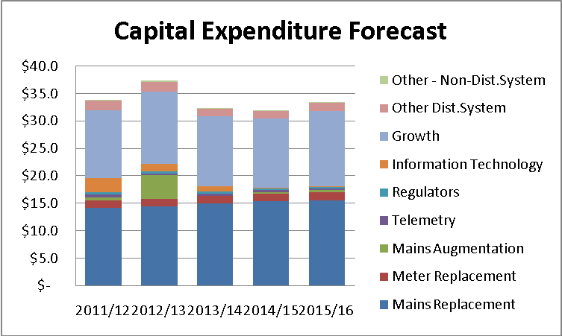

Refer Attachment 7-6 for a spreadsheet showing the derivation of this forecast.

  - Expert Review Of Capital Expenditure

Envestra engaged Zincara Pty Ltd to review forecast capital expenditure. Zincara examined the trends in expenditure and unit rates, and reviewed elements of capital expenditure and underlying assumptions and parameters. Where necessary, Zincara sought further information from Envestra and discussions were held with relevant operational and technical staff in order to examine the reasonableness of the forecast.

As a result of that analysis, Zincara concluded that Envestra’s forecasts are consistent with those of a prudent and efficient operator (see Attachment 6-6).

  - Compliance With National Gas Rules

Rule 78 provides for the projected capital base of the Network to include forecast conforming capital expenditure for the period. All of the forecast capital expenditure is conforming capital expenditure.

Rule 79(1) states that:

  - Conforming capital expenditure is capital expenditure that conforms with the following criteria:

(a) the capital expenditure must be such as would be incurred by a prudent service provider acting efficiently, in accordance with accepted good industry practice, to achieve the lowest sustainable cost of providing services;

(b) the capital expenditure must be justifiable on a ground stated in subrule (2).

Envestra submits that its capital expenditure meets the criteria in (a) above in that it would be incurred by a prudent service provider acting efficiently, in accordance with good industry practice, to achieve the lowest sustainable cost of delivering pipeline services.

As discussed in this Chapter 7, Envestra has prudent processes in place (planning, procurement, execution and governance processes) that ensures that expenditure is undertaken on a prudent basis. Costs are regularly monitored and reviewed, and prudent procurement and tendering practices ensures that costs are efficient. Network planning and maintenance activities are undertaken in accordance with the Asset Management Plan and in accordance with good industry practice.

There are a number of business plans that underpin much of the capital expenditure in the forecast period. Those plans each contain itemised costs, options considered and assumptions where relevant. In each (business) case, sufficient information is provided that demonstrates that the expenditure is prudent, efficient and in accordance with good industry practice.

The key elements of rule 79(2) provide that capital expenditure is justifiable if:

- The overall economic value of the expenditure is positive (rule 79(2)(a))

- The NPV of incremental revenue exceeds NPV of capex (rule 79(2)(b))

- It maintains or improves the safety of services (rule 79(2)(c)(i))

- It maintains integrity of services (rule 79(2)(c)(ii))

- It complies with a regulatory obligation (rule 79(2)(c)(iii))

- It maintains capacity to meet demand (rule 79(2)(c)(iv)).

In each of the respective sections in this Chapter 7 and in each of the relevant business cases, the relevance of the respective key element above is discussed and demonstrates compliance of the forecast capital expenditure with rule 79(2).
8. CAPITAL BASE

8.1 NGR Requirements

The requirements for establishing the opening capital base are set out in Rule 77 of the National Gas Rules. Rule 77(2) states that:

If an access arrangement period follows immediately on the conclusion of a preceding access arrangement period, the opening capital base for the later access arrangement period is to be:

- The opening capital base as at the commencement of the earlier access arrangement period (adjusted for any difference between estimated and actual capital expenditure included in that opening capital base); plus:

- conforming capital expenditure made, or to be made, during the earlier access arrangement period; plus:

- any amounts to be added to the capital base under rule 82, 84 or 86; less:

- depreciation over the earlier access arrangement period (to be calculated in accordance with any relevant provisions of the access arrangement governing the calculation of depreciation for the purpose of establishing the opening capital base);

- redundant assets identified during the course of the earlier access arrangement period; and

- the value of pipeline assets disposed of during the earlier access arrangement period.

8.2 Summary

Envestra has determined that the capital base on 1 July 2011 will be $310.5m ($ nominal) and is forecast to be $490.8m ($nominal) at 30 June 2016 as shown below:

Table 8.1 Closing Value of Regulatory Asset Base as at 30 June 2016

 | $m
Closing Value of Capital Base (nominal) | $490.8
Closing Value of Capital Base (real $2010-11) | $432.3

8.3 2011 Regulatory Asset Base

8.3.1 Opening Capital Base for the Second Access Arrangement Period

Envestra has established that the opening capital base as at 1 July 2006 is $227.8m. This opening position has been derived:

- Using the opening value of $214.4m for 1 July 2005 (in $June 2005) as set out in table 11.6 of the QCA’s Revised Access Arrangement for Gas Distribution Networks: Envestra (“Table 11.6: Envestra Access Agreement”);

- Adjusting this for actual capex in 2005-06 by Envestra of $13.8m;

- Adjusting this for the inflationary gain of $6.1m. This represents the sum of the full year’s inflation of the opening asset base and the half year’s inflation of the 2005-06 capex;

- Adjusting this for the QCA approved depreciation of $6.4m in 2005-06 (in $June 2006) as set out in Table 11.6: Envestra Access Agreement; and

- Deriving a closing 30 June 2006 capital base of $227.8m.

This differs from the QCA approved closing capital base as at 30 June 2006 of $228.4 (in $June 2006). This difference is solely due to the replacement of the forecast 2005-06 capex amount of $14.3m (in $December 2005) with the actual capex of $13.8m (in $December 2005).

This 30 June 2006 closing capital base of $227.8m becomes the revised opening capital base for the Second Access Arrangement Period. This is shown below.

Table 8.2 Opening Value of Regulatory Asset Base as at 1 July 2006 ($m Nominal)

Asset | $m
Mains and Inlets | 155.2
Meters | 47.7
Telemetry | 21.3
IT Systems | 0.1
Other Distribution Equipment | 2.3
Other Assets | 1.2
Total | 227.8

8.3.2 Closing Capital Base for the Second Access Arrangement Period

The approach for rolling forward the Capital Base from 1 July 2006 to 30 June 2011 is based on the following formula:

Opening Asset Value_{i}
+ Escalation_{i}
+ Capital expenditure_{i}
- Customer Contributions_{i}
- Asset Disposals_{i}
- Regulatory Depreciation_{i}
= Closing Asset Value_{i};
where:

All values are expressed in nominal terms.

_{i} denotes the relevant year in the Access Arrangement Period (1 to 5).

Escalation_{i} = inflation_{i} x Opening Asset Value_{i};

Depreciation is expressed in current cost terms and calculated on a straight-line basis over the economic useful life of the asset.

The inputs used by Envestra to roll forward the Capital Base are described below.

Capital Expenditure

Conforming Capital Expenditure was calculated by deducting capital contributions from gross capital expenditure, as shown below:

Table 8.3 Conforming Capital Expenditure 2006-07 to 2010-11

$m Nominal | 2006-07 | 2007-08 | 2008-09 | 2009-10 | 2010-11
Gross Capital Expenditure | 20.04 | 15.36 | 17.69 | 16.82 | 19.39
Capital Contributions | 1.62 | 1.29 | 3.87 | 2.58 | 2.34
Conforming Capital Expenditure | 18.42 | 14.07 | 13.82 | 14.24 | 17.05

Envestra considers that the gross capital expenditure in the Second Access Arrangement Period has been prudent and in accordance with the Access Code and National Gas Rules. As discussed further in section 7.3 (Capital Planning and Approval Process), Envestra has appropriate processes in place to ensure that expenditure is prudent. This includes:

- Preparation of cost estimates of capital works by experience planners, using current data and in liaison with operational staff;

- Investigation of options where appropriate, so that the most cost effective solution is deployed;

- Consideration of and liaison with other utilities and road authorities, in order to capture synergies of others’ road works and long term planning;

- Approval of projects in accordance with established hierarchal limits of authority;

- Where there is material time lapse between project approval and implementation (eg larger projects), review of key parameters (eg gas demand) prior to implementation to confirm that timing of spend is still optimum. Where appropriate, projects are deferred to ensure prudency of spend;

- Close operational management of projects and monitoring of spend. For major projects, monitoring of actual versus forecast cost occurs at senior Envestra management level.

For recurrent expenditure (eg mains replacement, new mains and services, etc), regular monitoring of financial performance and deviations from forecast also occurs at senior management level; and

- Where significant amounts of expenditure occur (eg major augmentation or IT projects), ad-hoc audits are carried out to ensure that processes in place deliver the best outcome from an operational and financial perspective.

In addition to the above:

- Envestra has regulatory incentives to reveal efficient costs and to outperform the level of expenditure previously approved under the Access Arrangement;

- Rigorous contracting and tendering processes ensure that prices paid to its contractors and for pipe and materials are efficient. Amongst significant tendered works are routine service connections, main laying, mains replacement and meter reading. Regular tendering of such works and individual tendering of larger projects ensures that prices paid for services are efficient.

- Envestra has a commercial incentive and responsibility to its shareholders to conduct its business in an efficient and prudent manner such that the commercial return on investment is maximised.

The above factors all ensure that that expenditure only occurs where prudent and that gold plating of the network does not occur. On the contrary, the effect of the recent Global Financial Crisis has meant that Envestra has had to critically examine what items of capital expenditure had to be maintained in order to ensure that the level of expenditure did not fall below that considered to be prudent. This is discussed in Chapter 2.

In November 2009, Marksman Consulting Services conducted an audit of the level of compliance with the Rules of Envestra’s capital expenditure in the current period (see Attachment 8-1). A total of 21 projects across a range of categories of capital expenditure were audited. The auditor concluded that “the current capital project process has a reasonable level of rigour, supporting the conclusion that past capital expenditure has been prudent and efficient and conforms to National Gas Rules Rule 79”.

Regulatory Depreciation over the Second Access Arrangement Period

Regulatory depreciation for the Second Access Arrangement Period has been set equal to the depreciation approved by the QCA (adjusted for actual inflation) and is as shown in the following table.

Table 8.4 Regulatory Depreciation for Second Access A

Depreciation $m  (nominal) | 2006-2007 | 2007-08 | 2008-09 | 2009-10 | 2010-11
QCA Depreciation | 5.1 | 5.9 | 6.4 | 6.8 | 7.2

Redundant Assets

Rule 85 states that an access arrangement may include a mechanism to ensure that assets that cease to contribute in any way to the delivery of pipeline services (redundant assets) are removed from the capital base.

Envestra is not forecasting any redundant assets for the Third Access Arrangement Period, and as per previous Access Arrangement periods, Envestra believes it inappropriate to remove any redundant assets should they arise. Hence Envestra’s Access Arrangement does not include a mechanism to remove any redundant assets.

Various regulators have given detailed consideration to the issue of redundant assets in previous access arrangement reviews, and agreed with distributors that there are likely to be substantial benefits to both customers and distributors from a policy of minimising the risk to distributors associated with recovering the regulatory value of their assets.

In any event, the value of any assets that might become redundant would be immaterial in the context of the asset base. Assets that may become redundant are essentially small amounts of mains and inlets. (In the case of meters, these are re-locatable-re-usable and therefore do not become redundant).

In relation to inlets, these assets are generally removed from service when

- they have deteriorated and require replacement –hence not a redundant asset;

- the associated premises are to be demolished – a redundant asset in this case;

- (in rare instance if ever) a consumer elects to no longer have gas permanently connected to the property, in which case Envestra would be obliged to remove its meter and abandon the inlet – a redundant asset in this case.

In the first two cases, the age of the inlet would be such that it would have minimal depreciated value. In each case the meter would be reused.

In the case of mains, it would be very rare for Envestra’s distribution network to have mains that are redundant and also of appreciable value. This is because, unlike a transmission pipeline, a gas network consists of a multitude of interconnected pipes-mains, with few mains dedicated to singular consumers. If a section of main does service only one consumer (eg a Tariff D consumer), and that consumer ceased operations, it is possible that the section of main concerned would be temporarily redundant for the period of time until a new consumer commenced operations at the same site. It is Envestra’s experience that such occurrences are very infrequent.

Due to the low frequency of and low asset value of any redundant assets that might arise, their overall value is immaterial and Envestra believes that it would not be efficient or productive to attempt to identify any such assets and remove them from the asset base.

Notwithstanding the above, Envestra believes that, as a matter of principle, expenditure that has been undertaken on a prudent basis at one point in time should not expose a distributor to the risk of not recovering the value of that investment at a later point in time.
Unlike an unregulated entity, Envestra is obliged to provide services (and the associated infrastructure) but cannot, for example, contract with a domestic consumer for 20 years to ensure that an asset is not stranded before a return on the investment is realised.

If a distributor were to bear the consequences of asset stranding, the AER would be obliged to provide distributors with compensation for the expected cost of accepting this liability. If the expected loss is quantified precisely, then prices would be expected to be unchanged on average compared to the current approach. However, if the compensation erred towards the upper end of a range of estimates, customers would be on average worse off compared to the current approach.

Taking into account:

- The immateriality of the value of any redundant assets;

- the effect on distributors’ confidence as to whether they will be able to recover the value of their past investments; and

- the direct impact on regulated charges of removing such assets compared to the long-term impact on prices that may arise from the increased risk associated with a policy of identifying and removing redundant or partially redundant assets,

there are benefits to both customers and distributors from a policy that minimises the risk to distributors associated with recovering the regulatory value of their assets.

Furthermore:

- many of the events that may result in a gas distributor’s assets becoming unused at some future time are outside of the distributors’ control, and therefore not events that could be planned against; and

- the current incentive arrangements, whereby only prudent expenditure is permitted to be rolled into the asset base, and distributors effectively bear the cost of their expenditure decisions for up to five to six years,

provide sufficient incentives for distributors to undertake only efficient investment.

In summary therefore, Envestra believes that

- the administrative costs associated with identifying and removing stranded assets compared to the cost of the potential materiality of any adjustment, does not provide a cost benefit;

- the long-term impact on reference tariffs that may arise from the increased risk associated with a policy of removing redundant assets is not in the long-term interest of consumers; and

- a policy of removing redundant assets may cause uncertainty in certain cases of extensions to the Network, causing Envestra to become more risk averse and err on the side of under-investment, to the detriment of providing services to Users and consumers.
Consequently, Envestra believes that a policy of identifying and removing redundant assets from the regulatory asset base would not be consistent with the national gas objective (section 23, National Gas Law).

No adjustments have been made for Redundant Capital.

Disposals

Envestra has few assets that do not form part of the gas distribution system. No disposals of assets have taken place to-date during the Second Access Arrangement Period and no disposal of any material value is planned for the remainder of the Second Access Arrangement Period, or for the Third Access Arrangement Period.

Inflation

For the purposes of rolling forward the regulatory asset base, Envestra has used the “actual percentage change in the CPI” as required under section 4 of the approved Access Arrangement. The Consumer Price Index is defined in the Access Arrangement as the “All Groups Weighted Average for the Eight Capital Cities, as published by the Australian Bureau of Statistics or its successor”.

Table 8.5 Inflation Assumptions

Increase in the Consumer Price Index 2006 – 2011 (June Qtr – June Qtr Preceding)
2006-07 Actual | 2.07%
2007-08 Actual | 4.51%
2008-09 Actual | 1.46%
2009-10 Actual | 3.05%
2010-11 Actual | 2.50%

Opening Asset Values as at 1 July 2011

Using the inputs outlined above, the Initial Capital Base has been rolled forward to 1 July 2011 as follows:

Table 8.6 Roll-forward of the Capital Base 2006-07 to 2010-11 ($m Nominal)

 | 2006-07 | 2007-08 | 2008-09 | 2009-10 | 2010-11
Opening Capital Base | 227.8 | 246.1 | 265.6 | 277.0 | 293.2
Less Depreciation | 5.1 | 5.9 | 6.4 | 6.8 | 7.2
Plus Conforming Capital Expenditure | 18.4 | 14.1 | 13.8 | 14.2 | 17.0
Plus Indexation | 4.9 | 11.4 | 4.0 | 8.7 | 7.5
Closing Value | 246.1 | 265.6 | 277.0 | 293.2 | 310.5

8.4 Projected Capital Base in the Third Access Arrangement Period

The projected capital base in the Third Access Arrangement Period has been determined by adjusting the closing value at 30 June 2011 for forecast capital expenditure, depreciation and inflation in the Third Access Arrangement Period. Each of these is addressed below.

8.4.1 Capital Expenditure

Capital expenditure for the next Access Arrangement Period is discussed in section 7 and is summarised below. For the purpose of rolling forward the asset base, capex has been allocated to the following categories and includes an adjustment in the PTRM model whereby capex is assumed to be incurred at the end of the year.

Table 8.7 Forecast Capital Expenditure

Capital Expenditure  $m (nominal) | 2011-12 | 2012-13 | 2013-14 | 2014-15 | 2015-16 | Total
Mains | 21.1 | 26.4 | 22.5 | 23.7 | 25.3 | 119.0
Inlets | 7.0 | 8.0 | 8.3 | 8.4 | 9.2 | 40.9
Meters | 3.0 | 3.0 | 2.8 | 2.9 | 3.3 | 14.9
Telemetry | 0.6 | 0.3 | 0.4 | 0.5 | 0.4 | 2.2
IT Systems | 2.9 | 1.6 | 1.1 | 0.1 | 0.1 | 5.8
Other Dist. System | 2.1 | 2.3 | 1.8 | 1.8 | 2.0 | 10.1
Other | 0.5 | 0.5 | 0.5 | 0.4 | 0.4 | 2.2
Total Capex | 37.1 | 42.0 | 37.4 | 37.8 | 40.6 | 195.0

8.4.2 Forecast Depreciation

Envestra has used a straight-line approach to depreciation based on defined asset lives. A straight-line approach ensures that:

- depreciation is allocated over the entire useful lives of the Network assets; and

- depreciation is consistent with the stable growth in demand that is forecast to occur over the Access Arrangement Period.

The straight-line approach also has the advantage of being:

- readily understandable;

- transparent; and

- easily capable of being replicated on an ongoing basis.

The depreciation criteria are set out in Rule 89(1) which states that the depreciation schedule should be designed:

- so that reference tariffs will vary, over time, in a way that promotes efficient growth in the market for reference services;

- so that each asset or group of assets is depreciated over the economic life of that asset or group of assets;

- so as to allow, as far as reasonably practicable, for adjustment reflecting changes in the expected economic life of a particular asset, or a particular group of assets;

- so that (subject to the rules about capital redundancy), an asset is depreciated only once (i.e. that the amount by which the asset is depreciated over its economic life does not exceed the value of the asset at the time of its inclusion in the capital base (adjusted, if the accounting method approved by the AER permits, for inflation));

- so as to allow for the service provider's reasonable needs for cash flow to meet financing, non-capital and other costs.

As noted in part (c) above, the economic life may be adjusted to reflect changes in the expected life of an asset. In the Access Arrangement periods to-date, Envestra has used the economic useful life (EUL) for assets as shown in the following table.

Table 8.8 Previously used Asset Lives for Network Assets

Asset Categories | EUL (years)
Mains and Inlets | 75
Meters | 31
Telemetry | 10
Regulators-Other Distribution Equipment | 75
IT Systems | 10
Equipment, Vehicle & Other | 75

Envestra has reviewed the EULs and consequently determined that those for mains, meters, regulators and telemetry should be amended.

Mains and Inlets Useful Life

A review of asset life has been prompted by the fact that the replacement of cast iron mains and unprotected steel (UPS) mains is being accelerated due to its limited useful life. Leakage at many of the joints in cast iron pipe and general corrosion of UPS indicates that in most cases the pipe has exceeded its useful life.

In reviewing Economic Useful Life (EUL), Envestra has benchmarked EULs as used in recent Access Arrangements, with the results shown in the following table. It is noted that not all distributors categorise pipe by material type, in which case it has been assumed that high pressure pipe relates to steel or PE pipe, and medium pressure relates mainly to PE pipe. Also shown are the asset lives proposed by Envestra.

Table 8.10 Benchmarking of Pipe EULs

Asset Life by Pipe Type  (years) | Jemena | ActewAGL | Country Energy | Envestra current | Envestra proposed
High pressure (steel) | 80 | 80 | 80 | 75 | 80
Medium pressure (PE) | 50 | 50 | 50 | 75 | 50
Low pressure (PE-cast iron) | n-a | n-a | 50 | 75 | 50

In the last access arrangement review of the Victorian gas networks, Multinet and SP Ausnet adopted EULs of 50 and 60 years respectively for mains and services generally. Envestra notes that there is little distinction in asset lives of mains versus services, and for all practical purposes the lives of both asset types are the same, since when a main is replaced so are the associated services.

An EUL of 50 years for pipe in general is considered to be reasonable given that:

- in respect of cast iron and UPS, this material is no longer used and what is in existence is scheduled for replacement due to it having surpassed its useful life;

- in respect of polyethylene, while plastics in general have long life spans, the integrity of gas pipework is dependent upon the integrity of joints, the installation quality (eg bedding materials), and degree of stress from operating pressure and pressure fluctuations. Given the changes in material composition and grades over the last two decades as improvements are made in plastics chemistry, the expected life, particularly of older grades of polyethylene, cannot be guaranteed for any particular length of time in the context of gas distribution with older grades of PE exhibiting signs of brittleness.

- Cathodically protected steel mains are expected to have a longer life than other mains due to the relatively higher standards of construction, including the jointing method (welding). The continual application of an impressed current and monitoring of voltage potentials means that the integrity of such mains can be assured for a longer period of time. Hence an EUL of 80 years, compared with 50 years for general mains, is considered to be reasonable.

Envestra believes that the proposed asset lives of 50 years and 80 years for general and steel mains respectively are appropriate and reasonable for the purposes of satisfying Rule 89(1), and that those asset lives are consistent with those adopted by Jemena, ActewAGL and Country Energy for similar assets.

As the depreciation calculation uses a weighted average in respect of asset life, Envestra has calculated a weighted average based on the length of pipe in each category (158 km of protected steel and 2217 km of other pipe), this being 52 years. Conservatively, a weighted average life of 60 years has been used, consistent with that used for Envestra’s South Australian assets.

Meters Useful Life

The current asset life of 31 years for meters was determined on the basis that many meters were able to be “recycled” after an initial approved life of 15 years. However, the purchase of those meters that were able to be easily recycled (eg. Email 602, Parkinson Cowan U6 and Hibberd Jubilee meters) ceased circa 1991. Domestic meters purchased since then only have regulatory approval for an initial field life of 10 years.

In 2006 a new Australian Standard (AS 4944) – “Gas Meters – In Service Compliance Testing” was published with the following key features:

- All domestic meters installed prior to 2006 are deemed to have a 15 year service life.

- Meters installed since 2006 are obliged to undergo a compliance test within 3-5 years of installation to establish an initial service life. Depending on the results of testing a service life of 5, 10, 15, 18 years can be deemed for that meter family.

- If compliance testing shows meter accuracy exceeding +-- 3% then the meter family must be replaced.

- Meter lives can be further extended up to 5 years at the expiry of their initial deemed service lives by a Field Life Extension (FLE) testing regime.

Technical Regulators in Victoria and Queensland have agreed to adopt this standard going forward. In South Australia the Technical Regulator has agreed in part, deeming a 10-year service life rather than 15 years for domestic meters installed prior to 2006 and accepting the compliance testing within 3-5 years.

The new FLE testing criteria in the current standard is more stringent than previously used in Queensland but about the same as those used in SA. In the past, FLE testing in Qld has enabled meter lives to be extended to 18 years while in SA, where FLE testing criteria approximates the new standard, only one family of meters has achieved a 12 month extension.

Under the current standard, and considering the meters in use and being purchased, it is unlikely that the average service life of a meter will be materially greater than 15 years. Consequently this has been adopted as the useful life.

Regulators-Other Distribution Equipment

Regulator stations are installed throughout the network to provide a step-down in pressure as gas flows from, for example, a high pressure network into a low pressure network. Other distribution equipment is essentially odorising apparatus which has relatively immaterial asset value by comparison.

The current EUL of 75 years for this category is considered excessive, given that regulator stations are being replaced after 30-40 years (see Business Case Q25). An asset life of 40 years is therefore considered reasonable and has been adopted.

Telemetry

Telemetry, otherwise known as “supervisory, control and data acquisition system” (SCADA) consists of a network of remote computerised data loggers or pressure monitors that communicate constantly by electronic means to a centralised computer in order to provide real time monitoring of metering data and network operating parameters. The current asset life of 10 years for this hardware and software is reasonable. It is noted that other distributors use an asset life for telemetry ranging from 7 years (Multinet) to 20 years (Country Energy). Envestra believes an asset life of 20 years, consistent with that proposed for its South Australian assets, is reasonable and has used this figure.

Equipment-Vehicle-Other

The current asset life of 75 years for this category is excessive, and consistent with the asset life for this category in respect of Envestra’s South Australian assets, an asset life of 10 is proposed.

A summary of the existing and proposed lives and remaining life is set out below.

Table 8.11 Summary of lives used to calculate depreciation

Asset Category | Original Useful Life | Revised Useful Life | Remaining Life
Mains | 75 | 60.0 | 52.6
Inlets | 75 | 60.0 | 39.4
Meters | 31 | 15.0 | 10.0
Telemetry | 10 | 20.0 | 17.5
IT Systems | 10 | 10.0 | 7.5
Other Distribution Equipment | 75 | 40.0 | 17.4
Other | 75 | 10.0 | 5.0

Envestra has used the revised lives to determine forecast depreciation as set out below.

Table 8.12 Regulatory Depreciation for the Third Access Arrangement Period.

Depreciation  $m (nominal) | 2011-12 | 2012-13 | 2013-14 | 2014-15 | 2015-16
Forecast Depreciation | 9.8 | 11.3 | 12.8 | 14.3 | 15.6

8.4.3 Forecast RAB Roll Forward

The projected capital base in the Third Access Arrangement Period, taking into account forecast depreciation and capex is set out in the table below. A CPI value of 2.57% (as determined in Chapter 9) has been assumed in the PTRM for 2011-12 to 2015-16. It is forecast that the Capital Base will increase to $490.8 million by June 2016 as set out below.

Table 8.13 Roll-forward of the Capital Base 2011-12 to 2015-16

$m Nominal | 2011-12 | 2012-13 | 2013-14 | 2014-15 | 2015-16
Opening Capital Base | 310.5 | 345.8 | 385.3 | 419.8 | 454.2
Plus Conforming Capital Expenditure | 37.1 | 42.0 | 37.4 | 37.8 | 40.6
Less Depreciation | 9.8 | 11.3 | 12.8 | 14.3 | 15.6
Inflation Adjustment | 7.9 | 8.9 | 9.9 | 10.8 | 11.7
Closing Value ($Nominal) | 345.8 | 385.3 | 419.8 | 454.2 | 490.8

9. RATE OF RETURN

  - Introduction

This section sets out Envestra’s submission on the appropriate rate of return to apply for the Third Access Arrangement Period.

Under the National Gas Rules, the rate of return is applied to the projected capital base at the beginning of each year of the access arrangement period for the purposes of determining the return on that projected capital base. That return forms part of the building blocks from which total revenue is calculated.

Envestra submits that the rate of return that best meets the criteria in the National Gas Law and National Gas Rules for determining total revenue and reference tariffs is 10.64% (nominal post-tax).

This rate of return has, in accordance with the requirements of Rule 87(1) of the National Gas Rules and section 24(5) of the National Gas Law, been established as a weighted average of a cost of equity and a cost of debt which are commensurate with prevailing conditions in the market for funds and the risks involved in providing reference services and set so as to allow a return commensurate with the regulatory and commercial risks involved in providing those reference services.

This rate of return has been derived using the Capital Asset Pricing Model, and taking into consideration a number of alternative estimates of the cost of equity derived from other well accepted financial models and the cash flow requirements necessary to support the operations of a business with a credit profile commensurate with the benchmark BBB+ Standard & Poor’s credit rating.

The remainder of this chapter provides the information supporting the derivation of the proposed rate of return and is structured as follows:

- Section 9.2 and 9.3 provides an analysis of the regulatory framework applicable to determining the rate of return for covered natural gas distribution systems;

- Section 9.4 describes the deficiencies in the standard AER methodology for determining the rate of return;

- Section 9.5 discusses the approach taken by Envestra to determine the rate of return;

- Sections 9.6-9.12 provides the estimated cost of equity;

- Section 9.13 provides the estimated cost of debt;

- Section 9.14 provides the parameter values for gearing, gamma and inflation;

- Sections 9.15-9.18 outlines the rate of return proposed by Envestra for the Third Access Arrangement Period

  - Regulatory Framework

9.2.1 National Gas Law

The objective of the National Gas Law is, as set out in section 23 of that Law, as follows:

“The objective of this Law is to promote efficient investment in, and efficient operation and use of, natural gas services for the long term interests of consumers of natural gas with respect to price, quality, safety, reliability and security of supply of natural gas.”

Under section 28(1) of the National Gas Law:

“The AER must, in performing or exercising an AER economic regulatory function or power, perform or exercise that function or power in a manner that will or is likely to contribute to the achievement of the national gas objective.”

The AER is required to take into account the revenue and pricing principles when assessing those parts of an access arrangement relevant to the determination of a reference tariff. Those parts of an access arrangement relevant to the determination of a reference tariff clearly include the rate of return, given this is a component of the building blocks used to determine the reference tariff. The requirement to take into account the revenue and pricing principles means that the AER must take each of the revenue and pricing principles into account “and give them weight as fundamental elements in assessing a proposed Access Arrangement with a view to reaching a decision whether or not to approve it.”

9.2.2 National Gas Rules

The relevant rules are Rule 74 and Rule 87.

Rule 74 provides:

“(1) Information in the nature of a forecast or estimate must be supported by a statement of the basis of the forecast or estimate.

(2) A forecast or estimate:

(a) must be arrived at on a reasonable basis; and

(b) must represent the best forecast or estimate possible in the circumstances.”

Rule 87 provides:

“(1) The rate of return on capital is to be commensurate with prevailing conditions in the market for funds and the risks involved in providing reference services.

(2) In determining a rate of return on capital:

(a) it will be assumed that the service provider:

(i) meets benchmark levels of efficiency; and

(ii) uses a financing structure that meets benchmark standards as to gearing and other financial parameters for a going concern and reflects in other respects best practice; and

- a well accepted approach that incorporates the cost of equity and debt, such as the Weighted Average Cost of Capital, is to be used; and a well accepted financial model, such as the Capital Asset Pricing Model, is to be used.”

9.2.3 Analysis of Rule 87(1)

Rule 87(1) requires that the rate of return meet two criteria. The return must be:

(a) commensurate with prevailing conditions in the market for funds; and

(b) commensurate with the risks involved in providing reference services.

It is clear that the National Gas Law does not contemplate the mechanistic application of a financial model to the determination of a rate of return. If it did then Rule 87 would simply direct the application of such model and there would be no reference to the more general factors of return being commensurate with funding and reference service risks. Rather the employment of any model requires the exercise of judgement to ensure that the overriding criteria of reflecting conditions in the market for funds and the risks involved in providing the reference services is achieved.

9.2.4 Analysis of Rule 87(2)

Rule 87(2)(a)(i) provides that in determining a rate of return on capital it is to be assumed the service provider meets benchmark levels of efficiencies. While there will be elements of judgement and analysis in determining what are the benchmark levels of efficiencies, it is unarguable that the regulator must conduct its analysis on the basis that the service provider meets such benchmarks.

Rule 87(2)(a)(ii) requires it to be assumed that the service provider uses a financing structure that meets benchmark standards as to gearing, and other financial parameters for a going concern and reflects in other respects best practice. As with Rule 87(2)(a)(i) there are significant elements of judgement and analysis in determining what are the benchmarks and what reflects best practice, but there is no discretion to depart from these assumptions in assessing the rate of return.

It appears that Rule 87(2)(a)(ii), in its reference to gearing, and financial parameters, is concerned with issues of the efficiency of a service provider’s financing structure. Rule 87(2)(a)(i) would therefore appear to be concerned with the efficiency with which the service provider raises and utilises capital, which the service provider is assumed to do at benchmark levels. These benchmarks to which Rule 87(2)(a) applies include the credit rating which it is assumed a service provider meets.

9.2.5 Rule 87(2) – Well Accepted Financial Model

Rule 87(2) requires the rate of return on capital to be determined by the use of a well accepted financial model, such as the Capital Asset Pricing Model.

“Well-accepted” is not defined in the Rules. However as the intent of the Rules is to set a rate of return commensurate with the real-world market for funds, Envestra considers that the natural meaning of well-accepted is “well-accepted” by those persons who undertake the task of assessing the cost of funds in relevant markets. Envestra submits that this group includes corporate treasurers, fund managers, finance practitioners, corporate valuation professionals and academics. Envestra does not consider that the group includes economic regulators assessing third party access pricing issues. These regulators do not participate in capital market activities aimed at attracting and retaining debt and equity funds. Regulators are interested observers of the market for funds who do not have a requirement to participate in capital market transactions, and tend to be reactive to developments in finance literature and finance markets. As noted, correctly in Envestra’s view, in submissions of other service providers, to proceed on the basis that a model is not well-accepted until it is well-accepted by regulators would be self-defeating by failing to give effect to the explicit scope in the Rules for flexibility as to the financial model chosen, and prevent the National Gas Rules from responding to developments in market conditions and practices.

The term Capital Asset Pricing Model is not defined and Envestra notes that there are many variants of the Capital Asset Pricing Model. The original Capital Asset Pricing Model was the model developed by William Sharpe and John Lintner. This “Sharpe-Lintner CAPM” was further developed by Fischer Black to make the original borrowing assumptions more reflective of reality and the outturn cost of equity estimates more empirically robust (i.e. Black CAPM).

While Envestra has taken into consideration the results from both the Sharpe-Lintner and Black versions of the Capital Asset Pricing Model it also notes that the overriding criteria in Rule 87(1) is that the rate of return is to be commensurate with prevailing conditions in the market for funds and the risks involved in providing reference services. The Capital Asset Pricing Model is a theoretical model that requires the estimation of a number of input parameters that are difficult to precisely estimate. If poor or incorrect estimates of these input parameters are used, the mechanistic application of this model will not reflect the reality of the “real-world” market for funds, will not satisfy the requirements of Rule 87(1) and certainly not satisfy the requirements of the revenue and pricing principles. Despite its shortcomings Envestra submits that the CAPM can be used to estimate the rate of return as long as the input parameter values are properly estimated and provide an outcome that is commensurate with the prevailing conditions in the market for funds. Whether the CAPM, conditional on a particular set of input parameter values, achieves this objective (as it must under the Rules) can be tested against the results of other asset pricing models used as a cross-check.

Envestra submits that what, when read together, Rules 87(1) and 87(2) require the Capital Asset Pricing Model (or the other well-accepted financial model used) to be applied with the necessary elements of judgement to ensure that the rate of return derived is commensurate with prevailing conditions in the market for funds and the risks involved in providing reference services. If the intention of the Rules is that one simply applied a well-accepted financial model and accepted the results without any further checks of whether those results are reasonable, Rule 87(1) would be unnecessary.
Of its nature, Rule 87(2) is subordinate to Rule 87(1), as Rule 87(1) sets out the general test and Rule 87(2) the methodology applied. That is, Rule 87(2) must be applied in a way which gives effect to Rule 87(1). If the contrary were intended, that is that the Regulator just applies the model, approach and benchmarks referred to in Rule 87(2) in a mechanistic way without regard to whether the output is reasonable or even plausible, then Rule 87(1) would not be required (as it would not perform any meaningful role in the determination of the rate of return).

In this respect Envestra’s notes the comments of Grant Samuel in its Independent Expert Report in relation to “the Proposed Acquisition of the Alinta Assets from Singapore Power International Pte Limited” dated 5 November 2007:

“The CAPM is probably the most widely accepted and used methodology for determining the cost of equity capital. There are more sophisticated multivariate models which utilise additional risk factors but these models have not achieved any significant degree of usage or acceptance in practice. However, while the theory underlying the CAPM is rigorous the practical application is subject to shortcomings and limitations and the results of applying the CAPM model should only be regarded as providing a general guide. There is a tendency to regard the rates calculated using CAPM as inviolate. To do so is to misunderstand the limitations of the model.

For example:

- the CAPM theory is based on expectations but uses historical data as a proxy. The future is not necessarily the same as the past;

- the measurement of historical data such as risk premia and beta factors is subject to very high levels of statistical error. Measurements vary widely depending on factors such as source, time period and sampling frequency;

- the measurement of beta is often based on comparisons with other companies. None of these companies is likely to be directly comparable to the entity for which the discount rate is being calculated and may operate in widely varying markets;

- parameters such as the debt/equity ratio and risk premium are based on subjective judgements; and

- there is not unanimous agreement as to how the model should adjust for factors such as taxation. The CAPM was developed in the context of a “classical” tax system. Australia’s system of dividend imputation has a significant impact on the measurement of net returns to investors.

In this context, regulators such as the Australian Competition & Consumer Commission (“ACCC”) and the various state regulatory bodies undertake extremely detailed analysis of discount rate calculations and each of the relevant variables. Grant Samuel has had regard to this analysis (particularly in relation to Alinta’s businesses) but in Grant Samuel’s view it can give a misleading impression of the precision about what is, in reality, a relatively crude tool of unproven accuracy that gives, at best, a broad approximation of the cost of capital….

The models, while simple, are based on a sophisticated and rigorous theoretical analysis. Nevertheless, application of the theory is not straightforward and the discount rate calculated should be treated as no more than a general guide. The reliability of any estimate derived from the model is limited.”

Envestra notes that these comments focus on the appropriateness of the overall outcome and are made by a well regarded professional corporate valuation firm operating in the actual market for funds, who is required to hold a financial services licence and who could potentially incur civil liability if their reports are not accurate. All other things equal, Envestra considers that these comments should be given significant weight in the cost of equity analysis as the corporate valuation professionals are active participants in capital market transactions and are required by law to provide independent and unbiased advice.

Envestra considers that the requirement to apply Rule 87(2) with discretion means that the “well-accepted financial model” must be applied:

1. having regard to the issues identified with the application of the model (for example its reliability and the selection of input parameters); and

2. having regard to the manner in which corporate valuation professionals and finance practitioners apply the model, given that the behaviour of these persons actually in the market place is clearly highly relevant to the actual cost of funds in the market place and the reliability of the models estimates.

In respect of the above points Envestra notes that good valuation practice requires the use of more than one valuation methodology. This is reflected in ASIC’s Regulatory Guideline 111 “Content of Expert Reports” which provides “We consider that an expert should, when possible, use more than one valuation methodology. We consider that this reduces the risk that the expert’s opinion is distorted by its choice of methodology. We also consider that an expert should compare the figures derived from using the different methodologies and comment on any differences.”

ASIC Regulatory Guideline 111 is a ‘best practice’ guideline for corporate valuations professionals performing company valuations in the context of market-based transactions, such as takeovers. Valuing businesses using either the dividend growth model or the discounted cash flow methodology is analogous to deriving the rate of return for regulatory purposes insofar as it requires a reasonable point estimate of a business’s efficient cost of capital in prevailing market conditions. Therefore, the requirements and recommendations contained in ASIC Regulatory Guideline 111 are relevant considerations in the task of estimating the rate of return in accordance with the National Gas Rules.

Furthermore, the desirability of this approach was also acknowledged by the Australian Competition Tribunal in Application by Telstra Corporation Limited ABN 33 051 775 556 [2010] ACompT where the Tribunal stated, at paragraphs 477-478:

'477 Both the ACCC and Telstra have employed a variety of techniques to estimate the equity beta. Each of these techniques is capable of generating a value for the equity beta. The Tribunal supports this approach. This is because the value of WACC requires an exercise of some balancing and judgment. It applies equally to the ultimate WACC value as it does to the individual parameter values - like the equity beta.
478 For that reason employing a variety of techniques provides a firmer foundation from which to make those judgments. It also allows parameter values derived under one technique to be effectively tested for its robustness against another technique. In this way the process of balancing and the exercise of judgment can be more refined.'

Therefore, best practice dictates that the results produced by the CAPM should be cross-checked against the results produced by other asset pricing models to ensure consistency with Rule 87(1).

9.3 National Electricity Law

Envestra is conscious that in the decisions thus far made under the National Gas Rules there has been a strong reliance placed by the AER on the 2009 WACC Review undertaken under the National Electricity Rules and decisions under the National Electricity Law. While Envestra does not dispute that such analysis has a degree of relevance to analysis under the National Gas Rules, it is not the case that analysis undertaken under the National Electricity Rules can be automatically relied upon in applying the National Gas Rules. This is because:

- there is a clear intent of the legislature to regulate the industries differently – the language and structure of the National Electricity Rules, in its regulation of the rate of return, differs significantly from that of the National Gas Rules;

- the provision of reference services by a gas distribution business requires significantly different physical assets and technology to those standard control services provided by electricity distribution businesses; and

- the characteristics of the electricity industry differ significantly from those of the gas industry.

In respect of (a), the National Electricity Rules mandate the use of the CAPM and provide the parameter values to be used in the CAPM in the Statement of Regulatory Intent. These are subject to five yearly reviews and may only be departed from in a specific decision if there is persuasive evidence to justify this. The National Electricity Rules are a far more restrictive decision making framework. Further under the National Electricity Rules considerations of the rate of return needing to be commensurate with prevailing conditions in the market for funds and the risks in providing standard control services only arise in the context of the five yearly parameter reset.

In respect of (b) and (c), the gas industry is a more risky industry than the electricity industry – demand is more volatile and gas faces greater competition from other fuels. Electricity is an essential service without which people cannot live and businesses cannot function, whereas people and businesses, by substituting to electricity or other fuels, can live without gas. Therefore electricity industry based analysis cannot be automatically applied to the gas industry – consideration needs to be given to whether the application is appropriate.

While regulatory precedent has a degree of relevance in the application of the National Gas Rules, the fact that the AER may have decided on several occasions in the past (under the National Gas Rules and National Electricity Rules) that a parameter has a certain value is not persuasive evidence as to the current best estimate of the value of that parameter. This is because it is the same body making each decision. Before a National Electricity Rules decision may be used under the National Gas Rules, the robustness and correctness of the reasoning underpinning a decision made under the National Electricity Rules must first be established and then the relevance of that reasoning to the National Gas Rules confirmed.

9.4 Deficiencies in the Standard AER Method for Determining the Rate of Return

The AER’s standard method for deriving the required cost of equity is simply adding a 5.2% Equity Premium (i.e. 0.8 equity beta multiplied by the 6.5% market risk premium) to the short-term average yield that is observed on the 10-year Commonwealth Government Bond. This methodology was an outcome of the electricity transmission and distribution network service providers’ WACC Review in 2009 pursuant to the National Electricity Rules.

The AER assumes its cost of equity is satisfactory in all circumstances because it has (i) estimated each of the input parameters separately; (ii) determined that the individual input parameter estimates are appropriate; and (iii) incorporated the parameter estimates into the Sharpe-Lintner CAPM (‘CAPM’). There is no consideration of whether the outcome is reasonable (or even plausible), or how the parameters relate to each other in real world capital markets, or of the inverse relationship that exists between the market risk premium and the 10 year Commonwealth Government Bond in times of heightened risk aversion. Without such consideration, it would be merely serendipitous if the combination of a disparate set of parameter estimates in the CAPM provided a reasonable and accurate estimate of the cost of equity in the prevailing market conditions.

This issue is highlighted in the graph below where we have calculated the AER’s standard cost of equity between January 2007 and May 2010. As can be seen the AER Cost of Equity tracks the 10 year Government bond yield and it actually fell below the cost of debt (as measured by the yield payable on the 10 year BBB+ corporate bond) between January and June 2009.

Figure 9.1 Comparison of AER Cost of Equity with Cost of Debt (BBB+ 10 year corporate bond)

This outcome is clearly implausible (both at a commercial and theoretical level) given that equity providers require a significantly higher return than debt providers due to the higher levels of risk borne by equity holders. This incongruous outcome is caused by the mechanistic application of the CAPM and highlights the need for cross-checks to be performed to ensure the AER determined cost of equity reflects the prevailing market conditions and provides the cash flow necessary to support the business operations at the benchmark credit rating. Hence, the AER’s standard approach to estimating the cost of equity cannot be considered to meet the relevant criteria of the National Gas Rules.

At the core of the problem with the AER’s approach is the focus on the input parameters, rather than on the output. Indeed, there is a false level of precision attributed to the values of equity beta and market risk premium used by the AER, notwithstanding the small sample sizes and very large standard errors that result from its analysis. The deficiencies of this type of approach were highlighted in a recent speech by Guy Debelle, Assistant Governor (Financial Markets) at the Reserve Bank of Australia, about risk and uncertainty:

.....the risk assessment was often based on too short a history that did not include a set of observations relevant to the events that were unfolding. Comfort was taken in the precision of the measurement without thinking enough beyond the measurement. That is, not enough judgement was exercised. Indeed, it seems to have often been turned off.

Clearly, there is a requirement to apply skill and judgement when estimating the cost of equity with the CAPM. The outcome needs to then be cross-checked with other independent estimates to ensure it is suitable and reflects the prevailing market conditions.
9.5 Methodology for Determining the Rate of Return

To avoid the problems with the AER’s standard methodology for deriving the rate of return Envestra proposes to estimate a reasonable, and plausible, range for the benchmark level of gearing, value of imputation credits and each of the cost of equity and cost of debt, using a range methods.

The cost of debt will be estimated with reference to the yield payable on a corporate bond of sufficient size to finance the debt portion of both (a) the capital base plus (b) the forecast capital expenditure over the Access Arrangement Period. This notional corporate bond will be priced in accordance with the BBB+ benchmark credit rating and a 10 year term to maturity. Data will be sourced from independent corporate bond yield service providers.

The cost of equity will be estimated using the CAPM, with the outcome cross checked against estimates obtained from other well known and recognised asset pricing models. This process requires the application of skill and judgement, such that the range for the cost of equity is as narrow (and therefore as accurate) as possible. This approach seeks to ensure the cost of equity is commensurate with the prevailing conditions in the market for funds and is consistent with the views of the Australian Competition Tribunal and best practice principles contained in ASIC Guideline 111.

The final step in the process is to determine a point estimate of the cost of equity to be used in the rate of return. To minimise the subjectivity in choosing the cost of equity, Envestra will select it from within the reasonable and plausible range, such that the projected cash flow requirements support the business’s operations at the benchmark credit rating level.

9.6 Estimating the Cost of Equity

Envestra has estimated its cost of equity by use of the CAPM. Consistent with Envestra’s submission on the proper application of Rules 87(1) and 87(2), the views of the Australian Competition Tribunal and ASIC’s Regulatory Guideline 111 and best practice, Envestra has also had regard to the cost of equity implied by other models. The asset pricing models used by Envestra to estimate the plausible range for the cost of equity are:

(a) the Sharpe-Linter Capital Asset Pricing Model (‘CAPM’)
(b) the Black Capital Asset Pricing Model (‘Black CAPM’);
(c) the Fama-French three factor model (‘FFM’); and
(d) the dividend growth model (‘DGM’).

The reason for use of the Black CAPM, FFM and DGM is that they are either used by other regulators and market practitioners and/or empirically these models perform at least as well as the CAPM (refer to expert reports from CEG and Professor Grundy as provided in Attachment 9-1-1 and 9-1-2). They therefore provide, in Envestra’s submission, an appropriate benchmark against which to test the appropriateness of the cost of equity generated by use of the CAPM for use in accordance with Rule 87.

As noted above, in Envestra’s submission this is a necessary step in establishing that the rate of return is commensurate with prevailing conditions in the market for funds and the risks involved in providing the reference services.
While as noted by Grant Samuel these models do not carry the same acceptance as the CAPM that does not mean they do not provide some mechanism for checking the robustness of the results produced by the CAPM. Each of these asset pricing models is discussed below.

9.6.1 Sharpe-Linter Capital Asset Pricing Model (‘CAPM’)

Modern Portfolio Theory provides a framework to construct and select portfolios based on the expected performance of the investments and the risk appetite of the investor. Modern Portfolio Theory postulates that markets are efficient, trading is frictionless (ie. no transaction costs or taxes) and there is a positive relationship between risk and reward. The CAPM uses Modern Portfolio Theory to postulate that there is a positive linear relationship between risk and reward.

The CAPM is the ex-ante basis for estimating the risk adjusted return on equity required by investors. The general formula used to derive the cost of equity is the CAPM.

$$E(R_{i})=R_{f}+β_{i}[E(\text{MRP})]$$

Where

E(R_{i}) is the expected return on asset i (or the cost of equity (R_{e}))

R_{f} is the nominal risk free rate of return (ie. zero variance in returns)

E(MRP) is the expected Market Risk Premium and is calculated as E(R_{m}) − R_{f}.

E(R_{m}) is the expected return on the market portfolio

β_{i} is the systematic risk of asset i

As can be seen from the CAPM formula the market risk premium, equity beta and the risk free rate are linked together to estimate the required rate of return on equity. Hence, they cannot be considered in isolation. To simply combine estimates of the risk free rate, market risk premium and equity beta that have been derived from disparate and incomparable analyses will be likely to result in an inconsistent estimate of the required rate of return on equity. Standard & Poor’s acknowledge this issue by providing flexibility in CAPM parameter selection so as to derive realistic estimates the ex-ante cost of equity.

“The cost of equity is typically derived from the Capital Asset Pricing Model (CAPM), which requires some estimate of the firm’s equity market beta. Since the historical beta may bear little relevance for the future, analysts are granted the flexibility to modify their estimates to allow for what they view as realistic assumptions of relative share price volatility going forward.”

Despite the shortcomings of the CAPM, and the statistical noise surrounding some of the input parameters, Envestra proposes to use it in the Access Arrangement but not in a mechanistic way, rather in a manner akin to that used by corporate valuation professionals and other market practitioners with appropriate cross-checks on the outcome.

9.6.2 Black Capital Asset Pricing Model

This version of the Capital Asset Pricing Model does not assume a risk free rate and does not assume the availability of unrestricted borrowing and lending. The risk free rate is replaced by the concept of a zero-beta portfolio, which is the portfolio for which the return is uncorrelated with the return on the market portfolio.

Under the Black CAPM the expected return on an asset i is determined as follows:

E(r_{i}) = E(r_{z}) + [E(r_{m}) – E(r_{z})] x ß_{i}

Black’s analysis also found that where there is a risk free asset available but investors are not able to take short positions in that asset then, r_{rf} < E(r_{z}) < E(r_{m)}). Under such conditions, for low betas, the CAPM predicts a lower return than the Black CAPM and for higher betas the CAPM predicts a higher return.

The Black CAPM’s results were consistent with econometric tests conducted by Friend and Bloom (1970) and Black, Jensen and Scholes (1972). This may be because the Black CAPM does not rely on the assumption of unlimited borrowing and lending at the risk free rate of return.

However while more consistent with the results observed in the market than the CAPM, the analysis of the model shows that it still falls considerably short of satisfactorily explaining asset prices.

9.6.3 Fama-French three-factor model

The Fama French three-factor model is empirically documented to perform well in explaining asset prices, and is therefore a logical model to use in cross-checking the CAPM. This model seeks to explain asset prices by reference to the following factors:

- the excess return to the market portfolio, E(r_{m}) – r_{rf}

- the difference between the return to a portfolio of high book-to-market shares and the return to a portfolio of low book-to-market shares (HML); and

- the difference between the return to a portfolio of small capitalisation shares and a portfolio of large capitalisation shares (SML).

The model itself sets the expected return on an asset i as:

E(r_{i}) = r_{f} + [E(r_{m}) – r_{f}] x b_{i} + HML x h_{i} + SMB x s_{i}

Analysis of United States share prices suggests that the explanatory power is greater than that of the CAPM. Analysis of Australian share prices points the same way.

9.6.4 Dividend Growth Model

The Dividend Growth Model (DGM) is used extensively by US economic regulators in setting the rate of return and is therefore a logical choice in cross-checking the CAPM output. The DGM estimates the prevailing cost of equity by estimating the discount rate required to explain current share prices given current projections of future dividends. In the case of equity, the future payments from the asset are in the form of dividends (D_{t}) paid at future points in time “t”. The present value of a finite dividend stream beginning at time zero and ending at time T, is given by the following formula – where “k” is the discount rate applied to equity (which is also assumed to be constant).

$\text{Value of finite series of dividend payments}=\sum_{t=1}^{T}{\frac{D_{t}}{{\left(1+k\right)}^{t}}}$ (1)
If it is assumed that, beyond time T, dividends will grow perpetually at a constant rate “g” then today’s value of payments beyond T is given by:

If the investor has a finite set of forecasts up to time T and a perpetually growing forecast beyond time T we can estimate the value of the equity as:

  - the present value of dividends D₁ to D_{T} from equation (1); plus
  - the present value of dividends beyond D_{T} using equation (2).

This gives the following formula for the value of the equity.

$\text{Present value of all dividend payments}=\sum_{t=1}^{T}{\frac{D_{t}}{{\left(1+k\right)}^{t}}}+\left[\frac{D_{T}×\left(1+g\right)}{k−g}×\frac{1}{{\left(1+k\right)}^{T}}\right]$ (3)

The first term in square brackets on the right hand side of equation (3) is the present value of a series of dividend forecasts covering dividends from now to period t=T. The second term in square brackets is the present value of all dividends beyond time T.

If future dividends are forecast accurately then application of formula (3) should result in a value equal to the market price of the equity. Consequently, if markets’ expectations of dividends are accurately forecast then it is possible to ‘back out’ of equation (3) the markets’ implied cost of equity (k). This simply requires solving equation (3) for a value of k that gives a present value of future dividends equal to the market price.

Corporate valuation professionals have noted that caution is warranted when estimating the return to equity with the DGM because of the difficulties of putting all the dividend yields on a comparable basis due to the potential for taxation treatments to differ.

9.7 CAPM Input Parameter Values

While Envestra has utilised the CAPM to determine the cost of equity, a check on the appropriateness of the results produced by this model was performed with the Black CAPM, the Fama-French three factor model and Dividend Growth Model.

While Rule 87(2) refers to use of a “model” Envestra does not consider this prevents the testing of that model against other models to ensure that the model used is producing meaningful results which fulfil the criteria of Rule 87(1). Indeed, such a comparative analysis is in accordance with the best practice principles outlined in ASIC Regulatory Guideline 111, the views of the Australian Competition Tribunal and it assists in the fulfilment of the criteria in Rule 87(1). The derivation of the inputs into the CAPM is explained below.

9.8 Risk Free Rate

The nominal risk free rate (being the return on a truly free risk asset) cannot be measured directly as there are no such assets. Therefore proxies are used. To determine the nominal risk free rate variable it is necessary to identify a proxy and then determine the period over which that proxy is to be observed.

Envestra has used as a proxy Commonwealth Government bonds with a term to maturity of 10 years. The nominal riskfree rate is estimated from the yield of these securities. In determining the appropriate period for determination of this rate it is necessary to have regard to a number of factors. Use of too short a period increases the risk of the data being distorted by “noise” (random factors). Further in current economic conditions, yields on bonds are likely to be reduced due to excess demand created by the “flight to quality” of risk averse investors. That is, particularly in current conditions, short-term averaging could provide an artificially low riskfree rate. Whereas, long-term averaging would align the risk free rate with the measurement term of the market risk premium and reduce “noise” in the data. If the long-term average of the risk free rate is materially different to the short-term average then judgement needs to be applied to the other CAPM input parameter values to ensure the cost of equity reflects market requirements.

On the basis of the above, Envestra submits that, consistent with market practice, the most appropriate way to estimate the nominal risk free return in normal capital market conditions is to use daily yield data, as reported by the Reserve Bank of Australia, for Commonwealth Government securities with a term to maturity of 10 years over 10 to 40 trading days. For the purposes of this submission the averaging period was 20 trading days from 4 June to 2 July 2010.

9.9 Market Risk Premium

In its Final Decision in respect of the Jemena New South Wales Access Arrangement Review, the AER used a market risk premium of 6.5%. The market risk premium was set above the 6% level (which was the level customarily used by Australian regulators) having regard to the analysis in the 2009 WACC Review and also because of the elevated levels of risk aversion in the market for funds. As is apparent, the global capital markets continue to be impacted by various financial crises, which are not expected to abate for the foreseeable future.

The elevated risk conditions, below average government bond yields and continued uncertainty in the capital markets in the period since the 2009 WACC Review, indicate that re-assessment of the market risk premium is warranted. The 5.3% risk free rate is some 100bp below the long-term average. Due to the inverse relationship between the 10 year Commonwealth Government bond yield and the market risk premium one would expect that the use of the short-term average 5.3% risk free rate in the CAPM will require a market risk premium above 6%. Historically, the value for the market risk premium has extended up to 8% with the long-term averages over some periods above 7% (see Attachment 9-2), making the AER’s estimate of 6.5% (after an upward adjustment of 0.5% in relation to the assumed effects of the global financial crisis) an estimate from the low end of the reasonable range.

More recent evidence and analysis suggests that the best forward looking estimate of the market risk premium in the current market conditions is around 8%, with CEG estimating 8%. Envestra submits that a market risk premium of between 6.5% and 8% is a reasonable range for use in the CAPM.

9.10 Equity Beta – CAPM

In accordance with strict CAPM theory the value of equity beta is an estimate of the statistical relationship between returns on equity and the market portfolio of all risky assets. Equity beta estimates for the benchmark gas distribution business range from 0.8 to 1.1.

Table 9.1 Equity Beta Used in Regulatory Decisions

Regulator | Regulatory Decision | Value of Equity Beta
Essential Services Commission of Victoria (VIC) | Gas Access Arrangement Review 2008-2012 Final Decision (7 March 2008) | 0.8
Essential Services Commission of South Australia (SA) | Proposed Revisions to the Access Arrangement for the South Australian Gas Distribution System Final Decision (June 2006) | 0.9
Queensland Competition Authority (QLD) | Final Decision Revised Access Arrangement for Gas Distribution Networks: Envestra (May 2006) | 1.1
Independent Pricing & Regulatory Tribunal (NSW) | Revised Access Arrangement for AGL Gas Networks (April 2005) | In the range 0.8 – 1.0 (mid-point of 0.9)
Economic Regulation Authority (WA) | Final Decision on the Proposed Revisions to the Access Arrangement for the Mid-West and South-West Gas Distribution Systems (July 2005) | In the range 0.8 – 1.0 (mid-point of 0.9)
The above estimates were made in the context of an assumed gearing ratio of 60%, but given the imprecision of the underlying beta estimates these ranges will not alter materially for small changes in the gearing assumption. The CEG report estimates the value for asset beta of around 0.4-0.45 which at gearing levels of 55-60% provides an equity beta of 0.9 – 1.1.

Grant Samuel in its Independent Expert Report in relation to “the Proposed Acquisition of the Alinta Assets from Singapore Power International Pte Limited” dated 5 November 2007 used an equity beta of 0.8-0.9 to value the energy distribution business. This estimate was a pre-GFC expectation and likely to be higher post-2008 due to the heightened systematic risks associated with the relatively more highly geared corporations.

In the Jemena New South Wales Access Arrangement Review of June 2010 the AER used a value for equity beta of 0.8. This was based on the 2009 WACC Review analysis where the AER made an ad hoc adjustment to the 0.4 – 0.7 range determined from the empirical analysis. The AER’s equity beta analysis used data from the 1 January 2002 to 1 September 2008 period. This data sampling period exhibited a historically low level of volatility and specifically excluded the period of the global financial crisis on the basis that this data was unlikely to be consistent with equilibrium (i.e. the AER took the view that the GFC was a temporary aberration to the low inflation, low volatility global economy). There was no justification to support this practice and, with the benefit of hindsight, its effect was to downwardly bias the beta estimate given the continued systematic shocks and heightened instability in the global economy since September 2008 (e.g. European debt crisis). Recent comments by the Reserve Bank of Australia confirm that the AER’s practice of using a low volatility data set to estimate equity beta is incorrect and unreasonable:

Models could do a good job of measuring what was taking place during the Great Moderation. The models were also doing a good job of out-of-sample prediction because the future was unfolding broadly in line with the samples used to estimate the models. When shocks occurred, they were still consistent with the error distribution that underpinned the models and hence provided further validation to the models. Models were continually refined, but this was not too difficult. They may have become more complex, taking advantage of the improvement in computing power to analyse price movements and discrepancies at a higher and higher frequency. But the underlying data were still assumed to come from the one stable Data Generating Process.

Adding to these data sampling issues is the difficulty of generating accurate and reliable estimates of the value of equity beta for the benchmark gas distribution business. It is a problematic exercise from the perspectives of finding reliable proxies and obtaining statistically reliable and robust estimates. These problems include:

- The sample size of the data;

- Timing and length of the estimation period;

- The sample frequency to use is a subjective decision (ie. daily, monthly, annual) and can impact the estimated value;

- Beta estimates can have unacceptably high standard errors;
- Some estimates of beta are less than zero;

- Some estimates are unstable through time.

These issues are well known to all involved in the regulatory rate of return setting process. Therefore, the equity beta used in the CAPM requires significant judgement to ensure it provides a cost of equity outcome that is reflective of the prevailing market conditions, compares satisfactorily with estimates derived from other asset pricing models and provides the cash flow necessary to support business operations at the benchmark BBB+ credit rating.

The below average government bond yields and continued uncertainty in the capital markets since completion of the AER’s 2009 WACC Review indicate that risk relativities have changed and an upward re-assessment of the value attributed to equity beta is warranted. Envestra submits that the range for the value of equity beta is between 0.8 and 1.1 and that is consistent with the current market conditions.

9.11 CAPM Cost of Equity

The CAPM estimates the risk adjusted returns required by equity holders in the form of dividends and capital gains (i.e. the cost of equity). The ranges for each of the CAPM parameter values are summarised in the table below. The cost of equity, as estimated using the CAPM for the benchmark gas distribution business, is in the range of 10.5% to 14.1%.

Table 9.2 CAPM Parameters

CAPM Parameters | Reasonable Range
Risk Free Rate | 5.3%
Market Risk Premium | 6.5% to 8.0%
Equity Beta | 0.8 to 1.1
Cost of Equity | 10.5% to 14.1%

In Envestra’s submission the 10.5% cost of equity is unreasonably low, as this is only equal to the average dividend yield on comparable firms. The CAPM cost of equity needs to be higher than 10.5% to incorporate expected capital gains on the investment.

SFG estimated that a reasonable level of capital gains is 1.5% to 3.5% per annum, and when added to the average dividend yield of 10.5% per annum requires that a commercially plausible cost of equity would be in the 13% to 14% range in the current market circumstances (see Attachment 9-3).

9.12 Outcomes from Alternative Asset Pricing Models

The next step in determining the point estimate of the cost of equity is to narrow the CAPM range by cross-check against the outputs from the Black CAPM, FFM and DGM. For completeness we have included the cost of equity estimated in accordance with the standard AER methodology and using the 0.4 - 0.7 equity beta range. The outcomes from the cross-check analysis are shown in the table below.
Table 9.3 Cross Check of Cost of Equity Estimates

Asset Pricing Model | Range for cost of equity  (55% to 60% gearing)
CAPM | 10.5% to 14.1%
Black CAPM** | 11.4% to 13.3%
Fama-French three factor model | 11.6% to 14.4%
DGM based on Australian utility data | 11.6% to 16.7%
SFG market based estimate | 12% to 14%
AER CAPM with β adjusted to 0.8 | 10.5%
AER CAPM (β of 0.4 – 0.7) | 7.9% to 9.9%

**Bottom of range is based on the application of the Black CAPM with Australian data and an equity beta of 0.55 and an MRP of 6.5%. Top of the range is associated with an equity beta of 1.0 and a MRP of 8.0%

Envestra notes that the AERs application of the CAPM produces the lowest rate of return of any of the recognised models used to calculate rates of return. CEG’s expert advice is that the best estimate of the cost of equity for the benchmark gas distribution business is between 11.4% and 14.4%. This is within the range estimated by the CAPM and broadly consistent with the advice from SFG.

On the basis of this expert advice, Envestra submits that a cost of equity between 11.4% and 14.4% can be regarded as consistent with the National Gas Rules and the National Gas Objective. The point estimate of the cost of equity to be used in the WACC will be chosen from this range following an analysis of the projected cash flows required to maintain the benchmark BBB+ credit rating in (9.17).

9.13 Cost of Debt

The cost of debt is estimated, and cross checked from a number of sources, as the sum of the nominal risk free rate of return and debt risk premium. The cost of debt needs to be sufficient to allow the necessary volume of debt to finance the debt portion of both (a) the capital base plus (b) the forecast capital expenditure over the Access Arrangement Period. The derivation of the cost of debt is discussed below.

9.13.1 Debt Risk Premium

The debt risk premium (‘DRP’) is the margin between the annualised yield on the 10 year commonwealth government bond (proxy for the nominal risk-free rate) and the annualised yield on Australian corporate bonds with a term to maturity of 10 years at the benchmark credit rating level. In its Final Decision in respect of the Jemena New South Wales Access Arrangement Review, the AER determined that it was not appropriate to depart from past regulatory practice and set the credit rating for the benchmark gas distribution network service provider at the Standard & Poor’s BBB+ level.
According to Standard & Poor’s a business with a rating in the “BBB” range (i.e. BBB+, BBB, BBB-) exhibits adequate protection parameters, with a BBB+ expected to be less vulnerable to default than a BBB or BBB-. However, adverse economic conditions or changing circumstances are more likely to lead to a weakened capacity of the obligor to meet its financial commitment on the obligation. Businesses rated below BBB- are deemed non-investment grade and are severely constrained in their ability to efficiently access wholesale capital markets. Those businesses rated in the 'BB', 'B', 'CCC', 'CC', and 'C' range are regarded by Standard & Poor’s as having significant speculative characteristics. 'BB' indicates the least degree of speculation, and 'C' the highest.

Access to debt markets increases (decreases) the higher (lower) the credit rating, with significant difficulty and high costs experienced in raising new debt and refinancing existing debt (if available) once below BBB- levels. The asymmetric negative consequences for consumers of a regulated network business not being able to refinance maturing debt and/or fund its capital expenditure suggests that to provide a rate of return commensurate with a credit rating at the higher end of the “BBB” rating band is efficient and consistent with the National Gas Objective and the Revenue and Pricing Principles. Envestra therefore agrees with the AER that the benchmark credit rating for the notional regulated entity should be Standard & Poor’s BBB+ rating.

9.13.2 Determining the Benchmark Debt Risk Premium

CBASpectrum and Bloomberg provide ‘fair value’ estimates of the yields on corporate bonds. These yield/cost of debt estimates are not the lowest, or the highest, cost of debt attainable. Rather these are estimates of what it would cost to issue, and/or trade, a corporate bond with sufficient volume, liquidity and marketability in the domestic market place at the stated credit rating level. The implicit assumption has been that these ‘fair value’ yield estimates allow the required volume of debt finance to fund both (a) the capital base plus (b) the forecast capital expenditure over the Access Arrangement Period. ‘Fair value’ yield estimates are therefore appropriate for determining the benchmark cost of debt in accordance with the National Gas Rules.

CBASpectrum provides estimates of the fair value yield on 10 year BBB+ corporate bonds, which after deducting the risk free rate provides an estimate of the DRP. Bloomberg provides fair value yield estimates for BBB and A rated corporate bonds but only for a maximum tenor of seven years. In the past, BBB corporate bond seven year yields have been interpolated out to 10 years to provide an alternative data point for use in estimating the benchmark DRP.

The 10-year Commonwealth Government bond yields, the CBASpectrum BBB+ fair value yield and the interpolated Bloomberg BBB rated corporate bond yield estimates are shown in the table below.

Table 9.4 Yield on 10 Year Corporate Bonds

 |  |  | Yield 10 Year Corporate Bond
 |  | Yield | CBA Spectrum | BloombergBBB
Day | Date | 10 Yr CGS | BBB+ | CGS interpolation
1 | 4 June 2010 | 5.42 | 8.42 | 9.35
2 | 7 June 2010 | 5.29 | 8.39 | 9.44
3 | 8 June 2010 | 5.33 | 8.44 | 9.46
4 | 9 June 2010 | 5.31 | 8.34 | 9.42
5 | 10 June 2010 | 5.35 | 8.55 | 9.43
6 | 11 June 2010 | 5.40 | 8.60 | 9.45
7 | 15 June 2010 | 5.36 | 8.52 | 9.47
8 | 16 June 2010 | 5.43 | 8.65 | 0.00
9 | 17 June 2010 | 5.36 | 8.56 | 9.45
10 | 18 June 2010 | 5.36 | 8.54 | 9.42
11 | 21 June 2010 | 5.44 | 8.68 | 9.39
12 | 22 June 2010 | 5.40 | 8.63 | 9.37
13 | 23 June 2010 | 5.33 | 8.61 | 9.39
14 | 24 June 2010 | 5.31 | 8.53 | 9.23
15 | 25 June 2010 | 5.26 | 8.59 | 9.31
16 | 28 June 2010 | 5.23 | 8.55 | 9.24
17 | 29 June 2010 | 5.14 | 8.53 | 9.13
18 | 30 June 2010 | 5.10 | 8.53 | 9.02
19 | 1 July 2010 | 5.08 | 8.52 | 8.98
20 | 2 July 2010 | 5.10 | 8.65 | 8.94
 | Average (%) | 5.30 | 8.54 | 8.84
 | Debt Risk Premium |  | 3.24 | 3.54
 | Debt Risk Premium mid-point (%) |  | 3.39

For the purposes of this submission averaging period was 20 trading days from 4 June to 2 July 2010. The interpolated Bloomberg BBB rated 10-year corporate bond fair value yield is 8.84%. The CBASpectrum BBB+ rated 10-year corporate bond yield is 8.54%. The fair value yield on the benchmark 10-year BBB+ corporate bond is between 8.84% and 8.54%. This implies a DRP in the range of 3.54% to 3.24% above the risk free rate of 5.30%.

For the purposes of this submission Envestra proposes a DRP of 3.39% as the mid-point between the Bloomberg and CBASpectrum fair value yield estimates consistent with the benchmark a BBB+ 10 year corporate bond. The 8.69% cost of debt is expected to be sufficient to allow the necessary volume of debt to finance the debt portion of both (a) the capital base plus (b) the forecast capital expenditure over the Access Arrangement Period. Therefore, a DRP of 3.39% above the risk free rate of 5.30% can be regarded as consistent with the National Gas Rules and the National Gas Objective.

9.14 Other Parameter Values

9.14.1 Gearing

The AER has generally applied a benchmark gearing of 60% debt for regulated assets. The efficient level of gearing could extend to the range of 40% to 80% depending on conditions in the market for funds and whether the credit profile is reflective of the benchmark BBB+ credit rating.

Standard & Poor’s have indicated that the gearing ratio, as measured by Total Debt to Total Capital, for the energy distribution businesses in the ‘BBB’ ratings category (i.e. BBB+ to BBB-) is between 55% and 80%. The higher rated BBB+ businesses would have gearing at the 55% level and those businesses at the lower BBB- end of the spectrum would be towards 80%.

The credit rating analysis in section 9.17 shows that recent AER regulatory decisions have not provided a credit profile consistent with the benchmark BBB+ credit rating. One of the reasons for this can be attributed to the 60% gearing level, indicating a reduction in the benchmark level gearing to 55% is warranted at this time.

Therefore, for the purposes of this submission Envestra proposes a benchmark gearing level of 55% (total debt to total capital) as consistent with the National Gas Rules and the National Gas Objective.

9.14.2 The Value of Imputation Credits

The value of imputation credits, or gamma (γ), is the factor used to adjust tax payable for the value attributed to imputation credits. Gamma is the product of two components, known as “the distribution rate” (the proportion of created franking credits that are distributed to shareholders by attaching them to dividends) and “theta” (the value to the relevant shareholder of each franking credit that is distributed to them. Envestra submits that the reasonable range for gamma is between zero and 0.5 and proposes to use a value for gamma of 0.2 in the Access Arrangement. This point estimate meets the objectives of the National Gas Rules, is consistent with the range of values expounded in the empirical literature and is consistent with a BBB+ credit rating. A full discussion and analysis is provided in Section 10.6.

9.14.3 Inflation

Envestra has estimated the annual rate of inflation consistent with the approach taken by the AER in other regulatory determinations. That is, the expected rate of inflation has been calculated on the basis of the geometric mean of the CPI forecasts of the most recent Reserve Bank of Australia Statement on Monetary Policy over a 10 year period.

The forecasts proposed to be used by Envestra are:

(a) 3.00% for the period to December 2011; and

(b) 2.5% for each year from December 2011.

The geometric mean of these forecasts is 2.57%

9.14.4 Debt Raising Costs

Envestra commissioned Deloitte Touche Tomatsu (‘Deloitte’) to provide an expert report on the prevailing debt raising costs for the notional benchmark regulated entity. Deloitte followed a similar methodology to estimate the debt raising costs as the 2004 Allen Consulting Group report entitled Debt and Equity Raising Costs, which has been relied upon by the AER in recent regulatory decisions. Given the significant changes in debt markets since 2004 the Deloitte report provides a more accurate estimate of the current costs associated with debt financing in capital base and capital expenditure program of the benchmark regulated entity, whilst maintaining the benchmark credit rating. The key recommendation from the Deloitte report are that:

- The annualised median debt raising costs for the benchmark 10 year corporate bond are 10.1 basis points per annum; and

- An additional 10.2 bp per annum is required to cover the cost of having short-term bank dent debt in place to mitigate the inability to refinance debt upon maturity, and the associated negative business and credit ratings consequences.

Envestra proposes to include 20.3 bp per annum as the benchmark level of debt raising costs in the operating expenditure forecasts. The Deloitte report is provided in Attachment 9-4.

9.15 Proposed Rate of Return

The rate of return on capital proposed in accordance with the National Gas Rules is the cost of equity plus the cost of debt weighted by the respective proportions of equity and debt in the benchmark capital structure. This is commonly referred to as the weighted average cost of capital (‘WACC’). Envestra submits that the point estimate for the WACC needs to be established such that:

- the cost of equity used in the WACC is within the reasonable bounds of that estimated, and cross checked, with other methodologies;

- the cost of debt used in the rate of return falls within the bounds of reasonable estimates and is sufficient to attract the volume of debt sufficient to fund the capital base and capital expenditure program;

- it is consistent with the other revenue setting parameters (such as benchmark expenditure allowances, the value of imputation credits and gearing); and

- the expected sustainable cash flows generated by the business are reflective of those required to provide a credit profile consistent with the benchmark BBB+ Standard & Poor’s credit rating.

Envestra submits that the point estimate for the WACC to be used in setting Reference Tariffs be determined using the input parameters from the ranges as set out below, such that the forecast cash flows over the Access Arrangement Period are reflective of a business with a credit profile consistent with the benchmark BBB+ Standard & Poor’s credit rating. The framework and method used to set the rate of return is described in section 9.16.

Table 9.5 Range for WACC Parameters

WACC Parameters | Reasonable Range
Risk Free Rate | 5.3%
Cost of Equity | 11.4% to 14.4%
Cost of Debt | 8.54% to 8.84%
Gearing | 40% to 80%
Value of Imputation Credits | 0 – 0.5
Benchmark Credit Rating | BBB+

9.16 Credit Rating and Rate of Return Analysis

As noted in Section 9.1, Envestra has determined the rate of return taking into account the cash flow requirements necessary to support the operations of the business, and to provide a credit profile commensurate with the benchmark BBB+ credit rating.

Setting the rate of return, from a set of parameters within the reasonable and plausible range of values, by reference to the cash flow requirements necessary to support and sustain the benchmark credit rating reduces the subjectivity in choosing parameter values from a range and ensures compliance with the National Gas Rules and National Gas Objective.

9.16.1 Credit rating Framework

There are two basic components to a credit rating: the business profile (qualitative) and the financial profile (quantitative). The business profile analysis considers factors such as:

- Business and Industry risk | - Financial governance, policies and practices
- Country and macroeconomic risk | - Liquidity and short-term factors
- Competitive position | - Quality of Management
- Operational efficiency | - Exposure to volume risk
- Asset age and condition | - Tariff setting mechanism
- Accounting | - Regulatory regime

The AER has acknowledged that the business profile for the notional regulated entity (gas and electricity) is consistent with the benchmark BBB+ credit rating. Therefore, the financial profile (quantitative) is the determining factor in assessing whether the notional regulated business meets the benchmark rating level. The quantitative analysis involves calculating the key financial ratios (credit metrics) that the business is expected to achieve over the medium term (i.e. 3 to 5 years) as this forward-looking analysis provides the basis to assess whether the benchmark credit rating level can be achieved and maintained.

Therefore, establishing the key credit metrics from the regulatory determination and selecting the rate of return such that it is able to generate the cash flows necessary to operate at BBB+ credit rating thresholds is a valid and reasonable method for establishing the point estimate of the WACC.

This “credit ratings approach” reduces subjectivity and provides the quantitative basis for selecting WACC parameters that are otherwise unobservable and subject to conjecture (e.g. equity beta and market risk premium) thus minimising estimation error and any bias in the WACC.

9.16.2 Target Credit Metrics

Credit ratings are designed to be forward looking and valid over the entire business cycle. Therefore the forecast financial metrics and their overall trend are important considerations in any credit rating analysis. The AER considers FFO Interest Cover (Funds From Operations (FFO) interest cover) and FFO to total debt to be the most appropriate credit metrics used in assessing the benchmark credit rating.

“The AER agrees with the JIA that the financial credit metrics; FFO to interest cover; and FFO to total debt are the most appropriate metrics when applying the ‘best comparators’ approach given that Standard and Poor’s specifically refer to these credit rating metrics (and not other credit rating metrics such as net cash flow to capital expenditure) in its reports”.

This is consistent with the Standard & Poor’s methodology:

“...cash flow-based ratios, such as funds from operations (FFO) interest coverage, and FFO to total debt, are given more weight in the analysis...”

For regulated energy distribution utilities Standard & Poor’s has outlined that for the “BBB” ratings band an FFO interest towards the three times level consistent with BBB+ and FFO interest towards two times is reflective of BBB-. Similarly, FFO to total debt should be towards 16% for BBB+ and towards 8% for BBB-. To further refine these levels a number of the most recent Standard & Poor’s actual credit rating decisions for energy utilities have been analysed with the results summarised in the table below:

Table 9.6 Standard & Poor’s Credit Metrics

Standard & Poor’s Credit Rating | FFO Interest Cover (times) | FFO to Debt (%)
A- | ≥3 | ≥12
BBB+ | ≥2.3 to < 3 | >9 to 13
BBB | >2 to ≤ 2.2 | >7.5 to <10
BBB- | >1.6 to < 2 | ≥4 to ≤7
Non-Investment Grade | <1.6 | <4

The AER considered that FFO interest cover of 2.1 – 2.2 times is consistent with a BBB+ credit rating. This is lower than the FFO interest cover of 2.3 – 2.5 times Standard & Poor’s enunciated as the levels they expected ElectraNet to maintain in order to continue to be rated BBB+.

Based on the current business profile of ElectraNet, where unregulated business represents less than 15% of total revenue, credit metrics of 2.3x-2.5x FFO interest cover and 9%-10% FFO to total debt would be expected for the ‘BBB+’ rating.

Similarly, Standard & Poor’s requirements for a stable BBB- rating is an FFO interest cover of 1.6 – 1.8 times and FFO to Debt of 4%-5%. Standard & Poor’s have also commented that the FFO interest cover of about 2 times and FFO to Debt of greater than 7.5% is consistent with a BBB credit rating profile. An FFO interest cover of around 3 times and FFO to Debt in the 12-13% range is consistent with an A- credit rating.

Envestra will use the FFO interest of ≥2.3 times and FFO to total debt of >9% as the target BBB+ credit metric levels in selecting the WACC. These levels have been publicly stated by Standard & Poor’s, amongst other parameters, to be the required metrics for Australian regulated utilities to achieve a BBB+ credit rating. Therefore, they represent the best estimate of what is required to attain and sustain the BBB+ benchmark credit rating.

9.16.3 Previous Regulatory Decisions

Envestra’s analysis of recent gas network regulatory decisions indicates that the AER’s standard equity premium of 5.2% (i.e. 0.8 beta x 6.5% MRP), gearing of 60% and a value of imputation credits of 65% do not support a credit rating of BBB+. None of the regulatory decisions provide the minimum FFO interest cover of 2.3 times and the FFO to total debt is below the 9% threshold (average 8% over each respective regulatory period). This analysis is contained in Attachment 9-5.

As the above analysis shows, the assumptions and parameters currently being applied by the AER do not provide a regulated business with the credit profile consistent with a benchmark BBB+ credit rating. Therefore, the 5.2% equity premium, 60% gearing and gamma of 0.65 do not provide sufficient cash flow and consequently, violate the National Gas Objective, the Revenue and Pricing Principles and the requirements of Rule 87.

9.17 Proposed Rate of Return

The cash flow projections derived using the AERs Post-Tax Revenue Model for the 1 July 2011 to 30 June 2016 Access Arrangement Period indicates that a WACC of 10.64%, coupled with a value for imputation credits of 0.2 (see Section 10), is necessary to attain the benchmark BBB+ credit rating in the short-to-medium term.

Moreover, the forecast FFO interest and FFO to total debt indicate that the BBB+ credit rating is sustainable in the long-term, albeit the metrics are at the low end of what can be considered consistent with BBB+ (see table below).

Table 9.7 Forecast Credit Metrics

Projected Credit Metrics | 2011-12 | 2012-13 | 2013-14 | 2014-15 | 2015-16
FFO Interest (times) | 1.82 | 2.10 | 2.32 | 2.33 | 2.36
FFO to total debt (%) | 8% | 10% | 12% | 12% | 12%

A WACC above 10.64% would strengthen the credit profile within the BBB+ range. However, Envestra has taken into consideration the needs of consumers in setting the rate of return and is of the view that the proposed price path supports prudent operation of the network and the long-term interest of consumers, in terms of access to services, supply reliability and safety.

The point estimates of each of the WACC inputs are summarised below:

Table 9.8 WACC Point Estimate

WACC Parameters | Reasonable Range | Point Estimate
Risk Free Rate | 5.3% | 5.3%
Cost of Equity | 11.4% to 14.4% | 13.02%
Cost of Debt | 8.54% to 8.84% | 8.69%
Value of Imputation Credits | 0 – 0.5 | 0.2
Gearing | 40% to 80% | 55%
Benchmark Credit Rating | BBB+ | BBB+

The basis on which the point estimates have been selected is as follows:

- The cost of equity of 13.02% has been selected on the basis it best reflects the prevailing market conditions, compares favourably with estimates derived from other asset pricing models and is necessary to provide the cash flows to support business operations at the benchmark BBB+ credit rating;
- The cost of debt of 8.69% is consistent with the BBB+ credit rating and has been selected based on ‘fair value’ yield estimates to ensure sufficient debt can be attracted to fund the capital base and capital expenditure program;

- The gearing of 55% has been selected as consistent with the Standard & Poor’s expectations for a rating at the high end of the “BBB” range (i.e. BBB+);

- The proposed operating and capital expenditure, return of capital allowances and forecasts of demand used in determining Reference Tariffs; and

- The value for imputation credits of 0.2 has been used as this is consistent with the empirical evidence.

9.18 Derivation of the WACC

The nominal post-tax WACC of 10.64% has been derived from the formula below. In this formulation of the WACC corporate taxes are dealt with in the forecast cash flows.

WACC (nominal, post-tax) $=R_{e}⋅\frac{E}{V}+R_{d}⋅\frac{D}{V}$
where

R_{e} | 13.02%, which is the risk adjusted post-tax cost of equity required by investors derived from the CAPM
E | 45%, which is the benchmark level of equity expressed as a percentage
D | 55%, which is the benchmark level of debt expressed as a percentage
V | Sum of assumed debt level plus assumed equity level (V = D + E)
R_{f} | 5.30% nominal risk-free rate of return
DRP | 3.39% Debt Risk Premium
R_{d} | 8.69% cost of debt (R_{f} + DRP)

For the reasons set out in this proposal, Envestra submits that a WACC of 10.64% is the value that best gives effect to the requirements of the National Gas Objective, the National Gas Law and the National Gas Rules.

10. COST OF TAX

10.1 Introduction

The regulated revenue requirement set by the AER must include a benchmark allowance for the tax liability (or cost of tax) of the distributor over the regulatory period. There are two approaches that can be used to determine the benchmark cost of tax for the distributor. The first is by applying a pre-tax regulatory framework to determine total revenue while the second is to adopt a post-tax regulatory framework.

The pre-tax approach incorporates the cost of tax directly into the weighted average cost of capital (WACC) used to determine the rate of return component of total revenue. The post-tax approach involves including as a separate building block a forecast of the taxable income of the distributor (and excluding tax from the WACC).

The AER has expressed a strong preference towards the use of a post-tax approach on the basis that it “is superior in that it facilitates an accurate allowance for tax in setting regulatory revenues”. While not required by the National Gas Rules (NGR), Envestra intends to adopt a post-tax approach in recognition of the AER preference on this matter.

While the previous Regulator applied a form of post-tax approach, it did so in a manner that is not consistent with the approach used by other regulatory bodies, including the Australian Energy Regulator (AER). This primarily reflected the use by that regulator of regulatory depreciation as a proxy for tax depreciation because no tax asset base (TAB) had been set in that State. Envestra therefore also needs to set a TAB value for Queensland in order to apply post-tax regulation going forward.

This chapter describes the methodology followed by Envestra to develop a regulatory TAB value as at the end of the current regulatory period (30 June 2011). This chapter also discusses the value of imputation credits (gamma) assumed in calculating the benchmark tax allowance for the next regulatory period. The benchmark cost of tax incorporated into the determination of total revenue is summarised at the end of this chapter.

10.2 NGR Requirements

The NGR provides the overarching framework for determining the cost of corporate income tax. Rule 72(1)(h) requires that:

“The access arrangement information for a full access arrangement proposal (other than an access arrangement variation proposal) must include.................. the proposed method for dealing with taxation, and a demonstration of how the allowance for taxation is calculated”.

Rule 76(c) provides that:

“Total revenue is to be determined for each regulatory year of the access arrangement period using the building block approach in which the building blocks are …..if applicable – the estimated cost of corporate income tax for the year.”
Importantly, Rule 76(c) does not mandate the use of a post-tax approach for gas distribution. If it did, then the rules would say so (as is the case in the National Electricity Rules).

Rule 74 is also relevant in determining the benchmark cost of tax allowance. Rule 74(2) states that:

“A forecast or estimate:

- Must be arrived at on a reasonable basis; and

- Must represent the best forecast or estimate possible in the circumstances.”

10.3 Methodology

The AER has provided significant guidance to those businesses that decide to transition from a pre-tax to a post-tax regulatory framework. This is set out in:

- AER 2007, ‘Electricity Distribution Network Service Providers: Transition of Energy Businesses from Pre-tax to Post-tax Regulation’, Issues Paper, June 2007 (referred to as the June 2007 paper); and

- AER 2007, ‘Matters Relevant to Distribution Determinations for ACT and NSW DNSPs for 2009-2014: Post tax revenue model, Roll forward model, Efficiency Benefit Sharing Scheme, Service Target Performance Incentive Scheme, Guideline on Control Mechanisms for Direct Control Services’, November 2007 (referred to as the November 2007 paper).

The guidance provided by the AER relates to its preferred approach for determining corporate income tax, the method for transitioning to its preferred approach and the manner by which the cost of tax is to be determined.

10.3.1 AER Preferred Approach

In its June 2007 paper, the AER expressed its strong preference for a post-tax approach to provide for an allowance for corporate income tax. Specifically, the AER (pg. 59) stated in its paper:

“The AER applies a post-tax nominal approach for the regulation of transmission businesses because it considers it the best and most transparent approach consistent with sound regulatory practice. As noted above, the allowance for tax under a post-tax approach is closely aligned to the timing of actual tax liabilities. The arguments used in support of the post-tax nominal approach have been repeatedly documented by the ACCC and, significantly, they apply equally as well to regulated distribution businesses as they do to transmission businesses.”

Envestra has placed significant weight on this preference by the AER for post-tax regulation in making its decision to transition from a pre-tax to a post-tax approach.

10.3.2 Transitioning to AER Preferred Approach

The transition from a pre-tax to a post-tax regulatory framework requires Envestra to establish a regulatory TAB value as at 30 June 2011. This is because the cost of tax calculation requires as one of its inputs tax depreciation for each year of the regulatory period, which is treated as an expense for taxation purposes. The AER (pg. 63) in its June 2007 paper requires distributors that transition to the post-tax approach to set its TAB on the basis of:

- the date the business was first subject to tax;

- the tax value of the assets at that date, in sufficient detail to distinguish regulatory assets from non-regulatory assets; and

- the vintage profile of the regulatory assets when first subject to tax (including any capital expenditure undertaken prior to the commencement of regulation).

The AER guidance then requires the business to use this information to adjust the starting tax value (as at the date the business was first subject to tax) taking into account relevant tax depreciation provisions and actual capital expenditure and disposals. In doing so, the AER (pp. 59-60) stated in its June 2007 paper that:

“Most of the DNSPs’ assets have economic lives of up to 50 years. Therefore a reasonable assessment of the tax status of each asset depends on the likely behaviour of a company acting in its commercial best interests to take full advantage of changes to tax legislation that have occurred over the life of these assets. This is a straightforward mechanical calculation for a business always subject to taxation using the different rates of depreciation permitted at the time of investment”.

Envestra has followed this guidance in setting its initial TAB as at 30 June 2011.

10.3.3 Calculating the Cost of Tax

Envestra intends to determine the forecast cost of tax (FCT) for each year of the next Access Arrangement in accordance with the following formula:

where:

RTI_{t} is an estimate of the regulatory taxable income for regulatory year t that would be earned by a benchmark efficient distributor as determined by the AER post-tax revenue model;

STR_{t} is the expected statutory tax rate for regulatory year t; and

γ is the assumed utilisation of imputation credits.

The determination of RTI is based on the same inputs used to determine the regulatory revenue requirement. Specifically, RTI is calculated as the regulatory revenue requirement less operating expenditure that is deductible for tax purposes, tax depreciation and interest expense. The STR is set at 30 per cent while the value of imputation credits (γ or gamma) is set at 0.2 (as explained in section 10.6).
The benchmark tax liability for Envestra is calculated as total tax payable (RTI multiplied by STR) adjusted for the value of imputation credits (gamma).

10.4 Setting the Tax Asset Value

Envestra has followed the guidance provided by the AER on establishing the TAB value. Envestra engaged PricewaterhouseCoopers (“PwC”) to test whether Envestra’s approach has complied with the relevant AER guidance and has also complied with Australian tax law (see attachment 10.1). The findings of the PwC review are as follows:

“We conclude that the method that has been applied by Envestra is consistent with the decisions that are available to a business under Federal tax law and moreover that the method is consistent with Envestra’s own practice. To the extent that simplifications have been made in the period after 1 July 1997 (for example, to assume mid-year expenditure), we note that the simplifications should be unbiased and consistent with the practice of regulators under post tax regimes.”

Envestra’s approach to determining a TAB value as at 30 June 2011 is explained in the remainder of this section. Envestra has also provided its model to the AER setting out how the value of the TAB as at 30 June 2011 has been calculated.

10.4.1 Setting the Starting Value

Envestra was listed on the Australian Securities Exchange in August 1997. Envestra has, pursuant to the AER guidance, taken the value of its opening TAB as at 1 July 1998, which is the closest and most practical starting point that accords with the first year that Envestra became subject to taxation. This 1 July 1998 starting value was taken from Envestra’s tax asset register, which information was used to compile Envestra’s 1998-99 audited tax return and financial statements.

The tax asset register records for each asset the:

- historical cost of the asset;

- date the asset was capitalised;

- accumulated tax depreciation prior to 1 July 1998; and

- the depreciation rate and method that has been used for each asset.

The tax asset register, which was maintained on a “Preceda” asset register system, has a high level of integrity. The registers have been reviewed annually by PwC as part of their audit of Envestra’s tax returns (PwC has reviewed each Envestra tax return since the company’s inception in 1997). The registers include all assets in the network, including those assets pre-dating the 1 July 1998 start date.

The tax asset register does not however distinguish between regulatory and non-regulatory assets. Envestra has therefore assumed that all assets are regulatory assets, which assumption will overstate the TAB (and lower the benchmark cost of tax) to the extent that there are non-regulatory assets included in the tax register.
Envestra expects the value of any non-regulatory assets that might be included in the TAB to be immaterial (and most likely non existent).

10.4.2 Tax Depreciation

Tax depreciation has also been based on the principles used by Envestra to complete its audited tax returns.

For assets that were in place prior to 1 July 1998, the method of tax depreciation and remaining life for the asset is as per the tax asset register. This method included a mixture of prime cost and reducing balance (diminishing value) approaches depending on when the asset was capitalised (which was subject to the PwC audit process described above). The 1 July 1998 starting value has therefore been adjusted in a manner that is consistent with the approach used by Envestra for its tax returns.

From 1 July 1998, tax depreciation has been calculated on a prime cost basis for all assets as per the Tax Commissioner’s safe harbour effective lives and or the Tax Commissioner's 20 year cap as it has applied. PwC have confirmed the appropriateness of Envestra’s tax depreciation rates as compliant with the tax law. The rates used by Envestra in respect of its capital expenditure are set out in Table 10.1 and in Envestra’s regulatory model provided to the AER.

Table 10.1 Tax Depreciation Rates applied to Capital Expenditure, 1998-99 to 2010-11

 | 1998-99 | 1999-00 | 2000-01 | 2001-02 | 2002-03 | 2003-04
Mains | 2% | 2% | 2% | 2% | 2% | 5%
Inlets | 13% | 13% | 13% | 5% | 5% | 5%
Meters | 13% | 13% | 13% | 4% | 5% | 5%
Other Distribution Equipment | 10% | 10% | 10% | 10% | 10% | 10%
RDL-Telemetry | 10% | 10% | 10% | 10% | 10% | 10%
Information Technology | 25% | 25% | 25% | 25% | 25% | 25%
Other Assets | 10% | 10% | 10% | 10% | 10% | 10%

Table 10.1 (continued)

 | 2004-05 | 2005-06 | 2006-07 | 2007-08 | 2008-09 | 2009-10 | 2010-11
Mains | 5% | 5% | 5% | 5% | 5% | 5% | 5%
Inlets | 5% | 5% | 5% | 5% | 5% | 5% | 5%
Meters | 5% | 5% | 7% | 7% | 7% | 7% | 7%
Other Distribution Equipment | 10% | 10% | 10% | 5% | 5% | 5% | 5%
RDL-Telemetry | 10% | 10% | 10% | 10% | 10% | 10% | 10%
Information Technology | 25% | 25% | 25% | 25% | 25% | 25% | 25%
Other Assets | 10% | 10% | 10% | 10% | 10% | 10% | 10%
10.4.3 Additions and Disposals

Envestra has relied on both statutory and regulatory information for the purpose of determining the capital expenditure and disposals for inclusion in the TAB. In particular, for:

- 1 July 1998 to 30 June 2005 – regulatory additions and disposals taken directly from the amounts used by the previous state regulator (the QCA) to roll-forward the regulatory asset base (RAB) up to the year prior to the commencement of the current regulatory period;

- 1 July 2005 to 30 June 2009 – regulatory additions and disposals taken from Envestra’s audited regulatory accounting statements;

- 1 July 2009 to 30 June 2010 – actual additions and disposals used in adjusting Envestra’s RAB for this year (see chapter 8); and

- 1 July 2010 to 30 June 2011 – forecast additions and disposals used in adjusting Envestra’s RAB for this year (see chapter 8).

In summary, the additions and disposals included in the TAB are consistent with the additions and disposals included in the RAB for every year aside from 1998-99 where that information is not available. Furthermore, the TAB uses gross capital expenditure while only net capital expenditure is included in the RAB. The resultant capital expenditure is set out in Table 10.2.

Table 10.2 Capital Expenditure and Disposals Included in the TAB, 1998-99 to 2010-11 ($’000 nominal)

 | 1998-99 | 1999-00 | 2000-01 | 2001-02 | 2002-03 | 2003-04
Mains | 8,630 | 6,356 | 5,657 | 6,208 | 5,024 | 6,414
Inlets | 1,228 | 1,848 | 1,645 | 1,807 | 2,105 | 2,073
Meters | 977 | 1,493 | 1,328 | 1,555 | 1,861 | 1,752
Other Distribution Equipment | 99 | 17 | 15 | 30 | 50 | 0
RDL-Telemetry | 0 | 0 | 0 | 0 | 0 | 0
Information Technology | 120 | 53 | 47 | 20 | 50 | 50
Other Assets | 0 | 195 | 174 | 40 | 380 | 170
Total | 11,054 | 9,962 | 8,866 | 9,660 | 9,470 | 10,460

Table 10.2 (continued)

 | 2004-05 | 2005-06 | 2006-07 | 2007-08 | 2008-09 | 2009-10 | 2010-11
Mains | 7,389 | 10,933 | 8,095 | 6,491 | 10,602 | 11,454 | 11,885
Inlets | 1,981 | 2,086 | 3,045 | 4,599 | 4,407 | 3,661 | 4,371
Meters | 1,309 | 1,567 | 1,433 | 1,983 | 1,821 | 1,623 | 1,929
Other Distribution Equipment | 0 | 0 | 0 | 0 | 261 | 28 | 123
RDL-Telemetry | 0 | 0 | 7,366 | 2,040 | 0 | 0 | 0
Information Technology | 90 | 93 | 0 | 107 | 599 | 501 | 710
Other Assets | 140 | 372 | 100 | 139 | 0 | 0 | 376
Total | 10,910 | 15,051 | 20,039 | 15,361 | 17,690 | 17,267 | 19,393

10.4.4 Remaining Life

The AER PTRM also requires that the remaining life for each category be calculated so that depreciation on the 30 June 2011 TAB can be determined. This is a relatively detailed calculation that requires the remaining life for each item of capital expenditure (as opposed to asset category) to be determined. The resultant remaining lives for each asset category then need to be aggregated into the asset classes that make up the TAB.

As part of its model review, and given the complexity of the task, Envestra engaged PwC to determine the remaining lives of each asset category that makes up the TAB. In general, the methodology required PwC to:

- calculate the implied remaining life for each asset (that is, for the individual pre 1 July 1997 assets comprising the starting TAB value and for the yearly capital expenditure by asset class from 1 July 1998 onwards) by dividing the depreciation that would be calculated for each asset in 2011-12 by the written down value of the asset at the start of 2011-12;

- aggregating the assets into the asset classes that comprise the TAB (i.e. mains, inlets, meters, other distribution system equipment, telemetry, information technology and other); and

- calculating the weighted average remaining life across the assets in each asset class, where the weights were derived as the share of the written down value of an asset to the total asset value for a particular asset class.

The actual calculations and results are set out in both attachment 10-1 (PwC report) and the model provided to the AER setting out the derivation of Envestra’s regulatory TAB.

10.4.5 Summary

Envestra has therefore adopted the guidance provided by the AER to calculate the value of the regulatory TAB as at 30 June 2011. PwC has confirmed that Envestra has complied with the AER guidance and that the 30 June 2011 TAB has been determined in a manner that is consistent with relevant tax law. The specific inputs required by the AER’s PTRM are set out in Table 10.3.

Table 10.3 TAB Inputs for the AER PTRM ($ nominal)

 | Initial Tax Value at 1 July 2011 ($000s) | Tax Lives - Average Remaining Lives | Tax Standard Life (New Assets)
Mains | 90,696 | 23.2 | 20
Inlets | 24,585 | 16.3 | 20
Meters | 12,637 | 13.0 | 15
Telemetry | 345 | 8.1 | 10
IT Systems | 255 | 1.0 | 4
Other Distribution System Equipment | 1,875 | 17.7 | 20
Other Asset Category | 820 | 6.6 | 10
Total | 131,213

10.5 Tax Losses Carried Forward

The AER requires that Envestra determine whether, in the hypothetical case that a post-tax approach was always applied, there would have been any tax losses as at 30 June 2011. This is because any such tax losses would need to be carried forward into the next Access Arrangement period to offset any future tax liabilities that might apply. Envestra also engaged PwC to undertake this calculation over the previous two regulatory periods.

In doing so, PwC took the relevant regulatory parameters required to calculate the cost of tax from previous regulatory decisions applying to Envestra’s South Australian network. These parameters included total regulatory revenue, benchmark operating expenditure and interest expense (determined using the regulatory cost of debt and gearing assumption). These factors were not adjusted for outturn inflation. Tax depreciation was taken from Envestra’s TAB model.

The resultant cost of tax calculation for the first Access Arrangement period is shown in table 10.4 and for the second (or current regulatory period) in table 10.5. This shows that there are no tax losses to be carried forward into the 2011-12 to 2015-16 period when adopting the regulatory (and unadjusted) parameters set in previous periods to determine tax losses.

Table 10.4 Benchmark Cost of Tax Calculation for the First Regulatory Period ($m nominal)

 | 2001-02 | 2002-03 | 2003-04 | 2004-05 | 2005-06
Total Revenue | 104.8 | 108.0 | 110.8 | 114.3 | 117.9
less Opex | 36.6 | 37.3 | 37.7 | 39.0 | 40.5
less Interest | 28.1 | 29.1 | 30.0 | 30.7 | 31.5
less depreciation | 11.8 | 11.9 | 12.3 | 13.1 | 13.1
less tax losses carried forward | 0.0 | 0.0 | 0.0 | 0.0 | 0.0
Taxable Income | 28.3 | 29.7 | 30.9 | 31.5 | 32.9
Tax payable | 8.5 | 8.9 | 9.3 | 9.4 | 9.9

Table 10.5 Benchmark Cost of Tax Calculation for the Second Regulatory Period ($m nominal)

 | 2006-07 | 2007-08 | 2008-09 | 2009-10 | 2010-11
Total Revenue | 122.0 | 128.9 | 133.7 | 141.0 | 147.9
less Opex | 56.6 | 59.5 | 60.3 | 63.1 | 64.7
less Interest | 36.3 | 39.0 | 40.6 | 42.7 | 44.5
less depreciation | 12.9 | 13.1 | 13.2 | 14.3 | 16.1
less tax losses carried forward | 0.0 | 0.0 | 0.0 | 0.0 | 0.0
Taxable Income | 16.2 | 17.3 | 19.6 | 20.9 | 22.6
Tax payable | 4.9 | 5.2 | 5.9 | 6.3 | 6.8

10.6 Value of Imputation Credits (Gamma)

Gamma is the factor used to adjust tax payable for the value attributed to imputation credits. Gamma is the product of two components, known as “the distribution rate” (the proportion of created franking credits that are distributed to shareholders by attaching them to dividends) and “theta” (the value to the relevant shareholder of each franking credit that is distributed to them.

In the regulatory context, the higher (lower) the value of gamma the lower (higher) the revenue and cash flow available to the regulated business. Consequently, the value of gamma affects the revenue and cash flow available to support the business’s operations and credit rating, and to provide the required return to its investors.

Corporate valuation professionals tasked with the job of estimating the fair and reasonable value of businesses, and subsequently relying on those valuations in making recommendations to company Boards and shareholders, generally make no adjustment in relation to franking credits. Company Boards and management evaluating potential new investment projects also make no adjustment in relation to franking credits. Contrary to the dominant real world practice, Regulators, such as IPART, ESCOSA, ERA etc., traditionally set the value of gamma between 0.3 - 0.5 prior to the WACC Review in 2009. In its 2009 WACC review under the National Electricity Rules, the AER increased the default value for gamma to 0.65. The AER has also used this value in its access arrangement decision in respect of Jemena Gas Networks New South Wales distribution network.

The AER’s gamma value of 0.65 is based on an assumption of a 100% payout ratio and a theta of 0.65. Envestra submits that the analysis applied by the AER to arrive at its value of 0.65 is in error. In Envestra’s submission the errors and analysis of the AER’s approach as pointed out in the submissions made by Jemena Gas Networks, ETSA Utilities and the Victorian Electricity Distribution businesses in their recent price reviews are correct. Envestra adopts the criticisms of the AER’s approach to gamma as set out in these submissions and sets out in this section what it submits is the correct approach to determining gamma.

In Envestra’s submission the empirical analysis indicates that the appropriate value for gamma lies in the range of 0 to 0.5. Envestra’s Access Arrangement proposal has been guided by an internally consistent analysis of the WACC, expenditure and projected cash flow requirements to support, and sustain business operations with the benchmark BBB+ credit rating over the forthcoming regulatory period. On that basis, Envestra proposes to use a value for gamma of 0.2, which is also consistent with the empirical literature. The analysis supporting this submission is outlined below.

10.6.1 Distribution Rate (or Payout Ratio)

Envestra submits that the appropriate value for the payout ratio is in the range of 0.66 to 0.71.

This value is based upon the following reports and expert analysis:

(a) the 2004 Officer and Hathaway study “The Value of Imputation Credits – Update 2004” which estimated a payout ratio of 0.71;

(b) the Synergies tax study, referred to in Jemena’s Regulatory Proposal, which found, based on tax statistics, a payout ratio averaging 66% in the period 2003-2007;

(c) the expert witness statements of Professor Officer and Peter Feros referred to in ETSA Utilities Price Reset Submission, both of which outlined reasons why the assumption that all imputation credits are distributed is inappropriate.
In contrast, to justify its use of a 100% payout ratio the AER relies upon a line of reasoning which Envestra submits is in error.

For example in its Final Decision in respect of Jemena Gas Networks the AER adopts the 100% payout ratio on the basis that it:

“(a) is consistent with the Officer WACC framework, which clearly assumes a perpetuity scenario;

(b) simplifies the framework for estimating gamma, which is particularly important due to the difficulty associated with reliably estimating the value of retained imputation credits; and

(c) is consistent with the post–taxation framework proposed by JGN, which assumes a perpetuity scenario and thus the full distribution of free cash flow each period.”

In addition, the AER assumes that distributed and undistributed credits have the same value.

The AER justifies the use of a 100% payout figure by reference to theoretical considerations relating to the model used and for the purpose of simplifying the estimating framework. These justifications are inconsistent with the requirements of the National Gas Law and National Gas Rules. The intent of Rule 87(1) is to reflect conditions in the actual market for funds, rather than a theoretical exercise that assumes a dividend payout ratio which is inconsistent with practices and considerations of participants in the actual market for funds.

In its Distribution Determination for ETSA Utilities, the AER stated that in the 2009 WACC review it applied a 100% payout ratio “based on an observed payout ratio from tax statistics of 71 per cent and the assumption that retained imputation credits do have value, the actual payout ratio in practice is unlikely to be significantly less than 100 per cent.” This assumption that the actual payout ratio is not significantly less than 100% is not supported by evidence of market behaviour, or analysis of the cash flow requirements to support business operations. Envestra submits that the ETSA Utilities determination, the AER failed to consider the credit profile of the business and incorrectly dismissed the persuasive arguments put to it in the NERA report; “Payout Ratio of Regulated Firms” and the Officer report; “Estimating the distribution rate of Imputation Tax Credits” in favour of its own analysis.

The AER has restated its view on payout ratio in its draft decision in respect of the Victorian Electricity Distribution businesses. For the reasons set out below, the AER’s analysis does not provide an appropriate basis for determining the distribution rate and consequently the value of gamma.

Officer Framework

The AER states that the assumption of a 100% payout ratio is consistent with the Officer Framework. However the designer of that framework, Professor Officer, states that this is incorrect.Error: Reference source not found

Simplifying Framework

The AER used the 100% payout ratio to simplify the analysis. Envestra submits that it is not appropriate to set the payout ratio at a particular level for the purposes of simplifying the AER’s analysis, given that the clear consequence of doing so is to deprive the service provider of revenue and cash flow to support business operations and its credit rating. This is clearly inconsistent with the requirements of the revenue and pricing principles, in particular:

- that a service provider should be provided with a reasonable opportunity to recover at least the efficient costs the service provider incurs in providing reference services; and

(b) a reference tariff should allow for a return commensurate with the regulatory and commercial risks involved in providing the reference service to which that tariff relates.

Expert Evidence on Payout Ratios

As well as being inconsistent with the evidence which has been submitted to it by ETSA Utilities, Jemena Gas Networks and the Victorian Electricity Distribution businesses, the AER’s conclusions in respect of the payout ratio are not consistent with the views of the experts relied upon by the AER in the Draft Decision in respect of the Victorian Electricity Distribution businesses: Associate Professor John Handley, Professor Michael McKenzie and Associate Professor Graham Partington.

McKenzie and Partington refer to the actual payout ratio as being about 70% and conclude that the appropriate payout ratio for estimating gamma should be between 70 and 100%, on the basis undistributed credits will have some value.

In respect of the AER’s assumption of a 100% payout ratio they state:

“The AER makes the assumption that there is a 100 percent payout of imputation credits. Taken literally, this is clearly incorrect. However, we view the 100 percent payout assumption as simply a convenient step designed to allow for the value of undistributed franking credits when computing gamma. It is equivalent to saying that undistributed franking credits have the same value as distributed franking credits. In principle, this is likely to overstate the value of the undistributed credits, but it is not clear by how much.”

Professor Handley also regards the AER’s assumption of full payout to be unrealistic in light of the empirical evidence and also the fact investors are likely to discount the value of undistributed credits. Professor Handley states:

“An assumption that all credits are distributed in the period in which they are created will likely overstate the value of gamma”

Distribution Times

The empirical evidence demonstrates that the distribution ratio for imputation credits at the time of their creation is around 70%. The experts relied upon by the AER support this view.

The AER assumes undistributed credits are distributed within a 1-5 year period, while acknowledging that there is no empirical evidence to support this assumption.

The AER’s assumption is inconsistent with the following:

(a) the practical improbability of distributing all imputation credits if only 70% are distributed on creation. A company will need to distribute more credits than are created to ensure a 100% payout ratio;

(b) the tendency for franking account balances to rise over time as noted by McKenzie and Partington;

(c) the ATO statistics as to the levels of retained credits, as noted in the Handley Report;

(d) the legal and regulatory impediments to distribution of retained credits as noted in the evidence of Peter Feros submitted in the ETSA Utilities Price Reset.

While Professor Handley notes that there are mechanisms available for the subsequent distribution of retained credits, such as off-market buy-backs and dividend re-investment plans, there are not comprehensive mechanisms which guarantee distribution. These examples do not counter the weight of the evidence presented in (a) to (d) above. Further any such distributions will already be captured in the empirical studies, which show a distribution ratio around the 70% ratio.

Value of Undistributed Credits

As noted above, the AER’s analysis assumes undistributed credits have the same value as distributed credits. Both of the experts relied upon by the AER note that this assumption is incorrect and is likely to overstate the value of gamma. Furthermore, as corporate valuation professionals do not attribute value to distributed imputation credits, it follows that the AER practice of assuming a positive value for undistributed credits is inconsistent with the requirement in the National Gas Rules that the rate of return be set commensurate with prevailing conditions in the market for funds or that gamma can be considered to be a best forecast possible in the circumstances.

10.6.2 Theta

Envestra submits that the appropriate value for theta is in the range 0 to 0.74.

AER approach

In its recent price determinations the AER derived its value for theta by averaging the point estimate from the Beggs and Skeels (2006) dividend drop-off study (0.57) and the upper bound estimate from the Handley and Maheswaran (2008) tax statistics study (0.74).

Background to dividend drop-off studies

The AER has considered two dividend drop-off studies: The Beggs and Skeels study and the SFG study.

In its Review of WACC Parameters and Jemena Draft Decision, the AER assigns zero weight to the SFG estimate of theta relied upon by the various service providers. The AER relies on Beggs and Skeels (2006) for its only market data estimate of theta.

The evolution of the SFG study is described in a report prepared for Envestra by SFG titled “The best available empirical estimate of Theta” attached to this proposal (Attachment 10-2), which identifies the issues that the AER has raised in relation to the SFG study and how all of those issues have been subsequently addressed by SFG.

The SFG study was also reviewed in detail by Associate Professor Skeels (one of the authors of the Beggs and Skeels study) who concludes in the ETSA Utilities response to the AER’s Draft Decision that:

“This leads me to consider that their [SFG’s] estimate of theta of 0.23 is the best such estimate currently available for Australia. It might be argued that their methodology does not perfectly replicate that of Beggs and Skeels (2006) and that the remaining differences may downwardly bias the estimates provided by SFG in Appendix I. I am not one who shares that view as I think their analysis is now compelling. However, if one was to take that view then I think that a very strong case could be made for the true value of theta to lie somewhere between the SFG estimate of 0.23 and the Beggs and Skeels (2006) estimate of 0.57, and in all probability to lie towards the lower end of that range. Any higher value for theta seems completely implausible, both in terms of the empirical evidence presented and in terms of the theoretical arguments underpinning them.”

The AER’s approach has been to set out a series of issues with the SFG study as the basis for its position of assigning zero weight to that study and subsequent reports prepared by SFG. All of these issues have been subsequently addressed by SFG and Associate Professor Skeels who conclude that the SFG estimate of 0.23 is the best available dividend drop-off estimate.
Envestra also notes that all of the data and all of the computer code used in the SFG study has been supplied to the AER, and the SFG results have been verified by the AER’s consultants. By contrast, none of the data nor any of the computer code for the Beggs and Skeels (2006) market value estimate of theta or the Handley and Maheswaran (2008) tax statistics upper bound have been made available for external scrutiny. Envestra submits that the AER is wrong to place zero weight on the SFG study and to instead rely upon studies that have not been scrutinised by the AER because the authors of those studies have been unable to supply to the AER any of their data or computer code.

In summary, Envestra submits that it is incorrect for the AER to rely exclusively on the Beggs and Skeels estimate and to place zero weight on the SFG estimate for the detailed reasons that are set out below.

Background to tax statistics studies

The Handley and Maheswaran (2008) study provides an estimate of the proportion of created franking credits that are redeemed by shareholders. Handley and Maheswaran estimate this redemption rate to be 0.81 for the post-2000 period and 0.67 for the pre-2000 period. The AER then takes an average of these two estimates, 0.74, and considers this to be an estimate of theta.

Associate Professor Handley has also prepared a number of expert reports for the AER in which he sets out his view that the tax statistics approach does not produce an estimate of theta, but only a theoretical maximum upper bound. The reason for this is that the approach can (at best, and only after the application of several assumptions) determine the proportion of franking credits that are redeemed. It can in no way estimate the value of those redeemed credits, which is what is required for an estimate of theta.

Internal consistency issues

Envestra submits that inconsistent estimates of the value of cash dividends are used in two places in the AER’s reasoning:

(a) The AER’s empirical estimates of theta (and consequently gamma) are conditional on an estimated value of cash dividends of 80 cents per dollar; and

(b) The AER’s estimate of the required return on equity using the CAPM is conditional on cash dividends being valued at 100 cents per dollar.

Envestra submits that it is inconsistent and wrong to use different values for the same parameter in two parts of the same WACC estimation process.

Envestra notes that one way of resolving the inconsistency is to estimate theta conditional on cash dividends being valued at 100, instead of 80, cents per dollar. As set out in the SFG report of 1 February 2009, this approach produces an estimate of theta that is immaterially different from zero.

Specific submissions

In response to the AER’s analysis in the Jemena Gas Networks distribution determination, the ETSA Utilities Distribution Determination and the Victorian Electricity businesses Draft Determination, Envestra makes the following submissions:

Relative weight to be applied to empirical estimates of SFG and Beggs and Skeels

(a) It is unreasonable for the AER to rely exclusively upon the 2006 Beggs and Skeels study for its market data estimate of theta in preference to the SFG study when the author of the Beggs and Skeels study considers that the SFG estimate is the best and most reliable estimate of theta that is available.

(b) The AER applies zero weight to the SFG study, in part, due to concerns about potential multicollinearity issues. The AER has not established that multicollinearity has affected the SFG estimate, but merely speculates that there is potential for it to do so. In addition, there is no reason to assume that multicollinearity is any less of an issue in the Beggs and Skeels study, which uses the same type of data and econometric methodology as the SFG study. Consequently, the AER was wrong to apply zero weight to the SFG study on this reasoning.

(c) The AER’s criticisms of the existence of “unacceptable” observations in SFG’s data have been fully addressed by SFG. The SFG September 2010 Report (Attachment 10-2) sets out in detail how the AER’s criticisms have been addressed. The small number of data points that the AER has identified as potentially unreliable have been manually checked and corrected or removed if required. All influential data points, and a random sample of non-influential data points have also been manually checked. The results have been shown to be robust to this detailed examination. The Beggs and Skeels data has not been made available, or examined by anyone. Consequently, the existence of potentially unreliable data points is no reason to prefer the Beggs and Skeels estimate to the SFG estimate.

(d) The AER’s criticisms of the Cook’s D procedure used by SFG to filter outlier data points are merely speculative and no evidence has been submitted that the employment of such procedure has affected SFG’s results. Subsequent iterations of the SFG study do not rely on the use of this procedure at all. Consequently, issues in relation to the Cook’s D procedure provide no reason to prefer the Beggs and Skeels estimate to the SFG estimate.

(e) The various criticisms of the SFG analysis for containing zero and negative drop-offs are misplaced. In this respect, Envestra submits that:

(i) The conjecture by McKenzie and Partington that the number of zero drop-off observations in the study is higher than what they would have expected is not supported by any evidence of what the expected number of zero drop-offs should be and why this is the expected number.

(ii) There is no analysis of the number of zero and negative drop-offs in the 2006 Beggs and Skeels study or any analysis of how this compares with the SFG study.

(iii) Negative and zero drop-offs are caused by random events in the same way that very large drop-offs are also caused by random events. In a large sample, this randomness cancels out and the only remaining systematic effect is the payment of the dividend and associated credit. Indeed, this is whole philosophy behind the dividend drop-off method. Consequently, removal of negative and zero drop-off observations, as suggested by McKenzie and Partington, will not remove bias but will rather introduce it.

Relative weight to be applied to estimates from tax statistics

(f) Tax studies based on franking credit redemption rates assess only the extent to which imputation credits are redeemed and provide no indication whatsoever of their value. These studies can therefore only set an upper bound for the value of theta, based on an assumption that the value of credits redeemed by investors is equal to 100% of their face value. This is acknowledged by both the experts relied upon by the AER in the Victorian Electricity Distribution Price Review. The Handley Report notes the tax studies set a theoretical upper bound for theta. McKenzie and Partington state that: “the link between taxation statistics and the market value of imputation credits remains indirect.” Envestra submits that tax studies should not be relied upon for estimating the value of theta because they do not estimate a value of theta and even their authors do not purport that they estimate a value for theta.

(g) There are several reasons why the Handley and Maheswaran study, specifically, should not be relied upon:

- That study does not empirically estimate the redemption rate for imputation credits for the post-2000 period. Rather, it only assumes, without analysis, that the redemption rate for individuals and funds over this period is 100%.

- The estimate produced by Handley and Maheswaran for the 2001-04 period (0.81) is substantially higher than for the previous decade (0.67), potentially due to the making of this assumption.

- A number of additional issues have been identified by the expert witness engaged by Powercor Australia, Dr Neville Hathaway:

A. the reliability of the results is doubtful as they are based on analyses of data created by the assumptions of the authors;

B. the reliability of the results is also potentially distorted by data being averaged over periods of materially differing tax regimes;

C. there is a risk of double counting arising from the methodology used to combine data for different groups; and

D. there are significant issues with the reliability of the taxation data, including unexplained discrepancies in that data.

(i) The AER’s approach is to average the Handley and Maheswaran upper bound from the post 2000 period (0.81) with the estimate from the pre-2000 period (0.67) to obtain an estimate of 0.74. There are several reasons why this cannot be considered to be a conservative estimate of theta in recognition of the point that tax statistics provide a maximum possible value of theta:

- relative to the value of 0.81, an estimate of 0.74 implies that credits are worth 91.4% of their face value, which is not particularly conservative;

- there is no basis for the view that franking credits are valued at 91.4% of face value;

- the AER’s other basis for estimating gamma (Beggs and Skeels, 2006) values cash dividends at 80% of face value and it is impossible for franking credits to be more valuable than cash dividends for any investor; and

- tax statistics produce an “upper bound” for theta and that an adjustment must be made to account for the fact that redeemed credits may not be valued at 100% of their face value. Such an adjustment must logically be based on an estimate of what the value of redeemed credits actually is. But the AER has based its adjustment on another upper bound estimate from a different period of time.

Logic of averaging a point estimate with an upper bound

(j) As noted above, the AER’s approach is to average a point estimate from Beggs and Skeels (0.57) with an upper bound from Handley and Maheswaran (0.74). It would be logically consistent to average two point estimates, or to form a range from a lower bound and an upper bound, but it is illogical to average a point estimate with an upper bound and there is no basis for doing this.

Logical inconsistencies in AER approach

(k) the AER’s framework makes two inconsistent assumptions – its empirical estimates of theta assume an estimated value of cash dividends of 80 cents per dollar whereas its estimate of the required return on equity using the Officer CAPM Framework is conditional on cash dividends being valued at 100 cents per dollar; and

(l) as the tax studies provide an upper bound estimate, the AER’s approach of averaging them with the 2006 Beggs and Skeels estimates produces an upward bias in the estimate of theta.

For the reasons set out above, Envestra considers the AER’s approach to the estimation of theta in its decisions made in respect of ETSA Utilities, Jemena Gas Networks and the Victorian Electricity Distribution businesses is in error and it would be unreasonable for the AER to continue to apply such an approach. Instead, the AER should accept Envestra’s submission that if a point estimate is to be used for theta, it should be 0.23 supported, by the SFG study and subsequent SFG reports which has addressed previous criticisms made by the AER and which the AER’s own expert considers to be “the best such estimate currently available for Australia”.

10.6.4 Regulatory Precedent

Prior to the 2009 AER WACC review Australian regulatory authorities generally set a value of gamma in the range of 0.3 to 0.5. This is demonstrated in the following table:

Table 10.6 Regulatory Determinations on Beta

Regulator | Regulatory Decision | Value of Gamma
Essential Services Commission of Victoria (VIC) | Gas Access Arrangement Review 2008-2012 Final Decision (7 March 2008) | 0.5
Essential Services Commission of South Australia (SA) | Proposed Revisions to the Access Arrangement for the South Australian Gas Distribution System Final Decision (June 2006) | In the range 0.35 - 0.6, with the range reduced to 0.35-0.5 under Appeal and the point estimate of 0.425 used in the WACC
Queensland Competition Authority (QLD) | Final Decision Revised Access Arrangement for Gas Distribution Networks: Envestra (May 2006) | 0.5
Independent Pricing & Regulatory Tribunal (NSW) | Revised Access Arrangement for AGL Gas Networks (April 2005) | In the range 0.3 - 0.5 (mid-point of 0.4)
Economic Regulation Authority (WA) | Final Decision on the Proposed Revisions to the Access Arrangement for the Mid-West and South-West Gas Distribution Systems (July 2005) | In the range 0.3 - 0.6 (mid-point of 0.45)

The above decisions were all based on empirical analysis similar to that used by the AER in the 2009 WACC Review, where it determined 0.65 to be the most appropriate value for gamma. Notably all of the regulators, acting independently from each other, have set the value of gamma at 0.5 or below.

Interestingly, however are the results from the Independent Pricing & Regulatory Tribunal of New South Wales (‘IPART’) research into the weighted average cost of capital. IPART conducted a formal research and consultation process, over late 2009 and early 2010, into the cost of capital and found that the value of gamma was 0.3 to 0.5.
IPART’s finding was made after the May 2009 AER WACC Review and emphasises the extreme departure of the AER’s recent decision on gamma.

It is Envestra’s submission that given the uncertainty which surrounds the correct value for gamma and the differing expert opinions, it is inappropriate for the AER to so significantly depart from established regulatory precedent when considering the feasible range for gamma.

10.6.5 Market Practice

The prevailing market practice of corporate valuation professionals is to make no adjustments in relation to franking credits. This is shown by the 2008 Truong, Partington and Peat study referred to in the Jemena Final Decision and numerous other Independent Expert Reports.

As the intent of Rule 87 is to set a rate of return which is commensurate with the prevailing conditions in the market for funds, Envestra considers that substantial regard should be had to the practice of corporate valuation professionals. If those professionals set gamma at a zero value, either because they consider it impossible to measure or because they consider this is the value of imputation credits or for some other reason, this is highly relevant to determining a rate of return which supports the businesses operations and credit rating, and enables the company to satisfy the conditions necessary for it to access funding in the capital markets.

In this respect Envestra notes the following comments from expert valuation reports of Grant Samuel:

Valuation for Origin Energy of ConoccoPhillips offer to acquire shares in Origin Energy CSG Limited (prepared for purposes of assessing the British Gas Bid for Origin Energy)

“In Grant Samuel’s opinion, while acquirers are attracted by franking credits there is no clear evidence that they will actually pay extra for a company with them…Importantly, the value of franking credits is dependent on the tax position of each individual shareholder. To some shareholders (e.g. overseas shareholders) they will have very little or no value. Similarly, if they are attached to a distribution which would otherwise take the form of a capital gain taxed at concessional rates there may be minimal net benefit.

Accordingly, while franking credits may have value to some shareholders they do not affect the underlying value of the company itself [or the discount rate used to value that company]. No value has therefore been attributed to Origin’s accumulated franking credit position in the context of the value of Origin as a whole.”

SPAUSNET – Valuation Report in relation to Proposed Acquisition of Alinta Assets from Singapore Power International Pte Limited

“There is no generally accepted method of allowing for dividend imputation. In fact, there is considerable debate within the academic community as to the appropriate adjustment or even whether any adjustment is required at all. Some suggest that it is appropriate to discount pre tax cash flows, with an increase in the discount rate to “gross up” the market risk premium for the benefit of franking credits that are on average received by shareholders. On this basis, the discount rate might increase by approximately 2% but it would be applied to pre tax cash flows. However, not all of the necessary conditions for this approach exist in practice:

- not all shareholders can use franking credits. In particular, foreign investors gain no benefit from franking credits. If foreign investors are the marginal price setters in the Australian market there should be no adjustment for dividend imputation;

- not all franking credits are distributed to shareholders; and

- capital gains tax operates on a different basis to income tax. Investors with high marginal personal tax rates will prefer cash to be retained and returns to be generated by way of a capital gain.

Others have proposed a different approach involving an adjustment to the tax rate in the discount rate by a factor reflecting the effective use or value of franking credits. If the credits can be used, the tax rate is reduced towards zero. The proponents of this approach have in the past suggested a factor of up to 50% as representing the appropriate adjustment (gamma). Alternatively, the tax charge in the forecast cash flows can be decreased to incorporate the expected value of franking credits distributed.

There is undoubtedly merit in the proposition that dividend imputation affects value. Over time dividend imputation will become factored into the determination of discount rates by corporations and investors. In Grant Samuel’s view, however, the evidence gathered to date as to the value the market attributes to franking credits is insufficient to rely on for valuation purposes. More importantly, Grant Samuel does not believe that such adjustments are widely used by acquirers of assets at present. While acquirers are undoubtedly attracted by franking credits there is no clear evidence that they will actually pay extra for them or build it into values based on long term cash flows. The studies that measure the value attributed to franking credits are based on the immediate value of franking credits distributed and do not address the risk and other issues associated with the ability to utilise them over the longer term. Accordingly it is Grant Samuel’s opinion that it is not appropriate to make any such adjustments in the valuation methodology. This is a conservative approach.”

Envestra notes that these reports were not prepared for any regulatory review or for the purpose of advocating any particular value for gamma. The reports are an entirely independent view by a highly reputable firm as to the appropriate value for gamma.

Indeed in the context in which these reports were prepared, making no adjustment for the value of imputation credits gamma lowered the value of the entities being valued.

In assessing the weight to give to the opinions of Grant Samuel it is important to have regard to the fact that not only is Grant Samuel a reputable firm but in preparing a report it is subject to various legal duties. These are described in the attached legal opinion from Johnson Winter & Slattery (Attachment 10-3). These duties include to use the care, skill and judgement required of an expert in the relevant field in expressing opinions and to ensure the report is based on reasonable assumptions. The opinions set out in an expert report are not to be expressed lightly and must be the product of a considered analysis. An expert who prepares a report without using reasonable care, skill and judgment exposes themselves to potential substantial civil liability.

10.6.6 Conclusion

In Envestra’s submission the value of 0.65 for gamma which is currently being adopted by the AER in its recent electricity and gas pricing decisions does not provide sufficient revenue and cash flow to support business operations at the benchmark BBB+ Standard & Poor’s credit rating and therefore does not meet the requirements of the National Gas Rules. For these reasons, and those set out above, gamma with a value of 0.65 is not the best estimate arrived at on a reasonable basis.

It is clear that differences of opinion exist between highly qualified experts and there is considerable uncertainty as to the appropriate value for gamma within the range of 0 to 0.5. In light of that uncertainty, Envestra submits that the point estimate for gamma within the reasonable range of 0 to 0.5 needs to be established such that it is (i) consistent with the other revenue setting parameters (such as WACC and benchmark expenditure allowances) and (ii) with regard to the cash flow requirements necessary to support the operations of a business with a credit profile reflective of the benchmark BBB+ Standard & Poor’s credit rating.

In the Jemena New South Wales Gas Network’s decision, the AER acknowledges “the difficulty associated with reliably estimating the value of retained imputation credits”. In a climate of uncertainty the AER has adopted a value for gamma which is most adverse to the service provider’s position. This does not satisfy the requirement to provide a service provider with a reasonable opportunity to recover efficient costs or result in a reference tariff which is commensurate with commercial and regulatory risks. Rather it maximises the likelihood of understating the reference tariff and the cash flow requirements necessary to support the operations of a businesses with a BBB+ credit rating.

Further in an environment of such uncertainty, deriving the best estimate on a reasonable basis does not necessarily involve selecting one of the competing expert views. Rather it involves, in Envestra’s submission, the application of internally consistent parameter values in the rate of return and the subsequent analysis of the cash flow requirements necessary to support the operations of the notional benchmark business such that it, in all reasonable likelihood, can support a credit rating commensurate with the BBB+ benchmark.
This approach obviates the risk of selecting a value which relies entirely on the views of one group of experts which could either overstate or understate the regulated entity’s rate of return.

Having regard to the above matters, Envestra submits that the appropriate point estimate to be used for gamma is 0.2 being the point estimate that meets the objectives of the National Gas Rules, is consistent with the SFG empirical analysis, supports a BBB+ credit rating, is consistent with other revenue setting parameters and is supported by expert opinion. Documentation supporting Envestra’s submission on gamma is provided in Attachment 10-4.

10.7 Calculating the Cost of Tax

The cost of tax calculation, applying the approach and parameters set out in this chapter, is shown in table 10.7.

Table 10.7 Benchmark Cost of Tax Calculation, 2011-12 to 2015-16 ($m Nominal))

 | 2011-12 | 2012-13 | 2013-14 | 2014-15 | 2015-16
Total Revenue | 62.3 | 67.9 | 72.5 | 77.2 | 81.9
less Opex | 23.2 | 24.3 | 24.1 | 24.5 | 24.8
less Interest | 14.9 | 16.5 | 18.4 | 20.1 | 21.7
less depreciation | 6.9 | 9.1 | 11.5 | 13.6 | 15.6
less tax losses carried forward | 0.0 | 0.0 | 0.0 | 0.0 | 0.0
Taxable Income | 17.3 | 17.9 | 18.4 | 19.0 | 19.8
Tax payable | 5.2 | 5.4 | 5.5 | 5.7 | 5.9
Value of Imputation Credits | 1.0 | 1.1 | 1.1 | 1.1 | 1.2
Benchmark Cost of Tax | 4.1 | 4.3 | 4.4 | 4.6 | 4.7

11. INCENTIVE MECHANISM

11.1 General

The Queensland Competition Authority did not approve an incentive mechanism for the 2005-06 to 2010-11 Access Arrangement. Consequently, Envestra has not incorporated any efficiency carryover amount into Total Revenue for the Third Access Arrangement Period.

Envestra’s proposal is to adopt an incentive mechanism with respect to operating expenditure efficiencies in the Third Access Arrangement Period.

11.2 Regulatory Framework

The relevant Rule is rule 98 which sets out that:

(1) A full access arrangement may include (and the AER may require it to include) one or more incentive mechanisms to encourage efficiency in the provision of services by the service provider.
(2) An incentive mechanism may provide for carrying over increments for efficiency gains and decrements for losses of efficiency from one access arrangement period to the next.
(3) An incentive mechanism must be consistent with the revenue and pricing principles.

11.3 Proposed Incentive Mechanism for the Third Access Arrangement Period

For the Third Access Agreement Period, Envestra proposes that:

- Only an operating expenditure incentive mechanism should apply;

- The operating expenditure annual efficiency gain (or loss) in Financial Year t will be calculated as:

Efficiency Gain = Underspending_{t} - Underspending_{t-1}

where:

Underspending_{t} = Opex_{t} ^{Forecast} – Opex_{t} ^{Actual}

- The carryover that would result in Envestra retaining the reward associated with an efficiency-improving initiative for five years after the year in which the gain was achieved, ie. a reward earned in one year of an Access Arrangement Period would be added to the Total Revenue and carried forward into the Fourth Access Arrangement Period if necessary, until it has been retained by Envestra for a period of five years;

- Operating expenditure efficiencies achieved in accordance with the approved incentive mechanism in the Access Arrangement Period will give rise to an additional ‘building block’ in the calculation of the Total Revenue amounts;
- The costs associated with an Impost or complying with any retailer of last resort requirements will be excluded from the operation of the efficiency carryover mechanism.

- Any other activity that Envestra and the Regulator agree to exclude from the operation of the efficiency carryover mechanism will be so excluded.
- For the avoidance of doubt, the forecast expenditure amounts that are used as the basis for measuring efficiencies relate to the expenditure benchmarks approved by the Regulator, with the following exception:

- the carryover of cost-related efficiency gains will be calculated in a manner that takes account of any change in the scope of the activities which form the basis of the determination of the original benchmarks, but only where the scope changes arise from exogenous factors and where they impose material additional costs to Envestra. Any adjustment will be made following the provision of relevant information to the Regulator and the assessment of that information by the Regulator.

- It will be assumed that Envestra does not achieve more than the forecast productivity gain between the penultimate and last years of the Third Access Arrangement Period. As a result, if Envestra makes an efficiency gain in the last year of the Third Access Arrangement Period, there would be no carryover in respect of that year.

- To the extent that a negative efficiency carryover (in net present value terms) amount results at the end of the Third Access Arrangement Period, that amount will not be carried into the Fourth Access Arrangement Period.

- The incentive mechanism, with respect to operating expenditure efficiencies, be established as a fixed principle for the Third Access Arrangement Period.

12. TOTAL REVENUE

Envestra has determined its total revenue requirement using the building block approach (in accordance with Rule 76 of the NGR).

The building block components are:

    - a return (described in Chapter 9) on the projected capital base.

    - Depreciation of the projected capital base (set out in Chapter 8).

    - a forecast of opex as detailed in Chapter 6.

    - a forecast of the Cost of Tax (Chapter 10).

Envestra’s total required revenues for each year of the Third Access Arrangement Period are calculated using the Post Tax Revenue Model and summarised in the following table.

Table 12.1 Building Block Revenue

$m Nominal | 2011-12 | 2012-13 | 2013-14 | 2014-15 | 2015-16
Return on capital | 33.1 | 36.8 | 41.0 | 44.7 | 48.3
Return of capital | 1.9 | 24 | 2.9 | 3.5 | 4.0
Opex | 23.2 | 24.3 | 24.1 | 24.5 | 24.8
Cost of Tax | 4.1 | 4.3 | 4.4 | 4.6 | 4.7
Total Revenue Requirement | 62.3 | 67.9 | 72.5 | 77.2 | 81.9
Ancillary Reference Services Revenue | 0.5 | 0.5 | 0.6 | 0.6 | 0.6
Total Haulage Revenue Requirement | 61.7 | 67.3 | 72.0 | 76.7 | 81.3

The forecast Ancillary Reference Services revenue has been deducted from the Total Revenue Requirement to ascertain the Haulage Revenue Requirement (unsmoothed).

Envestra has then specified price paths for its Reference Services to smooth its required revenue for Haulage Reference Services and achieve price stability over the Access Arrangement Period. This smoothing gives rise to the price paths (Po and X factors) set out in Table 12.2. Prices are determined in nominal dollars. The net present value (NPV) of Envestra’s total cost of service and total revenue is estimated using Envestra’s proposed nominal post-tax real WACC of 10.64 per cent.

Table 12.2 Proposed Price Path

Cost & Revenue Alignment  ($M Nominal) | 2011-12 | 2012-13 | 2013-14 | 2014-15 | 2015-16 | NPV
Total Haulage Revenue Requirement - Unsmoothed | 61.72 | 67.34 | 71.96 | 76.67 | 81.28 | 264.08
Total Haulage Revenue Requirement - Smoothed | 56.93 | 66.44 | 74.44 | 79.02 | 84.03 | 264.08
Real Price Path | -15.32% | -12.00% | -9.00% | -3.00% | -2.00%

Note: The price path has been calculated as Tariff 2010-11 x (1+CPI) x (1-X).

Based on the cost allocation to the Haulage Reference Services, Envestra has solved for a price path that aligns the net present value (NPV) of its five-year cost of service with the NPV of its forecast revenues.

Envestra has adopted this price path having specific regard to its cash-flow requirements necessary to support prudent operation of the network, the long-term interest of consumers, in terms of access to services, supply reliability and safety, and a credit profile commensurate with the benchmark credit rating over the next Access Arrangement Period.

In determining price paths, Envestra has taken into account that it currently provides prudent discounts for a small number of Delivery Points.

Attachment 12-1 (Prudent Discounts Summary) and 12-2 (Prudent Discounts Calculations), summarises the prudent discounts by customer and demonstrates how the discounts have been calculated. The negotiated revenue from each prudent discount service is higher than the estimate of the avoidable costs. Without the prudent discounts, tariffs would be higher for all other users, therefore the proposed prudent discounts are consistent with Rule 96(2)(b).

Revenue from customers receiving prudent discounts has been deducted from the Haulage Revenue Requirement to calculate haulage revenue to be recovered from Haulage Reference Tariffs.

Table 12.3 below details the excepted revenue to be recovered from each tariff class, including large customers with a prudent discount. The total revenue recovered from all tariffs reconciles to the smoothed revenue requirement expected from Haulage Reference Services detailed in Table 12.2.

Table 12.3 Reconciliation of Revenue Recovery by Tariff Class to Haulage Revenue Requirement

Tariff Revenue  ($m Nominal) | 2011-12 | 2012-13 | 2013-14 | 2014-15 | 2015-16
Tariff R | 22.82 | 26.53 | 30.01 | 31.99 | 34.01
Tariff C | 21.62 | 25.45 | 28.42 | 30.14 | 32.12
Tariff D | 11.75 | 13.70 | 15.22 | 16.09 | 17.08
Prudent Discount | 0.75 | 0.76 | 0.78 | 0.80 | 0.83
Total All Haulage Tariffs | 56.93 | 66.44 | 74.44 | 79.02 | 84.03
Consistent with Rule 93(2)(a) the tariffs recover the costs directly attributable to their respective Reference Services. The cost allocation methodology for costs directly attributable to Reference Services is detailed in section 2.4 of attachment 14-1.

PART C – Derivation of Reference Tariffs
13. DEMAND FORECASTS

13.1 Introduction

This Chapter of the Access Arrangement Information document (AAI) describes how Envestra has forecast customer numbers, volume and Maximum Daily Quantity (MDQ) for the Third Access Arrangement Period. These forecast are prepared for Envestra’s three markets in Queensland:

- Domestic

- Commercial and small industrial (C&I); and

- Demand (medium to large industrial)

The demand and customer number forecasts drive parts of the capex requirements into the future. The forecasts are also a key input into determining prices for reference services.

This chapter firstly sets out trends in consumption over the past 10 years. This shows that Envestra has only once achieved the benchmark volumes set by the Regulator for the domestic and C&I markets, which contributes approximately 70% of total revenue recovery. The analysis also shows that Envestra has experienced a continual decline in average domestic consumption over the past 10 years.

It is against this background that Envestra has prepared its demand forecasts. In doing so, Envestra has sought independent and expert advice from the National Institute of Economic and Industry Research (NIEIR), which has prepared such forecasts for a range of entities over the past 30 years. The demand forecasts include the impact of Envestra’s marketing and network expansion programs proposed to occur over the Third Access Arrangement Period.

Overall, Envestra’s forecasts reflect a continuation of the trend decline in consumption experienced in the past. Envestra is primarily concerned with ensuring that, unlike earlier regulatory decisions, the regulatory benchmarks are achievable.

13.2 NGR Requirements

Rule 74 in the National Gas Rule is the relevant rule applicable to Envestra’s demand forecast. Rule 74 requires:

- Information in the nature of a forecast or estimate must be supported by a statement of the basis of the forecast or estimate.

- A forecast or estimate:

  - must be arrived at on a reasonable basis; and

  - must represent the best forecast or estimate possible in the circumstances.

Envestra believes that its demand forecasts and relevant supporting information and documentation presented satisfies Rule 74.

13.3 Past Performance

Envestra has only once achieved the benchmark volumes set by the Regulator for the domestic market, which is where Envestra recovers a significant amount of its Queensland revenue. This reflects, in part, the difficulty in forecasting domestic volumes given the uncertainty often surrounding the impact of the many factors on domestic sales (particularly the impact of weather and government policy).

Graph 13.1 shows the difference between actual and approved volumes for the domestic market between 2000 and 2010. This shows that, on average, actual volumes have been three per cent lower than the volumes set by the regulator. Actual volumes of gas delivered vary through the decade, however there is a consistent trend of not being able to achieve the regulatory determined volumes, with 2005-06 and 2006-07 being particularly poor years.

Graph 13.1 Actual less Approved Volumes for Domestic Customers (2000 to 2010)

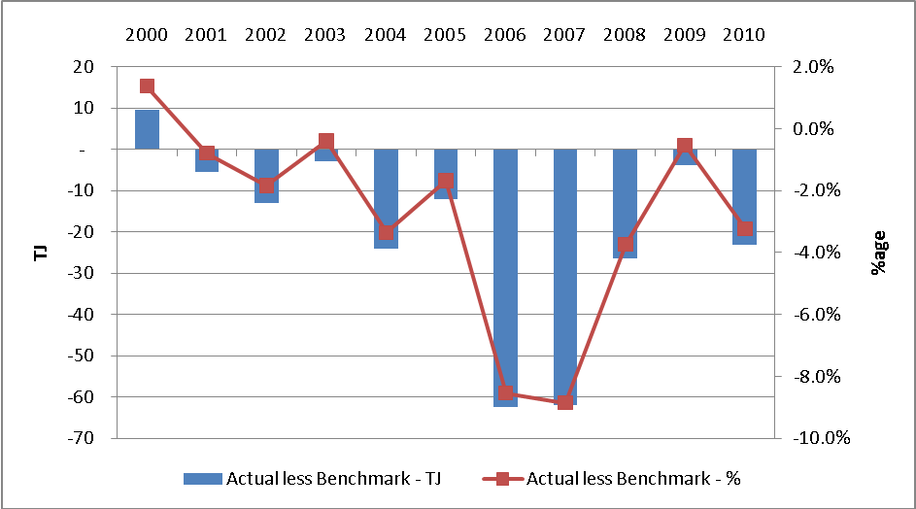

There are two primary reasons explaining this ongoing gap between actual and approved volumes. The first is actual customer numbers not achieving benchmark in the first five years of the decade (refer Graph 13.2 below). It is, however, worth noting that in the current AA period, Envestra has connected more residential customers than the regulatory benchmark, at a lower than regulatory approved average consumption.
Graph 13.2 Actual less Approved Domestic Customer Connections (2000 to 2010)

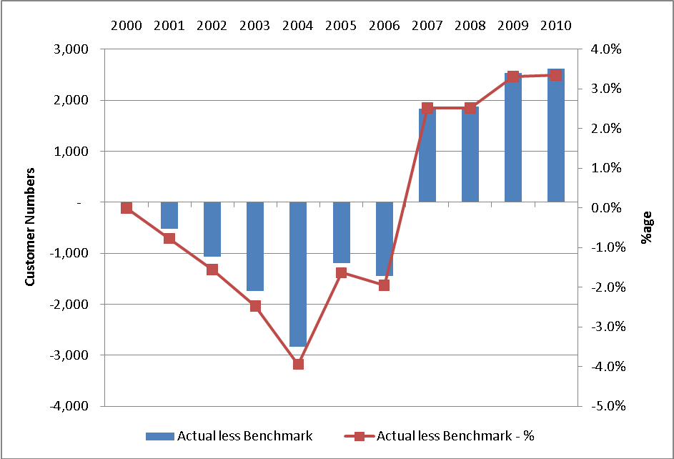

The second factor is average consumption per domestic connection has fallen at a faster rate than that allowed for by the regulator (see Graph 13.3). Between 2006 and 2010, actual average consumption for domestic connections has been six per cent lower than that allowed for by the regulator.

Graph 13.3 Actual less Approved Average Consumption for Domestic Customers (2000 to 2010)

The data show that there has been a long term trend towards declining average consumption for domestic connections (see Graph 13.4).

Average consumption has fallen from 10.7 gigajoules per annum (GJ-pa) in 2000 to 8.6 GJ-pa in 2010, reflecting an average annual decline of two per cent (as opposed to the one per cent decline allowed for by the regulator over this period).

Graph 13.4 Actual and Approved Domestic Average Consumption (2000 to 2010)

The data show that average consumption for domestic connections has:

- declined since 2000; and

- declined at a faster rate than forecast by the regulator in the Second Access Arrangement period.

These trends are also apparent in Envestra’s Victorian and South Australian networks.

What is most concerning for Envestra is the near constant decline in average consumption. There are a range of factors contributing to the decline in average consumption per domestic connection, many of which have strengthened their contribution to reducing average consumption over the more recent period. These factors include (but are not limited to):

- increased appliance efficiency – the appliance efficiency requirements set out in the Minimum Energy Performance Standards (MEPS) scheme have continued to increase;

- Government policy – policy is increasingly focused at initiatives that reduce energy consumption or distort preferences towards appliances that are less greenhouse intensive (such as solar hot water);

- Connection of new customers – new customers consume less on average than existing customers.

With regard to the last point, the lower average consumption of newer customers is attributable to factors such as fewer gas appliances per dwelling and those appliances being more efficient. Graph 13.5 shows that the average consumption for new connections is less than the gas consumption of connection installed in the previous year.
Graph 13.5 Actual Average Consumption for Domestic Consumption by Year of Installation (2003 to 2009)

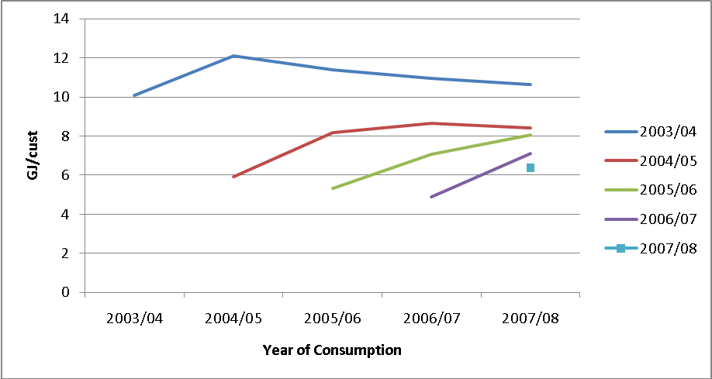

Envestra considers that direct government policy initiatives aimed at reducing energy consumption are more likely to be strengthened rather than weakened over the Third Access Arrangement Period. This reflects the increased focus on direct measures (such as rebates) to reduce greenhouse gas emissions given the delay of the CPRS. This would also be consistent with the general direction of energy policy over the past 10 years.

However, the continually evolving policy environment highlights the difficulty in forecasting volumes. For example, in some cases historic data might not be available to base a forecast where the policy has been recently introduced. Likewise, it is not possible to reliably forecast future changes to the current energy policy environment. This makes it difficult for the business to substantiate reasons for volumes to fall at a rate above trend levels, as has occurred over the Second Access Arrangement Period.

That said, what is clear is that the trend rate of decline in average consumption for domestic connections has increased over time and that the gap between actual and approved volumes has widened over recent years. In response to these concerns, Envestra engaged (National Institute of Economic Industry Research) NIEIR to provide it with independent and expert advice on forecast volumes (amongst other things) for the next regulatory period. NIEIR was primarily selected based on:

- its robust methodology to forecasting volumes; and

- its significant experience gained over the past 30 years in preparing forecasts for industry and government (including independent energy market operators such as VENCorp).

NIEIR was also the only expert known to Envestra at the time that had demonstrated experience in forecasting volumes from the ‘bottom up’.

This chapter explains in more detail the NIEIR methodology and the resultant forecasts of volumes, customer numbers and demand to apply over the Third Access Arrangement Period.

13.4 NIEIR Forecasting Approach

NIEIR was engaged to forecast customer numbers, sales and demand across Envestra’s network by customer type. This section describes the approach taken by NIEIR to prepare these forecasts and the key drivers that influenced the forecasts (the NIEIR report is provided as Attachment 13-1).

13.4.1 Forecasting Approach

NIEIR has used its energy modeling adjunct to its core Institute Multi Purpose Model (IMP) to produce demand forecasts for Envestra’s Queensland gas distribution network to 2019-20. NIEIR’s models are able to produce forecasts down to the regional level for the different segments of Envestra’s customer base. This level of disaggregation is required due to the disparate nature of the South Australian network, in terms of network penetration, geography and customer segmentation.

Figure 13.1 shows the relationships between the models used by NIEIR.

Figure 13.1 NIEIRs integrated energy modelling systems

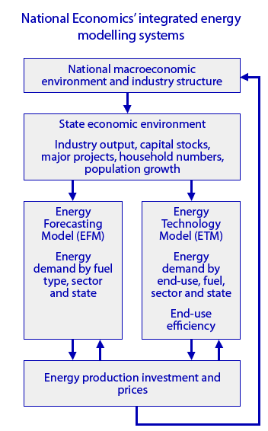

The Australian Energy Regulator (AER) has recently accepted the advice of its consultant (ACIL Tasman) that NIEIR’s methodology and approach to forecasting is generally sound. For example, in its decision for the NSW gas distribution business, which also used NIEIR to prepare its demand forecasts, the AER found “… the forecasting methodology in the NIEIR report provides forecasts that are statistically significant.”

Table 13.1 sets out the nature of the forecasts that NIEIR has prepared for each region on Envestra’s network. The forecasts prepared by NIEIR reflect the manner by which each customer group is billed.
For example, forecasts of maximum daily quantity are not required for residential customers as this group is charged based on the volume of gas used. This reflects the information required to forecast regulatory revenue from distribution tariffs over the upcoming AA period.

Table 13 Forecast prepared by NIEIR

 | Customer Numbers | Volume | Maximum Daily Quantity
Residential Tariff R | ✓ | ✓ | Not Required
Commercial Tariff C | ✓ | ✓ | Not Required
Industrial Tariff C | ✓ | ✓ | Not Required
Demand Tariff D | ✓ | ✓ | ✓

These forecasts are produced for each of the regions below:

- Brisbane and Riverview; and

- Northern.

13.4.2 Key NIEIR Assumptions

NIEIR’s fully integrated approach to gas demand modelling incorporates a comprehensive economic forecast, demographic forecast and gas price forecast (including the influence of the Carbon Pollution Reduction Scheme). This section outlines the key drivers used by NIEIR to prepare its forecasts.

13.4.2.1 Economic Drivers

NIEIR has forecast key economic drivers at the world, national, state and regional levels, which drivers are outlined below. A further explanation of the derivation of the forecasts is set out in Attachment 13-1.

World Economy

NIEIR’s forecasts of gross domestic product (GDP) for the world economy suggest a return to average growth rates post 2012 of almost 3.6% pa. Australia’s major trading partners in Asia are, however, expected to return to normal GDP growth rates of 5% pa from 2010.

National and Queensland Economies

The strong growth rates of Asian economies will have a positive impact on the national growth rate in the short term. NIEIR expects that the latter half of the Third Access Arrangement Period will be more challenging as governments rein in expenditure to reduce public sector deficits and private consumption falls in response to the high interest rates required to control inflation.

In line with history, Queensland is expected to grow at above the national average due to relatively stronger population, household expenditure and private investment growth. Queensland gross state product (GSP) is forecast to average 3.8% over the 2011-16 period versus a national average of 2.8%.
Graph 13.6 Australian Gross Domestic Product and Queensland Gross State Product

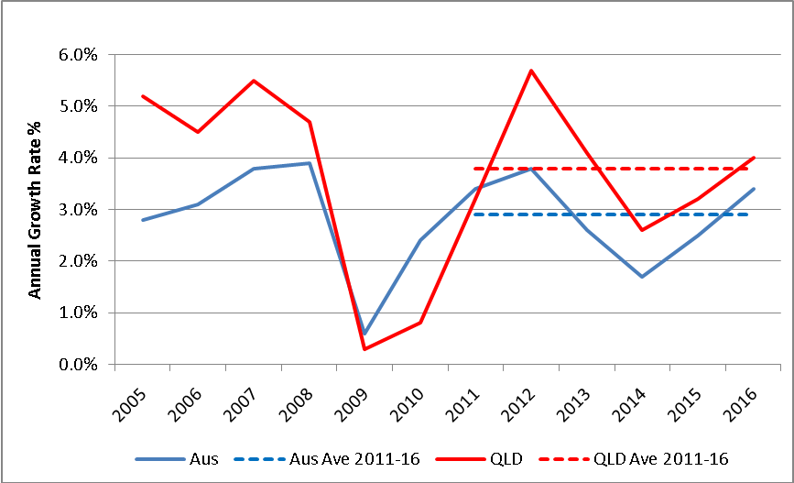

Population Growth

The Queensland population has averaged around 2.3% pa over the past decade. NIEIR forecast Queensland population growth of approximately 2.1% pa over the 2011-16 period (Graph 13.7). Although lower than the previous decade, Queensland population growth is expected to run 0.5% higher than the national average. NIEIR’s forecast is consistent with the Australian Bureau of Statistics (ABS) B series projection of 2.1%, which reflects the mid range of the ABS population projections.

Graph 13.7 Queensland Population Projections – NIEIR and ABS A, B and C Series

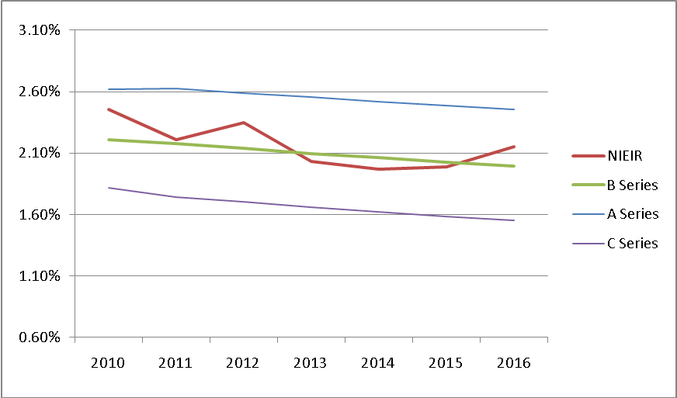

Private Consumption Expenditure and Dwelling Investment

Private consumption expenditure is expected to grow by around 3.4% pa over the next regulatory period to 2015-16. This is double the growth rate experienced in the years particularly affected by the Global Financial Crisis (GFC) of 2007-08 to 2008-09.

Private dwelling investment is forecast to have strong growth at the beginning of the next regulatory period. The end of the period however experiences declines in private dwelling investment. Annualised growth to 2015-16 remains positive at around 2.6% pa.

Government Expenditure

Government consumption is forecast to grow in line with recent history at around 4.7% pa to 2015-16. Government investment, however, is forecast to decline at an average of 5.5% pa as the Commonwealth’s stimulus package is unwound and other major infrastructure expenditures are completed. The decline of 5.5% pa follows very strong growth rates in earlier years.

The decline in government investment will be offset by a rise in private business investment at the beginning of the next regulatory period. The year 2013-14 possesses an unfortunate coincidence of declines in private business investment and government investment. These factors combine to drive a low GSP forecast in that year.

13.4.2.2 Gas Price

Gas demand is inversely related to the price of gas (with the extent of the relationship determined by the elasticity of demand). NIEIR is forecasting an increase in the gas price due to the introduction of the Carbon Pollution Reduction Scheme (CPRS) in 2014. NIEIR’s assumptions of the impacts of the CPRS are consistent with those used by Commonwealth Treasury. The gas price also takes account of the price impact of Envestra’s Access Arrangement proposal.

NIEIR’s modelling incorporates a lagged price effect – the impacts of price movements are spread over a number of years as opposed to a single year effect. This approach proxies the long run response or price elasticity.

NIEIR apply distinct residential and business gas prices in their demand forecasting. The forecast gas prices used in developing the demand forecasts are presented in Graph 13.8 below.

Graph 13.8 Queensland Gas Prices, Real 2005-06

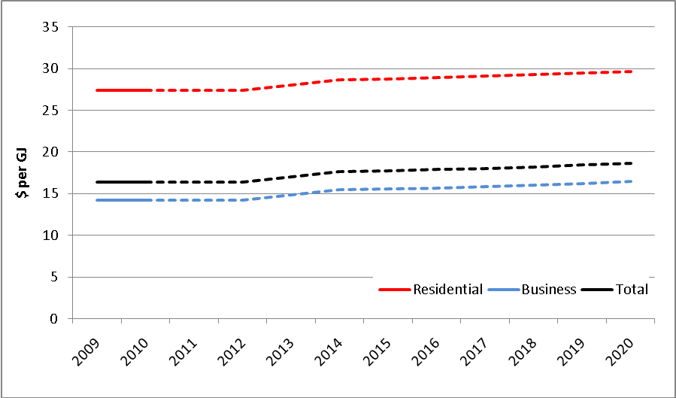

13.4.2.3 Energy Efficiency and the CPRS

The advent of climate change has triggered an array of Federal and State Government programs aimed at reducing the release of greenhouse gases. Schemes that will have a particular impact on forecast volumes are the:

- Carbon Pollution Reduction Scheme (CPRS) – a national scheme to impose a cost of carbon to the price of emissions. Following the most recent deferral of the CPRS, NIEIR expect the scheme to be in place by 2014. The price assumptions used by NIEIR are consistent with that applied by Commonwealth Treasury;

- Mandatory Renewable Energy Target (MRET) – a national scheme requiring energy retailers to purchase electricity from renewable sources. This obligation is met by retailers acquiring Renewable Energy Certificates (REC) from certified renewable energy producers. RECs can be obtained from large scale renewable generators such as wind farms or small scale appliances such as domestic solar hot water units;

- Specific appliance rebates – in addition to RECs, further Federal and-or State Government rebates exist for domestic appliances such as solar and heat pump hot water units. Rebates and RECs combine to reduce the total cost to consumers of choosing the most efficient energy appliances;

- Minimum Energy Performance Standards (MEPS) and labeling for appliances – appliance energy efficiency is recognised as a means of reducing green house gas emissions. To achieve this outcome MEPS have been introduced for appliances. Appliances not achieving the minimum energy efficiency standard cannot be legally sold in Australia. Labelling (star rating) enables consumers to compare appliances based on energy efficiency;

- Water Efficiency Labelling Scheme (WELS) – Akin to energy labelling, WELS enables consumers to compare appliances based on water efficiency.
Water efficient appliances impact on gas demand as a result of the reduced requirement for hot water; and

- Building Code of Australia requirements for residential and commercial buildings – requires newly constructed domestic and commercial dwellings to meet minimum thermal standards.

13.5 Residential Forecasts

The key drivers of the residential sales forecasts are:

- customer numbers; and

- average consumption.

13.5.1 Customer Numbers

Envestra’s customer numbers are projected to grow at 2.6% pa to 2015-16, which is above the 2.3% pa growth experienced by Envestra over the 2005-09 period. NIEIR’s customer number forecast is derived from its forecasts of population, household formation forecasts and dwelling stock. The forecast customer number growth rate is lower than recent history due to the forecast lower population growth. NIEIR’s customer number forecast is differentiated into “old” and “new” customers. NIEIR has allowed for the continual conversion of existing homes from electricity to gas (E to G) consistent with historic trends.

13.5.2 Average Consumption

Envestra’s residential average consumption is projected to decline by 2.6% pa over the 2011-12 to 2015-16 period. This compares to an actual decline of that experienced in the 2005-2009 period of approximately 2.0%.

Graph 13.9 details actual and forecast adjusted average residential consumption from 2006 to 2016.

Graph 13.9 Residential Average GJ pa

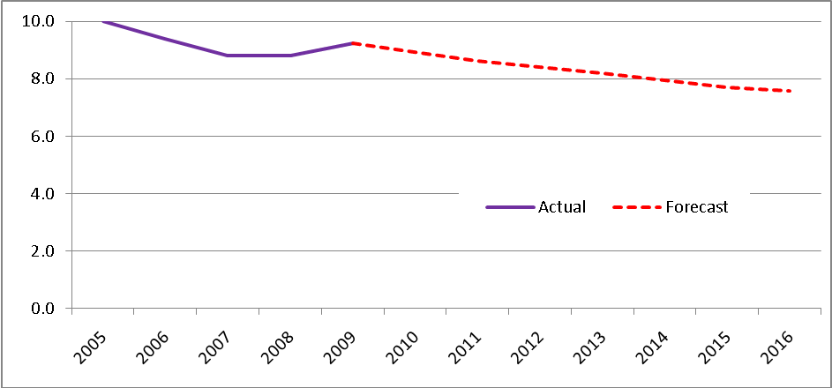

The following three key factors are driving the continual decline in average residential consumption:

- the average consumption of “new” versus “old” dwellings; and

- appliance selection and usage.

Although expressed separately the factors are not mutually exclusive and to a certain degree are interrelated.

13.5.2.1 New versus Old Dwelling Average Consumption

NIEIR’s Residential Energy Forecasting Model (EFM) produced a forecast of “old” and “new” average consumption based on an econometric regression analysis approach utilising the drivers of real household disposable income and real gas price. The relevant income and price elasticities of demand for the residential sector are based on NIEIR’s Queensland gas model estimates.

Average consumption is split between “new” and “old” customers as “new” customers continue to use less gas than existing customers (refer to Graph 13.5 above). The difference in consumption reflects different appliance penetration rates, greater energy efficiency of new appliances installed and dwelling shell efficiencies.

NIEIR’s EFM also uses a policy or emergence factor which is derived from an appliance end use model to take account of discrete policy-incentive impacts on gas consumption. The end use model takes into account the factors that will impact gas demand for new and existing customers into the future.

13.5.2.2 Appliance Selection

The decline in average residential consumption can be broadly explained by the switch from traditional gas storage hot water units to instantaneous gas and gas boosted solar hot water units. Appliance selection has an impact on both “new” and “old” customers.

Greater emphasis on appliance efficiency through MEPS and REES and dwelling shell efficiency through the Building Code Australia will promote gas consumption reductions. These regulations drive gas consumption reductions in two key ways: firstly by improving the energy efficiency of the appliances themselves and secondly by reducing the need to use those appliances.

Gas use in a Queensland residential dwelling is dominated by two functions:

- Water Heating; and

- Cooking

Water Heating

Consumers continue to elect for more efficient and environmentally friendly water heaters. Instantaneous and solar units continue to garner a greater share of the conventional gas market, displacing the less efficient gas storage units.

Solar gas units use a third to one half of the energy used by conventional gas water heaters. For the upcoming Third Access Arrangement Period, Envestra forecasts solar gas units to increase in penetration from their current levels. The increase in penetration of gas boosted solar is in response to the REC and rebates available.

A MEPS of 4 stars is proposed to be applied to gas hot water units. The associated Regulatory Impact Statement was released for consultation in October 2009. The proposed MEPS will have the greatest impact on new gas storage hot water units as the vast majority of current gas instantaneous units sold into Australia meet and exceed the minimum 4 star standard.

The amount of hot water use also impacts on gas used for heating water. ABS data show the continual shift from warm water to cold water washing and the uptake of water saving devices such as low flow shower heads and taps. This, combined with the shift to more water efficient appliances (such as front load washing machines), will continue to drive down domestic hot water requirements and gas consumption along with it.

These trends in hot water appliance mix and efficiency are also expected to continue to 2015-16.

Cooking

Cooking comprises a small but relatively consistent load for the domestic consumer. Envestra data shows a sharp decline in the penetration of gas cookers in new homes revealing a potential shift in customer preferences towards flat electric cook tops.

Residential Forecast

Envestra’s final domestic demand forecast is therefore a combination of NIEIR’s customer number and average consumption forecasts. Graph 13.10 below shows the final forecast.
Graph 13.10 Residential Volume TJ pa

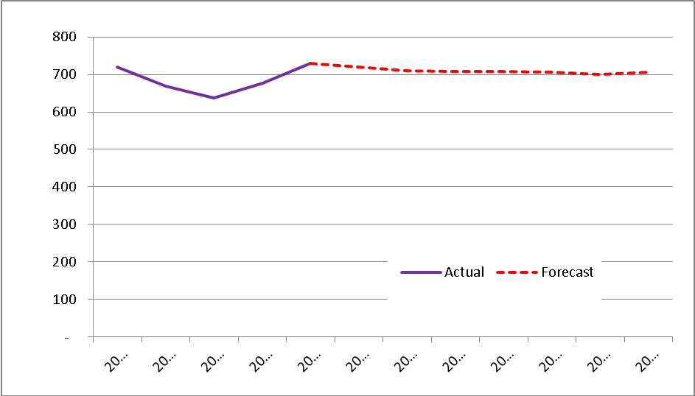

Total volume is forecast to remain relatively flat with a decline of 0.1% over the Third Access Arrangement Period 2011-12 to 2015-16. This compares to a increase of 0.2% pa over the 2005-09 period. Envestra considers this to be a conservative forecast given the significant trend decline in average consumption over an extended duration. As in past periods, there remains a risk that Envestra will again be unable to achieve this modest fall in volumes over the Third Access Arrangement Period, particularly in the light of the current policy environment.

13.6 Commercial and Small Industrial Forecasts

The key drivers of the commercial and small industrial volume and customer number forecasts are the:

- NIEIR economic forecast; and

- NIEIR real gas price forecast (incorporating lags in real prices to proxy the long run response or price elasticity).

NIEIR’s forecasts for commercial and small industrial volume are linked to a general equation for gas sales, where sales are related to gas prices and total commercial and industrial gross value added (GVA) for the distinct network areas. Historic commercial and small industrial volumes were corrected for weather in a manner consistent with residential volume, albeit at a lower sensitivity. Commercial and small industrial customer number forecasts are also linked to GVA forecasts.

Other than the impact of greenhouse reduction policies (eg CPRS) on the gas price, no other specific policy adjustments have been made. This is a conservative position as the Federal 2010 Budget did allocate funds directed at improving energy efficiency with in the commercial and industrial sectors of the economy.

Commercial and small industrial volume and customer numbers are expected to grow at 1.1% pa and 0.7% pa respectively over the 2011-12 to 2015-16 period. This compares to an increase in volume of 0.9% pa and customer numbers of 1.3% over the 2005-09 period.

13.7 Demand Customer Forecast

Demand customers comprise Envestra’s largest network users. Approximately 70 demand customers use more than half of the total gas delivered by Envestra. Forecasts of gas (sales) volumes and maximum daily quantity (MDQ) for Demand customers have been developed by NIEIR at industry and network district levels. The industry structure of this model is shown in Table 4.1 of NIEIR’s report (Attachment 13-1). NIEIR assigned an industry classification to every Demand customer on the network.

The industry regression models relate Demand customers gas consumption to:

- the change in output for that industry within the zone; and

- the change in real gas prices for that industry (incorporating lags in real prices to proxy the long run response or price elasticity)

The output and price elasticities at the network district level have been adjusted to reflect differences in the gas intensity between industries and regions. This reflects different types of industries (eg manufacturing versus recreation) use different amounts of gas to produce the same dollar value GVA.

The Demand customer forecasts by industry and network district to 2015-16 have been determined by:

- NIEIR’s outlook for industry growth in each of the districts; and

- the structural parameters and relationships embodied in NIEIR’s industry based Queensland natural gas demand model.

Demand customer numbers are expected to start at 69 in 2011-12 and close at 71 in 2015-16. The MDQ forecast follows a similar trajectory to the customer number forecast opening at 20,975 GJ MDQ and closing at 21,514 GJ MDQ.

13.8 Envestra Forecast

Table 13.2 below details the total Envestra demand and customer number forecast for the Third Access Arrangement Period.

Table 13.2 Final Demand and Customer Number Forecasts

Table 13.3 below details the gross connection forecast to 2015-16 used in developing the capital expenditure program. The gross connection forecast is derived from an extrapolation of the historic proportions between net customer growth and customer disconnections.

Table 13.3 Gross Connection Forecast

13.9 Use of Demand Forecasts

13.9.1 Development of Capex and Opex

As required under RIN clause 2.2.2 (g), the discussion below details how the demand forecasts have been used to develop the capex and opex forecasts.

The capex forecast for Mains Growth, Inlets Growth and Meters Growth is directly related to the new gross connection forecasts by customer class. The gross connection forecast is derived from an extrapolation of the historic relationship between net customer growth and disconnections. The capex is calculated by applying unit rates of construction relating to mains, inlets and meters by customer class.

Opex forecasts are partially driven by the incremental customer number forecasts, i.e. incremental costs arising from every new connection to the Network.

13.9.2 Tariff Billable Quantities

The forecasts presented in this chapter must be converted into the associated charging parameters in order to calculate forecast tariff revenue over the regulatory period (refer Chapters 14 and 15 for further discussion on tariffs, tariff classes, charging parameters and tariff structures). Supply charge days were determined by taking the average of two consecutive years’ customer numbers multiplied by 365. NIEIR utilised the proportions implied by the historic volumetric blocks and applied those to the forecast volume and MDQ. As Tariff R is being restructured, historic proportions are not applicable. Envestra derived the proportions to be applied to the forecasts from actual read data of a sample of approximately 10,000 residential MIRN’s which is further detailed in Attachment 15-1.
13.9.3 Ancillary Reference Services Revenue

The Ancillary Reference Service forecasts are used to derive the revenue to be recovered from the provision of these services for the Third Access Arrangement Period as detailed in Section 14.4.

13.10 A note on Confidence Intervals

Envestra notes that in its New South Wales Gas Distribution Business Final Decision, the AER gave regard to the use of Confidence Intervals as a form of check of the forecasts presented by the New South Wales gas business. Envestra holds that forecasting gas consumption requires an appreciation of numerous factors, such as the state of the economy, weather, policy changes etc which do not yield to simple, broad statistical tests.

Despite these reservations, Envestra has used the Confidence Interval calculation adopted by the AER’s consultant in the New South Wales Gas Distribution Access Arrangement review – ACIL Tasman – and presents the results below for the average residential consumption.

Graph 13.11 Queensland Average Residential GJ pa – Forecast vs 90% Confidence Interval

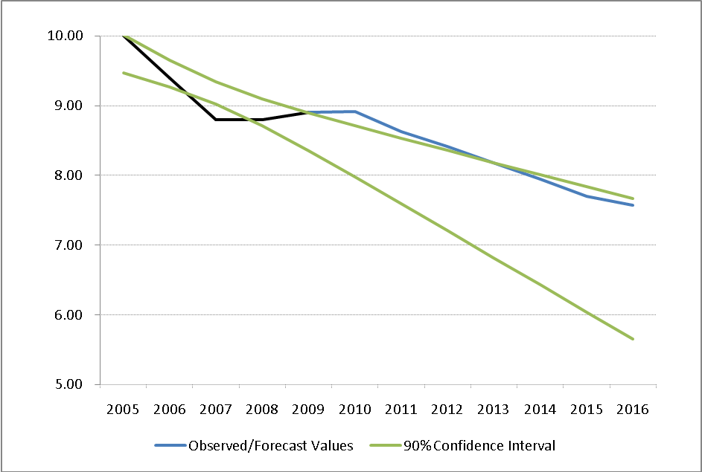

As can be seen from Graph 13.11 above, Envestra’s average residential forecasts out to 2015-16 fall within the 90% Confidence Interval. This implies that Envestra is not forecasting a significant departure form past trends in developing forecasts in the Third Access Arrangement Period.
14. REFERENCE TARIFFS

14.1 Introduction

Envestra recovers its regulated revenue by charging tariffs to customers for Haulage Reference Services and Ancillary Reference Services. The Haulage Reference Tariffs will apply to three categories of Delivery Points:

- Residential Volume Tariff (Tariff R);

- Commercial and Small Industrial Volume Tariff (Tariff C); and

- Demand Tariffs (Tariff D).

In earlier Access Arrangement Periods, Envestra’s Haulage Reference Tariffs covered two categories:

- Volume Tariff V – comprising residential, commercial and small industrial customers; and

- Demand Tariffs (Tariff D).

In the Third Access Arranagement Period, Envestra proposes to apply separate Reference Tariffs for residential (Tariff R) and commercial and small industrial (Tariff C) customers due to their different usage profiles. The new tariffs will apply from 1 July 2011. Envestra’s rationale for separating residential customers from commercial and small industrial customers is to enable flexibility in price signaling as Envestra responds to changes in customer behavior, and therefore more efficient pricing.

Customers will be assigned to each of the three tariffs based on their geographic zone, type of connection (ie residential-non-residential) and their usage profile (ie Tariff C versus Tariff D). The charging parameters for the volume tariffs (Tariffs R and C) are structured as “declining block tariffs” and also comprise a supply charge. The same price applies irrespective of geographic location.

Tariff D is also structured as a “declining block tariff,” however the quantity charged reflects a capacity signal, the Maximum Daily Quantity (MDQ) agreed between Envestra and the customer. Tariff D is also location specific, with different rates applying depending upon into which geographical zone in which a Delivery Point is situated.

Envestra is proposing no changes to the structure of Tariff D. Tariff C will continue with the same structure as the current Tariff V.

Tariff R will comprise a declining three block structure. This will enable greater flexibility in pricing as Envestra attempts to counter-act the continued decline in average residential consumption.

The Full Retail Contestability (FRC) charges in the Queensland tariff schedule for the current Access Arrangement Period will no longer be separately identified. FRC costs will now be bundled into the standard Reference Service Tariffs.

14.2 NGR Requirements

Rule 94, as outlined below, imposes the following requirements on Envestra with regards to tariffs.

- For the purpose of determining reference tariffs, customers for reference services provided by means of a distribution pipeline must be divided into tariff classes.

- A tariff class must be constituted with regard to:

  - the need to group customers for reference services together on an economically efficient basis; and

  - the need to avoid unnecessary transaction costs.

- For each tariff class, the revenue expected to be recovered should lie on or between:

  - an upper bound representing the stand alone cost of providing the reference service to customers who belong to that class; and

  - a lower bound representing the avoidable cost of not providing the reference service to those customers.

- A tariff, and if it consists of 2 or more charging parameters, each charging parameter for a tariff class:

  - must take into account the long run marginal cost for the reference service or, in the case of a charging parameter, for the element of the service to which the charging parameter relates;

  - must be determined having regard to:

    - transaction costs associated with the tariff or each charging parameter; and

    - whether customers belonging to the relevant tariff class are able or likely to respond to price signals.

- If, however, as a result of the operation of subrule (4), the service provider may not recover the expected revenue, the tariffs must be adjusted to ensure recovery of expected revenue with minimum distortion to efficient patterns of consumption.

- The AER's discretion under this rule is limited.

Envestra holds that the tariffs presented in Attachment 14-2 and the relevant supporting information provided in this chapter and Attachment 14-1 satisfy Rule 94.

14.3 Haulage Reference Service Tariff Classes

Clause 2.6.2.1(a) of the Regulatory Information Notice (RIN) requires that Envestra provide a description of each tariff Class for each reference service in its Access Arrangement proposal submission. Table 14.1 below details the Queensland Tariff Classes.

Table 14.1 Queensland Tariff Classes

Tariff Class | Haulage Reference Service | Geographical Zone
Tariff R – Residential | Domestic | Brisbane & Riverview
Tariff R – Residential | Domestic | Northern
Tariff C – Commercial | Commercial | Brisbane & Riverview
Tariff C – Commercial | Commercial | Northern
Tariff D – Northern | Demand | Gladstone & Rockhampton
Tariff D – Brisbane | Demand | Brisbane
Tariff D – Riverview | Demand | Ipswich

14.3.1 Volume Tariff Classes – Tariff R (Residential) and Tariff C (C&I)

Volume Tariff Classes comprise two categories – Tariff R (Residential) and Tariff C (Commercial). Tariff R relates directly to the Domestic Haulage Reference Service while Tariff C relates directly to the Commercial Haulage Reference Service. Each constitutes its own reference tariff.

Both Tariff R and Tariff C comprise the following charging parameters:

- Supply charge (in dollars per day); and

- Banded actual volume charges (in dollars per GJ per day).

These are discussed in turn below.

Supply Charge

The supply charge is a fixed daily charge that applies to all Volume Delivery Points. Different supply charges apply to Domestic and Commercial Delivery Points, and are designed to:

- provide signals to customers about their connection costs, having regard for the size, location and type of network user; and

- inform a customer’s decision to connect to Envestra’s network by providing a constant and foreseeable cost.

Banded Actual Volume Charges

Both Tariff R and Tariff C consist of a number of volumetric consumption charging parameters (in dollars per GJ per day). These charging parameters have been designed to recover any residual allocated costs that are relative to the “size” of the customer but not specifically their network demand.

Tariff R will shift to three volumetric consumption bands in the Third Access Arrangement Period. Tariff R currently has two volumetric consumption bands.

- a charge for the first 0.0082GJ of Gas Delivered ($GJ);

- a charge for the first 0.0192GJ of Gas Delivered ($GJ); and

- a charge for Additional Gas Delivered ($GJ).

Tariff C will maintain the volumetric consumption bands of the current Tariff V.

- a charge for the first 0.20GJ of Gas Delivered ($GJ);

- a charge for the next 0.30GJ of Gas Delivered ($GJ);

- a charge for the next 0.50GJ of Gas Delivered ($GJ);

- a charge for the next 1.00GJ of Gas Delivered ($GJ);

- a charge for the next 5.00GJ of Gas Delivered ($GJ); and

- a charge for Additional Gas Delivered ($GJ).

Tariff R and Tariff C are structured as “declining block tariffs”. The volumetric charging parameters apply to the actual gas consumed during the read cycle. The declining block structures reflect the declining unit costs to Envestra of customers increasing their gas consumption.

14.3.2 Demand Tariff Classes – Tariff D

The structure of the Demand Tariff Classes consist of a number of banded MDQ charging parameters (in dollars per GJ of MDQ per day), with the first band effectively representing a fixed charge as a minimum chargeable MDQ applies. Consistent with the Volume Tariffs, Tariff D is a “declining block tariff”, whereby the charges become smaller as MDQ increases.

The MDQ charges are capacity charges intended to reflect the demands on the network assets. The structure provides economic signals to customers of a preferred usage profile. The locational aspect of Tariff D reflects the cost of servicing customers and also incentivises customers to connect to those parts of the network that will impose the least costs on Envestra and customers.

For each of the Demand Tariff Classes in Queensland, Tariff D contain eight MDQ bands as follows:

- MDQ of 50GJ or less;

- next 50GJ of MDQ;

- next 75GJ of MDQ;

- next 150GJ of MDQ;

- next 250GJ of MDQ;

- next 500GJ of MDQ;

- next 10,000GJ of MDQ; and

- additional GJ of MDQ

14.4 Ancillary Reference Services

Envestra proposes to maintain its Reference Tariffs for Ancillary Reference Services in real terms over the Third Access Arrangement Period.

The tariffs reflect a continuation of those previously approved, with increases reflecting inflation only. The tariffs continue to reflect the cost of providing the services.

The following table shows demand forecast for Ancillary Reference Services. This has been based on historical demand.

Table 14.1 Ancillary Reference Services Forecast ($ 2011-12)

$ real 2009-10 | 2011-12 | 2012-13 | 2013-14 | 2014-15 | 2015-16 | Total
Special Meter Reading
Volume | 22,109 | 22,109 | 22,109 | 22,109 | 22,109 | 110,545
Price | $8.96 | $8.96 | $8.96 | $8.96 | $8.96
Revenue | $198,072 | $198,072 | $198,072 | $198,072 | $198,072 | $990,358
Disconnection
Volume | 2,566 | 2,566 | 2,566 | 2,566 | 2,566 | 12,830
Price | $60.48 | $60.48 | $60.48 | $60.48 | $60.48
Revenue | $155,179 | $155,179 | $155,179 | $155,179 | $155,179 | $775,894
Reconnections
Volume | 2,471 | 2,471 | 2,471 | 2,471 | 2,471 | 12,355
Price | $60.48 | $60.48 | $60.48 | $60.48 | $60.48
Revenue | $149,434 | $149,434 | $149,434 | $149,434 | $149,434 | $747,169
Total Revenue | $502,684 | $502,684 | $502,684 | $502,684 | $502,684 | $2,513,421

14.5 Avoidable and Stand-Alone Costs

14.5.1 Stand Alone Costs

Clause 2.6.2.1 (e) of the RIN requires that in the Access Arrangement proposal submission, Envestra must define the stand-alone cost for each tariff class of each reference service which should outline what costs comprise the stand-alone cost of providing each reference service to network users in each tariff class.

Consistent with Ergon Energy’s approach, Envestra has defined the stand-alone costs for each tariff class as the infrastructure costs associated with servicing that tariff class. These costs represent the upper bound of providing reference services to each tariff class, because the costs are calculated based on the assumption that no other network users use the network infrastructure, thereby ignoring the economies of scale that result from the other tariff classes that are also currently using the shared infrastructure.

Envestra estimated the stand-alone costs separately for the Demand Tariff classes and for the Domestic and Commercial Tariff classes in its Cost Allocation Model. The methodology for estimating the stand-alone costs both the Demand Tariff classes and Domestic and Commercial Tariff classes are set out below.

Demand Tariff Classes

The stand-alone cost for each of the Demand Tariff Classes was determined to be the cost associated with the High Pressure (HP) ring, where the HP ring was defined to comprise every network asset required to service the Demand Tariff classes. The costs associated with the HP ring were calculated as the pro-rata of 2011-12 building block revenue requirement based on the cost allocation methodology described in section 2.4 of Attachment 14-1.

Each Demand Tariff class has the same stand-alone cost. This is because the assets required to service each Demand Tariff class form part of the HP ring, and all of these assets must be present to enable supply to each of the network users in the Demand Tariff classes. Consequently, the stand-alone cost for each Demand Tariff class must be the cost of the HP ring, as no Demand Tariff Class can be considered in isolation.

Residential and Commercial Tariff Classes

The stand-alone costs for the Domestic and Commercial Tariff classes were determined to be the cost associated with the HP ring plus the connection assets associated with each Domestic and Commercial Tariff class.

The costs of the connection assets for each tariff class were based on the pro-rata of the total 2011-12 building block revenue less the building block revenue associated with the Demand Tariff classes. The residual amount was then further prorated between the Domestic and Commercial Tariff classes as set out in Section 2.4 of Attachment 14-1.

14.5.2 Avoidable Cost

Clause 2.6.2.1(f) of the RIN requires that in the Access Arrangement proposal submission, Envestra must define the avoidable cost for each tariff class of each reference service which should outline what costs comprise the avoidable cost of providing each reference service to network users in each tariff class. Envestra has defined avoidable cost for each tariff class to be the cost that can be avoided by not providing reference services to that tariff class. Put another way, this represents the costs (i.e. the Return On Capital, Return Of Capital (depreciation) and opex associated with dedicated connection assets such as meters, and inlets.

This definition is consistent with both Ergon Energy and Integral Energy’s interpretation of avoidable cost. Both electricity distributors interpret avoidable cost to be the cost which would be avoided by not providing a distribution service to a particular tariff class. Further, Envestra’s interpretation is also consistent with Ergon Energy’s interpretation of avoidable cost because it includes the presumption of the existing network in its current state.

14.5.3 Comparison of Avoidable Costs, Weighted Average Revenue and Stand Alone Costs

As detailed in the introduction, Rule 94(3) of the NGR requires that for each tariff class, the revenue expected to be recovered should lie on or between:

  - an upper bound representing the stand alone cost of providing the reference service to customers who belong to that class; and

  - a lower bound representing the avoidable cost of not providing the reference service to those customers.

In addition, clause 2.6.2.1(h) of the RIN requires that in the Access Arrangement proposal submission, Envestra must demonstrate that expected revenue recovered for each tariff class for each reference service lies on or between stand-alone and avoidable cost.

The tables below demonstrates that for each Queensland class, the 2011-12 weighted average revenue for each tariff class lies above the lower bound avoidable cost and below the upper bound stand alone cost, in accordance with Rule 94(3) and clause 2.6.2.1(h) of the RIN:

Table 14.2 Avoidable, Expected and Stand Alone Costs

Tariff Class | Avoidable Costs ($M) | Weighted Average Revenue  ($M) | Stand Alone Costs  ($M) | Complies
Tariff D: Brisbane | $1.48 | $11.48 | $34.33 | Yes
Tariff D: Northern | $0.16 | $0.60 | $34.33 | Yes
Tariff D: Riverview | $0 | $0.63 | $34.33 | Yes
Tariff R: Brisbane & Riverview | $6.24 | $18.92 | $60.39 | Yes
Tariff R: Northern | $0.25 | $0.70 | $35.37 | Yes
Tariff C: Brisbane & Riverview | $0.24 | $14.23 | $35.04 | Yes
Tariff C: Northern | $0.04 | $2.41 | $34.44 | Yes

14.6 Long Run Marginal Costs

14.6.1 Definition of LRMC

Clause 2.6.2.1(i) of the RIN requires that in the Access Arrangement proposal submission, Envestra must define Long Run Marginal Cost (LRMC) for each reference service or for each element of the service to which the charging parameter relates, whichever is relevant. The definition of LRMC needs to outline what costs comprise LRMC.

LRMC is not defined in the NGR. Envestra notes Integral Energy’s interpretations in their respective Pricing Proposals, which first defined short run marginal cost as:

The “cost to society of a network user using existing capacity in the network at any point in time. This is generally very low unless the system is capacity constrained, and reflects the fact that the great majority of the costs of an electricity network provider are fixed in the short run and do not vary with the usage of the network
.
Integral Energy then defined LRMC as “a situation in which the investment in plant and equipment is variable”, and further noted that LRMC will “relate broadly to the annualised cost of augmenting capacity (in the case of electricity, at a particular voltage, at a particular location, at a particular time), generally, per unit of additional capacity provided (i.e., kW or kVA)”.

Envestra considers that appropriate parallels exist between electricity distribution and gas distribution infrastructure for this definition to be broadly applicable to Envestra’s network. Consequently, Envestra interprets LRMC to be the costs of providing network capacity increments in the long term.
14.6.2 Envestra's Approach to Calculating LRMC

Envestra's approach to calculating the LRMC was developed with regard to the methodologies adopted by Jemena Gas Networks (Jemena) in NSW, ActewAGL, and ETSA Utilities and approved by the AER.

Envestra used the Average Incremental Cost (AIC) approach, whereby the present value of the incremental investment (both capital and operating costs) associated with increasing demand is divided by the present value of the change in incremental demand. This approach is consistent with that adopted by both Jemena and ETSA Utilities.

Mathematically, the AIC approach to calculating the LRMC can be expressed as:

where:

growth related shared network capex is the forecast annual capital investment (Capex) in shared network assets required to meet additional demand over the nominated forecast period;

growth related shared network opex is the forecast annual operational and maintenance expenditure required to operate and maintain the shared network costs required to meet additional demand over the nominated forecast period; and

incremental demand is the change in gas demand (in GJ) for each year over the nominated forecast period.

Using the methodology outlined above, Envestra attempted to calculate the LRMC for its distribution networks in Queensland and South Australia by tariff class (consistent with ETSA Utilities). Envestra considers that calculating the LRMC by tariff class, rather than on a whole-of-network basis, is consistent with NERA Economic Consulting's view that it is inaccurate to refer to a universal marginal cost. Specifically, the LRMC varies on the basis of factors including customer type, location and gas consumption profiles. These factors are reflected into Envestra's tariff classes, and as a result Envestra has attempted to calculate the LRMC for each of its tariff classes.

14.6.3 Other Considerations in the Calculation of LRMC

Growth-Related Expenditure Associated with the Shared Network (Deep Assets)

Consistent with the approaches taken by Jemena and ETSA Utilities, only forecast expenditure (both capital and operating expenditure) relating to the forecast growth of the shared network (deep assets) to service additional customer demand is included in Envestra’s LRMC calculation.
This is because the calculation of the LRMC relies on the key assumptions that expenditure on shared network assets is driven by growth in customer demand.

Forecast expenditure associated with connection assets such as meters and inlets are not included in the LRMC calculation. This is because connection assets are typically dedicated to specific customers and are driven by customer numbers, not demand growth.

Forecast period

The length of the forecast period over which the LRMC is calculated should take into consideration the useful life of shared network assets. However, the forecast period is not typically set to equal the useful life of new network assets (which can be as long as 60 years) because capital expenditure, operating expenditure and demand forecasts cannot be produced for such a long period into the future with any degree of accuracy.

Envestra adopted a forecast period of ten years as it considers that a ten year forecast period captures long run costs without drawing on forecasts that are projected too far into the future to be reliable. Further, a ten year forecast period is consistent with that used by ETSA Utilities.

14.6.4 LRMC Calculation Outcomes

Envestra was unable to calculate reasonable values for the LRMC at the tariff class level, by geographical region or even at a whole-of-network level for South Australia. The LRMC values calculated were either too large (relative to the actual tariffs within each tariff class) or negative.

Envestra analysed the data and underlying assumptions which led to these outcomes and identified that:

- forecast capital expenditure and operating expenditure cannot be produced down to the tariff class level or by geographical location in Queensland and South Australia. Consequently, Envestra needed to pro-rata the expenditure based on a combination of customer numbers and consumption in order to derive expenditure at the tariff class level;

- the forecast growth-related capital expenditure and operating expenditure relates to projects which only affect small segments of the gas distribution network that are experiencing growth in customer numbers;

- gas consumption is not growing steadily for any of the tariff classes South Australia. In fact, demand growth for Queensland residential volumetric customers is declining (i.e. negative growth) over the next ten years. This decline in residential gas consumption is due to a number of factors, including a decline in the use of gas for space heating (being taken up by growth in electric air conditioning for heating) and the proliferation of more efficient gas appliances.

This means that:

- there is insufficient data at the level of granularity required to accurately calculate the LRMC by geographical region and by tariff class; and
- the forecast expenditure and demand data suggests that at the tariff class level, expenditure on shared network assets is not driven by growth in customer demand.

As a result, it is not possible for Envestra to obtain reasonable LRMC outcomes using the AIC approach given the data limitations and the lack of a strong correlation between growth-related expenditure and demand growth. Further, Envestra is not aware of any other suitable or practical approaches to quantifying the LRMC in light of the issues identified above.

14.6.5 How Envestra’s Tariffs have been Developed with Regard to LRMC

Rule 94(4)(a) of the NGR requires that a tariff, and if it consists of two or more charging parameters, each charging parameter for a tariff class, must take into account the LRMC for the reference service or, in the case of a charging parameter, for the element of the service to which the charging parameter relates.

In addition, clause 2.6.2.1(j) of the RIN requires that Envestra demonstrate how the relevant LRMC has been taken into account in determining a tariff for a tariff class or the charging parameters within a tariff class. This may include a quantification of the LRMC (and its components) that relate to the reference service or element of the reference service to which the charging parameters relate.

Despite Envestra not being able to quantify the LRMC as stated above, Envestra has regard for the LRMC when determining a tariff for a tariff class or the charging parameters within a tariff class. Consistent with Ergon Energy’s approach, Envestra has selected its tariff parameters in order to effectively signal LRMC to network users, in particular to signal the impact that network users will have on the network, manage demand and volume variance risk, and avoid sending signals that could result in inefficient choices being made by network users of that tariff class. Refer to section 14.4 above, and section 2.2 of Attachment 14-1, for a detailed description of these charging parameters.

Furthermore, Envestra allocates revenue to tariff classes on the basis of:

- Customer number and volume consumption, used to apportion Return On Capital, Return Of Capital, opex and any other costs (i.e. Carry-Over Amounts and Benchmark Tax Liabilities) across the various cost categories for each Domestic and Commercial Tariff Class;

- The replacement costs of the assets, customer number and volume consumption used to apportion O&M, Return On Capital, Return Of Capital and any other costs (i.e. Carry-Over Amounts and Benchmark Tax Liabilities) across the various cost categories for each Demand Tariff Class. Replacement costs are used instead of depreciated optimised replacement cost (DORC) values because the replacement costs are relatively stable over time whereas the DORC values change. In this way, variations to network user prices would be avoided as the replacement cost is not affected by the replacement of old assets.

14.7 Grouping of Reference Tariffs on an Economically Efficient Basis

Clause 94(2)(a) of the NGR requires that a tariff class must be constituted with regard to the need to group network users for reference services together on an economically efficient basis. Clause 2.6.2.1(c) of the RIN requires that in explaining the response in 2.6.2.1(b), Envestra needs to provide information about the basis for grouping network users in a tariff class and how this grouping is economically efficient.

Envestra has developed its tariff classes in recognition of the need to group together network users on an economically efficient basis. Specifically, the tariff classes have been developed on the basis of:

- type of Haulage Reference Service provided to network User’s Delivery Point (i.e. Residential, Commercial and Demand). The type of Haulage Reference Service recognises the difference in consumption and demand profiles for each Network User that receives these services;

- connection characteristics (i.e. by connection pressure – HP, MP and LP); and

- demand (MDQ for demand network users).

14.8 Transaction Costs

Rule (94)(2)(b) of the NGR requires each tariff class must be constituted with regard to the need to avoid unnecessary transaction costs.

Rule 94(4)(b)(i) of the NGR requires that a tariff, and if it consists of two or more charging parameters, each charging parameter for a tariff class, must be determined having regard to the transaction costs associated with the tariff or each charging parameter.

Clause 2.6.2.1(d) of the RIN requires that in explaining the response in 2.6.2.1(b) the Service Provider needs to provide information about the type of transaction costs it has considered in determining tariff classes, what transaction costs are relevant to the proposed tariff classes and what transaction costs have been avoided. This explanation may include a quantification of the transaction costs that relate to the tariff class and those transaction costs avoided.

Clause 2.6.2.1(k) of the RIN requires that Envestra explain how the tariff or charging parameters that comprise a tariff have been determined with regard to relevant transaction costs. In doing so, Envestra needs to provide information about the type of transaction costs associated with the tariff or charging parameter of the tariff. This explanation may include a quantification of the transaction costs that relate to the tariff class and those transaction costs avoided.

Envestra considers that its proposed reference tariff structures and associated charging parameters effectively balance Envestra’s objectives of minimising transaction costs and providing appropriate price signals to network users.

Envestra has defined transaction costs associated with the reference tariffs and tariff parameters to be the cost to network users from having too many tariff classes (or charging parameters) or not enough tariff classes (or charging parameters) through inappropriately grouping and structuring tariffs.
With regard to tariff classes, Envestra is proposing two tariff classes (Tariff R and Tariff C) for the Third Access Arrangement Period as opposed to the current single Tariff V. This reflects the differing cost of supplying Envestra’s customers depending on the type of Haulage Reference Service used by the customer.

With regard to charging parameters, Tariff R has a three block structure in order for Envestra to provide better signals to residential consumers. Consideration was, however, given to rationalising the number of banded Tariff C (old Tariff V structure) consumption and Tariff D MDQ steps to reduce the complexity of the reference tariff structures and charging parameters. However, the existing reference tariff structures have been retained as reducing the number of consumption bands would distort the price signals sent to customers.

14.9 Response to Price Signals

Clause (94)(4)(b) of the NGR requires that a tariff, and if it consists of two or more charging parameters, each charging parameter for a tariff class must be determined having regard to whether network users belonging to the relevant tariff class are able or likely to respond to price signals.

Clause 2.6.2.1(l) of the RIN requires that Envestra explain how the tariff or charging parameters that comprise a tariff have been determined with regard to how network users may respond to price signals. This explanation should include analysis (preferable quantified) about network users’ responsiveness to price signals relevant to the tariff or charging parameters.

Envestra has developed its tariffs and the charging parameters that constitute each tariff in such a manner that customers are able or likely to respond to price signals. The manner in which the Tariff D, Tariff R and Tariff C tariffs, and their associated charging parameters, have been developed is set out below.

14.9.1 Demand Tariff Classes

Tariff D has been structured so that network users can respond to pricing signals whilst providing certainty to network users on the amount of their annual charge. This is because the Tariff D tariffs are structured as “declining block tariffs” based only on an agreed MDQ, not the actual consumption of gas consumed on any given day. Consequently, the Tariff D tariff structure incentivises network users to manage their actual gas consumption within the constraints of their agreed MDQ. This promotes better capacity utilization of Envestra’s network.

14.9.2 Domestic and Commercial Tariff Classes

The variable nature of the volume charge for Tariff R and Tariff C implies that customers are able to respond to price signals. Furthermore, the Tariff R threshold that defines the step between the first, second and third tariff bands has been set with regard to the spread of appliance penetrations across domestic network users in Queensland.

Tariff R and Tariff C are structured as declining block tariffs, which provides a strong incentive for network users to increase consumption, thereby shifting consumption towards the higher tariff bands where the volumetric rates are lower.

Envestra’s proposed Reference Tariffs for 2011-12 are set out in Annexure B of the Access Arrangement.
15. TARIFF VARIATION MECHANISM

Section 4 of the Access Arrangement sets out the Reference Tariff Policy and includes details of how Reference Tariffs are amended from year to year and procedures for withdrawing or introducing new Tariffs. The way Reference Tariffs will be amended annually is generally consistent with the current approach, but with the change from the Access Code to the Rules, terminology has been updated accordingly.

Rule 97 provides that Reference Tariff variation mechanism may provide for variation of a reference tariff:

- In accordance with a schedule of fixed tariffs; or

- In accordance with a formula set out in the access arrangement; or

- As a result of a cost pass through for a defined event (such as a cost pass through for a particular tax); or

- By the combined operation of 2 or more of the above.

As for the current period, Envestra proposes to continue to use a mechanism in accordance with (b) and (c) above. The formulae for annual routine adjustment of tariffs are described in section 4.4 of the Access Arrangement and set out in Annexure E of the Access Arrangement. Those formulae are unchanged from those that currently apply.

Rule 97(4) states that

A reference tariff variation mechanism must give the AER adequate oversight or powers of approval over variation of the reference tariff.

Envestra’s Access Arrangement complies with this obligation, as section 4.3 explicitly states that “Reference Tariffs are subject to the Regulator’s approval in accordance with the Rules”.

15.1 Haulage Reference Services

15.1.1 Tariff Variation Mechanism

Consistent with Rule 97 (1), clause 2.6.4.1 (a) of the Regulatory Information Notice (RIN) requires Envestra to “Outline the proposed reference tariff variation mechanism and the basis for any parameters used in the mechanism”.

Envestra proposes to maintain the current tariff basket annual tariff variation mechanism in the form of a weighted average price cap (WAPC) formula through to 2015-16. The tariff basket annual tariff variation mechanism is allowed under Rule 97 (2) (b). The definition of CPI has been altered to a comparator of indices, consistent with South Australia, as opposed to the current definition which is the change in CPI over a year. The change in the definition of CPI has no effect on the values calculated by the formula, but the formula shifts from having (1+CPI_{t}) to CPI_{t}.

The Tariff Control Formula is detailed in Box 1 and is consistent with the formula applied in the current Access Arrangement Period, other than updated values of X. This also forms part of Annexure B of the Access Arrangement.

BOX 1 TARIFF CONTROL FORMULA

The following formula applies separately to each of Tariff R, C and D:
$\left({\text{CPI}}_{t}\right)\left(1−X_{t}\right)≥\frac{\sum_{i=1}^{n}{\sum_{j=1}^{m}{p_{t}^{\text{ij}}⋅q_{t−2}^{\text{ij}}}}}{\sum_{i=1}^{n}{\sum_{j=1}^{m}{p_{t−1}^{\text{ij}}⋅q_{t−2}^{\text{ij}}}}}$
where:
 is calculated as the CPI for the year ending 31 March immediately preceding the start of year t, divided by the CPI for the year ending 31 March immediately preceding the start of year t-1;
is -0.12 for 20012-13;
is -0.09 for 20013-14;
is -0.03 for 20014-15;
is -0.02 for 20015-16;
is the number of different Reference Tariffs;
is the different components, elements or variables (“components”) comprised within a Reference Tariff;
is the proposed component of Reference Tariff i in year t;
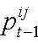 is the prevailing component of Reference Tariff i in year t – 1 ; and
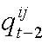 is the quantity of component of Reference Tariff i that was sold in year t – 2 (expressed in the units in which that component is expressed (eg, GJ)).

The Rebalancing Control Formula is detailed in Box 2 and is consistent with the formula applied in the current Access Arrangement Period, other than the inclusion of an X factor. The inclusion of the X factor will enable Envestra to recover its proposed allowed revenue and is consistent with its South Australian network and the AER’s recent Jemena NSW gas distribution final decision.

Envestra also proposes an increase in the value of Y from 0.025 to 0.10 to enable greater flexibility to respond to changes in customer gas usage profile. A Y of 0.10 is also consistent with the tariff rebalancing control formula approved by the AER for the NSW gas distribution business of Jemena.

The CPI definition has also been altered to be consistent with the definition used in the Tariff Variation Mechanism.

Box 2 forms part of Annexure B of the Access Arrangement.
BOX 2 REBALANCING CONTROL FORMULA

$$\left({\text{CPI}}_{t}\right)\left(1−X_{t}\right)(1+Y_{t})≥\frac{\sum_{j=1}^{m}{p_{t}^{j}⋅q_{t−2}^{j}}}{\sum_{j=1}^{m}{p_{t−1}^{j}⋅q_{t−2}^{j}}},i=1,\text{.}\text{.}\text{.}n$$

where:
is calculated as the CPI for the year ending 31 March immediately preceding the start of year t, divided by the CPI for the year ending 31 March immediately preceding the start of year t-1;
is -0.12 for 20012-13;
is -0.09 for 20013-14;
is -0.03 for 20014-15;
is -0.02 for 20015-16;
is 0.10;
is the components comprised within Reference Tariff ;
is the proposed component of Reference Tariff in year t;
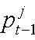 is the prevailing component of Reference Tariff in year t – 1;
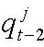 is the quantity of component of Reference Tariff that was sold in year t – 2 (expressed in the units in which that component is expressed (eg, GJ)); and
is the number of different Reference Tariffs.

15.1.2 Transitional measures

To accommodate the creation of the new Tariff R, Envestra proposes the following transitional measure.

The price control relies upon historic demand data from two years prior (year t-2) to provide the weights in the WAPC formula. It also relies on historic price from the year prior (year t-1) to assess the price movements into the year of the proposed prices (year t).

Historic Tariff R prices for year t-1 will not be available until 2012-13. Envestra has therefore developed a set of launch tariffs for 2010-11 to give effect to the WAPC. The 2010-11 launch tariffs are revenue neutral - that is, the revenue recovered form the launch tariffs matches the revenue recovered from the current 2010-11 tariffs utilising 2008-09 billed quantities (refer Attachment 14-1). The 2010-11 launch tariffs have been utilised in the PTRM to establish the implied tariffs for the 2011-12 to 2015-16 period.

Historic Tariff R data for year t-2 will not be available until 2013-14.
Envestra proposes to use the actual small domestic Tariff V data for 2009-10 and 2010-11 (the relevant t-2 years for regulatory years 2011-12 and 2012-13 respectively) and apply the proportions used for converting NIEIR’s gross residential forecasts into the chargeable quantities forecast used in the PTRM. The proportions were derived utilising actual read data from a sample of approximately 2,000 residential MIRNs and is detailed in Attachment 15-1.

Tariff V will be renamed Tariff C effective 1 July 2011 in recognition of its customer base consisting of commercial and small industrial customers.

15.1.3 Tariff Variation Process

The tariff variation process is detailed in section 4.6 of the Access Arrangement. In summary, Envestra will notify the Regulator in respect of any Reference Tariff variations at least 35 business days before the date of implementation. The notification will include an explanation and details of how the proposed variations have been calculated. Envestra proposes that the Regulator has 20 business days to approve or reject the proposed variations. This allows market participants 15 business days to prepare for the implementation of the new tariffs.

The tariff variation process as detailed in section 4.6 of the Access Arrangement satisfies the NGR 97 (4) requirement that “A reference tariff variation mechanism must give the AER adequate oversight of powers of approval over variation of the reference tariff”.

15.2 Ancillary Reference Services

Envestra proposes to maintain its Reference Tariffs for Ancillary Reference Services in real terms over the Third Access Arrangement Period. Envestra proposes the tariff variation mechanism in section 15.2.1 below to adjust the real Ancillary Reference Tariffs for inflation to determine the actual Ancillary Reference Tariffs applicable in each year of the Third Access Arrangement Period. This tariff variation mechanism is consistent with Rule 97 (1) (a).

15.2.1 Ancillary Reference Tariff Variation Mechanism

Subject to the approval of the Regulator, Envestra will have the right to vary the Reference Tariffs for Ancillary Reference Services, initially on 1 July 2011, and thereafter annually during the Third Access Arrangement Period, on the basis of the following Reference Tariff Control Formula:

where:

 is the Reference Tariff that will apply to an Ancillary Reference Service in year _{t};

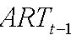 is the Reference Tariff that applied to that Ancillary Reference Service in year _{t-1}; and
 is calculated as the CPI for the year ending 31 March immediately preceding the start of year t, divided by the CPI for the year ending 31 March immediately preceding the start of year t-1.

15.2.2 Ancillary Tariff Variation Process

The tariff variation process will follow Envestra’s Haulage Reference Tariff variation process. Envestra will submit its annual tariff proposal including a pricing model that demonstrates compliance with the formula. The AER approval will be based on its confirmation that Envestra has correctly applied inflation adjustment to its tariffs.

The tariff variation process outlined above satisfies the Rule 97 (4) requirement that “A reference tariff variation mechanism must give the AER adequate oversight of powers of approval over variation of the reference tariff”.

15.3 Trigger Events

In accordance with Rule 97(c), Envestra has proposed a number of defined events or trigger events for the Third Access Arrangement Period. In defining trigger events, Envestra has given consideration to:

- events that are not within its control;

- events for which it is unreasonable or unable to provide cost forecasts for the purposes of total revenue requirement (whether it be due to the uncertainty of timing-occurrence or magnitude of the event), such costs being operating expenditure for the purposes of rule 76(e) (one of the building blocks of total revenue);

- whether, if one had been able to foresee and forecast the event and its cost impact, the associated cost would have been incorporated in access arrangement forecasts.

The proposed Trigger Events are defined in section 4.5 of the Access Arrangement, but are briefly summarised as follows:

- change in impost – essentially where a new tax or charge (eg increased licence fee is imposed on Envestra);

- retailer failure – where the failure of a retailer results in costs to Envestra and-or loss of revenue;

- compliance obligation – where Envestra is obliged to comply with new or changed obligations. For example, impending changes in the Gas Law and National Gas Rules may oblige Envestra to change systems and processes to accommodate the new National Energy Customer Framework (NECF). Envestra is yet to assess the full impact of NECF, as the legislation has not been finalised, however, it appears that the only material direct impact may be in relation to setting up facilities and systems for managing a direct interface with customers. If this is the case, then the cost pass-through process is expected to be far simpler than that undertaken when full retail contestability was introduced.

- force majeure – there are circumstances beyond Envestra’s control where, despite prudent levels of insurance or prudent measures to mitigate losses, Envestra may suffer financially, despite the cost being one that would have been recoverable if the event had been foreseeable. Such events are, by their nature, rare, but it is necessary for the continuity of the business for such costs to be recovered.

- carbon pollution reduction scheme – at the time of preparing Access Arrangement revisions, many uncertainties remain about the timing and cost impact of the scheme proposed by the Federal government, and whether the scheme itself will be implemented as opposed to some different scheme. The uncertainty associated with the scheme means that it is not possible for Envestra to reasonably forecast its impact, meaning that it is appropriate for it to be treated as a Trigger Event.

Materiality Threshold

Envestra’s current Trigger Events are not subject to a specific materiality threshold. Envestra has not believed it necessary to specify a threshold because it has been of the view that:

- a distributor would act reasonably in assessing the need for a cost pass-through, and given the administrative cost of arranging a tariff variation and supporting documentation, a distributor would not pursue frivolous claims;

- cost pass-through events are, by their nature, infrequent;

- it is inconsistent to apply a materiality threshold to a pass-through amount, when no such threshold exists when determining amounts to be recovered by way of forecast costs during an access arrangement review process; and

- the nature of the pass-through event would determine the complexity or otherwise of the tariff variation and hence the administrative cost associated with the tariff variation. For example, a variation associated with a new licence fee for a distributor (eg by AEMO) would require relatively little administrative cost compared to a variation associated with a new national energy framework. This allows flexibility in determining efficient arrangements by allowing pass-through events to be assessed on a case-by-case basis.

Envestra notes that the Rules require the AER to have regard to “the possible effects of the reference tariff variation mechanism on administrative costs of the AER, the service provider, and users or potential users” (rule 97(3)(b)). As explained in part (d) above, administrative costs will vary depending upon the nature of the pass-through event. Hence while the rules recognise that administrative costs are a consideration, the rules (rightly) stop short of quantifying costs and support the notion that such costs (ie administrative versus pass-through costs) should be considered on a case-by-case basis.

For all of the above reasons, Envestra believes it inappropriate to specify a materiality threshold. Nevertheless, Envestra recognises that the AER has a preference for establishing a specific threshold amount. Given that Envestra does not intend to claim a pass-through for an event with an impact of less than $100k a year, Envestra has proposed that figure as a threshold.

PART D – OTHER PROVISIONS OF AN ACCESS ARRANGEMENT
16. NON-TARIFF COMPONENTS

16.1 Capacity Trading

Envestra’s Access Arrangement has contained a trading policy since its inception. However, like a queuing policy, the trading policy had little relevance to the operation of a gas distribution network. This is because the Gas Access Code was originally drafted to suit transmission pipelines, where capacity is tradable, rather than distribution networks. In a network, a Network User is not granted a right to capacity in any section of a network, hence there is no tradable right. When a customer connects to the Network, the distributor assesses the available capacity in that part of the Network required to service that customer. From that point onwards, the distributor monitors and reviews network performance in maintaining supply to consumers as a whole.

Consequently, and unsurprisingly, there has been no capacity trading since Envestra’s trading policy was formulated. Capacity trading does occur upstream of Envestra’s Network, and this is a key feature of the Short Term Trading Market.

The Trading Policy, however, may have some practical use in relation to a User changing Receipt Points or Delivery Points. This aspect of the Trading Policy has been retained, and is consistent with the requirements of Rule 106, which states:

An access arrangement must provide for the change of a receipt or delivery point in accordance with the following principles:

(a) a user may, with the service provider’s consent, change the user’s receipt or delivery point;

(b) the service provide must not withhold its consent unless it has reasonable grounds for doing so.

The access arrangement may specify in advance conditions under which consent will or will not be given, and conditions to be complied with if consent is given.

The Trading Policy Section of the Access Arrangement has been renamed ‘Capacity Trading’, and states that a User may, with Envestra’s consent, change a Receipt Point or Delivery Point where the change is commercially and technically reasonable. The Access Arrangement also specifies the relevant conditions.

16.2 Network Extensions

Envestra’s proposed extensions policy is materially unchanged from its current policy. The only change of note is that references to expansions of the “pipeline” have been deleted. This is because expansion of pipeline capacity is of little relevance to distribution networks, as unlike transmission pipelines, compressors are not installed in a distribution network order to expand the capacity of a network or part of a network. Hence the relevant Section of the Access Arrangement deals with extensions only.

In relation to significant extensions, the existing criteria were that the anticipated load was to be 10TJ per year and that the cost of the extension exceed $1m.
The second criterion has been removed, for consistency with the South Australian Access Arrangement, and given the rarity of significant extensions, the change is not considered to have any material impact.

Mandatory requirements of the Rules are contained in Rule 104(2) and (3) as follows:

(2) Extension and expansion requirements included in a full access arrangement must, if they provide that an applicable access arrangement is to apply to incremental services, deal with the effect of the extension or expansion on tariffs.
(3) The extension and expansion requirements cannot require the service provider to provide funds for work involved in making an extension or expansion unless the service provider agrees.

The obligations described above are reflected in sections 8.3 and 8.4 of the Access Arrangement respectively.

16.3 Terms And Conditions

16.3.1 Overview of Terms And Conditions

The terms and conditions (T&C) applicable to the provision of Reference Services are dealt with in section 6 of the Access Arrangement. The detailed T&C are contained in Annexure G to the Access Arrangement.

The T&C have generally served the market well over two access arrangement periods, with some amendments having been made at the last access arrangement review. The impending National Energy Customer Framework will result in further changes to the T&C, and these will be implemented in due course when the new legislation comes into force.

The opportunity has been taken at this review to align the T&C with the South Australian T&C and to update and make a small number of refinements to the T&C. Material refinements and reasons are outlined in the following table. In the table, references to Change Code is a reference to one of the following:

U = Updated for current market - conditions
A = Agreed amendment resulting from negotiations with retailers – shaded light grey
C = Change (for business reasons)
I = Improved wording or clarification

Table 16.1 Amendment to Terms and Conditions

Old Clause Number | Change Code | Comment
All | U | References to Retail Market Rules have been amended to Retail Market Procedures.
2 | U, I | Gas delivery obligations have been clarified. Gas balancing clause updated to reflect Short Term Trading Market.
4 | U | Gas balancing clause removed.
8.2 | I, C | Improved wording clarifies that the standard of Metering Equipment at similar Delivery Points will essentially be the same.  Clarification that the cost of removal of interval metering equipment is borne by the Network User. This is consistent with current practice, but is not expressly stated elsewhere.
9.6 | U | The metering tolerance quoted has been superseded by new national metering standards, so the reference has been charged to refer to the tolerance that is permitted by law.
11 | C | Clarification of liability in respect of gas quality.
12 | I | A list of Receipt Point pressures has been attached as an appendix to make clear the requirements to prospective Users, rather than relying on a request for information.
12 | C | Clarification of obligations and liability in respect of gas pressures.
15 | C | Clarification regarding gas delivery.
16 | I | Clarification of curtailment priority.
16.3(a) | I | The definition of “Interruptible DP” has been included where the term is used here. The definition previously was contained in the glossary but not used elsewhere.
17 | I | Clauses have been condensed and simplified.
- | C | New clause 19 – clarifies that Envestra may provide other services on request.
24.2 | U | New part ‘(d)’ to reflect National Gas Rules.
24.8 | A | New clause reflects existing agreements with retailers that cater for “holding over”.
29.4 | I | The amendment clarifies that the additional costs incurred by misinformation or omissions may be due to the Network User as well as due to the customer, eg, where the Network User provides an incorrect address for disconnection.
37.10 | A | New clause reflects existing agreements with retailers that clarify stamp duty arrangements.
38.3 | I | “contra proferens” clause copied from Envestra’s Queensland terms and conditions, to provide consistency of terms and clarification in respect of this issue.
38.4 | I | “entire agreement” clause copied from Envestra’s Queensland terms and conditions, to provide consistency of terms and clarification in respect of this issue.

The following summary of the T&C may assist Prospective Users in understanding aspects of the terms of access:

            - Pursuant to section 6 of the Access Arrangement, it is a condition that a Prospective Network User enter into an Agreement with Envestra for the provision of any Network Service. The term ‘Agreement’ is defined in the Access Arrangement and means the entering into of a binding contractual arrangement between Envestra and a Network User. Prior to entering into an Agreement, a Prospective Network User must satisfy Envestra that it:

- has the necessary financial capacity to meet its obligations to Envestra; and

- has adequate arrangements in place to ensure it can keep Gas deliveries into and out of the Network in balance.

            - Annexure F allows for the details pertaining to the specific circumstances of the parties entering into the agreement.

            - Annexure G sets out the terms and conditions that are to apply, as a minimum, to the provision of each Reference Service. It describes terms and conditions which are applicable to both Haulage and Ancillary Reference Services (Part IV of the terms and conditions), as well as those terms and conditions which apply specifically to each type of Reference Service (Part II – Haulage Reference Services, and Part III – Ancillary Reference Services).

            - The clauses applying to Haulage Reference Services (Part II) address matters including:

- procedures for classifying Delivery Points;

- meter accuracy and reading;

- minimum Gas quality and delivery pressures;

- possession of Gas and responsibility;

- warranties and title to Gas; and

- supply curtailment.
(5) Part III applies only to the Ancillary Reference Services. This part only consists of one clause because the Retail Market Procedures deal extensively with the obligations surrounding these services.

(6) (Part IV) applies both to Haulage Reference Services and Ancillary Reference Services. These clauses address matters including:

- invoices and payment arrangements;

- procedures for determining delivered quantities;

- termination;

- liability and indemnities;

- relationship to the Trade Practices Act 1974;

- Force Majeure;

- assistance;

- access to premises;

- confidentiality;

- notices;

- assignment by the Network User;

- amendment of the Agreement; and

- other miscellaneous provisions.

The obligations, duties and responsibilities of Envestra and any Network User described in the T&C are in addition to those established in law or by any relevant regulatory instrument.

Where the terms and conditions described in Annexure G of the approved Access Arrangement are amended, the default position is that the terms and conditions applying to an existing Agreement will also change accordingly.

However, a Network User and Envestra may agree that all or some of the terms and conditions applicable to their Agreement will not change during the Term of an Agreement, regardless of any amendments to Annexure G of the Access Arrangement. Both parties are therefore free to agree to arrangements that reflect their preferred risk profile at a point in time.

The terms and conditions applying to provision of the Haulage Reference Services and the Ancillary Reference Services are consistent with good industry practice and are ‘reasonable’ in that they:

- are sufficiently well defined, so that the likelihood of a dispute over the terms and conditions of access is minimised; and

- are designed to protect the legitimate business interests of Envestra, as well as Network Users and Prospective Network Users.

16.3.2 Rules Compliance

Rule 48(1)(d) states that a full access arrangement must specify for each reference service:

  - the reference tariff; and

  - the other terms and conditions on which the reference service will be provided.

The terms and conditions are specified in section 6 and Annexure G of the Access Arrangement.

The terms and conditions applying to provision of the Reference Services are consistent with good industry practice and are ‘reasonable’ in that they:

- are essentially the same as those currently applying to Users (which terms have previously been approved as reasonable);

- are sufficiently well defined, so that the likelihood of a dispute over the terms and conditions of access is minimised; and

- are designed to protect and balance the legitimate business interests of Envestra, as well as Users and Prospective Users.

Source: ABARE (2010), Australian Energy Projections to 2029-30, p 27.
https:--www.ga.gov.au-resources-publications-oil-gas-resources-australia-2008-reserves-reserves-table-3.jsp
Envestra and Boral (1998), Annual Reports.
Source: Bear Stearns Fund Collapse Sends Shock Through CDOs (Update2) http:--www.bloomberg.com-apps-news?pid=20601087&sid=a7LCp2Acv2aw&refer=h. Bear, Stearns & Co. Inc. is the parent company of a leading global investment banking, securities trading and brokerage firm. Bear Stearns is headquartered in New York City and currently employs approximately 14,000 people worldwide.
George Wilkenfeld and Associates (2009), “Regulation Impact Study for Phasing out Greenhouse Intensive Water Heaters in Australian Homes”.
WA Office of Energy (2010), “Running costs and greenhouse gas emissions”.
Commonwealth Government (2008), Energy use – Technical Manual.
Origin Energy (undated), “Benefits of Natural Gas Powered Air Conditioning”.
LCS (2010), “Australian Life Cycle Assessment Data Base, Centre for Design, RMIT.
Rare (2010), GHG Life Cycle Assessment of Passenger Car Technologies and Fuels in Australia.
Rare (2009), Greenhouse Life Cycle Assessment of Heavy Vehicle Fuels in Australia”.
Personal Communication (2010), Envestra.
http:--www.standardandpoors.com
This was also the case for the commercial and small industrial volume market.
See table 5.1 herein.
Cain affidavit, paras 12, 13, 15 to 17; Little affidavit, para 82.
Little affidavit, paras 83, 102-103.
Little affidavit, paras 83, 102-103.
AER’s Final Decision under the National Gas Rules in respect of the New South Wales gas distribution network; AER’s Draft Decision in respect of the Victorian electricity distribution networks under the National Electricity Rules.
Little affidavit, para 103.
Little affidavit, para 121.
Little affidavit, para 121.
Little affidavit, para 121.
Little affidavit, para 26.
Little affidavit, para 26.
In 1998, Boral’s revenue was $4.7 billion compared with Envestra’s revenue of $0.1 billion. See Boral and Envestra 1997/98 Annual Reports.
Little affidavit, para77; Cain affidavit, paras 6 to 17 and 19
Cain affidavit, para 6
22 July 1999 Prospectus, pg. 16
Cain affidavits, paras 6 to 17; this affidavit was tendered as part of the 2008 Victorian review; the Victorian appeal panel in 2008 accepted this evidence.
Cain affidavit, para 12
Cain affidavit, para 21. Envestra notes than when APA purchased Origin networks these transitional costs were borne by APA: Little affidavit, para 109(e)
Cain affidavit, para 30
Little affidavit, para 98
Little affidavit, para 87-89; Cain affidavit, para 14-15
Little affidavit, para 103
Little affidavit, para 106
Little affidavit, para 106
Little affidavit, para 110.
Little affidavit, paras 109 and 111.
The equity interest is 30.6% today by reason of the matters referred to in section 5.4.
Ferguson affidavit, paras 7 to 11.
As extracted from the 2010 annual reports of Envestra Ltd and the APA Group .
Ferguson affidavit, para 60.
Ferguson affidavit paras 66-67.
Little affidavit, para 11; Ferguson affidavit paras 13-39; Cooledge affidavit paras 11-27.
Ferguson affidavit, para 49.
Ferguson affidavit, para 50.
Ferguson affidavit, paras 53-59.
Ferguson affidavit, paras60-68.
Little affidavit, para 115. There are certain other charges (i.e. for system use gas and government charges as described in this paragraph of the affidavit.
2007 OMA, cl. 22.
This is because the management fee is positively related to network sales/growth.
Little affidavit, para 24(c)(iv).
Little affidavit para 24(c)(iv).
Ferguson affidavit paras 73, 74 and 76.
Ferguson affidavit para 77.
The reference to Envestra undertaking activities itself does not of course mean Envestra personally discharging every activity but to Envestra performing the tasks, including engagement and management of contractors, which APA performs for Envestra.
WorleyParsons “Envestra Access Arrangement Submission Review of KPMG Report”.
See para 4.4 of the WorleyParsons report.
Section 2.6.1 of KPMG report.
P38
P38-39
P 16
P 17
Victorian Electricity Distributors Draft Decision P187
NERA report “Benchmark Study of Contractor Profit Margins” September 2010
See NERA report, p24
Victorian Electricity Distributors Draft Decision P186
and its predecessor under the National Third Party Access Code for Natural Gas Pipeline Systems
See Ferguson Affidavit, paras 49-59
Para 115.
This finding of the Appeal Panel is relevant for South Australia given that the outsourcing arrangement was accepted by SAIPAR in its 2001 review.
Para 118.
Para 126.
Victorian Electricity Distributors Draft Decision Page 175.
P181
P188
Page 185.
Jemena Final Decision p268
Jemena Final Decision p268
Review of Expenditure of ACT & NSW Gas Distributors, Jemena Gas Networks (NSW) Ltd, Wilson Cook & Commission, Dec 2009
Page 73
Jemena AAI, p156
ActewAGL AAI, p141
Country Energy AAI, p27
Re: Dr Ken Michael Am; ex parte Epic Energy (WA) Nominees Pty Ltd [2002] WASCA 231 at paragraph 55.
AER, Final decision Electricity transmission and distribution network service providers Review of the weighted average cost of capital (WACC) parameters, May 2009
Proxy for the risk free rate used in the Sharpe-Lintner CAPM
It is important to note that the AER does not use an equity beta of between 0.4-0.7 which it is what was proffered as the ‘correct’ range. But rather it makes an ad hoc adjustment and use an equity beta of 0.8.
That is, the short-term average of the yield on the 10 year Commonwealth government bond is used as the proxy for the risk free rate to which the 5.2% equity premium is added (0.8 beta x 0.65% MRP))
The yield on the 10-year Commonwealth Government Bond plus the 5.2% Equity Premium
Guy Debelle Assistant Governor (Financial Markets) RBA , Address to Risk Australia Conference, On Risk and Uncertainty, Sydney - 31 August 2010
Australian Competition Tribunal in Application by Telstra Corporation Limited ABN 33 051 775 556 [2010] ACompT
This is ubiquitously referred to as the weighted average cost of capital or ‘WACC’
Brealey R, Myers S, Partington G, Robinson D (2000) Principles of Corporate Finance, 1st Australian edition, McGraw-Hill Australia, p210-222
Standard & Poor’s, STock Appreciation Ranking System (STARS): Methodology, Analysis, & Performance Attribution, June 2005, p12
The Dividend Growth Model is also referred to as the Gordon Growth Model
Note that an investor does not have to expect to hold an equity security perpetually to benefit from perpetual dividend growth. They simply have to be able to sell the equity to another investor at a price that reflects the future dividends that investor will receive. Thus, the valuation of perpetual dividends is consistent with the valuation of a finite holding period followed by a sale where the sale price is determined by future dividends at that time.
Brealey R, Myers S, Partington G, Robinson D (2000) Principles of Corporate Finance, 1st Australian edition, McGraw-Hill Australia, p166.
SFG, The relationship between theta and MRP, September 2010, p3-4
Bishop & Officer Market Risk Premium, December 2009 p1.
CEG, Estimating the cost of capital under the NGR, A report for Envestra, September 2010, p40.
Guy Debelle Assistant Governor (Financial Markets) RBA , Address to Risk Australia Conference, On Risk and Uncertainty, Sydney - 31 August 2010
SFG, Return on equity commensurate with current conditions in the market for funds, September 2010, p1
SFG, Return on equity commensurate with current conditions in the market for funds, September 2010, p1
CEG, Estimating the cost of capital under the NGR, A report for Envestra, September 2010, p48
AER, Final Decision, Jemena Gas Networks Access Arrangement proposal for the NSW gas networks, June 2010, p184
Standard & Poor’s, Ratings Definitions, May 2010, p4
The NZ Commerce Commission applies a 40% gearing and BBB+ credit rating benchmark in determining the rate of return for regulated energy distribution businesses.
Standard & Poor’s, “International Utility Ratings and Ratios”, 5 September 2001, p4
The terms ‘gamma’, franking credits and ‘value of imputation credits’ are used interchangeably throughout this submission.
Standard & Poor’s, “International Utility Ratings and Ratios”, 5 September 2001, p4
AER, Final Decision, Jemena Gas Networks Access Arrangement proposal for the NSW gas networks, June 2010, p183
Standard & Poor’s is define FFO as net income from continuing operations adjusted for depreciation and amortization (D&A) and other noncash and nonrecurring items such as deferred taxes, write-offs, gains and losses on asset sales, foreign exchange gains and losses on financial instruments, and undistributed equity earnings or losses from joint ventures
AER, Final decision Electricity transmission and distribution network service providers Review of the weighted average cost of capital (WACC) parameters, May 2009, p375
Standard & Poor’s, “International Utility Ratings and Ratios”, 5 September 2001, p3
Standard & Poor’s, “International Utility Ratings and Ratios”, 5 September 2001, Table 2 p4
Standard & Poor’s, “International Utility Ratings and Ratios”, 5 September 2001, Table 2 p4
AER, Final decision Electricity transmission and distribution network service providers Review of the weighted average cost of capital (WACC) parameters, May 2009, p387
The AER considered ElectraNet as the most appropriate ‘best comparator’ business in the NSW gas network Draft Decision
S&P (23 November, 2008), ‘ElectraNet Outlook Revised To Negative On Prolonged Underperformance To Policies’; Rtg Affirmed’, Commentary Report, p.3.
Standard & Poor’s, Envestra Ltd, August 2008, Standard & Poor’s, WA Network Holdings Pty Ltd, 2 September 2010
Standard & Poor’s, Industry Report Card, May 2010, p8-10
Jemena Final Decision (2010), ActewAGL Final Decision (2010) and Wagga Wagga Final Decision (2010)
Standard & Poor’s, “International Utility Ratings and Ratios”, 5 September 2001, Table 2 p4 indicates an FFO interest towards 3 times and FFO to total debt of up around 16% is reflective of a strong BBB+
AER 2007, Electricity Distribution Network Service Providers Transition of Energy Businesses from Pre-tax to Post-tax Regulation, Issues Paper, June 2007, p51.
This is the earliest year for which Envestra has information (unlike South Australia, where a TAB value is available as at 1 July 1997).
The terms ‘gamma’, franking credits and ‘value of imputation credits’ are used interchangeably throughout this submission.
Corporate valuation professionals, such as Grant Samuel, hold Australian ﬁnancial services licenses under the Corporations Act, have a duty of care in providing financial advice and are subject to significant legal ramifications if their advice is found to be misleading or false in any regard.
The discussion and rationale for the benchmark BBB+ credit rating is provided in chapter 9 Rate of Return.
N. Hathaway and B. Officer, The Value of Imputation Tax Credits – Update 2004, Capital Research Pty Ltd, November 2004
Synergies Economic Consulting, Gamma: New Analysis Using Tax Statistics, 28 May 2009;
Robert R. Officer, Estimating the Distribution Rate of Imputation Tax Credits: Questions Raised by ETSA’s Advisers; 23 June 2009 and Peter Feros, Review of WACC parameters: Gamma – ETSA Price Reset, 22 June 2009
AER, Jemena Gas Networks Final Decision, June 2010, p214
AER, Final Decision South Australia distribution determination 2010 – 11 to 2014 – 15, May 2010, p 150.
Professor Michael McKenzie and Associate Professor Graham Partington, Evidence and submissions on gamma, 25 March 2010.
Professor Michael McKenzie and Associate Professor Graham Partington Evidence and submissions on gamma, 25 March 2010. P 26.
Associate Professor John Handley, Report prepared for the AER on the estimation of gamma, 19 March 2010, at page 33.
Professor Michael McKenzie and Associate Professor Graham Partington, Evidence and submissions on gamma, 25 March 2010, page 27.
Associate Professor John Handley, Report prepared for the AER on the estimation of gamma, 19 March 2010, page 36.
It is also noted that as of 28 June 2010, the Corporations Act has been amended so that dividends can now only be paid if the following three tests are met: 1. The “Balance Sheet” test. 2. The “fair to shareholders” test; and 3. The “no material prejudice to creditors” test. Previously, dividends could only be paid by a company out of the company’s profits.
Being Professor Michael McKenzie and Associate Professor Graham Partington and Associate Professor John Handley.
This upper bound is questionable as it is at the extreme end of what is considered plausible given it has been derived from taxation statistics. The taxation statistics do not convey any information about the value shareholders attribute to franking credits?
SFG: “The best available empirical estimate of theta”: Report prepared for Envestra Ltd September 2010 (SFG September 2010 Report)
Christopher Skeels, ‘A review of the SFG Dividend Drop-Off Study’, 28 August 2009, p31.
Insert report reference.
SFG: “The value of imputation credits implied by the methodology of Beggs and Skeels (2006).
See SFG September 2010 Report pages 21-22.
See page 8 of the SFG September 2010 Report.
As explained at pages 5 to 7 and 23 to 25 of the SFG September 2010 Report.
See SFG September 2010 Report, pages 9-10.
Associate Professor John Handley, Report prepared for the AER on the estimation of gamma, 19 March 2010, p.15.
Professor Michael McKenzie and Associate Professor Graham Partington, Evidence and submissions on gamma, 25 March 2010, p. 9.
Neville Hathaway, Comment on: “A Measure of the Efficacy of the Australian Imputation Tax System” by John Handley and Krishnan Maheswaran, p3.
Neville Hathaway, Imputation Credit Redemption: ATO data 1988-2008, July 2010
Where a regulator has determined a feasible range for gamma the mid-point of that range has been used as the point estimate determined by the regulator.
Grant Samuel, ‘Variation for Origin Energy of Conocco Phillips offer to acquire shares in Origin Energy CSG Limited (prepared for the purposes of assessing the British Gas Bid for Origin Energy)’, 15 September 2008, p130.
Grant Samuel, ‘SPAUSNET – Valuation Report in relation to Proposed Acquisition of ‘Alinta Assets from Singapore Power International Pty Limited’, 5 November 2007, Appendix 1 – p11.
AER, Jemena New South Wales Gas Networks decision, p214.
This was also the case for the commercial and small industrial volume market.
Final Decision June 2010 – Jemena Gas Networks Access arrangement proposal for the NSW gas networks 1 July 2010 to 30 June 2015, p299
The mild winters experienced in Envestra’s Queensland network result in a near non-existent gas space heating load. Historic gas consumption is therefore not traditionally weather normalised.
BIS Shrapnel The Household Appliances Market in Australia 2008 Volume 4: Hot Water Systems
Chapter 5 ABS 4602.0.55.001 March 2008
Pricing Proposal to the Australian Energy Regulator - Distribution Services for 1 July 2010 to 30 June 2011, Ergon Energy, 4 June 2010, p48
Pricing Proposal to the Australian Energy Regulator - Distribution Services for 1 July 2010 to 30 June 2011, Ergon Energy, 4 June 2010, pp 48
Pricing Proposal to the Australian Energy Regulator - Distribution Services for 1 July 2010 to 30 June 2011, Ergon Energy, 4 June 2010, pp 48
Direct Control Services Annual Pricing Proposal 2010-11, Integral Energy, 30 April 2010, p78.
ibid
Jemena Gas Networks (NSW) – Access Arrangement Information – Appendix 15.4 Long Run Marginal Cost Report 26 August 2009.
ActewAGL Distribution Access arrangement information for the ACT, Queanbeyan and Palerang gas distribution network, June 2009.
ETSA Utilities Pricing Proposal 2010-11, June 2010.
NERA Economic Consulting, Distribution Pricing Rule Framework Network Policy Working Group, December 2006, p32.
Pricing Proposal to the Australian Energy Regulator - Distribution Services for 1 July 2010 to 30 June 2011, Ergon Energy, 4 June 2010, p53.
Page 372 AER Final Decision Jemena Gas Networks Access arrangement proposal for the NSW gas networks 1 July 2010 to 30 June 2015 – June 2010
ibid
Customers currently assigned to Tariff V are designated as domestic or commercial-small industrial. Domestic currently also includes bulk hot water for multi unit dwellings. It is proposed that Tariff R will only apply to single unit dwellings. Multi unit bulk hot water will shift to Tariff C (the old Tariff V).

