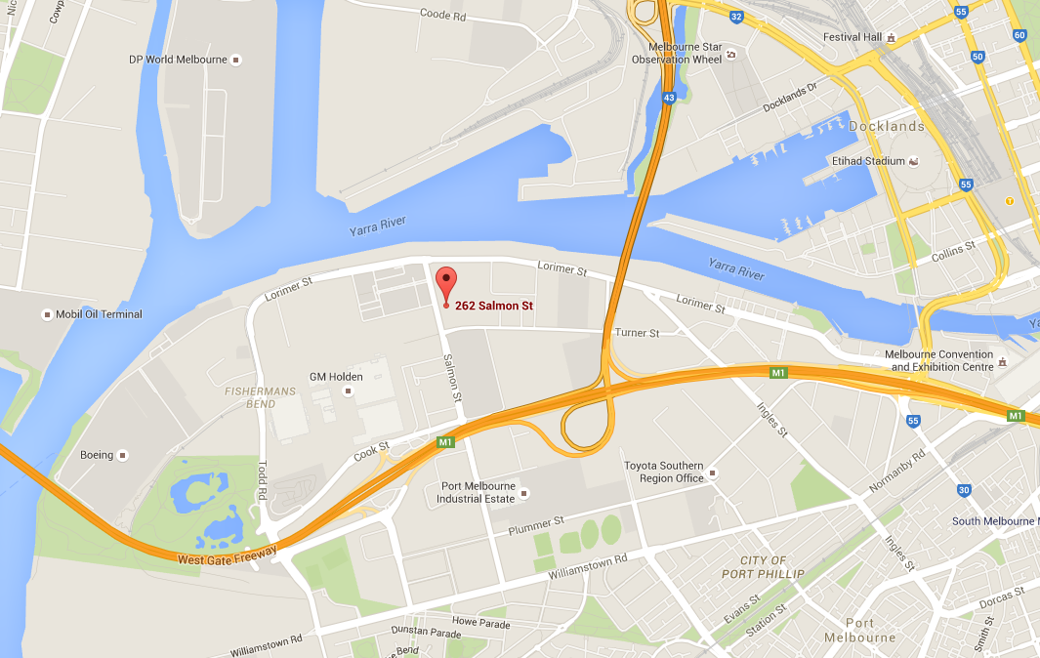

**262 Salmon Street, Port Melbourne. Crema Constructions Group.**