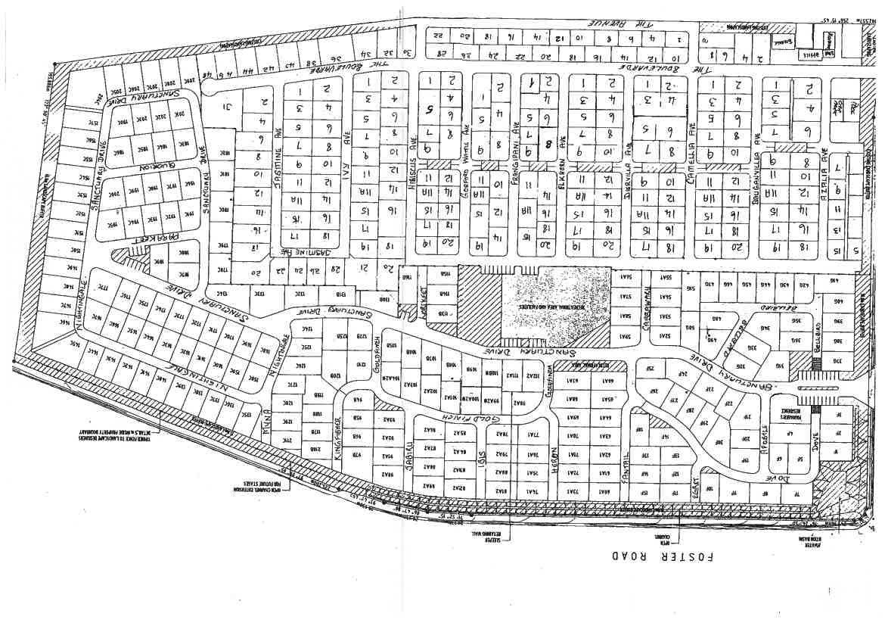

Bruce Highway Eastern Service Road, Burpengary East