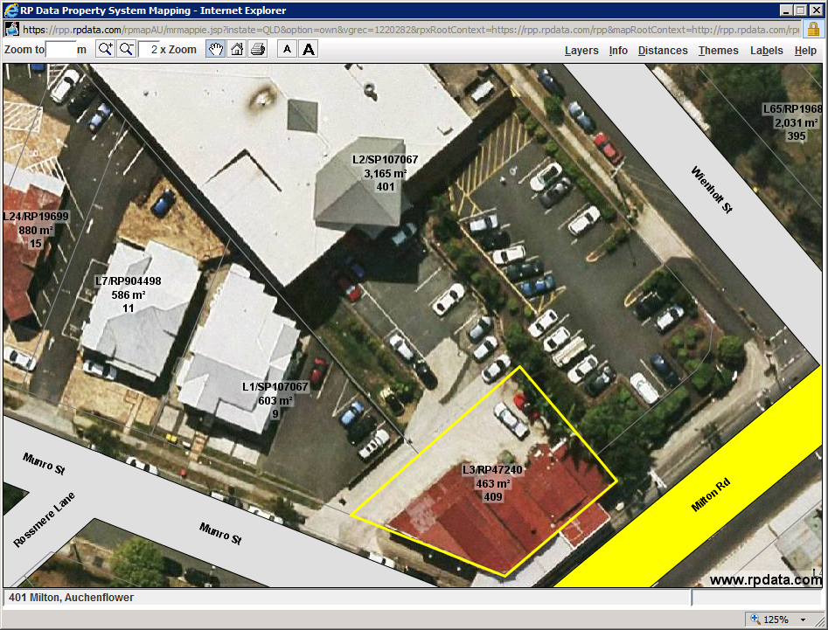

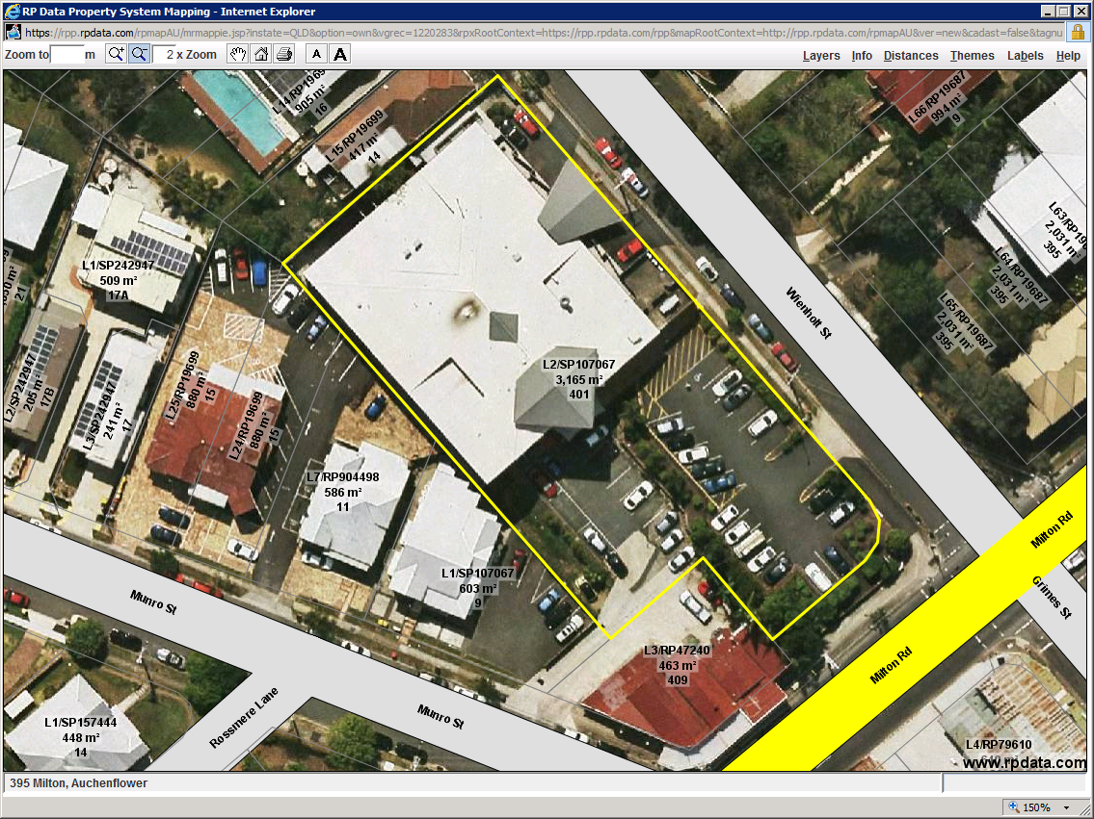

|  |  |  |
| --- | --- | --- |
| 409 Milton Road – 3165m2 | | 87.24% |
| 401 Milton Road - 463m2 | | 12.76% |
| Total Area = 3628m2 |  |  |